Lab 2 – CS 3340

Contents

1 Lab Objectives 1

2 Preliminaries 1

3 Download & Install VS 2022 1

4 Create a Project & Solution 5

5 Build a Web Page 8

6 Explore Folder Structure 10

7 License Expiration 11

8 Package Lab/Assignment for Submission 12

# Lab Objectives

1. Download & install Visual Studio 2022 (VS 2022) if desired.
2. Create an ASP.NET Web Application project in the Visual Studio 2019 (or 2022) (VS) IDE
3. Create and display a web page.
4. Understand how the project and solution is stored on disk.
5. Zip solution for submission.

Follow the steps below to complete this lab.

# Preliminaries

For the next unit of this course you will use either VS 2019 or VS 2022. Note the following:

* VS 2019 is installed in the CS Open Lab and our classroom. It is not available anywhere else on campus. This software is no longer available for download. When you launch VS 2019 in the CS Open Lab, it will prompt you to log in. You can do that or choose: “Not now, maybe later.”
* VS 2022 is not installed anywhere on campus. It is available for download for free following the directions in the next section of this lab. There is not a version for the Mac that will work for our purposes.

For your work for this unit, you can exclusively work in the lab with VS 2019. If you intend to work in the CS Open Lab, you can proceed to Section 4.

Or, you can download VS 2022 and do your work on your personal device. If you choose to download:

* **I cannot help you with the downloading and installation.**
* **The labs I will have you do are written for VS 2019. At times, you may have to figure out how to do what I am asking you to do in the labs. So far, I’ve gone through them and put notes where things are different from VS 2019.**
* **There is a “Visual Studio for Mac”; however, (a) it is a much lighter weight version that is completely different than VS 2022 (b) it has been phased out and there will not be any more releases. It will not work for this course.**

# Download & Install VS 2022

Note: These directions (and subsequent labs) were developed for VS 2019. Thus, some of the screens may be different.

1. Verify that your computer meets the minimum requirements.
2. <https://learn.microsoft.com/en-us/visualstudio/releases/2022/system-requirements#visual-studio-2022-system-requirements>
3. Visit this page: <https://azureforeducation.microsoft.com/devtools>
4. Choose: *Sign In*
5. Type your VSU email address, *e.g.* [dgibson@valdosta.edu](mailto:dgibson@valdosta.edu) and choose: *Next*
6. [This might occur] Choose: *Work or school account*
7. At the *MyVSU* login, type your credentials and choose: *Sign In*
8. [This might occur] You will be prompted for 2-factor authentication through the Microsoft Authenticator App.Choose:
9. The landing page is shown below.

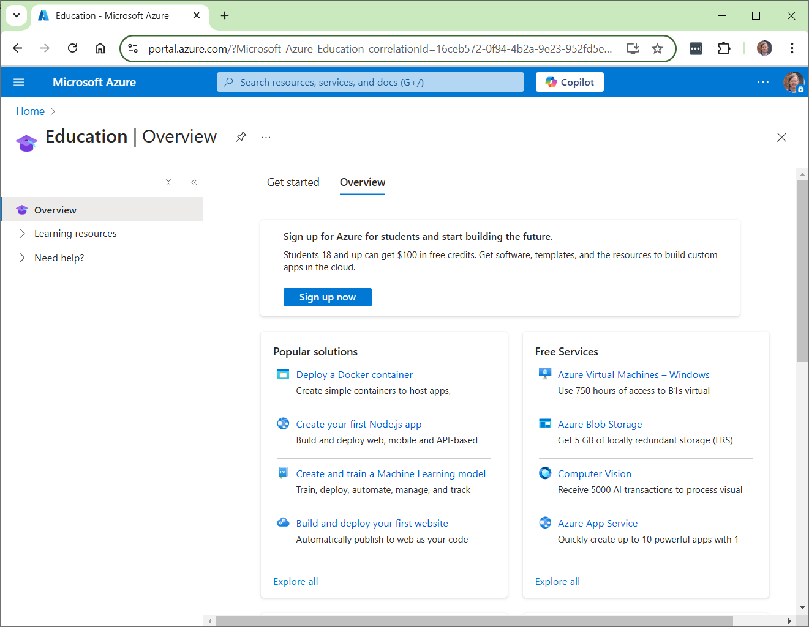

1. Choose: Learning Resources, Software (from menu on left)
2. Choose: Developer Tools from the Product Category dropdown. The resulting page is shown below

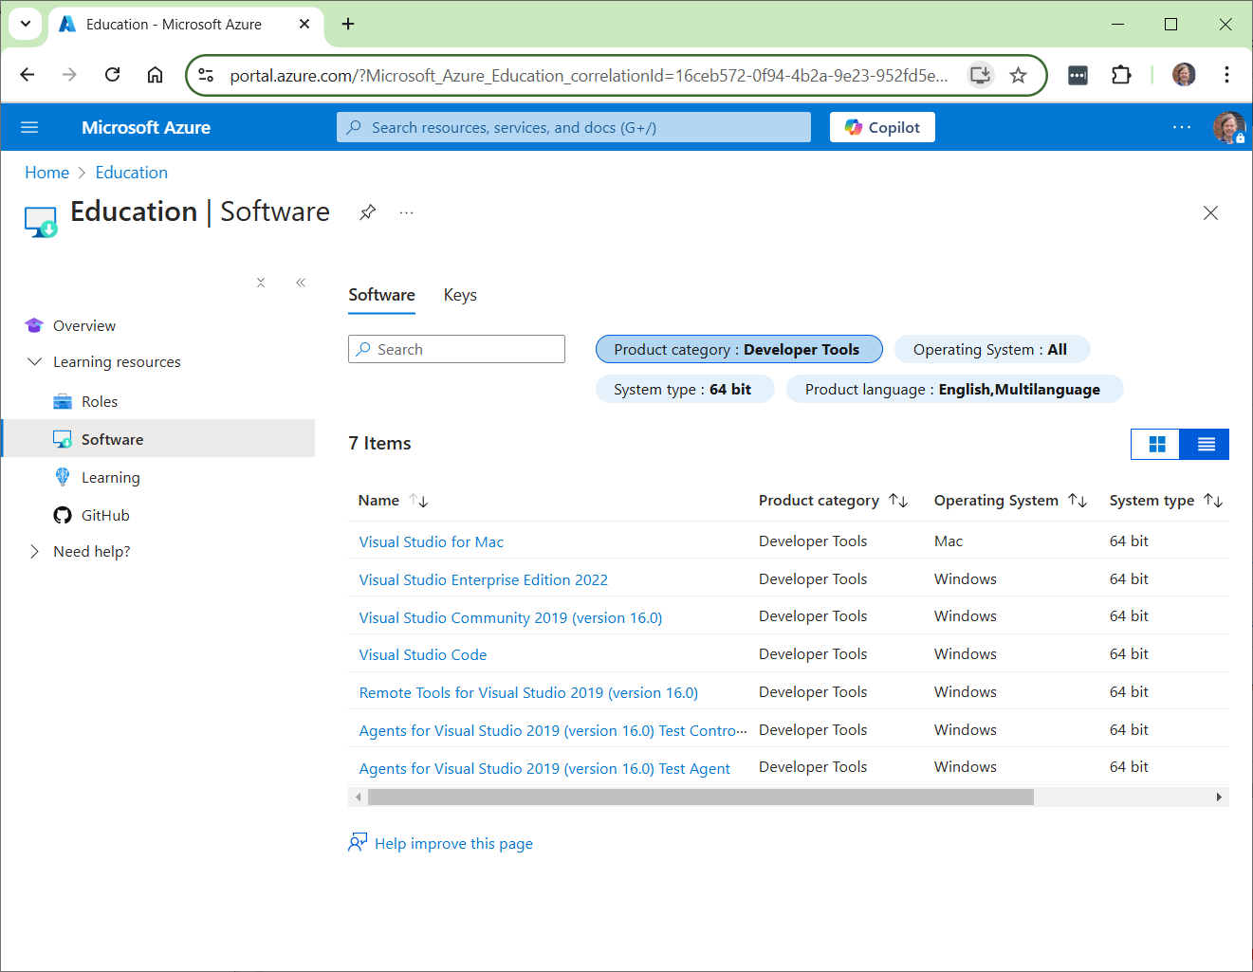

1. Find and select: *Visual Studio Enterprise 2022*
2. Choose Download.
3. Run the installer. It will prompt you to choose the *Workloads* you want installed (see image below). The only one you need is: “ASP.NET and web development.” You can install any of the others at a later date if desired. The install takes a long time (30+ minutes) and requires a reboot along the way. When I rebooted, it didn’t prompt me to resume the install. As I remember, I think I simply restarted the installer and it picked up where it left off.

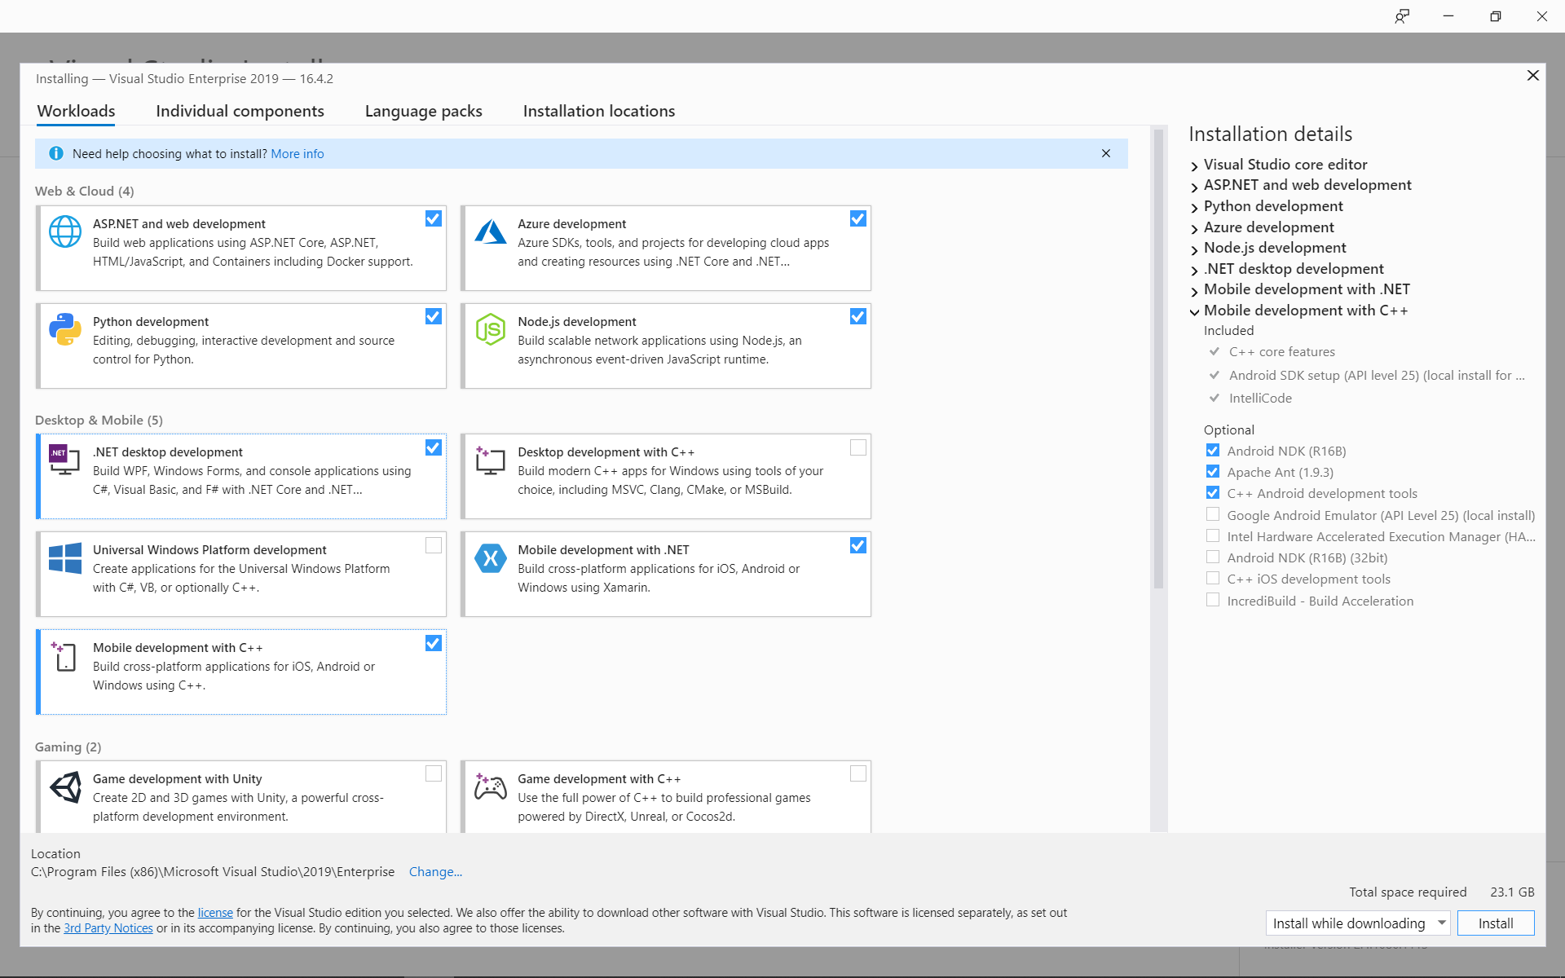

|  |  |
| --- | --- |
| 1. Run VS and you will probably be presented with this dialog. You should be able to log in. Howeve, but it is not working (Spring 2024). You can try. If not, restart VS and choose: “Not now, maybe later” at the bottom.   cid:02324c30-c858-4742-aa61-31e5f0cb019d | 1. The first time you run VS, it will probably ask you set the Development Settings. Choose: Web Development, and then: Start Visual Studio.   cid:80f111b5-194c-44cf-9361-bb8692487a79 |

# Create a Project & Solution

1. **Create Workspace** – Create a folder on your hard drive where you will store the work for this lab and subsequent labs. This is similar to a *workspace* in Eclipse. It can be any folder. You might name it: *cs3340_labs.* Then, you can put all your labs in this folder. Whatever folder you choose, we will call this your *labs folder*.
2. (Read, no action required). In this class we will use the Visual Studio 2019 Enterprise IDE (VS) to create *projects*. Note the following about how VS organizes your work:

* A *VS project* contains the code you write for a particular lab, or homework, *etc.* There are many different types of projects, but we will only create *ASP.NET Web Application* projects.
* A VS *project* is housed in a *solution*. A *solution* can contain any number of *projects.*
* You will use VS to create a project will be named: *lab01_lastName*. Among other files and folders, there will also be a solution file named: *lab01_lastName.sln.* You can double-click this to launch your project in VS.
* In summary, the file structure will look like this:

anyFolder // any folder on your computer

lab01_lastName // project folder

lab01_lastName.sln // solution file

... // other project files & folders

lab02_lastName // project folder

lab02_lastName.sln // solution file

... // other project files & folders

* To submit your labs and homeworks, you will zip the project folder into file named: *lab01_lastName.zip.* You will do this in the last section of this lab.
* Every lab and homework will have this same structure: *lab02_lastName, lab03_lastName, …, hw01_lastName, hw02_lastName, …*

1. 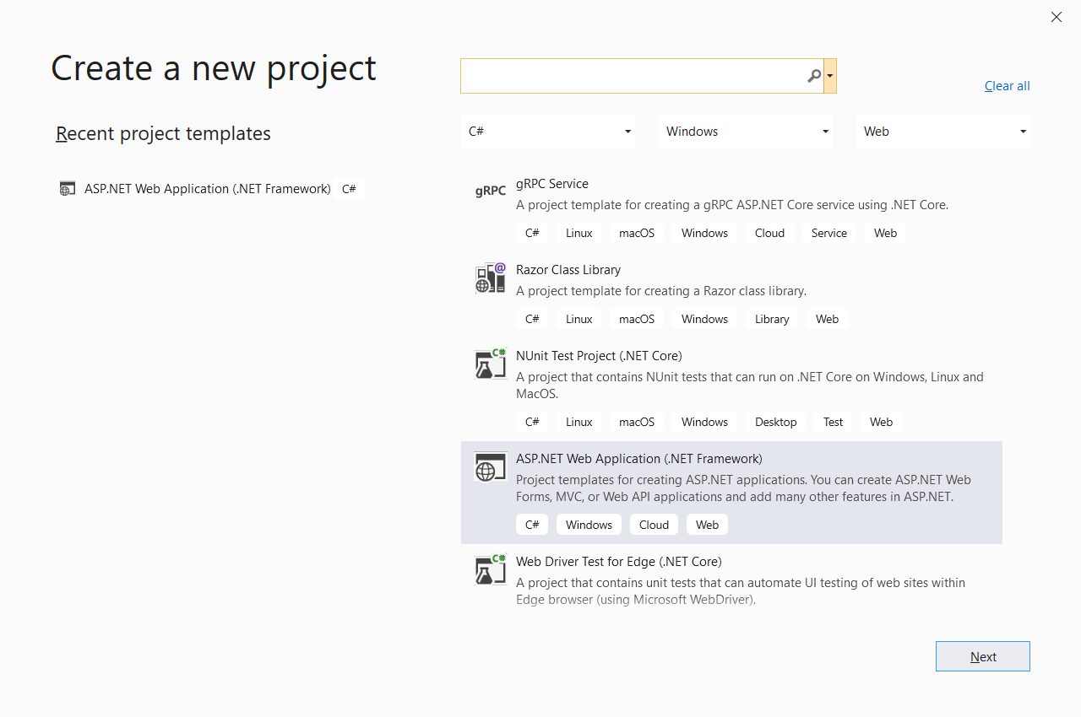**Create Your Project**
2. Launch VS 2019/2022.
3. Choose: *Create a new Project*
4. On the *Create a new project* dialog, select the, *ASP.NET Web Application (.NET Framework)* template (language should be C#) and choose: Next.

This is easy to mess up because there are a lot of similarly named project templates and languages. The easiest way to do this is to set the filters at the top: (a) *C#* in the first, (b) *Windows* in the second, (c) *Web* in the third.

1. 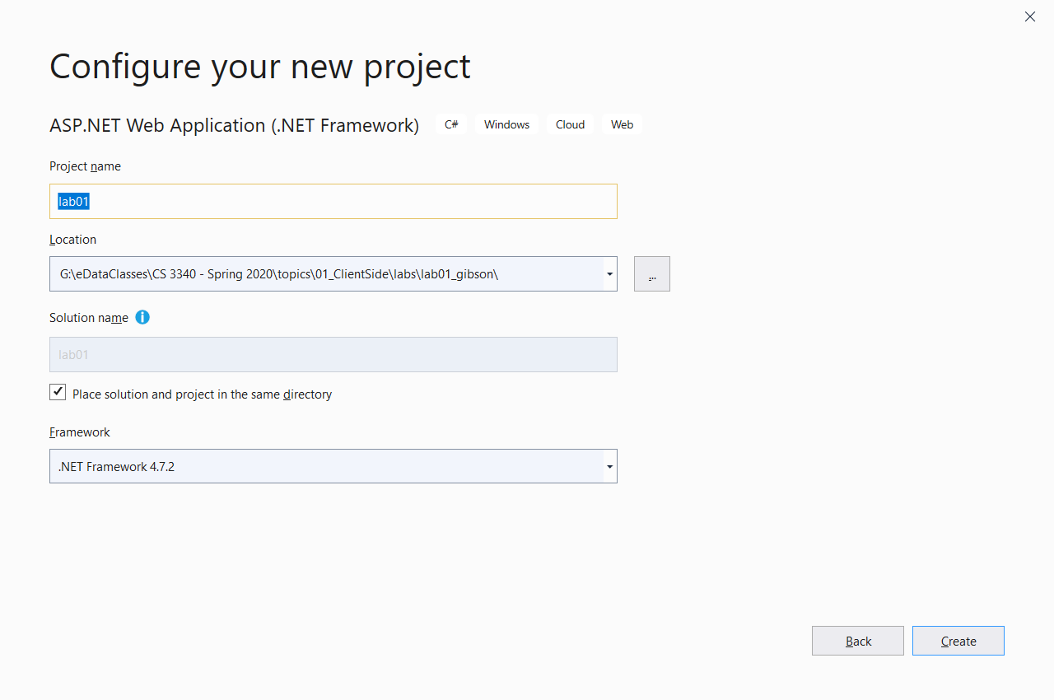Do the following on the *Configure your new project* dialog:
2. Type the *Project name*: “lab02_lastName” (use your last name!)
3. Choose the *Location* by navigating to your *labs folder* created above.

Warning: if your path is too long, you get a cryptic error and the project is not created. I’ve tried a path of 113 characters, 7 folders deep, and it failed.

1. Check the box that says, “Place solution and project in the same directory”
2. Choose: Create.
3. 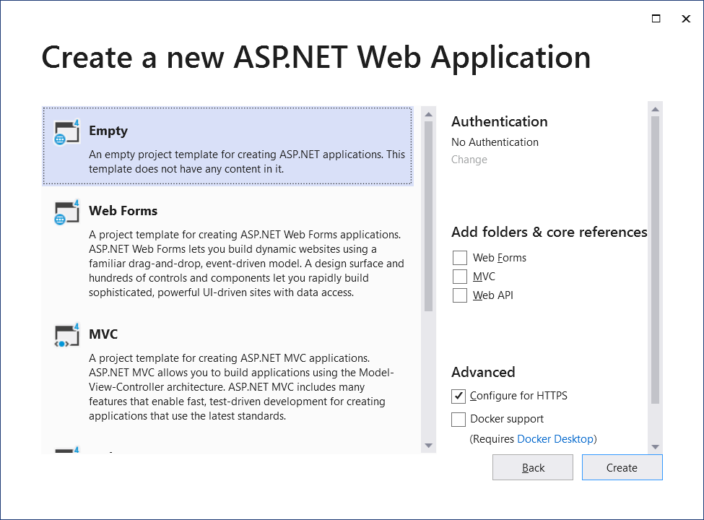Do the following on the *Create a new ASP.NET Web Application* dialog:
4. Choose: Empty
5. Choose: Create (this takes a few seconds)
6. (Read, no action required). Your window will look similar to what is shown below. Note the following:
7. The *Solution Explorer* (SE) lists all the projects in your solution. When a project is selected, it lists the files in that project. We will generally only have one project in a solution; however, it can be useful to create another project inside a solution to test something out, *etc.*

* If the SE is not displayed, choose: View, Solution Explorer

1. In the diagram below, in the SE, the *solution* is named: *lab01* (yours will be named: *lab01_lastName,* same as the project name). And, the *project* is named: *lab01* (yours will be named: *lab01_lastName*).
2. If you select the project, the *Properties Window* displays properties for the project. We won’t change any project properties. However, any item selected has properties and we will use this pane heavily throughout the course.

* If the Properties pane is not displayed, choose: View, Properties Window

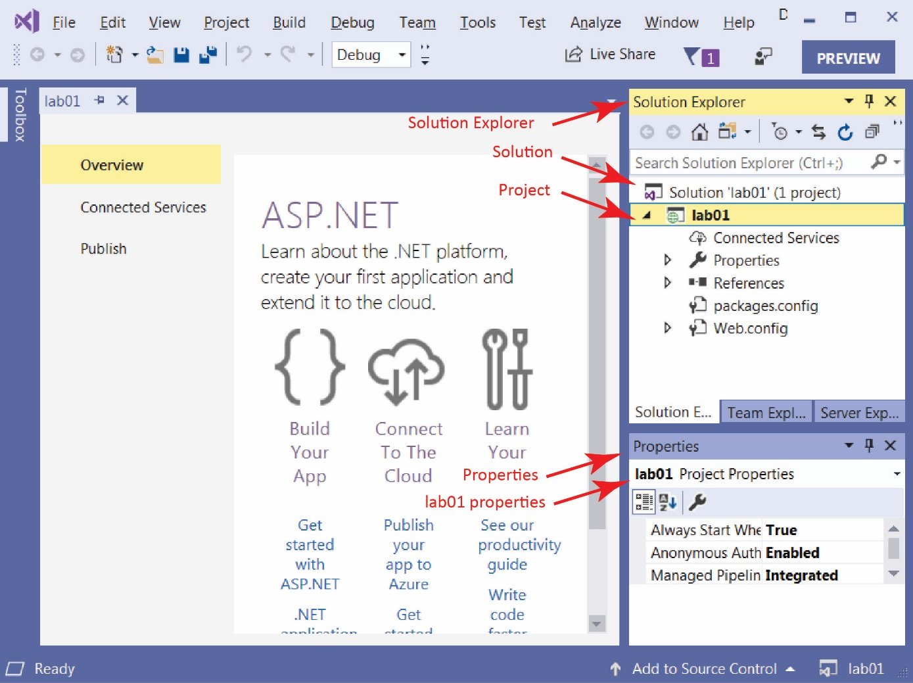

# Build a Web Page

1. **Build a Web Page**
2. Select the *lab02_lastName* project in the *Solution Explorer (SE)*, right-click and choose: *Add, HTML Page*. Supply the name, *default* and choose, *OK*.

* If you do not see *HTML Page*, then choose: *Add, New Item, Visual C#, Web, HTML Page.*

1. Notice the web page is open in the code window and the file is displayed in the SE.
2. The page is open in *Source* view showing HTML. We can also open the page in *Design* view where we can type text into the page as well as use tools to, for instance, create a table. We will use a different editor to open the page so that it supports: *Design, Split,* and *Code* views.
3. Close *default.html*
4. Right-click *default* in the SE

**VS 2022 Note:** Skip this, Design tab is present

1. Choose: *Open With, HTML (Web Forms) Editor*

**VS 2022 Note:** Skip this, Design tab is present

Then, you will see *Design, Split* and *Source* buttons in lower left to change the view. You should be in *Design* view now.

1. Change to *Source* mode by selecting the *Source* button in the lower-left. Type the values shown in the image below, substituting your name. Save.

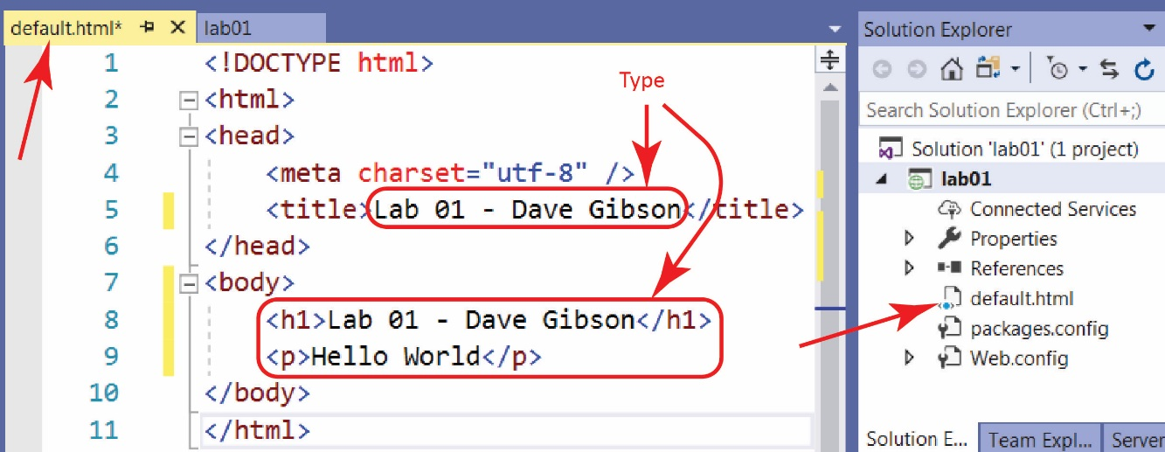

1. (Read, no action required) Window’s computers have a webserver to serve pages locally, to the machine you are working on. The webserver’s name is *localhost.* This is where we will test pages.
2. 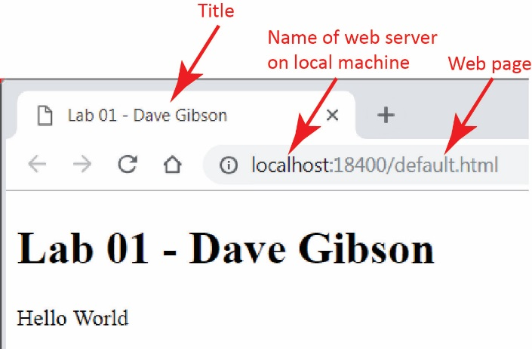Display your page. When you are done, return to VS.

|  |
| --- |
| **There are 3 ways to display your page on localhost:**   1. Right-click in page and choose *View in Browser* 2. Choose: *File, View in Browser* 3. Press: *Ctrl+Shift+W* |

|  |
| --- |
| **Warning**  Sometimes *View in Browser* gives this error:  cid:5d609726-7afd-42f7-b6db-21bb460c5314  One solution is to use the drop down at top that says “IIS Express (Google Chrome)” and choose another browser. E.g. Edge.  I’m not sure, but I think the problem results when you continually run your page, and then a page has a fatal error, but the process displaying the page doesn’t get destroyed. I also think I have “fixed” this error by rebooting my computer. |

1. **Edit page in Design View**
2. 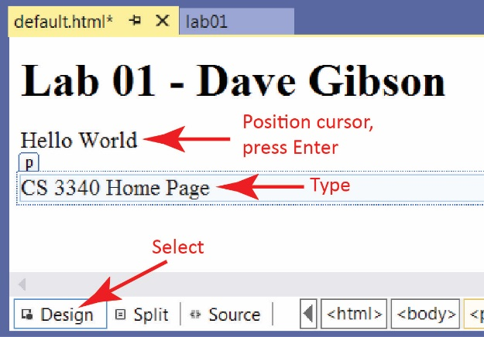Do the following:

**VS 2022 Note:** Design mode is more of a “Live Preview”. You might not have much luck with the steps below. If not, just type the code into the source.

1. Open the page in VS and select the *Design* button in the lower-left.
2. Place the cursor and the end of the text, “Hello World,” and press Enter
3. Type the text as shown in the image on the right.
4. Display the *Source* (choose the *Source* tab) and verify that HTML has been added to your page.
5. Save
6. Display your page.
7. Close Visual Studio (save if prompted).

# Explore Folder Structure

1. **Explore Folder Structure**
2. 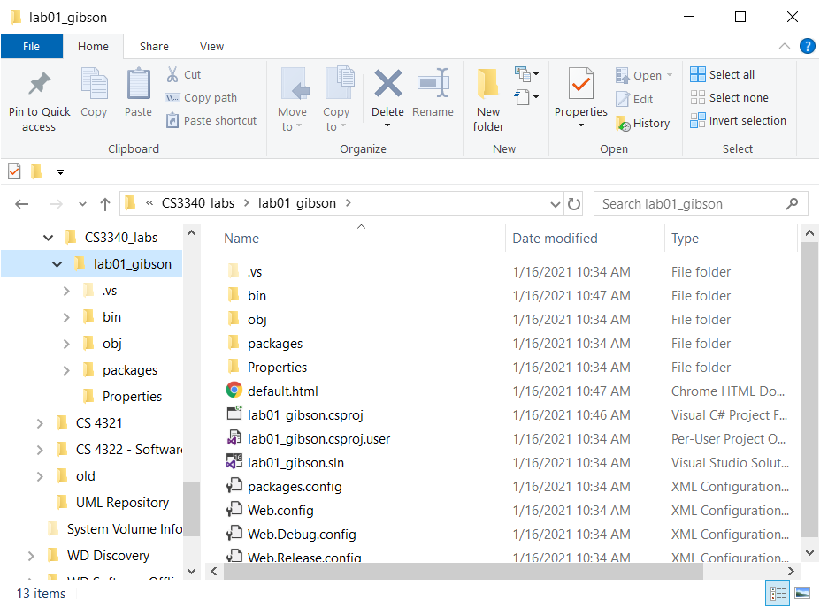Navigate to your *labs folder* (in the example on the right the folder is: *CS3340_labs*) in *File Explorer* and select the project folder (*lab01_lastName*). Note the contents of the folder, specifically, these will be of interest as we go along:

*default.html*

*lab01.sln*

*web.config*

1. Double-click the solution file (*lab01_lastName.sln*) and VS will open the *lab01_lastName* project.
2. (Read, no action required) Three ways you can open your solution:
3. Launch VS and your solution may be listed under *Open recent*
4. Launch VS and choose *Open a project or solution* and then navigate to your *.sln* file.
5. Double-click the *.sln* file in the File Explorer (Windows 10) or Windows Explorer (Windows 7)
6. 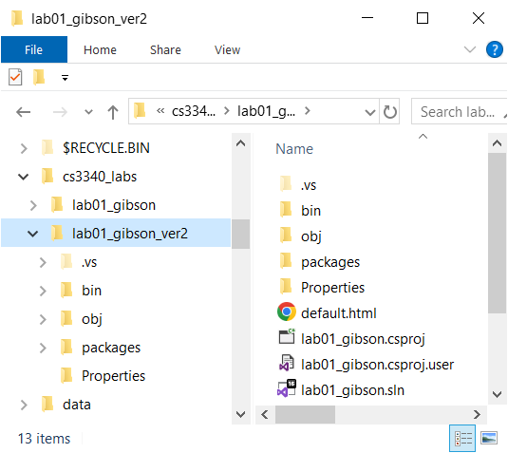(Read, no action required) If you want to make a copy of your project, the best way is to use File Explorer and copy the project folder. For example:
7. You could copy: *lab01_lastName* and paste it in the same parent folder (your *labs* folder) (or elsewhere).
8. Rename it, say: *lab01_gibson_ver2*
9. The solution file will still be: *lab01_gibson.sln* and will work fine.

Notes: VS does not have a “Save as” to save a solution (or project) to another location. Also, there does not appear to be a way to copy/paste the project in the SE.

1. Close VS. Sometimes you will be prompted to save your solution file. If you say yes, sometimes it wants a location. At that point I just back out and tell it not to save.

# License Expiration

**There is nothing to do for this section. You will need this later, so read through it now.**

At some point during the semester, your license is likely to expire and VS will not open and you will be required to update your license. Follow these directions to update the license.

1. Login: [https://azureforeducation.microsoft.com/devtools](https://nam12.safelinks.protection.outlook.com/?url=https%3A%2F%2Fazureforeducation.microsoft.com%2Fdevtools&data=05%7C02%7Cdgibson%40valdosta.edu%7Ce41c27d2d0bc4f8dc69808dd67e02d3e%7C25a5d3408abc4053b4bddc1213280353%7C0%7C0%7C638780934730546522%7CUnknown%7CTWFpbGZsb3d8eyJFbXB0eU1hcGkiOnRydWUsIlYiOiIwLjAuMDAwMCIsIlAiOiJXaW4zMiIsIkFOIjoiTWFpbCIsIldUIjoyfQ%3D%3D%7C0%7C%7C%7C&sdata=I8D%2F2mC0WT8B0GvUx4JrRvNe4zflXbDBbqWx6uvVojU%3D&reserved=0)
2. Choose: Learning Resources, Software, search for “visual”
3. Select Visual Studio Enterprise Edition 2022 and then choose View Key and copy the key

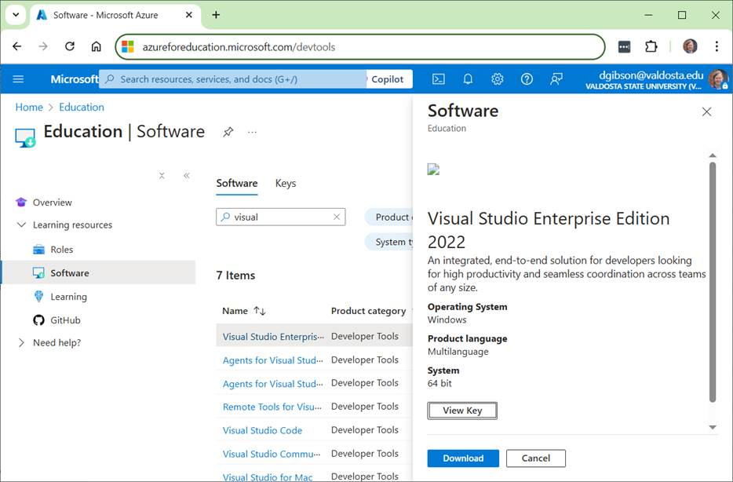

1. Open Visual Studio and choose: File, Account Settings

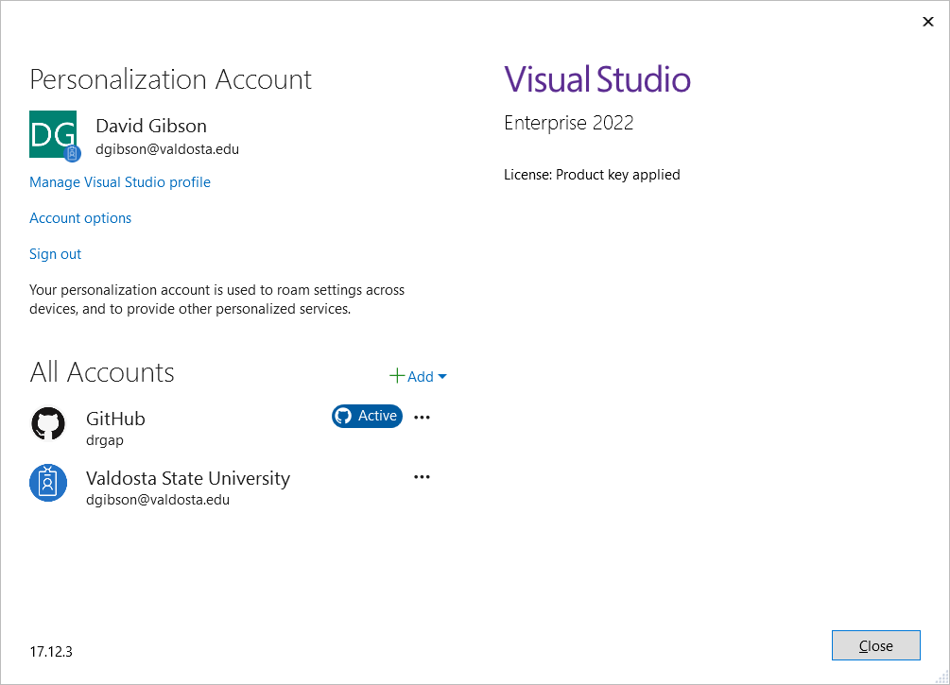

1. Click on "Activate License with Product Key" (not showing above because I already did it)
2. Paste the code from Microsoft Azure.

# Package Lab/Assignment for Submission

1. Do the following:
2. Select your project folder (*lab02_lastName*) in File Explorer
3. Right-click and choose: *Send to, Compressed (zipped) folder.* It should be named: *lab02_lastName.zip* (which probably is the default name).
4. **Test your zip file before submission. There is a penalty if you have not zipped the correct files/folders. Do the following:**
5. Copy the zip file to some other location,
6. Uunzip
7. Launch the solution file (*lab01_lastName.sln*) and make sure everything works.
8. Submit the zip file on Blazeview by the due date.