Lab 1 – WAMP Installation
Contents
1 Introduction 1
2 Installation Notes 1
2.1 MAMP Installation 1
2.2 WAMP Installation Notes 1
3 Run WAMP 3
4 Make a Virtual Host 5
Appendix 1 References 7

Introduction
What is WAMP? A server that runs on your local machine. WAMP stands for Windows, Apache, MySQL, and PHP. There is also MAMP for Macs and LAMP for Linux.
You will install it on your computer and configure it to display a web site you are working on. The directions are for Windows; however, if you are using a Mac, you’ll need to follow along, but perhaps doing things differently.

Installation Notes

MAMP Installation
For Mac computers, download MAMP and install: https://sourceforge.net/projects/mamp/ . I have not tried this, nor do I have a Mac. You’ll still need to follow the directions below and adapt as needed. Several resources are available in the Appendix.

WAMP Installation Notes
- Downloaded Wampserver, https://sourceforge.net/projects/wampserver/.
- Run to install, you’ll probably get this error below. Make a note of the exact things that are missing. In my case, there were two things, as shown below, separated by the dashed lines. Choose: OK, and then cancel the installation. We’ll run it again shortly.

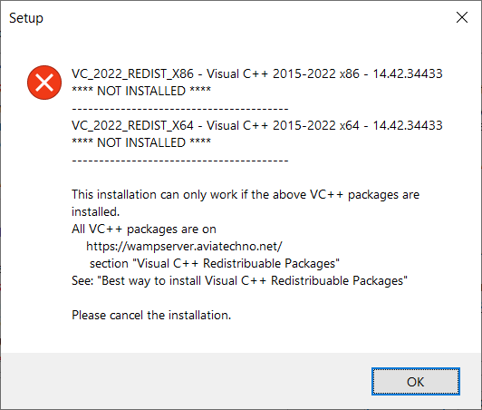

- Next, we will download and install the missing files. Go to: https://wampserver.aviatechno.net/
- Choose: VC++ Packages button (lower-right of image below)
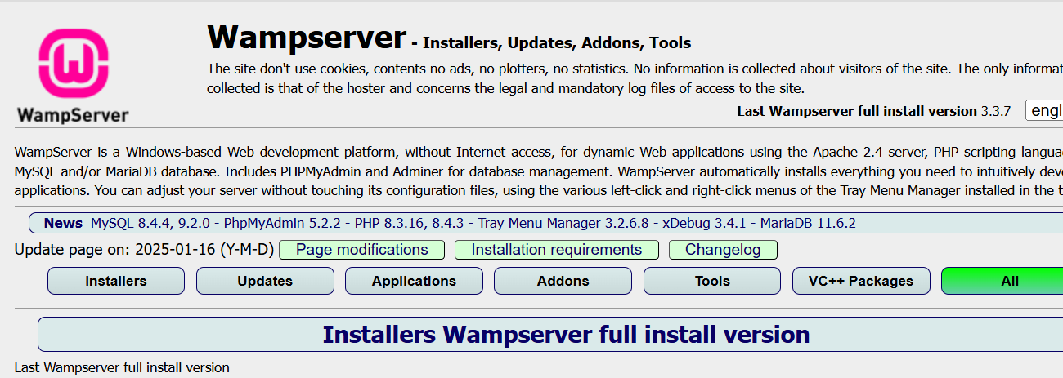
- For my case, I downloaded the two items circled below and ran them one-at-a-time. Each one will require a restart. Do this now for each download.

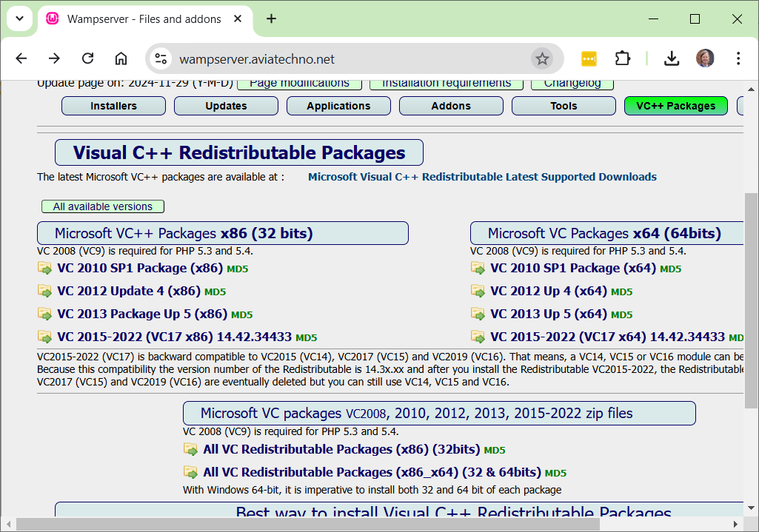

Run WAMP
- Look for the icon on the desktop (Search for: Wampserver64, in search bar if needed). Run the program.

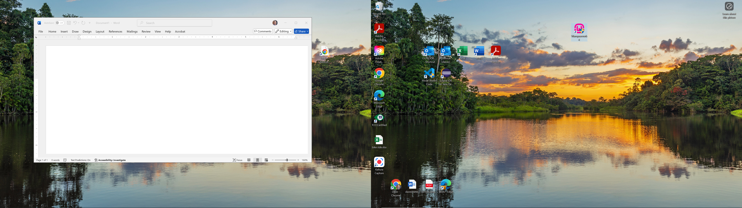

- When you run it, it puts itself in the System Tray as shown below (green icon, lower-right), it may be in the overflow area where the up arrow is. Click this icon.
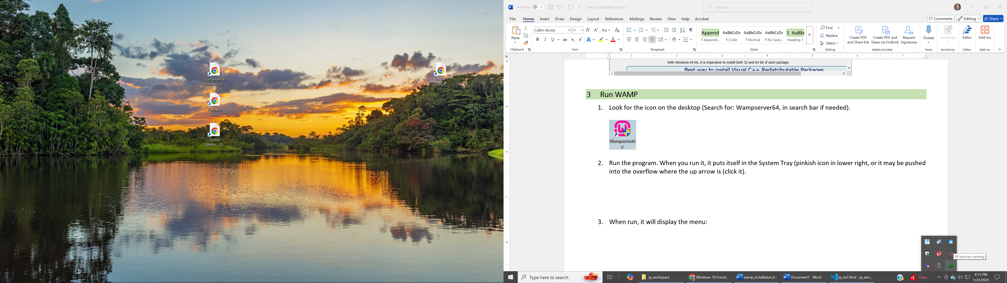
- It will display the WAMP menu as shown below. Choose: Localhost
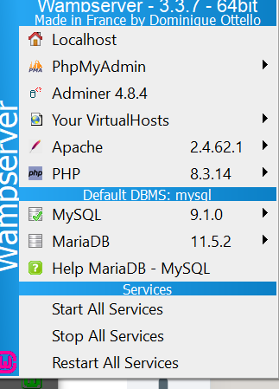
- It will show this info screen. Choose: Add a Virtual Host (bottom-left)

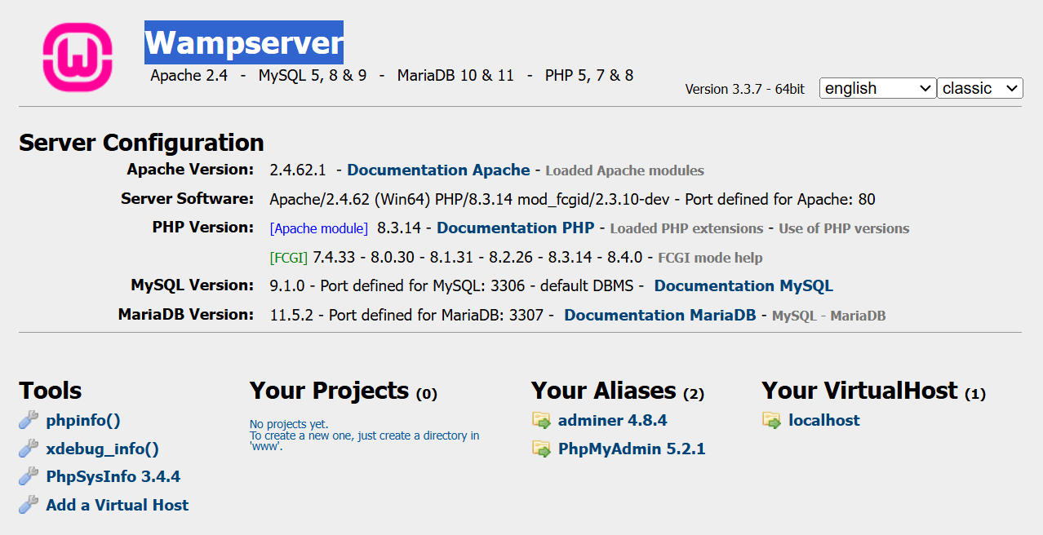

- It will display as shown below. Note the ServerName (localhost) and where it is located on disk (c:\wamp64\www). Choose: Back to homepage.
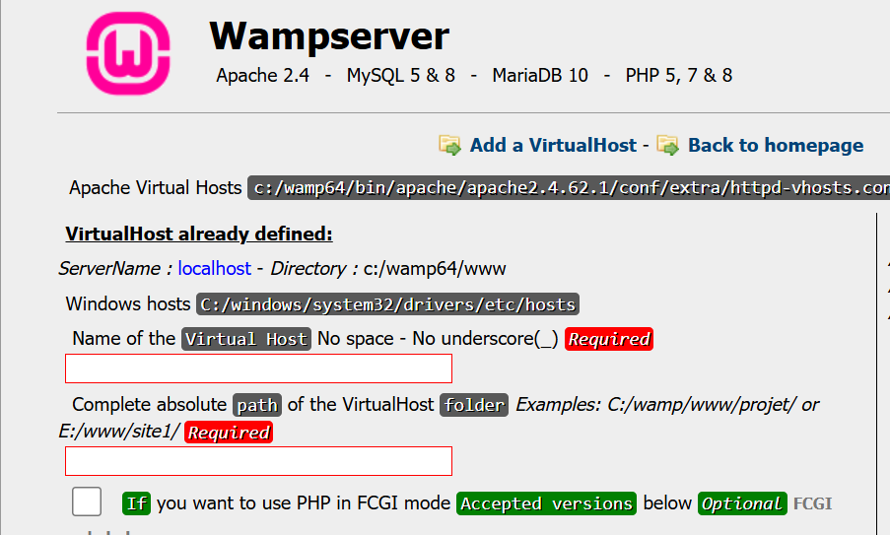
- In File Explorer, navigate to: C:\wamp64\www. This is your localhost website. You can put files and folders in their and then view them on localhost. Find or create an HTML file and put it in this folder. Below, I put js_checkbox.html.
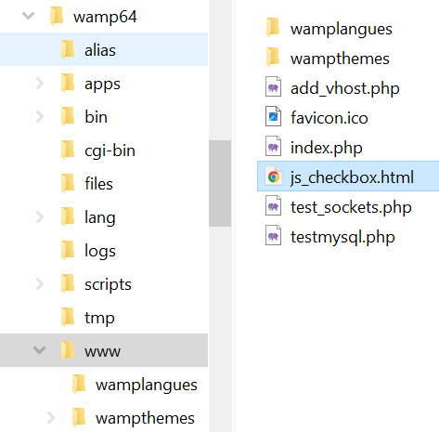
- Open a browser and type this URL: http://localhost/js_checkbox.html (use the name of your HTML file). Your page will be displayed. In my case, the page is:
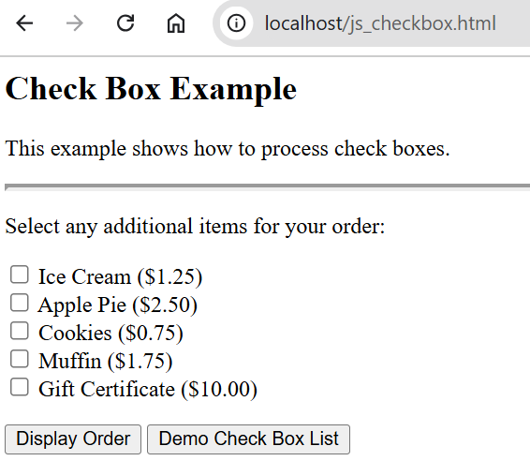

- Do the following:
- Download: lab1_yourLastName.docx and change the name of the file so that it has YOUR last name.
- Make a screen shot similar to the one above showing your page being displayed on local host. It must show the complete URL (mine doesn’t!).
- Paste the screen shot into the first place in the a lab1_yourLastName document.

Make a Virtual Host
In this section, we will create a website (virtual host) around an existing VSCode workspace.
- Navigate to a VSCode workspace on your disk. In the image below, mine is named: jq_workspace
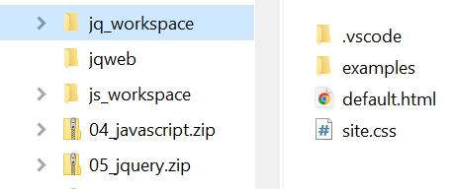
- Copy the path (we’ll paste it shortly). In my case it is:
E:\data_courses\CS 3340 - Web Programming\CS 3340 - Spring 2025\topics\01_ClientSide\notes_2023\jq_workspace
- Get this on your screen (Steps 1-4 previous section). Choose: Add a Virtual Host
- Type a name for your virtual host (I use: jqweb), paste the path to folder you want to be the root of the website (Step 2 above), and choose: Start the creation…
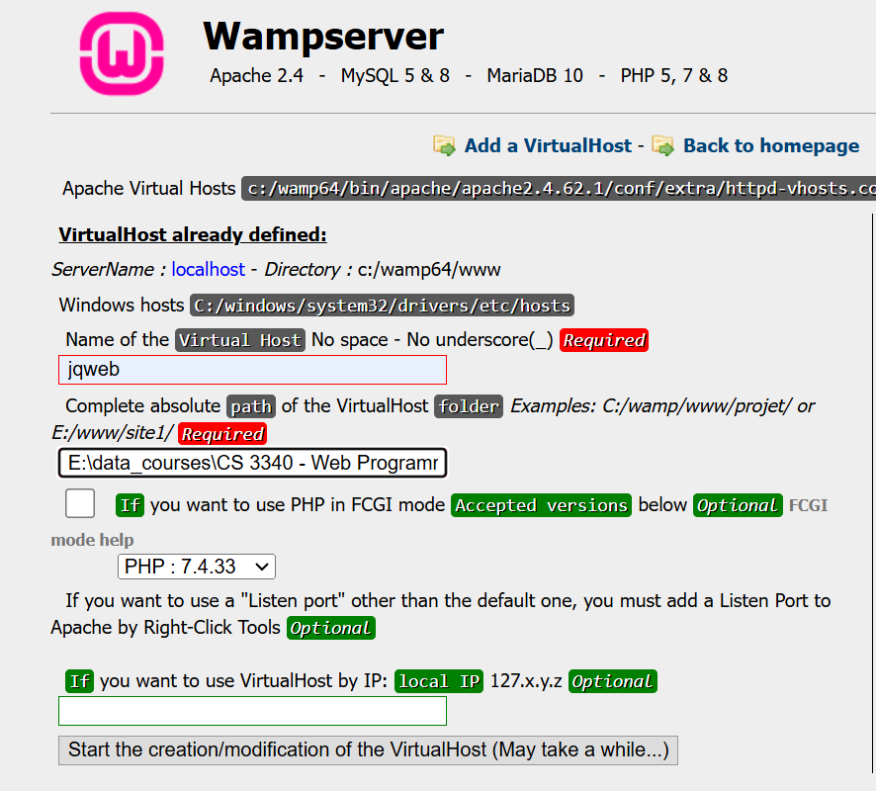

- You’ll get this message. We’ll restart DNS next.
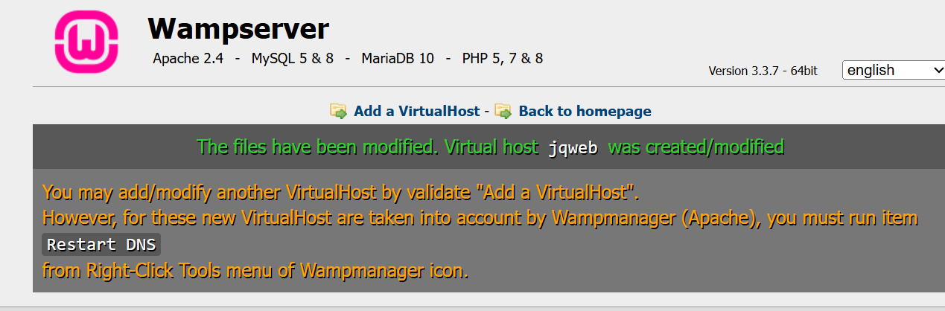
- Right-click the WAMP icon in the system tray (shown below), and choose: Tools, Restart DNS
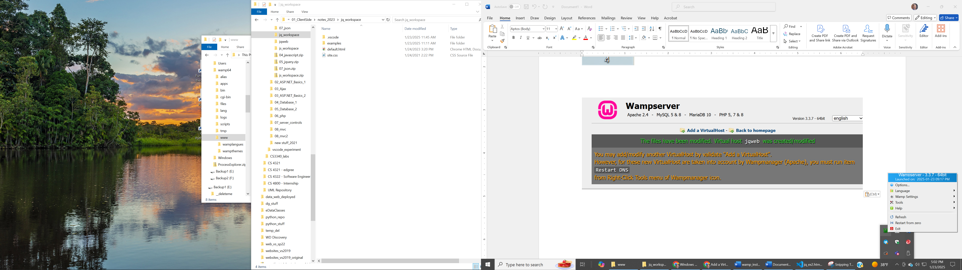
- Return to your browser and this page. Choose: Back to homepage
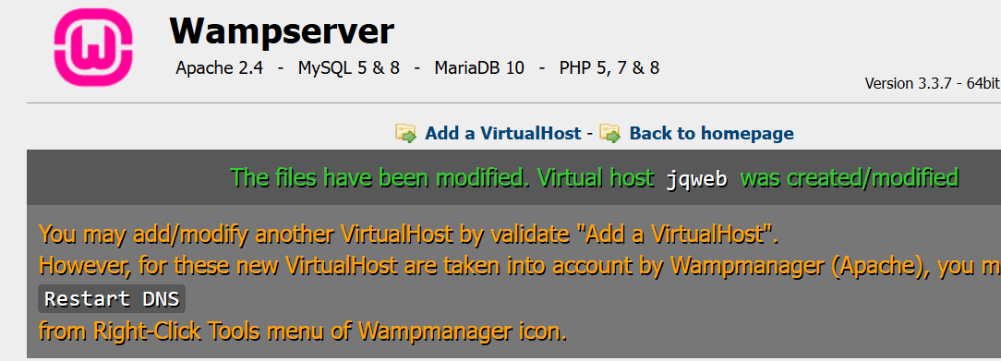

- Now, you will see your virtual host listed. Choose the link.
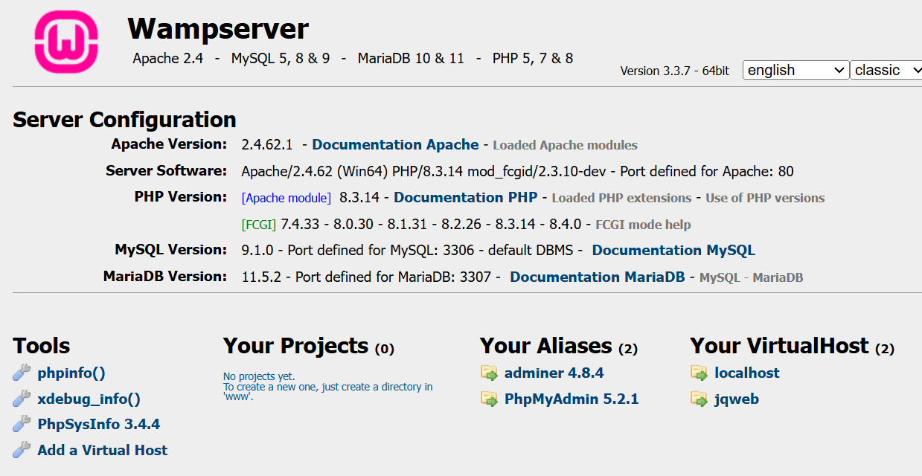

- In my case, it displays as shown on the left, below. When I choose the default.html page it is displayed as shown on the right, below.
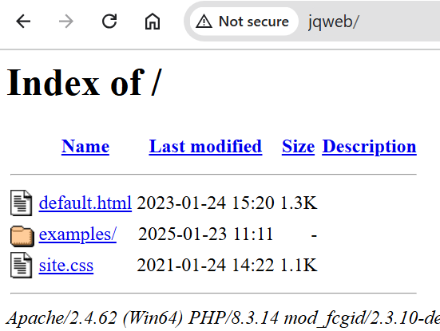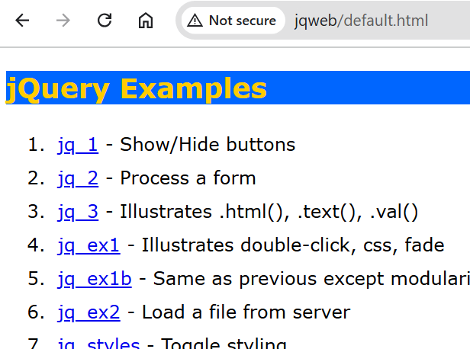
- Do the following:
- Make a screen shot similar to the one above showing your page being displayed on your virtual host. The full URL must be visible.
- Past the screen shot into the second place in the a lab1_yourLastName document.

- Submit your lab1_yourLastName document on Blazeview.

Appendix
- References
- How to Install WAMP Server 3.3.2 on Windows 10/11 [ 2024 Update ] Step-by-Step Installation guide
https://www.youtube.com/watch?v=M2at7D-lciw.
Mostly used this one. It dealt with the missing Visual C++ Redistributable Packages.
- Step by Step Guide to Download and Install Wamp Server with MySQL
https://eecs.csuohio.edu/~sschung/CIS408/StepbyStepGuidetoDownloadInstallWampServerMySQL_2020.pdf

- MAMP (macOS) Documentation
https://documentation.mamp.info/en/MAMP-Mac/Installation/
- Using MAMP on a MAC
https://phpandmysql.com/extras/installing-mamp/
- Installing MAMP on a Mac
https://courses.cs.washington.edu/courses/cse154/19sp/resources/assets/servers/mamptutorial_mac.html

