HW 1 – Problem 8

Contents

8 Problem 8a – Responsive Design, Grid & Flexbox (85 points) (2 hrs) 1

9 Problem 8b – Enhancements (15 points) 2

Appendix 1 HTML 3

Appendix 2 CSS 4

# Problem 8a – Responsive Design, Grid & Flexbox (85 points) (2 hrs)

This is worth 85 points. You have been provided a page that renders as shown below.

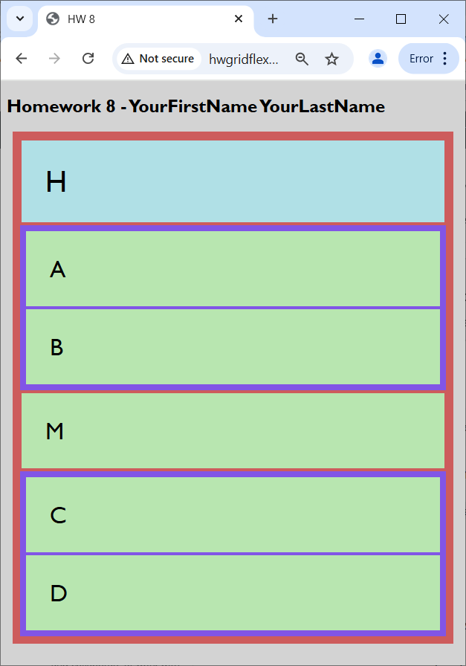

You will modify the CSS so that it looks like this on a screen with width greater than 800px:

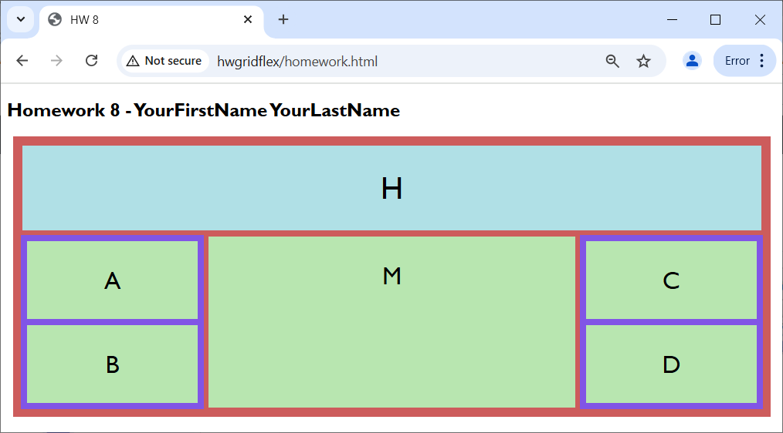

And renders like this when the screen is less than or equal to 800px:

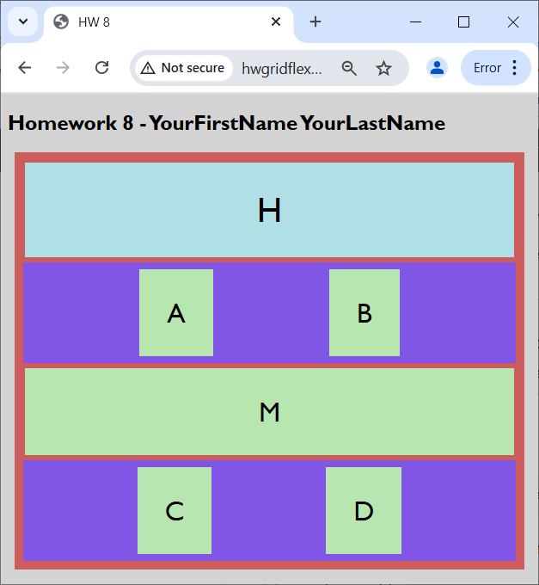

1. Create a page, *responsive-gridflex.html*.
2. Modify the “Problem 8” link on *default.html* to link to this page.
3. Copy the code in the Appendix in to *responsive.html*.
4. Create a CSS file named: *site.css* and copy the CSS from Appendix 2 into the file.

If you need directions:

1. In VSCode, choose: File, New Text File and an “Untitled” file will appear in the editor.
2. Copy the CSS from Appendix 2 into this file.
3. Choose: File, Save, type the file name: *site.css*, and the press Save.
4. The style properties I used are provided in the CSS in Appendix 2; however, some of the values for the properties are missing (I highlighted one instance of this below in the CSS). You should supply the correct values so that the display renders as describe above.

**Note:**

* **You can add more properties and/or selectors to the CSS, though it is not necessary**
* **For more fun, you can ignore my CSS and write your own!**

# Problem 8b – Enhancements (15 points)

This is worth 15 points. You have been provided a page that renders as shown below.

1. Create a page, *responsive-gridflex2.html* (or copy *responsive-gridflex.html* from above and rename)
2. Modify the “Problem 8” link on *default.html* to link to this page.
3. Make an enhancement to the original page. I’m looking for structural changes and/or more/different content. These are NOT considered enhancements: colors, padding, margin, fonts, *etc.*
4. HTML

<!DOCTYPE html>

<html>

<head>

    <title>HW 8</title>

    <link rel="stylesheet" href="site.css">

    <meta name="viewport" content="width=device-width, initial-scale=1.0">

</head>

<body>

    <h2>Homework 8 - YourFirstName YourLastName</h2>

    <div class="grid-container">

        <div class="grid-item-h">H</div>

        <div class="grid-item-a-b">

            <div class="flex-container-1">

                <div class="grid-item-a">A</div>

                <div class="grid-item-b">B</div>

            </div>

        </div>

        <div class="grid-item-m">M</div>

        <div class="grid-item-c-d">

            <div class="flex-container-2">

                <div class="grid-item-c">C</div>

                <div class="grid-item-d">D</div>

            </div>

        </div>

    </div>

</div>

</body>

</html>

1. CSS

* {

    box-sizing: border-box;

}

body {

    font-family: 'Gill Sans', 'Gill Sans MT', Calibri, 'Trebuchet MS', sans-serif

}

.grid-container {

    background-color: indianred;

    margin: 0.5rem;

    padding: 0.5rem;

    display: ;

    grid-template-columns: ;

}

.flex-container-1, .flex-container-2 {

    background-color: rgb(129, 85, 230);

    margin: 0.125rem;

    padding: 0.25rem;

    display: ;

    flex-direction: ;

}

.flex-container-1>div, .flex-container-2>div {

    background-color: rgb(184, 230, 176);

    margin: 0.25rem;

    padding: 2rem;

    font-size: 2rem;

    text-align: ;

}

.grid-item-h {

    background-color: powderblue;

    margin: 0.25rem;

    padding: 2rem;

    font-size: 2.5rem;

    grid-column-start: ;

    grid-column-end: ;

    text-align: ;

}

.grid-item-m {

    background-color: rgb(184, 230, 176);

    margin: 0.25rem;

    padding: 2rem;

    font-size: 2rem;

    text-align: ;

}

@media only screen and (max-width: 800px) {

    body{

        background-color: lightgrey;

    }

    .grid-container {

        grid-template-columns: ;

    }

    .flex-container-1, .flex-container-2 {

        justify-content: ;

        flex-direction: ;

    }

    .grid-item-h {

        grid-column-start: ;

        grid-column-end: ;

    }

}