HW 1 – Problem 7

Contents

7 Problem 7– Responsive Design (2 hrs) 1

Appendix 1 Code 2

# Problem 7– Responsive Design (2 hrs)

You have been provided a page that renders as shown below.

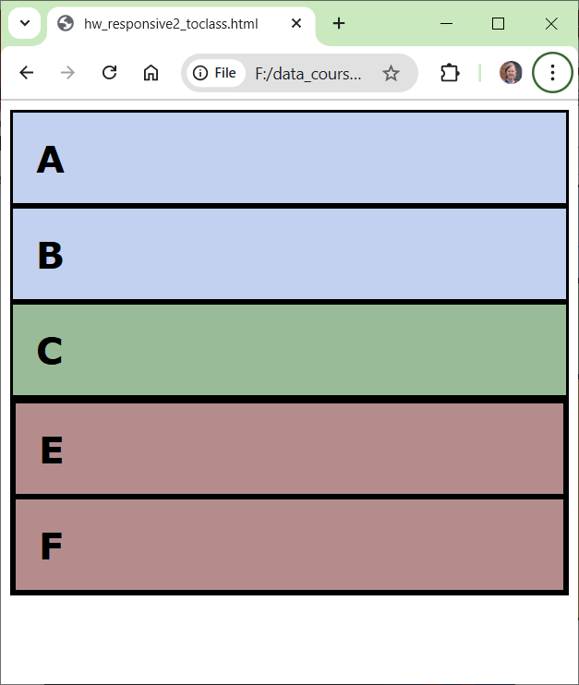

You will modify the CSS so that it looks like this on a screen with width greater than 800px:

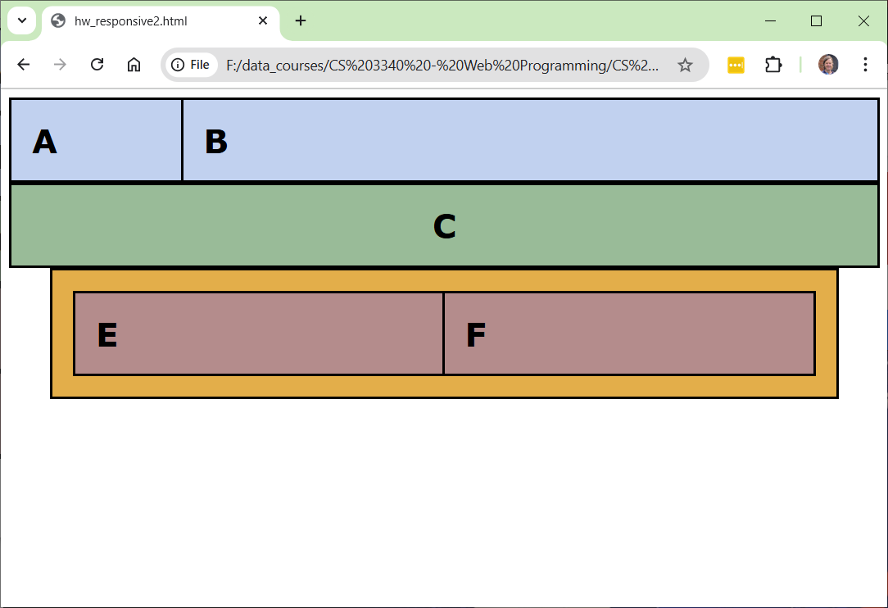

And renders like this when the screen is less than 800px:

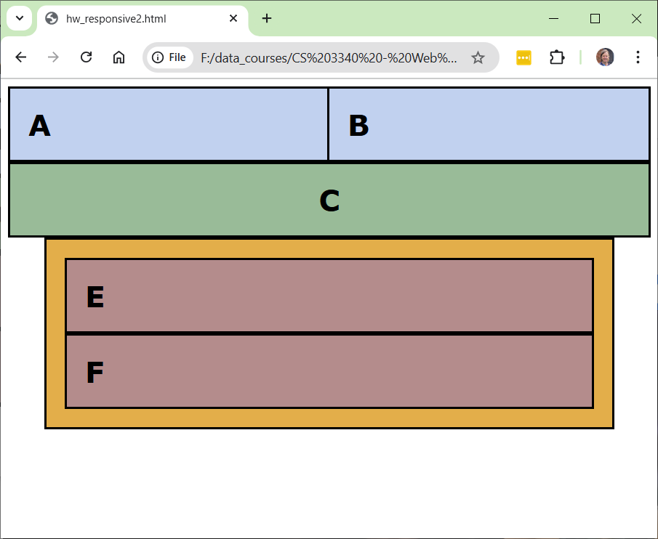

1. Create a page, *responsive.html*.
2. Copy the code in the Appendix in to *responsive.html*.
3. Add to style rules to the (internal) CSS selectors that are provided. These are the properties I used:

*float, margin, margin-right, pad, text-align, width*

**Note: You should not need add any selectors, nor any more HTML.**

1. Code

<!DOCTYPE html>

<html>

<head>

<meta name="viewport" content="width=device-width, initial-scale=1.0">

<style>

/*---

  Should not have to modify these 4 style definitions

---*/

    * { box-sizing: border-box; }

    body { font-family:Verdana; }

    h1 { margin: 20px; }

    div { padding:0px; margin: 0px; border-style: solid; }

/*---

  Add rules to any of the selectors below to achieve the displays (viewport size dependent)

  specified on the homework document

---*/

    .divA {

        background-color:#c1d1ef;

    }

    .divB {

        background-color:#c1d1ef;

    }

    .divC {

        background-color:#99bb98;

    }

    .divD {

        background-color:#e3ae4a;

    }

    .divE {

        background-color:#b48c8c;

    }

    .divF {

        background-color:#b48c8c;

    }

    @media only screen and (max-width:800px) {

        .divA {

        }

        .divE {

        }

    }

</style>

</head>

<body>

    <div class="divA">

        <h1>A</h1>

    </div>

    <div class="divB">

        <h1>B</h1>

    </div>

    <div class="divC">

        <h1>C</h1>

      </div>

      <div class="divD">

        <div class="divE">

            <h1>E</h1>

        </div>

        <div class="divF">

            <h1>F</h1>

        </div>

      </div>

</body>

</html>