HW 1, Problem 3

# Problem 3 – Java Script (4 hrs)

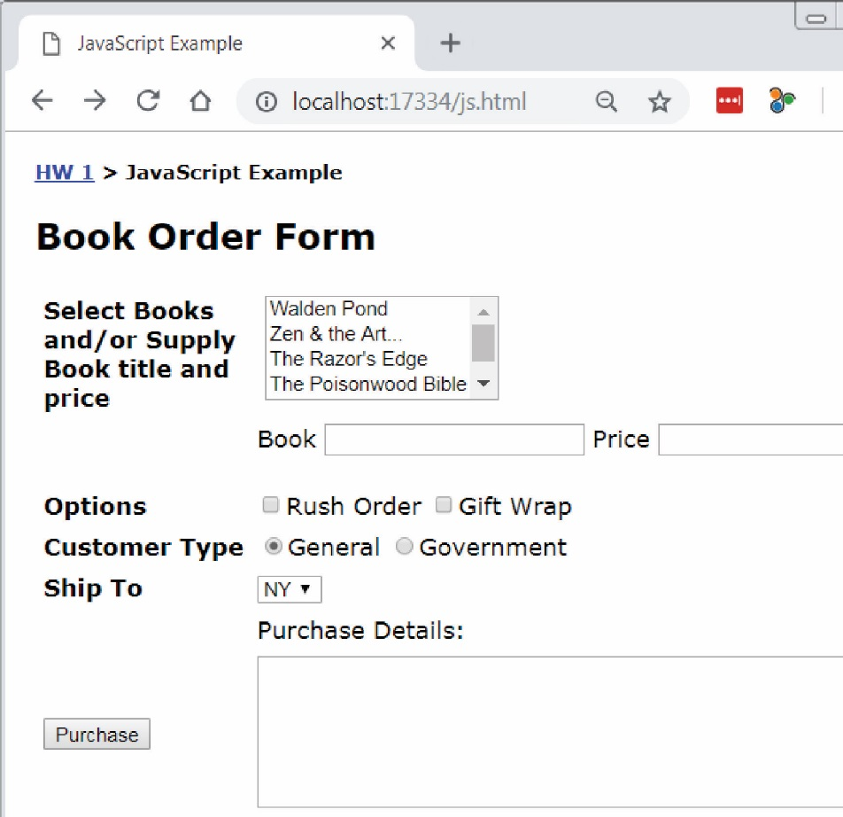Write a web page named: *javascript.html*.

1. Modify the “Problem 3” link on *default.html* to link to this page (*javascript.html*).
2. The page should appear similar to what is shown on the right.
3. Ignore the bread crumbs: “HW 1 > JavaScript Example”. You do **not** need this on your page.
4. The easiest approach is to use a table to organize the input portion of the page. 2 columns are all that is needed. You are allowed to use a more advanced approach.
5. All code must be written in JavaScript (not jQuery).
6. The multi-select box must display these exact 5 books with the corresponding prices:
   1. Walden Pond ($20)
   2. Zen and the Art…($15)
   3. The Razor’s Edge ($8)
   4. The Poisonwood Bible ($15)
   5. Wuthering Heights ($10)
7. The user can select multiple books from the drop down.
8. The user can optionally supply a book with a title and price in the textboxes.
9. A rush order is $10 and gift wrapping is $5.
10. A general customer receives no discount and is the default. A government customer receives a 10% discount on the entire purchase.
11. The dropdown lists these exact three states and the corresponding price to ship to that state:
12. NY ($5)
13. CA ($7)
14. SC ($3)
15. All prices must be stored in the *value* attribute of the HTML tags. No prices should be hard-coded.
16. When the purchase button is pressed the complete order is neatly displayed along with the total price. For example:

|  |  |  |
| --- | --- | --- |
| Example 1 |  | Example 2 |
| Order  ----------------------  $15.00 – Zen and the Art…  $15.00 – The Poisonwood Bible  General Customer  $10.00 – Rush order  $3.00 – Ship to SC  ----------------------  Total: $43.00 |  | Order  ----------------------  $15.00 – Zen and the Art…  $15.00 – The Poisonwood Bible  $25.00 – On the Road (user specified)  Government Customer  $10.00 – Rush order  $5.00 – Gift wrap  $3.00 – Ship to SC  ----------------------  Sub Total: $73.00  Discount (10%): $7.30  Total: $65.70 |

1. Each time the user presses the purchase button, a fresh calculation is done based on whatever is supplied, selected, *etc.* In other words, if the user supplies the data in Example 1 and presses Purchase, then the result is as shown above. Then, if they change from “General Customer” to “Government Customer”, add “Gift wrap”, and add a custom book, then the correct total should be displayed. **Your code will do this correctly as long as you do not use any global variables.**