HW 1, Problem 2

# Problem 2 – CSS (2 hrs)

Write a web page named: *css.html*.

1. Modify the “Problem 2” link on *default.html* to link to this page (*css.html*).
2. Provide 5 examples of using CSS.
   1. You must use either internal styles or an external style sheet but NOT inline styles.
   2. The five examples should illustrate these selectors, in this order: (a) element, (b) class, (c) id, (d) anonymous, (e) descendent selector.
   3. Each example must show actual CSS followed by the example. See example below.
   4. Each example is separated by a horizontal rule. See example below.
3. You are permitted to do additional examples and/or have multiple (linked) pages.

Example:

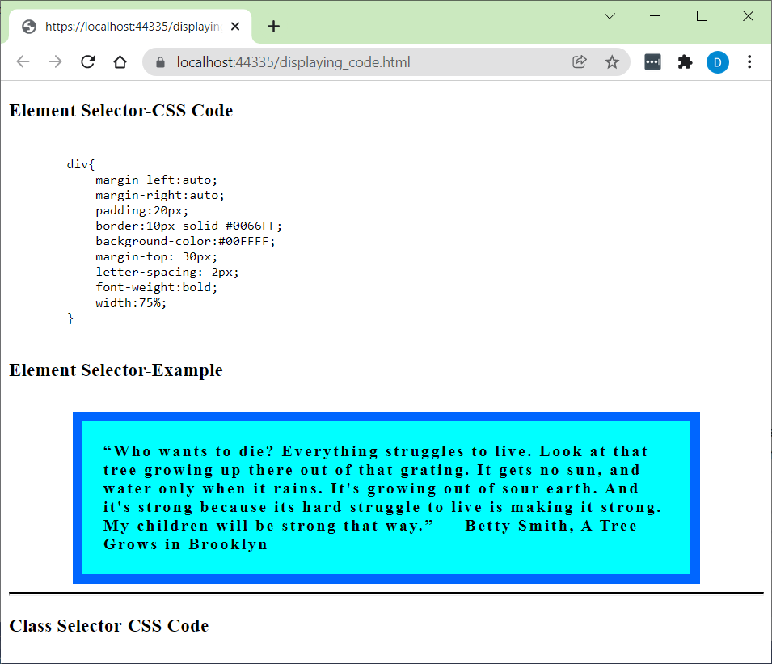

To display code, you should surround it in <pre><code> tags as shown below. Code for example above:

<h3>Element Selector-CSS Code</h3>

<pre><code>

div{

margin-left:auto;

margin-right:auto;

padding:20px;

border:10px solid #0066FF;

background-color:#00FFFF;

margin-top: 30px;

letter-spacing: 2px;

font-weight:bold;

width:75%;

}

</code></pre>

<h3>Element Selector-Example</h3>

<div>

“Who wants to die? Everything struggles to live. Look at that tree growing up there out of that grating. It gets no sun, and water only when it rains. It's growing out of sour earth. And it's strong because its hard struggle to live is making it strong. My children will be strong that way.”

― Betty Smith, A Tree Grows in Brooklyn

</div>

<hr style="border-top: 3px solid black;" />

<h3>Class Selector-CSS Code</h3>