HW 1, Problem 1

Contents
0 Overview 1
1 Problem 1 – HTML (2 hrs) 2

Overview
There are 8 problems in this assignment and the estimated development time is about 23 hours. It may take a little less, or much more, depending on your skill. In total, this assignment is 20% of your final grade. Only Problem 1 is described in this document. Subsequent documents will describe the other problems. The breakdown for each problem is shown below:
HW 1 | Estimated Development Time (hrs) | Weight
Problem 1 | 2 | 10%
Problem 2 | 2 | 10%
Problem 3 | 4 | 20%
Problem 4 | 3 | 15%
Problem 5 | 0.5 | 2%
Problem 6 | 3 | 15%
Problem 7 | 4 | 10%
Problem 8 | 4 | 20%
Total | 22.5 | 100%
Only Problem 1 is described in this document. Subsequent documents will describe the other problems.

Problem 1 – HTML (2 hrs)
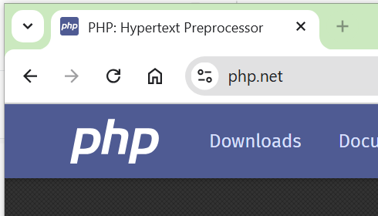
Create a VS Code workspace with the name: hw1_lastName.
Write these web pages:
- default.html –
  - Has a title that appears in the browser tab. For example, in the image on the right, the title is, “PHP: Hypertext Preprocessor”.
  - Has a header with your name.
  - Below the header there is a row with 8 links: Problem 1, Problem 2, …, Problem 8. The “Problem 1” link links to a page named: about.html (described next). The other links link to the subsequent problems in this HW and will be describe as you go along. Be sure to come back to this and supply the links as you work on subsequent problems.
- about.html –
  - In the top left of this page, provide a link, “Home” that returns to default.html.
  - Beside the “Home” link, provide a link, “Page 2” that links to a page, page2.html (described below) located in a subfolder named: info.
  - This page provides information about yourself (anything at all, for example, any/all/ or none of these: interests, hobbies, computing interests, career hopes, etc.)
  - You must use all of these tags: title, p, table (with headers, td, and using rowspan or colspan), a, ul, ol. You can use other tags.
- page2.html –
  - This page is located in a subfolder named, info. In other words, the file structure is:
hw1_lastname // folder
index.html
about.html
info // folder
page2.html
  - In the top left of this page, provide a link, “Home” that returns to default.html.
  - Beside the “Home” link, provide a link, “Back” that links back to about.html.

