CS 3340 – Lab 8, Verify Database Access

Contents

1 Download & Install MS Access 1

2 Verify MS Access is Working Correctly 1

3 Verify Sample Page Reads Database 3

4 Submission 4

Appendix 1 MS Access via Office 365 5

**Note: this is not a graded lab. It is simply to make sure you can use Access in your programming assignments**

# Download & Install MS Access

**If you have MS Access, Version 2016 or newer, proceed to the** **next section****.**

1. Navigate to: <https://azureforeducation.microsoft.com/devtools>
2. Do the following:
3. Login with VSU credentials. Use full email address (i.e. .valdosta.edu).
4. Choose: “Work or School account” This will take you to VSU’s login page where you will login again.
5. Make sure “Software” is selected on the left, and then type, “access” into the search bar. You should see “Access 2016” as shown below. Newer versions probably will work. Download and install.

If you don’t see Access (as was the case Spring 2024), see the directions for downloading it from Office 365.

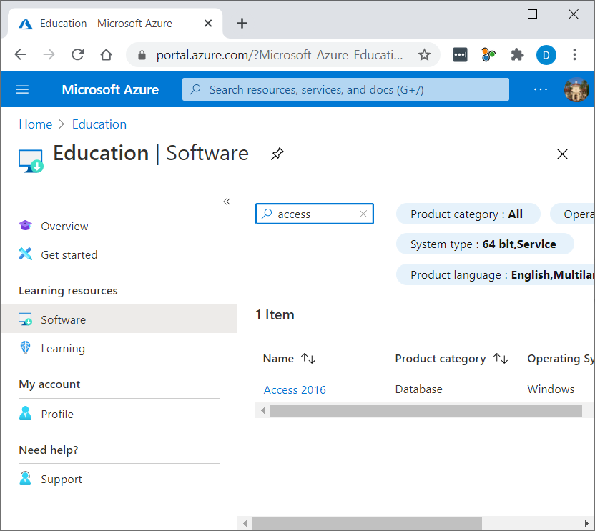

# Verify MS Access is Working Correctly

1. Use the “code” link (located beside the “Lab 8” link on the Schedule) to download a VS Solution. Unzip the code.
2. Find *players.mdb* in the *lab8_test_db/App_Data* folder. Double-click *players.mdb* to launch MS Access. If Access does not open, go to Stage 2. Otherwise, precede.
3. If successful, the program will look as shown below.

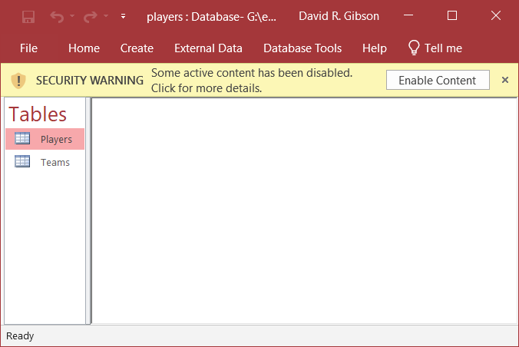

1. Choose: Enable Content, and then double-click the Players table on the left. The result will be similar to what is shown below:

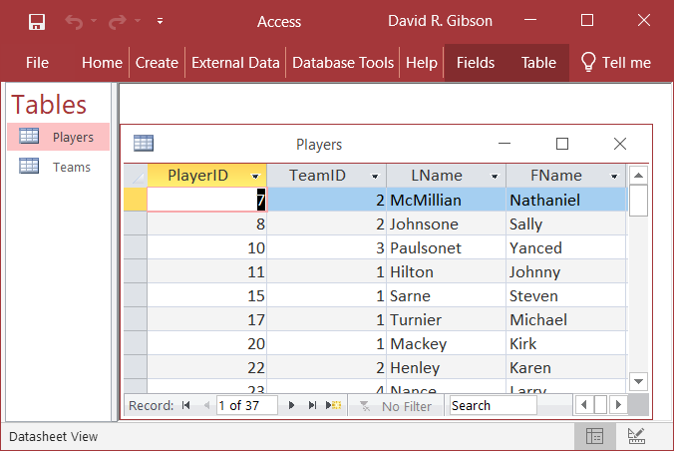

1. In the next section we will read this database table with C# code. Close MS Access. Note, however, it can be useful to have the database open as you write code to read a table, so that you can verify that you are reading the data correctly.

# Verify Sample Page Reads Database

Next, you will open a VS solution and run the code to verify that your system will allow you to have ASP.NET communicate with MS Access.

1. Double-click, *lab8_test_db.sln* in the *lab8_test_db* folder to Launch the solution in VS.
2. Run the *Default.aspx* page. One of 3 things may occur:
3. OUTCOME 1: In the textbox, at the bottom, you will see Success. You will also see various diagnostics as the code executes. If you achieve this, go to the next section.

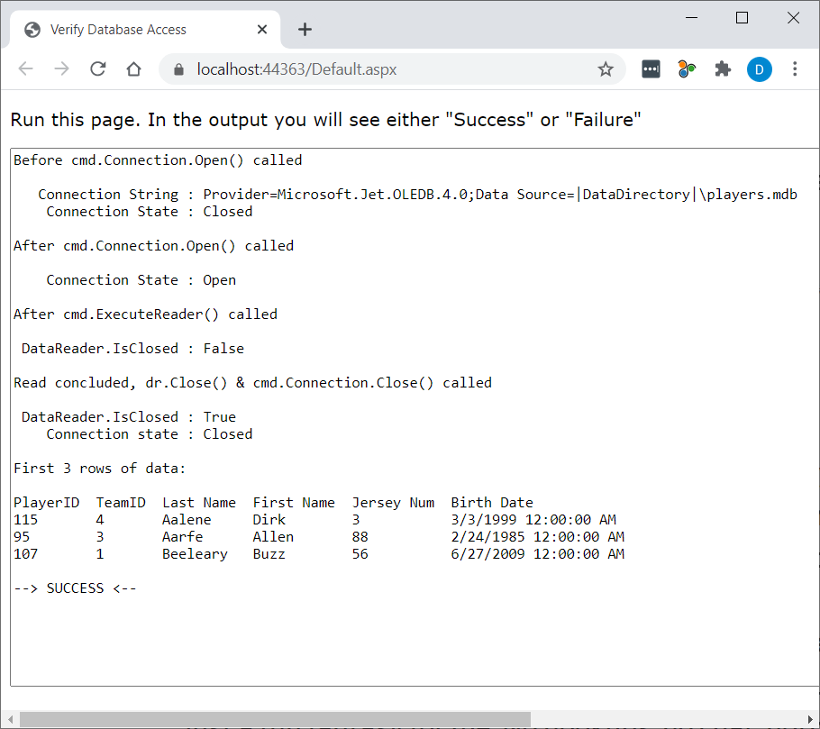

1. OUTCOME 2: In the textbox, at the bottom, you will see FAILURE and the resulting stack trace. Copy everything in the textbox, you will use it later.
2. OUTCOME 3: You could get an error like this:

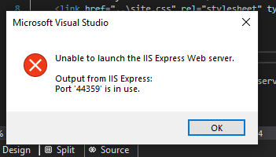

If so, do (try) the following (has worked for a student before):

1. Select the project folder in the SE, right-click, and choose: Properties.
2. Select “Web” from the left navigation panel.
3. Reference the “Project Url”. Change a digit in the port (in the example below, the port is 44358, it was 44355)
4. Choose: Create Virtual Directory

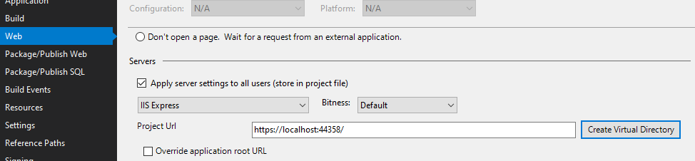

1. Rerun the page. Repeat this change if still getting the same error.

# Submission

If the steps above worked correctly on your personal device, then, “Congratulations”, you’ll be able to complete your assignments there. If not, you will either need to work in the CS Lab.

To submit: type, “Success” or “Failure” in the comment/remarks section of Lab 8 dropbox on Blazeview. If “Failure”, then copy the stack trace into comment box also.

Appendix

1. MS Access via Office 365

All VSU students have free access to MS Office 365 which includes MS Access. Follow these steps to download and setup Access.

1. Login into MyVSU
2. Choose: Email
3. In upper-right corner select the 9 dots menu and then choose: Microsoft 365 →

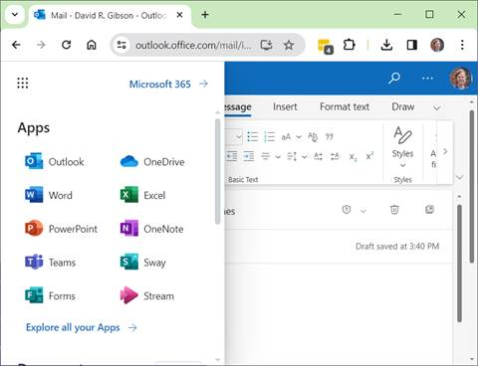

1. Choose: “Install and more” and then choose: Install Microsoft 365 apps

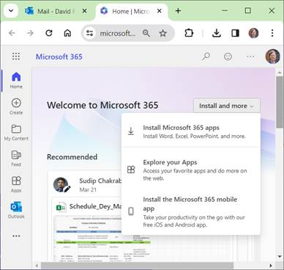

1. Choose: Install Office

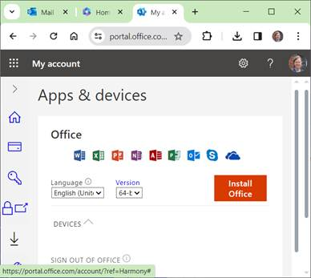

1. That downloads the setup: OfficeSetup.exe. Run this file and follow the directions. You can probably install just MS Access if you want only that.