Basic Web Controls
Contents
1 Introduction to Web Controls 1
2 Overview of Basic Web Controls 3
3 Introduction to List Controls 5
3.1 Example 6
3.2 SelectedIndexChanged Event 6
3.3 Most common scenario: No Event Handler 7
3.4 Other Scenarios 7
3.5 A fuller description of the List Controls: 9
3.6 Value Must be Unique 10
3.7 Adding & Removing ListItems 11
3.8 Removing ListItems – Approaches that don’t Work 11
Appendix 1 n/a 12

Introduction to Web Controls
- An ASP.NET server control (also called: web control or control) is a tag written inside a web page that represents a server-side object that is programmable and is used for displaying information on a web page, collecting information from a user, or allowing a user to cause some action by interacting with it.

- For example, an ASP.NET Button could be defined like this in a web page on the server.

<asp:Button ID="btnPurchase" runat="server" onclick="btnPurchase_Click" Text="Purchase" />

The runat attribute specifies that the control is run on the server. When the server delivers the page to a browser, it is converted into a HTML element:

<input type="submit" name="btnPurchase" value="Purchase" id="btnPurchase" />

All web controls are translated to HTML before being sent to the server.

- Behind the scenes there is a lot going on. The server creates JavaScript code and sends it to the browser so that when this button is pressed by a user:

- The page is posted back to the server
- When the page is posted back to the server, a Button instance is created (on the server) and can be programmed. For instance, we can change the Text on the button
- The btnPurchase_Click event handler is called on the server

- Essentially what Microsoft (MS) has done is create a virtual programming environment where we can create a user interface and write event handlers without having to think about how to do this in HTML and JavaScript. In other words, it allows us to us a more robust programming environment. When a page is requested from the server, the ASP.NET engine processes the page and renders it in HTML and provides the JavaScript to support it.

- We will study these web controls: Label, Button, TextBox, DropDownList, ListBox, CheckBoxList, RadioButtonList. Calendar, and Panel

Overview of Basic Web Controls
Web controls have properties, methods, and events. Below, we list the most common properties, methods, and events for each of the controls mentioned above.

- WebControl – This is the super class for all controls

Properties:
- Enabled – When true, this control can be interacted with. When false it is visible, but grayed out.
- Visible – When true, the control is displayed on the web page. When false, it is not visible.

We have omitted style properties (BackColor, BorderColor, BorderSyle, BorderWidth, Font, ForeColor, Height, SkinID, ToolTip, Width, and others) which all controls have.

Methods:
- Focus – Gives the control focus.

- Control: Button

Display:

Properties:
- CausesValidation – Gets or sets a value indicating whether validation is performed when the Button control is clicked
- OnClientClick – Gets or sets the client-side script that executes when a Button control's Click event is raised.
- PostBackUrl – Gets or sets the URL of the page to post to from the current page when the Button control is clicked. Text – Gets or sets the text caption displayed in the Button control.

Events:
Click – Occurs when the Button control is clicked. Calls the Click event handler.

Note: By default, when a button is pressed, it always does a postback to the server, to the page the button is on. If the PostBackUrl is set, then the page does a postback to the page specified in this property. If OnClientClick is set to a JavaScript function, then the page will run the function and if the function returns True then it will post back to the server before posting back. If the function returns False, the page will not postback to the server.

- Control: Label

Properties:
Text – Gets or set the text caption that is displayed.

- Control: TextBox
Display:
Properties:
- ReadOnly – Gets or sets a value indicating whether the contents of the TextBox control can be changed.
- Text – Gets or sets the text content of the TextBox control.
- TextMode – Gets or sets the behavior mode (TextBoxMode.SingleLine, .MultiLine, .Password, and others)

- Control: Panel – Represents a control that acts as a container for other controls

- Control: Calendar

Display:

Properties:
- SelectedDate – Usually used to gets the selected date, returning a DateTime object. Can also be used to set the selected date.
- SelectedDates – Usually used to get the selected dates, returning a SelectedDatesCollection of DateTime objects.
- SelectionMode – The calendar has three selection modes: CalendarSelectionMode.Day, .DayWeek, .DayWeekMonth. It does not have a way to select an arbitrary range of dates.

Events:
SelectionChanged – Occurs when a day (or week or month) is selected.

- The four controls listed below have different appearances but internally operate similarly (as we will see shortly)

Control | Display | Notes
DropDownList: |  | Only one item may be selected
ListBox | 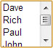 | One item may be selected if SelectionMode is Single. Multiple items can be selected if SelectionMode is Multiple.
CheckBoxList |  | One or more items may be selected
RadioButtonList |  | Only one item may be selected

Introduction to List Controls
- The DropDownList (ddl), ListBox (lst), RadioButtonList (rbl), and CheckBoxList (cbl) controls have the following properties and events in common:

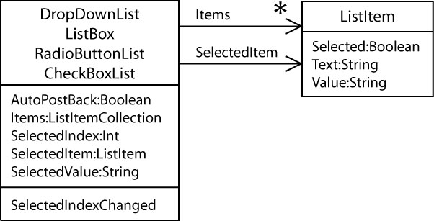

- The Items property is a ListItemColllection which can be thought of as an array of ListItems which can be accessed by an index (and other ways). For instance, suppose (for any of the four controls) the collection of ListItem’s is:

Index | Text | Value | Selected
0 | Jones | 870333232 | False
1 | Williams | 870556782 | False
2 | NeSmith | 870349216 | True
3 | Thomas | 870890223 | False

Then, the following properties would have these values:

Property | Value
SelectedIndex | 2
SelectedItem | Text Value Selected  NeSmith 870349216 True
SelectedValue | 870349216

Initially, the SelectedIndex is set to -1 which means that nothing has been selected. Once the user chooses an item, the SelectedIndex is set to the index of that item.

Example
- Example Code. Here we assume we have a ListBox, but the code is identical for the other controls:

- Loop through all the Items:

foreach (ListItem li in lstPlayers.Items) {
msg += li.Text + ", " + li.Value + ", " + li.Selected;
}

Or

for (int i = 0; i < lstPlayers.Items.Count; i++) {
ListItem li = lstPlayers.Items[i];
msg += li.Text + ", " + li.Value + ", " + li.Selected;
}

- Access the SelectedValue:

msg += lstPlayers.SelectedValue;

- Access the SelectedItem:

ListItem selItem = lstPlayers.SelectedItem;
msg += selItem.Text + ", " + selItem.Value + ", " + selItem.Selected;

Note:
- SelectedItem is null if nothing is selected.
- The ListBox and CheckBoxList allow for multiple selections. If multiple items are selected in a ListBox, only the first item is available in the SelectedItem property. In this case, you need to loop through all the items and determine which are selected.

- Determine if anything has been selected:

if (lstPlayers.SelectedItem != null)

Or

if( lstPlayers.SelectedIndex != -1)

SelectedIndexChanged Event
- All four of these controls also fire the SelectedIndexChanged event and have the AutoPostBack property set to false by default. In other words, when the user makes a selection from any of these controls, the page does NOT postback automatically. What happens is that if there is an event handler defined for SelectedIndexChanged then the event is registered when a selection takes place. When some other control (like a Button) causes a postback, then the event handler is called.

Most common scenario: No Event Handler
- Most common scenario:

- We have a DropDownList (and/or any of the other 3) and (i) AutoPostBack is set to false and (ii) no event handler is defined
- We have a Button with a Click event handler defined.
- The user makes a selection from the DropDownList and presses the Button which causes a post back.

The server responds by

- Calling Page_Load
- Then calling the Button’s Click event handler which would determine which item was selected in the DropDownList and take some action.

protected void Page_Load(object sender, EventArgs e)
{
// Called first
}

protected void btnSubmit_Click(object sender, EventArgs e)
{
// Called next, does something with DropDownList
}

Other Scenarios
- Another scenario:

- We have a DropDownList (or any of the other 3) and (i) AutoPostBack is set to true and (ii) we do have an event handler defined
- The user makes a selection from the DropDownList which causes a post back.

The server responds by

- Calling Page_Load
- Then calling the DropDownList’s SelectedIndexChanged event handler.

protected void Page_Load(object sender, EventArgs e)
{
// Called first
}

protected void ddlMoiveChoice_SelectedIndexChanged(object sender, EventArgs e)
{
// Called next, does something with DropDownList
}

- Another scenario:

- We have a DropDownList (or any of the other 3) and (i) AutoPostBack is set to false and (ii) we do have an event handler defined
- We have a Button with a Click event handler defined.
- The user makes a selection from the DropDownList and presses the Button which causes a post back.

The server responds by

- Calling Page_Load
- Then calling the DropDownList’s SelectedIndexChanged event handler.
- Then calling the Button’s Click event handler

protected void Page_Load(object sender, EventArgs e)
{
// Called first
}

protected void ddlMoiveChoice_SelectedIndexChanged(object sender, EventArgs e)
{
// Called second, does something with DropDownList
}

protected void btnSubmit_Click(object sender, EventArgs e)
{
// Called third, does something
}

A fuller description of the List Controls:

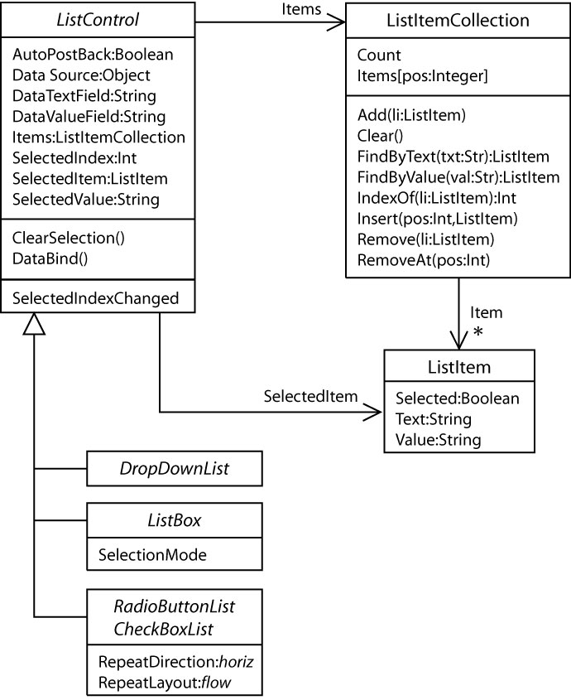

Note that Items is actually a ListItemCollection and is defined as an indexer which we discuss shortly.

Value Must be Unique
- The value in a DropDownList/ListBox must be unique to ensure proper operation. In real problems it is almost always a key field from a database (which is always unique). We will do this later in the course.

This is how it works:

- Suppose two items have the same value. For example, notice below that Thomas & Williams both have value of 5.

Index | Text | Value | Selected
0 | Jones | 8 | False
1 | Williams | 5 | False
2 | NeSmith | 1 | False
3 | Thomas | 5 | False

- The user selects “Thomas”. Thus, on the client-side, this is what is represented:

Index | Text | Value | Selected
0 | Jones | 8 | False
1 | Williams | 5 | False
2 | NeSmith | 1 | False
3 | Thomas | 5 | True

- The value “5” is posted-back to the server.

- On the server, the ListBox (or DropDownList) object is created. As it is being created, the server uses the value that was posted-back to search through the ListBox (or DropDownList) to find the selected item. It starts at the beginning of the list and finds the first match. Thus, on the server, internally, the control looks like this:

Index | Text | Value | Selected
0 | Jones | 8 | False
1 | Williams | 5 | True
2 | NeSmith | 1 | False
3 | Thomas | 5 | False

Adding & Removing ListItems
- Suppose you want to add a ListItem to a ListBox (or any of the other 3 list controls) and you have TextBoxes to allow the user to specify the Text and Value. A Button click event to handle this would look like this:

protected void btnAdd_Click(object sender, EventArgs e) {
ListItem li = new ListItem();
li.Text = txtText.Text;
li.Value = txtValue.Text;

lstPlayers.Items.Add(li);
}

- Suppose you want to remove the selected item from a single-selection ListBox or DropDownList via a button click event:

protected void btnRemoveOne_Click(object sender, EventArgs e) {
lstPlayers2.Items.Remove(lstPlayers2.SelectedItem);
}

- Removing selected items from a multi-select ListBox or DropDownList via a button click: An approach that works is to iterate through the items in reverse order so that when an item is deleted the renumbering only affects items that have already been processed.

protected void btnRemoveAllSelected_Click(object sender, EventArgs e) {
for (int i = lstPlayers.Items.Count - 1; i >= 0; i--) {
if (lstPlayers.Items[i].Selected) {
lstPlayers.Items.Remove(lstPlayers.Items[i]);
}
}
}

- Another approach for removing all selected items from a multi-select ListBox or DropDownList via a button click:

protected void btnRemoveAllSelected2_Click(object sender, EventArgs e) {
int count = 0;
List<ListItem> selectedItems = new List<ListItem>();
if (lstPlayers.SelectedIndex != -1) {
// Get selected items
foreach (ListItem item in lstPlayers.Items) {
if (item.Selected) {
selectedItems.Add(item);
}
}
// Loop over selected items and remove
foreach (ListItem item in selectedItems) {
lstPlayers.Items.Remove(item);
count++;
}
txtMsg.Text = "" + count + " items removed";
}
else {
txtMsg.Text = "Nothing selected";
}
}

Removing ListItems – Approaches that don’t Work

- Removing selected items from a multi-select ListBox or DropDownList via a button click event is a bit more involved.

- You can’t use a for-each loop as the contents of the collection cannot be modified with such a loop (same as Java). For example, this will compile, but will bomb if there is an attempt to remove an item.

protected void btnRemoveAllSelected_Click(object sender, EventArgs e)
{
String msg = String.Empty;

foreach (ListItem li in lstPlayers.Items)
{
if (li.Selected)
{
lstPlayers.Items.Remove(li);
}
}
}

- You can’t use an indexed for loop that starts at the beginning because it will skip the second of two consecutively selected items. For example:

protected void btnRemoveAllSelected_Click(object sender, EventArgs e)
{
for (int i=0; i<lstPlayers.Items.Count; i++)
{
if (lstPlayers.Items[i].Selected)
{
lstPlayers.Items.Remove(lstPlayers.Items[i]);
}
}
}

Explanation – Suppose these two items (Williams & NeSmith) are selected. Consider what happens to the items as loop begins and ends for each iteration of the loop.

 | Beginning of Loop | End of Loop
i=0 | Index Text Value Selected  0 Jones 8 False  1 Williams 5 True  2 NeSmith 1 True  3 Thomas 9 False | Index Text Value Selected  0 Jones 8 False  1 Williams 5 True  2 NeSmith 1 True  3 Thomas 9 False | Item at i=0 not selected, so now deletion
i=1 | Index Text Value Selected  0 Jones 8 False  1 Williams 5 True  2 NeSmith 1 True  3 Thomas 9 False | Index Text Value Selected  0 Jones 8 False  1 NeSmith 1 True  2 Thomas 9 False | Item at i=1 (Williams) is removed, then the ones following are renumbered. Notice that the item at i=2 (NeSmith) is renumbered to i=1.
i=2 | Index Text Value Selected  0 Jones 8 False  1 NeSmith 1 True  2 Thomas 9 False | Index Text Value Selected  0 Jones 8 False  1 NeSmith 1 True  2 Thomas 9 False | Thus, NeSmith was skipped.

Appendix
- n/a

