Lab 1 – CS 3340

Contents

1 Lab Objectives 1

2 Create a Project & Solution 1

3 Build a Web Page 4

4 Explore Folder Structure 6

5 Package Lab/Assignment for Submission 6

# Lab Objectives

1. Create an ASP.NET Web Application project in the Visual Studio 2019 (VS) IDE
2. Create and display a web page.
3. Understand how the project and solution is stored on disk.
4. Zip solution for submission.

Follow the steps below to complete this lab.

# Create a Project & Solution

1. **Create Workspace** – Create a folder on your hard drive where you will store the work for this lab and subsequent labs. This is similar to a *workspace* in Eclipse. It can be any folder. You might name it: *cs3340_labs.* Then, you can put all your labs in this folder. Whatever folder you choose, we will call this your *labs folder*.
2. (Read, no action required). In this class we will use the Visual Studio 2019 Enterprise IDE (VS) to create *projects*. Note the following about how VS organizes your work:

* A *VS project* contains the code you write for a particular lab, or homework, *etc.* There are many different types of projects, but we will only create *ASP.NET Web Application* projects.
* A VS *project* is housed in a *solution*. A *solution* can contain any number of *projects.*
* You will use VS to create a project will be named: *lab01_lastName*. Among other files and folders, there will also be a solution file named: *lab01_lastName.sln.* You can double-click this to launch your project in VS.
* In summary, the file structure will look like this:

anyFolder // any folder on your computer

lab01_lastName // project folder

lab01_lastName.sln // solution file

... // other project files & folders

lab02_lastName // project folder

lab02_lastName.sln // solution file

... // other project files & folders

* To submit your labs and homeworks, you will zip the project folder into file named: *lab01_lastName.zip.* You will do this in the last section of this lab.
* Every lab and homework will have this same structure: *lab02_lastName, lab03_lastName, …, hw01_lastName, hw02_lastName, …*

1. **Create Your Project**
2. Launch VS 2019.
3. Choose: *Create a new Project*
4. 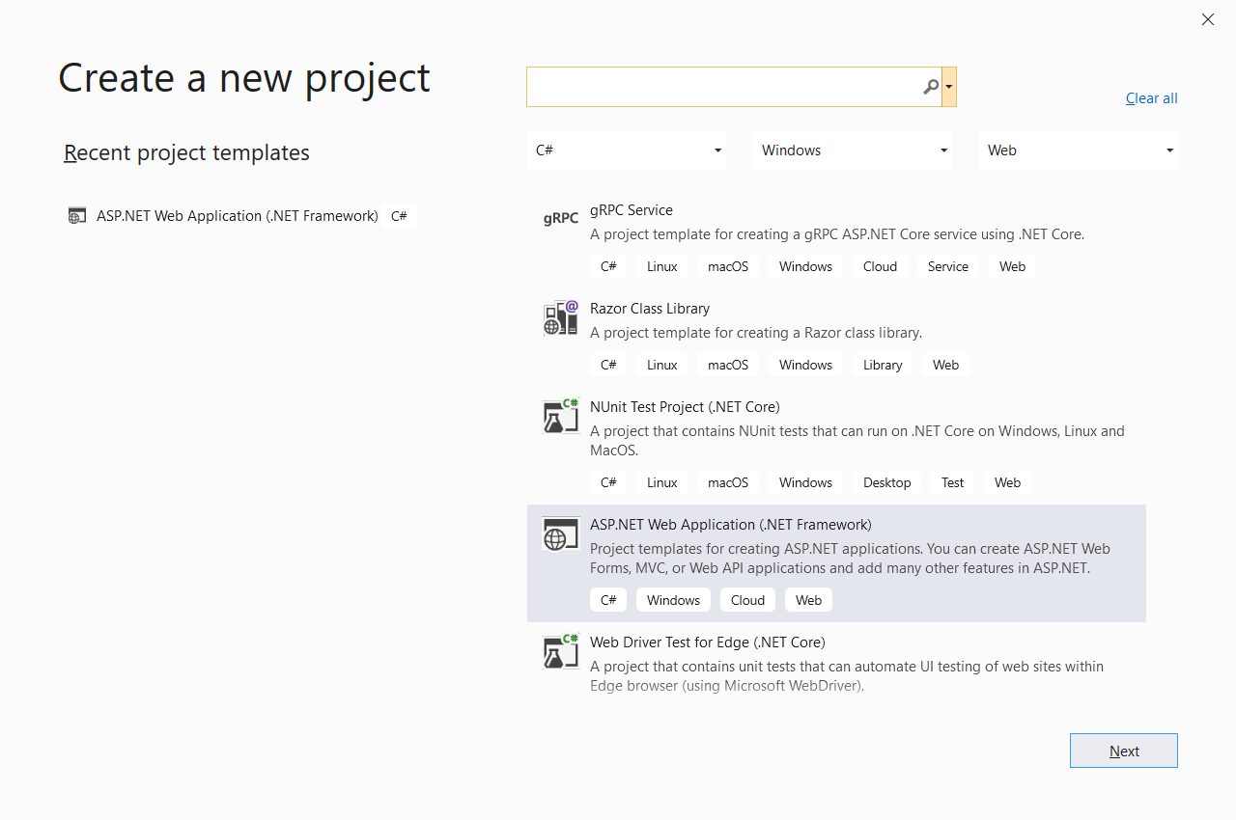Do the following on the *Create a new project* dialog:
5. Select the, *ASP.NET Web Application (.NET Framework)* template and choose: Next.

You can filter the list of templates by selecting from the 3 drop downs: (a) *C#* in the first, (b) *Windows* in the second, (c) *Web* in the third.

1. Scroll down in the list of project types and choose: “ASP.NET Web Application (.NET Framework)”
2. Choose: Next
3. 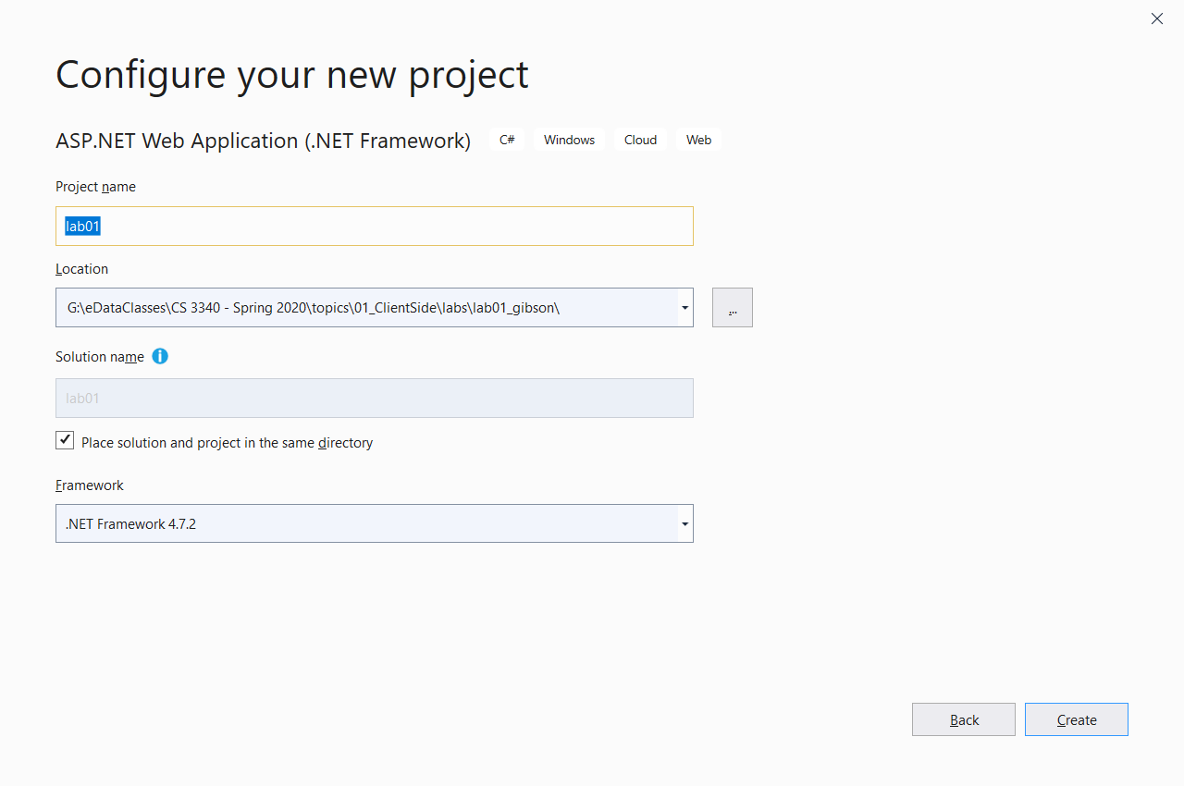Do the following on the *Configure your new project* dialog:
4. Type the *Project name*: “lab01_lastName”
5. Choose the *Location* by navigating to your *labs folder* created above.

Warning: if your path is too long, you get a cryptic error and the project is not created. I’ve tried a path of 113 characters, 7 folders deep, and it failed.

1. Check the box that says, “Place solution and project in the same directory”
2. Choose: Create.
3. 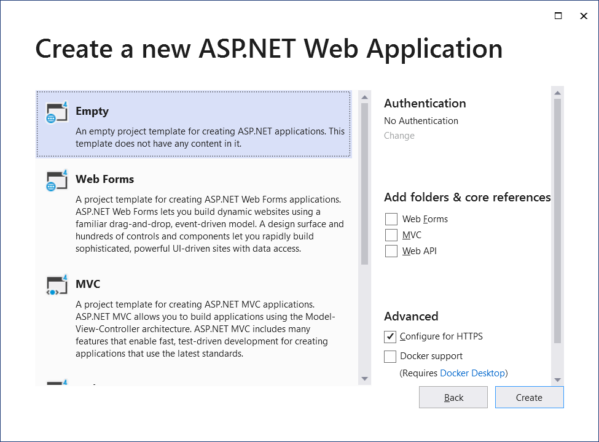Do the following on the *Create a new ASP.NET Web Application* dialog:
4. Choose: Empty
5. Choose: Create (this takes about 30 seconds on my computer for this to complete)
6. (Read, no action required). Your window will look as shown below. Note the following:
7. The *Solution Explorer* (SE) lists all the projects in your solution. When a project is selected, it lists the files in that project. We will generally only have one project in a solution; however, it can be useful to create another project inside a solution to test something out, *etc.*

* If the SE is not displayed, choose: View, Solution Explorer

1. In the diagram below, in the SE, the *solution* is named: *lab01* (yours will be named: *lab01_lastName,* same as the project name). And, the *project* is named: *lab01* (yours will be named: *lab01_lastName*).
2. If you select the project, the *Properties Window* displays properties for the project. We won’t change any project properties. However, any item selected has properties and we will use this pane heavily throughout the course.

* If the Properties pane is not displayed, choose: View, Properties Window

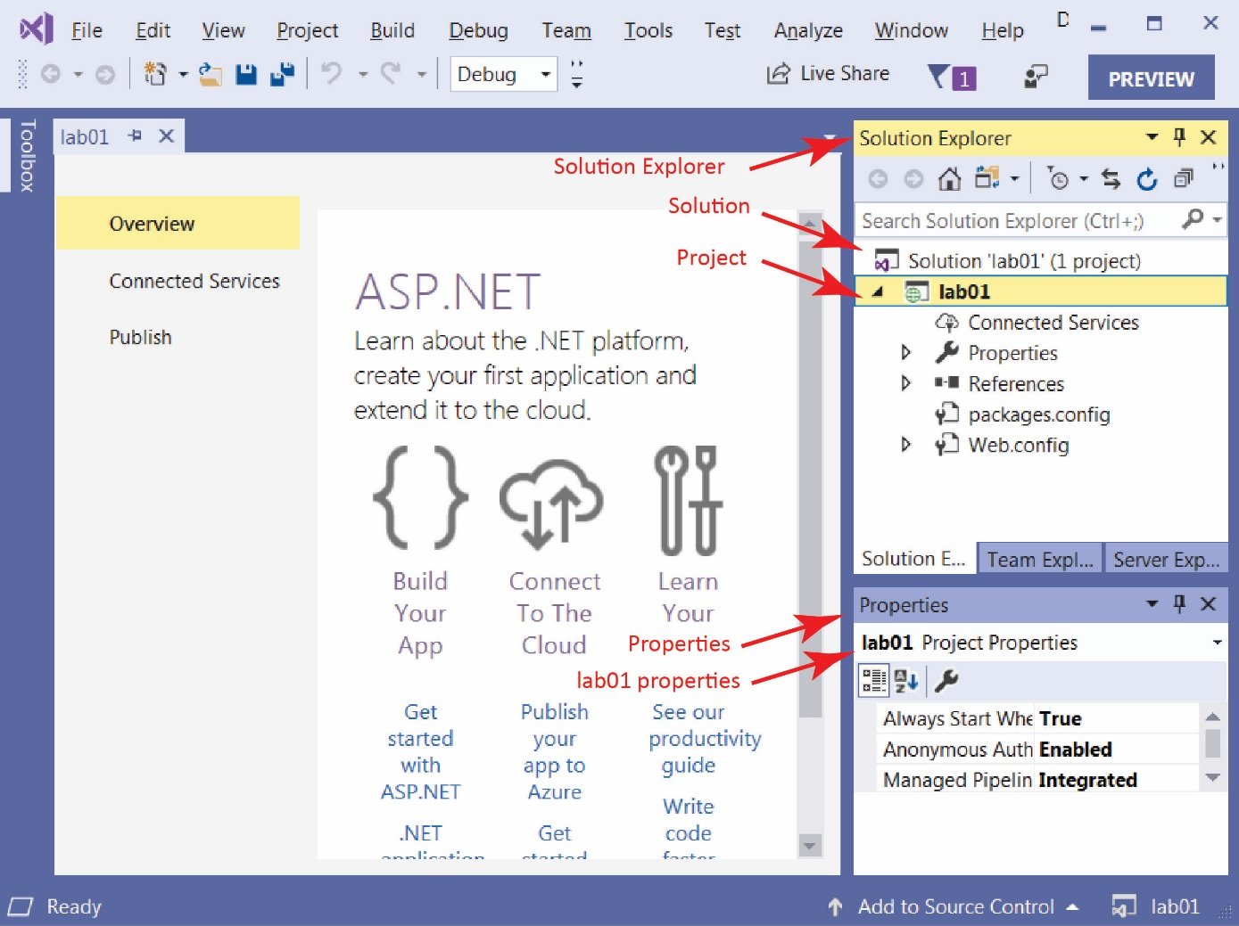

# Build a Web Page

1. **Build a Web Page**
2. Select the *lab01_lastName* project in the *Solution Explorer (SE)*, right-click and choose: *Add, HTML Page*. Supply the name, *default* and choose, *OK*.

* If you do not see *HTML Page*, then choose: *Add, New Item, Visual C#, Web, HTML Page.*

1. Notice the web page is open in the code window and the file is displayed in the SE.
2. The page is open in *Source* view showing HTML. We can also open the page in *Design* view where we can type text into the page as well as use tools to, for instance, create a table. We will use a different editor to open the page so that it supports: *Design, Split,* and *Code* views.
3. Close *default.html*
4. Right-click *default* in the SE
5. Choose: *Open With, HTML (Web Forms) Editor*

Then, you will see *Design, Split* and *Source* buttons in lower left to change the view. You should be in *Design* view now.

1. Change to *Source* mode by selecting the *Source* button in the lower-left. Type the values shown in the image below, substituting your name. Save.

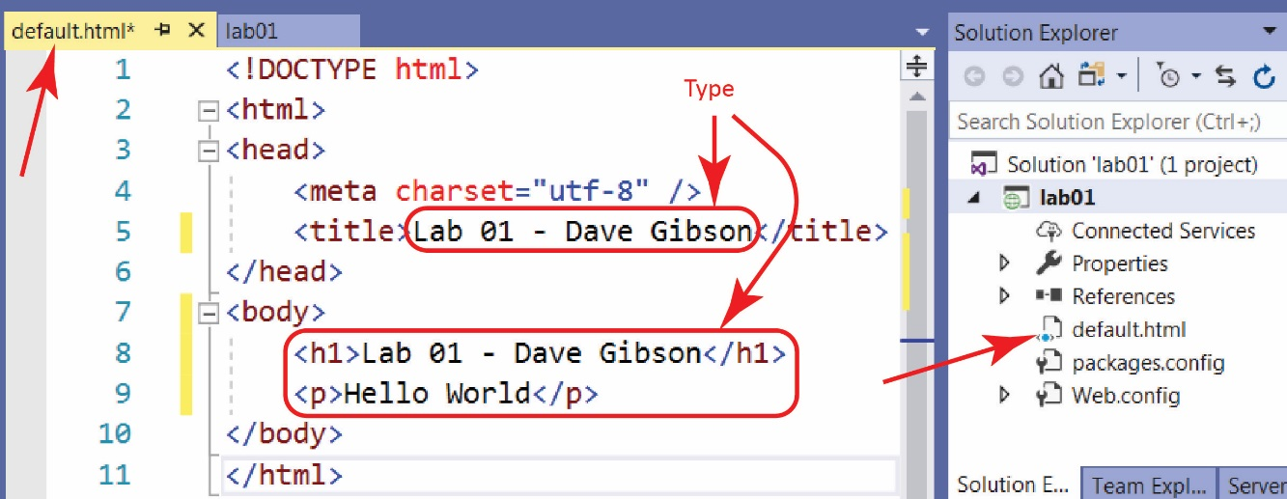

1. (Read, no action required) Window’s computers have a webserver to serve pages locally, to the machine you are working on. The webserver’s name is *localhost.* This is where we will test pages.
2. 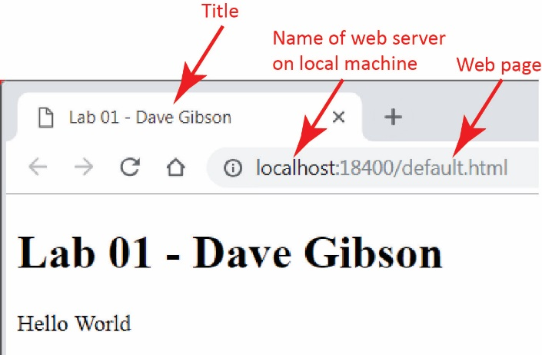Display your page. When you are done, return to VS.

|  |
| --- |
| **There are 3 ways to display your page on localhost:**   1. Right-click in page and choose *View in Browser* 2. Choose: *File, View in Browser* 3. Press: *Ctrl+Shift+W* |

|  |
| --- |
| **Warning**  Sometimes *View in Browser* gives this error:  cid:5d609726-7afd-42f7-b6db-21bb460c5314  One solution is to use the drop down at top that says “IIS Express (Google Chrome)” and choose another browser. E.g. Edge.  I’m not sure, but I think the problem results when you continually run your page, and then a page has a fatal error, but the process displaying the page doesn’t get destroyed. I also think I have “fixed” this error by rebooting my computer. |

1. **Edit page in Design View**
2. 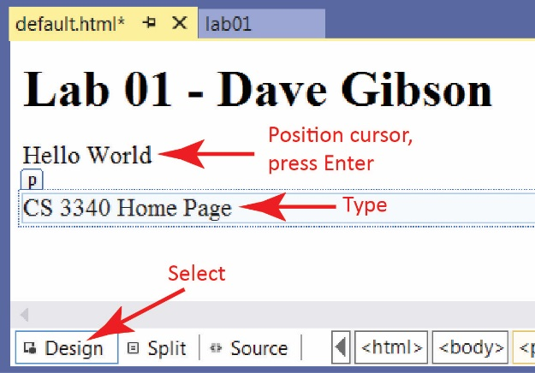Do the following:
3. Open the page in VS and select the *Design* button in the lower-left.
4. Place the cursor and the end of the text, “Hello World,” and press Enter
5. Type the text as shown in the image on the right.
6. Display the *Source* (choose the *Source* tab) and verify that HTML has been added to your page.
7. Save
8. Display your page.
9. Close Visual Studio (save if prompted).

# Explore Folder Structure

1. **Explore Folder Structure**
2. 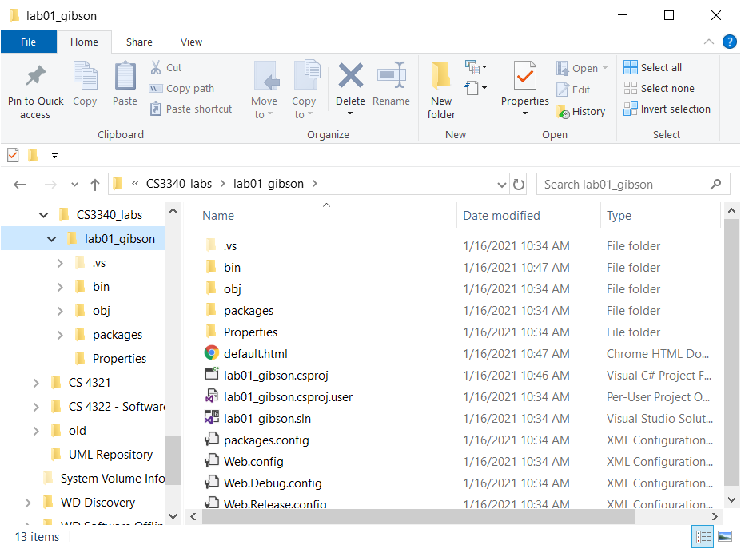Navigate to your *labs folder* (in the example on the right the folder is: *CS3340_labs*) in *File Explorer* and select the project folder (*lab01_lastName*). Note the contents of the folder, specifically, these will be of interest as we go along:

*default.html*

*lab01.sln*

*web.config*

1. Double-click the solution file (*lab01_lastName.sln*) and VS will open the *lab01_lastName* project.
2. (Read, no action required) Three ways you can open your solution:
3. Launch VS and your solution may be listed under *Open recent*
4. Launch VS and choose *Open a project or solution* and then navigate to your *.sln* file.
5. Double-click the *.sln* file in the File Explorer (Windows 10) or Windows Explorer (Windows 7)
6. 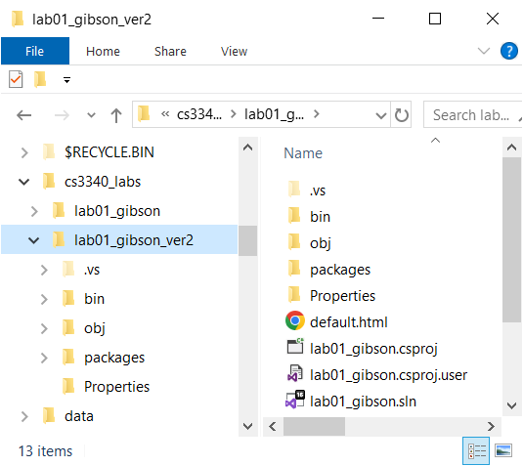(Read, no action required) If you want to make a copy of your project, the best way is to use File Explorer and copy the project folder. For example:
7. You could copy: *lab01_lastName* and paste it in the same parent folder (your *labs* folder) (or elsewhere).
8. Rename it, say: *lab01_gibson_ver2*
9. The solution file will still be: *lab01_gibson.sln* and will work fine.

Notes: VS does not have a “Save as” to save a solution (or project) to another location. Also, there does not appear to be a way to copy/paste the project in the SE.

1. Close VS. Sometimes you will be prompted to save your solution file. If you say yes, sometimes it wants a location. At that point I just back out and tell it not to save.

# Package Lab/Assignment for Submission

1. Do the following:
2. Select your project folder (*lab01_lastName*) in File Explorer
3. Right-click and choose: *Send to, Compressed (zipped) folder.* It should be named: *lab01_lastName.zip* (which probably is the default name).
4. **Test your zip file before submission. There is a penalty if you have not zipped the correct files/folders. Do the following:**
5. Copy the zip file to some other location,
6. Uunzip
7. Launch the solution file (*lab01_lastName.sln*) and make sure everything works.
8. Submit the zip file on Blazeview by the due date.

**This Lab is now complete.**