Lab 0 – CS 3340

Contents

1 Preliminaries 1

2 Download & Install VS 2019 1

3 License Expiration 4

# Preliminaries

For most of this course we will use the “Visual Studio Enterprise 2019” (VS) software. This software is available in the CS open lab and classroom (Nevins 2115). It is not available anywhere else on campus. The Windows version of VS is also available for free for VSU students and the directions for installing are provided in the next section.

**Note:**

* **I cannot help you with the downloading and installation.**
* **There is a *Visual Studio 2019 for Mac*; however, it is not the enterprise edition and will not work for this course.**

This lab is not graded and there is nothing to turn in. However, you must complete this lab. To complete this lab, you must either:

1. Commit to using VS in the CS lab – in which case you are done with this lab – there is nothing else to do. You can move on to Lab 1, or
2. Install the software on a personal device by following the directions in Section 2 below.

# Download & Install VS 2019

1. Verify that your computer meets the minimum requirements.

<https://learn.microsoft.com/en-us/visualstudio/releases/2019/system-requirements#visual-studio-2019-system-requirements>

1. Visit this page: <https://azureforeducation.microsoft.com/devtools>
2. Choose: *Sign In*
3. Type your VSU email address, *e.g.* [dgibson@valdosta.edu](mailto:dgibson@valdosta.edu) and choose: *Next*
4. [This might occur] Choose: *Work or school account*
5. At the *MyVSU* login, type your credentials and choose: *Sign In*
6. [This might occur] You will be prompted to enter your phone number for verification text.
7. Choose: Software (from menu on left, under *Learning resources*)
8. Find and select: *Visual Studio Enterprise 2019*

**Do not choose:**

* ***“Visual Studio 2019 for Mac”* nor *“Visual Studio for Mac”.* Neither will work for this class.**
* **“Visual Studio Enterprise 2022”**

1. 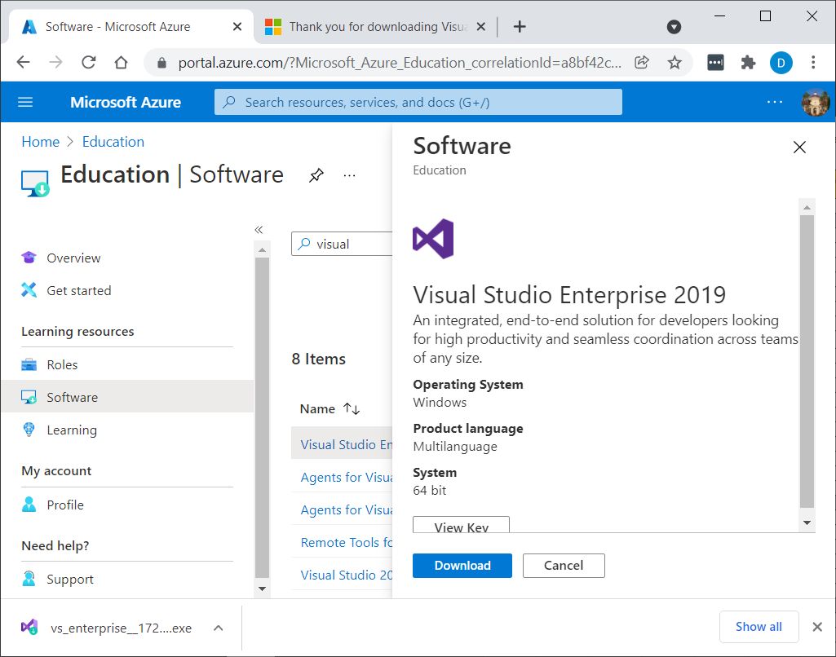Notice *View Key* (see image on the right). You can view the key and copy it. I’m not sure if you need it during installation, but you will need it if the VS expires later in the semester. You could save it in a text file for future reference. Or, Section 3 discusses how to retrieve the key should VS expire.
2. Choose Download.
3. Run the installer. It will prompt you to choose the *Workloads* you want installed (see image below). The only one you need is: “ASP.NET and web development.” You can install any of the others at a later date if desired. The install takes a long time (30+ minutes) and requires a reboot along the way. When I rebooted, it didn’t prompt me to resume the install. As I remember, I think I simply restarted the installer and it picked up where it left off.

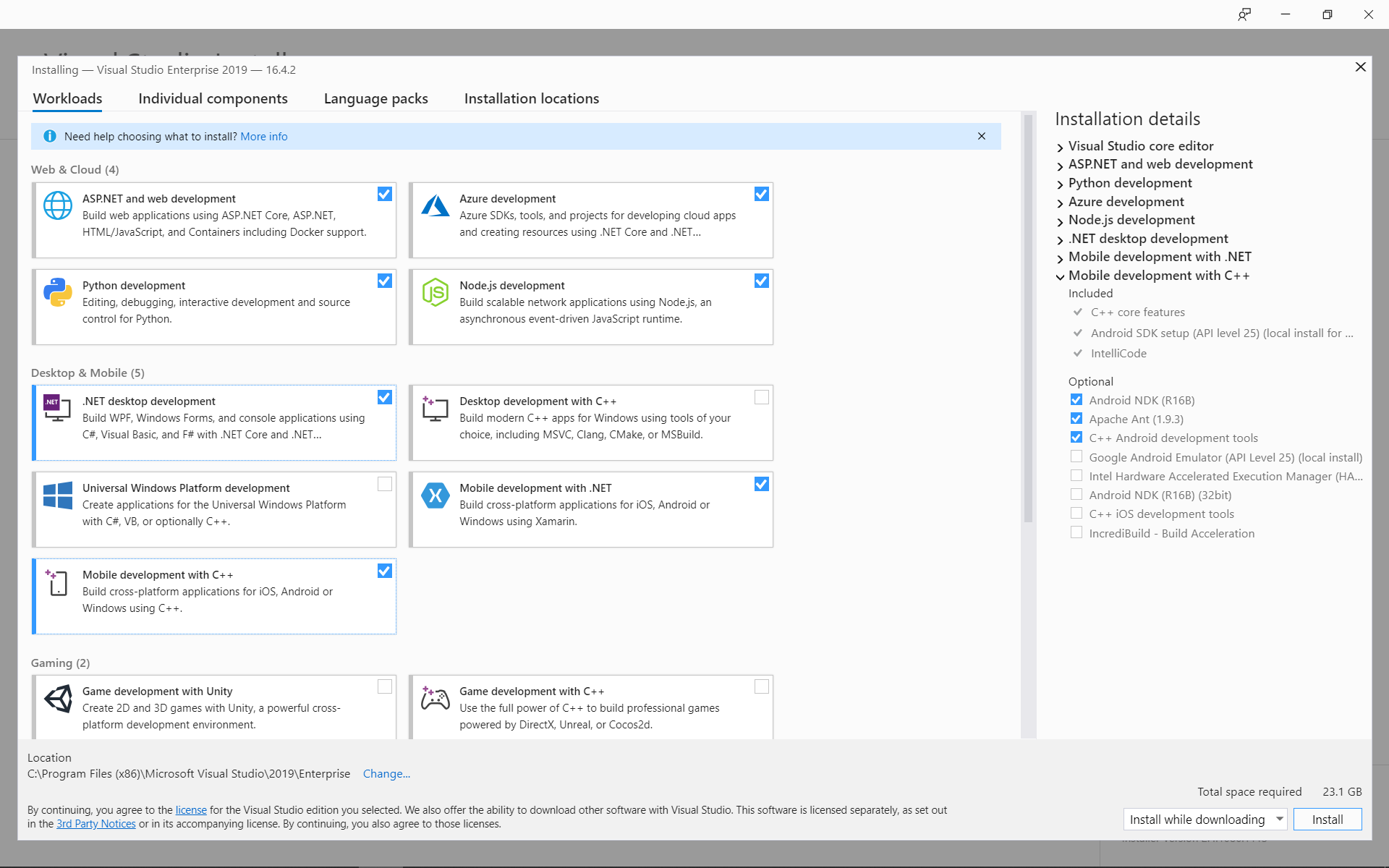

|  |  |
| --- | --- |
| 1. Run VS and you will probably be presented with this dialog. You should be able to log in, but it is not working (Spring 2024). You can try. If not, restart VS and choose: “Not now, maybe later” at the bottom.   cid:02324c30-c858-4742-aa61-31e5f0cb019d | 1. The first time you run VS, it will probably ask you set the Development Settings. Choose: Web Development, and then: Start Visual Studio.   cid:80f111b5-194c-44cf-9361-bb8692487a79 |

1. VS should be displayed. Close it.

# License Expiration

**There is nothing to do for this section. You will need this later, so read through it now.**

At some point during the semester, your license is likely to expire and VS will not open and you will be required to update your license. Follow these directions to update the license.

1. If you see a dialog similar to the one below, choose: Update License

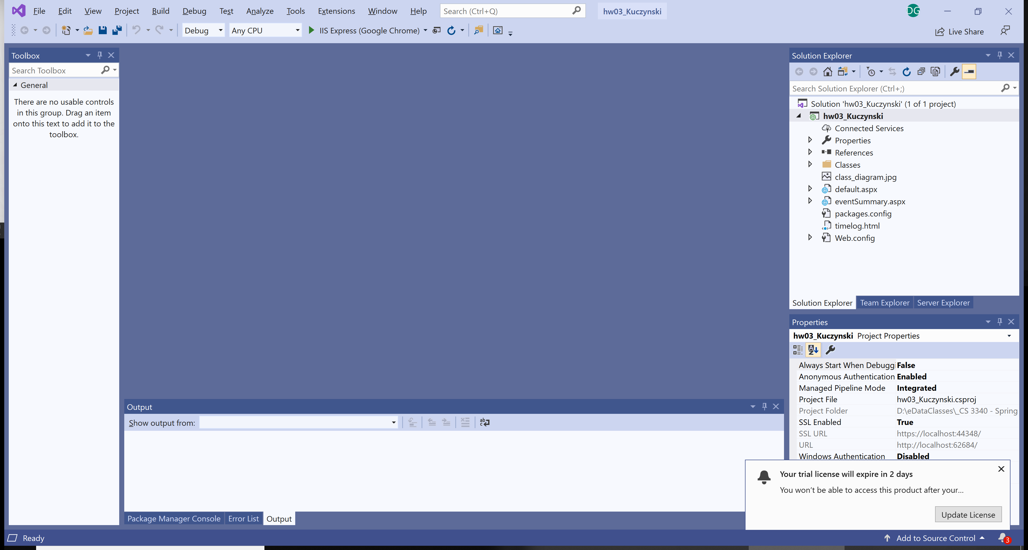

1. The dialog below is displayed. You can try, *Check for an updated license.* However, this didn’t work May 2, 2020 nor Dec 31, 2020, nor Jan 13, 2023, but has in previous years. Otherwise, you will need to: *Unlock with a* *Product Key*. First, we need to get the product key. Then, we will come back and choose *Unlock with a Product Key*.

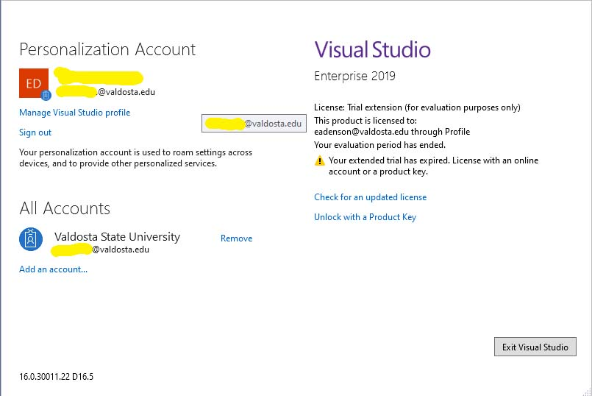

1. Login into: <https://azureforeducation.microsoft.com/devtools>
2. Find and select the software, *Visual Studio Enterprise 2019* as you did when you installed it.

Or, you can choose: *Keys* as shown below:

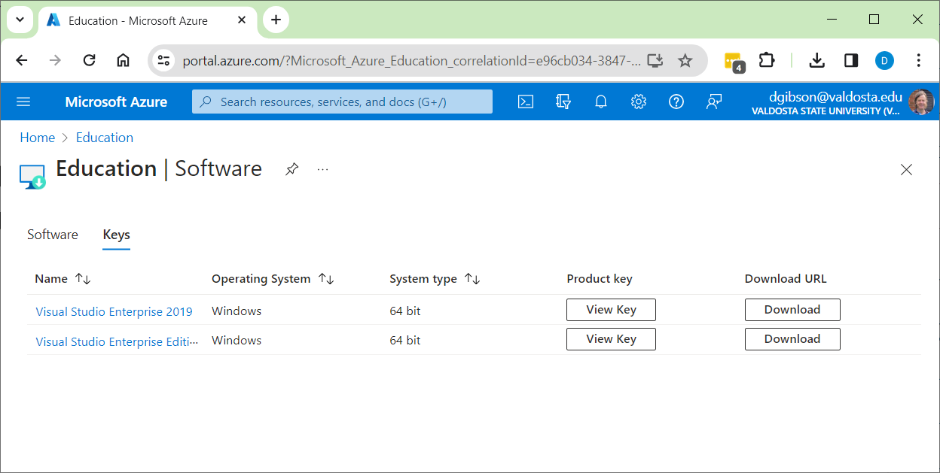

1. 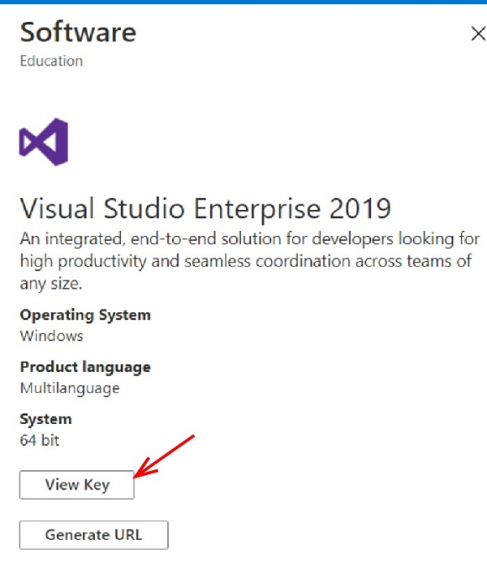As shown on the right, choose: View Key, and when it is displayed, copy it.
2. As shown below, return to VS and choose: *Unlock with a Product Key*, paste the key, and choose: Apply.

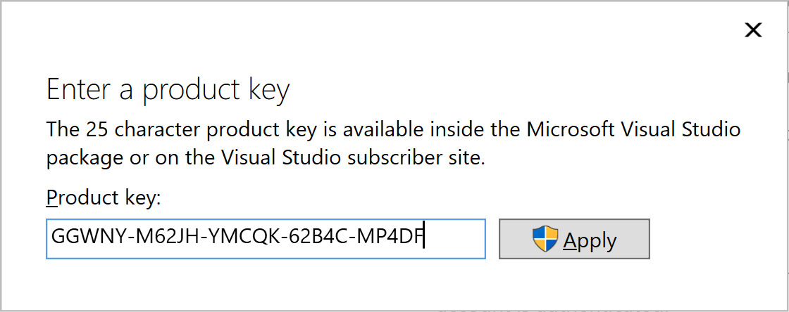

1. In the upper-right of the dialog that results, you should see a message like this:

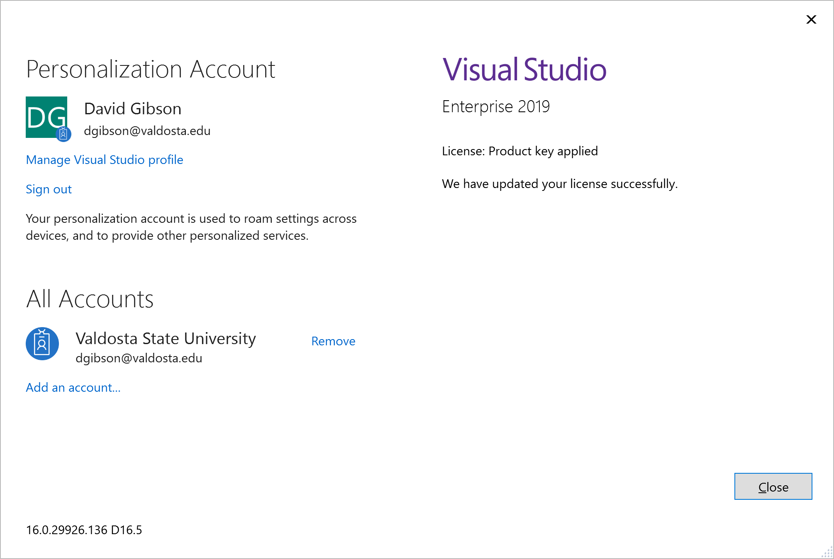

**You are done! There is nothing to turn in.**