Responsive Design & Bootstrap
Contents
1 Adaptive vs. Responsive Design 1
2 Implementing Responsive Design 3
2.1 Responsive Design 3
2.2 Semantic Layout Elements 3
2.3 Responsive CSS Properties 4
3 CSS Grid & Flexbox 5
4 Responsive Design Tutorials 6
4.1 W3Schools 6
4.2 freeCodeCamp 6
Appendix 1 Responsive Design Resources 6
Appendix 2 Firefox Tools 8
Appendix 2.1 Responsive Design Mode 8
Appendix 2.2 Developer Tools 9

Adaptive vs. Responsive Design
Responsive Design:
A responsive website shows content based on the available browser space. If you open a responsive site on the desktop and then change the size of the browser window, the content will move dynamically to arrange itself (at least in theory) optimally for the browser window. On mobile phones, this process is automatic; the site checks for the available space and then presents itself in the ideal arrangement.
Responsive design is straightforward. Because it is fluid, it means that users can access your online world and enjoy as much of it on their handheld device as they would on a massive monitor. For this to be true, responsive design requires a very good conceptualization of the site and a deep knowledge of the needs and wants of the end users!
Adaptive Design:
Where responsive design relies on changing the design pattern to fit the real estate available to it, adaptive design has multiple fixed layout sizes. When the site detects the available space, it selects the layout most appropriate for the screen. So, when you open a browser on the desktop, the site chooses the best layout for that desktop screen; resizing the browser has no impact on the design.
Some sites have been quick to embrace adaptive design. Amazon, USA Today, Apple, and About.com configured themselves to be mobile-optimized websites. The layout displayed on a mobile website using adaptive design may be different from the desktop’s version. However, this is because the designers have picked a different layout for the phone’s screen rather than leaving the design to try to rearrange itself.
In adaptive design, it’s normal to develop six designs for the six most common screen widths; 320, 480, 760, 960, 1200, and 1600 pixels.
Comparison:
Responsive Design is easier and takes less work to implement. … Responsive designers create a single design to be used on all screens and will generally start in the middle of the resolution and use media queries to determine what adjustments will be made for the lower and higher end of the resolution scale.
Adaptive design will (theoretically) ensure the best user experience according to whichever device the user is using to interface. Unlike responsive design, where a screen “flows” from desktop design into a smaller device’s, adaptive design offers tailor-made solutions…. Another advantage — research shows that a company with an adaptive website will often outperform, on speed tests, a company with a responsive website. This isn’t a small difference either; adaptive sites are often 2-3 times faster than responsive ones and give rather less data to the user in order to deliver the user experience
Responsive Design is the most popular, currently.
Source: https://www.interaction-design.org/literature/article/adaptive-vs-responsive-design
Other references:
- https://www.interaction-design.org/literature/topics/responsive-design
- https://www.interaction-design.org/literature/topics/adaptive-design
- https://www.interaction-design.org/literature/topics/ui-design-patterns
- https://www.uxpin.com/studio/blog/responsive-vs-adaptive-design-whats-best-choice-designers/

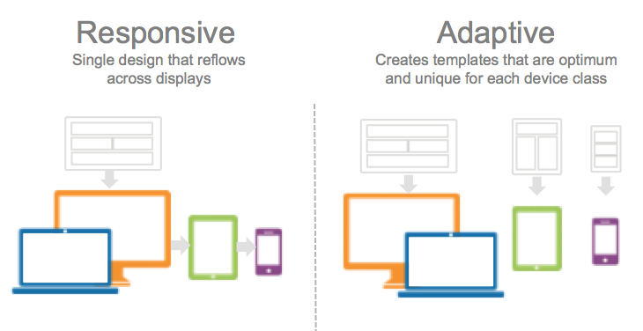
Source: https://www.gomolearning.com/blog/elearning-technology/responsive-versus-adaptive-content-elearning/

Implementing Responsive Design
This section discusses some of the techniques need for designing responsive sites.

Responsive Design
There are two approaches to build responsive or adaptive sites:
- Manually – Apply CSS to HTML in such a way that the site is responsive. This involves techniques we consider next: semantic HTML elements (next Section 2.2) and/or divs; and styling them properly using CSS display, float, clear, box-sizing, and others; Media Queries; CSS Grid; and CSS Flexbox. We consider these in Section 2.3.
- Framework - Use a CSS framework such as W3.CSS or Bootstrap to build responsive designs. These are built on top of the CSS concepts in the preceding paragraph. We consider bootstrap in the next lesson. They usually also rely on JavaScript.
“In essence, a CSS framework comprises several CSS stylesheets ready for use by web developers and designers. The stylesheets are prepped for standard web design functions: setting colors, layout, fonts, navbars, etc. Generally, stylesheets are supported and expanded by other scripting technologies like SASS and JavaScript.”
“With a CSS framework, the user has a completed CSS stylesheet, and they only have to code the HTML with accurate classes, structure, and IDs to set up a web page. The framework already has classes built-in for common website elements – footer, slider, navigation bar, hamburger menu, column-based layouts, etc.”
Source: https://www.browserstack.com/guide/top-css-frameworks

Semantic Layout Elements
HTML has several semantic elements that define the different parts of a web page:
- <header> - Defines a header for a document or a section
- <nav> - Defines a set of navigation links
- <section> - Defines a section in a document
- <article> - Defines an independent, self-contained content
- <aside> - Defines content aside from the content (like a sidebar)
- <footer> - Defines a footer for a document or a section
- <details> - Defines additional details that the user can open and close on demand
- <summary> - Defines a heading for the <details> element

Source: https://www.w3schools.com/html/html_layout.asp
For more detail, see HTML Semantics.
Using an approach like this makes the HTML more understandable, and easier to apply CSS. Of course, you could do it all with div tags.

Responsive CSS Properties
This section has a few more CSS topics that are useful for responsive design and for an understanding of the bootstrap framework we consider in the next lesson.
- The display property is the most important CSS property for controlling layout.
Reference | Comments
CSS display Property | [W3schools]
display | In second section, Definition & Usage, choose the “Show demo” button. [W3schools]
CSS Display: One-Stop Tutorial | [simplilearn]
- The CSS overflow property controls what happens to content that is too big to fit into an area.
Reference | Comments
CSS Layout - Overflow | [W3schools]
overflow | [developer.mozilla]
Flow layout and overflow | [developer.mozilla]
- The CSS float property specifies how an element should float (left, right, none, inherit). Examples: float an image to the left or right around text.
Reference | Comments
CSS Layout - float and clear | [W3schools]
float | [developer.mozilla]
- The CSS clear property specifies what should happen to an element when it is next to a floating element. In other words, if you have some floated elements and you want the next element to be below, you use the clear property. The authors recommend: clearfix::after to handle an element (e.g. an image) that overflows its container.
Reference | Comments
CSS Layout - clear and clearfix | [W3schools]
clear | [developer.mozilla]
- The CSS box-sizing property allows us to include the padding and border in an element’s total width and height. By default, the actual width of an element is: width + padding + border. In other words, if you have a div with a width of 100 and add 10-pixel padding, then the div will appear bigger than you have set. In this case, the width of the div would be 120 pixels. By applying: box-sizing: border-box, to an element, this will force the element’s actual width to include the padding and border. A common rule defines that all elements on the page (“*” is the universal selector, it selects everything on the page) will have this feature applied to them.
* {
box-sizing: border-box;
}
Reference | Comments
CSS Box Sizing | [W3schools]
box-sizing | [developer.mozilla]

- High-level overview of CSS Grid & Flexbox. Examples of each of these techniques is found in the code download (ResponsiveDesign.zip).
Source for all: https://www.simplilearn.com/tutorials/css-tutorial/css-grid-vs-flexbox
CSS Grid:
- Two-dimensional. Defined with rows and columns, which can be merged.
- Uses: display: grid in the container.
- Useful for creating more complex and organized layouts.
CSS Flexbox:
- One-dimensional, useful in allocating space among the flex items in the flex container.
- Uses: display: flex in the container.
- Can model a row or column (grids work with both).
“Another major difference between the two is that Flexbox takes a basis in the content while Grid takes a basis in the layout.”
- CSS Grid layout is used to create a grid of elements. It utilizes the: display: grid, grid-template-columns, and gird-column properties.
Reference | Comments
CSS Grid Layout Module | [W3schools]
CSS grid layout | There are many “Guides” towards the bottom of the page. [developer.mozilla]
Basic concepts of grid layout | [developer.mozilla]
CSS Grid Layout | [simplilearn]
CSS Grid Crash Course | Excellent video (54 min) [Traversy Media]
- CSS Flexbox is used to arrange elements. It utilizes the: display: flex, justify-content (center, flex-start, flex-end), and align-content. Other sources: CSS Flexbox. CSS Grid vs. Flexbox.
Reference | Comments
CSS Flexbox | [W3schools]
Basic concepts of flexbox | Other related topics in left menu. [developer.mozilla]
CSS Flexbox: he Best Guide | [simplilearn]
CSS Grid Vs. Flexbox: A Tutorial | [simplilearn]
Flexbox Crash Course 2022 | Excellent video (47 min) [Traversy Media]
- Media Queries are a way to conditionally apply a CSS rule, depending on the screen size. Also see Examples.
Reference | Comments
Intro | [W3schools]
Beginner’s guide to media queries | Other related topics in left menu. [developer.mozilla]
Using media queries | More detailed [developer.mozilla]
Printing | [developer.mozilla]

Video – Responsive Web Development Tips
Responsive Web Development Tips That Everyone Should Know (len: 9:40)
Time | Description
0:00 | Responsive Design
7:02 | SASS Preprocessor
7:40 | BEM (Block Element Modifier)
8:36 | What is next for CSS

Responsive Design Tutorials

W3Schools
Go through this in class: https://www.w3schools.com/html/html_responsive.asp
- What is responsive design?
- Setting the viewport (another source: Viewport meta tag)
- Responsive images – max-width property, picture property (scan/ignore)
- Responsive text size – use the “vw” unit for text sizes (viewport width)
- Media queries – Different styles for different browser sizes. (Another source: Using media queries)
- Full Example
- Frameworks:
  - w3.css – smaller, alternative to bootstrap, independent of jQuery and any other JS library. Shows example with no explanation, and provides link to tutorial: https://www.w3schools.com/w3css/default.asp. We will NOT cover this
  - Bootstrap - uses jQuery, most popular of frameworks. Shows example with no explanation, and provides link to tutorial: https://www.w3schools.com/bootstrap/default.asp. We will cover this later.

freeCodeCamp
Go through this in class: https://www.freecodecamp.org/news/learn-responsive-web-design-in-5-minutes/

Appendix
- Responsive Design Resources
Responsive Design, UI Design, RD-Let Device to the Work. More detail than w3schools. High-level. Useful.
- https://www.interaction-design.org/literature/topics/responsive-design
- https://www.interaction-design.org/literature/topics/ui-design-patterns
- https://www.interaction-design.org/literature/article/responsive-design-let-the-device-do-the-work
- https://developer.mozilla.org/en-US/docs/Learn/CSS/CSS_layout/Responsive_Design - First bit is useful, detailed later
The Encyclopedia of Human-Computer Interaction, 2nd Ed. 4000 pages, 53 chapters.
- https://www.interaction-design.org/literature
HTML 5
- https://www.tutorialspoint.com/html5/html5_new_tags.htm – New tags in HTML 5 (2014)
- https://www.techonthenet.com/html/index.php – Index on right of all tags, simple example of each
- Header sizes in em: https://html.spec.whatwg.org/multipage/rendering.html#sections-and-headings
- HTML spec: https://html.spec.whatwg.org/multipage/rendering.html

CSS
The is the W3School tutorial on CSS. The items in blue were (mostly) not considered in class

CSS Tutorial  - CSS HOME – Already covered  - CSS Introduction – Already covered  - CSS Syntax – Already covered  - CSS Selectors – Already covered  - CSS How To – Already covered  - CSS Colors – Already covered  - CSS Backgrounds – Already covered  - CSS Borders – Already covered  - CSS Margins – Already covered  - CSS Padding – Already covered  - CSS Height/Width – Already covered  - CSS Box Model – Already covered  - CSS Outline – Already covered  - CSS Text – Already covered  - CSS Fonts – Already covered  - CSS Icons - Omit  - CSS Links – Scan quickly  - CSS Lists – Already covered  - CSS Tables – Already covered | - CSS Display – Scan  - CSS Max-width - Scan  - CSS Position – Read carefully  - CSS Overflow - Scan  - CSS Float – Read carefully  - CSS Inline-block - Read carefully  - CSS Align – Read carefully  - CSS Combinators – Already covered  - CSS Pseudo-class – Read carefully  - CSS Pseudo-element – Scan  - CSS Opacity – Omit  - CSS Navigation Bar – Scan  - CSS Dropdowns – Scan  - CSS Image Gallery – Omit  - CSS Image Sprites – Omit  - CSS Attr Selectors – Scan Quickly  - CSS Forms – Read carefully  - CSS Counters – Scan Quickly  - CSS Website Layout – Read very carefully  - CSS Units – Scan quickly  - CSS Specificity – Scan quickly
The “Advanced” section at the bottom of the tutorial also has some useful topics:
CSS Advanced Tutorial  - CSS Rounded Corners – Scan quickly  - CSS Border Images – Omit  - CSS Backgrounds – Omit  - CSS Colors – Scan quickly, only first section: RGBA Colors  - CSS Gradients – Omit  - CSS Shadows – Omit  - CSS Text Effects – Scan quickly, only first section: CSS Word Wrapping  - CSS Web Fonts – Omit  - CSS 2D Transforms – Omit  - CSS 3D Transforms – Omit  - CSS Transitions – Omit  - CSS Animations – Omit | - CSS Tooltips – Scan quickly  - CSS Style Images – Omit  - CSS object-fit – Omit  - CSS Buttons – Scan  - CSS Pagination – Scan quickly  - CSS Multiple Columns – Scan quickly  - CSS User Interface – Scan quickly, only the second section: CSS Resizing  - CSS Variables – Scan quickly  - CSS Box Sizing – Read carefully  - CSS Media Queries – Read carefully  - CSS MQ Examples – Scan quickly, just the first 3 examples.  - CSS Flexbox  - CSS Flexbox – Read carefully  - CSS Flex Container – Scan  - CSS Flex Items – Scan quickly, just the first 2 sections: Child Elements & The order Property  - CSS Flex Responsive – Scan

- Firefox Tools
  - Responsive Design Mode
Firefox has a tool to allow you to see what you page looks like with different screen sizes, without having to resize the browser. It allows you to resize the web page, inside the browser, without changing the size of the browser itself.
Choose: Application Menu (Hamburger menu), More Tools, Responsive Design Mode.
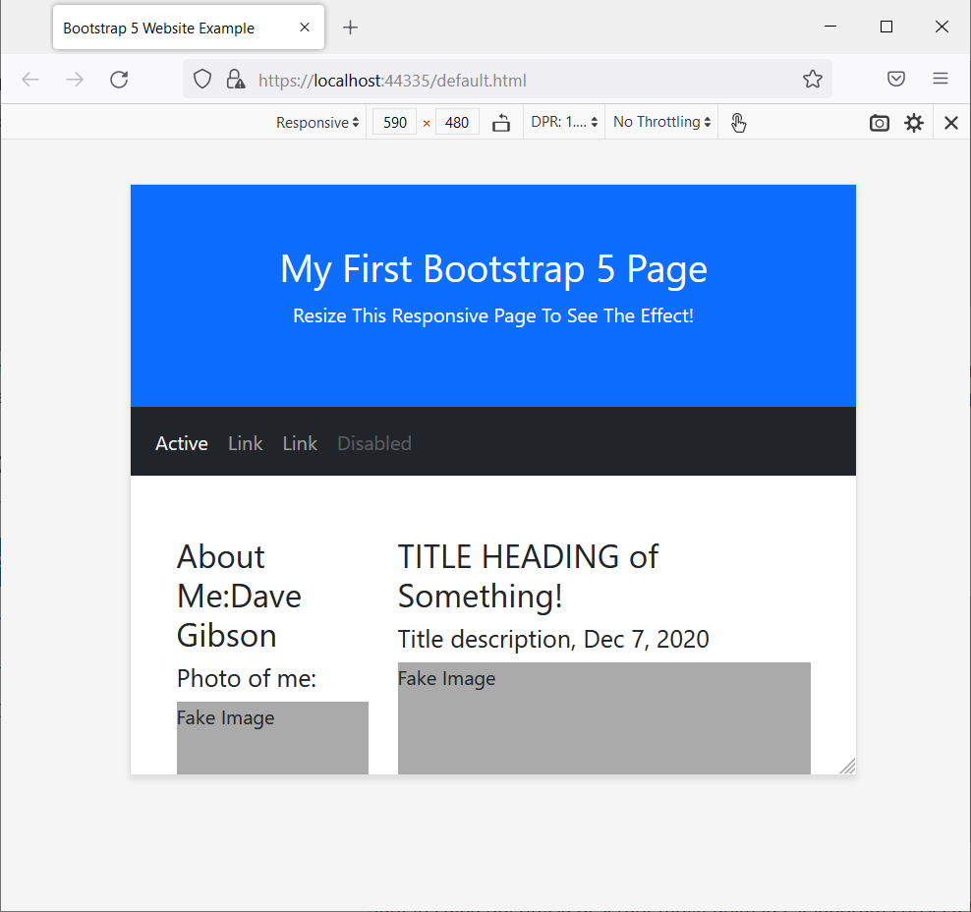

  - Developer Tools
You can also add the Developer Tools. Under Inspector, can select a tag and see what CSS is used and the size of the element including borders, padding, margins.
Choose: Application Menu (Hamburger menu), More Tools, Responsive Design Mode.
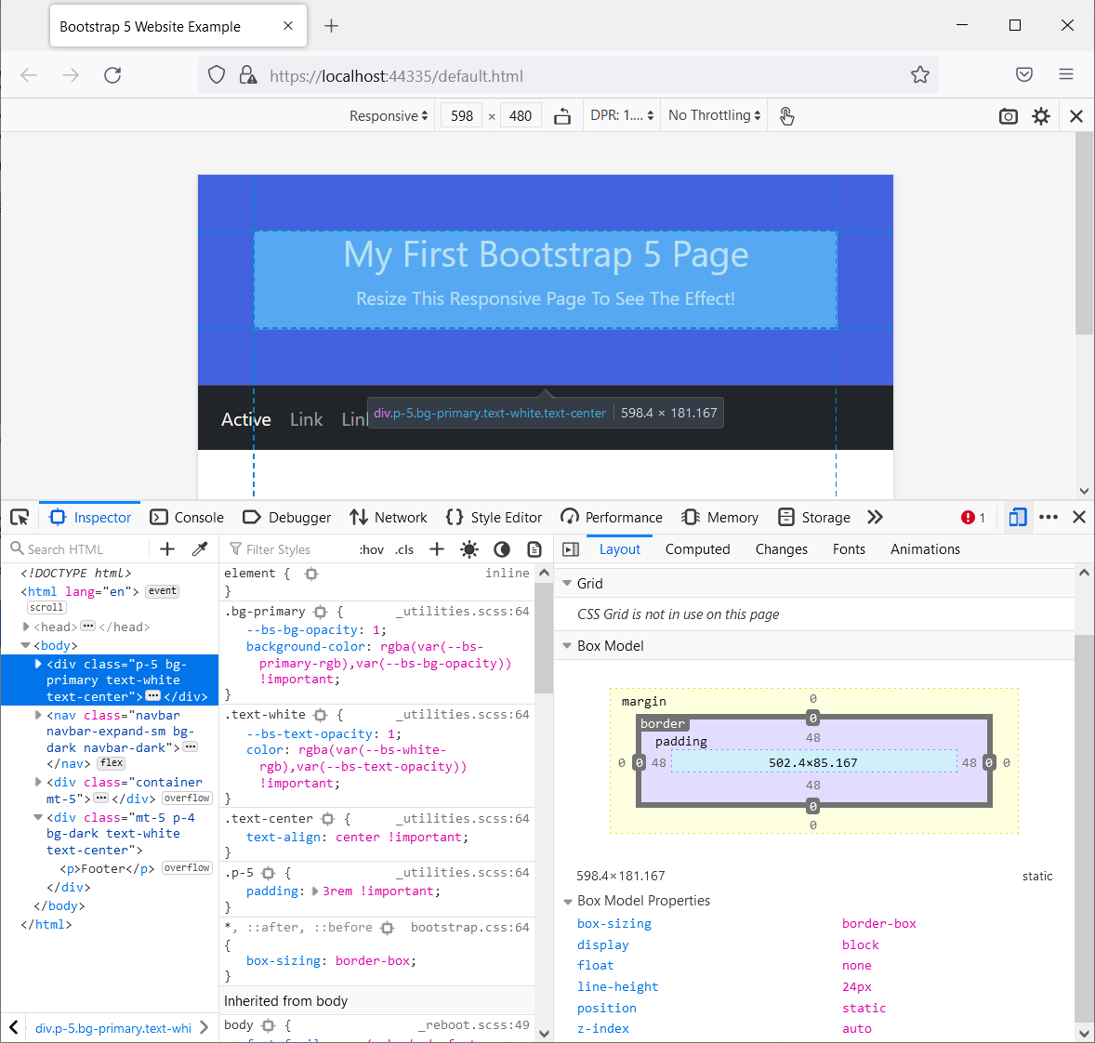

https://medium.muz.li/what-is-awd-5-great-adaptive-web-design-examples-for-inspiration-3218e9f624ea

