Java Script

Contents
1 Introduction 1
2 Java Script DOM Tutorial 2
3 Simple Java Script Example 4
4 Programming the HTML DOM 6
4.1 Browser Object Model 6
4.2 HTML DOM Objects 7
5 Accessing Elements via the DOM 9
5.1 TextBox 9
5.2 Check Boxes 9
5.3 Radio Buttons 10
5.4 Drop-Down (Single Selection) 10
5.5 Drop-Down (Multiple Selection) 11
6 Events 12
7 Expectations 12
Appendix 1 N/A 13

Introduction
Java Script (JS):
- Is an object-oriented; however, many programmers don’t use OO very much. With JS, you frequently write event-handlers that might call helper functions.
- It is a way to make a page interactive: update content dynamically, data validation, control multimedia, pop-up menus, etc.
- It is used on both the client-side and the server-side. We will only use it on the client-side. On the client-side, it runs in the browser.
- Can manipulate HTML elements, e.g. hide or show a paragraph of text, or build a table dynamically, etc. This is possible because of the HTML DOM (Document Object Model) which we consider a later Section.
For this course, we will create Form based apps that work only in the browser. This approach is occasionally useful in the real world. However, it is a great approach to learn JS and how to manipulate the DOM.
that runs in the browser. Among other ways, JS can be used in these 3 ways:
- As a stand-alone feature in a web page to provide some functionality, e.g. a monthly payment calculator.
- Data validation, e.g. determining if a number a user entered is an integer between 1 and 10..
- Manipulate HTML elements, e.g. hide or show a paragraph of text, or build a table dynamically. This would usually be done in the context of item 1 or 2 above.
We may cover the highlighted sections of the W3School’s Java Script Tutorial in class, or I may have you cover it outside of class.
- JS HOME – Read carefully  - JS Introduction – Read carefully  - JS Where To – Read carefully  - JS Output – Read carefully  - JS Statements – Scan  - JS Syntax – Read carefully  - JS Comments – Scan  - JS Variables – Scan  - JS Operators – Scan  - JS Arithmetic – Scan  - JS Assignment - Scan  - JS Data Types – Scan  - JS Functions – Read carefully  - JS Objects – Omit  - JS Events – Read carefully  - JS Strings – Scan  - JS String Methods – Scan  - JS Numbers – Scan  - JS Number Methods – Scan  - JS Arrays – Read carefully. Omit: “Adding Array Elements”, “Associative Arrays?” and everything below “The Difference Between Arrays and Objects”  - JS Array Methods – Scan  - JS Array Sort – Scan  - Js Array Iteration – Scan, this shows newer ways, we will use syntax similar to java  - JS Dates – Omit  - JS Date Formats - Omit  - JS Date Get Methods – Omit  - JS Date Set Methods – Omit | - JS Array Methods – Omit  - JS Math – Scan  - JS Random - Omit  - JS Booleans – Scan  - JS Comparisons – Scan  - JS Conditions – Scan  - JS Switch – Scan  - JS Loop For – Scan  - JS Loop While – Scan  - JS Break – Scan  - JS Type Conversion – Omit  - JS Bitwise – Omit  - JS RegExp – Omit  - JS Errors – Omit  - JS Scope – Read carefully  - JS Hoisting – Omit  - JS Strict Mode – Omit  - JS this Keyword – OmitJS Let – Omit  - JS Const - Omit  - JS Debugging – Omit  - JS Style Guide – Scan  - JS Best Practices – Omit  - JS Mistakes – Omit  - JS Performance – Omit  - JS Reserved Words – Omit  - JS Versions – Omit  - JS Versions ES5 – Omit  - JS Versions ES6 - Omit  - JS JSON – Omit.

Java Script DOM Tutorial
We may cover the highlighted sections of the W3School’s DOM and BOM tutorials in class, or I may have you cover it outside of class.
JavaScript HTML DOM Tutorial  - DOM Intro – Read carefully  - DOM Methods – Read carefully  - DOM Document – Read carefully. Omit “Adding and Deleting Elements” and “Finding HTML Objects”.  - DOM Elements – Read carefully. Omit last two sections starting with, “Finding HTML Elements by CSS Selectors .”  - DOM HTML – Read carefully.  - DOM CSS – Read carefully only the second section, “Using Events”  - DOM Animations – Omit  - DOM Events – Read carefully  - DOM EventListener – Useful, interesting, and powerful, but you can omit.  - DOM Navigation – Omit  - DOM Nodes – Omit  - DOM Collections - Omit  - DOM Node Lists – Omit | JavaScript Browser BOM Tutorial  - JS Window – Read carefully two sections only. Scan from, “Window Size” and below  - JS Screen – Omit  - JS Location – Omit  - JS History – Omit  - JS Navigator – Omit  - JS Popup Alert – Read carefully  - JS Timing – Omit  - JS Cookies – Omit

Simple Java Script Example
Consider this example where a user types in a name, and then a “hello world” message is displayed in different ways: text area, paragraph, div, table.
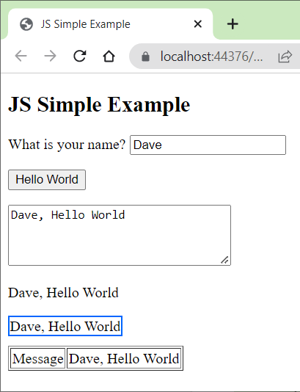 | The Java Script is:  function helloWorld() {  var txbName = document.getElementById("name");  var message = txbName.value + ", " + "Hello World"  alert(message);  var txaResult = document.getElementById("txaMessage");  txaResult.value = message;  document.getElementById("pMessage").innerHTML = message;  document.getElementById("divMessage").innerHTML = message;  document.getElementById("tdMessage").innerHTML = message;  txbName.value = null;  txbName.focus();  }
The HTML is:
<form id="hello">
<p>
What is your name?
<input id="name" type="text" />
</p>

<p><button type="button" onclick="helloWorld()">Hello World</button></p>

<p><textarea rows="4" id="txaMessage" cols="30"></textarea></p>

<p id="pMessage"></p>

<div id="divMessage" style="border:2px solid #0066FF; display:inline-block;
margin-bottom:10px"></div>

<table border="1">
<tr>
<td>Message</td>
<td id="tdMessage"></td>
</tr>
</table>

<div id="divMessage" style="border:2px solid #0066FF; display:none; margin-bottom:10px"></div>
</form>

Takeaways:
Statement | Description
document.getElementById(id) | Returns the HTML element with id.
.value | Used to get or set the value in a form control: input(type=”text”), textarea, select, & others.
.innerHTML | Get or set the HTML content of tags that are not form controls. For example: p, div, td. In the example above, we have this line to put the message in the paragraph:  document.getElementById("pMessage").innerHTML = message;  We could have supplied some HTML as well as the message:  document.getElementById("pMessage").innerHTML = "<b>"+message+"</b>";
.innerText | Get or set the text content of tags that are not form controls. For example: p, div, td. In the example above, we could have used: innerText instead of innerHTML:  document.getElementById("pMessage").innerText = message;

Programming the HTML DOM
This is an introduction to HTML DOM (document object model) programming and briefly the HTML BOM (browser object model). The DOM (and BOM) are API’s that provide JavaScript (JS) code access to any HTML elements on a webpage. For example, we can access the values a user types in (or selects), process them, and then display output.

Browser Object Model
Practically anything you could want to know about a web page is available in HTML BOM (Browser Object Model). An instance of each of these classes is available in any webpage. We will use the methods shown in red. The class diagram is not complete. There are many more properties and methods for each class. Reference:
https://www.w3schools.com/js/js_window.asp
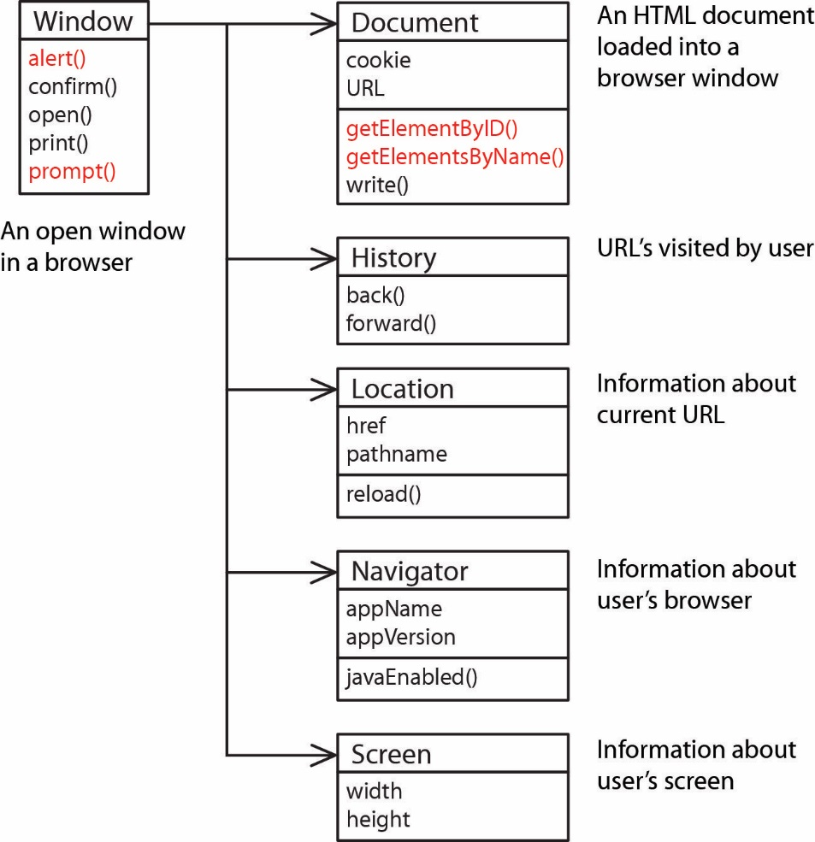
In the example in Section3, we used the alert() method, e.g.
alert("Hello World");
However, we could have written this:
window.alert("Hello World");
Thus, we see that JS is pretty loose about some things: e.g. the window object is available in any page and since there is only one alert method, JS knows what to do. Similarly, we used this to obtain a reference to the textbox with the id “name”:
var txbName = document.getElementById("name");
Note that the line above gave a reference to the textbox itself. The line below shows that we use the textbox’s value property to obtain the value that was typed in. This will be explained a bit more later.
var name = txtName.value;
And, we could have used window to precede document, but usually don’t.
var txbName = window.document.getElementById("name");

HTML DOM Objects
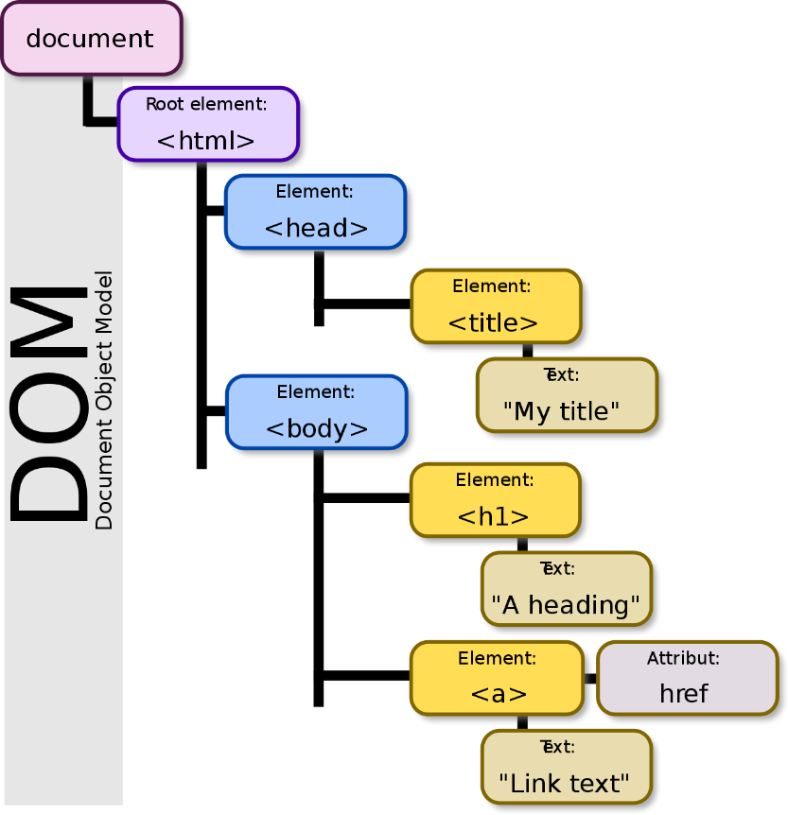
The Document Object Model (DOM) is an API for accessing, changing, and manipulating all aspects of an HTML (or XML) document. The DOM represents an HTML page as a tree. Each branch of the tree ends in an HTML element, elements can contain elements, and elements can contain attributes and text.

By Birger Eriksson - Own work, CC BY-SA 3.0, https://commons.wikimedia.org/w/index.php?curid=18034500
You can see a visualization of the DOM for a page on this site: https://bioub.github.io/dom-visualizer/. You can also turn on the Developer Tools (select the 3 vertical dots in upper-right of Chrome, choose: More Tools, Developer Tools and select the Elements tab.
We can use JavaScript to access the DOM methods to change the page. When an HTML page is rendered, the browser also creates a DOM object which is an object-oriented representation of the page. Each element on the page has properties, methods, and events. Here, we are interested mostly in the form controls (button, text box, text area, check box, radio button, drop down); however, we will also access paragraphs, divs, and table cells. An abbreviated (somewhat generalized) class diagram is shown below:
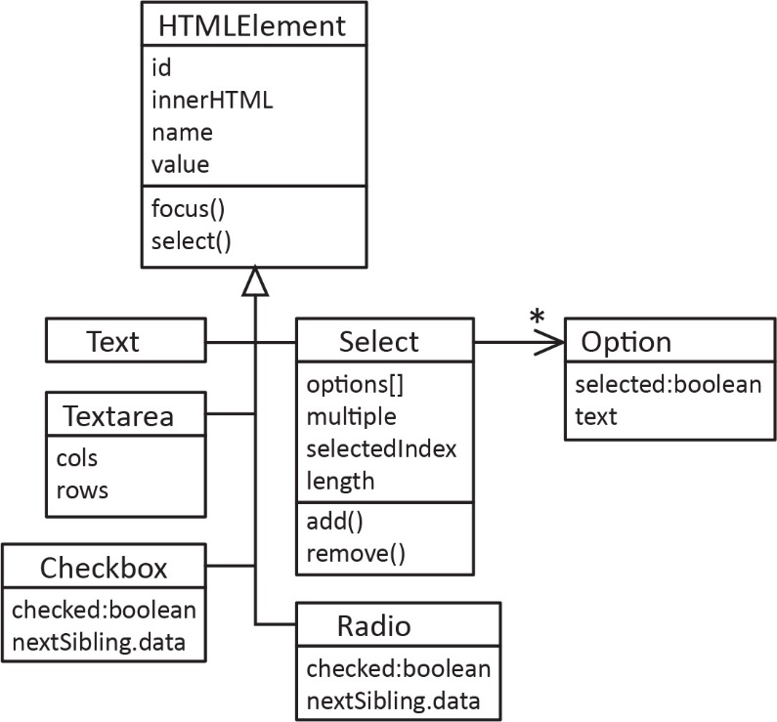
Note:
- We see that all the classes share a number of common properties and methods (every object has an id, name, and value, innerHTML, etc.).
- Each of these classes corresponds to an HTML tag. For instance, input type=text is represented by the TextBox class; however, I have used simplified names, not the actual class names.
- A fuller class diagram, with the actual interface names is shown below.

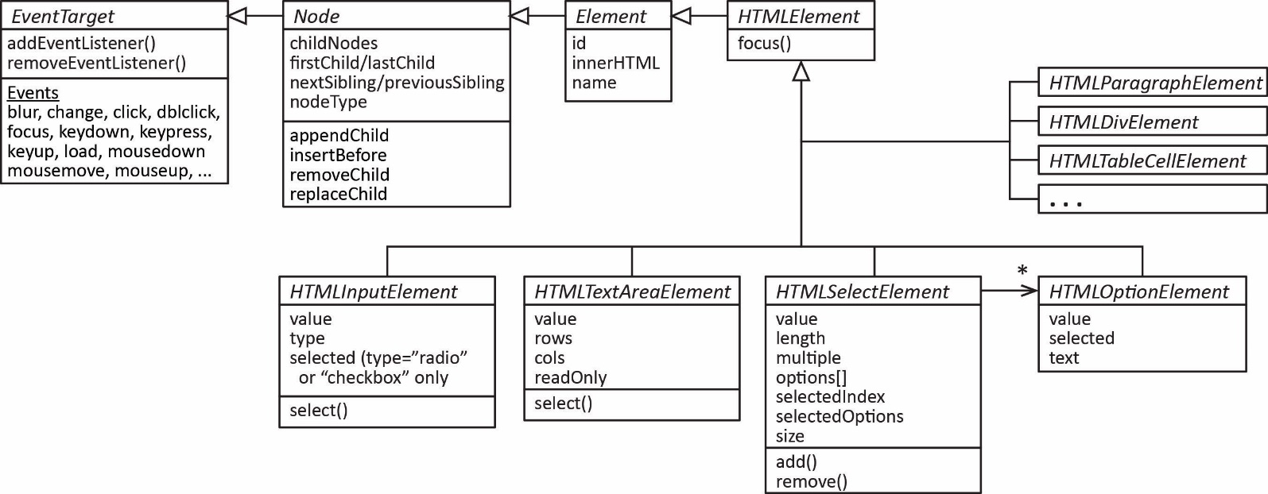
An excellent reference for the DOM:
https://developer.mozilla.org/en-US/docs/Web/API/Document_Object_Model
An excellent high-level discussion of the DOM:
https://web.stanford.edu/class/cs98si/slides/the-document-object-model.html

Accessing Elements via the DOM

TextBox
The first question to address is where do we get the references for the objects in the DOM? The most common way is to use the getElementById method in the Document class. Every element should have a unique Id.
Example: An HTML text box is defined:
<input type="text" id="txtName">
Then, in JS, we could obtain a reference to the textbox:
var tbox = document.getElementById("txtName");
Then, we could access the value typed in:
var name = tbox.value;
Or, we could set text into the textbox:
tbox.value = "what is your name?";
Or we could set the focus and select the text in a text box:
tbox.focus();
tbox.select();
Note: your source code does not change, just the DOM. In other words, after you execute the JS, and view the page source, it does not show an element where you have set the innerHTML. Can right-click element, and choose: Inspect to see.

Check Boxes
Often, it is more convenient to process check boxes as a group. For instance, we may have check boxes where a user can select any number of deserts they want:
<input type="checkbox" name="chkDesert" value="1.25"/>Ice Cream ($1.25)<br>
<input type="checkbox" name="chkDesert" value="2.50"/>Apple Pie ($2.50)<br>
<input type="checkbox" name="chkDesert" value="0.75"/>Cookies ($0.75)<br>
Notice that the check boxes all have the same name attribute. This is convenient because we can now access them as an array of check boxes using the getElementsByName(name) method.
var chkDes = document.getElementsByName("chkDesert");
And, a general-purpose loop to process all the check boxes:
for (i=0; i<chkDes.length; i++) {
if ( chkDes[i].checked ) {
// Do something useful with chkDes[i].value
}
}

Radio Buttons
Radio buttons are similar:
<input type="radio" value="1.00" name="optDrink" id="d1"/>Soda ($1.00)<br>
<input type="radio" value="2.00" name="optDrink" id="d2"/>Beer ($2.00)<br>
<input type="radio" value="0.75" name="optDrink" id="d3"/>Coffee ($0.75)
Notice again that the radio buttons all have the same name attribute. Now, we access them as an array of radio buttons in JS:
var optD = document.getElementsByName("optDrink");
And, a general-purpose loop to process all the radio buttons:
for (i=0; i<optD.length; i++) {
if ( optD[i].checked ) {
// Do something useful with optD[i].value
break;
}
}

Drop-Down (Single Selection)
A drop-down (single selection) for a user to select an interest rate might be defined like this:
<select size="1" id="ddIntRate">
<option value="0.040">4.00%</option>
<option value="0.045">4.50%</option>
<option value="0.050">5.00%</option>
</select>
To access the drop down:
var dd = document.getElementById("ddIntRate");
We can access the value of the selected item directly by using the value property:
alert(dd.value);
We can also obtain the index of the item that is selected by using the selectedIndex property (zero-based):
alert(dd.selectedIndex);
We remember that the Select class also has an options collection. Thus, an alternate way to obtain the value of the selected item is:
alert(dd.options[dd.selectedIndex].value);
Similarly, we can drill down into the options collection to see the individual items:
alert(dd.options[dd.selectedIndex].selected);
alert(dd.options[dd.selectedIndex].text);
alert(dd.options[dd.selectedIndex].value);
Due to a feature in JS, we can write the code above, shorter, as shown below. The two sets are equivalent. Essentially, treating the object reference as an array itself automatically drills down into the options collection. In .NET languages this is called an indexer. I’m not sure what it is called in JS.
alert(dd[dd.selectedIndex].selected);
alert(dd[dd.selectedIndex].text);
alert(dd[dd.selectedIndex].value);

Drop-Down (Multiple Selection)
A drop-down (multiple selection) for a user to select multiple food items might be defined like this:
<select size="4" id="ddFood" multiple>
<option value="3.25">Hamburger ($3.25)</option>
<option value="2.75">Tofo Burger ($2.75)</option>
<option value="1.00">Soda ($1.00)</option>
<option value="2.00">Beer ($2.00)</option>
<option value="4.00">Wings ($4.00)</option>
<option value="0.50">Cookie ($0.50)</option>
</select>
And, to access the drop down:
var dd = document.getElementById("ddFood");
And, a general-purpose loop to process all the selections:
for( i=0; i<dd.length; i++ ) {
if ( dd.options[i].selected ) {
// Do something useful with dd.options[i].value
}
}
There is a selectedoptions property that contains just the selected options. Thus,
for(i=0; i<dd.selectedoptions.length; i++ ) {
selOption = dd.selectedoptions[i]
// Do something useful with selOption.value, etc
}

Events
Form elements can fire events. For instance, when a user clicks on a button, an event is fired. An event is handled by an event handler, which is usually a call to a JS function.
Example, a button might be defined like this:
<input type="button" value="Enter" id="btnCalc" onclick="helloWorld()">
The onClick attributes specifies the event handler. In this case, it is a call to the helloWorld JS function which resides in the head section of the HTML:
function helloWorld() {
window.alert("Hello World");
}
The available events are shown below (copied from W3Schools). The most common ones have been highlighted.
Attribute | The event occurs when...
onblur | An element loses focus
onchange | The content of a field changes
onclick | Mouse clicks an object
ondblclick | Mouse double-clicks an object
onerror | An error occurs when loading a document or an image
onfocus | An element gets focus
onkeydown | A keyboard key is pressed
onkeypress | A keyboard key is pressed or held down
onkeyup | A keyboard key is released
onload | A page or image is finished loading
onmousedown | A mouse button is pressed
onmousemove | The mouse is moved
onmouseout | The mouse is moved off an element
onmouseover | The mouse is moved over an element
onmouseup | A mouse button is released
onresize | A window or frame is resized
onselect | Text is selected
onunload | The user exits the page

Expectations
These are expectations I have of you for testing:
- Given a description of client-side dynamic behavior write the HTML and JavaScript to implement it. An abbreviated version of the HTML DOM is provided.
- Apply the onclick event and write a corresponding event handler.
- Write code to obtain input from form elements (text box, text area, drop-down, check boxes, radio buttons)
- Display output to a form element, div, paragraph, text area etc.

Appendix
- N/A
.

