Ch 14 – Functional Interfaces & Lambda Expressions

Contents
1 Running Example 2
2 Interfaces 2
3 Functional Interfaces 3
4 Lambda Expressions 3
4.1 Example 1 3
4.2 Best Practices: 4
4.3 So what is a lambda expression? 4
5 Interface Default & Static Methods 4
6 Comparator<T> Interface 5
6.1 The .comparingInt Static Method 5
6.2 Method References 6
6.3 The .reversed Method 6
6.4 The .thenComparing Method 6
7 Iterable<T> Interface 7
7.1 The .forEach 7
7.2 The .andThen Method 8
8 List<T> Interface – 8
8.1 The .sort Method 8
8.2 The .replaceAll Method 9
9 Collection<T> Interface – The .removeIf Method 9
10 Map<T> Interface – The .forEach Method 10
11 The Stream API 10
11.1 Stream<T> Interface – The filter & forEach Methods 11
11.2 Stream<T> Interface – The collect Method 11
11.3 Stream Lifetime 12
11.4 Stream<T> Interface – The sorted Method 12
11.5 Stream<T> Interface – The map Methods & IntStream Interface 13
12 Collectors Class – The toMap Method 14
13 Collection Interface – The parallelStream Method 15
14 Next Steps 16
Appendix 1 Sources 17

Note, these resources do a better job than my note below at explaining and developing the topics:
https://www.baeldung.com/java-8-functional-interfaces
https://www.baeldung.com/java-method-references

Running Example
The running example in these notes uses an Employee class.
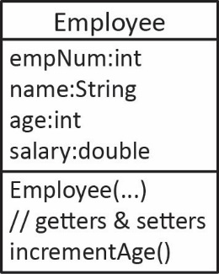 | Most examples will assume we have a list of employees:  List<Employee> emps = new ArrayList<>(Arrays.asList(  new Employee(4832, "Fran", 41, 48.23),  new Employee(7232, "Devi", 68, 55.26),  ...  ));  A few examples will use a map of employees, where empNum is the key:  Map<Integer,Employee> empsMap = new HashMap<>();  for(Employee e : emps) {  empsMap.put(e.getEmpNum(), e);  }

Interfaces
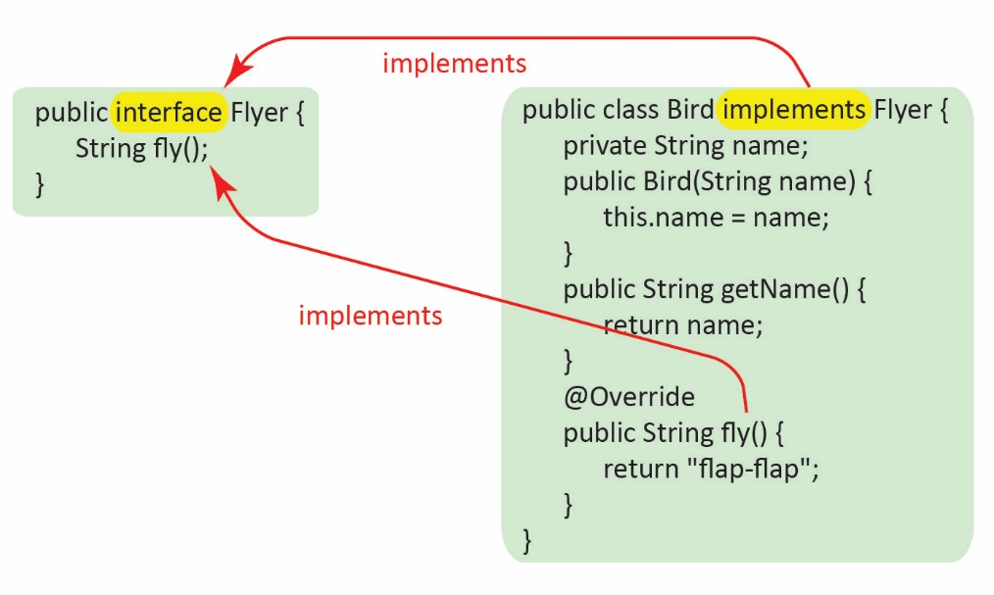
An interface in Java is similar to an abstract class except: (a) all methods are abstract and (b) it cannot define any instance variables (it can define constants). A concrete class can implement an interface which means that all the methods defined in the interface must be implemented (have code). Methods in an interface are by default, public and abstract, so we do not have to add those modifiers. An example is shown on the right.

Functional Interfaces
A functional interface is an interface that specifies exactly one abstract method. For example, Comparator in the java.util package is a functional interface:
@FunctionalInterface
public interface Comparator<T> {
int compare(T o1, T o2);
}
Suppose we want to sort a list (emps) of Employee objects on age. One technique is to define a Comparator (or implement Comparable):
public class AgeComparator implements Comparator<Employee> {
@Override
public int compare(Employee e1, Employee e2) {
return e1.getAge()-e2.getAge();
}
}
Then, create an instance of the comparator and pass it to Collections.sort:
Comparator<Employee> comp = new AgeComparator();
Collections.sort(emps,comp);

Lambda Expressions
A lambda expression can be used to implement a functional interface. The syntax for a lambda expression is:
(Type1 parm1, Type2 parm2, ...) -> {lambda body}
The left side specifies the parameters. The “->” is the arrow operator. The right side is referred to as the lambda body which is simply lines of code that operate on and/or use the parameters.
Since a functional interface only has one abstract method, then then essence of an implementation is simply the specification of the parameters and the code to execute.

Example 1
The highlighted line below is a lambda expression that implements the Comparator<Employee> interface;
Comparator<Employee> comp = (Employee e1, Employee e2) -> { return e1.getAge()-e2.getAge(); };
Collections.sort(emps,comp);
Or, if we don’t need to reuse the comparator, then we can use the lambda expression itself as the argument:
Collections.sort(emps, (Employee e1, Employee e2) -> { return e1.getAge()-e2.getAge(); });

Best Practices:
- Do not specify the type for parameters. The compiler uses type inference to determine the type. For example, the generic type argument for the comparator below is Employee so the compiler infers that the parameters for the compare method are this same type:
Collections.sort(emps, (e1,e2) -> e1.getAge()-e2.getAge() );
The inference engine can be weak at times. Sometimes the compiler will balk at a lambda expression and force you to state the type of a parameter. We will see an example of this later. Sometimes the compiler will want to cast some
Verbose Style
(int n) -> {return n*n;}
Preferred Style
n -> n*n
value in a lambda expression. When I’ve encountered that, I try to rewrite it, or perhaps state the type of parameters to avoid what seems to me to be an unnecessary cast.
- If there is only one parameter, do not use the surrounding parentheses.

- If there is only one line of code, do not use the surrounding braces and remove the return statement and semicolon.

- Strive for a single line of code in the lambda body.

So, what is a lambda expression?
- A method that doesn’t belong to any class
- Can be passed around as if it was an object and executed on demand

Interface Default & Static Methods
Java 8 introduced support for two types of fully implemented methods in interfaces:
- static methods which are not inherited and cannot be overridden
- default methods which are inherited and can be overridden.
As stated above, a functional interface has exactly one abstract method, but it can have any number of default and static methods. As we will see later, calling interface default and static methods is useful when building lambda expressions.
Example:
Functional interface with a static and default method | Usage
public interface Procedure {  double takeTemperature();  default void log(double temp) {  System.out.println(  "Your temp is:"+temp);  }  static double convertToCelsius(double temp) {  return (temp-32)*5.0/9.0;  }  } | Procedure pro = () -> Math.random()*100.0;  double temp = pro.takeTemperature();  pro.log(temp);  double tempC = Procedure.convertToCelsius(temp);

Comparator<T> Interface
Java 8 introduces a number of static and default methods in the Comparator<T> interface, a few of which are shown in the figure below. The parameters for each of these methods is one or more functional interfaces. Thus, the arguments can be lambda expressions.
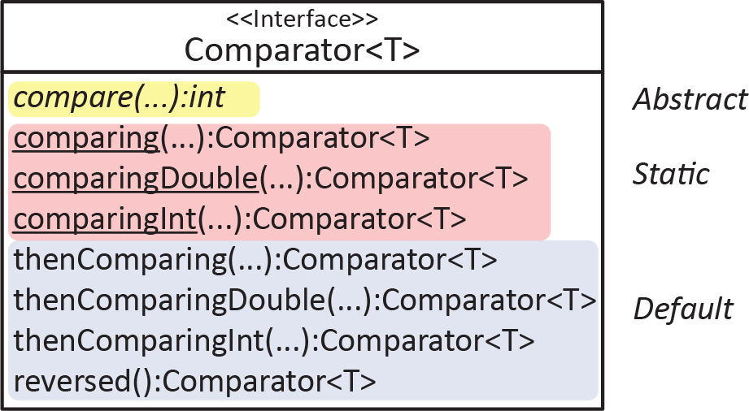

The .comparingInt Static Method
The signature for the comparingInt method is shown below. It accepts an instance of the functional interface, ToIntFunction and returns a Comparator.
static <T> Comparator<T> comparingInt​(ToIntFunction<? super T> keyExtractor)
The purpose of this method is to create a comparator that compares objects based on an integer value. For example, to sort on age using a lambda expression:
Collections.sort(emps, Comparator.comparingInt(e -> e.getAge()));
According to the documentation for comparingInt:
Accepts a function that extracts an int sort key from a type T, and returns a Comparator<T> that compares by that sort key.
Thus, in the example above, the keyExtractor is this function: e -> e.getAge(), expressed as a lambda expression. Then, the comparingInt method makes a comparator from this function, which is then used to sort the elements.
The ToIntFunction interface is one of a number of functional interfaces that were introduced in Java 8. It has one abstract method, applyAsInt which accepts a T argument and returns an integer.
public interface ToIntFunction<T> {
int applyAsInt​(T value);
}
Thus, the lambda exression, e -> e.getAge(), implements this interface.
To more fulling appreciate how this works, consider an implementation of ToIntFunction without using a lambda expression:
public class AgeFunction implements ToIntFunction<Employee> {
@Override
public int applyAsInt(Employee e) {
return e.getAge();
}
}
Then, we can instantiate the class and pass it to comparingInt:
AgeFunction ageFxn = new AgeFunction();
Collections.sort(emps,Comparator.comparingInt(ageFxn));
However, there is really no need to ever do this. As long as we can “extract” what we want to compare on in a single line of code, we would use a lambda expression. And, if the comparator needed to use some more complex logic, we would define a comparator just as we would in the pre-Java8 world.

Method References
If a lambda expression only calls a single method, then a shorter, more readable way of writing it is to use a method reference as shown in the examples below:
Lambda Expression | Method Reference
e -> e.getAge() | Employee::getAge
e -> System.out.println(e) | System.out::println
For example, to sort Employees on age, we can rewrite the earlier code as shown in the first example below. Of course, all three approaches are identical:
Collections.sort(emps, Comparator.comparingInt(Employee::getAge));
Collections.sort(emps, Comparator.comparingInt(e -> e.getAge()));
Collections.sort(emps, (e1,e2) -> e1.getAge()-e2.getAge() );

The .reversed Method
The Comparator<T> interface has a default reversed method:
default Comparator<T> reversed()
which returns a Comparator with the reverse order of this comparator. For example:
Collections.sort(emps,Comparator.comparingInt(Employee::getAge).reversed());
In the equivalent example below, we use a lambda expression instead of a method reference. It is unclear why the compiler forces e to be explicitly typed.
Collections.sort(emps, Comparator.comparingInt((Employee e) -> e.getAge()).reversed());

The .thenComparing Method
The Comparator<T> interface has a default thenComparing method:
default <U extends Comparable<? super U>> Comparator<T> thenComparing​(
Function<? super T,? extends U> keyExtractor)
The method accepts a keyExtractor which simply specifies where to obtain the value to “next” sort on. In other words, if you want to sort on age, then name:
Collections.sort(emps,
Comparator.comparingInt(Employee::getAge).thenComparing(Employee::getName));
Note:
- The result of Comparator.comparingInt is piped to thenComparing. The result could then be piped to another thenComparing.
- There are also other methods: thenComparingInt and thenComparingDouble (and others). In this case we use, thenComparing because the value the key extractor returns is an object.
- The generic specification for this method is more complex because the parameter, Function must specify the input, T, which in this case is Employee; and U, which is the type of the return, in this case, String.

Iterable<T> Interface
LEFT OFF HERE!!!
Java 8 introduces a default method in the Iterable<T> interface.
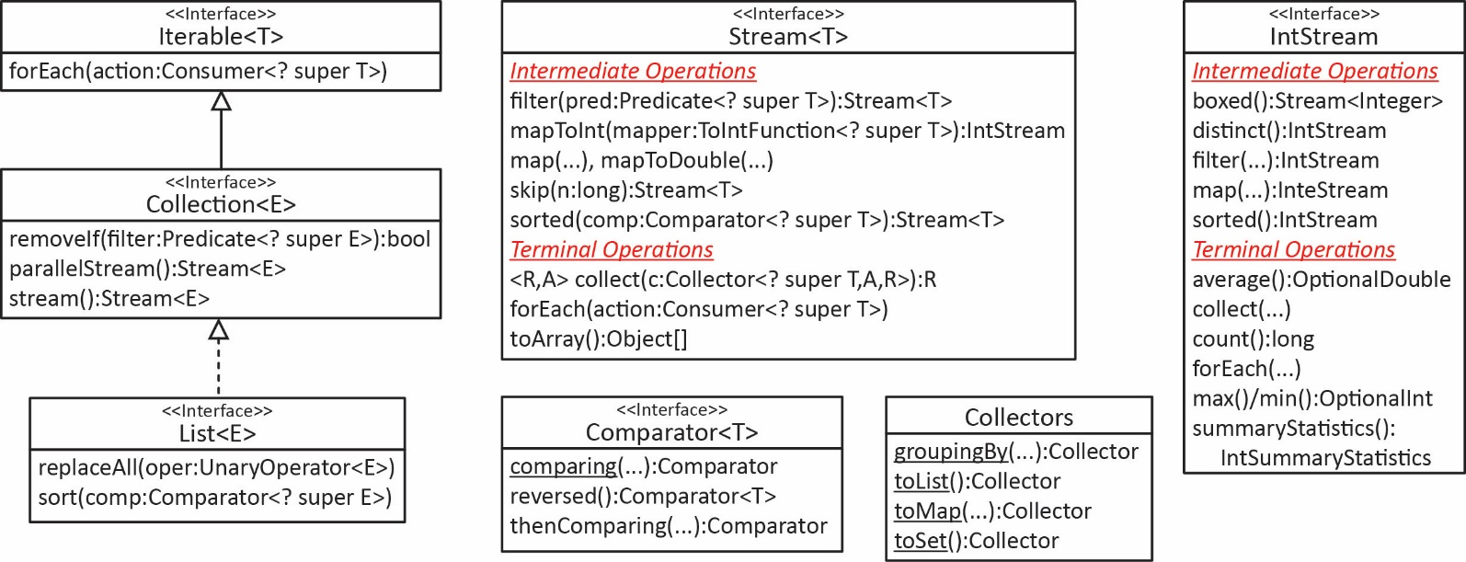

The .forEach
Java 8 introduced the default method, forEach in the Iterable interface:
default void forEach​(Consumer<? super T> action) {
Since Collection extends Iterable, every concrete collection class inherits this method. The method simply performs action on each element in the collection. Since Consumer is a functional interface, action can be specified as a lambda expression (or method reference). For example, to add 1 to each employee’s age:
emps.forEach(Employee::incrementAge);
emps.forEach(e -> e.setAge(e.getAge()+1)); // Same as previous
And then a simple way to print the elements using a method reference:
emps.forEach(System.out::println);
The Consumer interface is another one of the functional interfaces that were introduced in Java 8. It specifies the abstract accept method that accepts a T, operates on it, and returns nothing
@FunctionalInterface
public interface Consumer<T> {
void accept​(T t);
}
Thus, we could create an explicit reference to method:
Consumer<Employee> cons = e -> e.incrementAge(); // or...
Consumer<Employee> cons2 = Employee::incrementAge;
emps.forEach(cons);

The .andThen Method
The Consumer interface defines a default method, andThen which accepts a Consumer and returns a Consumer:
default Consumer<T> andThen​(Consumer<? super T> after)
For example, to increment the age of each employee, and then increase their salary by 10%:
emps.forEach(((Consumer<Employee>)(Employee::incrementAge)).andThen(
e -> e.setSalary(e.getSalary()*1.1)));
Again, it is unclear why the cast is necessary. It seems that two successive invocations of forEach would result in cleaner code:
emps.forEach(Employee::incrementAge);
emps.forEach(e -> e.setSalary(e.getSalary()*1.1));
Finally, if we explicitly define the two Consumers then we can combine them with andThen without any casting:
Consumer<Employee> consumer1 = Employee::incrementAge;
Consumer<Employee> consumer2 = e -> e.setSalary(e.getSalary()*1.1);
emps.forEach(consumer1.andThen(consumer2));

List<T> Interface –

The .sort Method
The List interface has added a default sort method that accepts a Comparator.
default void sort​(Comparator<? super E> c)
So, instead of using Collections.sort we can sort a list with a native implementation. For example:
emps.sort(Comparator.comparingInt(Employee::getAge));

emps.sort(Comparator.comparingInt(Employee::getAge)
.thenComparingDouble(Employee::getSalary));

The .replaceAll Method
The List interface has added a default replaceAll method that accepts a UnaryOperator.
default void replaceAll​(UnaryOperator<E> operator)
It replaces each element of this list with the result of applying the operator to that element. We don’t have a good example with a custom class (e.g. Employee) so we will show an example with strings where we will make all strings in a list lower case:
ArrayList<String> letters = new ArrayList<>(Arrays.asList("f", "B", "a", "D", "H"));
letters.replaceAll(String::toLowerCase);

Or: letters.replaceAll(s -> s.toLowerCase());
In this example, we truncate all integers in a list that are greater than 10 to be 10:
ArrayList<Integer> nums = new ArrayList<>(Arrays.asList(3,15,22,6));
nums.replaceAll(n -> n>10 ? 10 : n);

Collection<T> Interface – The .removeIf Method
The Collection interface has added a default removeIf that accepts a Predicate:
default boolean removeIf​(Predicate<? super E> filter)
This method removes the items from the collection where filter returns true. In this example, we remove employees who are older than 45:
emps.removeIf(e -> e.getAge()>45);
The Predicate interface is another functional interface that was introduced in Java 8. It specifies one abstract method, test that accepts a T and returns a boolean.
public interface Predicate<T> {
boolean test​(T t);
}
The Predicate interface has several default methods, two of which are:
default Predicate<T> and​(Predicate<? super T> other);
default Predicate<T> or​(Predicate<? super T> other);
However, my experience has been that they require the unwieldly casting when used anonymously:
emps.removeIf( ((Predicate<Employee>)(e->e.getAge()>45)).and(e->e.getAge()<60) );
Which could be written more simply:
emps.removeIf(e -> e.getAge()>45 && e.getAge()<60);

Map<T> Interface – The .forEach Method
For the examples where we use a Map, we define a map of employees, emps where the key is the id and the value is an Employee object.
Map<Integer,Employee> emps = ...
The Map interface has added a default forEach method:
default void forEach​(BiConsumer<? super K,? super V> action)
Which works similarly to Iterable’s forEach where in this case action is performed on all the map entries. For example, to increase the age of each employee:
emps.forEach((k,v) -> v.incrementAge());
emps.forEach((k,v) -> System.out.println(k + ", " + v));
The BiConsumer is the same as Consumer, except that it accepts two inputs.
@FunctionalInterface
public interface BiConsumer<T,U> {
void accept​(T t, U u);
}
The Map interface has also added these default methods: compute, computeIfAbsent, computeIfPresent, merge, putIfAbsent, replaceAll.
There is not a removeIf in the Map or related sub-interfaces. However, you can obtain the EntrySet and use removeIf on it:
emps.entrySet().removeIf(entry -> entry.getValue().getAge()>40);

The Stream API
New in Java 8, the Collection interface has introduced the default stream and parallelStream methods which both return a Stream object:
default Stream<E> stream​()
default Stream<E> parallelStream​()
A Stream is a sequence of elements that can be operated on either sequentially or in parallel. To perform a set of operations, they are composed in a stream pipeline. Operations on the stream do not affect the underlying collection.
The Stream interface defines a number of methods which can be categorized into two types:
- Intermediate operations process a stream of elements in some way and produce a (usually modified) Stream (or other related types like IntStream) that leaves the source (e.g. ArrayList) unmodified. Thus, intermediate operations can be piped together. Some of the intermediate Stream methods:

concat, distinct, dropWhile, empty, filter, flatMap, generate, iterate, limit, map, mapToDouble, mapToInt, mapToLong, peek, skip, sorted, takeWhile.

- Terminal operations produce a result (e.g. a double, or create a list from stream) or produce a side effect. Some of the most useful terminal Stream methods: collect, forEach, and reduce. A few others are: allMatch, anyMatch, noneMatch, count, findAny, findFirst, max, min, noneMatch, toArray

The typical pipeline is:
collection.stream().intermediate1(…).intermediate2(…)….terminal()
The stream is no longer available after a terminal operation is executed.
Intermediate operations are lazy – they are only invoked if it is necessary for the terminal operation to succeed. Thus, elements are not pushed from the stream, rather, they are pulled from the terminal operation.

Stream<T> Interface – The filter & forEach Methods
Consider the example below where a Stream is created from a list of Employees, then those whose age is 40 or more are removed, finally the remaining stream elements are printed.
emps.stream()
.filter(e -> e.getAge()<40)
.forEach(System.out::println);
- The filter method is an intermediate operation. It accepts a Predicate and returns a Stream.
Stream<T> filter​(Predicate<? super T> predicate)
As we saw earlier, Predicate has a test method that accepts a T and returns a boolean. The returned Stream contains the elements where test returns true.
- The forEach method is a terminal operation. This method works identically to the forEach defined in the Iterable interface discussed earlier, except that it operates on a stream as opposed to the underlying collection.
void forEach​(Consumer<? super T> action)
And, as we saw earlier, the Consumer interface has an accept method that accepts a T and returns nothing.

Stream<T> Interface – The collect Method
Consider the example below where again we filter a stream of Employees; however, now we collect the filtered elements into a new list:
List<Employee> emps2 = emps.stream()
.filter(e -> e.getAge()<40)
.collect(Collectors.toList());
- The collect method is a terminal operation. It uses the collector to put the elements into a container such as a list in this example.
<R,A> R collect​(Collector<? super T,A,R> collector)
- The Collectors.toList method returns a Collector that puts the stream elements into a new list.
public static <T> Collector<T,?,List<T>> toList​()
- Of course, we could assign the returned list back to the source of the stream:
emps = emps.stream().filter(e -> e.getAge()<40).collect(Collectors.toList());

Stream Lifetime
A stream is no longer available after a terminal operation is performed as the example below illustrates:
Stream<Employee> stream = emps.stream().filter(e -> e.getAge()<40);
// Stream still alive
stream.forEach(System.out::println);
// Stream dead, throws IllegalStateException
System.out.println(stream.count());
The code above throws this exception:
Exception in thread "main" java.lang.IllegalStateException: stream has already been operated upon or closed

Stream<T> Interface – The sorted Method
The Stream interface defines a default sorted method that accepts a Comparator returns an ordered stream:
List<Employee> emps2 = emps.stream()
.filter(e -> e.getAge()<40)
.sorted(Comparator.comparingDouble(Employee::getSalary))
.collect(Collectors.toList());
- The sorted accepts a Comparater just as List.sort and Collection.sort do, however, this method returns a an ordered Steam as opposed to ordering the underlying collection.
Stream<T> sorted​(Comparator<? super T> comparator)
- As we saw earlier, the Comparator interface has a default thenComparing method to define another level of ordering:
List<Employee> emps3 = emps.stream()
.sorted(Comparator.comparingDouble(Employee::getSalary)
.thenComparing(Comparator.comparing(Employee::getName)))
.collect(Collectors.toList());

Stream<T> Interface – The map Methods & IntStream Interface
Consider this example that computes the sum of the ages of the employees in a stream:
int sum = emps.stream()
.mapToInt(Employee::getAge)
.sum();
The mapToInt method accepts a mapper that extracts an int from each element in the stream forming a new stream of integers of type IntStream:
IntStream mapToInt​(ToIntFunction<? super T> mapper)
The IntStream method has a sum method that returns the sum of the integers in the stream. Since IntStream is a type of stream we can use many of the methods available to Stream (collect, filter, forEach, sorted, etc.). It also adds several useful terminal operations: average, max, min, sum.
Finding the average of an IntStream is slightly more involved:
double avg = emps.stream()
.mapToInt(Employee::getAge)
.average()
.getAsDouble();
The average method returns an OptionalDouble:
OptionalDouble average​()
The OptionalDouble class is used as a container that may or may not contain a double. It contains an isPresent method that returns true if it does contain a double in which case getAsDouble returns the value.
IntStream has the following method:
IntSummaryStatistics summaryStatistics​()
The IntSummaryStatistics class defines methods to get the summary statistics: getAverage, getCount, getMax, getMin, getCount. For example:
IntSummaryStatistics stats = emps.stream()
.mapToInt(Employee::getAge)
.summaryStatistics();
System.out.println("Avg of ages=" + stats.getAverage());
System.out.println("Min of ages=" + stats.getMin());
System.out.println("Max of ages=" + stats.getMax());
System.out.println("Count =" + stats.getCount());

The Stream interface also defines mapToDouble, mapToLong, map methods for mapping double, long, and objects, respectively. For example:
// List of names
List<String> names = emps.stream().map(e -> e.getName()).collect(Collectors.toList());
// List of ages
List<Integer> ages = emps.stream().mapToInt(e -> e.getAge())
.boxed().collect(Collectors.toList());
// Array of ages
int[] ages2 = emps.stream().mapToInt(e -> e.getAge()).toArray();
List<Double> salaries = emps.stream().mapToDouble(e -> e.getSalary())
.boxed().collect(Collectors.toList());

Collectors Class – The toMap Method
Consider this example that filters a stream of employees and then creates a map as the return. The map uses the empNum as the key and the employee object as the value:
Map<Integer,Employee> empsMap = emps.stream()
.filter(e -> e.getAge()<50)
.filter(e -> e.getSalary()>10.0)
.collect(Collectors.toMap(e -> e.getEmpNum(), e -> e));
This example create a new Blob object from each Employee that contains only empNum and salary fields:
Map<Integer,Blob> blobsMap = emps.stream()
.collect(Collectors.toMap(e -> e.getEmpNum(),
e -> new Blob(e.getEmpNum(),e.getSalary())));

Collection Interface – The parallelStream Method
This example compares four approaches to sorting a list. The last approach uses the parallelStream method defined in the Collection interface.
Collections.sort(emps3, Comparator.comparingDouble(Employee::getSalary));
emps.sort(Comparator.comparingDouble(Employee::getSalary));
emps1 = emps1.stream()
.sorted(Comparator.comparingDouble(Employee::getSalary))
.collect(Collectors.toList());
emps2 = emps2.parallelStream()
.sorted(Comparator.comparingDouble(Employee::getSalary))
.collect(Collectors.toList());
We generated a list of 1,000,000 randomly generated Employee objects and sorted the list on salary using the first approach above. This was replicated 10 times. This was repeated for the other sorting approaches. The results were timed on my desktop computer (4 cores @ 3.3GHz, 16 GB Ram) and shown below:

We did a similar experiment using four approaches to increasing the salary of all employees by 10%:
emps.stream().forEach(e -> e.setSalary(e.getSalary()*1.1));
emps.parallelStream().forEach(e -> e.setSalary(e.getSalary()*1.1));
emps.forEach(e -> e.setSalary(e.getSalary()*1.1));
for(Employee e : emps) e.setSalary(e.getSalary()*1.1);
The results were timed and shown below. Note that the manual approach (the last one above) averaged 5.1 seconds and is not shown in the graph.

Next Steps
Where do we go from here?
- Use this functional programming approach when applicable
- Write methods that accept functional interfaces. This, I think is a real key. Generic classes and methods are a clear programming abstraction. Functional interfaces and lambda expressions are a step further.
- Utilize a map of lambda expressions and programmatically apply. For example:
public enum age {
isOld, isPoor, isOldAndPoor, isOldOrPoor;
}
Predicate<Employee> isOld = e -> e.getAge()>45;
Predicate<Employee> isPoor = e -> e.getSalary()<50.0;
Predicate<Employee> isOldAndPoor = isOld.and(isPoor);
Predicate<Employee> isOldOrPoor = isOld.or(isPoor);

Map<age,Predicate<Employee>> agePreds = new HashMap<>();
agePreds.put(age.isOld, isOld);
agePreds.put(age.isPoor, isPoor);
agePreds.put(age.isOldAndPoor, isOldAndPoor);
agePreds.put(age.isOldOrPoor, isOldOrPoor);

Appendix
- Sources
https://www.baeldung.com/java-8-new-features
https://www.journaldev.com/2389/java-8-features-with-examples
https://www.codejava.net/java-core/collections/java-stream-aggregate-functions-examples-intermediate-operations
https://www.codejava.net/java-core/collections/java-8-stream-terminal-operations-examples

Actually, from Java 8 onward, interfaces can now have default methods and static methods. https://www.geeksforgeeks.org/default-methods-java/
We learn later that an abstract class can implement an interface, but does not have to implement all the methods.
Also introduced in Java 8 were the ability to write default and static methods in an interface.
Java 9 introduces private static and instance methods.
https://docs.oracle.com/javase/9/docs/api/java/util/function/package-summary.html
https://docs.oracle.com/javase/9/docs/api/java/util/function/package-summary.html

