Ch 13 – Binary Files
Contents
1 Introduction 1
2 Text I/O in Java 3
3 Text I/O vs. Binary I/O 3
4 Binary I/O Classes 3
5 Binary I/O in Java 4
6 Random Access Files 8
Appendix 1 n/a 9

Introduction
ASCII | Dec | Hex | Binary
0 | 48 | 30 | 0011 0000
1 | 49 | 31 | 0011 0001
2 | 50 | 32 | 0011 0010
3 | 51 | 33 | 0011 0011
4 | 52 | 34 | 0011 0100
5 | 53 | 35 | 0011 0101
6 | 54 | 36 | 0011 0110
7 | 55 | 37 | 0011 0111
8 | 56 | 38 | 0011 1000
9 | 57 | 39 | 0011 1001
…
A | 65 | 41 | 0100 0001
B | 66 | 42 | 0100 0010
C | 67 | 43 | 0100 0011
D | 68 | 44 | 0100 0100
E | 69 | 45 | 0100 0101
…
W | 87 | 57 | 0101 0111
X | 88 | 58 | 0101 1000
Y | 89 | 59 | 0101 1001
Z | 90 | 5A | 0101 1010
…
a | 97 | 61 | 0110 0001
b | 98 | 62 | 0110 0010
c | 99 | 63 | 0110 0011
d | 100 | 64 | 0110 0100
e | 101 | 65 | 0110 0101
…
w | 119 | 77 | 0111 0111
x | 120 | 78 | 0111 1000
y | 121 | 79 | 0111 1001
z | 122 | 7A | 0111 1010
- There are two types of files: text and binary. Text files are binary files that use character encoding. Binary files represent numbers in their binary format.
- Definitions:
- Character Encoding – Associates a unique (usually) value (number) with each character (glyph) in a character set. For example, the integer 97 (binary: 0110 0001) is associated with the letter “a” in the English character set. This mapping is a convenient way to store and transmit data.
- Encode –The process of turning a character into its unique value. When we write a character to disc, it is encoded, its value is written to disc.
- Decode – The process of turning a value into a character. When we read a character from disc, we are actually reading the value, and it is decoded into its representation as a character.
- There are two general ways for a program to save data to disk:
- Using a standard encoding scheme. ASCII and UTF-8 are both universally accepted and are identical for the most common characters in the English character set. When we persist data to disc using a standard encoding scheme, we call this file a text file. We say that such a file is human readable because practically any software we use to open the file will detect that it is stored using the UTF-8 encoding, thus properly decoding the data to render the associated characters.
- Using a custom encoding scheme. For example, programming languages can do binary encoding where numbers (in base 10) are represented as their binary equivalent. For example, the integer 6 is “110” in binary. Thus, when a program reads “110”, it can decode that as the integer 6.
- Standard Encoding
- ASCII (American Standard Code for Information Interchange) is a character encoding scheme that maps the English alphabet, some punctuation, and a few other characters into unique numbers which can be expressed in either hexadecimal or binary. The table on the right shows a few of the mappings.
- Originally, ASCII represented 128 characters. Since $2^{7}=128$, 7 bits can be used to represent each unique character. Thus, in a file such as the one above, every 7 bits would be encoded as a particular character. Soon after, ASCII was extended to 8-bit since 8 bits are stored in a byte and the extra bit allows the accommodation of 128 additional characters. ASCII was the standard on the internet until 2007 when UTF-8 was adopted as a world-wide standard.
- UTF-8 (Universal Character Set Transformational Format – 8 bit) represents every character in the Unicode character set. Unicode is a standard for encoding most of the world’s written languages. UTF-8 was designed for backwards compatibility with ASCII. Thus, an ASCII code is the same as a UTF-8 code (code point) for the same character. Java uses UTF-8 encoding.
- A text file is binary data that is UTF-8 encoded so that (usually) every 8 bits represents a character. We say that such a file is human readable because practically any software (WordPad, NotePad, Word, Eclipse, etc) decodes the data and presents as human-readable text. For example, the binary stream:

1001010110000111101101100001100000110100111100111000001100001

Is decoded as:

01001010 | 01100001 | 01110110 | 01100001 | 00100000 | 01101001 | 01110011 | 00100000 | 01100001
J | a | v | a |  | i | s |  | a

- Binary Encoding – A binary file written with a binary writer class (ObjectOutputStream) in Java (or some other language) is not human-readable; it is designed to be read by programs. For example, Java source programs are stored in text files and can be read by a text editor, but Java classes are stored in binary files and are read by the JVM. The advantage of binary files is that they are more efficient to process than text files. In the example below, in (a), the number 199 is encoded with UTF-8 as the characters “1”, “9”, and “9”. In (b) below, the number 199 is converted to its binary representation as a number (11000111 or C7). Thus, one byte was used to store the number and three bytes were used to store the text based encoding.

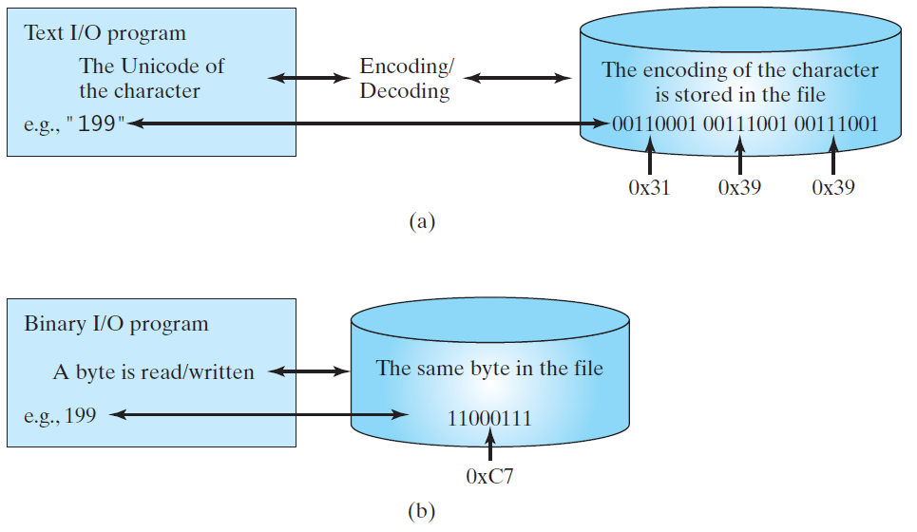

Text I/O in Java
- As a reminder, we can write text files using the PrintWriter class:
File outFile = new File( "src\\textfile_examples\\output.txt" );
PrintWriter writer = new PrintWriter( outFile );
writer.print( ... );
writer.close();
- And, we can read text files using the Scanner class:
File inFile = new File( "src\\textfile_examples\\employees.txt" );
Scanner input = new Scanner( inFile );
while( input.hasNext() ) {
name = input.next();
salary = input.nextDouble();
...
}
input.close();

Text I/O vs. Binary I/O
- Text I/O requires encoding and decoding. Binary files are read as an input stream of bytes and written as an output stream of bytes.

Binary I/O Classes
- The binary I/O classes are shown below. We will only consider ObectInputStream and ObjectOutputStream.
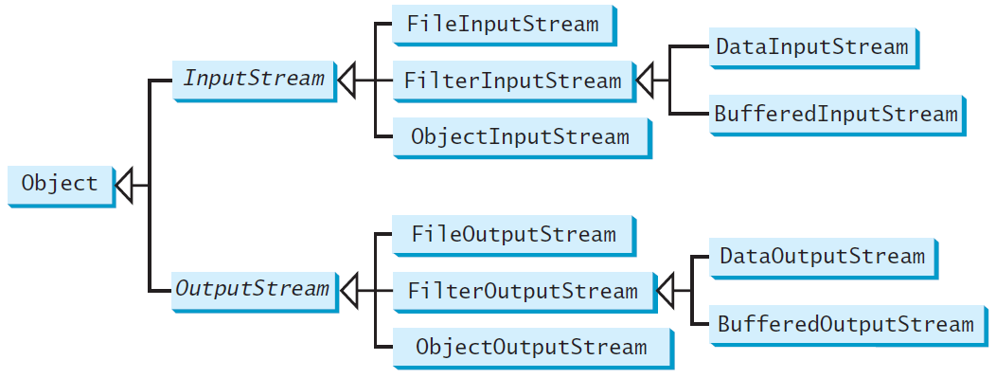
- Input Stream:
- OutputStream

Binary I/O in Java
- Writing Java data types – A simple example of writing a binary file with ObjectOutputStream:
String s = "Hello Binary";
double x = 3.34;
int y = 13;
double[] vals = new double[] {3.4, 4.2, 6.7};
ObjectOutputStream oos = new ObjectOutputStream(
new FileOutputStream(
new File( "src\\examples1\\out1.dat.txt" )));
oos.writeObject(s);
oos.writeDouble(x);
oos.writeInt(y);
oos.writeObject(vals);
oos.flush();
oos.close();
oos = null;

- Reading Java data types – A simple example of reading a binary file with ObjectInputStream:
ObjectInputStream ois = new ObjectInputStream(
new FileInputStream(
new File( "src\\examples1\\out1.dat.txt" )));

// Try to read values. Will throw exception when EOF.
// Input stream does not provide a way to check EOF.
try {
while ( true ) {
s = (String)ois.readObject();
x = ois.readDouble();
y = ois.readInt();
vals = (double[])ois.readObject();
}
}
catch (EOFException eofEx) {
System.out.println(" End of file...");
}
finally {
ois.close();
ois = null;
}

- Writing Custom Objects –In this example we write Book objects to a binary file. An instance of any class can be written to binary if it implements the Serializable interface. The Serializable interface is a marker interface which means there are no methods to implement and that the interface serves as a marker to the compiler that the class might be serialized, e.g. written in binary format. Note, static variables are not serialized.
class Book implements Serializable {
String name;
int pages;
public Book(String name, int pages) {
this.name = name;
this.pages = pages;
}
public String toString() {
return name + ":" + pages;
}
}
Writing Book objects to a binary file:
Book b1 = new Book("Zen and the", 343);
Book b2 = new Book("Moby Dick", 875);
ObjectOutputStream oos = new ObjectOutputStream(new FileOutputStream(...));
oos.writeObject(b1);
oos.writeObject(b2);
- Reading Custom Objects – Deserialization refers to the process of converting binary data into objects. This is an example of reading Book objects from a binary file.
ArrayList<Book> books = new ArrayList<Book>();
ObjectInputStream ois = new ObjectInputStream(new FileInputStream(...));
try {
while ( true ) {
Object obj = ois.readObject();
if (obj instanceof Book) {
b1 = (Book)obj;
books.add( b1 );
}
}
}
catch (EOFException eofEx) {
System.out.println(" End of file...");
}
finally {
ois.close();
ois = null;
}

- Reading and Writing Objects Associated with Other Objects – In this example, a Person has an ArrayList of Books. Note that both classes must implement the Serializable interface.

class Book implements Serializable {  String name;  int pages;  public Book(String name, int pages) {  this.name = name;  this.pages = pages;  }  public String toString() {  return name + ":" + pages;  }  } | class Person implements Serializable {  String name;  ArrayList<Book> books = new ArrayList<>();  public Person(String name) {  this.name = name;  }  public String toString() {  StringBuilder sb = new StringBuilder();  sb.append( name + "'s books:");  for( Book b : books )  sb.append(b + ", ");  return sb.toString();  }  }

Example writing (nothing new):
b1 = new Book("Zen and the", 343);
b2 = new Book("Moby Dick", 875);
b3 = new Book("Kite Runner", 224);
Person p = new Person( "Dave" );
p.books.add(b1); p.books.add(b2); p.books.add(b3);
ObjectOutputStream oos = new ObjectOutputStream(new FileOutputStream(...));
oos.writeObject(p);
Example reading (nothing new):
ObjectInputStream ois = new ObjectInputStream(new FileInputStream(...));
p = (Person)ois.readObject();

- The transient Modifier –The transient modifier is used to indicate variables that are not to be serialized. It tells the JVM to ignore it when serializing.
class Employee implements Serializable {
String name;
transient Assignment assignment;
public Employee(String name) {
this.name = name;
}
public void initJob() {
assignment = new Assignment( "Programmer" );
}
}
class Assignment {
String jobType;
public Assignment(String jobType) {
this.jobType = jobType;
}
}
- Appending a Binary File – Each time you open a new output stream, a header is written in the binary file. If you open the stream again to write, you will write another header. This causes a problem when you to read the file back in. Thus, when we are appending a file, we must override the writeStreamHeader method to do nothing.
FileOutputStream fos=new FileOutputStream(new File(...),true);
// Determine if file is new.
boolean append=f.exists() && f.length()>0;
ObjectOutputStream oos;
if (append) {
// If appending, create an OOS that overrides writeStreamHeader to do nothing.
oos = new ObjectOutputStream(fos) {
protected void writeStreamHeader() throws IOException {}
};
}
else {
// If file is new, use default implementation of OOS which prints header.
oos = new ObjectOutputStream(fos);
}
oos.writeObject(b1);
oos.writeObject(b2);
oos.writeObject(p);

Random Access Files
Allows non-sequential read/write access to a file. Use the RandomAccessFile class.

Appendix
- n/a

