Ch 12 – Generics
Contents
1 Introduction 2
1.1 Non-Generic ArrayList Class 3
1.2 Generic Type Arguments 4
2 Defining Generic Classes & Interfaces 4
2.1 Example – Person Class 5
2.2 Example – Queue Class 6
2.3 Exercises 7
3 Generic Classes – Bounded Types 7
4 Generic Methods 9
5 Generic Methods – Bounded Types 10
5.1 Exericises 12
6 Bounded Wildcard Generic Types 13
6.1 Exericises 14
7 Erasure and Restrictions on Generics 14
Appendix 1 Resources 15

Introduction
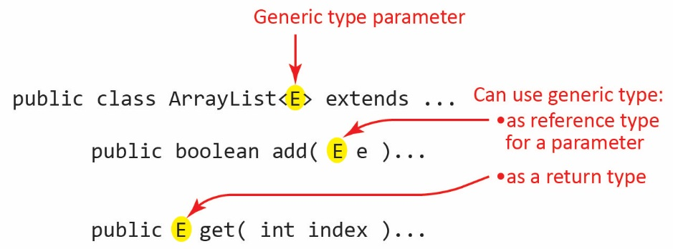
Generics is the ability of a language to allow for parameterized types. This means, loosely, that a class (or interface or method) needs to use another class, but the type of that class is not known until compile time.
ArrayList is a generic class. As shown on the right, the code for the ArrayList class uses a generic type parameter, E. There is nothing special about E, it can be any valid Java identifier (more on this later). When you use the ArrayList class you supply a specific type argument which is substituted for E and specifies what type of objects can be stored in the ArrayList. For example:
ArrayList<Dog> dogs = new ArrayList<>();
dogs.add(new Dog("Spot"));
Dog dog = dogs.get(0);
Generics provides type safety which means that it enables errors to be detected at compile time rather than at runtime. For example, the ArrayList below can only hold Dog (or any subclass of Dog) instances.
ArrayList<Dog> dogs = new ArrayList<>();
Thus, if we try to add any other type of object, the line will generate a compile error:
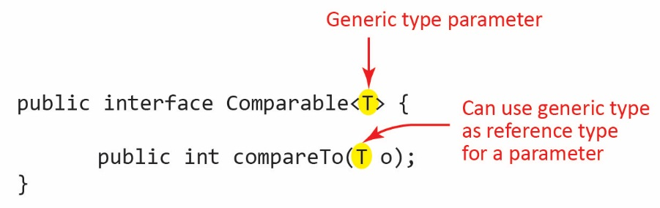
dogs.add(new Computer("fast"));
Comparable is a generic interface and defines the generic type parameter, T. The type argument supplied at compile time specifies the type of the object that can be passed to the compareTo method as shown in the figure on the right. To use the interface, we specify the type of object we want to compare. For example:
class Dog implements Comparable<Dog> {
private String name;
...
public int compareTo(Dog d) {
return this.name.compareTo(d.name);
}
}

Non-Generic ArrayList Class
Generics was introduced in Java 1.5 (2004). Prior to that, the ArrayList class held Object instances. For backwards compatibility, Java allows the non-generic versions of all generic classes (and interfaces) in the API to be used (however, you will get a compile warning).
Figure a below shows the non-generic ArrayList class and Figure b shows the generic ArrayList class. Notice that the add method accepts an argument of type E and that the get method returns an object of type E.
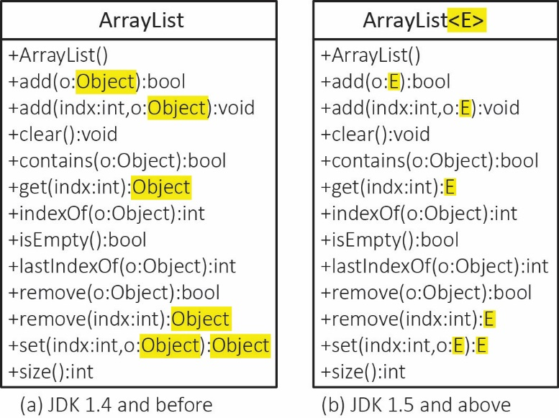
For example, the ArrayList below is defined without generics.
ArrayList dogs = new ArrayList();
dogs.add(new Dog("Spot"));
Since the non-generic ArrayList holds Object instances, a cast is required when retrieving items:
Dog dog = (Dog)dogs.get(0);
With the non-generic ArrayList we can add any object:
dogs.add( new Computer("fast") );
So now the ArrayList holds a Dog at index 0, and a Computer at index 1. If we get the Object at index 1 and (incorrectly) cast it as a Dog:
Dog d = (Dog)dogs.get(1);
The code compiles, but it will generate a runtime error when the line is executed and throws a ClassCastException. Thus, the non-generic ArrayList is not type safe meaning we don’t detect errors at compile time, we encounter them at runtime.

Generic Type Arguments
Type arguments must be reference types; they cannot be primitive types. For example, to create an ArrayList of ints we must use the Integer wrapper class as the generic type:
ArrayList<Integer> vals = new ArrayList<>();
Note that we can still add a primitive, int to vals:
int x = 7;
vals.add(x);
As we saw in an earlier chapter, Java automatically converts the primitive value 7 into an Integer through a process called autoboxing. We can also retrieve a value from vals and store it in a primitive data type through a process called unboxing.
int y = vals.get(0);
A type argument can be any type. For example, ArrayList<Integer> can be used as a type argument. Thus, you could create a list of lists of integers:
ArrayList<ArrayList<Integer>> classScores = new ArrayList<>();

Defining Generic Classes & Interfaces
We can write custom generic classes, interfaces, and methods (we consider generic methods in the next section).
A generic type parameter is defined for a generic class (or interface) by placing:
<symbol>
immediately after the class (or interface) name as shown for ArrayList above. The symbol can be any valid Java identifier, but by convention, the generic type parameter is a single, uppercase letter. The most common are:
- E – Element
- T – Type
- K – Key
- V – Value
The generic type parameter (E above) can be used inside the class as the type for:
- method parameters
- method return type
- instance variables
- local variables

Example – Person Class
Example – A Person has a hobby which can be anything:
public class Person<E> {
private E hobby;
private String name;

public Person(String name) {
this.name = name;
}

public void addHobby(E hobby) {
this.hobby = hobby;
}

public E getHobby() {
return hobby;
}

public String toString() {
return name + "'s hobby is " + hobby.toString();
}
}
Which we can use with code like this:
Person<Basketball> p1 = new Person("Holly");
p1.addHobby(new Basketball());
Basketball basketball = p1.getHobby();

Person<Cooking> p2 = new Person("Lorenzo");
p2.addHobby(new Cooking());
Cooking cooking = p2.getHobby();
Perhaps you can see that inside the generic class as defined above, there is not very much we can do with the instance of the generic type – because we know nothing about it! Inside the class, we can’t call any methods on hobby except those defined in the Object class (toString in example above).Later we see that we can use a bounded generic type parameter which allows us to use methods of the generic instance variable.

Example – Queue Class
A queue is a collection that models objects waiting for a service. For example, people waiting in line to be admitted to a movie, or orders waiting to be picked at Amazon.
A queue is a first-in-first-out (FIFO) data structure. When a new object is placed in a queue it goes at the end (tail) of the queue. When an object is removed from a queue it is taken from the front (head) of the queue. We frequently define these operations on a queue:
- offer – Inserts an object at the tail of the queue
- poll – Retrieves and removes the object at the head of the queue
- peek – Retrieves, but does not remove the object at the head of the queue.
- isEmpty – Returns true if the queue has no elements
- size – Returns the number of elements in the queue.
We would like to define a generic Queue class to represent a queue of any type of object. For example, we might like to create a queue of Person objects in one situation:
Queue<Person> people = new Queue<>();
people.offer( new Person("Dave",22) );
and a queue of Order objects in another:
Queue<Order> orders = new Queue<>();
orders.offer( new Order() );
Write a generic Queue class that supports the operations above.
public class Queue<E> {
private ArrayList<E> queue;

public Queue() {
queue = new ArrayList<E>();
}
public void offer(E item) {
queue.add(item);
}
public E poll() {
return queue.remove(0);
}
public E peek() {
return queue.get(0);
}
public boolean isEmpty() {
return queue.size()==0;
}
public int size() {
return queue.size();
}
}
A generic class can have more than one parameter. A good example is HashMap or TreeMap that have two generic parameters: K and V.

Exercises
These are the same as the examples above.
- Write a generic Person class with a name read-only property. A person also has a favorite object which can be anything: Dog, Guitar, Integer, String, etc. The user of this class can retrieve the favorite object and can also change which object is their favorite.
- A queue is a collection that models objects waiting for a service. For example, people waiting in line to be admitted to a movie, or orders waiting to be picked at Amazon. A queue is a first-in-first-out (FIFO) data structure. When a new object is placed in a queue it goes at the end (tail) of the queue. When an object is removed from a queue it is taken from the front (head) of the queue. We frequently define these operations on a queue:
- offer – Inserts an object at the tail of the queue
- poll – Retrieves and removes the object at the head of the queue
- peek – Retrieves, but does not remove the object at the head of the queue.
- isEmpty – Returns true if the queue has no elements
- size – Returns the number of elements in the queue.
Write a generic Queue class that supports the operations above and draw a class diagram. Write some test code.

Generic Classes – Bounded Types
Consider the generic Person class we considered earlier:
public class Person<E> { ...
There, we saw that we know nothing about the actual type of E except that it is an Object, so we couldn’t call any methods on E (except toString and other methods in Object.)
Suppose we have an abstract Sport class that prescribes an abstract method, play that returns a string and that we have subclasses: Basketball and Soccer. We could define a bounded generic type parameter like this
<E extends Sport>
to specify that E can be Sport or any subclass. Then, inside a class that uses this bounded generic type parameter we can use any methods defined in Sport. For example:
public class BoundedPerson<E extends Sport> {
private E sport;
private String name;
public BoundedPerson(String name) {
this.name = name;
}
public void setSport(E sport) {
this.sport = sport;
}
public E getSport() {
return sport;
}
@Override
public String toString() {
return name + " is " + sport.play();
}
}
Which we could use in the following ways:

BoundedPerson<Basketball> p1 = new BoundedPerson("Holly");
p1.setSport(new Basketball());
System.out.println(p1);
Basketball basketball = p1.getSport();
// Doesn't compile
//person1.setSport(new Soccer());

BoundedPerson<Soccer> p2 = new BoundedPerson("Lorenzo");
p2.setSport(new Soccer());
System.out.println(p2);
Soccer soccer = p2.getSport();

BoundedPerson<Sport> p3 = new BoundedPerson("Mia");
p3.setSport(new Soccer());
System.out.println(p3);
p3.setSport(new Basketball());
System.out.println(p3);
Sport sport = p3.getSport();
And if we had a class Streetball that is a subclass of Basketball then we could:
BoundedPerson<Basketball> p4 = new BoundedPerson("Niles");
p4.setSport(new Streetball());
System.out.println(p1);
Basketball streetball = p4.getSport();
You might ask why we even need a generic type parameter. After all, we can just declare the instance variable to be of type Sport:
public class ConstrainedPerson {
private Sport sport;
private String name;
public ConstrainedPerson(String name) {
this.name = name;
}
public void setSport(Sport sport) {
this.sport = sport;
}
public Sport getSport() {
return sport;
}
@Override
public String toString() {
return name + " is " + sport.play();
}
}
It really depends on what you are after. ConstrainedPerson allows:
ConstrainedPerson p1 = new ConstrainedPerson("Holly");
p1.setSport(new Basketball());
p1.setSport(new Soccer());
While BoundedPerson restricts the type of sport to the generic type argument:
BoundedPerson<Basketball> p1 = new BoundedPerson("Holly");
p1.setSport(new Basketball());

// Doesn't compile
p1.setSport(new Soccer());

Generic Methods
As we saw in the last section, when we define a generic class
public class MyClass<E> { ...
E can be used as the type for: method parameters, method return type, instance variables, and local variables.
We can also define generic methods which are usually (a) not members of a generic class and (b) static. This is the only case we will consider. The general syntax is:
public static <E> returnType myMethod(...
As with a generic class, E can be used as the type for: local variables, parameters, and the return type.
Example – The Collections class provides a generic method with this signature:
public static <T extends Comparable<? super T>> void sort​(List<T> list)
The generic type parameter is a little more complicated and we will consider this later. We can use this method to sort a list of Dog objects where Dog implements Comparable:
ArrayList<Dog> dogs = new ArrayList<Dog>;
dogs.add(new Dog(“Juno”);
…
Collections.sort(dogs)
Notice, unlike using a generic class, we don’t have to explicitly state the type argument when using a generic method. Java infers the type argument: Dog implements Comparable<Dog>.
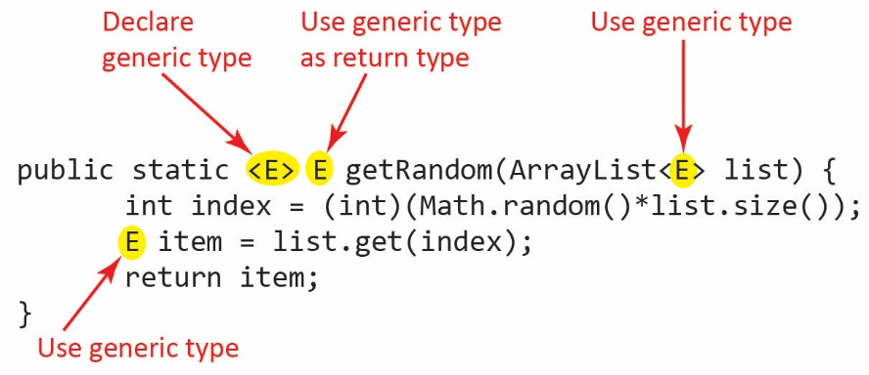
Example – The generic method on the right accepts an ArrayList of any type of object and returns a random element in the list.

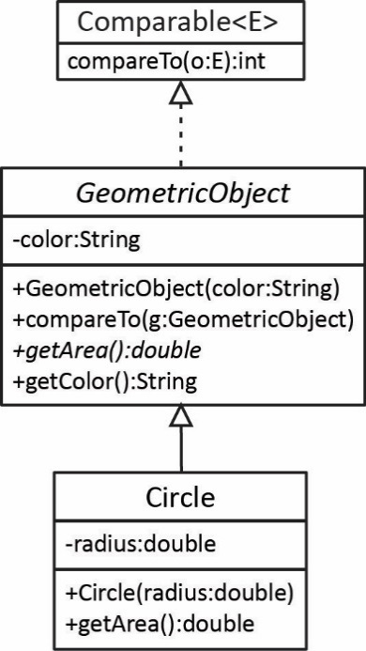
We can call this method with any type of list. For example, GeometricObjects:
Rectangle rectangle = new Rectangle(2, 2);
Circle circle = new Circle(2);
...
ArrayList<GeometricObject> shapes =
new ArrayList<>(Arrays.asList(rectangle, circle, ...));

GeometricObject geoObj = getRandom(shapes);
Or Integers:
ArrayList<Integer> ints = new ArrayList<>(Arrays.asList(3,6,2,5,7,9));
int val = getRandom(ints);

Generic Methods – Bounded Types
In the generic method above we don’t know anything about the class of E so we can’t call any methods on E. More often when we write generic methods, we will bound the type of the generic parameter just as we did with generic classes. We can use the extends keyword when defining a generic type parameter:
<E extends SomeClass>
to specify that E can be SomeClass or any subclass. This provides much more flexibility as now we can use any accessible methods provided in SomeClass in the generic method.
Example – Consider the generic method below which accepts an ArrayList of GeometricObject (or any subclass) and then finds the shape with the smallest area.
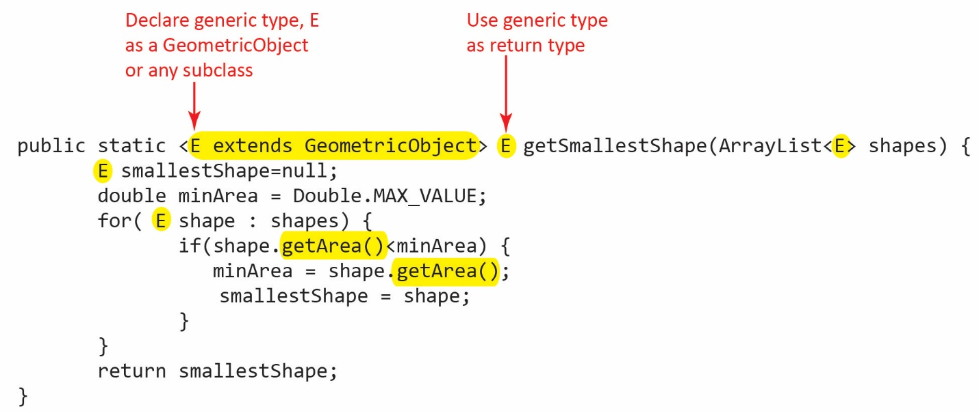
Now that we know E is a GeometricObject:
- We can use any accessible methods of the GeometricObject class in the method, for example, we use getArea.
- The return type is the exact type of the type argument. Thus, we can call this method with an ArrayList of GeometricObjects and receive the return as a GeometricObject:
ArrayList<GeometricObject> shapes = ...
GeometricObject geoObj = getSmallestShape(shapes);
And we can call this method with an ArrayList of Circles and receive the return as a Circle
ArrayList<Circle> circles = ...
Circle smallestCircle = getSmallestShape(circles);
You might ask why we even need generics in the example above. For example, couldn’t we have written the method without generics like this?

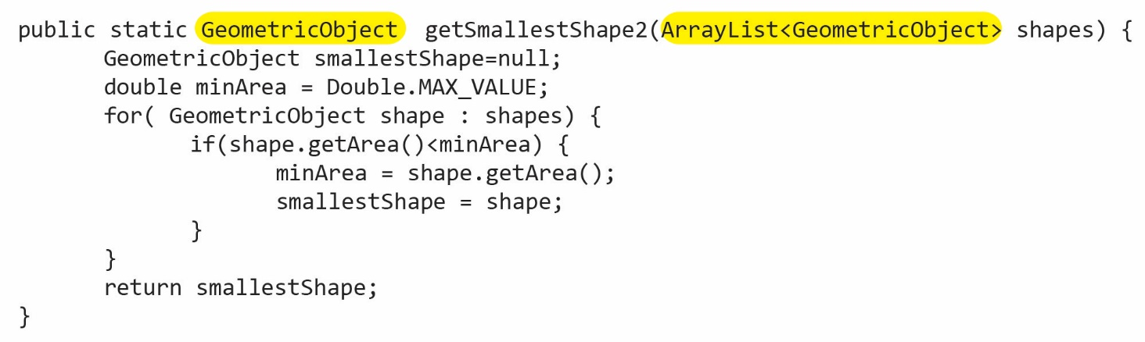
The answer is yes; however, there is a limitation. We can of course still pass an ArrayList of GeometricObjects to this method. However, consider:
ArrayList<Circle> circles = new ArrayList<>();
And then try to pass circles to the method; it will not compile:
GeometricObject smallestCircle = getSmallestShape(circles);
This brings us to an important point: a Circle is-a GeometricObject but ArrayList<Circle> is not an ArrayList<GeometricObject>. In general:

If S is a subtype of T, then ArrayList<S> is not a subtype of ArrayList<T>

An explanation of this: https://stackoverflow.com/questions/9606428/why-is-liststring-not-a-subtype-of-listobject
Notice that most of the methods in the Collections class are generic methods.
- Example – Suppose we want to write a method that accepts two objects of the same class that are Comparable and return the object that is largest (according to Comparable).

- The method is shown below. Notice that the generic type parameter, E is bounded such that any class that implements Comparable is acceptable.
public static <E extends Comparable<E>> E max( E o1, E o2 ) {
if (o1.compareTo(o2) > 0)
return o1;
else
return o2;
}
- We can use this method with an example using String which implements Comparable:
String s1 = "Garble";
String s2 = "Anteater";
String maxStr = max(s1,s2);

- If the types of the two arguments are not the same, the code doesn’t compile:
String s1 = "Garble";
Date d = new Date();
Comparable m = max(s1,d); // doesn't compile
And the same is true if the arguments are the same type but don’t implement Comparable:
public class Dog {  String name;  public Dog(String name) {  this.name = name;  }  } | Dog d1 = new Dog("Leo");  Dog d2 = new Dog("Chaps");  Dog dMax = max(d1,d2); // doesn't compile

Exericises
- Suppose an abstract Account class has a getBalance method that returns the balance of the account. Write a generic method, getAccountLowBalance that accepts an ArrayList of Account objects, or any subclass of Account and returns the account with the smallest balance.

- Suppose an abstract Account class has a getBalance method that returns the balance of the account. Write a generic method, getAccountsLowBalance that accepts an ArrayList of Account objects, or any subclass of Account and also an amount, amt. This method will return an ArrayList of the appropriate type that contains all accounts that have a balance less than amt.

Bounded Wildcard Generic Types
In some situations when we are writing a generic method, we define a generic type parameter to specify the type of a parameter, but we never use it in the method or for the return type. For example, consider the generic method below which returns the average area of an ArrayList of GeometricObjects or any subclass defined with a bounded generic type parameter. Notice that the method does not use E as a return type nor in the method itself.
public static <E extends GeometricObject> double getAverageArea(ArrayList<E> shapes) {
double sum=0.0;
for( GeometricObject shape : shapes) {
sum += shape.getArea();
}
return sum/shapes.size();
}
The method above is correct; however, in such a case it is recommended (but not required) that we use a wildcard generic type. We use “?” to denote a wildcard and means that any type is acceptable. When we use a wildcard, we are saying that the type is anonymous, thus it is not available for use in the method or a return type. We also define bounded wildcards. The general syntax is:

Wildcard | Meaning
<?> | Wildcard – any type is acceptable
<? extends SomeClass> | Upper bound wildcard – SomeClass or any subclass is acceptable
<? super SomeClass> | Lower bound wildcard – SomeClass or any superclass is acceptable
Thus, we can write the method above using a bounded wildcard:
public static double getAverageArea2(ArrayList<? extends GeometricObject> shapes) {
double sum=0.0;
for( GeometricObject shape : shapes) {
sum += shape.getArea();
}
return sum/shapes.size();
}
The reason it is recommended to use wildcards is that they are easier to read.
As stated previously, a lower bound wildcard is specified like this:
<? super T>
which means T or any superclass of T. This is a bit harder to understand. Let’s consider the overloaded sort method from the Collections class which specifies that T must be Comparable. The signature is:
public static <T extends Comparable<? super T>> void sort(List<T> list)

This is a generic method with a bounded generic parameter, T. The bound is Comparable. However, as part of the generic type parameter for Comparable we use a lower bound wildcard. This specifies that T must be Comparable and implement compareTo or inherit compareTo that is implemented in a superclass of T.
- For example, consider the class diagram shown on the right. It shows that GeometricObject implements Comparable and that Circle inherits the compareTo method. Thus, the signature above allows us to sort: ArrayList<Circle> circles.

Had the signature for the sort method been:

public static <T extends Comparable<T>> void sort(List<T> list)

then this would have required the Circle class to implement Comparable directly.

- You can’t use a wildcard to specify the type of a variable or return type. It can only be used for specifying the type of a generic class. For example:
private ? method1(? param) {return param;} // invalid
private List<?> method2(List<?> param) {return param;} // valid
Of course you can, for the situation above that is invalid, define a generic type parameter:
private static <E> E method3(E e) { return e; } // valid

Exericises
- Suppose an abstract Account class has a getBalance method that returns the balance of the account. Write a generic method, areAllAboveThreshold that accepts an ArrayList of Account objects, or any subclass of Account and a threshold value. This method returns true if all accounts have a balance greater than the threshold value; and false otherwise. Use the wildcard approach.

Erasure and Restrictions on Generics
The compiler uses generics to ensure that your code is using generics correctly. However, after it has done this, it erases all the generics and converts the code to raw types. Thus, the generic information is not available at runtime. Example:
Code written using generics:
ArrayList<String> list = new ArrayList<>();
list.add("Oklahoma");
String state = list.get(0);
Code translated to raw type for runtime use:
ArrayList list = new ArrayList();
list.add("Oklahoma”);
String state = (String)(list.get(0));

There are several restrictions on generics:
- Can’t create an instance of a generic type. For example:
E object = new E();
gives a compile error. The reason this is incorrect is because the instantiation occurs at run-time, but the generic type E is not available at run-time.
- Can’t create a generic array. For example:
E[] elements = new E[10];
Is not allowed. However, you can circumvent this with the code below; however, you get a compile warning.
E[] elements = (E[]) new Object[10];
- A generic type parameter of a class is not allowed in a static context
- Exception classes cannot be generic

Appendix
- Resources
A thorough, fairly advanced FAQ on generics:
http://www.angelikalanger.com/GenericsFAQ/JavaGenericsFAQ.html

