CS 1302 – Sample Test 5 Handout, Spring 2026

For problem 1
Consider the class diagram below. You will write only the (complete) Game class. However, you will need some of the methods defined in the Player class.
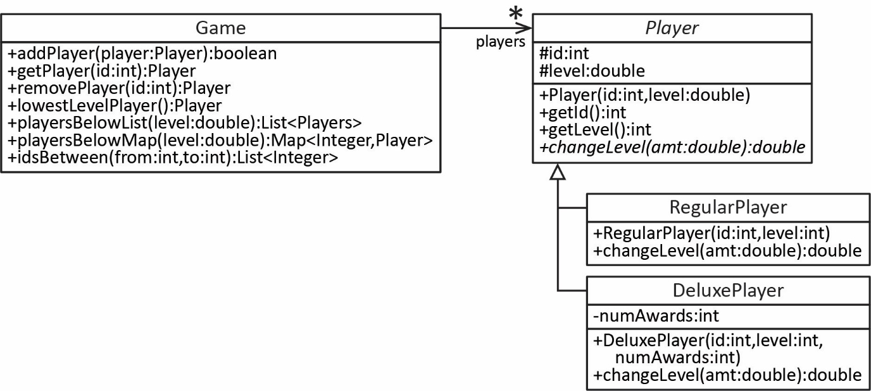
Some notes about the Game class:
- The Game class maintains a map of Player objects where the key is the id.
- addPlayer – accepts a Player object and adds it to the map, provided there doesn’t already exist a player with the same id, and returns true. If the id already exists, then return false.
- getPlayer – accepts an id and returns the corresponding player if they exist; otherwise, it returns null.
- removePlayer – accepts an id and removes and returns the corresponding player (assume the room exists)
- lowestLevelPlayer – returns the Player with the lowest level.
- playersBelowList – accepts a level and returns a list of players at or below level.
- playersBelowMap – accepts a level and returns a map of players at or below level, where id is the key.
- idsBetween – accepts two integers, from and to and returns a list of ids of the players whose id is between from and to, inclusive.

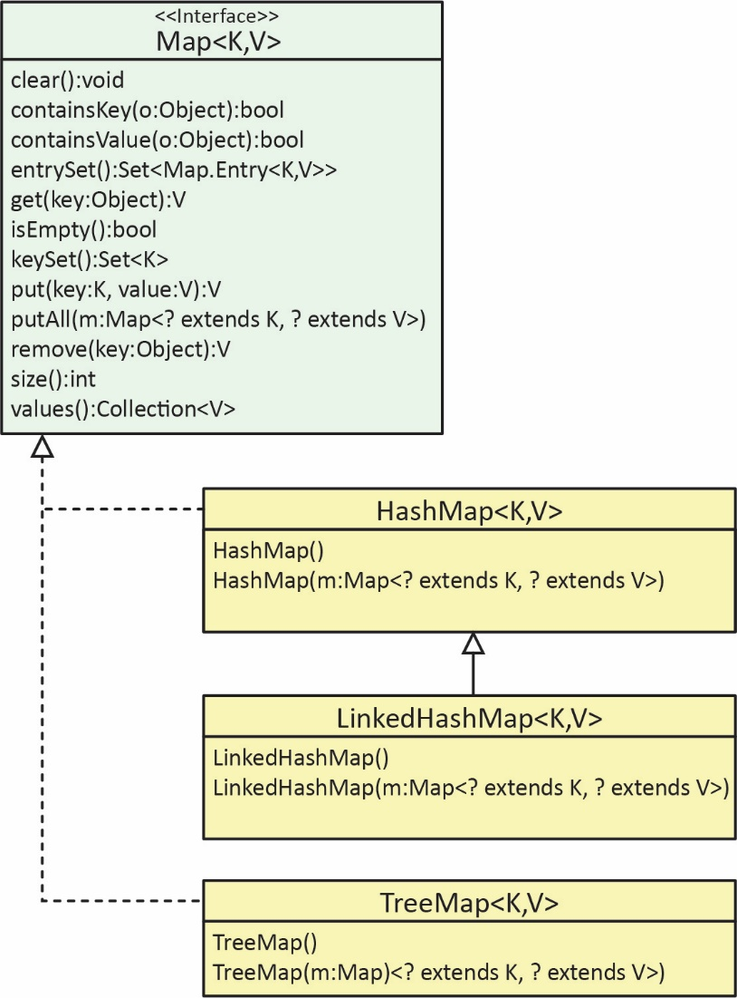
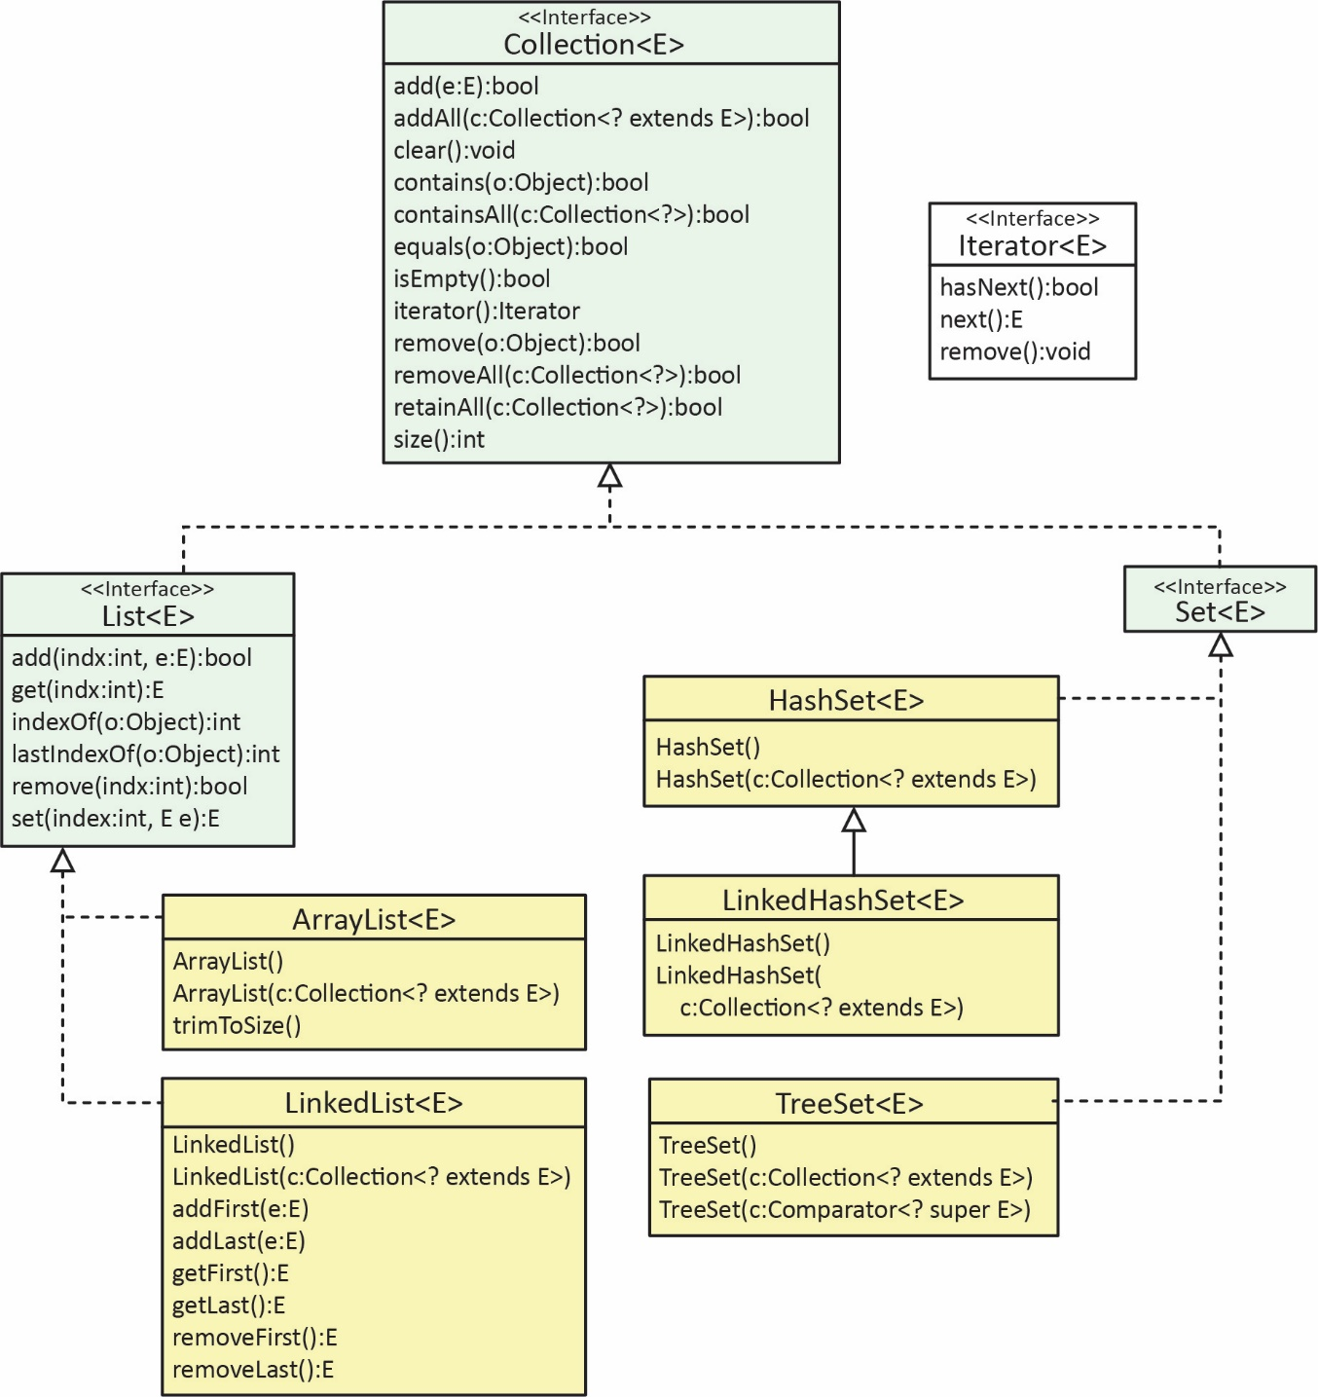

CS 1302 – Sample Test 5, Spring 2026 | Name:
No electronics, notes, smart watches/glasses, etc. allowed. |  | Print: FirstName LastName

- (53 points) Write the entire Game class (see the handout provided)
- (12 points) Pick a problem from Ch 9 in the text: (a) Sec 3.1, Exercises 1, 3 (b) Sec 8.1, Exercise 6
- (10 points) Pick another problem from Ch 9 in the text: (a) Sec 3.1, Exercises 1, 3 (b) Sec 8.1, Exercise 6
- (10 points) Pick a problem from Ch 10 in the text: (a) Examples in Sections 4.1-4.5, (b) Section 4.6, Exercises 1-8.
- (8 points) Pick another problem from Ch 10 in the text: (a) Examples in Sections 4.1-4.5, (b) Section 4.6, Exercises 1-8.
- (8 points) Pick another problem from Ch 10 in the text: (a) Examples in Sections 4.1-4.5, (b) Section 4.6, Exercises 1-8.

These problems are now in the text (with different problem numbers): Ch 9, Sec 3.1
- (Solution in exercise_??? package) Suppose you have two HashMaps, each with the same number of entries and the same keys. Each map stores the sales (double) at each of 5 stores, using the store ID (string) as the key. The first map, current, stores the sales at the 5 stores for the current week. The second map, totals, stores the total sales at each of the 5 stores over the last 3 weeks. Write a method, updateTotals, that accepts the two maps and returns the totals map, updated as with the current week. For example:
Input |  |  | Output
current | totals |  | totals
  ID | Sales
  “SLC” | 50.0
  “LA” | 75.0
  “ATL” | 60.0
  “NYC” | 100.0
  “DET” | 40.0
  ID | Sales
  “LA” | 300.0
  “NYC” | 425.0
  “DET” | 100.0
  “ATL” | 200.0
  “SLC” | 120.0
  ID | Sales
  “LA” | 375.0
  “NYC” | 525.0
  “DET” | 140.0
  “ATL” | 260.0
  “SLC” | 170.0

- (Solution in exercise_??? package) Suppose you have a HashMap, (as previous problem) that stores the sales for a stores, where the store ID is the key. Write a method, removeStores, that accepts such a map and a list of store ID’s. The method should remove the stores from the map that correspond to the store ID’s in the input list. (a) Assume all store ID’s in the input list exist in the map. (b) It is possible that some store ID’s in the input list don’t exist in the map. For example:
Input |  |  | Output
sales | storeIDs |  | sales
  ID | Sales
  “SLC” | 50.0
  “LA” | 75.0
  “ATL” | 60.0
  “NYC” | 100.0
  “DET” | 40.0
  “FAR” | 80.0
  “LA” | “DET” | “NYC”
  ID | Sales
  “ATL” | 60.0
  “SLC” | 50.0
  “FAR” | 80.0

These problems are now in the text (with different problem numbers): Ch 10, Sec 4.6
- (Solution in exercise_??? package) We have bunnies standing in a line, numbered 1, 2, ... The odd bunnies (1, 3, ..) have the normal 2 ears. The even bunnies (2, 4, ..) we'll say have 3 ears, because they each have a raised foot. Recursively return the number of "ears" in the bunny line 1, 2, ... n (without loops or multiplication). Very similar to problems 3 & 4.
Source: https://codingbat.com/prob/p107330
bunnyEars2(0) → 0
bunnyEars2(1) → 2
bunnyEars2(2) → 5
- (Solution in exercise_??? package) Given a string, compute recursively a new string where identical chars that are adjacent in the original string are separated from each other by a "*". Very similar to problem 6.
Source: https://codingbat.com/prob/p158175
pairStar("hello") → "hel*lo"
pairStar("xxyy") → "x*xy*y"
pairStar("aaaa") → "a*a*a*a"

