CS 1302 – Sample Test 5 Handout

For problem 1
Consider the class diagram below. You will write only the (complete) Game class. However, you will need some of the methods defined in the Player class.
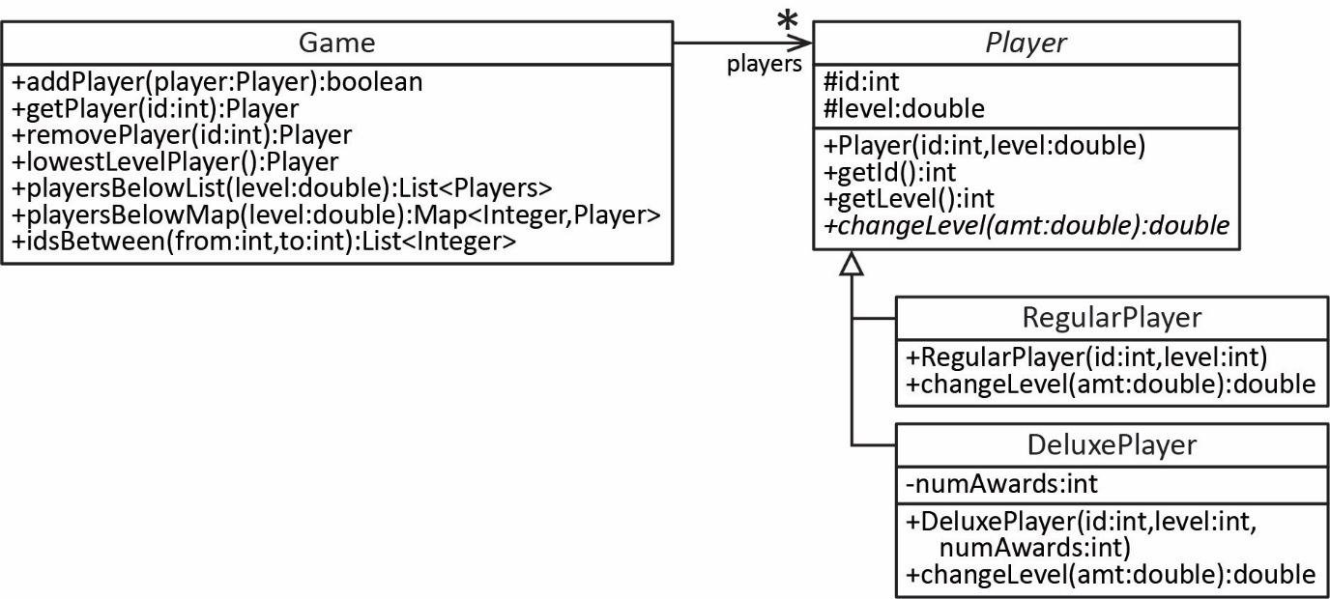
Some notes about the Game class:
- The Game class maintains a map of Player objects where the key is the id.
- addPlayer – accepts a Player object and adds it to the map, provided there doesn’t already exist a player with the same id, and returns true. If the id already exists, then return false.
- getPlayer – accepts an id and returns the corresponding player if they exist; otherwise, it returns null.
- removePlayer – accepts an id and removes and returns the corresponding player (assume the room exists)
- lowestLevelPlayer – returns the Player with the lowest level.
- playersBelowList – accepts a level and returns a list of players at or below level.
- playersBelowMap – accepts a level and returns a map of players at or below level, where id is the key.
- idsBetween – accepts two integers, from and to and returns a list of ids of the players whose id is between from and to, inclusive.

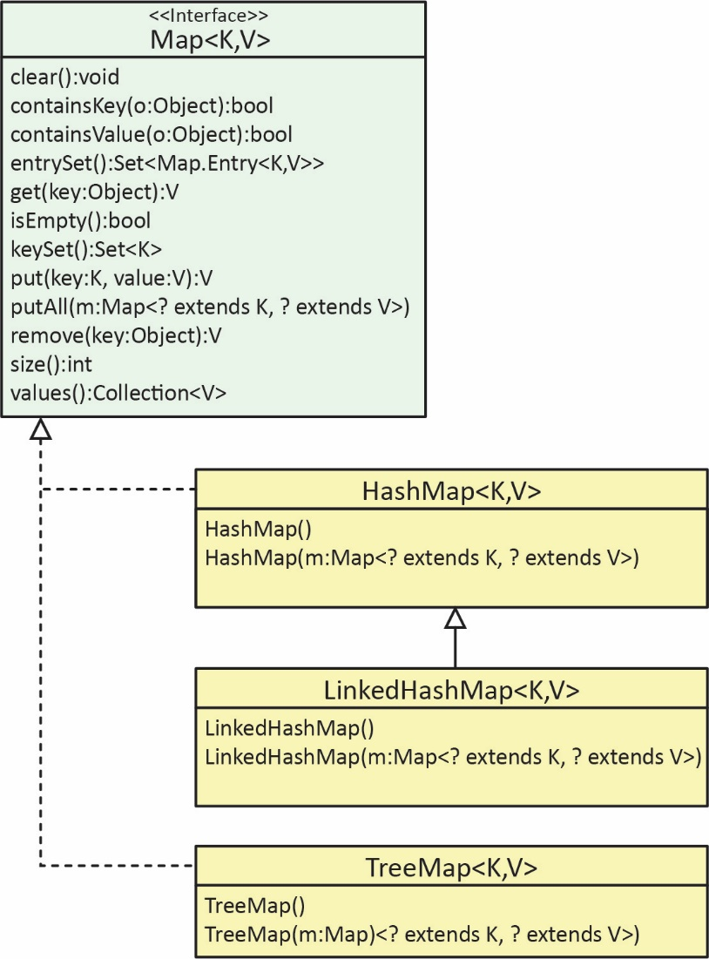
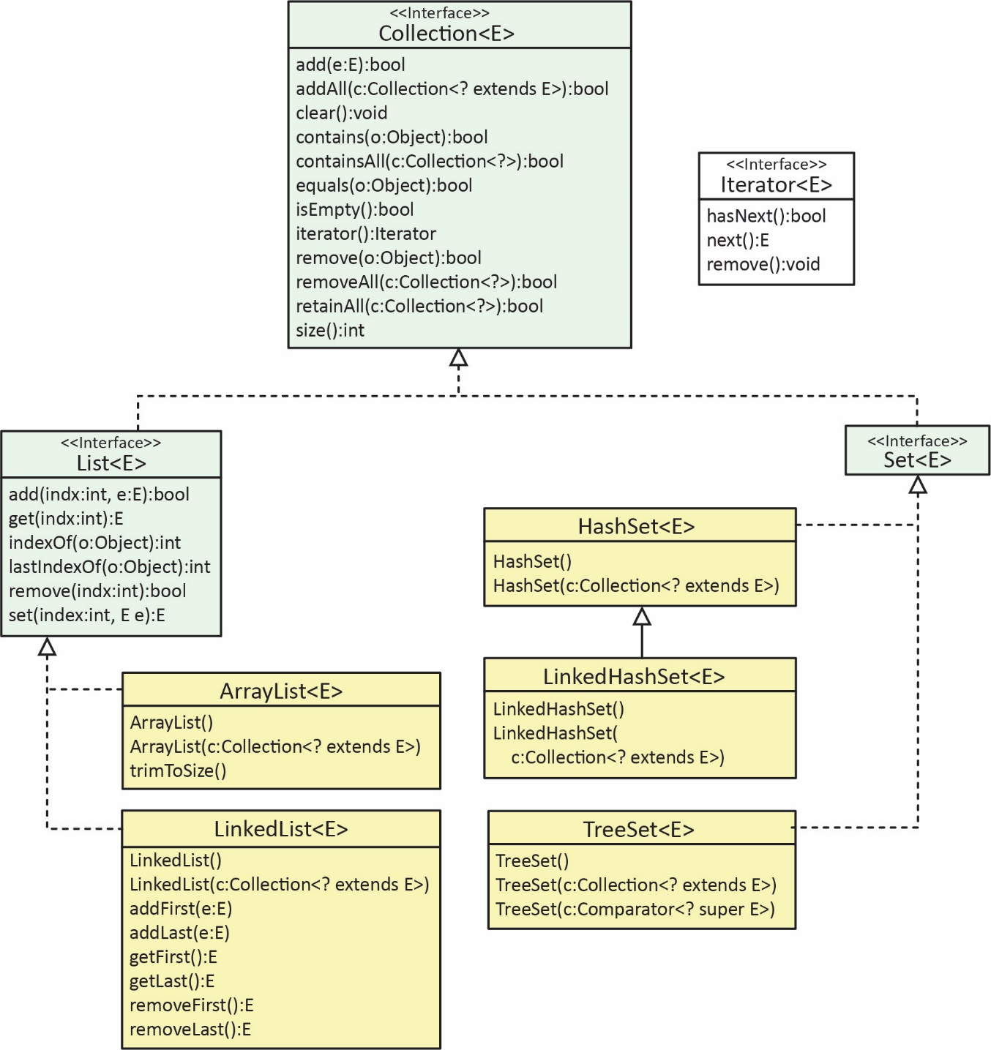

CS 1302 – Sample Test 5 | Name:
No electronics, notes, smart watches, etc. allowed. |  | Print: FirstName LastName

- (55 points) Write the entire Game class (see the handout provided)
- (10 points) Pick a problem from: (a) Ch 9, Sec 2.1, Exercises 1-4. (b) Ch 9, Sec 7.1, Exercises 5, 6, 9
- (10 points) Pick another problem from: (a) Ch 9, Sec 2.1, Exercises 1-4. (b) Ch 9, Sec 7.1, Exercises 5, 6, 9
There will be 2 or 3 recursion problems chosen from different types:
- (10 points) Pick a problem from: (a) Ch 10, examples in Sections 4.1-4.5, (b) Ch 10, Sec 4.6, Exercises 3-5.
- (10 points) Pick a problem from Ch 10, examples in Sections 5.2-5.3
- (10 points) Pick a problem from: (a) Ch 10, examples in Sections 6.1-6.3, or (b) Ch 10, Sec 6.4, Exercise 11
- (10 points) Pick a problem from: (a) Ch 10, examples in Sections 7.1-7.3, or (b) Ch 10, Sec 7.4, Exercises 12-13
- (10 points total) Given the skeleton of a binary search method and recursive helper method, that searches for an integer in an array (or ArrayList) of integers, fill in the blanks of the missing code. The best way to study for this is to be able to write the code for the example in Ch 10, Sec 8.5.
- (10 points total) Given the skeleton of a binary search method and recursive helper method, that searches for an Employee in an array (or ArrayList) of Employee objects, given that the Employee class implements the Comparable interface, fill in the blanks of the missing code. The best way to study for this is to study the changes we made to example in Ch 10, Sec 8.5, when I presented a similar problem in class. Hint: the main thing you need to change is: key < vals[mid] and key > vals[mid].

