Handout – CS 1302 – Sample Test 4
Tear this page off to use for reference Turn this page in with test.
Use this information for Problem 3:
- An Employee has a name
- A HourlyEmployee has a name and an hourlyRate, and one constructor
- A SalariedEmployee has a name, salary, and bonus, and two constructors.
- The Company class provides the method addEmployee(Employee e) to add an employee to the company.
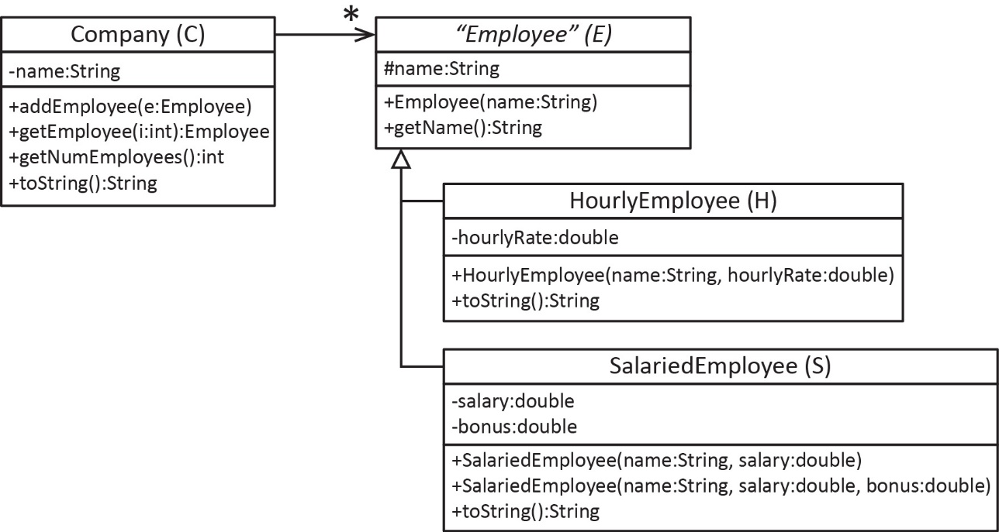
A text file contains an employee on each line. There are three valid formats as shown in the table below, on the left. A sample file is shown below on the right.
- Assume all data is valid
- You can abbreviate: Double.parseDouble(…) as D.pd(…)
  Valid Format | Description
  h name hourlyRate | HourlyEmployee
  s name salary | SalariedEmployee
  s name salary hourlyRate | SalariedEmployee
  Example File
  h Dave 20.50
  s Sue 60000
  s Mike 75000 0.10
  h Nicole 18.25
  s Sherry 55000
  ...

CS 1302 – Sample Test 4 | Name:
No electronics, phones, smart watches, notes, etc. allowed. |  | Print: FirstName LastName
- (20 points) Consider a text file which contains integers separated by one or more spaces. Complete the method below that accepts an integer, target. This method returns the number of times target appears in the file. For example, if the file contains: 5 8 3 8 2 8 10, and the method is called with the target=8, then the method returns 3.
private static int readAndCountOccurrencesOf(int target) throws IOException {
Scanner in = new Scanner(new File("nums.txt"));

- (20 points) Consider a text file which contains integers separated by one or more spaces. Complete the method below that returns the largest value found in the file.
private static int readAndFindLargestValue() throws IOException {
Scanner input = new Scanner(new File("nums.txt"));

- (60 points) Complete the method below to read the text file described on the handout and return a Bank that contains the accounts that were read.
public Bank readAccounts(String fileName) throws FileNotFoundException {
Scanner in = new Scanner(new File(fileName));

