CS 1302 – Sample Test 4 Handout
Tear this page off to use for reference Turn this page in with test.
Use this information for problems 1-3:
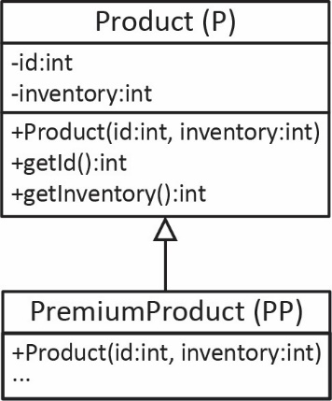
Use this information for problem 4:
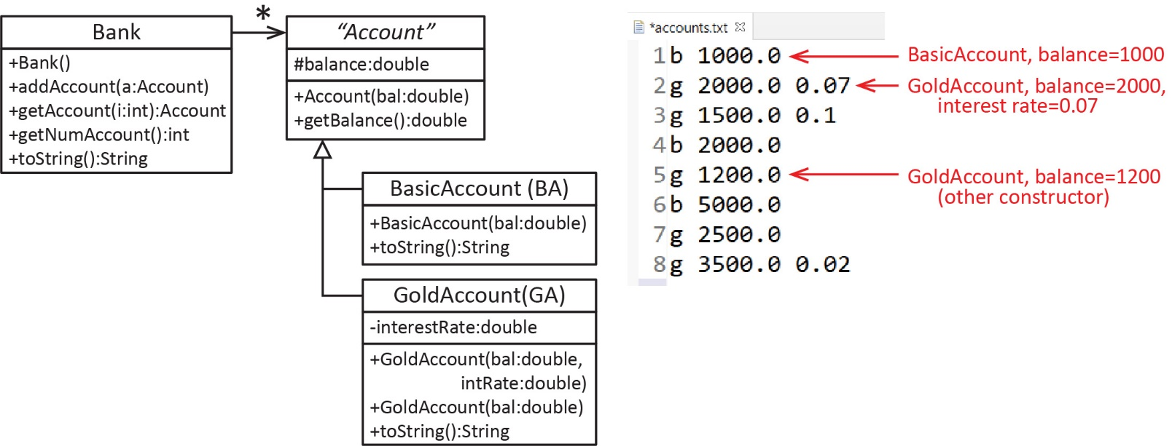

Class diagram for Collection classes on the reverse side

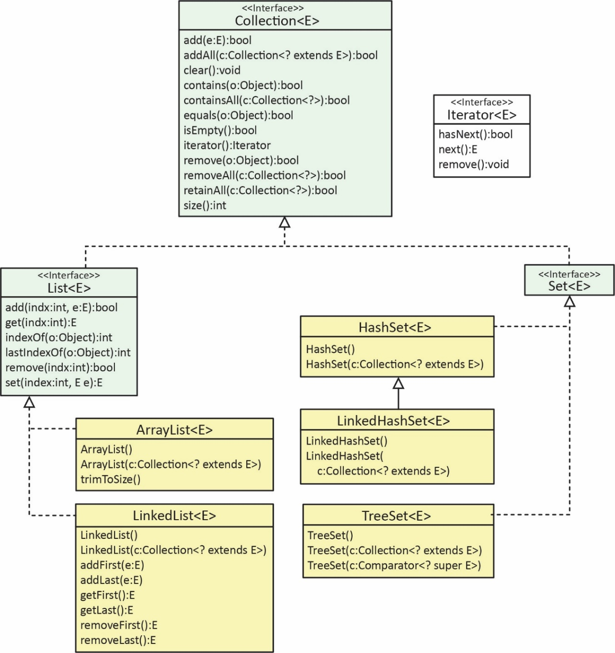

CS 1302 – Sample Test 4 | Name:
No electronics, phones, smart watches, notes, etc. allowed. |  | Print: FirstName LastName

- Reference the handout…
- (10 points) A Product has an id and an inventory level, inv. Write the PremiumProduct (PP) constructor that accepts an id and an inventory level, inv. The id is required to be less than 9000 and the inventory level must be positive; otherwise, it should throw an exception.

- (10 points) Write a snippet of code that (a) creates a PremiumProduct (PP) with a balance an id of 8 and an inventory (inv) of -100.00, (b) prints any exception that might be thrown.

- (10 points) Consider the Product class on the handout. Write a complete Comparator class such that Product objects are ordered on their id.

- (4 points) Suppose you have a list, products, of Product objects. Write a snippet of code to use the comparator to sort products on their id ascending.

- (4 points) Write either 1 or 2 lines of code to create the appropriate type of Collection class that could hold Product objects ordered on their id. In other words, whenever you add a new Product to this collection, it is put in the correct position.

- (15 points) Write a method, remHigh that accepts a list of Product objects, and an inventory level, max. This method should remove the Products whose inventory is greater than max while also returning the removed accounts in a new list.

- (30 points) Consider the classes shown on the handout. Notice that the GoldAccount has two constructors, one that takes an interest rate and one that does not. The one that doesn’t take an interest rate simply sets the interest rate to the default value, 0.05. Next, consider an example text file shown on the handout which contains information for a number of accounts. Write this static method below to read such a file and return a Bank object populated with the appropriate Accounts. Note: (a) Assume all data is valid, (b) You do not need try/catch, (c) You may use: I.pI(val) to parse a string as an int.

public Bank readAccounts(File file) throws FileNotFoundException {
Scanner in = new Scanner(file);

}
- (10 points) Do one of the Exercises 1-4, Ch. 8, Sec. 2.1

- (7 points) Do Exercise 11, Ch 8, Sec 9.1.

public static Set<String> getUnique2(ArrayList<String> names) {

- (7 points) What does this code output?

public static void main(String[] args) {
myMethod(4,3); System.out.println();
myMethod(4,0); System.out.println();
}
public static void myMethod( int x, int y ) {
try {
System.out.println("1");
divide(x,y);
System.out.println("2");
}
catch( Exception e ) {
System.out.println("3");
}
finally {
System.out.println("4");
}
System.out.println("5");
}

public static void divide( int x, int y ) {
int z = x/y;
}

