Handout – CS 1302 – Sample Test 3
Tear this page off. Turn in with test
Use the information below for problems 1-4. As prompted on the test, you will write the code for all the items that are highlighted, using best practices. Assume any non-highlighted members are present (i.e. you do not need to write them).
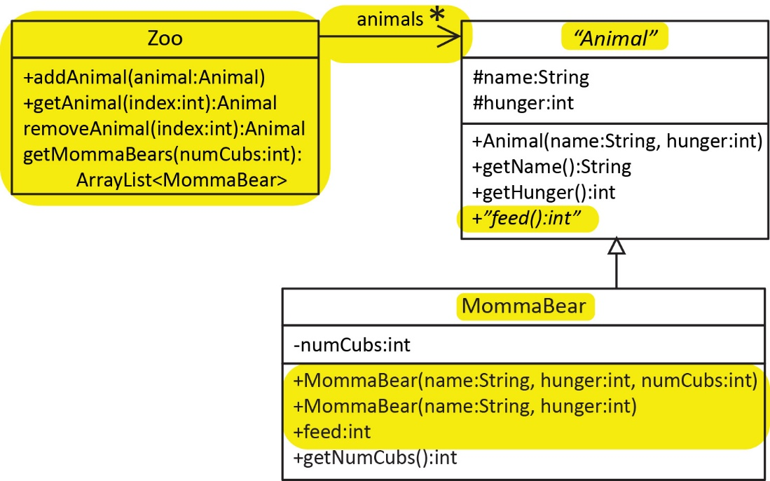
Animal Class
Abstract class that represents an animal with a name and hunger. The feed method is abstract.
MommaBear Subclass (abbreviate MB)
Represents a momma bear which also has an instance variable, numCubs that represents the number of cubs it has.
- The first constructor accepts the name, hunger, and number of cubs, numCubs
- The second constructor accepts a name, hunger. The number of cubs is set to the default value 2.
- The feed method should reduce hunger by 1 for itself and each of its cubs, and return the (new) hunger
Zoo Class
- You can assume there is a no-arg constructor (you do not need to write this).
- Has an ArrayList of Animals’s.
- addAnimal simply adds the argument to the list. Hint: this is very simple. The Animal class does not override equals so there is no concept of a two animals being the same. Just add the animal!
- getAnimal returns the animal at i, if i is valid, otherwise, it returns null.
- removeAnimal removes and returns the animal at i. You can assume i is valid.
- getMommaBears accepts a number of cubs, numCubs, and returns a list of MommaBears’s whose number of cubs is within 2 of numCubs. For example, if getMommaBears(5) is called, then it will return a list of the MommaBears with 3 to 7 cubs.

CS 1302 – Sample Test 3 | Name:
No electronics-phone, smart watch, notes, etc. allowed. |  | Print: FirstName LastName
Write all code using best practices
- (6 points total) Do the following for the abstract Animal (A) class (only the 2 highlighted items, assume the others are implemented).
- (3 points) Write the header/signature for the abstract class.

- (3 points) Write the abstract feed method.

- (24 points) Do the following for the MommaBear (MB) class (only the 4 highlighted items, assume the others are implemented).

- (5 points) Write the header/signature for the class.

- (6 points) Write the first constructor.

- (6 points) Write the second constructor.

- (7 points) Override the feed method.

- (40 points) Do the following for the Zoo (Z) class, using best practices:

- (3 points) Write the header/signature for the class.

- (4 points) Write the instance variable(s):

- (7 points) Write the addAnimal method.

- (8 points) Write the getAnimal method.

- (8 points) Write the removeAnimal method.

- (10 points) Write the getMommaBears method.

- (15 points) Use the classes and methods from the handout to write a single line of code to:

- Create a MommaBear (either constructor) and store it in a variable.

- Create a Zoo and store it in a variable.

- Add the momma bear from part a to the zoo.

- Assume lots of animals have been added to the zoo. Use a method from the Zoo class to get the 26th animal from the zoo and be sure to define a variable to hold the return from this method.

- Call a Zoo method that returns a list of the momma bears from the zoo with at 5 to 9 cubs, inclusive and be sure to define a variable to hold the return from this method.

public class Person {
private String name;
private int age;

public Person(String name, int age) {
this.name = name;
this.age = age;
}
public String getName() {
return name;
}
public int getAge() {
return age;
}
}

- (15 points total) Consider the Person class shown on the right which shows that a Person has a name and age.

  - (4 points) Override the equals method such that two Person objects are considered equal if they have the same name.
public boolean equals(Object o) {

  - (2 points) Suppose you want to be able to sort an ArrayList<Person> on persons’ names. What interface declaration should appear in the Person class header?
public class Person implements _________________________________________________________ {
  - (4 points) Implement the compareTo method so that Person objects are ordered by name in ascending order
public int compareTo(Person p) {

  - (3 points) Suppose you have an ArrayList of Person objects named people that contains a number of Person objects. Write a single line of code to sort people.

_____________________________________________________________________________________________________
  - (2 points) Assuming the list from part d has been sorted, write a single line of code to print the name of the first person.

____________________________________________________________________________________________________

