CS 1302 – Test 3 Review Problems
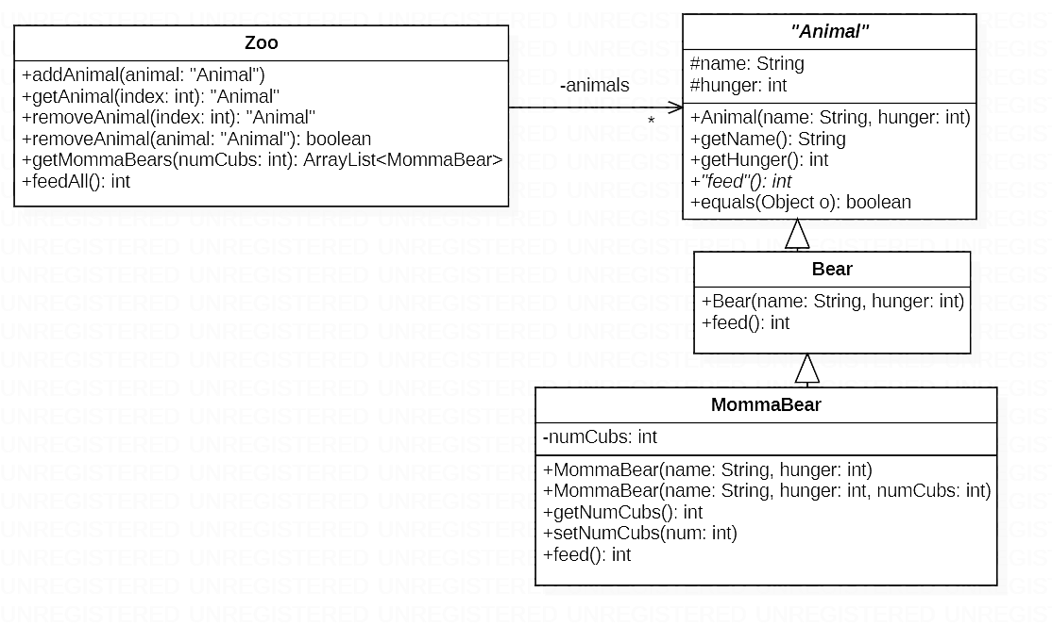
Here are some sample problems that may help you prepare for Test 3. These are based on the material from chapters 4 and 5. I do not have solutions for these problems available at this time. Problems 1-5 are based on the class diagram provided below.
- Write the Animal class header, equals method, and feed abstract method. The equals method will return true if two Animals have the same name. You do not need to write the instance variable nor the other methods not mentioned above.
- Write the entire Bear class.
- The feed method should reduce hunger by 1, and return the (new) hunger. However, hunger cannot fall below zero. Thus, if hunger is zero, a call to feed will not change hunger and simply return zero.
- Write the entire MommaBear class.
  - If number of cubs is not specified in the constructer, it should be set to the default of 2.
  - The feed method should work the same as in the Bear class, but the return value should be increased by the number of cubs.
- Write the entire Zoo class.
  - You can assume the class has a no-arg constructor which you do not need to write.
  - The class has a list of Animals.
  - addAnimal accepts an Animal and adds it to the list of Animals.
  - getAnimal returns the Animal at index if index is valid; otherwise, it returns null.
  - removeAnimal(index:int) removes the Animal at index from the list of Animals and returns the removed Animal. You can assume the index is valid.
  - removeAnimal(a:Animal) – Removes a from the list of Animals, returning true if successful and false otherwise. Note: we haven’t written a method like this in class or HW; however, it is simple. Hint: research the ArrayList method, remove(object:Object).
  - Add a getAnimal method (not shown in diagram) to the Zoo class that accepts a name and returns the Animal with that name, if it exists; and null otherwise. Your code should be as efficient as possible – this means that it should not use a loop. Hint: use the “dummy” object approach used in class and HW.
  - Add a removeAnimal method (not shown in diagram) to the Zoo class that accepts a name. This method should remove the Animal with that name and return it, if it exists; and should return null otherwise. Your code should be as efficient as possible – this means that it should not use a loop. Hint: use the “dummy” object approach used in class and HW.
  - The getMommaBears method returns an ArrayList of MommaBears with at least as many cubs as specified in the parameter. For example, getMommaBears(2) would return Ursa with 2 cubs and Barda with 3 cubs, but not Sammy with 1 cub.
  - The feedAll method calls the feed method for all animals at the zoo and returns the sum total of the returned values.
- Write the following snippets of code:
  - Make a Bear object and store it in a variable.
  - Make two MommaBear objects using different constructors, storing both in different variables.
  - Make a Zoo object and store it in a variable.
  - Add all three Animals created above to the Zoo.
  - Assume lots of animals have been added to the zoo. Get the 8th animal from the zoo and store it in a variable
  - Remove the 5th animal in the zoon and store the result in a variable
  - Remove the animal with name, “Quola” from the zoon and store the result in a variable.
  - Call a method that returns a list of the mamma bears from the zoo with at least 3 cubs and be sure to define a variable to hold the return from this method.
  - Call the feedAll method and catch the result in a variable.

- Write a Fighter interface. The Fighter interface has an attack method that accepts a double and doesn’t return anything.
- Short explanation: Modify the class below so it can be sorted alphabetically by name.
Longer explanation: Implement the Comparable interface such that an ArrayList<Person> could be sorted on name. You are not to write code to sort an ArrayList, you are modifying the Person class so that a list could be sorted. Hint: there are 3 separate things you need to do.

public class Person {
private String name;
private int age;

public Person(String name, int age) {
this.name = name;
this.age = age;
}
public String getName() {
return name;
}
public int getAge() {
return age;
}
}

