CS 1302 – Sample Test 2 Handout
Tear this page off to use for reference Turn this page in with test.
- This version contains extra problems which are highlighted in Yellow.

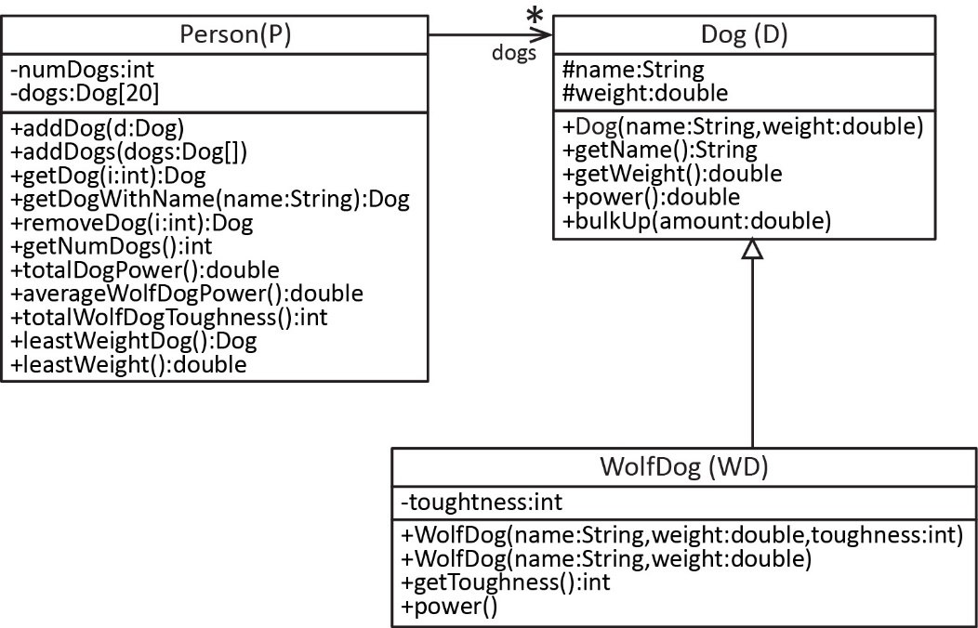
The information below will be used for problems 1-2.

Dog Class
You can assume the Dog class is already written, except for this method which you will write:
- bulkUp(amount:double) – Increases the dog’s weight by amount.

WolfDog Class
You will write most of the WolfDog (can abbreviation: WD) class, which is a subclass of Dog. It requires following members:

- toughness instance variable.
- WolfDog(name:String, weight:double, toughness:int) – Constructor.
- WolfDog(name:String, weight:double) – Constructor, in this case, the toughness is set to 1. Use best practices.
- getPower():double – Returns the weight of the dog multiplied by the toughness.
- You do not need to write the getToughness method; however, you can assume it exists.

Person Class
You will write most of the Person class. This class requires the following members:
- An array of size=20 of Dog objects (you may NOT use an ArrayList)
- addDog(d:Dog) – Adds d to dogs if there is available space in the array.
- addDogs(newDogs:Dog[]) – add all the newDogs to the dogs array. You can assume newDogs is full.
- getDog(i:int):Dog – Returns the dog at i if i is valid and null otherwise.
- getDogWithName(name:String) – Returns the dog whose name is name, if found, and null otherwise.
- remDog(i:int):Dog – Returns and removes the dog at i (you can assume i is valid).
- totalDogPower():double – Returns the total power of all the dogs (and subclasses) added together.
- averageWolfDogPower():double – Returns the average power of all the wolf dogs.
- totalWolfDogToughness():int – Returns the total toughness of all the wolf dogs added together.
- leastWeightDog():Dog – Returns the dog with least weight
- maxWeight():double – Returns the weight of the dog with largest weight.

You can assume the Person class has:
- a no-arg constructor that does nothing.
- a getNumDogs method that returns the number of dogs in the dogs array.

CS 1302 – Sample Test 2 | Name:
 |  | Print: FirstName LastName
Closed Book Test. No Notes Allowed. Write answers on the test.
- (60-70 points) Write the code described on the handout.
  - Write the method only for the Dog class.
  - Write the WolfDog class as described.
  - Write the Person class as described.

- (15-20 points) Write a line of code that:

- Creates a Dog (any name and weight)
- Creates a WolfDog with toughness equal to 4 (any name and weight)
- Creates a Person.
- Adds one of the dogs from above to the person.
For the rest of the questions, assume many dogs have been added to the person.
- Use the appropriate Person method to get the 5th dog and store the result in a variable.
- Use the appropriate Person method to get the total power of all the dogs added together and store the result in a variable.
- Use the appropriate Person method to get dog with the least weight and store the result in a variable.
- Suppose you have references to 2 dogs: d1 & wd2. Define an array, newDogs, to hold these two dogs and put them in the array. Write 1-3 lines to accomplish this.

- Use the appropriate Person method to add the dogs in newDogs (part h above) to the person.

- Suppose you have a reference to a Person, p that has some number of dogs. Write a snippet of code to loop through the person and print the weight of each dog with one decimal.

- Consider classes A and B shown in the table below. What output do each of these object creations produce?

 | Code | Output
a. | A a1 = new B();
b. | A a2 = new B(22);
c. | A a3 = new B("Q");

class A {  public A() {  this("M");  }  public A(String s) {  System.out.print("L" + s);  }  } | class B extends A {  public B() {  this("N");  }  public B(int num) {  System.out.print("P");  }  public B(String s) {  super(s);  System.out.print("O");  }  }

- Consider the class diagram and references shown below. For each of the Assignments, determine whether the assignment compiles (valid) or does not compile (invalid)

Class Diagram | References | Assignments
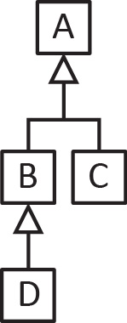 | A a = new A();  B b = new B();  C c = new C();  D d = new D(); | - B b1 = a; Compiles or Doesn’t Compile  - D d1 = b; Compiles or Doesn’t Compile  - A a1 = b; Compiles or Doesn’t Compile  - C c1 = d; Compiles or Doesn’t Compile  - B b2 = d; Compiles or Doesn’t Compile  - A a2 = d; Compiles or Doesn’t Compile  - B b3 = c; Compiles or Doesn’t Compile  - A a3 = c; Compiles or Doesn’t Compile

  - Consider the partial StackOfPersons class below. In the box below, write the push & pop methods for this stack.
public class StackOfPersons {
private Person[] persons;
private int size = 0;

public StackOfPersons(int capacity) {
persons = new Person[capacity];
}

public boolean isEmpty() {
return size == 0;
}

}
  - Suppose you have two Person objects, p1 and p2. Write a snippet of code to
    - create a StackOfPersons with capacity 50 (abbreviate SOP),
    - push the two persons onto the stack,

    - pop the stack, storing the value that is returned in a variable.

