CS 1302 – Sample Test 1b Handout
Tear this page off to use for reference Turn this page in with test.

All problems on the test use this information:
You will write a Circle class (can abbreviate, C) with the following characteristics:
- Has a center that is denoted by x and y (double), a radius (double), and a color (string) that are all supplied in a constructor.
- A constructor that accepts all 4 properties..
- A constructor that accepts a radius only. In this case the x and y should be set 0.0 each and the color set to “orange”, using best practices.
- A constructor that accepts x and y only. In this case the radius should be set 1.0 and the color set to “purple”, using best practices.
- A getter and setter for the radius property only. (you do not need to write a getter and setter for the other properties; however, you can assume they exist).
It should also have these methods:
Note: on an actual test, you will write 4 or 5 methods like the ones below, additional one are provided for practice.
- area – returns the area of the circle. The area of a circle is: $a={πr}^{2}$
- moveXBy – accepts a value to move x by this value. For example, if x=3.0 and the argument is 2.0, then x will become 5.0.
- moveXY – accepts two values and moves x and y, respectively by these values.
- swap – swaps x and y.
- distanceFrom – accepts another Circle and returns the distance from the center of this circle to the input circle. The distance between two points: ${(x}_{1},y_{1})$ and ${(x}_{2},y_{2})$ is: $d=\sqrt{{{(x}_{1}-x_{2})}^{2}+{{(y}_{1}-y_{2})}^{2}}$
- merge – accepts another Circle and does the following: (a) this x is updated so that it is the average of this x and the x for the input circle, (b) this y is updated so that it is the average of this y and the y for the input circle, (c) this radius is updated so that it is the average of this radius and the radius for the input circle.
- numSameColor – accepts an array of Circles and returns the number of circles in the input array that have the same color as this circle.
- beginsWithCharacter – accepts a character and returns true if the color of this circle’s first character is the same as the input character; and false otherwise.
- toString – returns a string that shows x and y with two decimal places, and the color in the following format:
“Color: color, x=#.##, y=#.##”
For example, if the color is “Orange”, x=12.341234, y=9.82323, then the returned string would be:
“Color: Orange, x=12.34, y=9.82”

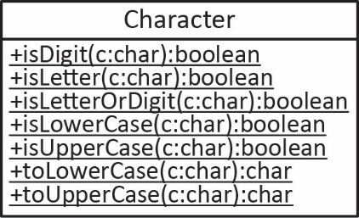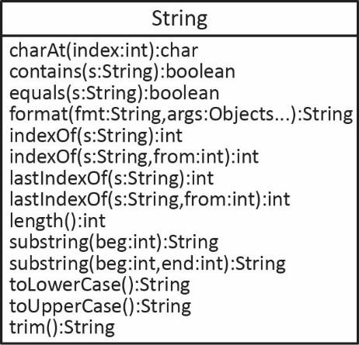
CS 1302 – Sample Test 1b | Name:
 |  | Print: FirstName LastName
Closed Book Test. No Notes Allowed. Write answers on the test. This is longer than an actual test would be.
- (~50 points) Write the Circle class described on the handout.
- (~20 points) Write a single line of code that:

- Creates a Circle using the first constructor. Call it c1.

- Creates a Circle using the second constructor. Call it c2.

- Changes the radius of c1 to 5

- Retrieves the area of the c2, storing the result in a variable.

- Finds the distance between c1 and c2 storing the result in a variable.

- Suppose you have Circles: c5 and c6. Define an array to hold these circles and put the circles in the array. You can do this in one line or several.

- Find the number of circles in the array from the previous step that have the same color as c1, storing the result in a variable..
- Suppose you have a class, CircleUtilities. This class has no instance variables, it just has methods that accept arrays of Circles.
Note: on an actual test, you will write 2 or 3 methods like the ones below, additional ones are provided for practice.

- (~10 points) Write a method for this class, averageRadius, that accepts an array of Circle objects and returns the average radius of the circles in the input array. (The solution does not provide a solution for this method)
- (~10 points) Write a method for this class, smallestCircle, that accepts an array of Circle objects and returns the Circle with the smallest area. (The solution does not provide a solution for this method)
- (~10 points) Write a method for this class, closestCircle, that accepts an array of Circle objects and another Circle object (call this Circle, c). The method should return the Circle in the array that is closest to c. (The solution does not provide a solution for this method)
- (~10 points) Write a method for this class, circleColors, that accepts an array of Circle objects and returns and array of only the color of each circle in the input array. (This solution does not provide a solution for this method)
- (~10 points) Write a method for this class, changeRadii, that accepts an array of Circle objects and a radius. This method should change the radius of each circle in the array, whose radius is less than the input radius, to the value of the input radius. For example, if a circle in the array has a radius of 2.0, and the input radius is 5.0, the this circle will have its radius changed to 5.0. (This solution does not provide a solution for this method)

