CS 1302 – Sample Test 1a Handout
Tear this page off to use for reference Turn this page in with test.

All problems on the test use this information:
You will write a Dpg (can abbreviate: Emp) class with the following characteristics:
- has name and age (int) properties.
- A constructor that accepts both the name and age.
- A constructor that accepts a name only, and sets the age to 1using best practices.
- A getter and setter for the age property only. (you do not need to write a getter and setter for name; however, you can assume they exist).
It should also have these methods:
- bark – accepts an integer and return a string “bark” concatenated the number of times specified by the integer. For example: bark(3) would return: “bark bark bark”.
- increateAge – accepts a percent (in decimal form) and increases the age of this dog by that percent. (This solution does not provide a solution for this method)
- dogNameAbbreviation (can abbreviate: gNA) – Returns the dog name’s abbreviation which is the first three characters of the dog’s name. You can assume a dog’s name is 3 or more characters long. (This solution does not provide a solution for this method)
- barkAt – accepts another Dog and returns a string like this: “thisDogName barks at anotherDogName”. For example, if this dog is named fido and the input dog is named leo, then the method will return: “fido barks at leo”.
- countOlder – accepts an array of dogs and returns the number of dogs in the array that this dog is older than.

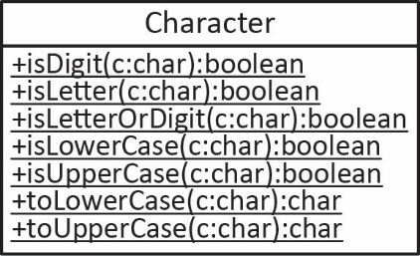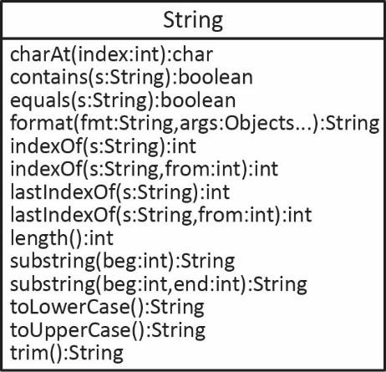
CS 1302 – Sample Test 1a | Name:
 |  | Print: FirstName LastName
Closed Book Test. No Notes Allowed. Write answers on the test. This is longer than an actual test would be.
- (~50 points) Write the Dog class described on the handout.
- (~20 points) Write a single line of code that:

- Creates a Dog using the first constructor. Call it d1.

- Creates a Dog using the second constructor. Call it d2.

- Changes the age of d1 to 5

- Has d1 bark 4 times storing the result in a variable.

- Has d1 bark at d2 storing the result in a variable.

- Suppose you have dogs: d5 and d6. Define an array to hold these dogs and put the dogs in the array. You can do this in one line or several.

- Calls the countOlder method on d1, passing the array of dogs from the previous step. The result should be stored in a variable.
- Suppose you have a class, DogUtilities. This class has no instance variables, it just has methods that accept arrays of Dogs.
Note: on an actual test, you will write 2 or 3 methods like the ones below, additional ones are provided for practice.

- (~10 points) Write a method for this class, getAverageAge, that accepts an array of Dog objects and returns the average age of the dogs in the array. (The solution does not provide a solution for this method)
- (~10 points) Write a method for this class, getOldestAge, that accepts an array of Dog objects and returns the age of the oldest Dog. (The solution does not provide a solution for this method)
- (~10 points) Write a method for this class, getOldestDog, that accepts an array of Dog objects and returns the Dog that is the oldest. age of the dogs in the array. (The solution does not provide a solution for this method)
- (~10 points) Write a method for this class, getAges, that accepts an array of Dog objects and returns a new array of the age of each dog in the input array. (The solution does not provide a solution for this method)
- (~10 points) Write a method for this class, getEveryOther, that accepts an array of Dog and returns a new array of Dog that contains every other Dog from the array that was passed to the method. An example is below; however, note that it shows only the dog name’s, when it really represents actual Dog objects.
Example 1 | Example 2
Input: [fido, snoopy, leo, chaps] | Input: [fido, snoopy, leo, chaps, zorro]
Output: [fido, leo] | Output: [fido, leo, zorro]

- (~10 points) Write a method for this class, createMutants, that accepts an array of Dog and returns a new array of Dog. This array has a new dog for each input dog where the name of each dog is the same as the input except that the first and last characters are removed. For example:
Input Array | Output Array
[name:”Fido”, age=3 | [name:”id”, age=3
name:”Snoopy”, age=4 | name:”noop”, age=4
name:”Leo”, age=2] | name:”e”, age=2]
- (~6 points) Consider this sample piece of code:
double len = 14.823423489;
String product = “crackers”;
Int quantity = 4
String msg = ______________________________________________________________________________;
System.out.println(msg)
Complete the line of code to create a formatted string that when printed, displays:
“Quantity of 4 crackers, where each has length of 14.823”
Note: this is just an example. Your code should work no matter what the values of the variables are. You must use the variables themselves, not their values in the answer.

