Lab 15b – JavaFX Setup in Eclipse

Setting up to Work on a Personal Device

*Last updated: 2.27.2025*

* **This lab is a tutorial on setting-up JavaFX on a personal device. If you intend to work in the CS Open Lab (2111 Nevins) there is nothing for you to do here.**
* **Setting up JavaFX on a personal computer fails for 2-3 people in each class. Especially (but not always) with a Mac. If it fails, start completely over, from the beginning. I am willing to help once, in my office with this if necessary, but I still may not be able to get it. You can work in the lab if you can’t get it going on your computer.**
* **This Lab is not graded – there is nothing to turn in.**

Contents

1 Introduction 1

2 Install e(fx)clipse 2

3 Download JavaFX Libraries 3

4 Create a JavaFX Application 5

5 Build User Library 5

6 Attach JavaFX Libraries to Project 5

7 Customize the GUI 5

8 Attach JavaFX Libraries to Subsequent Projects 5

9 Use Downloaded Packages with JavaFX Code 5

10 Use Jar File with JavaFX Code 5

# Introduction

To create Graphical User Interfaces (GUI) in Java, we need to do the following:

Do these once:

1. Install a plugin for Eclipse that facilitates us making a new kind of project, a JavaFX Project.
2. Download the JavaFX libraries

Do these each time you create a new project:

1. Create a JavaFX Project (Lab 15a, Section 2)
2. Build a User Library (Lab 15a, Section 3)
3. Attach JavaFX libraries to a project (Lab 15a, Section 4)

Once these things are done, then you will:

1. Customize the Gui (Lab 15a, Section 5)
2. Attach JavaFX libraries to subsequent projects (Lab 15a, Section 6)
3. Use download packages with JavaFX code (Lab 15a, Section 7)
4. Use Jar files with JavaFX code (Lab 15a, Section 8)

This document only contains the steps for the first 2 items above. For the remainder, you will use Lab 15a.

I developed the instructions below (through internet resources, several students’ help, and trial-and-error); however, in 2023, I found [this video](https://www.youtube.com/watch?v=MND0mbrMgTk) that is almost identical to these instructions.

# Install e(fx)clipse

The first thing we need to do is to install the E(fx)clipse plugin which allows us to create a “JavaFX Project”.

1. 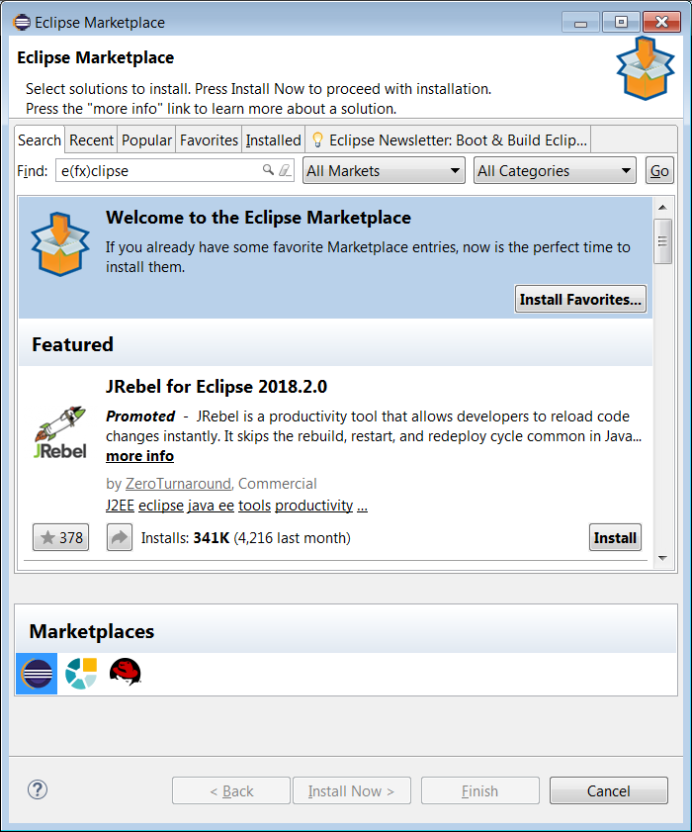Open Eclipse in any workspace (existing or new).
2. In Eclipse, choose: Help, Eclipse Marketplace
3. In the *Find* field, type: “e(fx)clipse.” Then choose: Go
4. 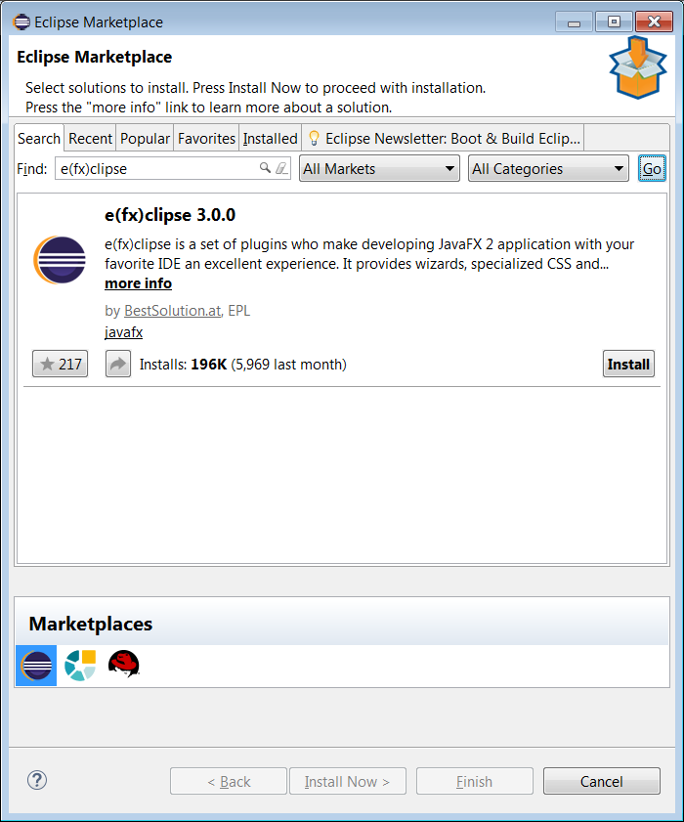The result should be similar to the figure on the right (except different version). Choose: Install

Note: the install dialog will close and Eclipse will be minimized. However, it is still installing. The Eclipse icon in the Task Bar will have a green bar moving left to right showing that it is still installing. Might take a minute or two.

1. Choose to: Restart Now when prompted.

# Download JavaFX Libraries

In this section, the JavaFX libraries are downloaded. You’ll only need to do this once on your computer.

1. Visit this site below and scroll down to “Downloads”. Fill the drop-downs with appropriate values (your version will probably be 20.0.2 or later) and download.

<https://gluonhq.com/products/javafx/>

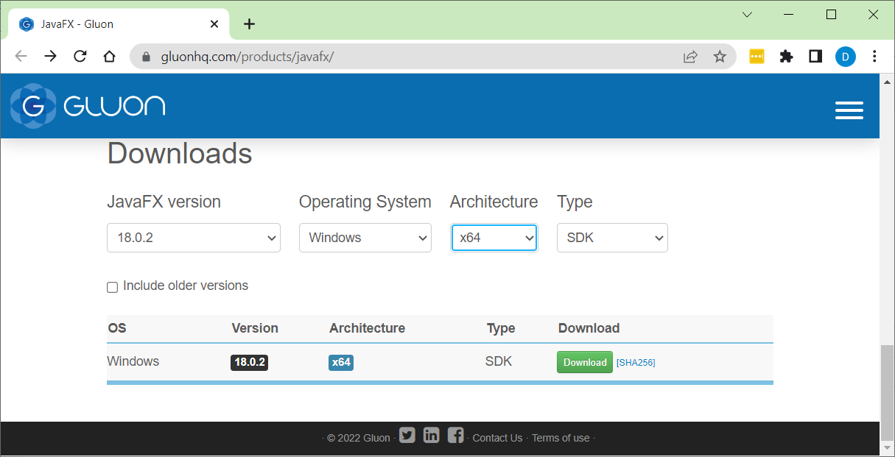

1. (Read, no action required) You will need to unzip the downloaded file somewhere. It doesn’t matter where, you just **need to remember the path to this folder.** I’m going to create a folder named: *c:\javafx* and unzip mine there, mainly because that will be an easy place to remember where it is.
2. Create a folder named: *javafx* in the root folder for the *C* drive.
3. Drag the downloaded file (in my case: *openjfx-20.0.2_windows-x64_bin-sdk.zip*) to the *javafx* folder from the step above
4. Unzip the file to the *javafx* folder: right-click the file and choose: Extract All. Then *Browse* to the *javafx* folder and choose: *Select Folder*

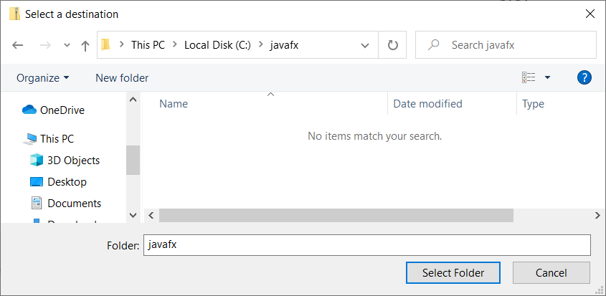

1. Then chose *Extract*

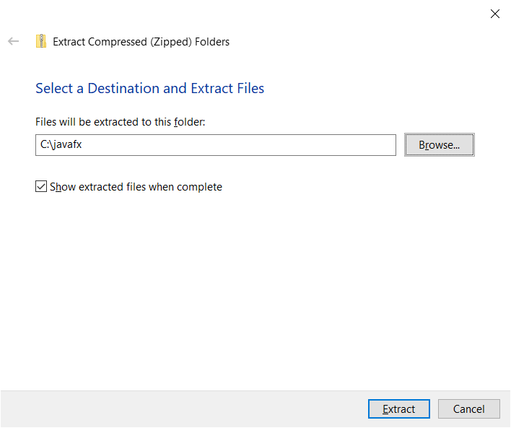

1. The result will look as shown below. The files that are needed are in the *lib* folder. Note the path (highlighted below). You will need this path later. Either remember how to get back to it or copy it into a Word document or anywhere for use later.

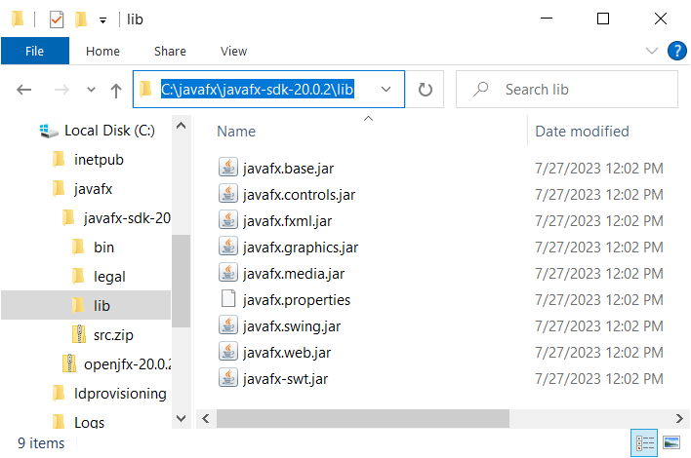

# Create a JavaFX Application

See Lab 15a, Section 2

# Build User Library

See Lab 15a, Section 3

For step 4 in that document, you’ll need the path to the location where you copied your JavaFX libraries (Section 3, step 7 above)

# Attach JavaFX Libraries to Project

See Lab 15a, Section 4

# Customize the GUI

See Lab 15a, Section 5

# Attach JavaFX Libraries to Subsequent Projects

See Lab 15a, Section 6

# Use Downloaded Packages with JavaFX Code

See Lab 15a, Section 7

# Use Jar File with JavaFX Code

See Lab 15a, Section 8