Lab 15 – JavaFX Setup in Eclipse
Setting up to Work on a Personal Device or in CS Open Lab
Last updated: 8.17.2025
Contents
1 Introduction 1
2 Install e(fx)clipse 2
3 Download JavaFX Libraries 3
4 Create a JavaFX Application 6
5 Build User Library 8
6 Attach JavaFX Libraries to Project 11
7 Some Possible Errors & how to Fix them: 13
8 Customize the GUI 15
9 Attach JavaFX Libraries to Subsequent Projects 16
10 Use Downloaded Packages with JavaFX Code 17
11 Use Jar File with JavaFX Code 20

Introduction
To create Graphical User Interfaces (GUI) we use a set of libraries called JavaFX. In this lab you will:
- Setup Eclipse to use JavaFX on your personal device. These are done one-time. – Sections 2 & 3
- Build a HelloWorld app – Sections 4-9
- Configure a JavaFX app to use code you have been provided – Section 10
- Configure a JavaFX app to use a Jar file you have been provided – Section 11
A few people (usually, but not always with Mac users) will encounter problems, probably at the end of Section 6. You will do 3 labs and 4-5 homework assignments using JavaFX, so this lab is important! If you encounter problems:
- Check the possible solutions in Section 7.
- Start completely over in Section 4 with a new JavaFX project.
- Seek help from me. I’m willing to help one time. However, I’ve never used a Mac so if that is the case, I probably can’t help.
- You can ask me to find a student who can possibly help you.
- Do your work in the CS Open Lab (Nevins 2111). The computers in the CS Open Lab are set up correctly. If you choose to work in the CS Open Lab, then Sections 2 & 3 are already complete and you will complete this lab by doing Sections 4-11. This will be clearly marked at the beginning of each Section.
I developed the instructions below (through internet resources, the help of several students, and trial-and-error); however, in 2023, I found this video that is almost identical to these instructions.

Install e(fx)clipse
This Section is only if you are working on a personal device. If working in the CS Open Lab, advance to Section 4.
The first thing we need to do is to install the e(fx)clipse plugin for Eclipse which, among other things, allows us to create a “JavaFX Project” in Eclipse.
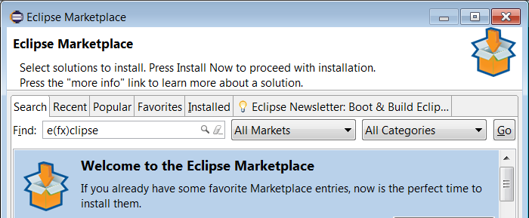
- Open Eclipse in any workspace (existing or new).
- In Eclipse, choose: Help, Eclipse Marketplace
- In the Find field, type: “e(fx)clipse.” Then choose: Go

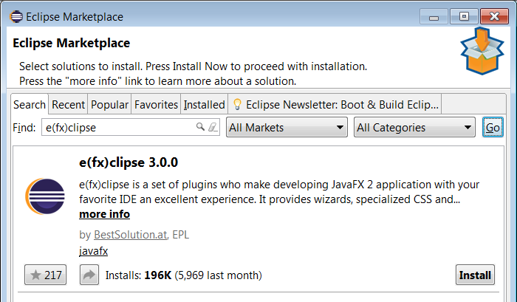
- The result should be similar to the figure on the right (except different version). Choose: Install
Note: the install dialog will close and Eclipse will be minimized. However, it is still installing. The Eclipse icon in the Task Bar will have a green bar moving left to right showing that it is still installing. Might take a minute or two.
- Choose to: Restart Now when prompted.

Download JavaFX Libraries
This Section is only if you are working on a personal device. If working in the CS Open Lab, advance to Section 4.
In this section, the JavaFX libraries are downloaded to your device. You’ll only need to do this once; however, you’ll need to remember the location where you download them.
- Create a folder named: javafx in the root folder for the C drive. It doesn’t matter where, you just need to remember the path to this folder.
- Visit this site below and view the “Roadmap” which shows the “Release” versions of JavaFX and the “Minimum JDK”. As of Sep 23, 2025, the versions are shown in the table below. You will be choosing (next step) either 25 or 21, depending on your version of the JDK.
https://gluonhq.com/products/javafx/
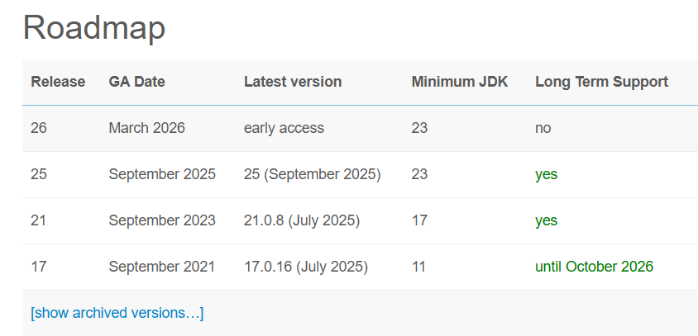
- Scroll down to “Downloads”. Fill the drop-downs with appropriate values.
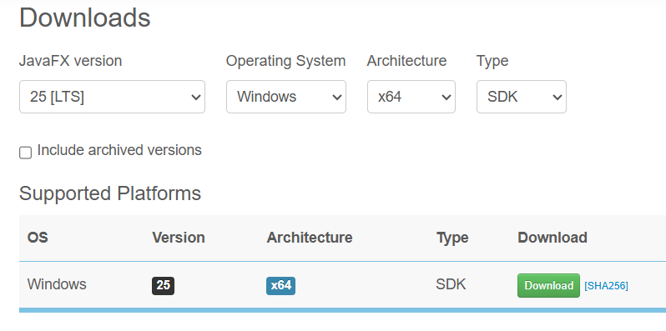
- Drag the downloaded file (in my case: openjfx-25_windows-x64_bin-sdk.zip) to the javafx folder from step 1 above.

- Do the following:
  - Right-click the zip file and choose: Extract All.
  - Choose: Browse and then browse to the javafx folder and choose: Select Folder
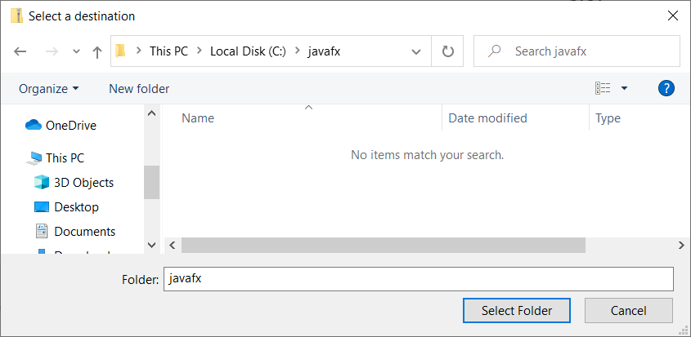
  - Right-click the file and choose: Extract All. Then Browse to the javafx folder and choose: Select Folder
  - Right-click the file and choose: Extract All. Then Browse to the javafx folder and choose: Select Folder
  - Chose Extract
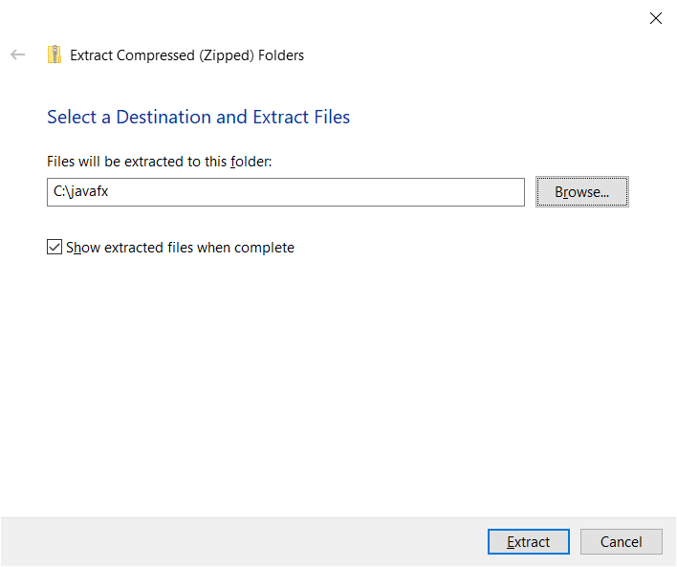

- (Read, no action required) The result will look as shown below. The files that are needed are in the lib folder. Note the path (highlighted below). You will need this path later. Either remember how to get back to it or copy it into a Word document or anywhere for use later.
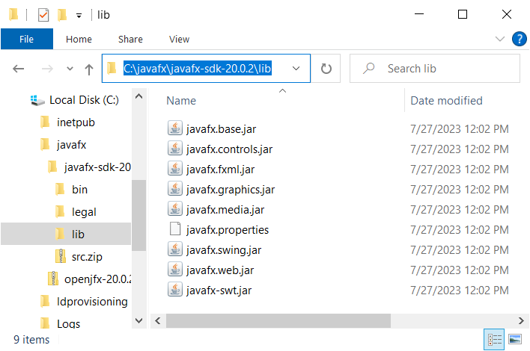

Create a JavaFX Application
Everyone (working on personal device or in the CS Open Lab) does this Section.
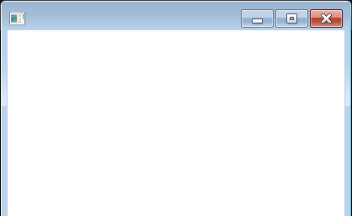
In this section, we create a JavaFX project which allows us to create a GUI (Graphical User Interface) application. When you create a JavaFX project, it automatically provides sample code that when run displays a GUI consisting only of an empty window as shown on the right.

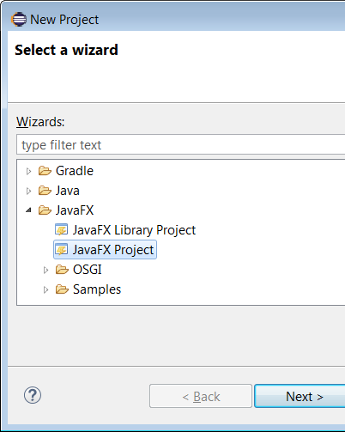
- Do the following: in Eclipse, as shown on the right, choose: File, New, Project, JavaFX, JavaFX Project, Next

- Do the following:
- Provide a Project name: samplegui
Warning: The name cannot have any spaces or special characters and should be lower-case
- CHECK: Create module-info.java at the bottom
- Choose: Finish
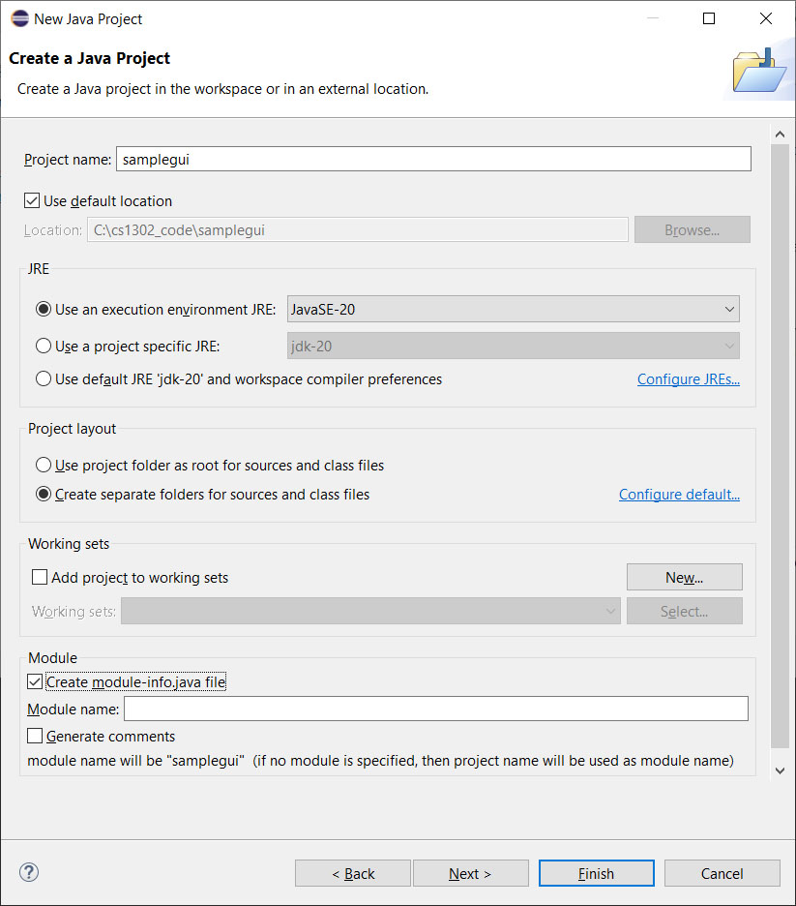

- (Read, no action required) Reference the figure below.
- An application package was created. Inside this package is a class, Main.java that contains a very simple Gui.
- Double-click Main.java to open it as shown below on the right.
- Notice the red “x”’s – that means there are compilation errors. We’ll resolve those next.
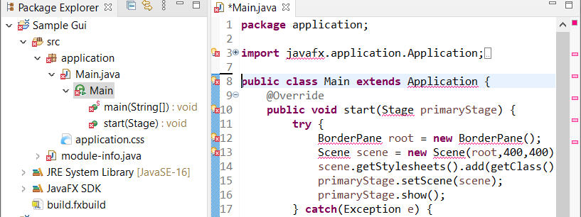

Build User Library
Everyone (working on personal device or in the CS Open Lab) does this Section.
In this section you will build a User Library in Eclipse that contains the JavaFX libraries. In the next section, you will attach this User Library to your JavaFX project. You’ll need to create this library each time you use a new workspace. Probably, you’ll just have a single workspace for working on JavaFX projects and they can all use this User Library.
- In Eclipse, choose: Window, Preferences. Then, from the tree on the left, choose: Java, Build Path, User Libraries, and then New (on the right)
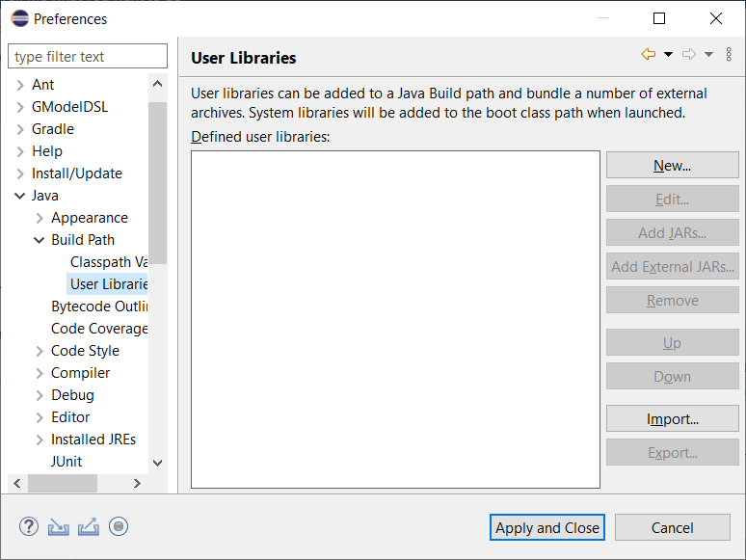

- Choose: New, and then provide the name: JavaFX2 (name doesn’t matter) and then OK.
The figure below shows the name as JavaFX – don’t use that, put a 2 or something on the end. There may already exist one with the name, JavaFX, but it doesn’t work and/or is not what we need.
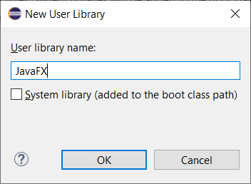
- Choose: Add External Jars (on the right)
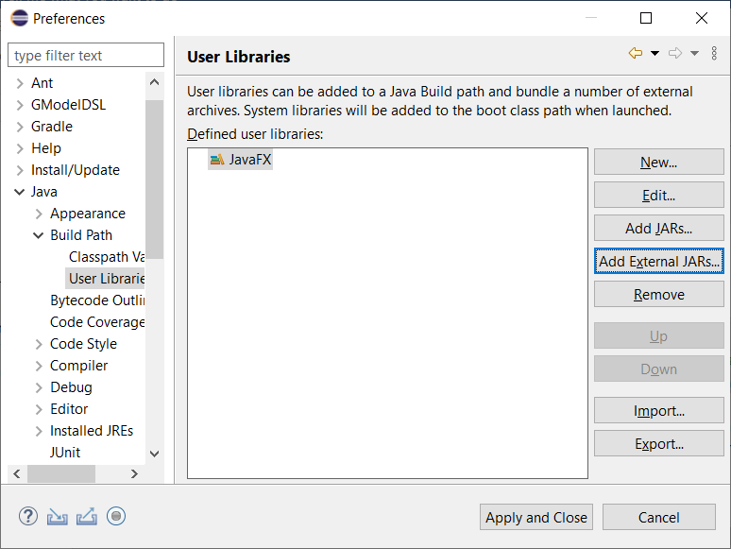

- Navigate to the JavaFX jar files, select them, and choose: Open
Note: if working in the CS Open Lab (2111 Nevins), the location of the JAR files is: C:\Eclipse\JavaFX\lib
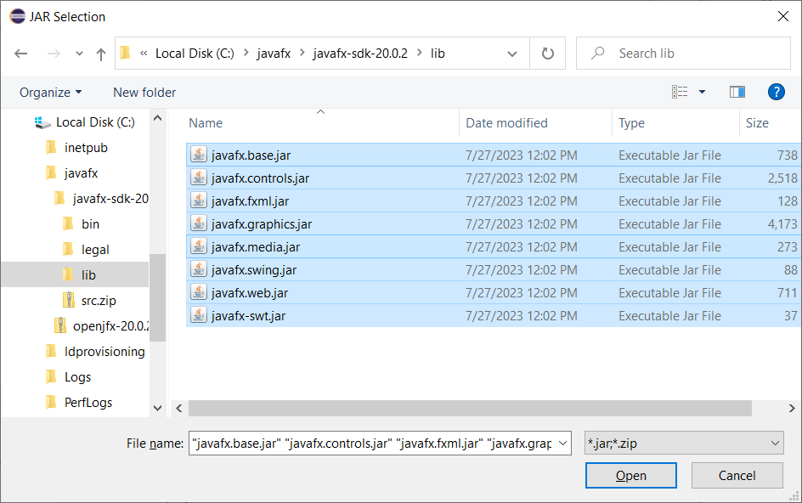
- Choose: Apply and Close
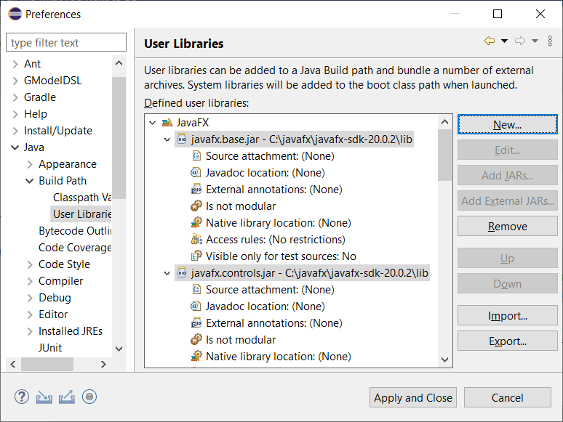
- The compilation errors are still there. We’ll fix that in the next section by attaching the User Library we just built to the project.

Attach JavaFX Libraries to Project
Everyone (working on personal device or in the CS Open Lab) does this Section.
In this section you will attach the JavaFX User Library from the previous section to the JavaFX Project you created earlier. At the conclusion, the sample GUI will compile, run, and display (hopefully!).
- Next, we need to attach the JavaFX libraries to our project.
- Select the SampleGui project node, right-click, and choose: Build Path, Configure Build Path
- Choose the Libraries tab and the Modulepath node. Then choose: Add Library
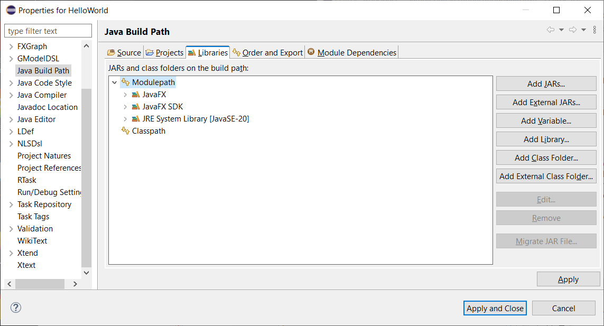
- Choose: User Library, and then Next
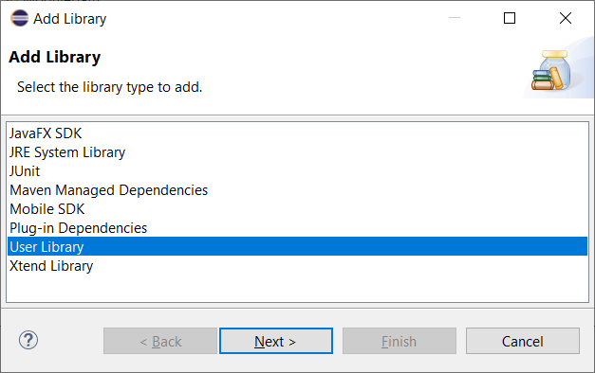

- Select: JavaFX2 and Finish (the figure shows JavaFX, on your screen, you’ll see: JavaFX (possibly) and JavaFX2 (the one you created)
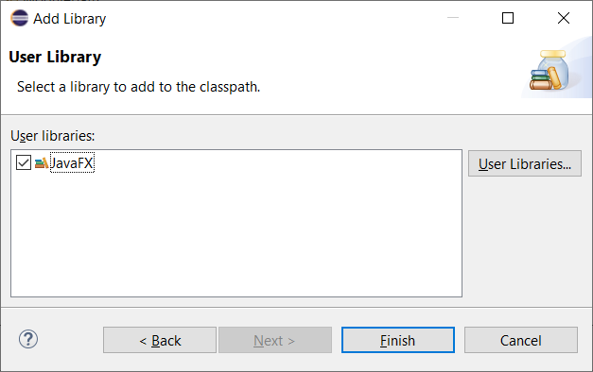
- Choose: Apply and Close.
- Open Main.java and the compile errors should be gone now:
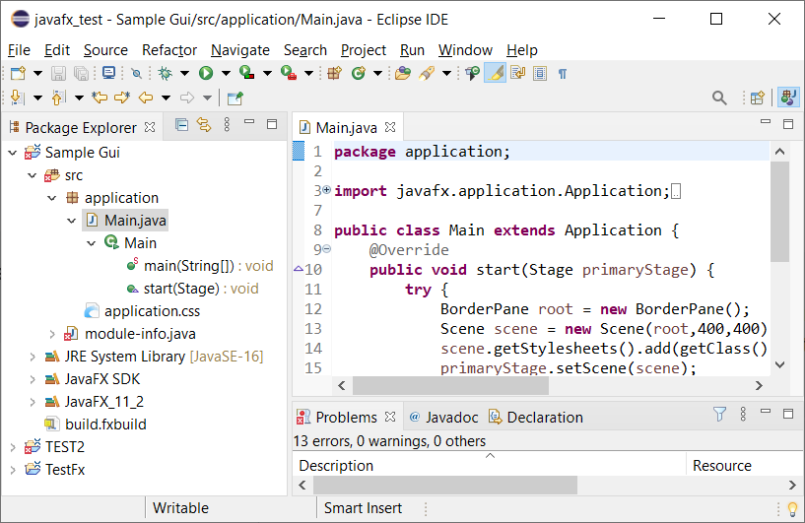
- Run Main by choosing: Run, Run (or the Green arrow icon). If things are successful, you’ll see an empty Gui as shown on the right. If you are successful, move on to section 8. If you encounter problems:
- Check the possible solutions in Section 7.
- Start completely over in Section 4 with a new JavaFX project.
- Seek help from me. I’m willing to help one time. However, I’ve never used a Mac so if that is the case, I probably can’t help.
- You can ask me to find a student who can possibly help you.
- Do your work in the CS Open Lab (Nevins 2111). The computers in the CS Open Lab are set up correctly. If you choose to work in the CS Open Lab, then Sections 2 & 3 are already complete and you will complete this lab by doing Sections 4-11. This will be clearly marked at the beginning of each Section.

Some Possible Errors & how to Fix them:
Remember to try creating a new JavaFX project if things go wrong.
These are some possible errors you got from the previous step and their solution.
- Error 1
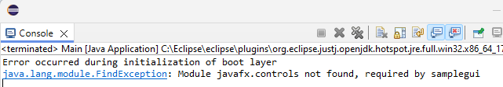
- DELETE module-info.java from the Package Explorer.
- Note: you are going to “undo” this delete in a future step. On a Windows machine, I press: “Del” and it asks to confirm the delete. Then, in the future step, I use: Ctrl+z to undo the delete.
- Rerun the program and you will probably get this error:
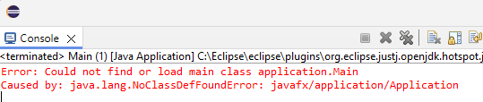
  - Press: Ctrl+z (undo) and module-info.java should appear back in the Package Explorer.
  - Rerun Main by choosing: Run, Run (or the Green arrow icon) and it will display an empty Gui as shown on the right.

- Error 2 – This is probably related to the above error; however, I’ve seen this one without the earlier error above. In this case, I simply created a new JavaFX project (in the same workspace, perhaps named: samplegui2, built the user library, attached it, and things worked.

- Error 3 – The error message in the console refers to “Css2Bin”. It will look similar to:
Exception in thread "main" java.lang.IllegalArgumentException: expected file name as argument
at com.sun.javafx.css.parser.Css2Bin.main(Css2Bin.java:44)
The solution is to: right-click the project in the Package Explorer and choose: Run/Debug Settings. Then, select “Css2Bin” and choose: Delete (on the right).
- Error 4 (MAC Specific) – The error message will look similar to:
2025-03-06 16:05:53.358 java[4314:363476] +[IMKClient subclass]: chose IMKClient_Modern
2025-03-06 16:05:53.359 java[4314:363476] +[IMKInputSession subclass]: chose IMKInputSession_Modern
This guide is what fixed it for a student:
https://medium.com/@yuhsuanho_65370/javafx-setup-with-eclipse-on-mac-57aadba939f4
If JavaFX is attached properly per your guide and the rest of the steps are followed, all you need to do is:
- When the project is open in eclipse, click the "Help" tab on the top of the screen, then type in "Run Configurations".
- This should pop up a little window that looks as shown below. From here click on the "Arguments tab"
- Uncheck the box that says "Use the -XstartOnFirstThread argument when launching with SWT".
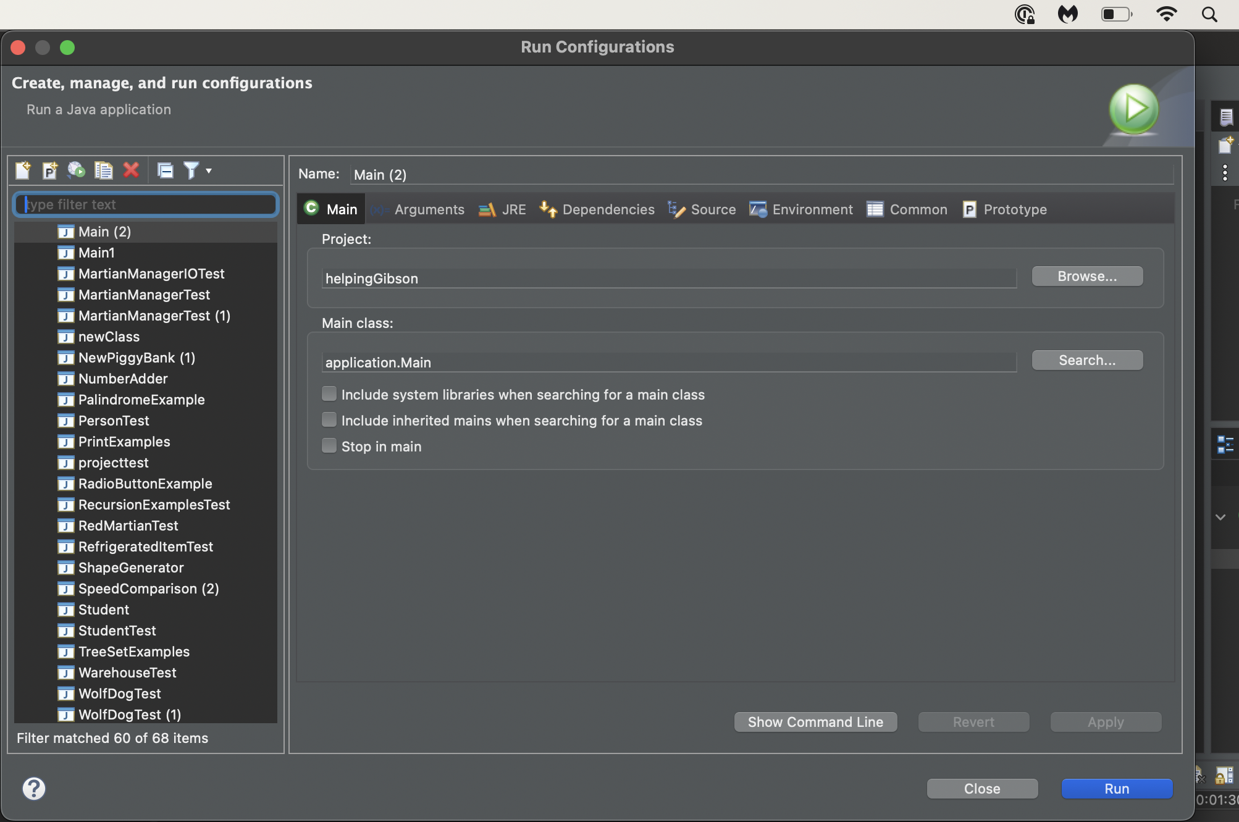

- Error 5 – The error message will look similar to:

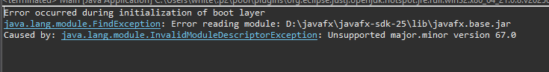
This means that the JDK you are compiling with is below the minimum required for the version of the JavaFX libraries you are using. In this case, download the next earlier version of the libraries.
To see which version of the JDK you are using:
- Right-click project and choose: Properties
- Choose: Java Compiler from the left menu.
- Then you will see, “JDK Compliance” and a checkbox that states the version. Mine shows: “JavaSE-16” (I’m using an older version)

In Lab 15, Section 3, Step 2, it shows a table (copied from the download site) the most recent versions of the libraries. In my case, I would be using Release 17 as Release 21 requires a minimum JDK of 17.
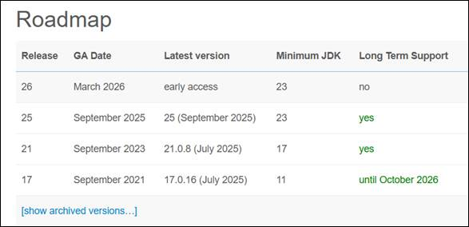

Customize the GUI
Everyone (working on personal device or in the CS Open Lab) does this Section.
Your goal here is to make a simple GUI just to show that things are working.
- Next, we add some controls to the GUI as a very brief example of how to build a GUI. Do the following
- Close the empty GUI window that you launched above.
- Identify this line in the code window:
BorderPane root = new BorderPane();
- Immediately after the line above, add these two lines (use your name):
Label lbl = new Label("Dave Gibson");
root.setCenter(lbl);
The resulting code will appear as shown below:
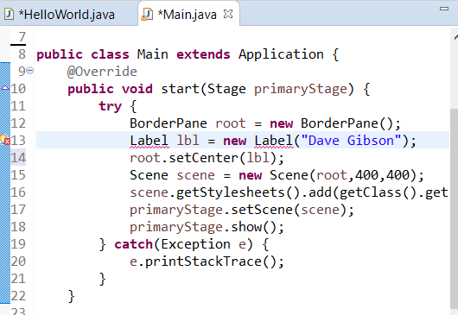
- You’ll notice a red X in the left margin that indicates a compile error. You also see the red squiggly under the Label. This indicates where the compile error is. To resolve this compile error, we need to add in import statement. You can do this in one of three ways. Do one of the following:
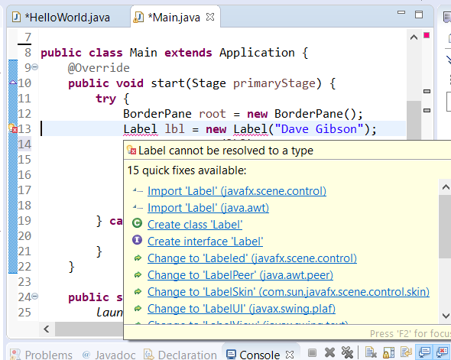
- Hover your mouse under the Label and a context menu will appear as shown below (if necessary, click away from that line, and then move your mouse to hover over the Label). Then, choose:
“Import ‘Label’ (javafx.scene.control)”
Note: In the figure on the right, it is the first item in the list, but might not be on your computer. Make sure you pick the correct one.
- Or, similar to ii above, click the red X in the margin and then, choose:
“Import ‘Label’ (javafx.scene.control)”

- Add this in the import section at the top of the file:
import javafx.scene.control.Label;

- Run Main by choosing: Run, Run (or the Green arrow icon) and it will display the Gui as shown below.
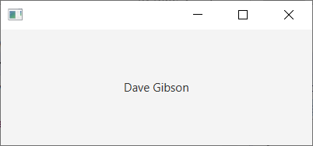

Attach JavaFX Libraries to Subsequent Projects
(Read, no action required)
The User Library lives in the workspace. In other words, if you create another JavaFX project in this workspace, all you need to do is attach the User Library as described in Section 6 above. However, if you create a new workspace, or use one without the JavaFX User Library, then you’ll need to first create the library as described in a Section 5 above, and then attach it to the project.
Note that when you first create a new JavaFX Project, you can attach the User Library immediately, instead of adding it after the project is created. On the “New JavaFX Project” dialog, after you supply the project name, instead of choosing: Finish, choose: Next. Then follow the steps (see image below) to attach as described in a Section 6 above, starting at step 1b.
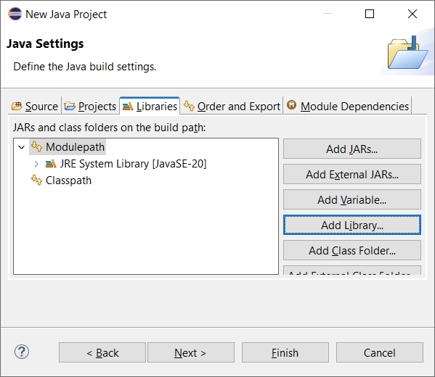

Use Downloaded Packages with JavaFX Code
Everyone (working on personal device or in the CS Open Lab) does this Section.
This section shows how to setup and run a JavaFX Project that has been provided to you in a zip file. The process is similar to a Section above, except that there is one additional step. This technique is important so that you can run sample code I provide to you for examples, for a homework, or a project.
- Download: lab15_code.zip from the Lab 15 “code” link on the Labs page. Unzip somewhere (doesn’t matter where). Once unzipped, you will find (figure on the left, below): (a) martianmanager.jar which we will use in the next section, (b) an example_combobox folder with 2 files inside (figure on the right, below)
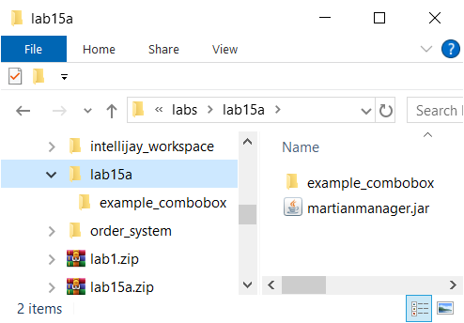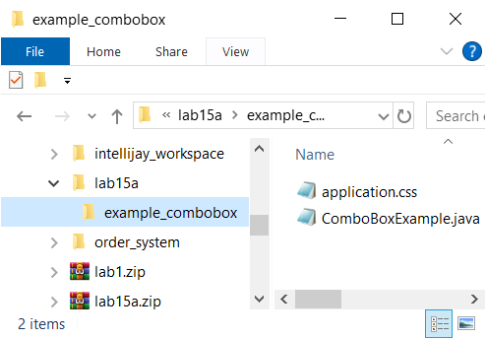
- In the existing workspace, create a new JavaFX project by doing the following:
- Provide a Project name: examplecombobox
Warning: The name cannot have any spaces or special characters and should be lower-case
- CHECK: Create module-info.java at the bottom
- Choose: Finish
- Attach the JavaFX libraries following directions from Section 6. Now, Main.java should run correctly. Verify this.
- Copy (or drag) the example_combobox folder into src node. When prompted, choose: Copy files and folders. Open ComboBoxExample.java as shown below:
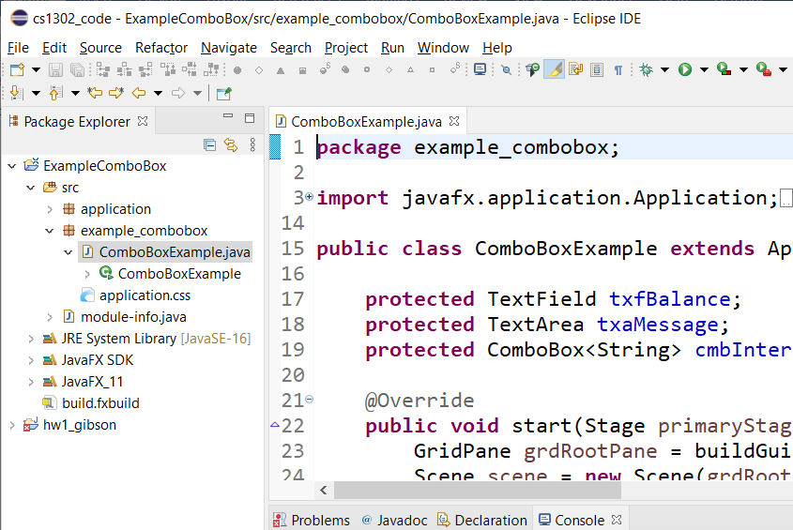

- ComboBoxExample.java compiles, but will not run. Try it and note the error:
Exception in Application constructor
Exception in thread "main" java.lang.reflect.InvocationTargetException
at java.base/jdk.internal.reflect.NativeMethodAccessorImpl.invoke0(Native Method)
...
- To make it run, we need to modify module-info.java. Open module-info.java (in the Package Explorer under the src node). The result is shown below:
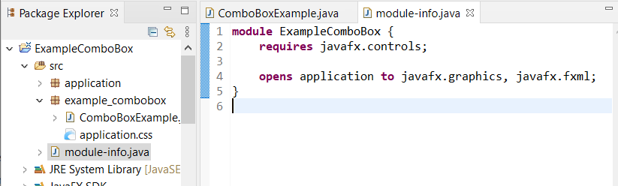
- Add this line to module-info.java:
opens example_combobox to javafx.graphics, javafx.fxml;
So that the file now reads:
module examplecombobox {
requires javafx.controls;

opens application to javafx.graphics, javafx.fxml;
opens example_combobox to javafx.graphics, javafx.fxml;
}
- Save and run. Now, ComboBoxExample.java should run and function properly as shown below.
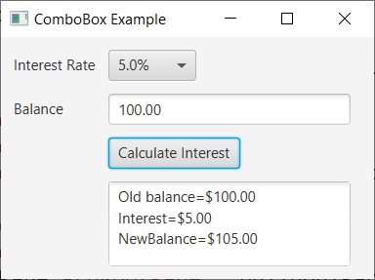

Use Jar File with JavaFX Code
Everyone (working on personal device or in the CS Open Lab) does this Section.
Jar files are like zip files and are used for distributing Java code. This section explains how to add a Jar file to a JavaFX project.
- Find martianmanager.jar in the download from Section 10, step 1 above.
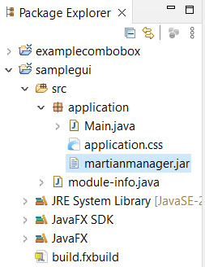
- Return to your samplegui project in the Package Explorer. Drag the jar file into the src node into the application folder in the Package Explorer as shown on the right (choose: Copy files and OK on the dialog that appears).

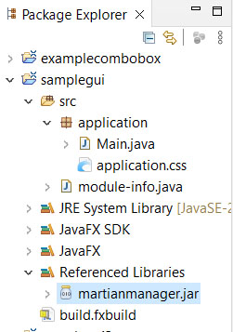
- Right-click the jar file in the Package Explorer and choose: Build Path, Add to build path. The file will “move” from the package folder to the “Referenced Libraries” folder as shown in the figure on the right.

- Open module-info.java and add this line: “requires martianmanager;” Thus, the entire file might look like this:
module samplegui {
requires javafx.controls;
requires martianmanager;

opens application to javafx.graphics, javafx.fxml;
}

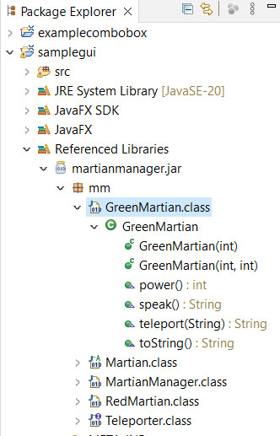
- Expand martianmanager.jar in the Referenced Libraries node. As shown on the right, for this example, the available classes are shown (GreenMartian, Martian, etc.), as well as the methods in each class and their signature (e.g. GreenMartian has a constructor that accepts an integer, and another that accepts 2 integers, etc.). In addition, it shows that these classes are in the mm package, this will be important next.
- Open Main.java (the one in the samplegui project). Add the line below the import statements that are already there.
import mm.*;
Note: to use any of the classes in the JAR file, you must first import them. The statement above imports everything (*) in the JAR file. Note that you must include the package (mm for this example) in the path.
- In the start method, replace this line:
Label lbl = new Label("Dave Gibson");
With these two lines (use your name):
RedMartian rm = new RedMartian(3,3);
Label lbl = new Label("Dave Gibson\n " + rm.toString());
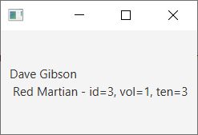
- Verify that Main.java runs correctly. The display will look similar to the figure on the right.

- Make a screen shot of your GUI and turn in on Blazeview in the Lab 15 dropbox.

The lab is now complete.

