Lab 10 – Text Files
Last updated: 2.25.2026
Contents
1 Introduction 1
2 Reading Integers, Example 1 2
3 Reading Integers, Example 2 4
4 Reading other Data Types, Example 3 5
5 Reading Entire Lines, Example 4 6
6 Bank*Employee, Example 5 7
7 String.split() 11
8 Bank*Account, Example 6 14
9 Writing Data to a Text File 16
10 The File Class 17
11 Submission 17
Appendix 1 Parsing Data 18
Appendix 2 More Parsing 21

This lab has 2 places where you will write code yourself.

Introduction
When a program runs, it may accumulate data, for example in an array list. However, that data is gone when the program ends. Clearly, to write real systems, we must have data that persists between running a program again. One way to persist data is in text files, which contain simple text with no formatting. This lab describes how to read data from a text file into your program, and, how to write data you have in your program into text files.

To make this document easier to read, it is recommended that you turn off spell checking in Word:

- Choose: File, Option, Proofing
- At the very bottom, check: “Hide spelling errors…” and “Hide grammar errors…”

Reading Integers, Example 1
- Setup – Create a project named, lab10_lastName and create a package named: read_examples.
- Create Text File – Do the following:
- Select the package, read_examples.
- Choose: File, New, Untitled Text File (or File, New, Other, General, Untitled Text File)
- Type in some integers on a single line:
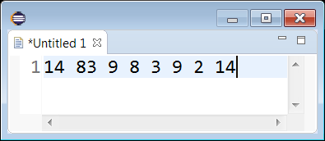
- Choose: File, Save As
- Navigate to the package folder. It will be something like: lab10_lastName/src/read_examples
- Type in the file name: numbers1.txt
- Verify that the numbers1.txt is in the package
- Create Class to Read Data – Create a class named ReadExample1 in the read_examples package and replace everything in the class with the code below which simply reads the first two value in the text file:
package read_examples;
import java.io.File;
import java.io.IOException;
import java.util.Scanner;
public class ReadExample1 {
public static void main(String[] args) {
String fileName = "src/read_examples/numbers1.txt";
File inFile = new File(fileName);
int x;
try {
Scanner input = new Scanner(inFile);
x = input.nextInt();
System.out.print(x + " ");
x = input.nextInt();
System.out.print(x + " ");
input.close();
}
catch(IOException e) {
System.out.println("Error reading file");
}
}
}

- Run the program and verify that the first two numbers in the text file are displayed in the console.
- Do the following:
- Change the name of the text file to: numbers2.txt.
- Run the program and observe the output: “Error reading file”.
- Change the name of the text file back to: numbers1.txt.
- Run the program and verify that the first two numbers are displayed in the console.
- Read, no action required. Note the following in the code above:
- We must specify the path (src/read_examples) along with the file name and then we use the file name to create a File object:
String fileName = "src/read_examples/numbers1.txt";
File inFile = new File(fileName);
- There is a try block followed by a catch block. When we read a text file, we must put the code that reads inside a try block. If the file is not found, the catch block is executed.
- We use a Scanner object and use its nextInt method to read an integer
Scanner input = new Scanner(inFile);
x = input.nextInt();

- When we are done reading, we must close the Scanner object:
input.close(); // Close the file
- Open numbers1.txt and add a character somewhere in the file. For example:
14 83a 9 8 3 9 2 14
- Run and verify that the program crashes by throwing an un-caught InputMismatchException.
Exception in thread "main" java.util.InputMismatchException
at java.base/java.util.Scanner.throwFor(Scanner.java:977)
at java.base/java.util.Scanner.next(Scanner.java:1632)
at java.base/java.util.Scanner.nextInt(Scanner.java:2297)
at java.base/java.util.Scanner.nextInt(Scanner.java:2251)
at Lab10/read_examples.ReadExample1.main(ReadExample1.java:13)

- Read, no action required. Note that nextInt() will only read an int.
- Open numbers1.txt and remove the character. Rerun and verify the output.
14 83a 9 8 3 9 2 14

Reading Integers, Example 2
- Copy ReadExample1.java and paste giving it the new name: ReadExample2.java
- Replace everything in the class with the code below which reads all the values in the text file.
package read_examples;
import java.io.File;
import java.io.IOException;
import java.util.Scanner;
public class ReadExample2 {
public static void main(String[] args) {
String fileName = "src/read_examples/numbers1.txt";
File inFile = new File(fileName);
int x;
try {
Scanner input = new Scanner(inFile);
while(input.hasNext()) {
x = input.nextInt();
System.out.print(x + " ");
}
input.close();
}
catch(IOException e) {
System.out.println("Error reading file");
}
}
}

- Run the code and verify that all values in the text file are displayed in the console.
- Read, no action required. Note the following in the code above. The Scanner class has a hasNext method that returns true if there is something left to read in the file. Thus, the loop reads integers until there is nothing left to read.
while(input.hasNext()) {
x = input.nextInt();
System.out.print(x + " ");
}

Reading other Data Types, Example 3
- Copy ReadExample2.java and paste giving it the new name: ReadExample3.java
- Create a text file named: stuff.txt with these values:
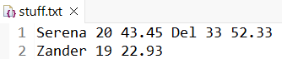
Note:
- The data is 3 sets of: name, age, salary
- Two sets are on the first line and one on the second.
- Replace everything in the class with the code below which reads all the values in the text file.
package read_examples;
import java.io.File;
import java.io.IOException;
import java.util.Scanner;
public class ReadExample3 {
public static void main(String[] args) {
String fileName = "src/read_examples/stuff.txt";
File inFile = new File(fileName);
try {
Scanner input = new Scanner(inFile);
while(input.hasNext()) {
String name = input.next();
int age = input.nextInt();
double salary = input.nextDouble();
String msg = String.format("Name: %s, age:%d, salary:$%.2f", name, age, salary);
System.out.println(msg);
}
input.close();
}
catch(IOException e) {
System.out.println("Error reading file");
}
}
}
- Run the code and verify that all values in the text file are displayed in the console.
- Read, no action required. Note the following in the code above. We use the Scanner’s:
- next() method to read a String.
- nextInt() method to read an int.
- nextDouble() method to read a double.

Reading Entire Lines, Example 4
- Copy ReadExample3.java and paste giving it the new name: ReadExample4.java
- Read, no action required.
- The Scanner class has a nextLine() method that read an entire line
- In this example, we will read the same file, stuff.txt except we will read an entire line each time through the loop. Thus, the loop will occur twice.
- Replace everything in the class with the code below which reads the file, line-by-line
package read_examples;
import java.io.File;
import java.io.IOException;
import java.util.Scanner;
public class ReadExample4 {
public static void main(String[] args) {
String fileName = "src/read_examples/stuff.txt";
File inFile = new File(fileName);
try {
Scanner input = new Scanner(inFile);
while(input.hasNext()) {
String line = input.nextLine();
System.out.println(line);
}
input.close();
}
catch(IOException e) {
System.out.println("Error reading file");
}
}
}
- Run the code and verify that all values in the text file are displayed in the console.

Bank*Employee, Example 5
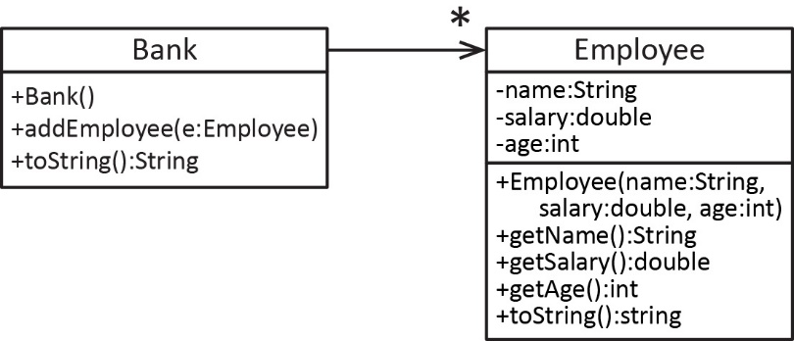
- Read, no action required.

- Consider the class diagram shown on the right. A Bank has many Employees and each Employee has a name, salary, and age.

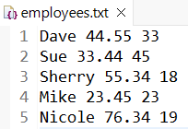
- Consider the text file shown on the right that has information about a number of employees of the bank. Each row has the name, salary, and age of an employee.

- In this example, we are going to write a method that reads the employees, putting each one in the bank, and returning a Bank object. The signature is shown below. We’ll explain why the method is static shortly.
public static Bank buildBank(File inFile) {
- Create Text File – Do the following:
- Create a package named: bank_employees.
- Create a text file named: employees.txt and copy this data in:
Dave 44.55 33
Sue 33.44 45
Sherry 55.34 18
Mike 23.45 23
Nicole 76.34 19
Note: You will probably end up with a blank line in the file (line 16). I don’t think it will affect the reading, but probably better to use backspace to delete that line.
- Save the file in the bank_employees package.

- Create Data Classes (Employee & Bank) – Do the following:
- Create a class named Employee (in the bank_employees package) and replace everything in the class (except the package statement at the top) with:
public class Employee {
private String name;
private double salary;
private int age;

public Employee(String name, double salary, int age) {
this.name = name;
this.salary = salary;
this.age = age;
}

public String getName() { return name; }
public double getSalary() { return salary; };
public int getAge() { return age; }

@Override
public String toString() {
String msg = String.format("name: %s, salary: $%.2f, age: %d", name, salary, age);
return msg;
}
}
- Create a class named Bank (in the bank_employees package) and replace everything in the class (except the package statement at the top) with:
import java.util.ArrayList;

public class Bank {
private ArrayList<Employee> emps = new ArrayList<>();

public Bank() {}

public void addEmployee(Employee emp) {
emps.add(emp);
}

@Override
public String toString() {
String msg = "Bank Employees\n";
for(Employee e : emps) {
msg += e + "\n";
}
return msg;
}

}

- Create the Reader Class & buildBank Method – Do the following:
- Create a class named EmployeeReader and replace everything in the class (except the package statement at the top) with:
import java.io.File;
import java.io.IOException;
import java.util.Scanner;

public class EmployeeReader {

public static Bank buildBank(File inFile) {
Bank bank = new Bank();
try {
Scanner input = new Scanner( inFile );
while(input.hasNext()) {
String name = input.next();
double salary = input.nextDouble();
int age = input.nextInt();
Employee e = new Employee(name, salary, age);
bank.addEmployee(e);
}
input.close();
}
catch( IOException e ) {
System.out.println(e);
}
return bank;
}
}
- Note the algorithm for the buildBank method below and then look back at the code to see the correlation.
- Create Bank
- Create Scanner
- Loop until no more Employees
  - Read the name, salary, and age
  - Use them to build an Employee object
  - Add Employee to the Bank.
- Return Bank
- Note the following:
- We always put reading (or writing) a text file in a separate class, separate from the data classes (Employee & Bank).
- We make the buildBank method static because there is no need to create an EmployeeReader object to use the method.
- The buildBank method accepts a File. Thus, whichever code uses this method, will need to supply a valid File.

- Create and Run the Test Class – Do the following:
- Create a class named EmployeeReaderTest and replace everything in the class (except the package statement at the top) with:
import java.io.File;

public class EmployeeReaderTest {

public static void main(String[] args) {
testBuildBank();
}

public static void testBuildBank() {
String fileName = "src/bank_employees/employees.txt";
File inFile = new File(fileName);
Bank bank = EmployeeReader.buildBank(inFile);
System.out.println(bank);
}

}
- Run the test class and verify the output.
- Your Turn! – Do the following:
- Write a new method, buildEmployeeList in the EmployeeReader class that accepts a File and returns an ArrayList of Employee objects that are read from the file. Hint, the signature of the method is:
public static ArrayList<Employee> buildEmployeeList(File inFile) {
- In EmployeeReaderTest , write a test method for this new method named: testBuildEmployeeList

- Read (no action required) – Consider the three text files shown below. The code we wrote above to read employees.txt will read any one of these properly. Try it if you like.
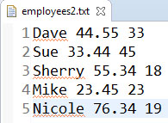
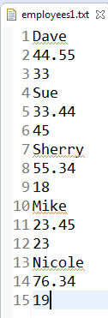

String.split()
The Scanner class’s nextLine() method reads an entire line – whatever is on it, as a string. For example, if a text file has a line like this:
43.85 66.239 8.223
Then, if we have a Scanner named: input, then:
String line = input.nextLine();
Once this executes, then:
line = "43.85 66.239 8.223";
When dealing with text files, sometimes it is useful and/or necessary to read a text file line-by-line. Then, as we learn in this section, we can break (split) the line into the individual pieces. This is called parsing data. To learn how to parse data, we must learn how to break a string into tokens using the String class’s split method.
- (Read, no action required) –
- Consider a text file with a line like this.
43.85 66.239 8.223
We say that there are 3 tokens on this line. The tokens are the things we are interested in, in this case, 3 numbers. The space(s) between the tokens are called delimiters. Thus, delimiters separate tokens in a text file.
- The String class has a split method that breaks a string into “tokens” based on a delimiter and returns the tokens in an array. For example:
String s1 = "43.85 66.239 8.223";
String[] vals = s1.split(" ");
Results in the vals array containing 3 elements: "43.85", "66.239", "8.223". The delimiter in this case is a space (" "). Thus, everything between the spaces is a token.
- Above, we say that we “split the string on a space.” Though this will work for our examples, technically there are lots of different types of spaces. This delimiter, “\s” will catch more of them. Remember, since a backslash is a delimiter in a Java string, it must be delimited with a “\”. Thus, we would write it like this:
String[] vals = s1.split("\\s");
- The two examples above will split the string on a single space.
String[] vals = s1.split(" ");
String[] vals = s1.split("\\s");
If we want to split on any number of spaces, we do this:
String s1 = "43.85 66.239 8.223";
String[] vals = s1.split("\\s+");
Which results in the vals array containing: "43.85", "66.239", "8.223"
- To split a string any of multiple characters, we surround the characters with “[ ]”. For example:
String s1 = "4,3 5,,,2, 8";
String[] vals = s1.split("[,\\s]+");
Results in the vals array containing: "4", "3", "5", "2", "8"
- To split on common punctuation characters:
String s1 = "This. Is,,, \nfunny; \t\tyes: why? now!";
String[] vals = s1.split("[.,;:?!\\s]+");
Results in the vals array containing: "This", "is", "funny", "yes", "why", "now"

- The delimiter (the argument to the split method) is actually a regular expression, which can be composed to delimit and pattern match sophisticated situations.
Next, we will show some examples:
- Create Example – Do the following:
- Create a new package: string_split.
- Create a class named: StringSplitExamples and replace everything in the class (except the package statement at the top) with:
public class StringSplitExamples {
public static void main(String[] args) {
split_example1();
split_example2();
split_example3();
split_example4();
split_example5();
}

// Splits on a single space
public static void split_example1() {
System.out.println("split_example1()");
String s1 = "43.85 66.239 8.223";
String[] vals = s1.split("\\s");
printArray(s1, "\\\\s", vals);
}

// There are two spaces between the first and second numbers.
// Thus, one of the tokens is an empty string, "".
public static void split_example2() {
System.out.println("\nsplit_example2()");
String s1 = "43.85 66.239 8.223";
String[] vals = s1.split("\\s");
printArray(s1, "\\\\s", vals);
}

// Splits on one or more spaces
public static void split_example3() {
System.out.println("\nsplit_example3()");
String s1 = "43.85 66.239 8.223";
String[] vals = s1.split("[\\s]+");
printArray(s1, "[\\\\s]+", vals);
}

// Splits on or more commas or spaces
public static void split_example4() {
System.out.println("\nsplit_example4()");
String s1 = "4,3 5, ,,2, 8";
String[] vals = s1.split("[,\\s]+");
printArray(s1, "[,\\\\s]+", vals);
}

// Splits on common punctuation
public static void split_example5() {
System.out.println("\nsplit_example5()");
String s1 = "This. Is,,, \nfunny; \t\tyes: why? now!";
String[] vals = s1.split("[.,;:?!\\s]+");
printArray(s1, "[.,;:?!\\\\s]+", vals);
}

public static void printArray(String str, String delimeter, String[] vals) {
String msg = "\"" + str + "\".split(\"" + delimeter + "\")=\n";
int i=1;
for(String s : vals) {
msg += (i++) + ". \"" + s + "\"\n";
}
System.out.println(msg);
}
}

- Run, examine each method and the corresponding output.

Bank*Account, Example 6
- Read, no action required. Consider the classes shown below, on the left: A Bank has many Accounts, which can be BasicAccounts or GoldAccounts. Both types of accounts have a balance; however, notice that the GoldAccount also has an interestRate. The BasicAccount has one constructor and it accepts an initial balance. The GoldAccount has two constructors, one that takes an interestRate and a balance, and one that accepts only a balance (in this case, the constructor simply sets the interest rate to the default value, 0.05). Next, consider a text file as shown below, on the right, which contains information for a number of accounts. Each line represents an account, either Basic or Gold. Notice that a GoldAccount can be specified in two different ways, which corresponds to the two different constructors in the class.
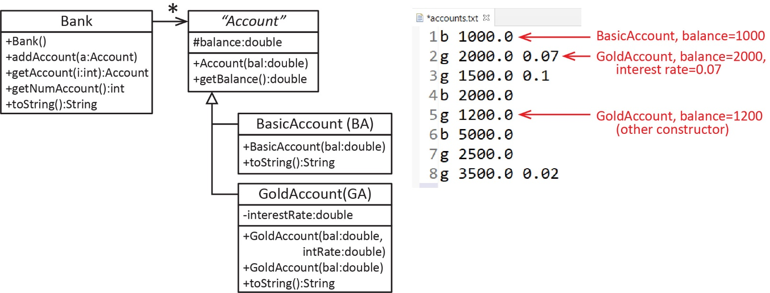
In this section, we will write this method:
readAccounts(file:File):Bank – Accepts a file argument and reads from that file the Account objects and adds them to a Bank, returning the Bank object. You can assume the file exists and all data is valid.
- Read, no action required. Consider the algorithm for the readAccounts method below and then look back at the code to see the correlation. Study it carefully before you move on.
- Create Bank
- Create Scanner
- Loop until no more Accounts
  - Read an entire line and split into tokens
  - Set type = tokens[0]
  - Set bal = tokens[1] // String, so must parseDouble
  - If type = “b”
    - Create BasicAccount(bal)
  - Else If number of tokens = 2
    - Create GoldAccount(bal)
  - Else
    - Set intRate = tokens[2] // String so must Double.parseDouble
    - Create GoldAccount(bal, intRate)
  - Add Account to the Bank.
- Return Bank

- Setup. Do the following:
  - Download the supplied code found on the Lab page beside the assignment.
  - Unzip, and you will find a bank_accounts folder with a number of files inside.
  - Drag the bank_accounts folder into the src node in Eclipse.
  - Open AccountIO.java and examine the readAccounts method. Study the method and correlate it with the algorithm presented above. Make sure you understand it.
  - Open AccountIOTest.java and run. Verify the output.
- Your Turn! Do the following:
  - Add a method to AccountIO, readAccountsHighRollers that accepts a File and a minimum balance, minBal. This method should build and return a Bank filled with the accounts whose balance is greater than minBal.
  - Add a method to AccountIOTest.java, testReadAccountsHighRollers that tests the new method. Call the method with 2000.0 and verify the output:
-->testReadAccountsHighRollers()
1. Basic: bal=$5,000.00
2. Gold: bal=$2,500.00, int rate=5.0%
3. Gold: bal=$3,500.00, int rate=2.0%

Writing Data to a Text File
In this stage we demonstrate how to write data to a text file using the PrintWriter class.
- (Read, no action required) –
- One way to write data to a text file is to use the PrintWriter class. It accepts a File as an argument:
File outFile = new File("src/write_examples/numbers.txt");
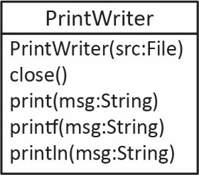
PrintWriter writer = new PrintWriter( outFile );
- Probably the three most useful (at least for our class) methods of the PrintWriter class are print(…), println(…), and printf(…) which work identically to the System.out.print(…) methods. For example, to loop over an array of integers (nums) and write them space-delimited to a text file:
for( int i=0; i<nums.length; i++ ) {
writer.print( nums[i] + " " );
}
- When we are done writing, we must close the writer: writer.close(); And, as with the Scanner class, we must try/catch (or throws…) all file manipulations.
- (Read, no action required) – Next, we are going to write a method that accepts a File and a Bank and writes the accounts to a new text file. Each line in the file will contain a single account in the format:
b balance
for a BasicAccount and:
g balance interestRate
for a GoldAccount and:
- Do the following:
- Open AccountIO.java and examine the writeAccounts method and study the code so that you understand it.
- Open AccountIOTest and examine the testWriteAccounts method. Read the comments and understand the test code.
- Uncomment: testWriteAccounts in main.
- Run the test and verify the output.

The File Class
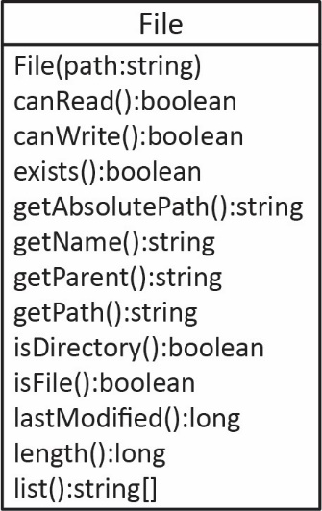
In this section we demonstrate a few methods of the File class. We won’t use this in this class, but some of them would be important when building a real system.
- The File class has many useful methods. The following example will illustrate some of them. Do the following:
- Open FileClassTest (in the bank_accounts package) and examine the code. Shown below for convenience.
import java.io.File;
import java.io.IOException;

public class FileClassTest {
public static void main(String[] args) throws IOException {
File inFile = new File( "src/bank_accounts/accounts.txt" );
System.out.println(" Does it exist? " + inFile.exists());
System.out.println(" Can it be read? " + inFile.canRead());
System.out.println("Can it be written? " + inFile.canWrite());
System.out.println("Is it a directory? " + inFile.isDirectory());
System.out.println(" Is it a file? " + inFile.isFile());
System.out.println(" Is it hidden? " + inFile.isHidden());
System.out.println(" Number of bytes: " + inFile.length() + " bytes");
System.out.println(" Absolute path: " + inFile.getAbsolutePath());
System.out.println(" Path: " + inFile.getPath());
System.out.println(" Parent: " + inFile.getParent());
System.out.println(" Last modified: " + new java.util.Date(inFile.lastModified()));

// Derive the absolute path without the file name.
String absPath = inFile.getAbsolutePath();
int posEndPath = absPath.lastIndexOf(File.separator);
String filePath = absPath.substring(0,posEndPath+1);
System.out.println("Abs path (derived): " + filePath);
}
}

- Run and verify the output. As long as accounts.txt is still in your package you will see information about that file.
- Change the filename to one that doesn’t exist and re-run and verify the output.
- Change the filename back to the original (accounts.txt), re-run and verify that it runs as expected.

Submission
- Do the following:
- Zip all the folders (packages) under the src folder into a zip file named: lab10_lastname.zip
- Upload your zip file to the lab10 dropbox in Blazeview.

You are done!

Appendix
These are some additional examples and are optional.
- Parsing Data
In this stage we show an example of parsing data.
- (Read, no action required) –
- Suppose we have a file that contains integers and words in any arbitrary order as shown in the figure below:
We would like to read the entire file and put all the integers in one ArrayList and all the words in another.
- One way to do this is to read each token:
String token = input.next();
And then use a method we can write to see if the token is an int.
public static boolean isAnInteger(String strNum) {
if (strNum==null) {
return false;
}
try {
int val = Integer.parseInt(strNum);
return true;
}
catch (NumberFormatException nfe) {
return false;
}
}
Note that this method would classify a double as a string. If we wanted to allow doubles, we could simply change to Double.parseDouble.
- Thus, the body of the read loop will look like this (where ints and words are the ArrayLists used to store the data):
while(input.hasNext()) {
String token = input.next();
if(isAnInteger(token)) {
int x = Integer.parseInt(token);
ints.add(x);
}
else {
words.add(token);
}
}
- Create Classes to Read and Store Data – Do the following:
- Create a new package: read_examples3.
- Create a text file (see directions above if necessary) named: numbersAndWords.txt.
- Copy this data into the file:
33 992 guitar 8 fire 29 344 5 hat pick rain 1 horse 18
- Create a class named ReadNumbersAndWords (in the read_examples package) and replace everything in the class (except the package statement at the top) with:
import java.util.ArrayList;
import java.util.Scanner;
import java.io.File;
import java.io.IOException;

public class ReadNumbersAndWords {
public static void main(String[] args) {
ArrayList<Integer> ints = new ArrayList<>();
ArrayList<String> words = new ArrayList<>();
File inFile = new File( "src/read_examples3/numbersAndWords.txt" );

try {
Scanner input = new Scanner( inFile );
while( input.hasNext() ) {
String token = input.next();
if(isAnInteger(token)) {
int x = Integer.parseInt(token);
ints.add(x);
}
else {
words.add(token);
}
}
input.close();
}
catch( IOException e ) {
System.out.println(e);
}

System.out.println(" ints: " + ints);
System.out.println("words: " + words);

}

public static boolean isAnInteger(String strNum) {
if (strNum==null) {
return false;
}
try {
int val = Integer.parseInt(strNum);
return true;
}
catch (NumberFormatException nfe) {
return false;
}
}
}

This approach is not the best, throwing an exception is expensive. However, it illustrates the idea of parsing. And, next we introduce a more efficient way.

- Run and verify the output:

ints: [33, 992, 8, 29, 344, 5, 1, 18]
words: [guitar, fire, hat, pick, rain, horse]

- (Read, no action required) – Another way to test each token to see if it is an integer is to use the matches method of the String class which accepts a regular expression. The regular expression below checks to see if all the characters in the token are digits.

if( token.matches("\\d+") ) {

Note: this will only detect positive integers; negative integers will be treated as strings. To match negative integers, you would use: ("-?\\d+"). The “?” means optional, thus, the “-“ is optional. There is a lot to understanding regular expressions. We will only consider the one above.

I will not be testing you on the matches method, but we will consider it in the next example.

- Open ReadNumbersAndWords and comment out the if statement and replace with:

if(token.matches("\\d+")) {

The while loop will look like this:

while( input.hasNext() ) {
String token = input.next();
// if(isAnInteger(token)) {
if(token.matches("\\d+")) {
int x = Integer.parseInt(token);
ints.add(x);
}
else {
words.add(token);
}
}

- Run and verify that the output is the same as before.

- More Parsing
In this stage we show another example of parsing data.
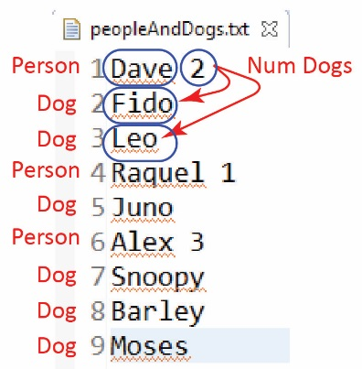
- (Read, no action required) –
- Suppose we have a file as shown on the right. A person (Dave) is shown on line 1 and the number of dogs he has (2). The next two lines show the two dogs.
- Thus, to read in this data, where each person can have a different number of dogs, we could read a person’s name
String name = input.next();
and then read their number of dogs
int numDogs = input.nextInt();
and then loop over the number of dogs reading each dog’s name:
for(int i=0; i<numDogs; i++){
String dogName = input.next();
...
}
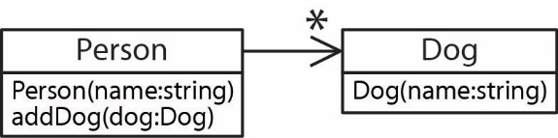
- Now, suppose we have Person and Dog classes as shown in the class diagram on the right. Then, we can build an ArrayList<Person> with code like this:
ArrayList<Person> people = new ArrayList<>();
...
while( input.hasNext() ) {
String name = input.next();
Person p = new Person(name);
int numDogs = input.nextInt();
for(int i=0; i<numDogs; i++){
String dogName = input.next();
Dog dog = new Dog(dogName);
p.addDog(dog);
}
people.add(p);
}

- Create Classes to Read and Store Data – Do the following:
- Create a text file (see directions above if necessary) named: peopleAndDogs.txt in the read_examples3 package.
- Copy this data into the file:
Dave 2
Fido
Leo
Raquel 1
Juno
Alex 3
Snoopy
Barley
Moses
- Create a class named Dog (in the read_examples3 package) and replace everything in the class (except the package statement at the top) with:
public class Dog {
private String name;

public Dog(String name) {
this.name = name;
}

public String getName() {
return name;
}
}

- Create a class named Person (in the read_examples3 package) and replace everything in the class (except the package statement at the top) with:

import java.util.ArrayList;

public class Person {
ArrayList<Dog> dogs = new ArrayList<>();
private String name;

public Person(String name){
this.name = name;
}

public void addDog(Dog dog) {
dogs.add(dog);
}

@Override
public String toString(){
StringBuilder msg = new StringBuilder();
msg.append("Person: " + name + " - Dogs: ");
for(Dog dog : dogs)
msg.append(dog.getName() + ", ");
msg.delete(msg.length()-2,msg.length());
return msg.toString();
}
}

- Create a class named ReadPeopleAndDogs (in the read_examples3 package) and replace everything in the class (except the package statement at the top) with:

import java.util.ArrayList;
import java.util.Scanner;
import java.io.File;
import java.io.IOException;

public class ReadPeopleAndDogs {
public static void main(String[] args) {
ArrayList<Person> people = new ArrayList<>();
File inFile = new File( "src/read_examples3/peopleAndDogs.txt" );

try {
Scanner input = new Scanner( inFile );
while( input.hasNext() ) {
String name = input.next();
Person p = new Person(name);
int numDogs = input.nextInt();
for(int i=0; i<numDogs; i++){
String dogName = input.next();
Dog dog = new Dog(dogName);
p.addDog(dog);
}
people.add(p);
}
input.close();
}
catch( IOException e ) {
System.out.println(e);
}

for(Person p : people) {
System.out.println(p);
}
}
}

- Run and verify the output:

Person: Dave - Dogs: Fido, Leo
Person: Raquel - Dogs: Juno
Person: Alex - Dogs: Snoopy, Barley, Moses

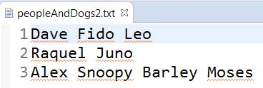
- (Read, no action required) Next, let’s consider the same problem except that the text file doesn’t contain the number of dogs, and each person (and their dogs are on the same line) as shown on the right. Here is the approach, inside the loop:

- Read the entire line:

String line = input.nextLine();

- Split the line on a space:

String[] tokens = line.split("\\s");

- The first token has the name:

String name = tokens[0];
Person p = new Person(name);

- The rest of the tokens are dog names. Notice that the loop below starts at 1.

for(int i=1; i<tokens.length; i++){
String dogName = tokens[i];
Dog dog = new Dog(dogName);
p.addDog(dog);
}
people.add(p);

- Code the example. Do the following:

- Create a text file named: peopleAndDogs2.txt in the read_examples3 package.

Dave Fido Leo
Raquel Juno
Alex Snoopy Barley Moses

- Create a class named ReadPeopleAndDogs2 (in the read_examples3 package) and replace everything in the class (except the package statement at the top) with:

import java.util.ArrayList;
import java.util.Scanner;
import java.io.File;
import java.io.IOException;

public class ReadPeopleAndDogs2 {
public static void main(String[] args) {
ArrayList<Person> people = new ArrayList<>();
File inFile = new File( "src/read_examples3/peopleAndDogs2.txt" );

try {
Scanner input = new Scanner(inFile);
while(input.hasNext()) {

String line = input.nextLine();
String[] tokens = line.split("\\s");
String name = tokens[0];
Person p = new Person(name);
for(int i=1; i<tokens.length; i++){
String dogName = tokens[i];
Dog dog = new Dog(dogName);
p.addDog(dog);
}
people.add(p);
}
input.close();
}
catch( IOException e ) {
System.out.println(e);
}

for(Person p : people) {
System.out.println(p);
}
}
}

- Run and verify the output is correct.

https://en.wikipedia.org/wiki/Whitespace_character
https://www.vogella.com/tutorials/JavaRegularExpressions/article.html#common-matching-symbols

