CS 1302 – Lab 6
Inheritance & Polymorphism

This is a tutorial on inheritance. There are 8 stages to complete this lab:

Stage | Title
1 | Superclass-Subclass Example
2 | Debugging the Example
3 | Adding a protected Instance Variable
4 | Adding Constructors & the super Keyword
5 | Adding a Instance Variable to the Subclass
6 | Polymorphism & Dynamic Binding
7 | Casting
8 | An Array of Dogs

To make this document easier to read, it is recommended that you turn off spell checking in Word:

- Choose: File, Option, Proofing
- At the very bottom, check: “Hide spelling errors…” and “Hide grammar errors…”

- Superclass-Subclass Example

In this stage we introduce the concept of inheritance and superclass-subclass relationships.

- (Read, no action required).

- Suppose we have the Dog class shown on the left and we need a new class, WolfDog on the right:

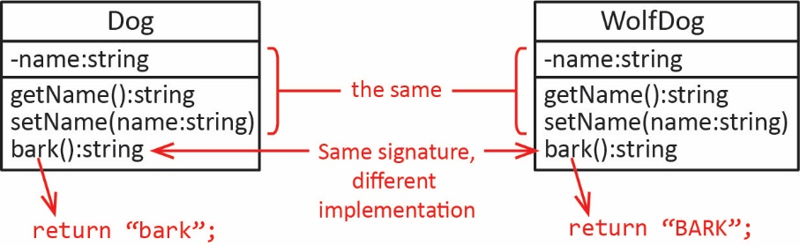

The two classes are identical, except that the bark method is different in the WolfDog class.

- Java provides a way to create the WolfDog class that extends the Dog class so that we don’t have to rewrite the (non-private) members that are the same, we only have to rewrite the bark method. This is called inheritance or subclassing.

- The Dog and WolfDog classes are shown below on the left and right, respectively.

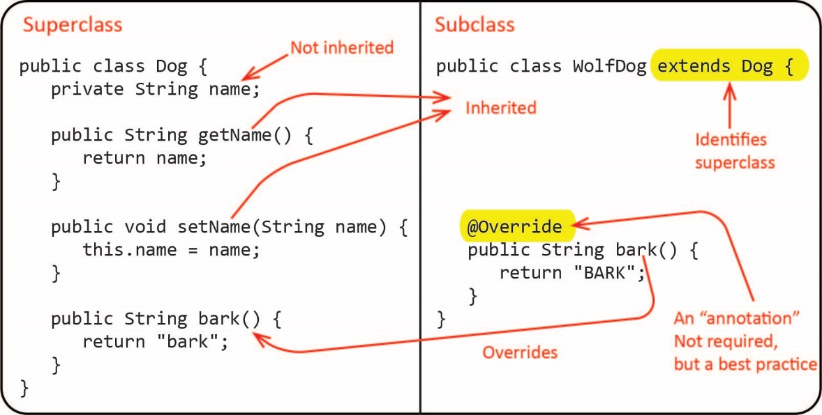

Note:
- The Dog class is referred to as the superclass and the WolfDog class is referred to as the subclass.
- For now, no constructor is explicitly defined. Remember, from Chapter 9, that if a class does not define a constructor explicitly, thus, by default, there is a no-arg constructor. We will consider constructors that accept arguments shortly.
- The getName and setName methods are inherited by the WolfDog class. This means that the WolfDog has these methods without have to explicitly write them.
- The name instance variable is not inherited because it is private. Thus, the WolfDog class cannot directly use the variable. Later, we will see how to make this variable available in the subclass.

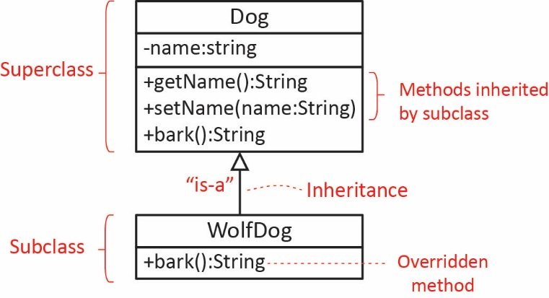
- To depict this relationship in a class diagram, we use a solid line with an open triangle pointing toward the superclass to denote a superclass-subclass relationship as shown in the diagram on the right. We also say that a WolfDog is-a Dog

- Create a Java project in Eclipse named: lab06_lastName.

- Do the following:

- Create a package named: ver1

- Create a class named Dog

- Replace everything in the Dog class (except the package statement at the top) with the code below:

public class Dog {
private String name;

public String getName() {
return name;
}

public void setName(String name) {
this.name = name;
}

public String bark() {
return "bark";
}

@Override
public String toString() {
return "Dog named " + name;
}
}

- Create a class named: WolfDog

- Replace everything in the WolfDog class (except the package statement at the top) with the code below:

public class WolfDog extends Dog {

@Override
public String bark() {
return "BARK";
}

@Override
public String toString() {
return "WolfDog named " + getName();
}
}

- Create a class named: WolfDogTest

- Replace everything in the WolfDogTest class (except the package statement at the top) with the code below:

public class WolfDogTest {

public static void main(String[] args) {
testDogAndWolfDog();
}

public static void testDogAndWolfDog() {
WolfDog wd = new WolfDog();
// Calling inherited method
wd.setName("Juno");
// Calling inherited method
String name = wd.getName();
System.out.println("WolfDog's name is: " + name);

// Calling overridden method
String msg = wd.bark();
System.out.println(msg);

System.out.println(wd);
}
}

- Study the test code above. As you can see, we can use the WolfDog subclass just as we would any class. Run and verify the output.

- Debugging the Example

In this stage we run the debugger to illustrate exactly how inheritance works. If something doesn’t seem to work simply end the debugging session (choose: Run, Terminate or press the red square on the ToolBar) and restart debugging.

- Do the following:

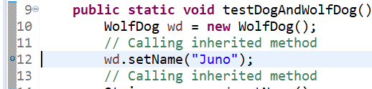
- Set a breakpoint on the this line of code:

wd.setName("Juno");

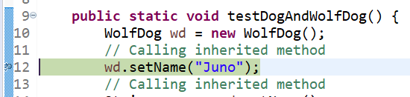
- Choose: Run, Debug (or F11). The code should stop on the line as shown in the figure on the right.

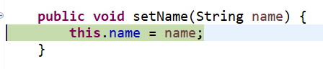
- Choose: Run, Step Into (or F5). Execution advances to the Dog class’s setName method. Note that WolfDog instance, wd inherits the setName method which is found in the Dog class.

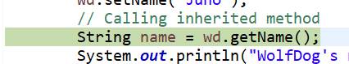
- Press F5 two times and execution returns to the WolfDogTest class as shown in the figure on the right.

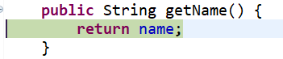
- Press F5 and execution advances to the inherited getName method in the Dog class.

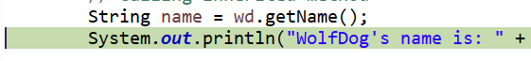
- Press F5 two times and execution returns to the WolfDogTest class as shown in the figure on the right.

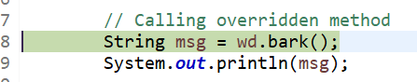
- Press F5 and execution stops on the line shown on the right. Next, we will step into the bark method which is in the WolfDog class.

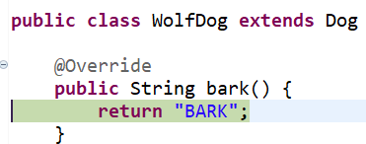
- Press F5 and execution advances to the bark method in the WolfDog class.

- End the debugging session (Run, Terminate, or press the Red square on the toolbar.

- Repeat steps a-I above making sure you understand the flow of the code.

- Open the Java perspective (icon in the upper right that says, “Java” when you hover over it).

- Adding a protected Instance Variable

- Do the following:

- Open the WolfDog class and change bark method to use the name instance variable as shown below:

@Override
public String bark() {
return name + " says: BARK";
}

Note that there is a compile error. Click the red x and note the message:

The field Dog.name is not visible.

Remember, private members are not inherited. We will fix this next.

- Open the Dog class and change the visibility of the name instance variable from private to protected

protected String name;

- Save the Dog class.

- Open the WolfDog class and save. Notice that there is no compile error now.

- (Read, no action required) A class member that is declared with protected visibility means that it is available in any subclass (and any class in the same package).

- Adding Constructors & the super Keyword

- Do the following:

- Open the Dog class and add this constructor and save.

public Dog(String name) {
this.name = name;
}

- Open the WolfDog class and note that it no longer compiles. To fix this, add this constructor:

public WolfDog(String name) {
super(name);
}

Save the class and now it has no compile error. However, WolfDogTest now has compile errors. We will fix that shortly.

- (Read, no action required) The super keyword is used to call a superclass constructor with a matching signature. This is similar to the way this is used to call another constructor in the same class.

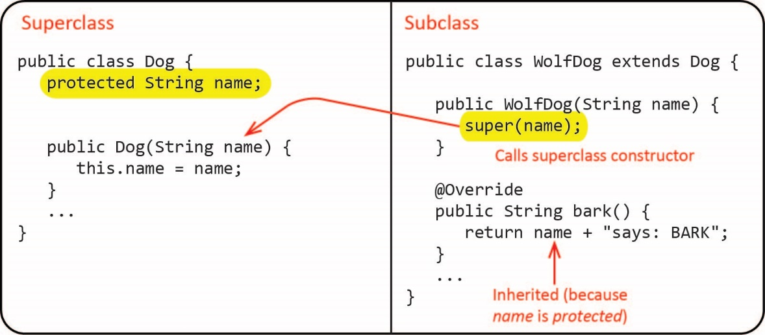

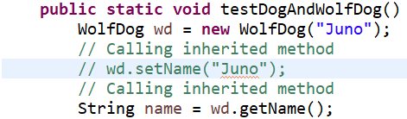
- Open the WolfDogTest class and:

- Add a name to the WolfDog constructor.
- Comment out the call to setName.
- Run, and verify the output.

- Adding an Instance Variable to the Subclass

- Close all open files, and then copy the ver1 package and paste giving the new name: ver2.

- Open the WolfDog class and do the following:

- Add an toughness (int) instance variable.
- Add a getter for toughness.
- Add a toughness parameter to the constructor.
- Add a line to save the parameter in the instance variable.
- The code will look like this:

public class WolfDog extends Dog {
private int toughness;

public WolfDog(String name, int toughness) {
super(name);
this.toughness = toughness;
}

public int getToughness() {
return toughness;
}
...
- Open the WolfDogTest class and replace the code in testDogAndWolfDog with:

WolfDog wd = new WolfDog("Juno", 7);
int toughness = wd.getToughness();
String name = wd.getName();
System.out.println("WolfDog's name is: " + name + ", toughness=" + toughness);

- Run and verify the output.

- Next, we will use the debugger to step through the constructor. Do the following:

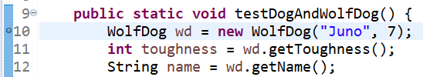
- In WolfDogTest, place a breakpoint on the first line in the test method.

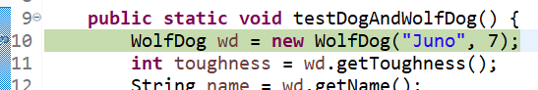
- Choose: Run, Debug. Execution is stopped at the breakpoint.

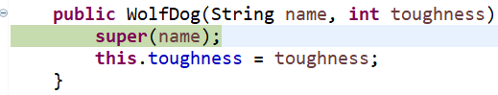
- Step into the constructor (F5). Execution is stopped in the WolfDog class in the constructor.

Note: if this fails, use the fix found in Lab 1, step 12.

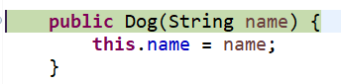
- Press F5 and execution advances to the Dog classes constructor.

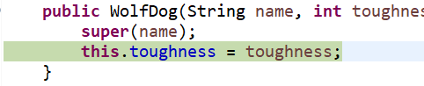
- Press F5 three times and execution returns to the WolfDog’s constructor.

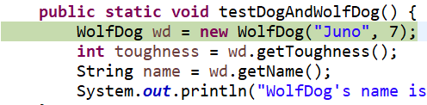
- Press F5 two times and execution returns to the WolfDogTest class.

- Choose: Run, Resume. This completes execution.

- Repeat steps a-g above and pay close attention to the flow of execution.

- Return to the Java perspective.

- Polymorphism & Dynamic Binding

In this stage we will consider the concepts of polymorphism and dynamic binding.

- (Read, no action required).

- When we write a statement like this:

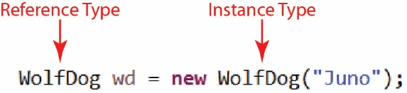

We say that we are using a WolfDog reference type to refer to a WolfDog instance. Other than the term reference type there is nothing new going on here.

- We can also use a Dog reference type to refer to a WolfDog instance:

Dog d = new WolfDog("Leo");

The reason (rather loosely) that we can do this is that a WolfDog is-a Dog. This is called a polymorphic reference. Anytime we have an is-a (inheritance, superclass-subclass) relationship, we can refer to a subclass instance (WolfDog) with a super-type reference (Dog). Now, why we would want to do this is a bit more challenging to understand. There are tremendous benefits which we will discuss throughout the remainder of the course!

- Do the following:

- Add this method to the WolfDogTest class:

public static void testPolymorphism() {
Dog d = new WolfDog("Juno", 7);
String bark = d.bark();
String name = d.getName();
System.out.println("WolfDog's name is: " + name + ", bark=" + bark);
}

- Comment out the call to testDogAndWolfDog in main and add a call to the new method:

public static void main(String[] args) {
//testDogAndWolfDog();
testPolymorphism();
}

- Run and observe the output:

WolfDog's name is: Juno, bark=Juno says: BARK

Note that even though we used a Dog reference, the WolfDog’s bark method was called. This is called dynamic binding. When the bark method is called, the actual bark method that runs is determined by the instance of the object (WolfDog) not the reference type (Dog).

- Next, we will illustrate dynamic binding by using the debugger. Do the following:

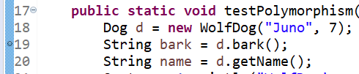
- Place a breakpoint on the line where the bark method is called.

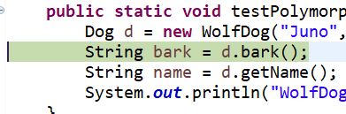
- Run the debugger (Run, Debug, or F11)

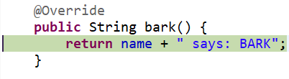
- Step into (F5) the method call and note that execution has advanced to the bark method in the WolfDog class.

- Continue to step through the code until it completes.

- Return to the Java perspective.

- Open WolfDogTest and add this line to the end of the testPolymorphism method:

int toughness = d.getToughness();

Note:

- The code does not compile.
- The instance is a WolfDog which does have a getToughness method.
- The reference type, however, is Dog.
- The reference type defines what methods can be called on an instance. Since the Dog class does not define a getToughness method, we cannot call this method, even though the actual instance is a WolfDog. This is probably very confusing! Reread this sentence several times. We will discuss this more in class.

Comment out this line so that the code now compiles.

- Casting

In this stage we will consider casting an object from one reference type to another. We may use a Dog reference to refer to a WolfDog, but there may be times we want to change the reference to a WolfDog reference so that we can call the getToughness method.

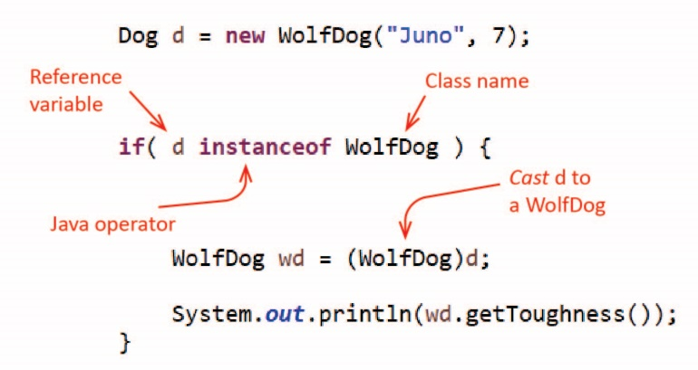
- (Read, no action required). Note the following:

- Java defines the instanceof operator which returns true if the left operand is an instance of the class specified as the right operand as shown in the figure on the right.

- Java allows us to cast an object from one reference type to another as shown in the figure on the right. This cast will only succeed if the cast is valid, i.e. if d really is a WolfDog. The cast here will succeed because we insured that d is a WolfDog with the preceding if statement.

- Do the following:

- Add this method to the WolfDogTest class:

public static void testCasting() {
Dog d = new WolfDog("Juno", 7);

if( d instanceof WolfDog ) {
WolfDog wd = (WolfDog)d;
System.out.println(wd.getToughness());
}
}

- Comment out the call to testPolymorphism in main and add a call to the new method:

public static void main(String[] args) {
//testDogAndWolfDog();
//testPolymorphism();
testCasting();
}

- Run and observe the output:

- An Array of Dogs

In this stage we illustrate that an array of type Dog can hold Dog instances as well as instances of any subclass of Dog.

- Do the following:

- Add this method to the WolfDogTest class:

public static void testArrayOfDogs() {
Dog[] dogs = new Dog[5];
dogs[0] = new Dog("Chaps");
dogs[1] = new Dog("Ace");
dogs[2] = new WolfDog("Juno", 7);
dogs[3] = new Dog("Gigi");
dogs[4] = new WolfDog("Mocho", 4);

for(Dog d : dogs) {
System.out.println(d);
if( d instanceof WolfDog ) {
WolfDog wd = (WolfDog)d;
System.out.println(" toughness=" + wd.getToughness());
}
}
}

- Study the code carefully. Note that the Dog[] dogs array can hold Dog instances as well as instances of any subclass.

- Comment out the call to testCasting in main and add a call to the new method:

public static void main(String[] args) {
//testDogAndWolfDog();
//testPolymorphism();
//testCasting();
testArrayOfDogs();
}

- Run and observe the output:

Submission

- Do the following

- Zip all the folders (packages) under the src folder into a zip file named: lab6_lastname.zip
- Upload your zip file to the lab6 dropbox in Blazeview.

You are done!

