Lab 3b – Video Demo

Contents

1 Overview 1

2 Steps to Complete 1

Appendix 1 From VSU’s eLearning 10

Appendix 2 Installing Capture 10

# Overview

For this lab you will make a video using Kaltura Capture in Blazeview to do a brief demo of lab 3. The purpose of this lab is for you to learn to make a video demo (using Kaltura Capture) which will be required in HW’s 5a, 6, 9, 10. When making videos:

* It is fine for you camera to be off.
* Do not scroll too quickly, *i.e.* don’t rush
* Speak clearly and loud enough as if someone 5 feet away could hear you.

# Steps to Complete

1. Open your Lab 3 code in Eclipse and then open: *ver1/AccountTest.java*
2. Login into Blazeview for this course.
3. In the upper-right, choose: Kaltura, My Media

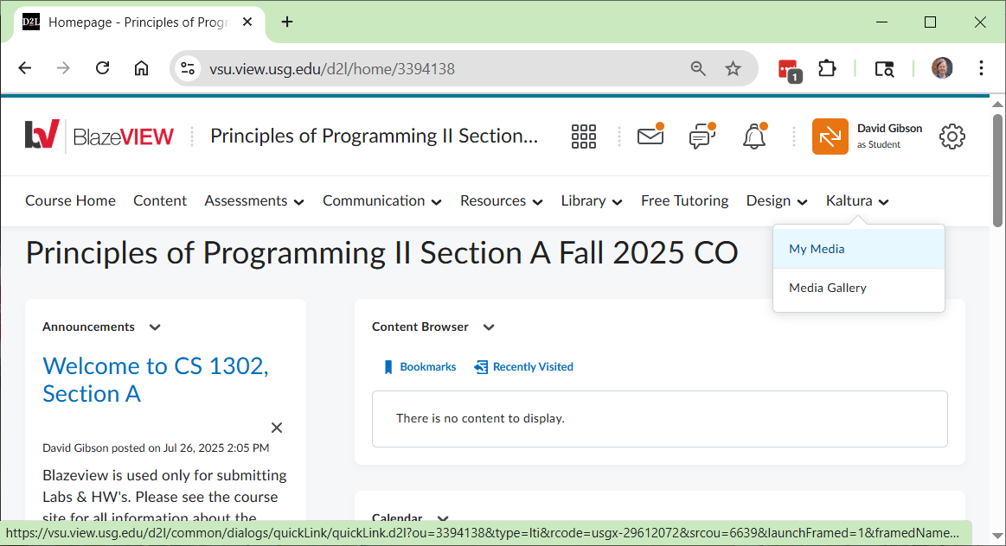

1. Choose: Add New, Kaltura Capture

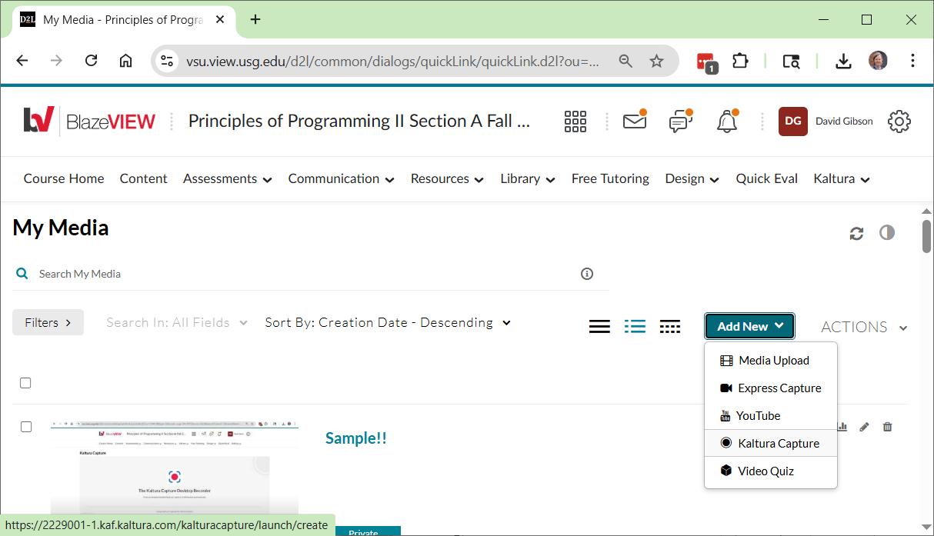

1. The window below will be displayed. It will open Kaltura Capture from your computer, if you have it installed. Otherwise, as it says at the bottom, you need to download it **(in which case, you may need to repeat the steps above**).

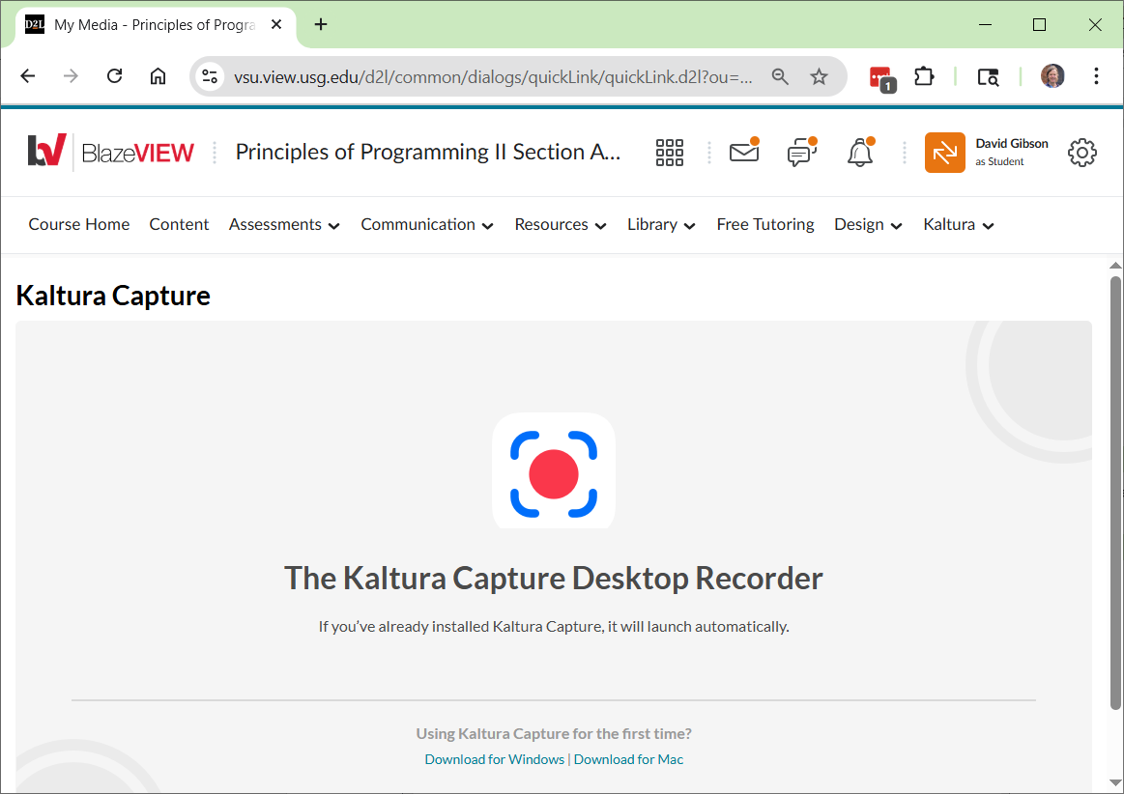

1. Once Kaltura Capture is open, **IF** you see the screen below, if the upper-right, choose: New Recording. Otherwise, go to the next step.

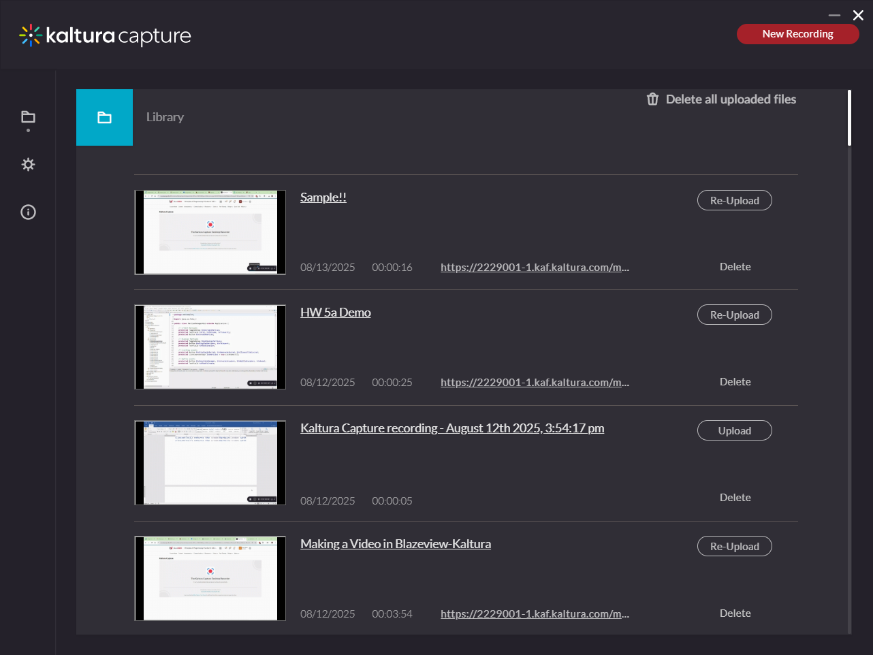

1. You should now see the Kaltura Capture app. Do the following:
   1. You can turn the camera off (as shown below).
   2. Make sure “Screen” is showing your code in Eclipse.
   3. Make sure your “Audio” is on.

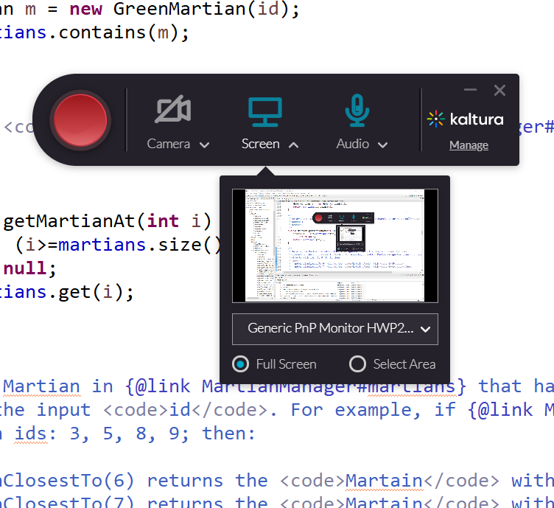

1. **When** (don’t do it yet) you press the Red button above, the recording will start. The app will drop to the lower-right of the screen and appear similar to what is shown below. If you have another monitor, you can drag the app off the screen being recorded (or you can minimize it).

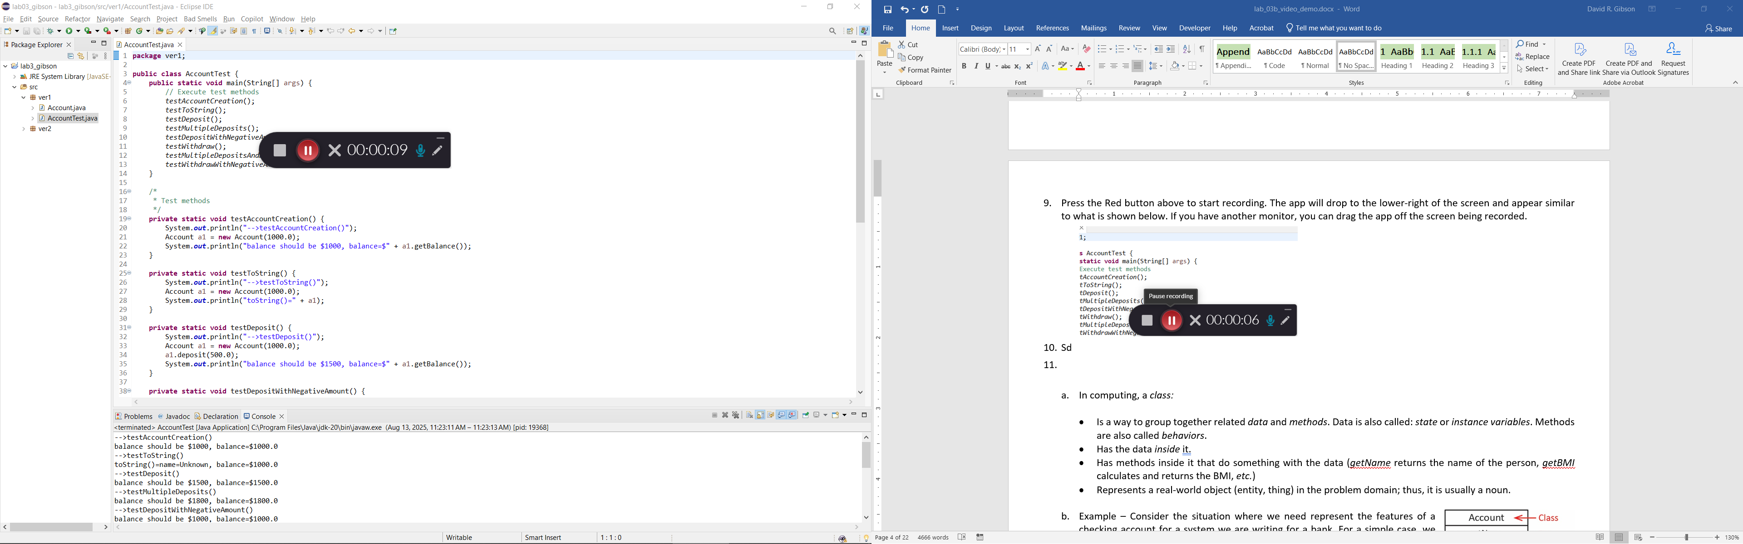

1. Next, you will make your demo. Do the following:
   1. Make sure *ver1/AccountTest.java* is displayed on the screen you will be recording.
   2. Press the Red button to start the recording.
   3. **State your first and last name.**
   4. State the name of the last method (*testWithdrawWithNegativeAmount*).
   5. Scroll down to the method code (next to last) and briefly explain the method.
   6. Run the *AccountTest* class and show the results that appear in the Console window. Resize the console so all the results are shown.
   7. Press the gray button to stop recording.

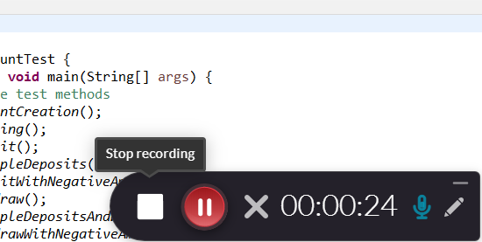

* 1. On the dialog that appears, choose: “Yes, Stop it”.

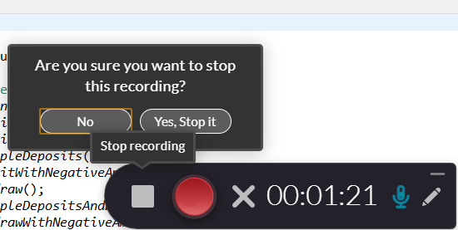

1. The dialog below will be shown. Provide a title, Lab 3 Video, and choose: Save & Upload

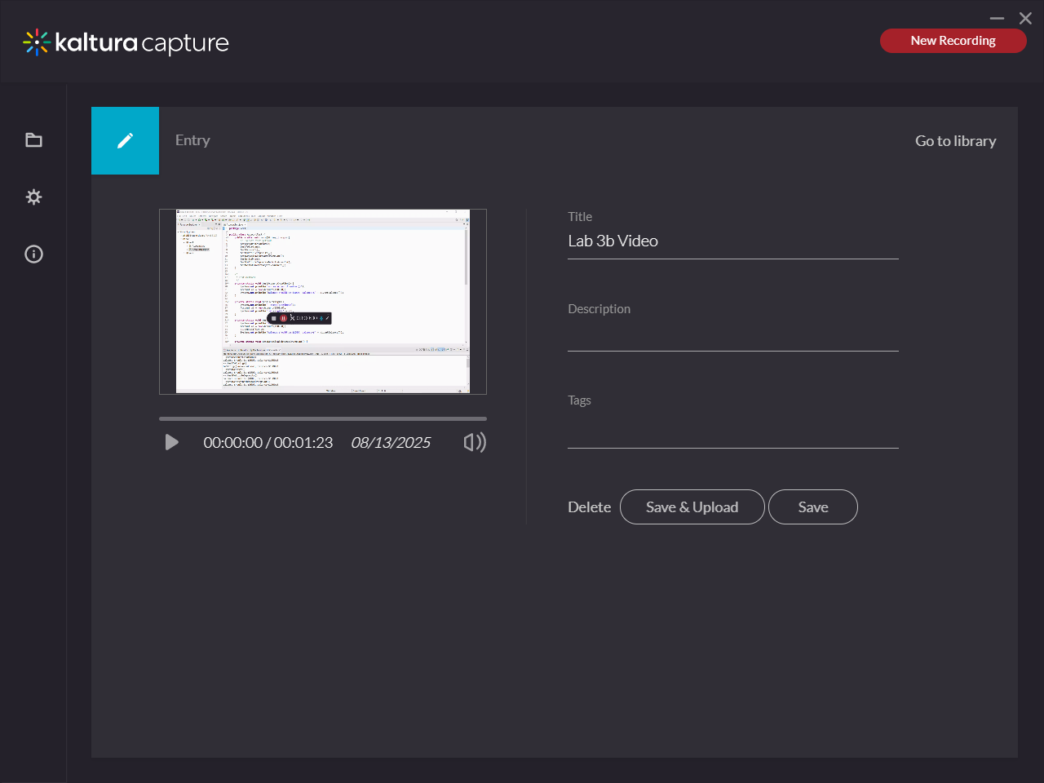

1. The video will appear in the Library. It may say, “Pending”. When complete with the upload, it will say, “Re-Upload”.

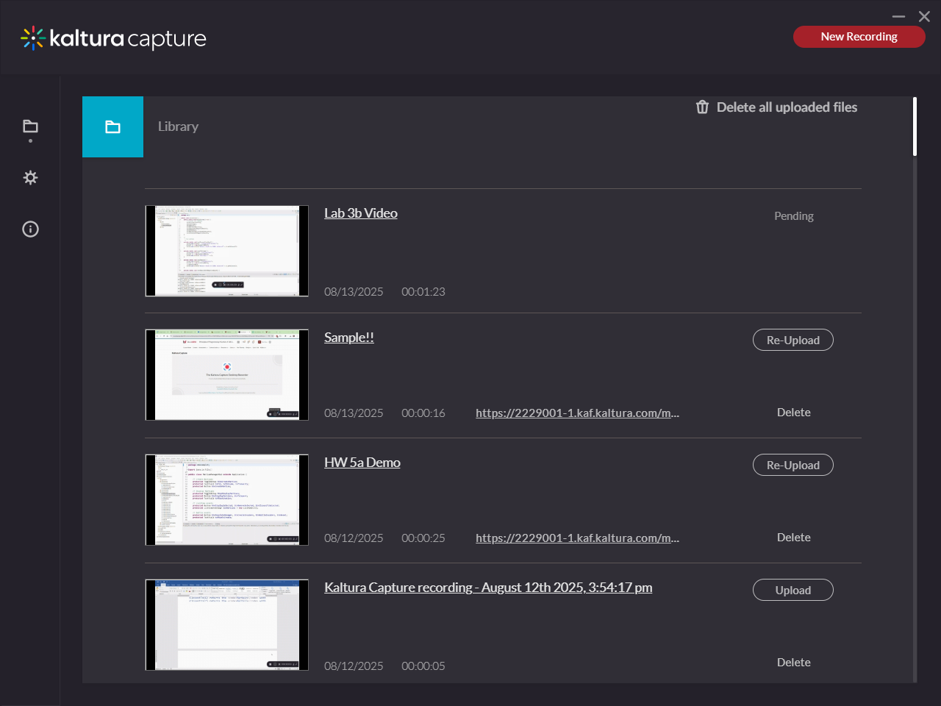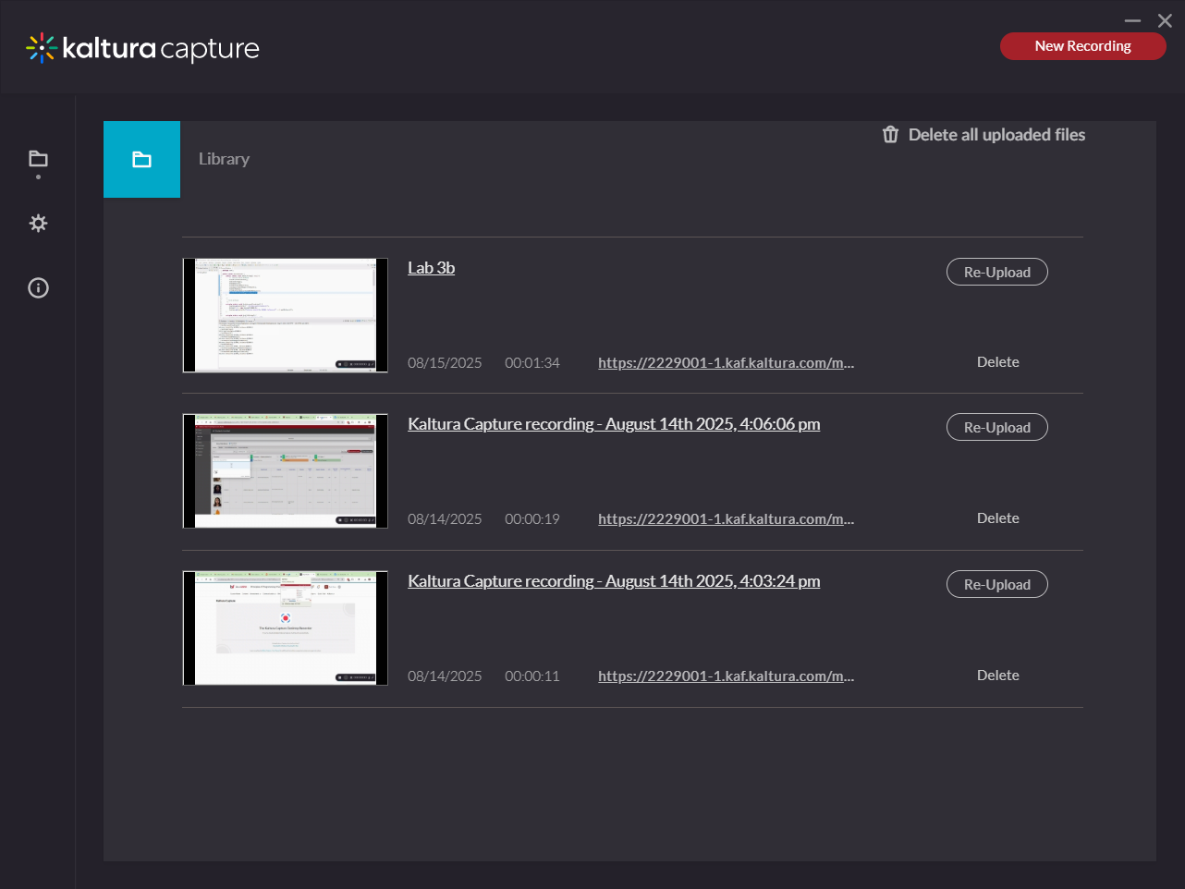

1. **Test your video – make sure the video plays and the audio is clear and audible!**
2. You can close the Capture window (above) now.
3. Return to Blazeview and open the Lab 3b dropbox.
4. In the Comments toolbar, select the Insert Stuff icon.

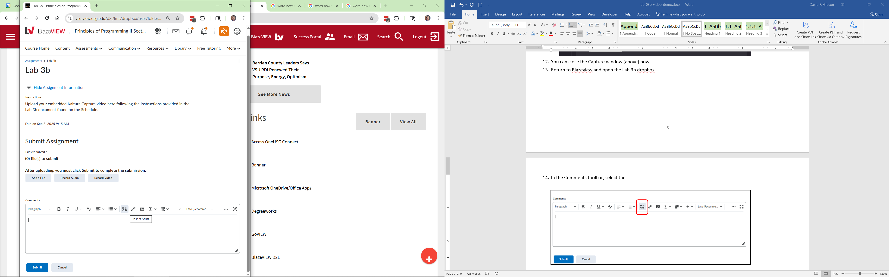

1. Select: Embed Kaltura Media

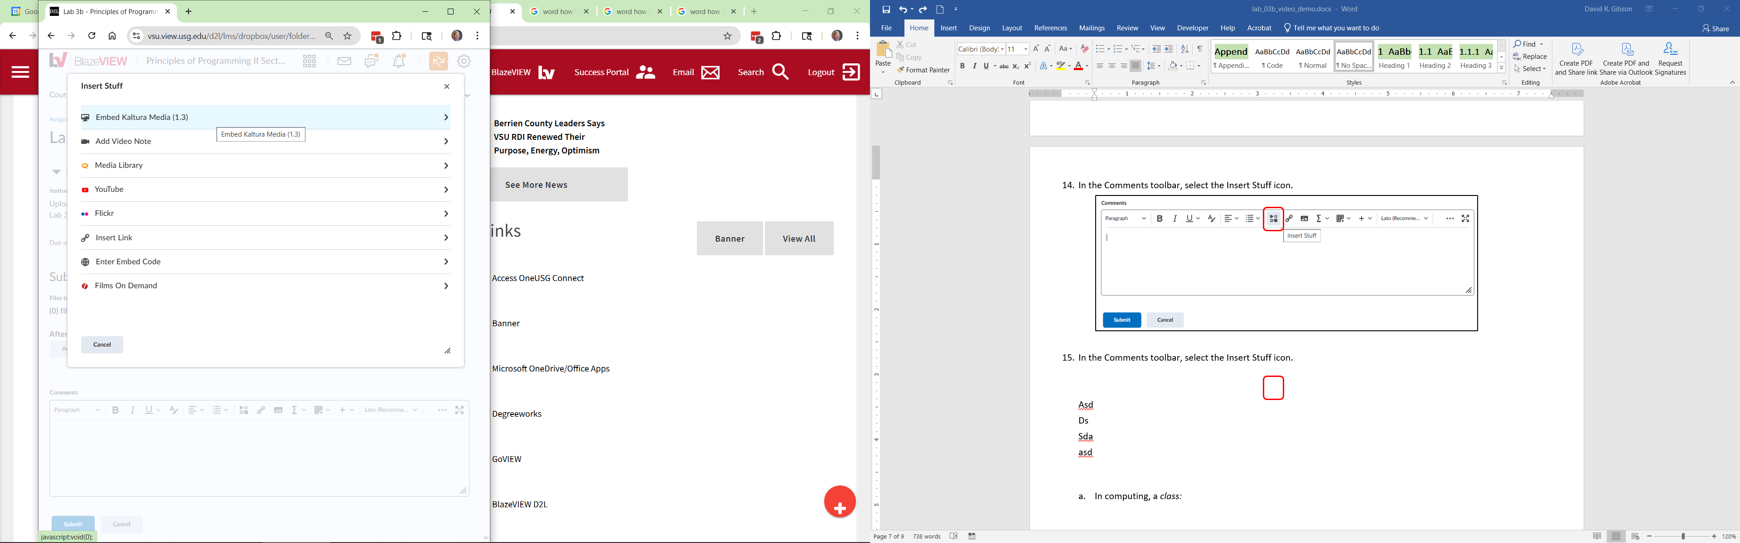

1. My Media will be displayed. Choose: Embed for the video you created.

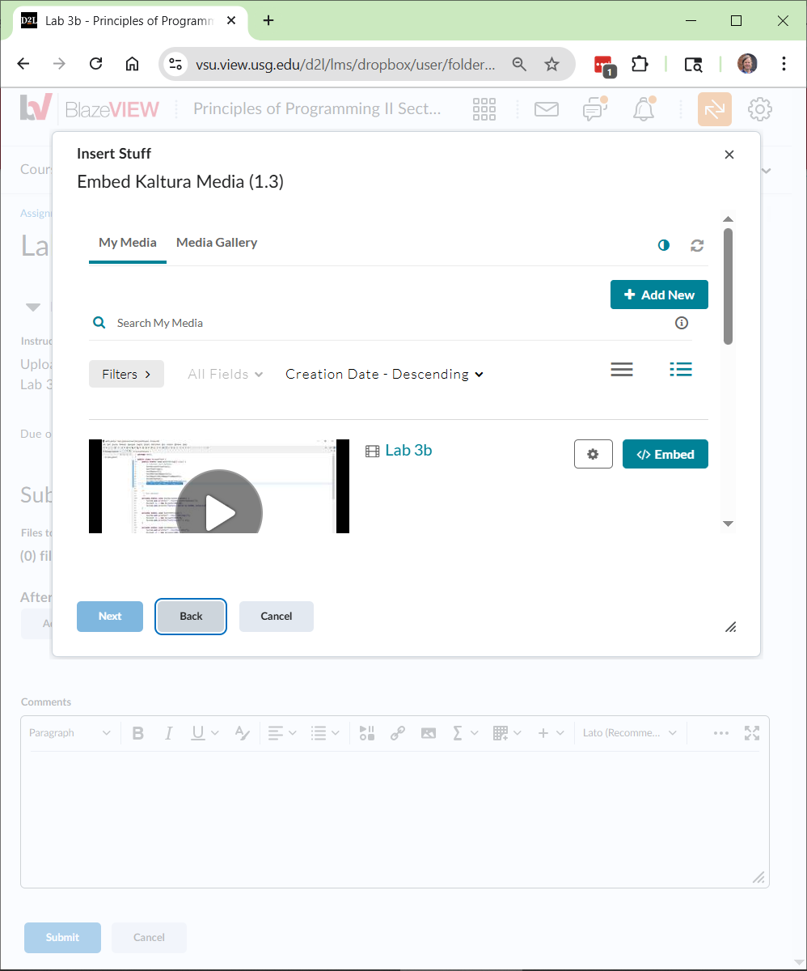

1. Choose: Insert

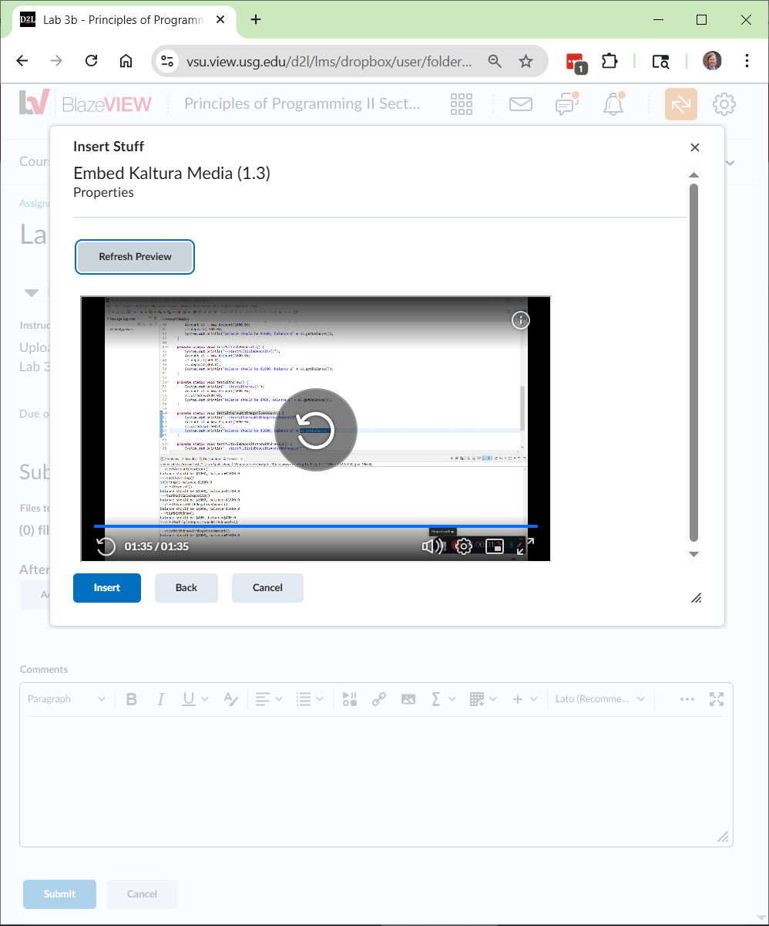

1. Choose: Submit

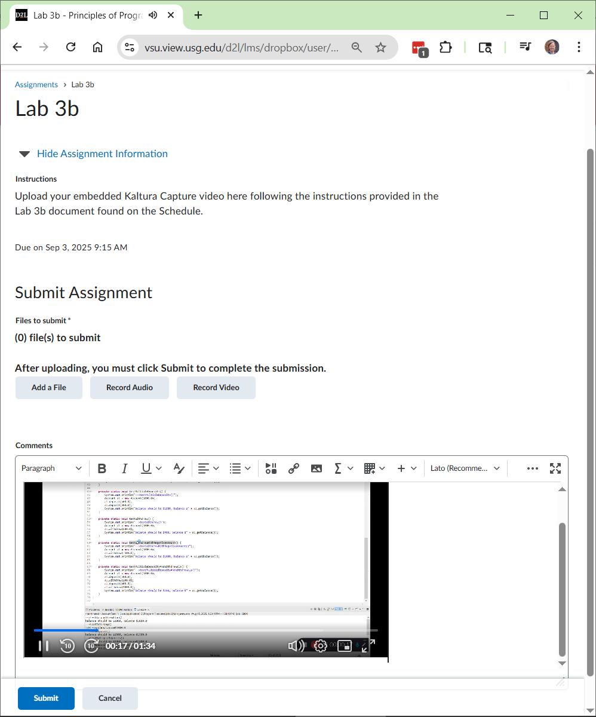

1. Choose: Done

**You are done!**

Appendix

1. From VSU’s eLearning

This document is much what I presented above. It has some additional techniques that might be useful. To follow basically the same as above, but with a bit more detail, do the following on page:

<https://www.valdosta.edu/academics/elearning/documents/kaltura-capture-guide.pdf>

1. Steps 1-7
2. Choose the link titled, *Recording Your Screen or Partial Screen*. Do Steps 1-7
3. Note: it never says to press the Red button to start recording. Do that.
4. Scroll down and see the section titled, *Completing Your Recording*.
5. Installing Capture

Windows: <https://knowledge.kaltura.com/help/download-and-install-kaltura-capture>

Mac: <https://knowledge.kaltura.com/help/install-kaltura-capture>