CS 1302 – HW 9

*Martian Manager App, ver 3*

Contents

1 Overview 1

2 Steps to Complete 2

3 Provided Code 4

4 Submission Requirements 4

# Overview

You have been provide the component shown in red below: the code to build it and the mostly empty event handlers. You will add this component to the Martian Manager App, ver 2 and program the event handlers. Comments in the event handlers tell what you are supposed to do and provides hints for the remove. In addition, you’ll need to modify these existing event handlers: *Create, Reset All, Read.*

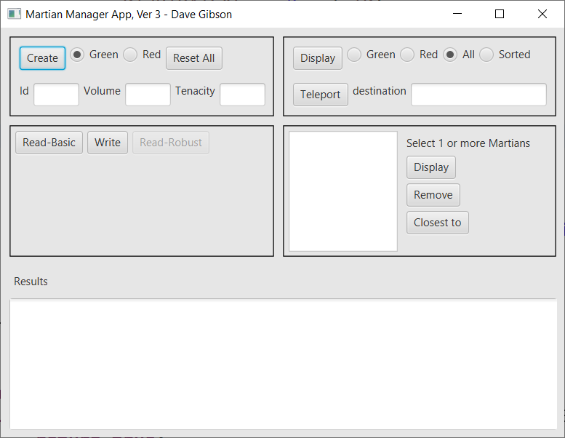

# Steps to Complete

1. Copy HW 6 (MartianManager App, ver 2). Change the title to “…ver 3”
2. From the supplied code, add the component, event handlers, and instance variables (they may already be present).
3. Modify the *Create* event handler to add the martian to the listview in the format: [G|R]-id

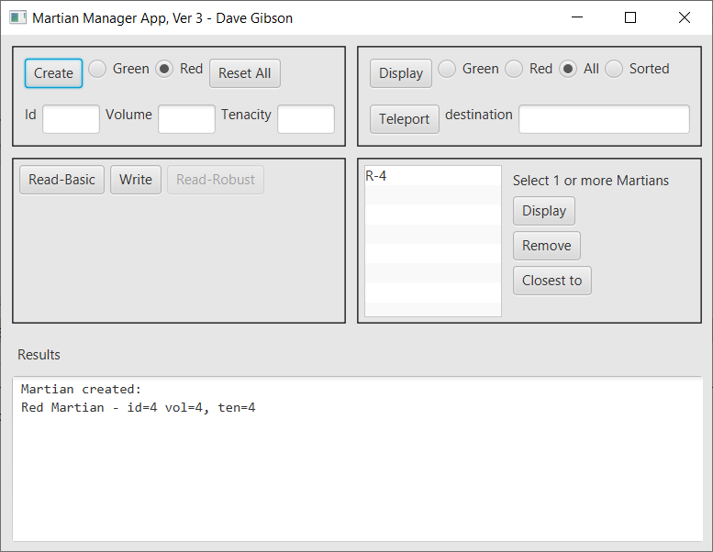

1. Add this rule to your CSS file to put less space between the listview items:

.list-cell {

-fx-padding: 0px;

}

1. Modify the *Reset All* event handler to also clear the items from the listview
2. Modify the *Read* event handler so that it adds the read martians to the listview.
3. Program the new *Display* event handler so that all selected martians are displayed.

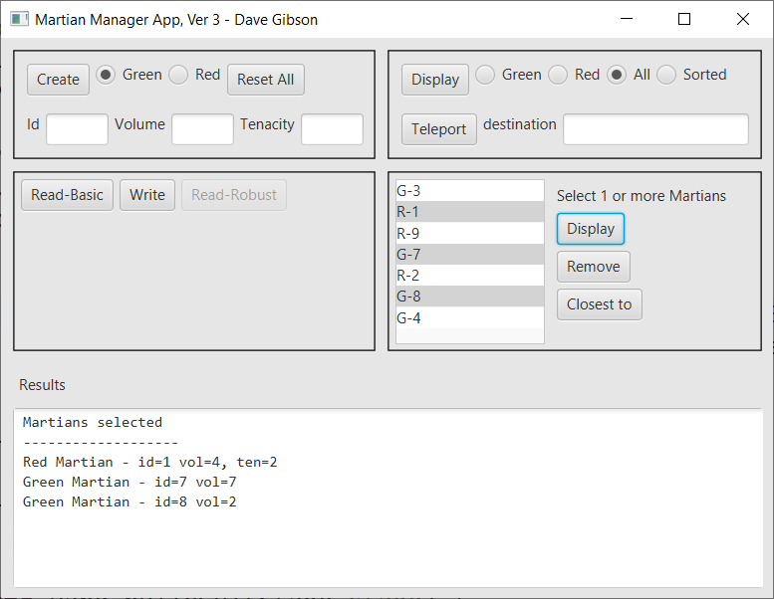

1. Program the *Remove* event handler so that all selected martians are: (a) removed from the martian manager, (b) removed from the listview, (c) displayed in the Results area.

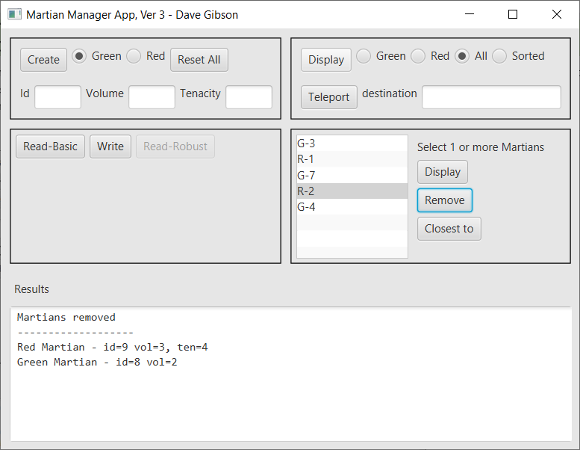

1. Program the new *Closest to* event handler so that the closest martian to each selected martian is displayed. Hint: use the martian manager’s closest to method. **WARNING: there may be a bug in the closest to method in the Jar file. If so, it will return the Martian itself. For example: G-7 selected below might return martian, G-7. If so, that is OK!**

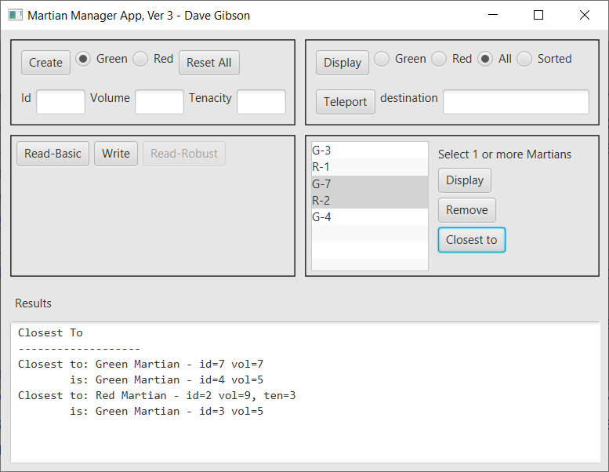

1. Create a video demo:
2. Launch the app and create 2 martians.
3. Press, “Reset All”
4. Read in a text files of martians.
5. Add two martians manually.
6. Select 3 martains from the listview and choose the new *Display*.
7. Select 3 martains from the listview and choose the new *Closest to*.
8. Select 3 martains from the listview and choose the new *Remove*.
9. Select “All” and then choose the original *Display* and verify that the removed martians have been removed form the martian manager.

# Provided Code

You have been provided code that produces:

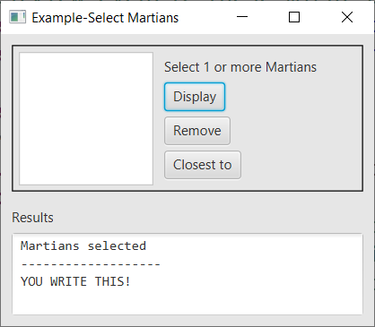

# Submission Requirements

Checklist:

|  |  |  |
| --- | --- | --- |
|  | **Complete?** | **Requirement** |
| 1. |  | Your project folder is zipped into a file name: *hw6_yourLastName.zip.*   * See Lab 2, Stage 9 for exact instructions. * Do not zip your workspace folder * Do not zip your *src* folder. * Do not zip just the java files * Do zip just your projectfolders |
| 2. |  | Video complete |
| 3. |  | Submit video and zip file in the *hw 9* dropbox on Blazeview by the deadline. |