CS 1302 – HW 6a

Text Files & GUI

Contents
1 Martian Manager App, Ver 2, Overview 1
2 Setup 4
3 Text File Format 9
4 Requirement 1: writeMartiansFile Method 9
5 Requirement 2: readMartiansFile Method 10
6 Verification 11
7 Video Requirements 11
8 Submission Requirements 12
Appendix 1 GUI App that Reads & Writes 12

Martian Manager App, Ver 2, Overview
AI is not allowed on this assignment.
You will add a component (highlighted in red below) that allows the user to read a text file of martians and add them to the martian manager instance variable. The user can also write the martians in memory to disk.
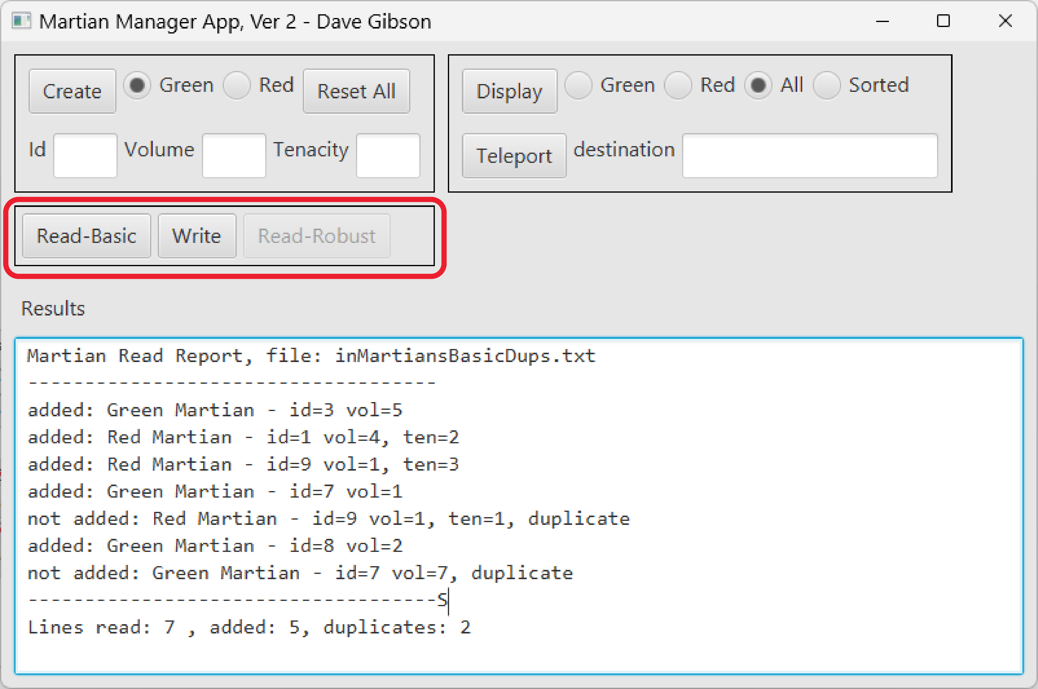
When “Read-Basic” is pressed, the standard File Open Dialog is displayed where the user can choose a file:
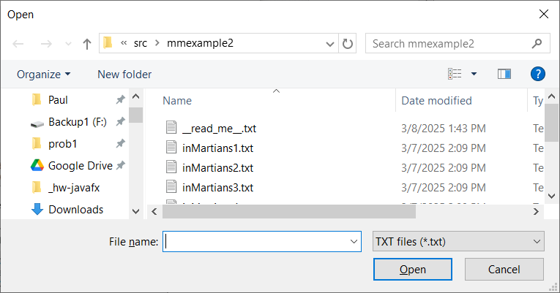
When a file is chosen, the code I provide to you displays:
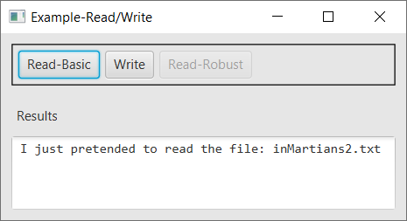
You will modify the code to read a file of martians.
When “Write” is pressed, similarly, a File Output Dialog is displayed and a sample message is displayed. You will modify this code to write the martians in memory (in the martian manager) to disk.
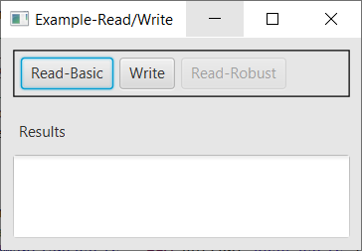
Note:
You have been provided a JavaFX application, MartianManagerGui2Class.java, shown on the right.

For this assignment, you will make a copy of your HW 5a assignment and modify it as needed. You may either:
- Copy the relevant code from MartianManagerGui2Class.java into your project. If you take this approach, drag the mmexample2 folder into the package node (possibly Application) node in Eclipse. You’ll have to modify module-info.java (see Lab 15 where you add the comboboxexample package)., or
- Follow the setup instructions in the next Section which explain what code to copy (providing the code) and where to place it.
The primary goal of this assignment is to integrate file processing with a JavaFX application, not to design a new GUI.

Setup
Do the following to get setup to complete the assignment.
- Create a copy of your Martian Manager App, ver 1 (HW 5a). You can do this in any of three ways:
  - In Eclipse, copy your HW 5a project and give it a new name. Recommended.
  - In file explorer (or Finder in Mac) Copy your workspace for HW 5a and paste somewhere.
  - Copy the package (probably application) in HW 5a into the same HW 5a project giving it a new name. In this case, you’ll have to modify module-info.java to recognize the new package (see Lab 15)
- Verify that your copy runs properly and all the functions of HW 5a work correctly.
- Download and unzip the code from the HW page. Inside, you’ll find a mmexample2 folder. Inside this folder, drag the 5 sample text files: inMartians1.txt, inMartians2.txt, inMartians3.txt, inMartians4.txt, inMartians5.txt into the package where your GUI file is.
- Add these instance variables to your GUI class:
// Read/Write events
protected Button btnReadMartiansBasic, btnWriteMartians, btnReadMartiansRobust;
// You will need to change the value of the PATH variable: it will be: "src/application"
// or whatever the name is of your package
private final String PATH = "src/mmexample2";
- Modify your buildGui method so that it accepts a Stage:
private Pane buildGui(Stage stage) {
- In start, modify the call to buildGui so that it passes the primaryStage. In my case, it looks like this:
Pane root = buildGui(primaryStage);
- Verify that HW 6a runs properly. There is no visible change, just making sure you didn’t break anything.
- Add the method below to your GUI class. (Later, you will call this method in your buildGui method and it will return a pane with 3 buttons in it (one of which, “Read-Robust” is disabled, just ignore it)).
private Pane buildReadWrite(Stage stage) {
// Create buttons
btnReadMartiansBasic = new Button("Read-Basic");
// Notice this event handler requires the "stage."
btnReadMartiansBasic.setOnAction(new ReadMartiansBasicEventHandler(stage));
btnWriteMartians = new Button("Write");
btnWriteMartians.setOnAction(new WriteMartiansEventHandler(stage));
btnReadMartiansRobust = new Button("Read-Robust");
btnReadMartiansRobust.setDisable(true);
// Build container, style, and add components.
HBox hBox = new HBox();
hBox.getStyleClass().add("boxBorder");
hBox.getChildren().addAll(btnReadMartiansBasic, btnWriteMartians, btnReadMartiansRobust);

return hBox;
}

- Copy the code below right above your main method (at the bottom of the file). It extends several pages.
//-----------------------------------------------------------------------------------------
// Event Handlers
//-----------------------------------------------------------------------------------------
/**
* Handles when the "Read-Basic" button is pressed. It requires
* a constructor so that it can remember the "stage" as an instance variable.
*/
private class ReadMartiansBasicEventHandler implements EventHandler<ActionEvent> {
Stage stage;
public ReadMartiansBasicEventHandler(Stage stage) {
super();
this.stage = stage;
}
/**
* Displays the standard "Open" dialog so the user can choose the
* file to read. Note that it returns a File object, so you don't
* need to create another one. In case you are interested, the getFile
* method is below.
*/
@Override
public void handle(ActionEvent event) {
File file = getFile(stage, "Open"); // Display Open dialog
if( file != null) {
try {
// Call this method to do the actual reading
readMartiansFile(file);
}
catch (FileNotFoundException e) {
txaMessage.setText("Error reading file");
e.printStackTrace();
}
}
}
}

/**
* Handles when the "Write" button is pressed.
*/
private class WriteMartiansEventHandler implements EventHandler<ActionEvent> {
Stage stage;
public WriteMartiansEventHandler(Stage stage) {
super();
this.stage = stage;
}
/**
* Displays the standard "Save" dialog so the user can type a file name or choose an
* existing file to overwrite. Note that it returns a File object, and passes it to
* the "writeMartiansFile" which you will write. In case you are interested,
* the getFile method is below.
*/
@Override
public void handle(ActionEvent event) {
File file = getFile(stage, "Save"); // Display Save dialog
if( file != null) {
try {
// YOU WRITE THIS METHOD (stub below)
writeMartiansFile(file);
}
catch (FileNotFoundException e) {
txaMessage.setText("Error writing file");
e.printStackTrace();
}
}
}
}

//-----------------------------------------------------------------------------------------
// Methods you will write
//-----------------------------------------------------------------------------------------
/**
* ---> YOU WRITE THIS METHOD. <--
* This method should read the martians from the "file" that was input.
*/
protected void readMartiansFile(File file) throws FileNotFoundException {
Scanner input = new Scanner(file);
txaMessage.setText("I just pretended to read the file: " + file.getName() + "\n");
input.close();
}

/**
* ---> YOU WRITE THIS METHOD. <--
* This method should write the martians in the MartianManager to the "file"
* that was input.
*/
protected void writeMartiansFile(File file) throws FileNotFoundException {
PrintWriter writer = new PrintWriter(file);
txaMessage.setText("I just pretended to write to the file: " + file.getName() + "\n");
writer.close();
}

//-----------------------------------------------------------------------------------------
// Helper methods
//-----------------------------------------------------------------------------------------
/**
* Display FileChooser to select an input or output file
*/
private File getFile(Stage stage, String type) {
FileChooser fileChooser = configureFileChooser();
File file = null;

switch(type) {
case "Open":
file = fileChooser.showOpenDialog(stage);
break;
case "Save":
file = fileChooser.showSaveDialog(stage);
break;
}
return file;
}

/**
* Configure FileChooser
*/
private FileChooser configureFileChooser() {
FileChooser fileChooser = new FileChooser();
FileChooser.ExtensionFilter extFilter = new FileChooser.ExtensionFilter("TXT files (*.txt)", "*.txt");
fileChooser.getExtensionFilters().add(extFilter);
File initPath = new File(PATH);
fileChooser.setInitialDirectory(initPath);
return fileChooser;
}
- Verify that HW 6a runs properly. There is no visible change, just making sure you didn’t break anything.
- Add this line to your buildGui method at the correct place:
Pane pRW = buildReadWrite(stage);
- Add pRW to your root pane. If you are using a GridPane as the root, you’ll need to decide where it goes and then change the row for any controls below it (Results label and the text area).
- Verify that HW 6a runs properly. It should now display the Read and Write buttons. If your Results is a TextArea named, txaResults, then when you press Read, the File Open Dialog is displayed. Choose a file and press enter and you will get a message like this:
Pressing the Write button and supplying a file name should produce a similar result.
Now, there are two things left to do, write two methods: readMartiansFile and writeMartiansFile (stubs provided in the code you copied above and highlighted yellow). You will receive guidance on this in subsequent sections of this document.

Text File Format
The format for the martians text file is shown below (left column). Thus, a GreenMartian is represented with a ‘G’ followed by the Id and optionally, the Volume. A RedMartian is represented by a ‘R’ followed by the Id, optionally a Volume, and aTenacity. You can assume all data is valid. An example file is shown below (right column). So, we can see that each Martian is on a separate line. For example, the first line in the example is a GreenMartian with id=3 and volume=5. The second line is a RedMartian with id=1, volume=4, and tenacity=2.
Format, either of these is valid | Key | Example
G I [V]  R I [V] T |  | G 3 5  R 1 4 2  G 5  R 9 4  G 7 7  R 2 9 3  G 8 2  G 4 5
  Code | Type | Meaning
  G | Character | Green Martian
  R | Character | Red Martian
  I | Integer | Id
  V | Integer | Volume
  T | Integer | Tenacity

Requirement 1: writeMartiansFile Method
The sample code provides this method stub:
protected void writeMartiansFile(File file) throws FileNotFoundException {
Write this method. This method write all martians currently stored in the martian manager instance variable to the file represented by the file parameter, using the format described above; however, the volume should always be present. In other words, these are the valid formats for writing:
G I V
R I V T
The output after a write should show a message like this, which shows the file name and the number of martians written:
File: out1.txt, Num Martians written:7
Hints:
- What MartianManager methods will you need to loop over the Martians? Reference the Javadoc for HW 5 (where the MartianManager and related classes were originally written) or the class diagram for HW 5.
- To get the file name, use: file.getName()

Requirement 2: readMartiansFile Method
- The sample code provides this method stub:
protected void readMartiansFile(File file) throws FileNotFoundException {
This method accepts a file object, reads the martians in the file, adds the martians to the martian manager instance variable (there may already be martians in there, just add to it), and display the added martians along with some statistics.
- Note the following:
- When you read martian data, you use it to create either a RedMartian or a GreenMartian. Note that there are 4 cases which correspond with the 4 constructors:
Input Format | Constructor
G I | GreenMartian(id)
G I V | GreenMartian(id, volume)
R I T | RedMartian(id, tenacity)
R I V T | RedMartian(id, volume, tenacity)

- Using the correct constructor, you will attempt to add the martian to the MartianManager. The MartianManager’s addMartian method will only add a martian, if there doesn’t already exist a martian with the same id. The addMartian method returns true if the martian was added and false otherwise. Your code will keep track of how many martians were successfully added and how many were not added because they already exist (duplicates).
- As lines are being read, martians created, and attempting to add them to the MartianManager, your code should keep track of:
- numLinesRead – the total number of lines read
- numSuccessfullyAdded – the total number of martians successfully added to the MartianManager
- numDuplicates – the total number of martians that could not be added to the MartianManager because they are duplicates, i.e. already exist.
Note: numLinesRead = numSuccessfullyAdded + numDuplicates
- The output should be similar to what is shown in an example below. In this example, the duplicates are highlighted
Sample File | Output
G 3 5  R 1 4 2  R 9 3  G 7  R 9 1 1  G 8 2  G 7 7 | Martian Read Report, file: inMartiansBasicDups.txt  ------------------------------------  added: Green Martian - id=3 vol=5  added: Red Martian - id=1 vol=4, ten=2  added: Red Martian - id=9 vol=1, ten=3  added: Green Martian - id=7 vol=1  not added: Red Martian - id=9 vol=1, ten=1, duplicate  added: Green Martian - id=8 vol=2  not added: Green Martian - id=7 vol=7, duplicate  ------------------------------------  Lines read: 7 , added: 5, duplicates: 2
Note that constructors that do not receive a volume use the default volume of 1, which is reflected in the output above.
- You have been provided 5 test input files: inMartians1.txt, inMartians2.txt, inMartians3.txt, inMartians4.txt, inMartians5.txt (has a few duplicates).

Verification
- Test reading from the provided files and verify the output.
- Reset the application, read one of the provided text files in. Then, write it back to disk with a different name. Verify that the output file is correct.
- Rest the application. Add a few martians manually. Read one of the provided text files in. Display all and verify that the martians added manually, and the ones read in are all there. Then, write it back to disk. Verify that the output file is correct.
- Reset the application. Then, read in the most recent output file. Verify that all martians were read in and added.
- Explain your readMartians method without reading anything.

Video Requirements
Create a video using Kaltura Capture (see Lab 3b for directions) following the agenda below. Adhere to these constraints:
- Your video must be narrated throughout.
- You must state your first and last name.
- The GUI should be expanded so that all labels are displayed (i.e. if the display is too narrow, it will show “…” for the labels that are too large).
- The Results are should show 5-10 lines so that I can see all results. However, scroll if necessary to show me.
Demo Agenda
- Launch the app
- Start the recording.
Narrate the following using a clear and audible voice:
- State your first and last name.
- Read in: inMartians2.txt.
- Use “Display” to display “All” the martians.
- Add two martians manually.
- Use “Display” to display “All” the martians (there should be 2 more).
- Write the martians to a file, out1.txt.
- Open the output text file just created and display the contents.
- Press, “Reset All”
- Read in the output file (out1.txt) you just created.
- Explain your readMartians method in your own words. Do not simply read the code or a written script aloud.
- Stop the recording.
- Test your video – make sure the video plays and the audio is clear and audible!

Submission Requirements
Checklist:
 | Complete? | Requirement
1. |  | Your application folder is zipped into a file name: hw6a_yourLastName.zip.  - See Lab 2, Stage 9 for exact instructions.  - Do not zip your workspace folder  - Do not zip your src folder.  - Do not zip just the java files  - Do zip just your application and prob2 folders
2. |  | Video complete
3. |  | Submit zip file in the hw 6a dropbox on Blazeview by the deadline.
4. |  | Submit video in the Comments area (Insert Stuff-see Lab 3b if needed) for the hw 6a dropbox on Blazeview by the deadline.

- GUI App that Reads & Writes
If the Setup section fails, I’ve provided you with a standalone GUI in the code download. If you need it, drag the mmexample2 folder into the src node in Eclipse. You’ll have to modify module-info.java (see Lab 15 where you add the comboboxexample package). When you run the GUI, it produces:
The name of this file is: MartianManagerGui2ToClass.java. You could use it to extract the pieces you need and/or to see how the code you copied above is placed.

