Chapter 11 – Graphical User Interfaces (GUI)

Contents
1 Introduction 3
2 Example: 5
2.1 Hello World App 5
2.2 Example: Hello World App with CSS 7
3 JavaFX GUI Architecture 7
4 Example: Hello World App – Modularized 8
5 The HBox Class 10
6 The VBox Class & CheckBox Class 12
7 More on Modularization 13
8 The ComboBox Class 14
9 The RadioButton & ToggleButton Classes 15
10 The ListView Class 16
11 Example – More on Modularizing & Nested Panes 17
12 Event Handlers 18
12.1 Introduction 18
12.2 Button Event Handler – Accessing a TextField & TextArea 19
12.3 Handling Events on Other Controls 20
12.4 Accessing a ComboBox in an Event Handler 21
12.5 Accessing a ListView in an Event Handler 22
12.6 Accessing a set of CheckBoxes in an Event Handler 23
12.7 Accessing a set of RadioButtons in an Event Handler 24
13 Maintaining State 25
14 Complete Applications 26
15 JavaFX Summary 28
15.1 Control Summary 28
15.2 Pane Summary 29
15.3 Event Handler Summary 29
16 Exercises 30
Appendix 1 The Scene Class Hierarchy 32
Appendix 2 CSS in JavaFX 33
Appendix 2.1 Introduction 33
Appendix 2.2 Class Styles 34
Appendix 2.3 Anonymous Selectors 36
Appendix 2.4 Pseudo-class Selectors 37
Appendix 2.5 Descendant Selectors 37
Appendix 2.6 ID Selectors 38
Appendix 2.7 Practical Issues 38
Appendix 2.8 Motivation for CSS 39
Appendix 3 BorderPane 40
Appendix 4 Slider Example 41
Appendix 5 Charts 41
Appendix 6 JavaFX Event Handling 42
Appendix 7 Inner Classes 43
Appendix 8 Event Handling using Anonymous Inner Classes 44
Appendix 9 Event Handling using Lambda Expressions 45
Appendix 10 Styling A GUI with Code 46
Appendix 11 Resources 49

Introduction
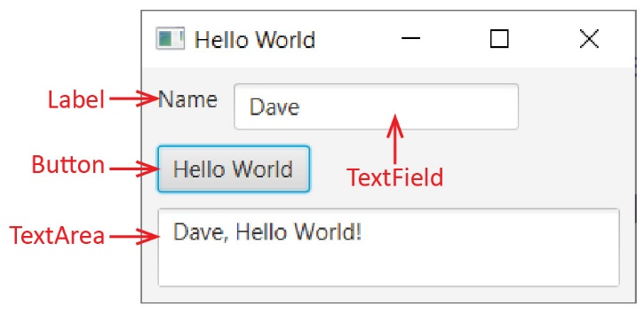
In this chapter we consider how to build GUI applications using JavaFX. To do JavaFX programming in Eclipse, see Lab 1, Sections 3-8. We start with some basic definitions:
- Graphical User Interface (GUI) – A window that allows the user to interact with graphical icons (controls). A GUI is also called a form or window. In web programming, it would be called a page.
- Control – An element that is displayed on a GUI. In the example on the right, there are four controls: Label, TextField, Button, TextArea. Controls are objects so we can program them. Controls are sometimes called widgets.
- Event – An event occurs (is fired or sent) when a user interacts with certain controls. For example, a button is clicked, and ActionEvent object fires. The programmer can write code to respond to an event.
- Event Handler – A method that is called automatically when an event is fired. It will usually pull in information from GUI controls, process the information, and then display some result. In the example above, when the button is pressed a button event handler is called to obtain the name that was typed into the TextField, compose a message, and display it in the TextArea.
- Event-Driven Programming – This refers to the process of writing GUI applications. The name comes from the fact that a GUI is generally static, it doesn’t do anything until the user interacts with it; hence, event-driven.
The two main goals of this chapter are:
- How to build a GUI.
- How to write event-handlers that respond to user interaction.
User interface design, often called user experience (UX) in another important consideration; however, we will not discuss this.

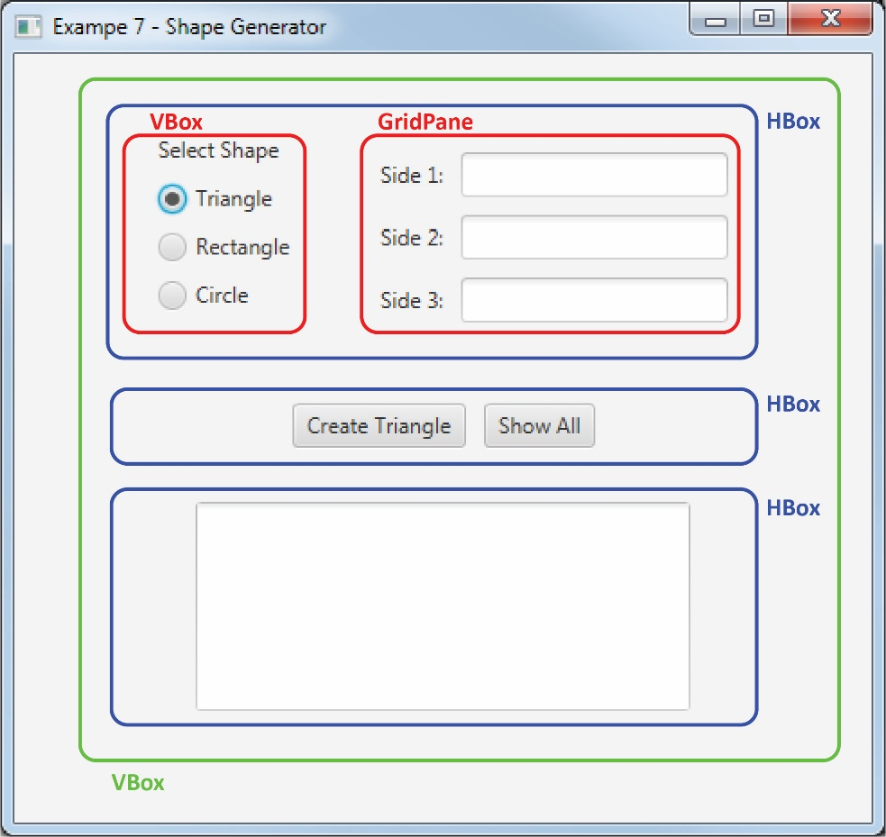
Below are a few of the basic ideas and concepts that surround GUI construction in JavaFX. We will learn the details as we move through the chapter.
- JavaFX refers to a set of classes that we use to build a GUI. To do JavaFX programming, you should use the e(fx)clipse plugin for Eclipse
- To build a GUI in JavaFX, you put Controls on a Pane. A Pane is an object that goes inside the window, which in JavaFX is a Stage object. I generally just think of a Pane as the GUI.
- A Pane is a container that arranges Controls in a particular layout. For example, the red VBox pane (outlined for emphasis) contains a Label, and 3 RadioButtons.
- Panes can be nested. For example, the blue HBox at the top contains a VBox and a GridPane.
- A GUI must have exactly one root pane. The root pane in the GUI on the right is the green VBox. Best practice is to name the root pane, root; however, I have not consistently done that in this chapter.
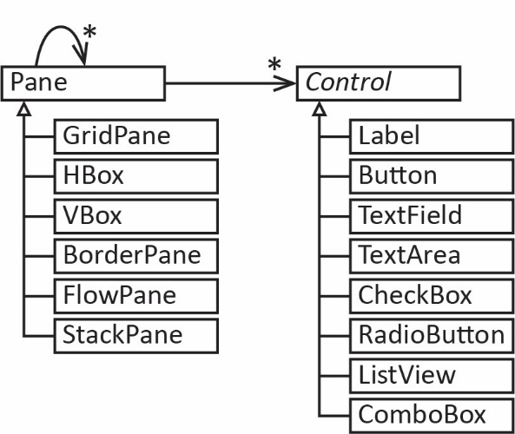
- Control is an abstract class in Java. Some common subclasses are shown in the diagram on the right. Some of the common controls are shown here:
https://docs.oracle.com/javafx/2/ui_controls/overview.htm
- Pane is a class in Java and is used as a container to hold Controls or nested Panes. Subclasses of Pane are used to layout controls in different ways. Some common subclasses are shown in the diagram on the right. Scroll through this page to see examples of different types of Panes:
http://docs.oracle.com/javafx/2/layout/builtin_layouts.htm
Java is on its third iteration of API’s to support event driven programming. AWT was first, followed by Swing, and the most current is JavaFX. Swing and AWT are still used. We will only consider JavaFX.
AWT (1995) | http://docs.oracle.com/javase/7/docs/api/java/awt/package-summary.html
Swing (1997) | http://docs.oracle.com/javase/7/docs/api/javax/swing/package-summary.html
JavaFX (2008) | https://docs.oracle.com/javafx/2/api/

Example:

Hello World App
The example in this section is in the examples_hello_world package, HelloWorld_1_No_CSS class. Note that this and subsequent examples may differ slightly from the screen shots shown: the title will usually be different, and the default colors for the frame of the window and background might be different due to a change in operating systems.
Our first example is the ubiquitous “Hello World” example as shown below, on the left. The GUI uses a GridPane as the root pane, which contains a single control, a Label as shown in the class diagram on the below, on the right.
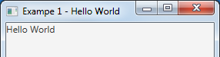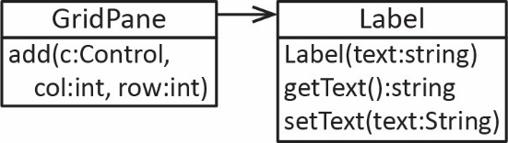
A Label is a subclass of Control that simply displays (non-editable) text (and optionally a graphic). One constructor accepts the text that you want to display. For example:
Label lblMsg = new Label("Hello World");
The Label class also has getText and setText methods for getting and setting the text that is displayed. We use getText when we consider event handlers, later. As a side note, the Label class inherits almost 500 methods.
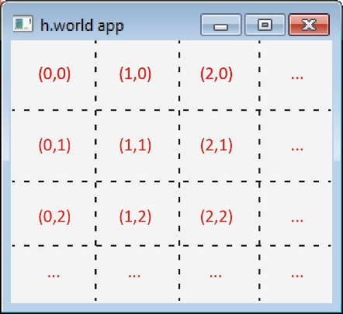
A GridPane is a subclass of Pane that holds Controls and arranges them in a grid with columns and rows as shown on the right. The GridPane only has one constructor, for example:
GridPane grdPane = new GridPane();
It has an add method that accepts the control to add and the position on the grid to put the control. For example:
Label lblMsg = new Label("Hello World");
grdPane.add(lblMsg, 0, 0);
adds a Label to the upper-left corner. Note that the second and third arguments are the column and row (zero-based).

The complete program to display the GUI is shown below. Note that main calls launch (an inherited method) and launch calls start. Thus, in a GUI application, we can think of start playing the role that main plays in a console application.
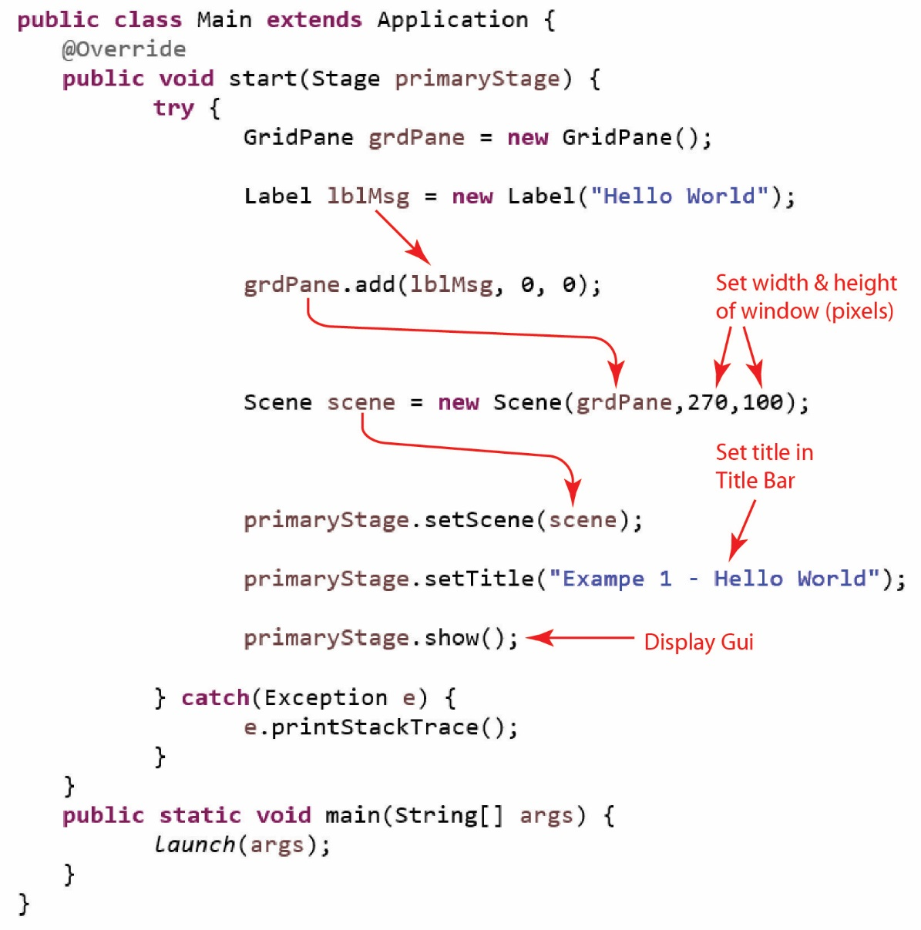
Notes:
- Although not required, there is a try/catch block in the start method in case an exception is thrown when trying to display the GUI. In Eclipse, when you create a JavaFX Project, it contains a sample GUI (an empty pane) which includes a try/catch in the start method.
- The sample GUI will also have an additional line of code, after the fourth line in the try block, as shown below, that we consider shortly.
scene.getStylesheets().add(getClass().getResource("application.css").toExternalForm());

Example: Hello World App with CSS
The example in this section is in the examples_hello_world package, HelloWorld_2_CSS class. Here, we introduce Cascading Style Sheets (CSS), which a useful way to style elements of a GUI. For example, things like: padding, margin, spacing, font, font size, etc. We only focus on the bare minimum amount of styling, typically just padding and spacing so that controls are not scrunched up on one another. We will mostly just show CSS by example. A further treatment is in an Appendix.
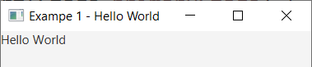
Notice the GUI considered previously (repeated on the right), that the label is displayed snuggly in the upper left corner. We can apply padding to the root pane by using a Cascading Style Sheet (CSS) where we write a style definition for the root pane. In the example above, the root pane is the GridPane, grdPane. Note: padding is probably what you think of as a margin. However, margin has a different meaning in JavaFX.
Next, let’s add a CSS to the previous example. When you create a JavaFX project in Eclipse, it creates a CSS file that is empty, application.css. We can add the root style definition as shown below and it will add 10 pixels of padding around the root pane (top, right, bottom, and left).
.root {
-fx-padding: 10px;
}
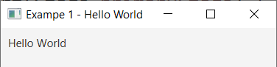
We add the highlighted line below to the start method code to apply the style definition. The result is shown on the right.
GridPane grdPane = new GridPane();
Label lblMsg = new Label("Hello World");
grdPane.add(lblMsg, 0, 0);
Scene scene = new Scene(grdPane,270,100);
scene.getStylesheets().add(getClass().
getResource("application.css").toExternalForm());
primaryStage.setScene(scene);
primaryStage.setTitle("Exampe 1 - Hello World");
primaryStage.show();

JavaFX GUI Architecture
Let’s look closer at the architecture. When you run a GUI application, the start method is called and passed a Stage object. As shown in the diagram below, you put Controls in a Pane, put the Pane in a Scene, put the Scene in the Stage and then call the show method. In this class you will be responsible for building a Pane object with the required Controls, but the rest we will consider boilerplate code.
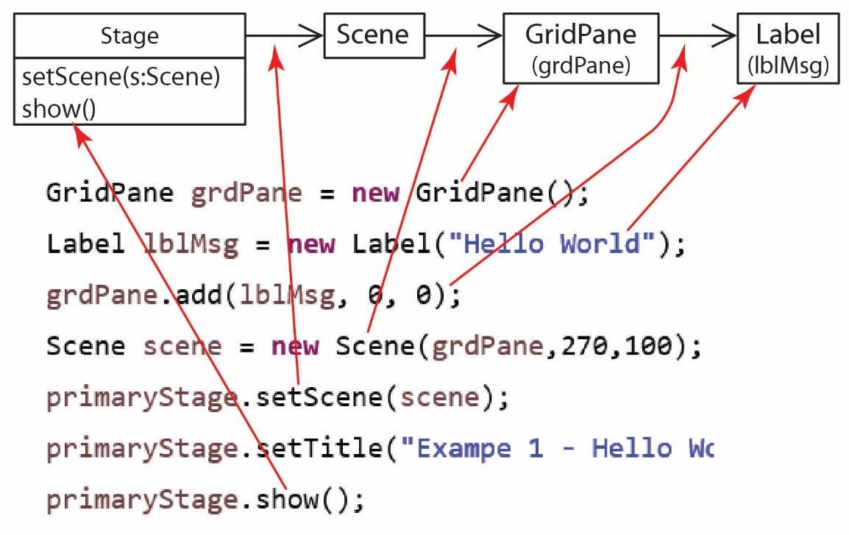
It is easy to create multiple Scenes and swap them out as needed by an application. For example, a login Scene has text fields for an id and password and a button that when pressed checks the credentials and then displays another Scene, the main page of an application. A short video that demonstrates this. In this class, we will only consider GUI’s with a single scene.

Example: Hello World App – Modularized
The example in this section is in the examples_hello_world package, HelloWorld_3_Modularized class.
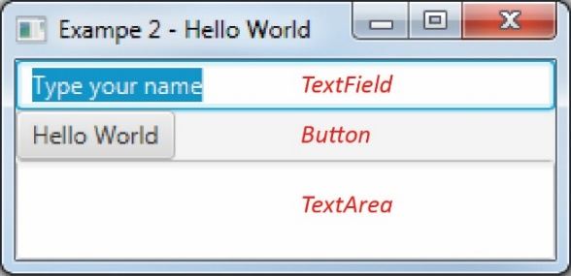
In our next example, we will build the GUI shown on the right. First, we introduce the controls we will use.
A TextField is a control that a user can type a single line of text into (and/or we can set text there with code). For example, to create the TextField on the right:
TextField txfName = new TextField("Type your name");
The TextField class also has getText and setText methods for getting and setting the text that is displayed, which we will use when we consider event handlers.
A Button is a control that can be pressed. We can configure the button to call an event handler when pressed; we do that in a later section. So, for now, we can display a button, and it can be pressed, but it will not produce any effect. We can create a Button like this:
Button btnHelloWorld = new Button("Hello World");
The Button class also has getText and setText methods for getting and setting the text that is displayed on the button itself.
A TextArea is a control that can display multiple lines of text (or allow a user to type text). Frequently, we will use a TextArea to display the output of our code. For example:
TextArea txaMessage = new TextArea();
The TextArea class also has getText and setText methods for getting and setting the text that is displayed. In some of the later examples, I may use setPrefRowCount and setPrefColumnCount to set the preferred number of rows and columns that are displayed.
Usually it takes a lot of code to build the GUI, so frequently we will modularize our code by writing a helper method to build and return a Pane object that contains the GUI. For this class, we will frequently name this method, buildGUI. As our GUI’s become more complex, our buildGUI method will use other helper methods to build the various pieces of the GUI. The program below produces the GUI shown above.
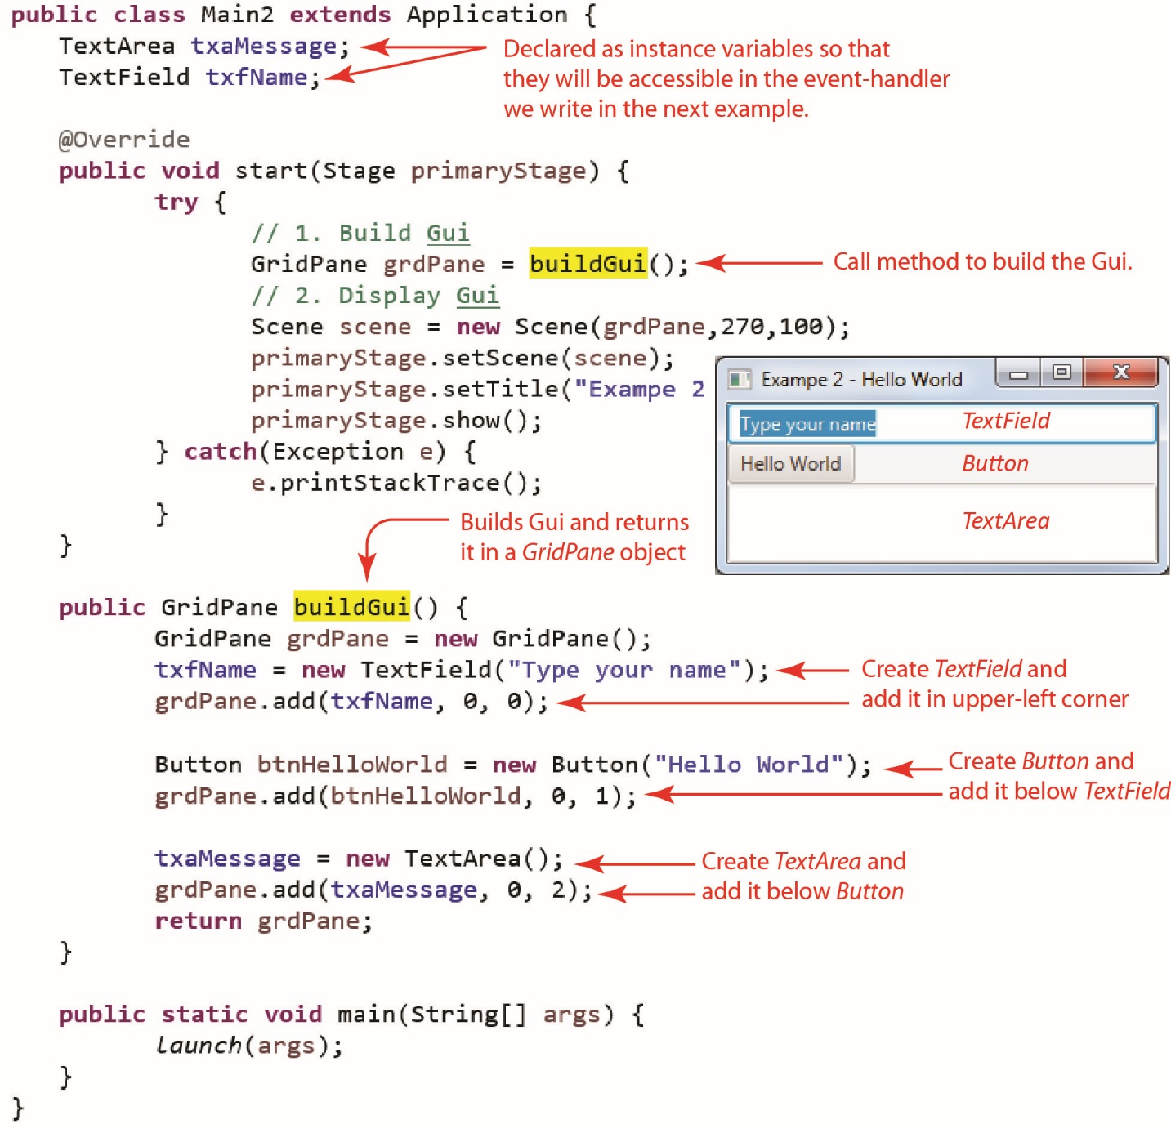
Notice that the TextField and the TextArea are defined as instance variables. This is important because when we define the event-handler, we will need to access these so that we can extract the name the user entered from the TextField and compose a message and put it in the TextArea. Had we defined them in the buildGUI method, they would have been local variables and no longer available once that method ended. Thus, they would not be accessible to the event-handler.

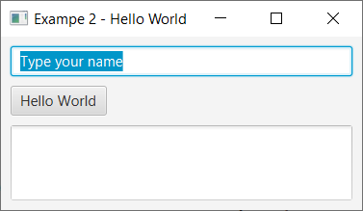
The example above did not have a style sheet attached; however, the ne in the code download does. As we saw previously, we can add a style definition for root to provide padding. However, that only applies to the edges of the pane. To create vertical distance between the cells in the GridPane, we add the GridPane style definition as shown below. There we set the hgap and vgap, which are the horizontal and vertical, respectively, distance between cells in the GridView. The result is shown on the right.
.root {
-fx-padding: 10px;
}

GridPane {
-fx-hgap:10px;
-fx-vgap:10px;
}
Note:
- In this case, we could have put the hgap and vgap in the root definition because the root pane, in this case, is a GridPane. However, the root pane could be any number of other types of pane, and these others would not have hgap and vgap properties.
- The GridPane style definition applies to all instances of GridPane in our GUI. In other words, if we had a GridPane inside the cell of a GridPane, they would both have these properties.
- The naming convention for the two style definitions is different, “.root” vs. a class name. This is explained in an Appendix.

The HBox Class
The example in this section is in the examples_hello_world package, HelloWorld_4_Modularized_HBox class.
An HBox is a container (Pane) that arranges the controls horizontally, one after the other, in a single row. For example, the code below renders as shown on the right (I have added a blue border around the HBox for emphasis):
Label lblPrompt = new Label("Name");
txfName = new TextField();

// Create HBox
HBox hBoxName = new HBox();

// Add controls to HBox
hBoxName.getChildren().addAll(lblPrompt, txfName);
Note that the HBox has a non-obvious way to add the controls. There is not an add method. Instead, you call the getChildren method that returns a collection of the controls in the HBox (in this case, initially empty) and then you can call the addAll method to add the controls. The getChildren collection also has an add method so that you can add the controls one at a time.
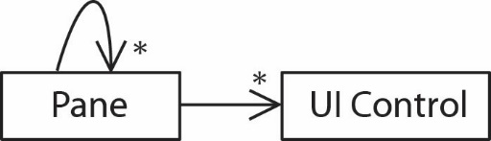
One very useful concept is that we can nest panes: we can put panes inside of other panes. This provides for infinitely more layout flexibility and organization. In other words, a Pane can contain any number of (sub) Panes, and each Pane can contain any number of controls as shown in the class diagram on the right.
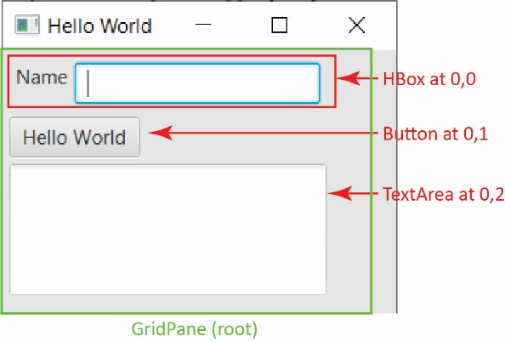
For example, consider the GUI shown on the right. Note the following:
- We use a GridPane as the root pane (green outline).
- The node at 0,0 is an HBox that contains a Label and a TextField.
The code below will create the GUI shown:

public GridPane buildGUI() {
GridPane grdPane = new GridPane();

// Build top row & add to GridPane
Label lblPrompt = new Label("Name");
txfName = new TextField();
HBox hBoxName = new HBox();
hBoxName.getChildren().addAll(lblPrompt, txfName);
grdPane.add(hBoxName, 0, 0);

// Build second row
Button btnHelloWorld = new Button("Hello World");
grdPane.add(btnHelloWorld, 0, 1);

// Build third row
txaMessage = new TextArea();
txaMessage.setPrefColumnCount(20);
txaMessage.setPrefRowCount(3);
grdPane.add(txaMessage, 0, 2);

return grdPane;
}
An HBox needs its spacing property set to set the distance between controls. Note: The figure above does not have this definition applied; however, the code download does.
HBox {
-fx-spacing: 10px;
}

The VBox Class & CheckBox Class
The example in this section is in the examples_hello_world package, HelloWorld_5_CheckBoxes class.
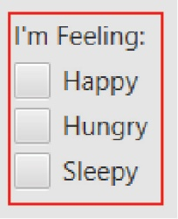
A VBox is the same as an HBox except that the controls are arranged vertically, in a single column. For example, the pane on the right shows a Label and 3 CheckBoxes in a VBox (note that I have added a red border around the VBox for emphasis). We will discuss CheckBox in more detail later. The code below will produce it. First, declare as instance variables:
protected Label lblImFeeling;
protected CheckBox chkHappy, chkHungry, chkSleepy;
Helper method that will return the pane:
private Pane buildFeelingsEntry() {
lblImFeeling = new Label("I'm Feeling:");
chkHappy = new CheckBox("Happy");
chkHungry = new CheckBox("Hungry");
chkSleepy = new CheckBox("Sleepy");
VBox vBoxFeeling = new VBox();
vBoxFeeling.getChildren().addAll(lblImFeeling, chkHappy, chkHungry, chkSleepy);
return vBoxFeeling;
}
Notice the buildFeelingsEntry method uses a VBox but returns it as a Pane. Of course, we can do this because VBox is a subclass of Pane. The benefit is that if we change the VBox to some other type of Pane, then the code that calls this method will not have to change.
The CheckBox class has getText and setText methods. It also has an isSelected method that returns true if it is checked and false otherwise.
We add a style definition to our style sheet to provide spacing in the VBox.
VBox {
-fx-spacing: 10px;
}
Some examples of other types of panes, that we didn’t consider are in the examples_panes package.

More on Modularization
The example in this section is in the examples_hello_world package, HelloWorld_5_CheckBoxes class.
First, let’s summarize what we learned earlier about modularization. Instead of building the GUI in the start method, we will have the start method call a method that builds and returns the GUI.
- First, we write a helper method, buildGUI that builds the entire GUI and returns a Pane object (which is the GUI). For example:
private Pane buildGUI() {
GridPane root = new GridPane();
...
return root;
}
- In start, we call this method and then pass the result to the scene.
// Create root container for controls
Pane root = buildGUI();

// Add root to Scene.
Scene scene = new Scene(root,400,300);
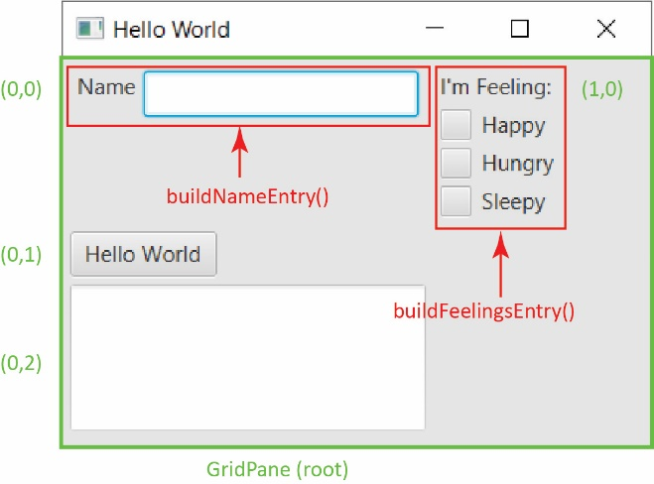
Consider the GUI on the right. We modularize further by writing helper methods to build the name entry, buildNameEntry() and to build the check box component, buildFeelingsEntry(). Then, in buildGUI, we call the two methods:
private Pane buildGUI() {
GridPane root = new GridPane();

Pane p = buildNameEntry();
root.add(p, 0, 0);

p = buildFeelingsEntry();
root.add(p, 1, 0);

Button btnHelloWorld = new Button("Hello World");
root.add(btnHelloWorld, 0, 1);

txaMessage = new TextArea();
txaMessage.setPrefColumnCount(7);
txaMessage.setPrefRowCount(3);
root.add(txaMessage, 0, 2);

return root;
}
The buildFeelingsEntry method was considered in the previous section. Here, we show the other helper method:
private Pane buildNameEntry() {
Label lbl = new Label("Name");
txfName = new TextField();
HBox hBoxName = new HBox();
hBoxName.getChildren().addAll(lbl, txfName);
return hBoxName;
}

The ComboBox Class
The example in this section is in the examples_hello_world package, HelloWorld_6_ComboBox class.
A ComboBox is what we frequently call a drop-down list. It can be declared as an instance variable as shown below. In this case, the generic type parameter, <String> indicates that the “list” will be displayed as strings (it could hold images or other objects).
protected ComboBox<String> cmbSalutation;
The method below will build and return a Pane that contains a label and a ComboBox as shown on the right.

private Pane buildSalutation() {
VBox saluation = new VBox();
Label lblSalutation = new Label("Salutation");
saluation.getChildren().add(lblSalutation);

cmbSalutation = new ComboBox<>();
cmbSalutation.getItems().addAll("Mrs", "Ms", "Mr", "Dr");
cmbSalutation.setValue("Ms");

saluation.getChildren().add(cmbSalutation);

return saluation;
}
Notes:
- The first highlighted line adds the items to display in the ComboBox.
- The second highlighted line sets the item that is initially displayed.

The RadioButton & ToggleButton Classes
The example in this section is in the examples_hello_world package, HelloWorld_7_RadioButtons class.
A portion of a GUI shown on the right shows a Label and two RadioButtons. A related group of RadioButtons should have the property that only one can be selected. For example, if the user, for example selects “Long” (figure on the right), then “Short” will automatically be deselected.
To achieve this, the we use a ToggleGroup which is a container that holds instances of RadioButton (actually, it holds anything that is a Toggle). The ToggleGroup should be declared as an instance variable. However, many times the RadioButtons themselves can be declared as local variables. This will be explained when we consider event handling. Here, I declare them as instance variables:
protected ToggleGroup tGrpStyleChoice;
protected RadioButton rbShort, rbLong;
The method below will build and return a Pane that contains a label and a two RadioButtons as shown above.
private Pane buildMessageStyleChoice() {
// Build message style component
VBox vbox = new VBox();
Label lbl = new Label("Message Style");
vbox.getChildren().add(lbl);

tGrpStyleChoice = new ToggleGroup();

rbShort = new RadioButton("Short");
rbShort.setToggleGroup(tGrpStyleChoice);
rbShort.setSelected(true);
vbox.getChildren().add(rbShort);

rbLong = new RadioButton("Long");
rbLong.setToggleGroup(tGrpStyleChoice);
vbox.getChildren().add(rbLong);

return vbox;
}
Notes:
- The first highlighted line creates a RadioButton which displays the text: “Short”.
- The second highlighted line assigns the radio button to the ToggleGroup
- The third highlighted line selects this radio button to be selected initially.

The ListView Class
The example in this section is in the examples_hello_world package, HelloWorld_8_ListView class.
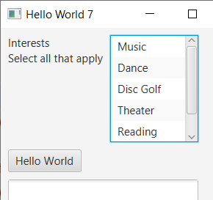
A ListView displays a list of items vertically and allows for single selection, or for multiple selections. Use the declaration below as an instance variable.
protected ListView<String> lvwInterests = new ListView<>();
Note that the ListView class is generic; thus, we should specify the type of items the list will contain.
The method below will build and return a Pane that contains a label (that contains a line break) and a ListView as shown on the right.
private Pane buildInterestsEntry() {
lvwInterests.getSelectionModel().setSelectionMode(SelectionMode.MULTIPLE);
lvwInterests.getItems().addAll("Music", "Dance", "Disc Golf", "Theater",
"Reading");
lvwInterests.setPrefHeight(150);
lvwInterests.setPrefWidth(120);
HBox hBox = new HBox();
hBox.getChildren().add(new Label("Interests\nSelect all that apply"));
hBox.getChildren().add(lvwInterests);
return hBox;
}
Notes:
- The first highlighted line sets the ListView so that multiple items can be selected. By default, the ListView only allows single selection.
- The second highlighted line assigns the items in the list.

Example – More on Modularizing & Nested Panes
The example in this section is in the example_shape_generator package.
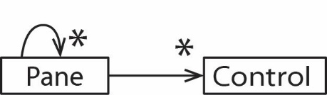
As noted previously, panes can be nested. This is particularly useful when building GUI’s with lots of controls. As a beginner (myself included), I recommend using just: GridPane, HBox, and VBox. When you need to build a GUI, I recommend sketching it quickly on paper and then identifying related regions of the GUI, deciding what pane to use for that region, and then writing a method to build that region.
Consider the GUI below:
- The root pane is a VBox (shown in green) and is built with the buildGUI method.
- The top row of the root pane is an HBox (shown in blue). It contains two other panes: a VBox containing the radio buttons, and a GridPane containing the labels and textfields.
- The middle row of the root pane contains an HBox with two buttons.
- The bottom row of the root pane contains an HBox with a text area.
- The methods to build the various panes are shown along the left.
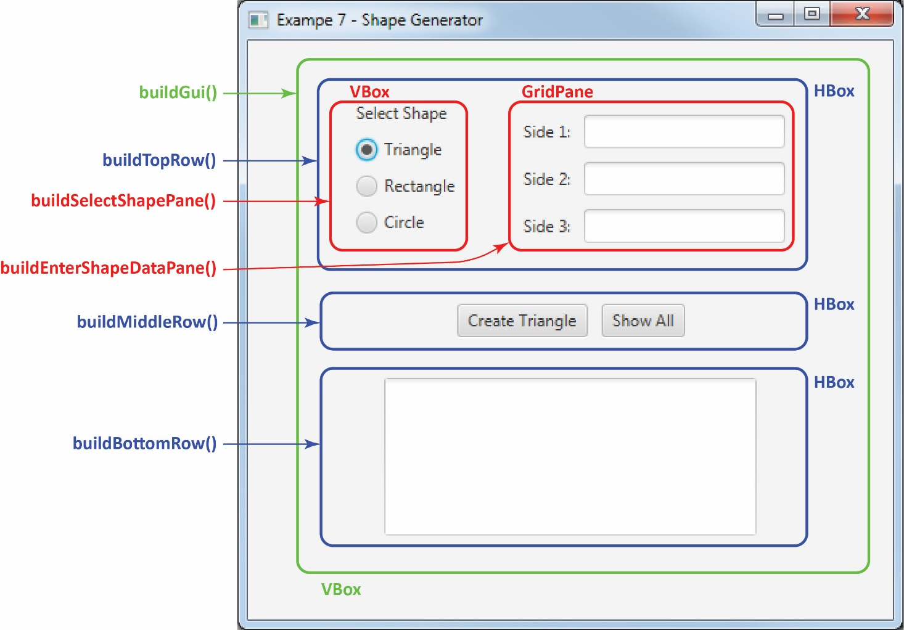

A portion of the code is below:
private Pane buildGUI(Stage stage) {
VBox root = new VBox();
root.getChildren().addAll(buildTopRow(), buildMiddleRow(), buildBottomRow());
return root;
}

private Pane buildTopRow() {
HBox topRow = new HBox();
topRow.getChildren().addAll(buildSelectShapePane(), buildEnterShapeDataPane());
return topRow;
}

private Pane buildSelectShapePane() {
VBox vBoxShape = new VBox();
Label lblSelectShape = new Label("Select Shape");
...
}

private Pane buildEnterShapeDataPane() {
GridPane gridShapeLengths = new GridPane();
lbl1 = new Label("Side 1:");
gridShapeLengths.add(lbl1, 0, 1);
...
}

private Pane buildMiddleRow() {
HBox hBoxButtons = new HBox();
btnCreateShape = new Button("Create Triangle");
hBoxButtons.getChildren().add(btnCreateShape);
...
}

private Pane buildBottomRow() {
HBox hBoxMessage = new HBox();
txaMessage = new TextArea();
...
}

Event Handlers

Introduction
The example in this section is in the examples_hello_world package, HelloWorld_9_Event_Handling class.
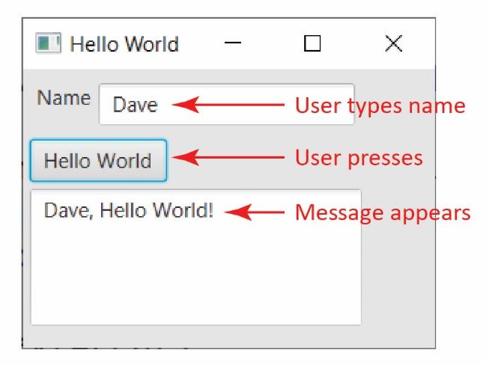
An event handler is code that is run when the user interacts with a control on a GUI and if the control is configured to respond to an interaction. For example, when a button is pressed in the example on the right, the event handler retrieves the name that was typed in, composes a message, and then displays it.

Button Event Handler – Accessing a TextField & TextArea
Assuming the GUI above is written, we define an inner class event handler. There are other techniques such as: anonymous event handlers, lambda expression, or simply a class that has an event handler as is used in MVC (Model-View-Controller). To implement an inner class event handler for the button on the GUI above, we do the following:
- Write a class that implements the EventHandler interface, which requires a handle method as shown below. There, we simply write code to respond to the event. However, this class is inside the main GUI class, placed at the same level as any other member of a class. Thus, we say that it is an inner class. An inner class can use all members of the enclosing class (even private).
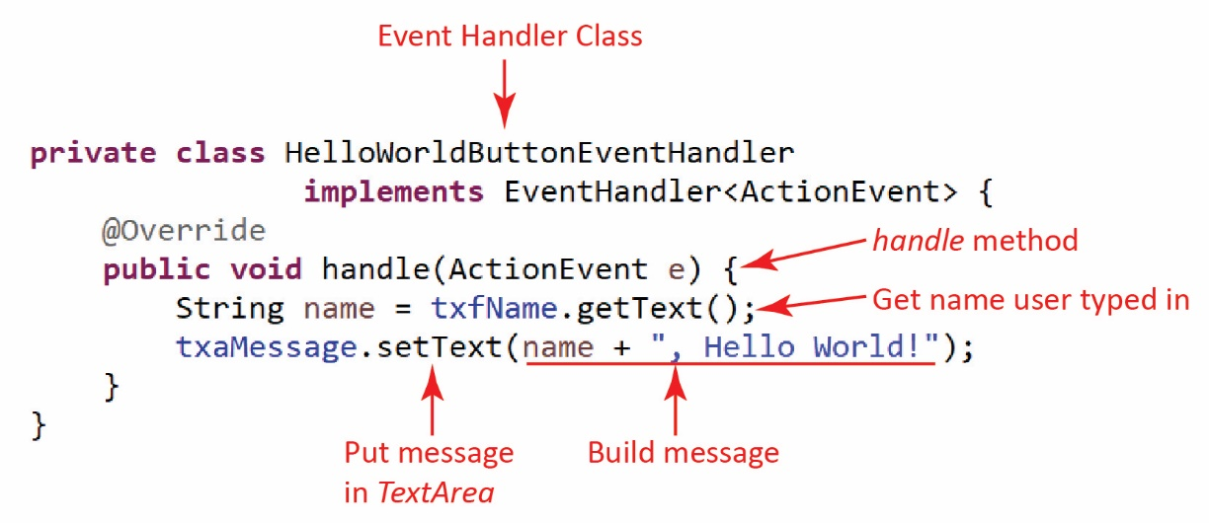
- Register the event handler with a control (e.g. button) that the user will interact with. When the program is run, and the button is pressed, the handle method is called.
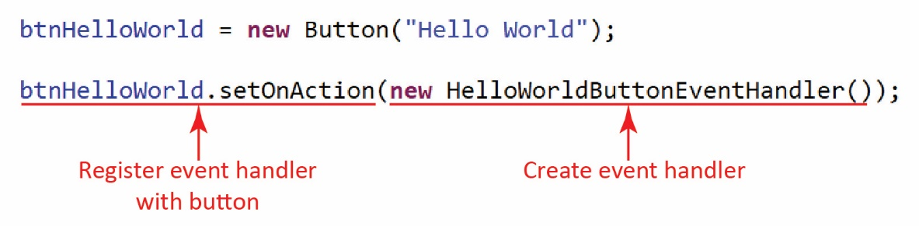

The TextField and TextArea must be declared as instance variables so that they can be accessed in the event handler. Note that the event handler does not use the Label nor the Button, so they could have been declared as local variables in the buildGui method. It might be useful to declare all controls as instance variables to avoid confusion.
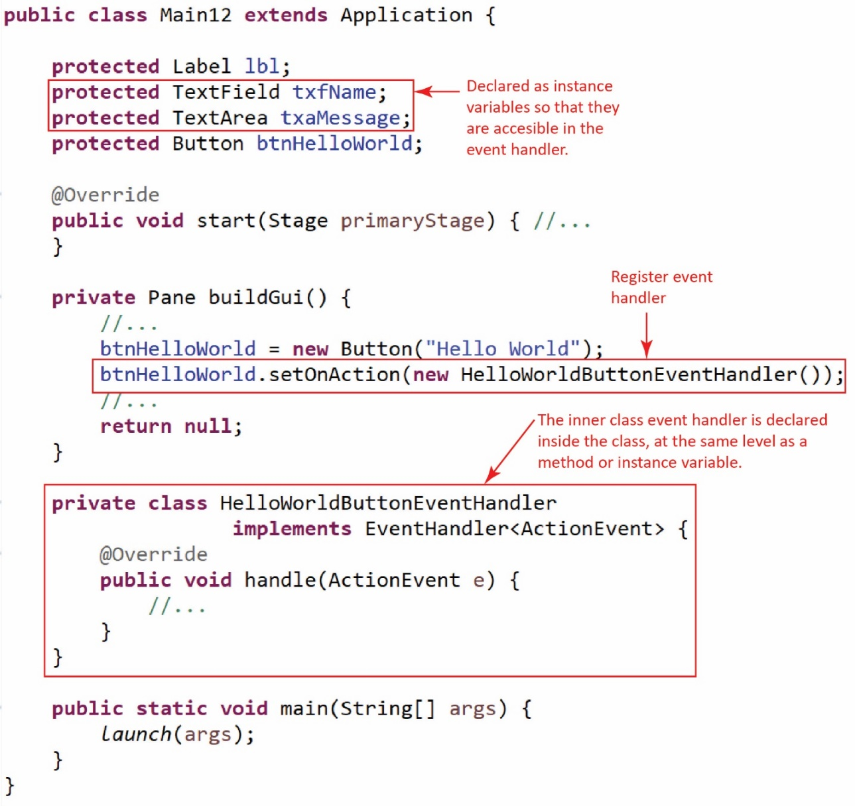

Handling Events on Other Controls
In this class we will only consider an ActionEvent that occurs on a Button. However, several other controls have a setOnAction method that accepts an EventHandler<ActionEvent> instance: CheckBox, RadioButton, TextField, ComboBox. The example in this section has a set of radio buttons (as shown below). When one is selected, it changes the text on the “Create” button, and changes the number of input text boxes and their labels.
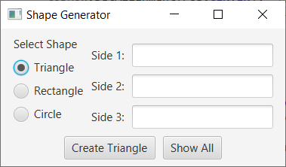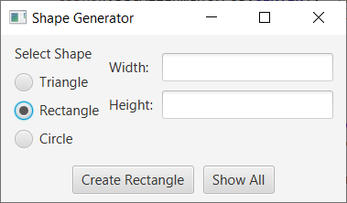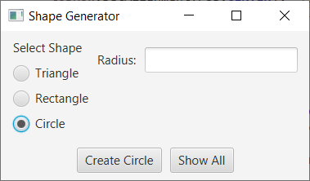
Again, we will only consider event-handlers for a Button. Other types of event handlers are considered briefly in an appendix.

Accessing a ComboBox in an Event Handler
The example in this section is in the examples_controls package, ComboBoxExample class.
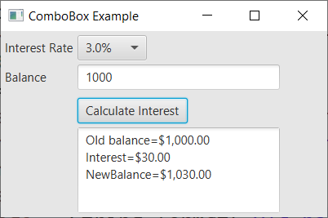
Consider the GUI on the right. The user selects an interest rate from the ComboBox, enters a balance, presses the button then a message is displayed showing the new balance after the interest is applied.
Thus, the button’s event handler needs to access the selected value from the ComboBox as well as the value in the TextField. Thus, these two must be declared as instance variables.
The selected value of the ComboBox is obtained through its getValue method. For example, if the ComboBox’s name is cmbInterestRate, then we can retrieve this value with this line of code in the event handler:
String strIntRate = cmbInterestRate.getValue();
Note, however, in the example above, that strInterestRate=”3.0%”. Thus, we need to strip off the “%”:
strIntRate = strIntRate.substring(0,strIntRate.length()-1);
And, we need to convert it to a double (and divide by 100 to make it a decimal) before doing computations with it.
double intRate = (Double.parseDouble(strIntRate))/100.0;
The event-handler is shown below.
private class CalculateInterestEventHandler implements EventHandler<ActionEvent> {
@Override
public void handle(ActionEvent event) {

String strIntRate = cmbInterestRate.getValue();
// Remove "%" from the end
strIntRate = strIntRate.substring(0,strIntRate.length()-1);

double intRate = (Double.parseDouble(strIntRate))/100.0;
double balance = Double.parseDouble(txfBalance.getText());
double interest = balance*intRate;
double newBalance = balance + interest;
String message = String.format("Old balance=$%,.2f\n" +
"Interest=$%,.2f\nNewBalance=$%,.2f", balance, interest, newBalance);
txaMessage.setText(message);
}
}
Register the event handler with the button by adding this line of code directly below the creation of the button in buildGui.
btnCalcInterest.setOnAction(new CalculateInterestEventHandler());
Finally, the buildGui method is partially shown below:
private Pane buildGui() {
...
Button btnCalcInterest = new Button("Calculate Interest");
btnCalcInterest.setOnAction(new CalculateInterestEventHandler());
grid.add(btnCalcInterest, 1, 3);

...
}

Accessing a ListView in an Event Handler
The example in this section is in the examples_controls package, ListViewExample class.
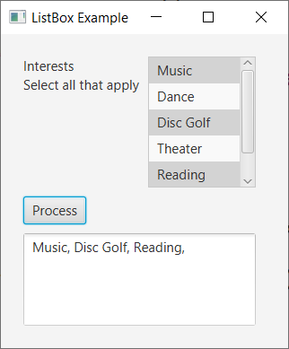
Consider the GUI on the right. The user selects any number of items from the ListView, presses the button then a message is displayed showing the items that were selected.
The selected items in the ListView are obtained with this line of code:
List<String> allItems =
lvwInterests.getSelectionModel().getSelectedItems();
Then, we can loop over the list to access each item:
String interests = "";
for(String interest : allItems) {
interests += interest + ", ";
}

The event-handler is shown below:
private class ProcessEventHandler implements EventHandler<ActionEvent> {
@Override
public void handle(ActionEvent event) {
String interests = "";
List<String> allItems = lvwInterests.getSelectionModel().getSelectedItems();
for(String interest : allItems) {
interests += interest + ", ";
}

txaMessage.setText(interests);
}
}

As usual, register the event handler with the button:
btnProcess.setOnAction(new ProcessEventHandler());

Accessing a set of CheckBoxes in an Event Handler
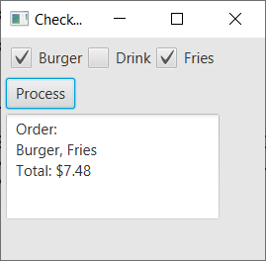
The example in this section is in the examples_controls package, CheckBoxExample class.
Consider the GUI on the right. The user selects any number of check boxes, presses the button then a message is displayed showing the items that were selected.
Note that we have individually named each CheckBox in a helper method to build the HBox that holds them.
private Pane buildFoodSelection() {
ckbBurger = new CheckBox("Burger");
ckbDrink = new CheckBox("Drink");
ckbFries = new CheckBox("Fries");

HBox hbxFood = new HBox();
hbxFood.getStyleClass().add("h_or_v_box");
hbxFood.getChildren().addAll(ckbBurger,ckbDrink,ckbFries);

return hbxFood;
}
In the handle event handler, we simply check the isSelected property of each CheckBox:
if(ckbBurger.isSelected()) {
cost += 5.99;
order += "Burger";
}
if(ckbDrink.isSelected()) {
cost += 1.99;
order += ", Drink";
}

if(ckbFries.isSelected()) {
cost += 1.49;
order += ", Fries";
}

The event-handler is shown below:
private class ProcessEventHandler implements EventHandler<ActionEvent> {
@Override
public void handle(ActionEvent event) {
double cost = 0.0;
String order = "Order:\n";

if(ckbBurger.isSelected()) {
cost += 5.99;
order += "Burger";
}
if(ckbDrink.isSelected()) {
cost += 1.99;
order += ", Drink";
}

if(ckbFries.isSelected()) {
cost += 1.49;
order += ", Fries";
}

String totCost = String.format("\nTotal: $%,.2f\n", cost);
order += totCost;
txaMessage.setText(order);
}
}
Register the event handler with the button:
btnProcess.setOnAction(new ProcessEventHandler());

Accessing a set of RadioButtons in an Event Handler
The example in this section is in the examples_controls package, RadioButtonExample class.
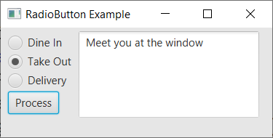
Consider the GUI on the right. The user selects a RadioButton, presses the button then a message is displayed showing the items that were selected.
Remember that we need to associate each RadioButton with a ToggleGroup to force them to work as a group (only one RadioButton can be selected). This is shown below in the helper method to build the VBox that holds them (and the Button). As we will see, the event handler only needs access to the ToggleGroup to determine which one is selected.
private Pane buildDiningChoice() {
tGrpDiningChoice = new ToggleGroup();
rbDineIn = new RadioButton("Dine In");
rbDineIn.setSelected(true);
rbDineIn.setToggleGroup(tGrpDiningChoice);
rbTakeOut = new RadioButton("Take Out");
rbTakeOut.setToggleGroup(tGrpDiningChoice);
rbDelivery = new RadioButton("Delivery");
rbDelivery.setToggleGroup(tGrpDiningChoice);

Button btnProcess = new Button("Process");
btnProcess.setOnAction(new ProcessEventHandler());

VBox vbxDiningChoice = new VBox();
vbxDiningChoice.getStyleClass().add("h_or_v_box");
vbxDiningChoice.getChildren().addAll(rbDineIn,rbTakeOut,rbDelivery,btnProcess);

return vbxDiningChoice;
}
In the handle event handler, we use the getSelectedToggle method of the ToggleGroup to return the RadioButton that was selected.
RadioButton rad = (RadioButton)tGrpDiningChoice.getSelectedToggle();
Next, we get the text of the radio button:
String choice = rad.getText();
Then, we use that text to determine which radio button was selected:
String message = "";
switch(choice) {
case "Dine In" : message = "Glad you are dining in with us";
break;
case "Take Out" : message = "Meet you at the window";
break;
case "Delivery" : message = "We will have it there shortly";
}
txaMessage.setText(message);

The event-handler is shown below:
private class ProcessEventHandler implements EventHandler<ActionEvent> {
@Override
public void handle(ActionEvent event) {

RadioButton rad = (RadioButton)tGrpDiningChoice.getSelectedToggle();
String choice = rad.getText();
String message = "";
switch(choice) {
case "Dine In" : message = "Glad you are dining in with us";
break;
case "Take Out" : message = "Meet you at the window";
break;
case "Delivery" : message = "We will have it there shortly";
}
txaMessage.setText(message);
}
}

Maintaining State
The example in this section is in the examples_complete_applications_shape_generator_basic package.
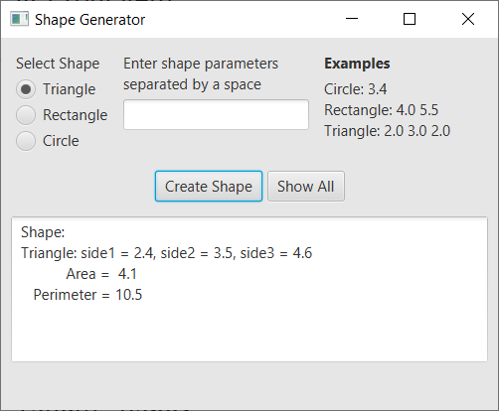
Maintaining state refers to “remembering” data between events. For example, an app to order food would need to remember the orders. In a real system, you would usually use a database. However, we can also keep the data in memory. And, this is simple: use instance variables in the Gui class. For example, you might have a list to hold orders. Actually, in practice, we separate the data from the Gui class. But, for our purposes, we will just introduce instance variables as needed.

Consider the ShapeGenerator app on the right. You can repeatedly create shapes and the system saves them. When Show All is pressed, all the shapes that have been created are displayed. To accomplish this:

- This instance variable is added to the class:
protected ArrayList<GeometricObject> shapes = new ArrayList<>();

- And, every time we create a shape in the event-handler, we added it to shapes:

// Add to collection
shapes.add(shape);

Complete Applications
These are complete examples that can be used for reference.
- This example is in the examples_complete_applications_student_data package. It does not maintain state.
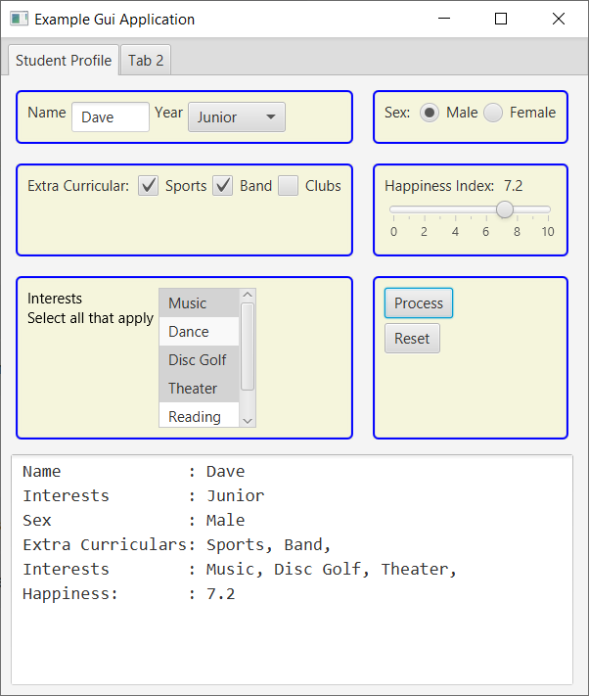
- This example is in the examples_complete_applications_order_menu package. It does not maintain state.
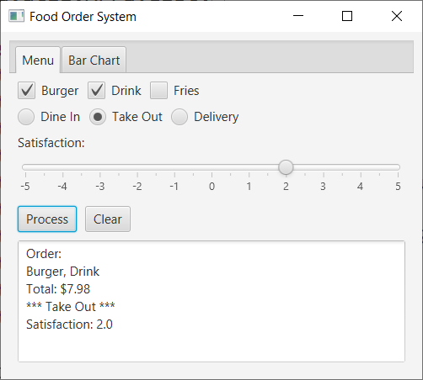
The charts are hard coded with data, just for illustrative purposes.
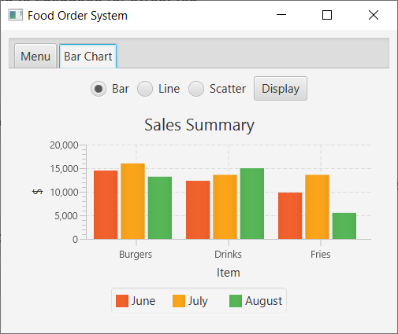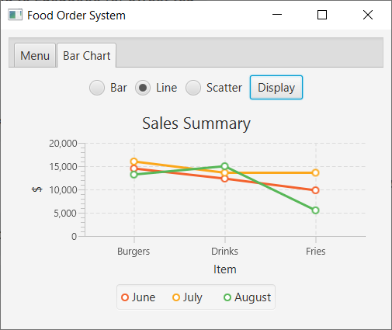

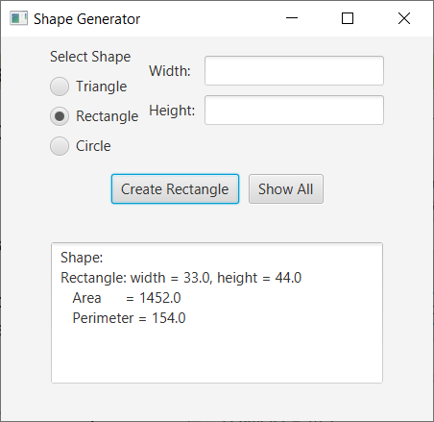
- This example is in the examples_complete_applications_shape_generator package. It does maintain state. Has an event handler for the radio buttons so that it changes the labels and number of text fields appropriate for the shape being created. A simpler version is below

- This example is in the examples_complete_applications_shape_generator_basic package. It does maintain state. Simpler than previous app. However, higher chance of entering bad data.

JavaFX Summary

Control Summary
- Label – getText, setText
Label lbl = new Label("description")
String desc = lbl.getText()
lbl.setText(“description”)
- TextField – getText, setText
TextField txf = new TextField("Type your name")
Str str = txf.getText() // might have to parseDouble/Int
txf.setText(“stuff”)
- Button – getText, setText
Button btn = new Button("description")
String str = btn.getText(“description”)
btn.setText(“description”)
- TextArea – getText, setText
TextArea txa = new TextArea()
String str = txa.getText()
txa.setText(“stuff \n more stuff”)
- CheckBox – getText, setText, isSelected, setSelected
protected CheckBox ckbBurger, ckbDrink, ckbFries;
if(ckbBurger.isSelected()) {
...
}
if(ckbDrink.isSelected()) {
...
}
...

- RadioButton – getText, setText, isSelected, setSelected, setToggleGroup
protected RadioButton rbDineIn, rbTakeOut, rbDelivery;
protected ToggleGroup tGrpDiningChoice;
tGrpDiningChoice = new ToggleGroup();
rbDineIn = new RadioButton("Dine In");
rbDineIn.setSelected(true);
rbDineIn.setToggleGroup(tGrpDiningChoice);
rbTakeOut =...

RadioButton rad = (RadioButton)tGrpDiningChoice.getSelectedToggle();
String choice = rad.getText();
- ComboBox – getItems.add(), getItems().addAll, setValue
ComboBox<String> cmb = new ComboBox<>() // Could be Integer, Double
cmb.getItems().add(str)
cmb.getItems().addAll(str1, str2, ...)
cmb.setValue(str)
String str = (String)cmb.getValue() // would use in event handler
- ListView – getItems.add(), getItems().addAll, getSelectionModel().setSelectionMode,
protected ListView<String> lvwInterests = new ListView<>();
lvwInterests.getSelectionModel().setSelectionMode(SelectionMode.MULTIPLE);
lvwInterests.getItems().addAll("Music", "Dance", "Disc Golf", "Theater", "Reading");

for(String interest : lvwInterests.getSelectionModel().getSelectedItems()) {
interests += interest + ", ";
}
- The Slider control is considered briefly in an Appendix, and the Chart is considered briefly in another Appendix.

Pane Summary
- GridPane – add
GridPane gPane = new GridPane();
gPane.add(control/pane, column, row);

- HBox, VBox – getChildren().add, getChildren.addAll
HBox hBox = new HBox();
hBox.getChildren().add(ctrl/pane);
hBox.getChildren().addAll(ctrl1, ctrl2);

VBox vBox = new VBox();
vBox.getChildren().add(ctrl/pane);
vBox.getChildren().addAll(ctrl1, ctrl2);
- The BorderPane control is considered briefly in an Appendix.

Event Handler Summary
control.setOnAction( new MyEventHandler() )
public void handle(ActionEvent e) {
// 1. Get info supplied by user
// 2. Compose a message, calculate, etc
// 3. Update gui
}

Exercises
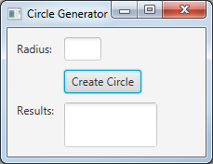
- Consider the GUI shown on the right.
- Write a few lines of code to: (a) create a GridPane, (b) create the TextArea, (c) and place the TextArea in the position shown in the GUI on the right. Note: you are not creating the entire GUI, just the piece described.
- When the button is pressed a Circle object is created using the radius from the text box. Then, its area is displayed in the TextArea. Assume: (a) all controls are accessible and (b) you have a Circle class with a constructor that takes a radius and a getArea method that returns the area of the Circle, (c) the name of the text box is txtRadius. Complete the handle method below to accomplish this.
private class CreateCircleEventHandler implements EventHandler<ActionEvent> {
public void handle(ActionEvent event) {
// Write code here...
}
}
- Write a line or two of code to register the inner class event handler from part b with the button. Assume the button’s name is btnCreate.

- Consider the Gui shown below, on the right. The user types in an email address. When the button is pressed, if the email address has a ‘@’ character anywhere in the email address, then the email address is displayed along with “Valid” on the next line. Otherwise, if the email address does not contain a ‘@’ character, then the invalid email address and “Invalid” are displayed as shown below, on the left.
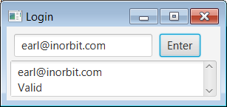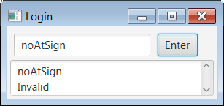
The partially written code for a Gui is shown on the next page. You will write the missing code in the two boxes so that the Gui functions as described. Note: You must use the two panes that are defined in the code.

public class Main extends Application {
TextArea txa = new TextArea();
TextField txf = new TextField("type email");
Button btn = new Button("Enter");

public void start(Stage primaryStage) {
HBox h = new HBox(); // You must use this
GridPane g = new GridPane(); // You must use this
Scene scene = new Scene(g,225,90);
primaryStage.setScene(scene);
primaryStage.setTitle("Stringinator");
primaryStage.show();
}
public static void main(String[] args) {
launch(args);
}

private class EH implements EventHandler<ActionEvent> {
public void handle(ActionEvent e) {

Appendix
- The Scene Class Hierarchy
- The figure below shows the framework for building a JavaFX GUI. Note that a Scene can contain a Pane, but in general, the association is more general; the Scene has an association with the Parent class of which Pane is a subclass. Note, also that a Pane can have many Node instances where each Node instance can be a GUI Control, another Pane, or other items such as a MediaView object.

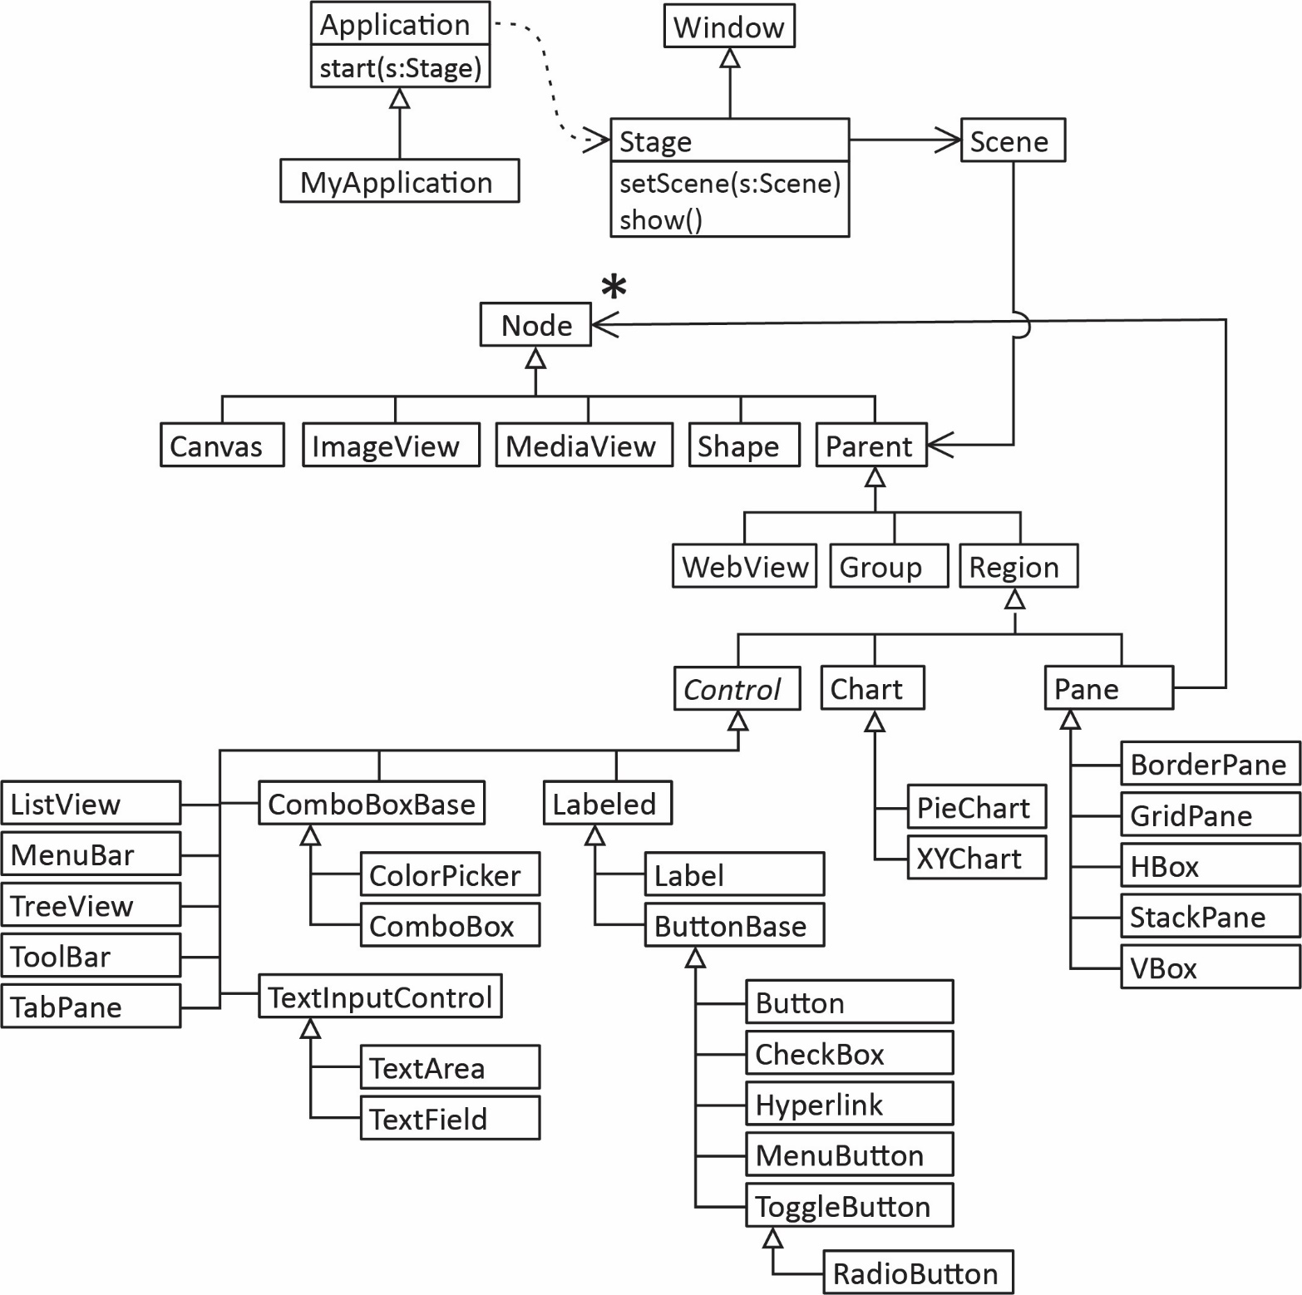

- CSS in JavaFX

  - Introduction
Cascading Style Sheets (CSS) is a technique for separating the styling (look and feel) of a GUI from its layout. We write Java code to build a GUI. We can write Java code, alongside the code to build the GUI, to style the GUI as well. However, it is considerably easier to do but construction and styling if we separate the two as much as possible. This is the basic idea of what CSS provides.
A style sheet is a text file usually saved with a .css extension. It contains style definitions which are named collections of style rules. Below, we show a style sheet. The .label style makes all Labels on our GUI blue. We explain more as we go along.
/* style definition */
.root {
/* style rules */
-fx-background-color:palegoldenrod;
-fx-padding: 10, 10, 10, 10;
-fx-font-size: 18pt ;
}
/* style definition */
.label {
/* style rules */
-fx-text-fill:blue;
}
To apply a style sheet (application.css), we add a line of code like this in start.
scene.getStylesheets().add(getClass().getResource("application.css").toExternalForm());
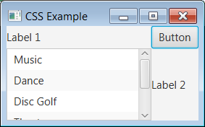
JavaFX defines a default style sheet (caspian.css). The GUI on the right does not define its own style sheet and so it is using the default style sheet. As we can see, things are a bit scrunched up together. To do any kind of modification to the style, we must create our own style sheet (or use code-not preferred).

  - Class Styles
A class style applies its style rules for all nodes of that class. The .root style definition below is a class style. root applies its style rules for all nodes in the root pane, including the root pane itself.
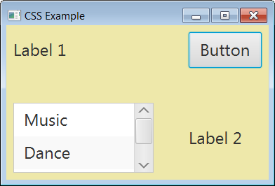
Consider the GUI on the right and the style sheet below.
This example is found in the code download for this chapter: examples_css/Example1.java and the corresponding style sheet is: application1.css.
.root {
-fx-background-color:palegoldenrod;
-fx-padding: 10, 10, 10, 10;
-fx-font-size: 18pt;
-fx-hgap: 50;
-fx-vgap: 50;
}
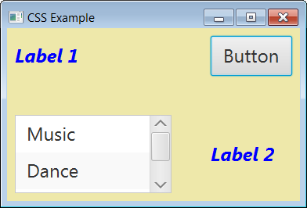
Consider the GUI on the right and the style sheet below.
This example is found in the code download for this chapter: examples_css/Example2.java and the corresponding style sheet is: application2.css.
.root {
-fx-background-color:palegoldenrod;
-fx-padding: 10, 10, 10, 10;
-fx-font-size: 18pt;
-fx-hgap: 50;
-fx-vgap: 50;
}

.label {
-fx-text-fill:blue;
-fx-font-style: italic;
-fx-font-weight: bold;
}
Notes:
- .label is a class style and applies its style rules to all instances of Label in the GUI.
- Reference for colors: https://docs.oracle.com/javafx/2/api/javafx/scene/doc-files/cssref.html#typecolor
- Reference for .fx-font: https://docs.oracle.com/javafx/2/api/javafx/scene/doc-files/cssref.html#fontprops
- Label properties: https://docs.oracle.com/javase/8/javafx/api/javafx/scene/doc-files/cssref.html#label
Class style definitions are named with the name of the JavaFX class in lower case. For example, you could define a style definition for all Button instances on your GUI with:
.button {
}
If the name of the class is compound, then you use dashes between the words. For example, to write a class selector for all CheckBox instances, you would write:
.check-box {
}

Class style definitions for Pane objects can be defined this way:
HBox {  } | VBox {  } | GridPane {  }
The name of a style definition is also called a selector because it defines which nodes (controls) are selected to be styled by the definition.
A style rule has this syntax:
css property: value;
When you type the “:” in Eclipse, usually (but not always) a popup dialog will appear to help you choose a value.
A reference for CSS properties and allowable values is here:
https://docs.oracle.com/javase/8/javafx/api/javafx/scene/doc-files/cssref.html
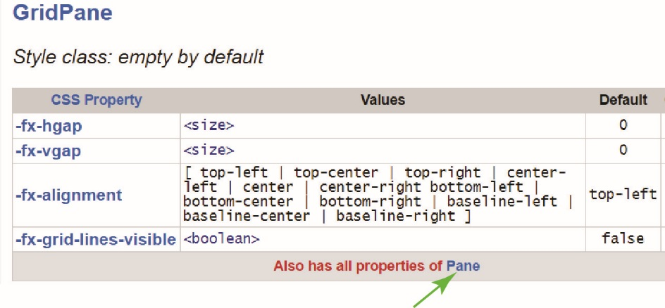
For instance, to see what properties you can use for a GridPane, select the link for GridPane and the result is shown below. There, you see that there are only four properties. However, since GridPane is a subclass of Pane, you can use any of the ones defined for Pane and notice there is a link for Pane at the bottom.

You can also style different nodes with common properties
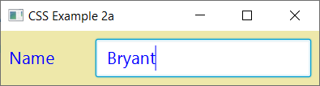
.label, .text-field {
-fx-text-fill:blue;
-fx-font-size: 16pt ;
}

This example is found in the code download for this chapter: examples_css/Example2a.java and the corresponding style sheet is: application2a.css.

  - Anonymous Selectors
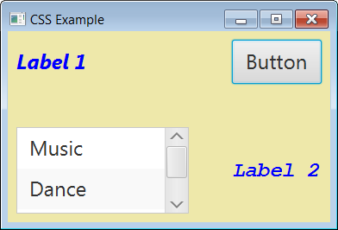
An anonymous (custom) selector is one that can be applied to any node, and must be applied with code. For this type, you create a name for the definition. For example:
This example is found in the code download for this chapter: examples_css/Example3.java and the corresponding style sheet is: application3.css.
.monosp {
-fx-font-family: "monospace";
}
Then, we apply it directly to the label (see figure on the right):
Label lbl2 = new Label("Label 2");
lbl2.getStyleClass().add("monosp");
We can apply this selector to any other nodes we want to.
You used a custom selector in the Lab on GUI construction, h_or_v_box that we applied to all HBox and VBox instances which is shown below on the left. The style sheet on the right is equivalent, and has the benefit that all of the styles are class styles, thus, automatically applied. Either approach is enough for any GUI you do make for this class.
.root {  -fx-padding: 5px;  }  .h_or_v_box {  -fx-padding: 5px;  -fx-spacing: 5px;  }  .gridpane {  -fx-hgap:10px;  -fx-vgap:10px; | .root {  -fx-padding: 10px;  }  GridPane {  -fx-hgap:10px;  -fx-vgap:10px;  }  HBox {  -fx-spacing: 10px;  }  VBox {  -fx-spacing: 10px;  }
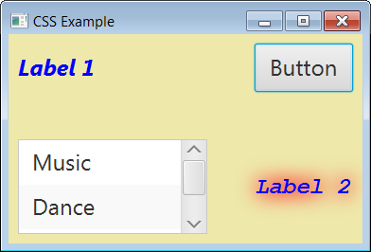
Multiple custom selectors can be applied to the same node. For example:
This example is found in the code download for this chapter: examples_css/Example4.java and the corresponding style sheet is: application4.css.
.shadow {
-fx-effect: dropshadow(three-pass-box, red, 30, 0.5, 0, 0);
}
Now, we apply it to the label (along with monosp):
Label lbl2 = new Label("Label 2");
lbl2.getStyleClass().add("monosp");
lbl2.getStyleClass().add("shadow");
The result is shown on the right above.
  - Pseudo-class Selectors
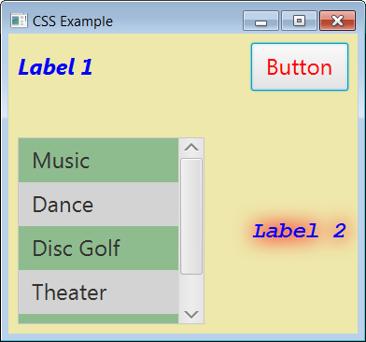
A pseudo-class selector is one that applies to a particular state the node may be in. The name of the style definition has an added keyword to denote this state. For example, in a ListView we can make every other row a different color. Also, we can make the button change color when it is hovered over:
This example is found in the code download for this chapter: examples_css/Example5.java and the corresponding style sheet is: application5.css.

.list-cell:even {
-fx-background-color:darkseagreen;
}

.list-cell:odd {
-fx-background-color:lightgray;
}

.button:hover {
-fx-text-fill: red;
}
Note that since ListCell is class in JavaFX representing a cell in the ListView, it is applied automatically.
  - Descendant Selectors
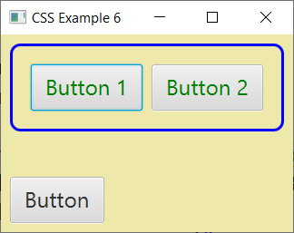
A descendant selector selects all nodes that are descendants of a specified selector. For example:
This example is found in the code download for this chapter: examples_css/Example6.java and the corresponding style sheet is: application6.css.

HBox > .button {
-fx-text-fill: green;
}

  - ID Selectors
An ID selector is a way to apply a style to exactly one element. This is done by using a “#” in front of the style name (which is the ID), and then setting the ID for a particular node. For example:

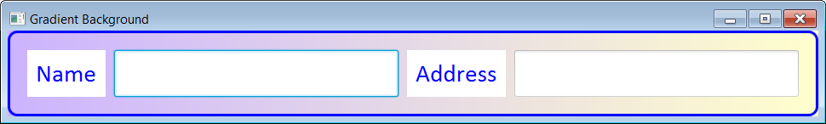

#hBoxStyle {
-fx-spacing:10.0;
-fx-background-color: linear-gradient(from 0.0% 0.0% to 100.0% 100.0%,
rgb(204,179,255) 0.0, rgb(255,255,204) 90.0, rgb(255,255,204) 100.0);
-fx-fill: blue;
-fx-padding:20 20 20 20;
-fx-border-color: blue;
-fx-border-width: 3;
-fx-border-style:solid;
-fx-border-radius:10;
}
It is applied to the HBox which serves as the root pane in this way:
HBox hBox = new HBox();
hBox.setId("hBoxStyle");
This example is found in the code download for this chapter: examples_css/Example7.java and the corresponding style sheet is: application7.css.
  - Practical Issues
Working with CSS can be tedious and confusing. Sometimes you will write a rule and it doesn’t appear to do anything. This can mean a number of things:
- The property is not valid for the selector. In this case, you don’t get an error, it just doesn’t do what you are expecting. For example, in the example above for the label selector, we defined the text color as blue:
-fx-text-fill:blue;
However, if you remove it from label and put it in root the text will not appear blue. (Strangely, that is not a valid property for root.)

- Sometimes, as you make changes to a CSS file, and save it each time, the rule doesn’t work. But, if you close the GUI, and run again, it will work. It is like the GUI is using a cached version of the CSS file. I have been very frustrated with this behavior and have even resorted to closing Eclipse and restarting which did work.

- Sometimes the rules you define with different selectors conflict. In this case, it is useful to comment out a bunch of rules to isolate what is causing the problem. Use: /* */ to surround what you want to comment out.
–

  - Motivation for CSS
You can think of a GUI as having four elements:

- Structure – the layout of the GUI and the controls.
- Content – the data/information that is in controls (e.g. names in a ComboBox) or in memory.
- Style – the look and feel of a GUI (e.g. borders, colors, fonts, etc.).
- Event Handlers – the code to run when events are triggered by the user.
All these elements have a distinctly different purpose but are interdependent. In computer science, we like to put elements with differing purposes, when possible, into their own module (class, file, method, package, etc.).
If we provide style in our GUI by using code (e.g. myButton.setPadding(…) ) then we are coupling style and structure. Think about it, for each control, you could easily have 5 or more lines of code to provide styling – that would be hard to read, hard to maintain. And think about all the duplication, e.g. set the padding on all elements to the same value. To reuse the GUI and change the styling would be very tedious.

In the remainder of this section we show how to separate style from structure by utilizing CSS (cascading style sheets). The basic idea is to define style rules in a file separate from the source code, and then use code to link the rules to controls and panes.
A good read on JavaFx CSS is:
https://docs.oracle.com/javase/8/javafx/user-interface-tutorial/apply-css.htm

- BorderPane
The example in this section is in the examples_panes package, BorderPaneExample class.
BorderPane is used as the default root pane when you create a JavaFX project. I have not found much use for it and typically replace it, probably because I don’t understand how it sizes elements. However, you will see it in examples on the web so we will cover it briefly. BorderPane defines five regions (top, right, bottom, left, center) in which to store a node. The GUI below on the left uses a BorderPane to hold five Labels. On the right, is the same GUI, but the window is stretched horizontally showing that some of the nodes resize automatically.
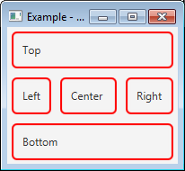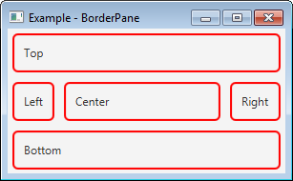
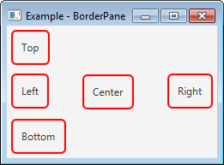
The essence of the code for this example is shown below. However, without some styling, it will look as shown on the right.
BorderPane brdRootPane = new BorderPane();
Label lblTop = new Label("Top");
Label lblRight = new Label("Right");
Label lblBottom = new Label("Bottom");
Label lblLeft = new Label("Left");
Label lblCenter = new Label("Center");

brdRootPane.setTop(lblTop);
brdRootPane.setRight(lblRight);
brdRootPane.setBottom(lblBottom);
brdRootPane.setLeft(lblLeft);
brdRootPane.setCenter(lblCenter);
The styling I applied is shown below. I’m sure you can do this with CSS, but I developed this example before I leaned CSS in JavaFX:
lblTop.setMaxWidth(Double.MAX_VALUE);
lblRight.setMaxWidth(Double.MAX_VALUE);
lblBottom.setMaxWidth(Double.MAX_VALUE);
lblLeft.setMaxWidth(Double.MAX_VALUE);
lblCenter.setMaxWidth(Double.MAX_VALUE);

- Slider Example
The example in this section is in the examples_controls package, SliderExample class.
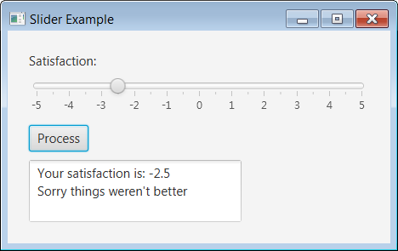
The GUI on the right utilizes a Slider control. It is constructed with this code:
sldSatisfaction = new Slider();
sldSatisfaction.setMinWidth(400);
sldSatisfaction.setMin(-5.0);
sldSatisfaction.setMax(5.0);
sldSatisfaction.setValue(0);
sldSatisfaction.setShowTickLabels(true);
sldSatisfaction.setShowTickMarks(true);
sldSatisfaction.setMajorTickUnit(1);
sldSatisfaction.setMinorTickCount(1);
sldSatisfaction.setSnapToTicks(true);
The Slider’s getValue method is used in an event-handler to obtain the value selected.
- Charts
The class diagram below shows the Chart hierarchy. You can think of a Chart as a subclass of Control; however, technically, Chart and Control are subclasses of Node. The code download that accompanies these notes shows examples of creating various charts.
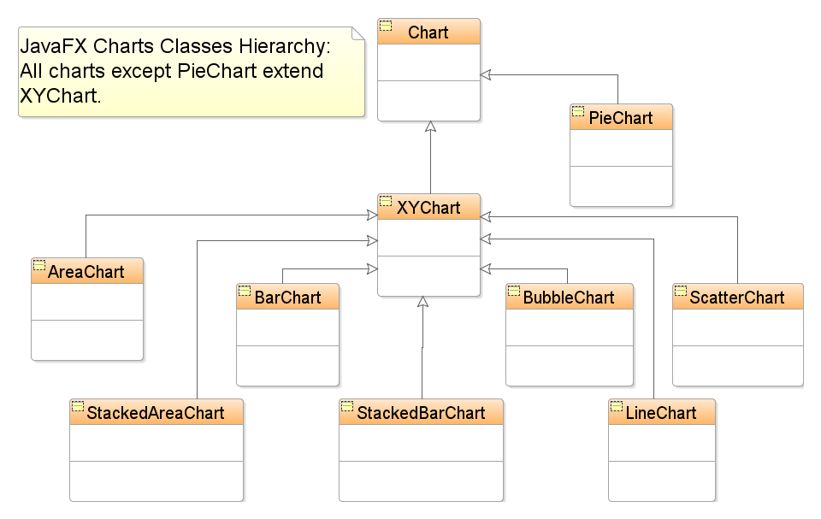
Source: https://www.javacodegeeks.com/wp-content/uploads/2013/01/JavaFXChartClassDiagram.png

- JavaFX Event Handling
The (partial) Event hierarchy is shown below. The only event that we consider is ActionEvent and we won’t directly use the event object itself that is passed to the event-handler. Other types of events provide a rich set of properties and methods to provide more information about the event. For example, a MouseEvent reveals whether the mouse was dragged, moved, a button was pressed, a button was released, which button was pressed, how many times the button was clicked, the location of the mouse relative to the scene, etc.
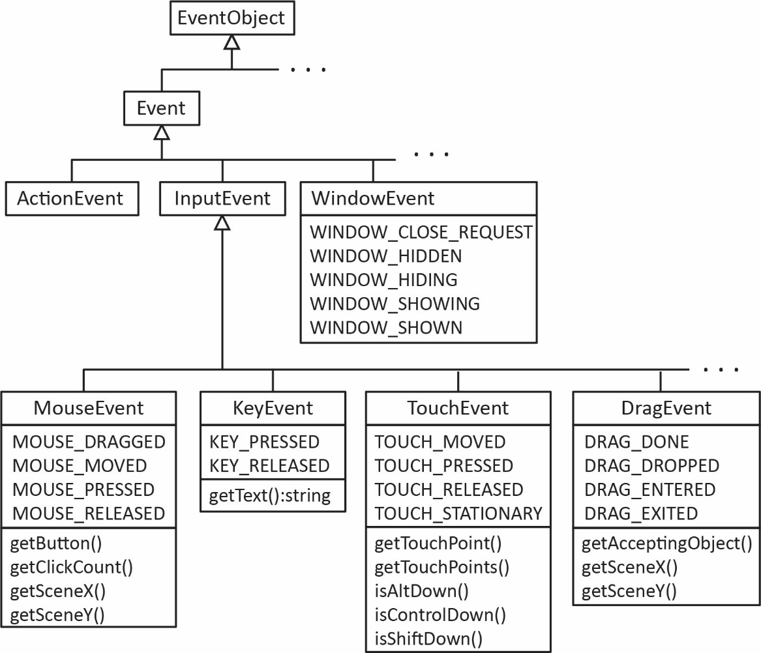
The EventHandler interface is generic and can be implemented with many different types of events:
interface EventHandler<T extends Event> {
void handle(T event);
}
The abstract Node class, which is a superclass for the controls we considered, provides a number of methods for hooking into various events that can occur as shown below. The parameters for these methods are generic and can be implemented with many different types of events
setOnContextMenuRequested, setOnDragDetected, setOnDragDone, setOnDragDropped, setOnDragEntered, setOnDragExited, setOnDragOver, setOnInputMethodTextChanged, setOnKeyPressed, setOnKeyReleased, setOnKeyTyped, setOnMouseClicked, setOnMouseDragEntered, setOnMouseDragExited, setOnMouseDragged, setOnMouseDragOver, setOnMouseDragReleased, setOnMouseEntered, setOnMouseExited, setOnMouseMoved, setOnMousePressed, setOnMouseReleased, setOnRotate, setOnRotationFinished, setOnRotationStarted, setOnScroll, setOnScrollFinished, setOnScrollStarted, setOnSwipeDown, setOnSwipeLeft, setOnSwipeRight, setOnSwipeUp, setOnTouchMoved, setOnTouchPressed, setOnTouchReleased, setOnTouchStationary, setOnZoom, setOnZoomFinished, setOnZoomStarted

- Inner Classes
- Inner Class – An inner class is a class that is a member of another class. In other words, it is a class defined inside another class.
public class Foo {
public Foo() {
InnerFoo innerFoo = new InnerFoo();
}
...
public class InnerFoo {
public InnerFoo() {...}
...
}
}
- Advantages – In some situations an inner class can make a program simpler for two reasons:
- An inner class can reference the all members of the outer class (including private).
- When the inner class is only needed inside the outer class. In other words, other classes in the system do not need to reference the inner class. In this case we would make the inner class private. However, other classes can access the inner class if needed, as long as it is public. Thus it provides better encapsulation.
- Features of Inner Classes:
- An inner class can be declared public, protected, or private subject to the same visibility rules applied to a member of the class.
- An inner class is compiled into a class named: OuterClassName$InnerClassName.class. For the example above: Foo$InnerFoo.class
- An inner class can be declared static. A static inner class can be accessed using the outer class name. A static inner class cannot access non-static members of the outer class.
- Objects of an inner class are often created from within the outer class (as in the example above). However, you can also create an object of an inner class from another class:
Foo foo = new Foo();
Foo.InnerFoo innerFoo = foo.new InnerFoo();

- Event Handling using Anonymous Inner Classes
- Anonymous Inner Class – An anonymous inner class is a class:
- Is a class without a name
- Is defined inside another class
- Extends a superclass and/or implements an interface
- Must immediately be instantiated as it is defined
- Example – An anonymous inner class event handler for the hello world application considered previously.:
btnHelloWorld.setOnAction(
// Create an instance of...
new
// Anonymous inner class
EventHandler<ActionEvent>() {
public void handle(ActionEvent e) {
String name = txfName.getText();
txaMessage.setText(name + ", Hello World!");
}
}
);
Which we usually write more compactly:
btnHelloWorld.setOnAction( new EventHandler<ActionEvent>() {
public void handle(ActionEvent e) {
String name = txfName.getText();
txaMessage.setText(name + ", Hello World!");}});
- More on Anonymous Inner Classes:
- Can access instance variables of the outer class as well as local variables defined by the enclosing method.
- Compiled into a class named OuterClassName$n.class. In the example above, the main class is Ex1b_HelloWorld.class and the anonymous inner class is Ex1b_HelloWorld$1.class. If there were more anonymous inner classes they would be numbered 2, 3, etc.

- Event Handling using Lambda Expressions
- Example – Event handling can also be implemented with a lambda expression, which is a new feature of Java 8. A lambda expression lets you create an anonymous instance of a single-method class more compactly.
btnHelloWorld.setOnAction(e -> {
String name = txfName.getText();
txaMessage.setText(name + ", Hello World!");
});
Or, we could write a method:
public void helloWorldEventHandler() {
String name = txfName.getText();
txaMessage.setText(name + ",asf Hello World!");
}
And then use a lambda expression to call the method:
btnHelloWorld.setOnAction(e -> helloWorldEventHandler() );
- Explanation –
“The compiler treats a lambda expression as if it is an object created from an anonymous inner class. In this case, the compiler understands that the object must be an instance of EventHandler<ActionEvent>. Since the EventHandler interface defines the handle method with a parameter of the ActionEvent type, the compiler automatically recognizes that e is a parameter of the ActionEvent type, and the statements are for the body of the handle method. The EventHandler interface contains just one method. The statements in the lambda expression are all for that method. If it contains multiple methods, the compiler will not be able to compile the lambda expression. So, for the compiler to understand lambda expressions, the interface must contain exactly one abstract method. Such an interface is known as a functional interface or a Single Abstract Method (SAM) interface.”
- Other Uses – You can do many other things with Lambda Expressions:
https://docs.oracle.com/javase/tutorial/java/javaOO/lambdaexpressions.html
Here are some examples that I will explain in class:
emps.forEach(e -> e.setAge(e.getAge()+1));

emps.removeIf(e -> e.getAge()>45 && e.getAge()<60);

int sum = emps.stream()
.mapToInt(Employee::getAge)
.sum();

List<Employee> emps2 = emps.stream()
.filter(e -> e.getAge()<40)
.collect(Collectors.toList());

emps.sort(Comparator.comparingInt(Employee::getAge)
.thenComparingDouble(Employee::getSalary));

Collections.sort(emps, (e1,e2) -> e1.getAge()-e2.getAge() );

printPersons(
roster,
// Lambda expression
(Person p) -> p.getGender() == Person.Sex.MALE
&& p.getAge() >= 18
&& p.getAge() <= 25
);

- Styling A GUI with Code
Note: most (if not all) of the things discussed here can be done with CSS. These notes were developed before I taught CSS. However, the methods used to set properties all have CSS properties that are the same. It is best practice to use CSS when possible.
- Example – In the examples considered so far, the actual code shown in these notes has not used any formatting (to make things simpler); however, the screen shots and the code downloads do have formatting. Below are a few methods for setting:
- Padding – All Pane objects have a setPadding method which accepts an Inset object which defines how far controls are inset from the border of the pane. For example, you can set the padding on a Vbox as shown in the example below.
- Spacing – VBox and HBox objects have a setSpacing method defines the space between controls as shown in the figure below. The other Pane objects we study do not have this method.
- Margin – All Pane objects have a static setMargin method which accepts the control to set the margin for and an Inset object which defines the additional space between the padding or spacing. The example below shows that the left margin has been set for the button, b2.

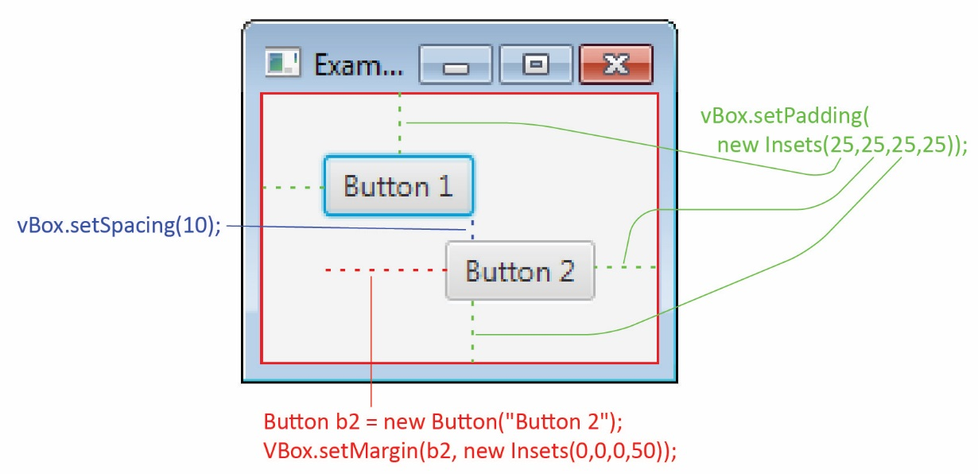

- Example – The GridPane has a setHGap and setVGap methods for setting the horizontal and vertical spacing between controls as shown in the example below:

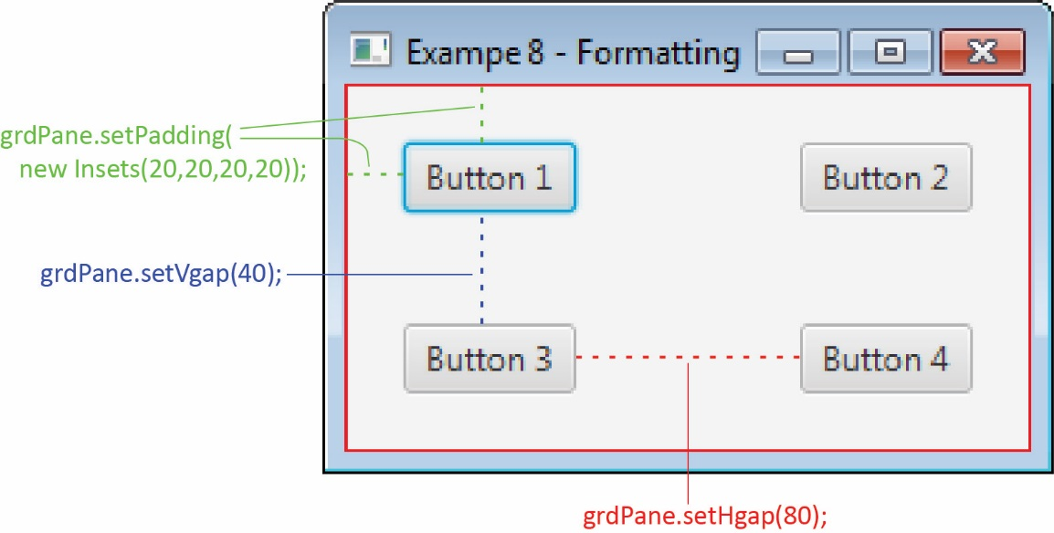
- Example – If the controls are different sizes they will render by default as shown on the left below. On the right we make controls the same width for each column:

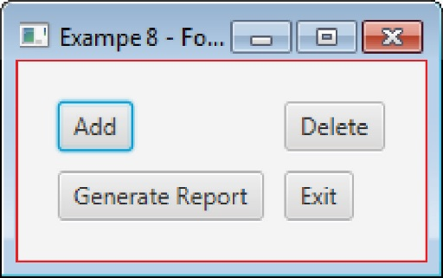 | 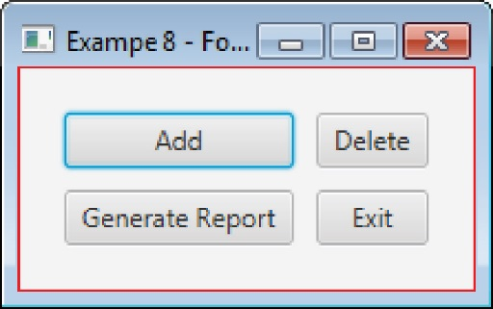  Button b1 = new Button("Add");  b1.setMaxWidth(Double.MAX_VALUE);  Button b2 = new Button("Delete");  b2.setMaxWidth(Double.MAX_VALUE);  Button b3 = new Button("Generate Report");  b3.setMaxWidth(Double.MAX_VALUE);  Button b4 = new Button("Exit");  b4.setMaxWidth(Double.MAX_VALUE);

- Example – To make all the controls the same size takes a bit more work.

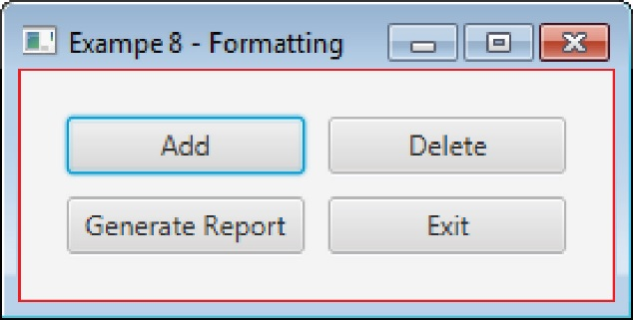 | // Determine width of largest item  Group root = new Group();  Scene scene = new Scene(root);  Button b3_dummy = new Button("Generate Report");  root.getChildren().addAll(b3_dummy);  root.applyCss();  root.layout();  double maxWidth = b3_dummy.getWidth();  System.out.println(maxWidth);  // Build GUI  Button b1 = new Button("Add");  Button b2 = new Button("Delete");  Button b3 = new Button("Generate Report");  Button b4 = new Button("Exit");  b1.setPrefWidth(maxWidth);  b2.setPrefWidth(maxWidth);  b3.setPrefWidth(maxWidth);  b4.setPrefWidth(maxWidth);  grdPane.add(b1, 0, 0);  grdPane.add(b2, 1, 0);  grdPane.add(b3, 0, 1);  grdPane.add(b4, 1, 1);

- Example – Right alignment in a VBox. Also illustrates the red border that was in all the examples above.

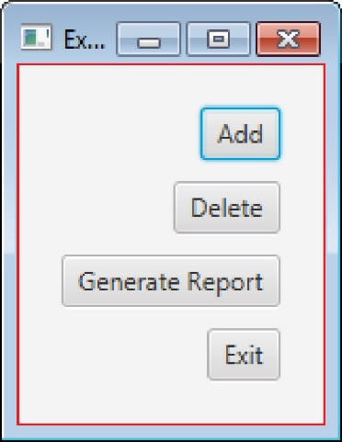 | VBox vBox = new VBox();  vBox.setPadding(new Insets(20, 20, 20, 20));  vBox.setSpacing(10);  vBox.setAlignment(Pos.CENTER_RIGHT);  vBox.setBorder(new Border(new BorderStroke(  Color.RED, BorderStrokeStyle.SOLID, null, null)) );  // Build GUI  Button b1 = new Button("Add");  Button b2 = new Button("Delete");  Button b3 = new Button("Generate Report");  Button b4 = new Button("Exit");  vBox.getChildren().addAll(b1,b2,b3,b4);

- Example – Two VBox’s in an HBox.

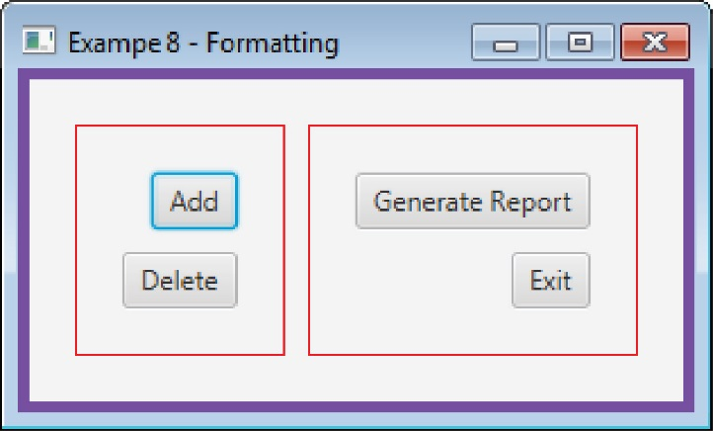 | // Left VBox  VBox vBoxL = new VBox();  vBoxL.setPadding(new Insets(20, 20, 20, 20));  vBoxL.setSpacing(10);  vBoxL.setAlignment(Pos.CENTER_RIGHT);  vBoxL.setBorder(new Border(new BorderStroke(Color.RED, BorderStrokeStyle.SOLID, null, null)) );  Button b1 = new Button("Add");  Button b2 = new Button("Delete");  vBoxL.getChildren().addAll(b1,b2);  // Right VBox  VBox vBoxR = new VBox();  vBoxR.setPadding(new Insets(20, 20, 20, 20));  vBoxR.setSpacing(10);  vBoxR.setAlignment(Pos.CENTER_RIGHT);  vBoxR.setBorder(new Border(new BorderStroke(Color.RED, BorderStrokeStyle.SOLID, null, null)) );  Button b3 = new Button("Generate Report");  Button b4 = new Button("Exit");  vBoxR.getChildren().addAll(b3,b4);  // Root container, HBox  HBox hBox = new HBox();  hBox.setPadding(new Insets(20, 20, 20, 20));  hBox.setSpacing(10);  hBox.setBorder(new Border(new BorderStroke(Color.BLUEVIOLET, BorderStrokeStyle.SOLID, null, BorderStroke.THICK)) );  hBox.getChildren().addAll(vBoxL, vBoxR);

- Sizing elements, and how different panes layout controls is rather involved. If you are interested, here is a reference:

http://docs.oracle.com/javafx/2/layout/size_align.htm

- Resources
Source | Description
JavaFX Tutorials | Oracle tutorials
Implementing JavaFX Best Practices | Custom preloader, meaningful package names, MVC with FXML, CSS, Run Tasks on a Background Thread
Best Practices for Efficient Development of JavaFX Applications | Conference paper. FXML, Scene Builder, MVC, GUI Testing
JavaFX Tutorial

https://en.wikipedia.org/wiki/User_interface_design
See the Anonymous inner classes Appendix, and the Lambda expressions Appendix.
Intro to Java Programming, 10th ed., Liang, p.598

