Chapter 9 – Maps

Contents
1 Maps 2
2 The HashMap Class 3
2.1 Exercises 5
3 Example 1: Map of Employee Objects 6
4 Example 2: Map of Lists 7
5 Example 3: 1 to Many 8
6 The LinkedHashMap Class 11
7 The TreeMap Class 11
7.1 Exercises 12
8 Example 4: Occurrences of Words & Modelling 13
8.1 Problem Description 13
8.2 Algorithm 13
8.3 Method 14
8.4 Single Responsibility Principle 14
8.5 Refactoring for Reuse 15
8.6 Exercises 18
Appendix 1 The SortedMap & NavigableMap Interfaces 19
Appendix 2 Class Diagram for Map Classes 20

Maps
A map stores objects, just like a list. However, instead of associating an index with each object, a map associates a unique key with each object. is like a list. In computing, we say that a map stores key-value pairs. For example:
- Banner: a student number (key) is associated with each student’s records (value).
- Web Server: a URL (key) is associated with each web page (value).
- Dictionary: each word (key) is associated with a definition (value)
- Phone book: each name (key) is associated with a phone number (value).
You can add, retrieve, and remove from a map with code like this:
map.put(key,object)
object = map.get(key)
object = map.remove(key)
Maps are very useful.
Java refers to key-value pairs as map entries. The Map interface is designed to store map entries. The example on the left below shows a map entry that consists of a key (person’s SSN) and a value (person’s name). The figure on the right below shows a map with a number of map entries. The keys must be unique, in other words, there are no duplicate keys in a map. We would describe this map this way: a map of names where SSN is the key.
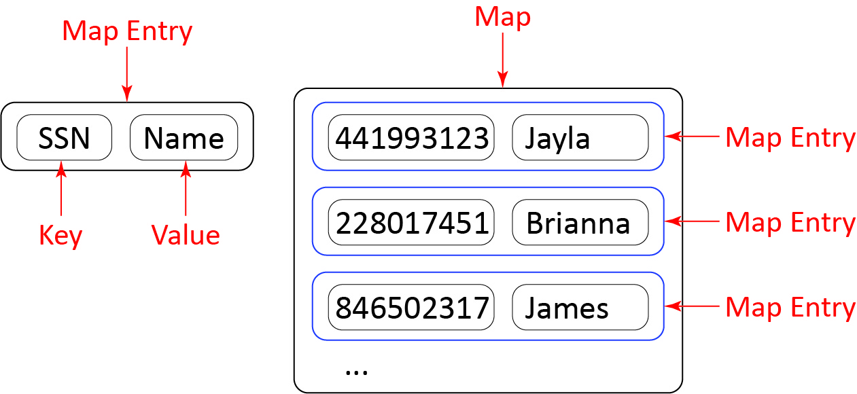
The Map interface is part of the Java Collections Framework (JCF). As shown in the diagram below, Java provides three common implementations of the Map interface. The main difference is the order the items are stored in.
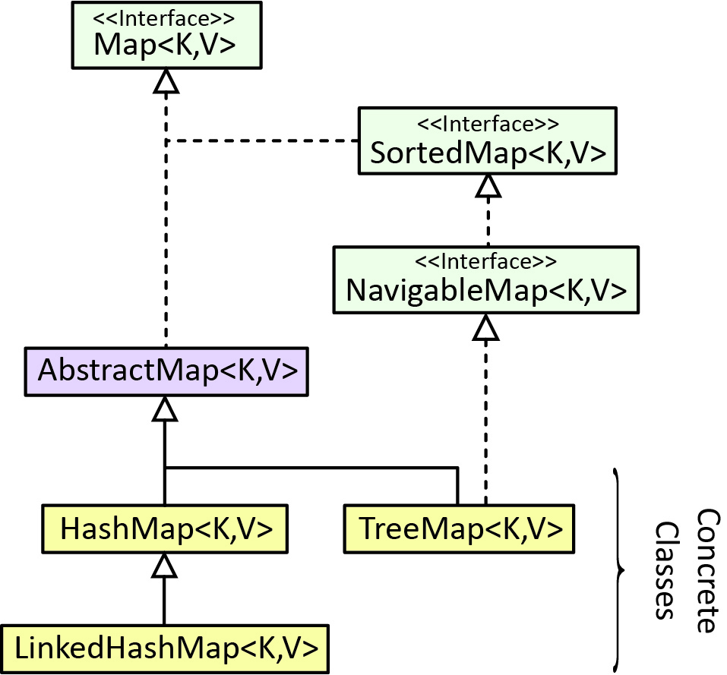
- HashMap – The map entries have no particular order.
- LinkedHashMap – The map entries are ordered according to the order they were inserted.
- TreeMap – The map entries are ordered according to their keys.
Note that the classes have two generic type parameters, K & V. Thus, you must specify the reference type for the key and the value. From the example above, the map of names:
HashMap<Integer,String> names = new HashMap<>()
names.put(754891113, “Stan”)
String name = names.get(228017451)

The HashMap Class
The example in this section is in the example_name_score package.
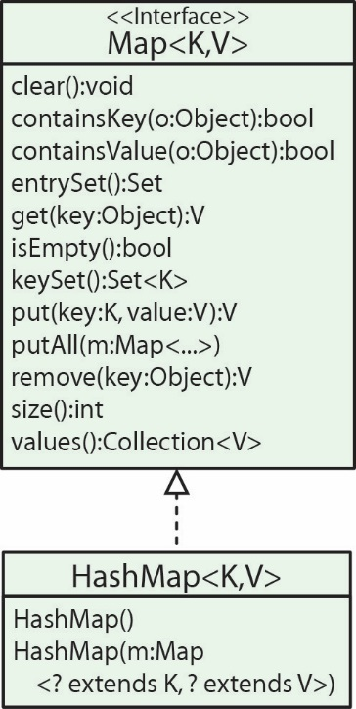
Some of the methods defined in the Map interface are shown in the class diagram on the right, where HashMap is a concrete implementation of Map. As stated earlier, a HashMap does not allow duplicate keys and the order of the elements is not predictable. A HashMap can be created with a no-arg constructor, or by passing in another map.
Suppose we need to represent the score for each person that played a game. If we assume that each person’s name is unique, then a map would be a good choice. Thus, we need a map of scores where the key is a person’s name. In other words, a map holds values, that is what it is storing, its objective; we just happen to use a key to access the values. Next, we illustrate some Map methods using the map of scores:
- We define the map this way:
Map<String,Integer> hmScores = new HashMap<>();
- The put(key,value) method is used to add a map entry to a map. For example:
hmScores.put("Felix", 42);
hmScores.put("Dania", 28);
hmScores.put("Cathy", 62);
If you put(key,val) with a key that exists, the value will be replaced in the existing entry with val. For example, the statement below will change the “Dania” entry so that the value is 99:
hmScores.put("Dania", 99);
- The size method returns the number of entries in the map. For example:
int numEntries = hmScores.size();
- The get method is used to retrieve a value given a key. For example:
int score = hmScores.get("Dania");
If the key does not exist, an exception is thrown. The containsKey(key:String) method is useful in this situation. For example:
if(hmScores.containsKey("Antonio")) {
score3 = hmScores.get("Antonio");
}
- The remove(key) method removes the entry associated with the key, if it exists, and returns the value. If it doesn’t exist, an exception is thrown. For example:
score3 = hmScores.remove("Felix");
- Internally, a map stores its keys in a Set, thus the keys in a map must be unique. The keySet method returns the Set of all the keys in a map. For example:
Set<String> names = hmScores.keySet();
returns the Set of all the names in the map. As shown in the class diagram above, the keySet method returns a Set object, not a HashSet nor other type of concrete set. Thus, we could not use a HashSet to hold the return from keySet, but you could use Collection since Collection is a super-interface for Set. The Set that the method returns is tied to the map, meaning changes in one will be reflected in the other. This implementation of Set does not support add or addAll, but supports the rest of the Collection methods. A call to add or addAll results in an exception being thrown. If you wanted a copy of the set that you could add to, you could create a List from the Set:
ArrayList<String> namesAL = new ArrayList<>(names);
namesAL.add("Lydia");
Or, create a TreeSet from the Set:
TreeSet<String> namesTS = new TreeSet<>(names);
namesTS.add("Eddy");
- One way to iterate over all the entries in a map is:
for(String key : hmScores.keySet()) {
System.out.println("key=" + key + ", value=" + hmScores.get(key));
}
Similar to a HashSet, a HashMap stores its entries in no particular order.
- Internally, a Map stores its values in a Collection, thus there can be duplicate values in a map as long as they have different keys. For example, two people could have the same score:
hmScores.put("Felix", 42);
hmScores.put("Dee", 42);
- The values method returns a Collection of all the values in a map. For example:
Collection<Integer> scores = hmScores.values();
returns the Collection of all the scores in the map. The Collection that the method returns is tied to the map, meaning changes in one will be reflected in the other. This implementation does not support add or addAll, but supports the rest of the Collection methods. A call to add or addAll results in an exception being thrown. If you wanted a copy of the set that you could add to, you could create a List from the Collection:
ArrayList<Integer> scoresAL = new ArrayList<>(scores);
scoresAL.add(66);
Or, create a TreeSet from the Collection (losing any duplicates):
TreeSet<Integer> scoresTS = new TreeSet<>(scores);
scoresTS.add(62);
- The clear method removes all entries from the map.
hmScores2.clear();
- There are at least 4 ways to iterate over a map. The approach depends on what you are trying to do. The approaches are below.
- Use case: need just the keys. Solution: get all the keys with the keyset method and iterate over them.
for(String key : hmScores.keySet()) {
System.out.println("key=" + key);
}
- Use case: need just the values. Solution: Get all the values with the values method and iterate over them.
for(int value : hmScores.values()) {
System.out.println("value=" + value);
}
- Use case: need both the keys and the values. Solution: get all the keys with the keyset, iterate over them, using each key to access the corresponding value with the get method.
for(String key : hmScores.keySet()) {
System.out.println("key=" + key + ", value=" + hmScores.get(key));
}
- Use case: need both the keys and the values. Solution: get all the entries via the entrySet method. This method returns a Set of Map.Entry objects. A Map.Entry object contains a key and associated value accessed with a getKey and getValue method, respectively.
for(Map.Entry<String, Integer> entry : hmScores.entrySet()) {
System.out.println("key=" + entry.getKey() + ", value=" + entry.getValue());
}
- The containsValue method returns true if value is found in the map; otherwise false. If the value is an object, then the corresponding class must override equals to work properly.
boolean isFound = hmScores.containsValue(42);
- The overloaded constructor, HashMap(m:Map<? extends K, ? extends V>) creates a map from another map.
Map<String,Integer> hmScores2 = new HashMap<>(hmScores);
- The putAll method accepts another map and adds all the entries into this map, replacing any that already exist.
hmScores2.putAll(hmScores);
- Finally, we can use custom objects as keys in a HashMap; however, it is subject to the same issues as storing custom objects in a HashSet, namely, you must override hashCode and equals.

Exercises
- (Solution in exercise_login_account_hashmap package) Suppose you have (a) a LoginAccount class with the following fields (and associated getters): userId, password, name, balance. (b) a LinkedList of LoginAccounts named accounts. Write a snippet of code that creates a HashMap of LoginAccount objects using the userID (string) as the key, from this linked list (accounts).
- (Solution in exercise_passwords_hashmap package) Suppose you have: (a) a LinkedList of userID’s (string) named ids, (b) a LinkedList of passwords (string) named passwords, (c) the two lists are the same size and have a 1-1 correspondence. In other words, the first userID in ids corresponds to the first password in passwords, etc. Write a snippet of code that creates a HashMap of the passwords where the key is the corresponding userID. However, only add the entry if the password has a length at least 6 and at least one digit. Also print the number of passwords that did not meet the criteria.
- (Solution in exercise_add_10_to_score_hashmap package) Suppose you have a HashMap, mapScores where the key is the teamID (integer) and the value is the team’s score (double). Write a snippet of code to add 10.0 to each team’s score for the teams with a teamID of 5 or more.
- (Solution in exercise_merge_scores_hashmap package) Suppose you have two HashMaps, mapScores1 and mapScores2. Each map has a key which is the teamID (integer) and the value which is the team’s score (double). Write a snippet of code to add any entries from mapScores1 that are not in mapScores2 to mapScores2. If a team in mapScores1 is in mapScores2 then modify the value in mapScores2 so that it is the sum of the two scores. For example:
Input |  | Result |  | Notes
mapScores1 Key Value 1 100.0 2 500.0 3 400.0 4 200.0 5 900.0 mapScores2 Key Value 3 200.0 4 700.0 8 100.0 10 400.0 |  | mapScores2  Key Value  1 100.0  2 500.0  3 600.0  4 900.0  5 900.0  8 100.0  10 400.0 |  | - Since the key, 1 in mapscores1 does not occur in mapscores2, it is added.  - Since the key, 3 in mapscores1 also occurs in mapscores2, then the values for the two maps are added, replacing the value in mapscores2

Example 1: Map of Employee Objects
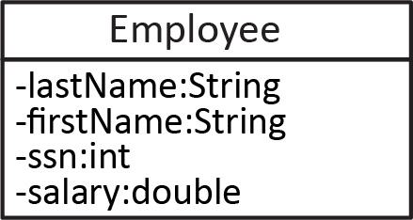
The example in this section is in the example_ssn_employee package.
Consider the Employee class on the right. The example below will utilize a map of Employee objects where the employee’s SSN is the key. In this case, the key is a property of the Employee class. We see how that comes into play, below, when we put an employee into the map.
// Create map
Map<Integer,Employee> hmEmployees = new HashMap< >();

// Create employees
Employee e1 = new Employee("Lyton", "Xavier", 243558673, 77.88);
...

// Put employee in map
hmEmployees.put(e1.getSSNum(), e1);
...

// Get all the SSN’s
Set<Integer> keys = hmEmployees.keySet();

// Iterate over all the employees via the SSN’s
for(int key : keys) {
Employee e = hmEmployees.get(key);
}

// Get all the employees
Collection<Employee> emps = hmEmployees.values();
// Iterate over the employees
for(Employee e : hmEmployees.values()) {
System.out.println(e);
}

Example 2: Map of Lists
The example in this section is in the example_map_of_lists package.
Suppose we need to represent a person’s favorite musical artists and we need to do this for a bunch of people. For example, something like this:
name=Dave, fav music: Bob Dylan, Dead, John Prine,
name=Lee, fav music: Dead, Bob Dylan, Steve Miller, Digit 60,
name=Anna, fav music: Boz Scaggs, Dead,
One way to do this would be to use a map of lists, where the key is a person’s name (assuming unique).
We create the map below. Note the generic type for the value highlighted in yellow below.
HashMap<String,List<String>> hmFavMusic = new HashMap<>();
To use this map, we can create a list of artists:
List<String> artists1 = new ArrayList<>();
artists1.add("Bob Dylan");
artists1.add("Dead");
artists1.add("John Prine");
Then, we can add the list to the map using a name as a key:
hmFavMusic.put("Dave", artists1);
Finally, one way we could iterate over all the lists is:
for(String key : hmFavMusic.keySet()) {
List<String> artists = hmFavMusic.get(key);
for(String artist : artists) {
System.out.printf(artist + ", ");
}
System.out.println();
}

Example 3: 1 to Many
The code for this example is in the example_person_animals_ver4 package.
Consider the example shown in the class diagram below. We considered this example extensively in Ch. 5. A Person has many Animals and also has many Flyers. Here, we replace the use of ArrayLists to manage the two 1-many relationships with Maps.
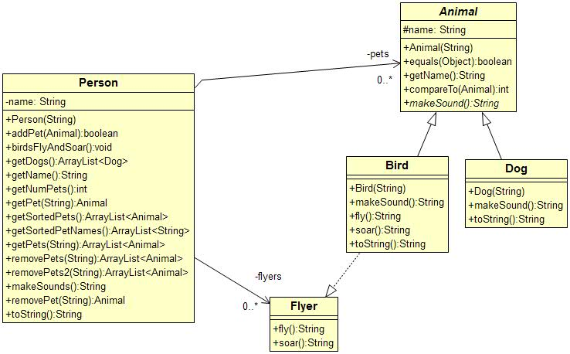
- Associations – Previously the two 1-many relationships were implemented as ArrayList:
private ArrayList<Animal> pets = new ArrayList<>();
private ArrayList<Flyer> flyers = new ArrayList<>();
Here, we replace the ArrayLists with HashMaps.
private HashMap<String,Animal> pets = new HashMap<>();
private HashMap<String,Flyer> flyers = new HashMap<>();
using the Animal’s name as the key and the value is the corresponding Animal object for the pets map or Flyer for the flyers map.
- The addPet method:
HashMap Implementation | ArrayList Implementation (Ch 5)
public boolean addPet(Animal a) {  String name = a.getName();  if(!pets.containsKey(name)) {  pets.put(name,a);  if(a instanceof Flyer) {  Flyer f = (Flyer)a;  flyers.put(name,f);  }  return true;  }  return false;  } | public boolean addPet(Animal a) {  if(!pets.contains(a)) {  pets.add(a);  if(a instanceof Flyer) {  Flyer f = (Flyer)a;  flyers.add(f);  }  return true;  }  return false;  }
- The getNumPets method does not change as a map has a size method just as a list does:
public int getNumPets() {
return pets.size();
}
- In Ch 5, we had two getPet methods:
- getPet(index:int):Animal – Returns the animal at index. With a map, this method no longer makes sense as there is no index to access animals.
- getPet(name:String):Animal – Returns the animal with name. There, we overrode equals in the Animal class so that two Animals were equal if they have the same name which allowed us to use indexOf to find the location of the animal as shown in the code below on the left. Note that that method found the index and then called getPet(index:int) to complete the retrieval.
getPet(name:String) – Ch 5 | getPet(index:int) – Ch 5
public Animal getPet(String name) {  Animal a = new Dog(name);  int loc = pets.indexOf(a);  return pets.get(loc);  } | public Animal getPet(int i) {  if( i>=0 && i<pets.size()) {  return pets.get(i);  }  return null;  }
To implement getPet(name:String):Animal with a map,
public Animal getPet(String name) {
if(pets.containsKey(name)) {
return pets.get(name);
}
return null;
}
- The situation with removePet is similar to getPet. We no longer have a removePet(index:int) method. The removePet(name:String) method with the map implementation is shown below:
public Animal removePet(String name) {
if(pets.containsKey(name)) {
Animal a = pets.get(name);
pets.remove(name);
if(a instanceof Flyer) {
flyers.remove(name);
}
return a;
}
return null;
}
- The getSortedPets method changes slightly:
HashMap Implementation | ArrayList Implementation (Ch 5)
public ArrayList<Animal> getSortedPets() {  ArrayList<Animal> sorted =  new ArrayList<>(pets.values());  Collections.sort(sorted);  return sorted;  } | public ArrayList<Animal> getSortedPets() {  ArrayList<Animal> sorted =  new ArrayList<>(pets);  Collections.sort(sorted);  return sorted;  }

- We add a getSortedPetNames method that returns a list of the pet names, sorted.
public ArrayList<String> getSortedPetNames() {
ArrayList<String> sorted = new ArrayList<>(pets.keySet());
Collections.sort(sorted);
return sorted;
}
- The birdsFlyAndSoar and getDogs methods change slightly (makeSounds is similar):
HashMap Implementation | ArrayList Implementation (Ch 5)
public void birdsFlyAndSoar() {  for(Flyer f : flyers.values()) {  f.fly();  f.soar();  }  }  public ArrayList<Dog> getDogs() {  ArrayList<Dog> dogs =  new ArrayList<>();  for(Animal a : pets.values()) {  if(a instanceof Dog) {  dogs.add((Dog)a);  }  }  return dogs;  } | public void birdsFlyAndSoar() {  for(Flyer f : flyers) {  f.fly();  f.soar();  }  }  public ArrayList<Dog> getDogs() {  ArrayList<Dog> dogs =  new ArrayList<>();  for(Animal a : pets) {  if(a instanceof Dog) {  dogs.add((Dog)a);  }  }  return dogs;  }
- We add a getPets method that accepts a string representing the beginning characters of a name, a partialKey. The method returns a list of Animals whose name begins with partialKey:
public ArrayList<Animal> getPets(String partialKey) {
ArrayList<Animal> matches = new ArrayList<>();
int len = partialKey.length();

for(String name : pets.keySet()) {
if(name.length()<partialKey.length()) {
continue;
}
String beginningOfName = name.substring(0, len);
if(beginningOfName.equals(partialKey)) {
matches.add(pets.get(name));
}
}
return matches;
}

- We add a removePets method that accepts a string representing the beginning characters of a name, a partialKey. The method returns and removes all Animals from the map whose name begins with partialKey. Note that this method uses getPets to get the Animal objects to remove. Then, the remove is easy.
public ArrayList<Animal> removePets(String partialKey) {
// Use getPets method to get a list of all pets that match
// the partialKey. Thus, these are the pets that will be removed.
ArrayList<Animal> removed = getPets(partialKey);

for(Animal a : removed) {
pets.remove(a.getName());
if(a instanceof Flyer) {
flyers.remove(a.getName());
}
}
return removed;
}

The LinkedHashMap Class
The LinkedHashMap class is identical to HashMap except that the order of insertion is preserved.
(Optional) The entries in a LinkedHashMap can also be accessed in the order in which they were last accessed, from least recently accessed to most recently. This is called access order and is specified, for example, by using true for the last argument in the constructor below:
LinkedHashMap(initialCapacity, loadFactor, true).
This can be used in what is called a Least Recently Used Cache (LRU) where you want to maintain a finite sized cache and when a new entry is added which increases the size beyond the desired maximum, the stalest (least recently used) entry is removed. It supports a protected method, removeEldestEntry which can be overridden when extending LinkedHashMap.

The TreeMap Class
A TreeMap is a simply a map where the keys are ordered (where Comparable or Comparator is used for the ordering). Below, we create a TreeMap of Employee objects where the keys are ordered.
// Create map
TreeMap<Integer,Employee> tmEmployees = new TreeMap<>();

// Create employees
Employee e1 = new Employee("Lyton", "Xavier", 243558673, 77.88);
...

// Put employee in map
tmEmployees.put(e1.getSSNum(), e1);
...
A TreeMap also supports a number of additional methods via the SortedMap and NavigableMap interfaces. More information about this is found in an appendix.

Exercises
For the next four problems: Suppose you have a LoginAccount class (same as a previous exercise) with the following string fields (and associated getters): userId, password, name and balance (double). Solutions for the following four problems are in the exercise_loginaccount_treemap package, LoginAccountTest class.
- (createTreeMapFromHashMap method) Suppose you have a HashMap of LoginAccounts named hmAccounts where userId is the key. Write a snippet of code to create a TreeMap named tmAccounts which is the same as hmAccounts except the keys are ordered. Hint: you can do this in one line with a constructor (preferred), or you can use a loop.
- (getPasswords method) Suppose you have a TreeMap of LoginAccounts where userId is the key. Write a method, getPasswords that accepts such a TreeMap of LoginAccounts and returns a list of just the passwords.
- (getPasswords2 method) Suppose that you have a TreeMap of LoginAccounts where userId is the key. Write a method, getPasswords2 that accepts such a TreeMap of LoginAccounts and returns a set of the unique passwords (i.e. just one occurrence of each password).
- (removeAccounts method) Suppose that you have a TreeMap of LoginAccounts where userId is the key. Write a method, removeAccounts that accepts such a TreeMap of LoginAccounts and removes accounts where the userID doesn’t contain the “@” symbol. This method does not return anything. Hint: this requires two loops, one to collect the userIds that don’t contain “@”, and another to loop over this list and remove each from the map.
- (Solution in exercise_swap_key_value package) Consider a TreeMap where the key is a character and the value is an integer. For example, see the Input table (map) below on the left. Write a static method, swapKeyValue that accepts such a map. Next, consider a TreeMap where the key is an integer and the value is a string. For example, see the Output table (map) below in the middle. The method should swap the key and value from the input map such that if a value occurs more than once in the input map, then the corresponding keys are concatenated to form the value for the output map. For example:
Input |  | Output
Key Value  A 8  B 2  C 4  G 2  L 8  P 2  R 1  V 3 |  | Key Value  1 R  2 BGP  3 V  4 C  8 AL | Note: in the input map that the value:  - 1 occurs only once, so the output map has a key of 1 and the value “R”.  - 2 occurs three times, so the output map has a key of 2 and the value “BGP”  - 8 occurs twice. Thus, the output map has a key of 8 and the value is “AL”.

Example 4: Occurrences of Words & Modelling
In this section, we will look at an example that uses a map, and then think about how to develop it as part of a larger system.

Problem Description
Consider a scenario where we have an array of keywords and we want to read a text file and count the number of occurrences of each keyword. For example, if the keywords are:
String[] happyWordsAry = {"content", "cheerful", "cheery",
"merry", "joyful", "joy", "jovial", "jolly", "joking", "joke", "jocular", "gleeful",
"glee", "carefree", "untroubled", "delighted", "delight", "smiling", "smile",
"delighted", "delight", "elated", "elation",
"glad", "joyous", "jubilant", "lively", "pleased", "thrilled", "happy",
"upbeat", "blessed", "blest", "blissful", "chipper", "chirpy", "content",
"convivial", "gay", "gratified", "laughing", "laugh", "mirthful", "peppy",
"playful"};
And we compare these to the text of The Catcher in the Rye, the result is (only the keywords that actually occurred in the text are shown):
Keyword | Count
gay | 1
glad | 14
happy | 7
joy | 1
laugh | 8
laughing | 4
playful | 3
smile | 5
smiling | 1

Algorithm
A TreeMap (or other type of map) will be useful to store the results. We can use a keyword as the key, and the number of occurrences as the value. For example:
TreeMap<String,Integer> tmOccurrences = new TreeMap<>();
Suppose the keywords are in a set:
Set<String> keywords = new HashSet<>(Arrays.asList(“happy”, “joy”, “upbeat”, ...));
Finally, we could loop over each word (token) in the file and then use the algorithm below to add the word to the map, or increase the count if it is already there:
For each word in file
If word is a keyword
If returnMap doesn’t already have the word
Put word in returnMap with a count of 1
Else returnMap has the word
newCount = currentCount + 1
Put word in returnMap with a count of newCount

Method
Next, we write a method that accepts a File and a Set of keywords and returns a Map of occurrences of keywords. The solution is found in the code download in the example_count_word_occurrences_map package.
public static TreeMap<String,Integer> getKeywordOccurrences(File file, Set<String> keyWords) throws FileNotFoundException {

TreeMap<String,Integer> tmOccurrences = new TreeMap<>();
Scanner input = new Scanner(file);

while (input.hasNext()) {
String word = input.next(); // get next word
word = getCleanWord(word); // clean word up

if (keyWords.contains(word)) { // word is a keyword
if (!tmOccurrences.containsKey(word)) { // word not in map
tmOccurrences.put(word, 1);
}
else { // word in map
int count = tmOccurrences.get(word); // get current count
tmOccurrences.put(word, ++count); // update count
}
}
}
input.close();
return tmOccurrences;
}
Note, that we use getCleanWord above to remove any leading or trailing blank spaces, convert the word to lower-case, and remove any punctuation or double quotes.
As a variation, we could write another method to count all the occurrences of each word in the file by simply eliminating this if statement below (in the code above):
if (keyWords.contains(word)) {
This is also contained in the code download, the method, getWordOccurrences.

Single Responsibility Principle
Next, we consider how to take the methods from the previous section and make them more reusable. But first, we consider a design principle that will help guide us. There are a number of OO design principles that help make software designs more understandable, reusable, and maintainable. Here, we discuss just one, a very import one, and one I think you should seek to incorporate completely into the way you think about design. The Single Responsibility Principle:
A class should have only one reason to change, in other words, a class should have only one responsibility
As we develop a software system, classes can become bloated; they take on too much responsibility. If we look carefully at such classes, we can often break them into two (or more) classes each with a single responsibility.
Here is a simple example that violates the single responsibility principle: Suppose we have an Employee class with name, payrate, hours worked, etc and a method to calculate their pay. Suppose this class also has a method to write the instance variables to a text file (or database, etc.). This is two responsibilities: one is to manage the employee’s attributes and the other is to persist it to disk. We always have a separate class(es) to do data persistence.

Refactoring for Reuse
The code below is in the code download in a package named: example_text_analyzer.
First, we need to pull the reading out into its own class. Thus, we can provide a TextReader class with a getWords static method that accepts a File and returns a List<String> of the words in the file as shown below. We use a static method because this is a utility method that doesn’t rely on any state information. It only needs what is passed into it, the File.
public class TextReader {
public static List<String> getWords(File file) {
List<String> words = new ArrayList<>();
Scanner input;
try {
input = new Scanner(file);
while(input.hasNext()) {
words.add(input.next());
}
input.close();
} catch (FileNotFoundException e) {
e.printStackTrace();
}
return words;
}
}
Next, we need to change the earlier getKeywordOccurrences method so that it doesn’t read the words, but instead accepts a list of words as input.
static TreeMap<String,Integer> getKeywordOccurrences(List<String> words, Set<String> keywords) {
Currently, the method returns a Map of the counts of each keyword. Suppose, in addition, we also need to return the total number of unique keywords found, and the total number of keywords. In the example in Section 8.1, there were 9 different keywords found (the number of keys in the map), and 44 instances of those (the sum of all the values in the map). This is a frequent problem we encounter – needing to return more than one thing. Java only allows us to return one object – but that is actually a good thing if we are trying to follow the single responsibility principle. We create a class to hold the items we need to return. First, we define a KeywordOccurrence class to record the word and the count:
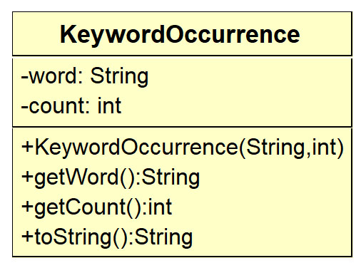
public class KeywordOccurrence {
private String word;
private int count;

public KeywordOccurrence(String word, int count) {
this.word = word;
this.count = count;
}
public String getWord() {
return word;
}
public int getCount() {
return count;
}
...}
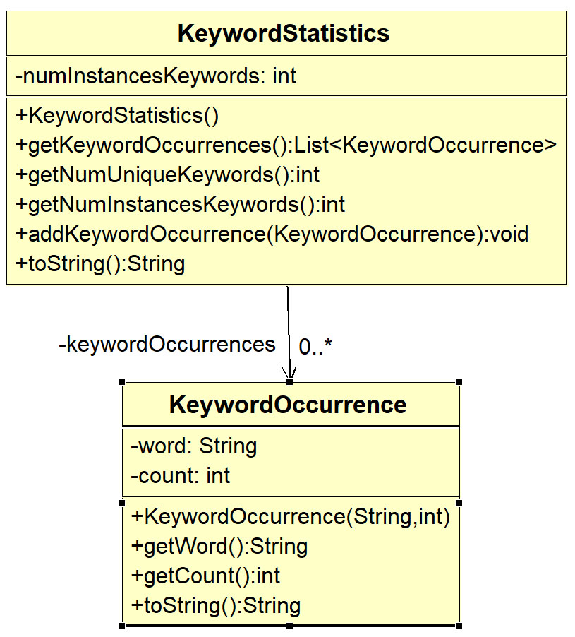
Next, we define a KeywordStatistics class that encapsulates the list of KeywordOccurrences and the other two statistics.
public class KeywordStatistics {
private List<KeywordOccurrence> keywordOccurrences = new ArrayList<>();
private int numInstancesKeywords = 0;
public KeywordStatistics() {}

public List<KeywordOccurrence> getKeywordOccurrences() {
return keywordOccurrences;
}

public int getNumUniqueKeywords() {
return keywordOccurrences.size();
}

public int getNumInstancesKeywords() {
return numInstancesKeywords;
}

public void addKeywordOccurrence(KeywordOccurrence keywordOccurrence) {
numInstancesKeywords += keywordOccurrence.getCount();
keywordOccurrences.add(keywordOccurrence);
}
...
}
Finally, we can change the return type of getKeywordOccurrences to KeywordStatistics and add code to build the KeywordStatistics object.
static KeywordStatistics getKeywordOccurrences(List<String> words, Set<String> keywords) {

TreeMap<String,Integer> tmOccurrences = new TreeMap<>();

for(String word : words) {
word = getCleanWord(word);
if (keywords.contains(word)) {
if (!tmOccurrences.containsKey(word)) {
tmOccurrences.put(word, 1);
}
else {
int count = tmOccurrences.get(word);
tmOccurrences.put(word, ++count);
}
}
}
return buildKeywordStatistics(tmOccurrences);
}

We use a helper method, buildKeywordStatistics that transfers the Map of results into a KeywordStatistics object. Sometimes, we call (loosely) such a method, a factory method. The method is a factory for making a KeywordStatistics object.
static KeywordStatistics buildKeywordStatistics(TreeMap<String,Integer> tmOccurrences) {
KeywordStatistics stats = new KeywordStatistics();

for(String word : tmOccurrences.keySet()) {
int count = tmOccurrences.get(word);
KeywordOccurrence occurrence = new KeywordOccurrence(word, count);
stats.addKeywordOccurrence(occurrence);
}
return stats;
}
The final issue is where does this method belong? What class? We choose to write a class, TextAnalyzer, in which we place the static method, getKeywordOccurrences. The class diagram for these classes is shown below.
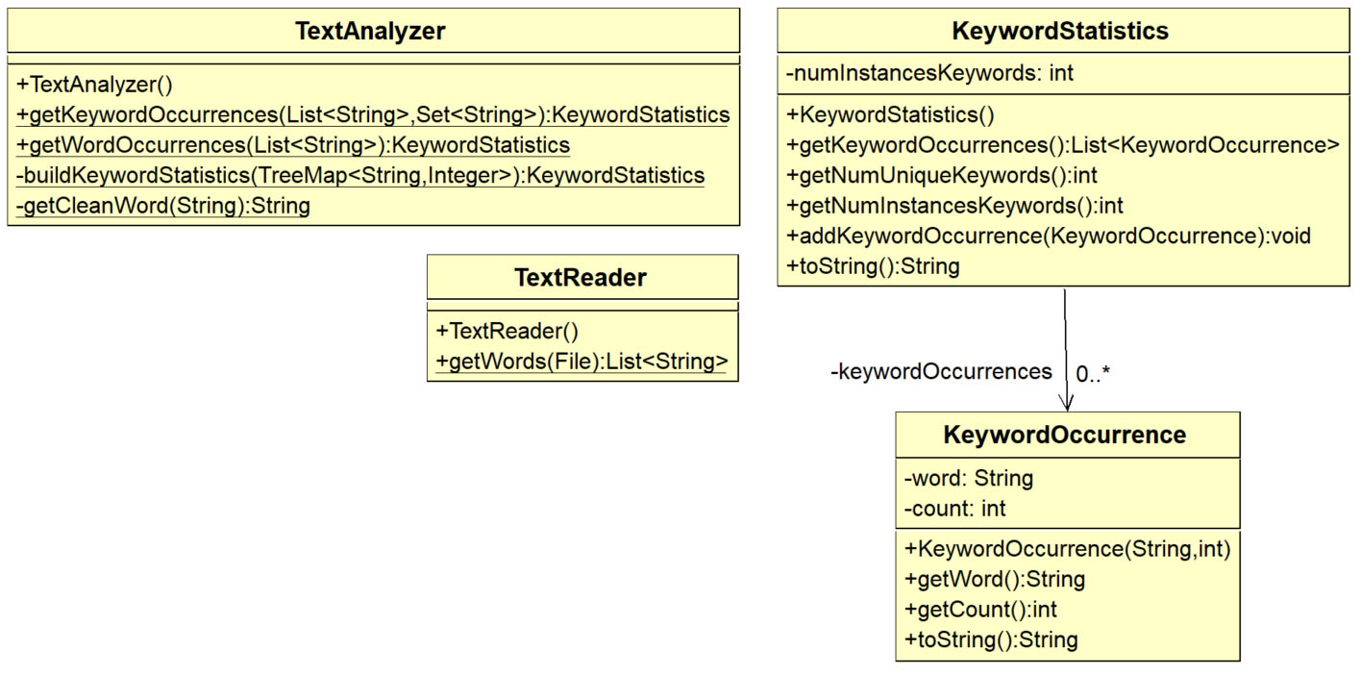
Test code would look like this:
File file = new File(filename);
List<String> words = TextReader.getWords(file);
KeywordStatistics stats = TextAnalyzer.getKeywordOccurrences(words, happyWords);
System.out.println(stats);
Where filename and happyWords are defined as constants:
static final Set<String> happyWords = new HashSet<>(Arrays.asList("glad", "playful", "joy"));
static final String filename = "src/example_text_analyzer/Catcher_in_the_Rye.txt";

Exercises
- (Solution NOT available at present, eventually will be in example_text_analzer package) In the KeywordStatistics class above, the getKeywordOccurrences method returns a list of KeywordOccurrence objects that is simply ordered on the word. An example is shown in left column of the table below. Add a method to this class, getSortedKeywordOccurrences that returns a list that is ordered on count (number of occurrences), and if there is a tie, then ordered on the word. An example is shown in the right column in the table below. Hints: (a) define a Comparator to order KeywordOccurrence objects. (b) create a copy of the keywordOccurrences, (c) sort the copy using the comparator, (d) return this list.
getKeywordOccurrences | getSortedKeywordOccurrences
gay-1 | gay-1
glad-14 | joy-1
happy-7 | smiling-1
joy-1 | playful-3
laugh-8 | laughing-4
laughing-4 | smile-5
playful-3 | happy-7
smile-5 | laugh-8
smiling-1 | glad-14

Appendix
- The SortedMap & NavigableMap Interfaces
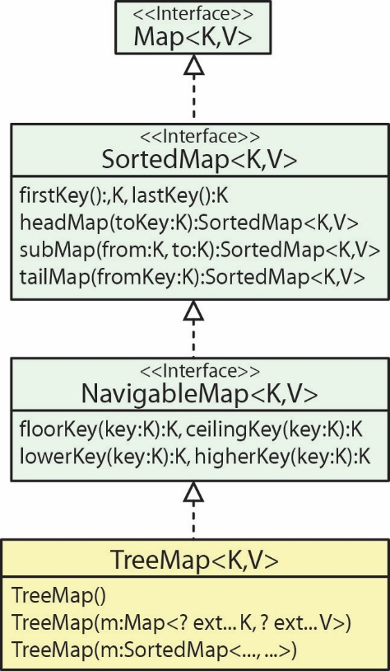
Some sample code if in the example_sorted_map package. As shown in the class diagram above on the right, a TreeMap implements methods from SortedMap that are analogous to the methods TreeSet inherits from SortedSet:
TreeMap (SortedMap) | TreeSet (SortedSet)
firstKey():K | first():E
lastKey():K | last():E
headMap(toKey:K)  :SortedMap<K,V> | headSet(toElement:E)  :SortedSet<E>
tailMap(fromKey:K)  :SortedMap<K,V> | tailSet(fromElement:E)  :SortedSet<E>
subMap(from:K,to:K)  :SortedMap<K,V> | subSet(from:E, to:E)  :SortedSet<E>
For example, headMap(toKey) returns a SortedMap of map entries corresponding to the keys that are strictly less than toKey, {x|x<toKey}.
Also shown in the class diagram above on the right, a TreeMap implements methods from NavigableMap that are analogous to the methods TreeSet inherits from NavigableSet:
TreeMap (NavigableMap) | TreeSet (NavigableSet)
floorKey(key:K):K | floor(e:E):E
lowerKey(key:K):K | lower(e:E):E
ceilingKey(key:K):K | ceiling(e:E) :E
higherKey(key:K):K | higher(e:E):E
For example, floorKey(key) returns the greatest key less than or equal to the given key, or null if there is no such key.

- Class Diagram for Map Classes
These are the classes and methods you are responsible for on a test. I will provide a copy of this image on a test.
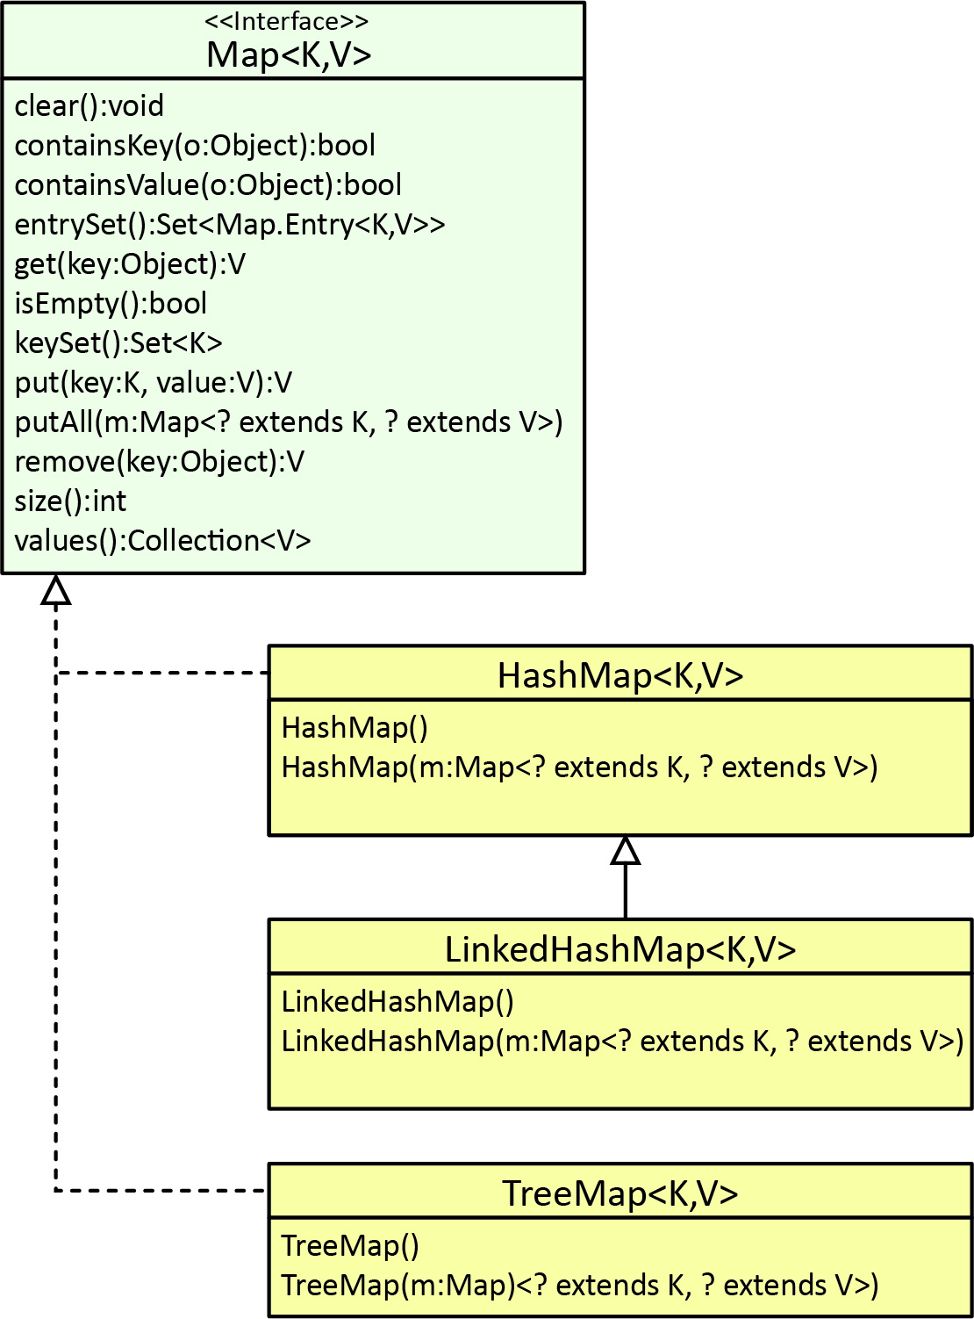

https://docs.oracle.com/javase/tutorial/collections/TOC.html
https://en.wikipedia.org/wiki/Cache_replacement_policies
Unless you an iterator over the entrySet()

