Chapter 8 – Lists & Sets

Contents
1 Collections 2
2 The List Interface & Additional ArrayList Methods. 3
2.1 Exercises 4
3 Iterators 5
3.1 Iterating over a Collection with an Iterator 5
3.2 Filtering a Collection with an Iterator – Removing Elements 5
3.3 Filtering a Collection with an Iterator – Removing & Returning Elements 6
3.4 Exercises 7
4 The LinkedList Class 7
5 The Comparator Interface 9
5.1 Exercises 12
6 The Set Interface 13
7 The HashSet Class 14
7.1 Exercises 15
8 The LinkedHashSet Class 15
9 The TreeSet Class 15
9.1 Exercises 16
10 The TreeSet Class with Custom Objects 16
10.1 Exercises 18
11 Performance of Sets & Lists 19
12 Example: Counting Keywords 20
Appendix 1 Filtering a Collection Incorrectly 22
Appendix 1.1 Filtering a Collection with a for-each Loop Incorrectly 22
Appendix 1.2 Filtering a Collection with a Forward, Indexed Loop Incorrectly 22
Appendix 2 Other Approaches to Filtering a Collection 23
Appendix 3 Static Methods for Lists & Collections 24
Appendix 4 Class Diagram for Collection Classes 25
Appendix 5 The Vector & Stack Classes 27
Appendix 6 Queues and Priority Queues 28
Appendix 7 The SortedSet & NavigableSet Interfaces 30

Collections
A collection class (also called a container class) is a generic term used to describe a class that is used to hold a group of elements. For example, an ArrayList is a collection class. The Java Collections Framework (JCF) defines the organization of all the collection classes in Java. It is composed of classes, interfaces, and abstract classes as (partially) shown in the class diagram below. In the JCF, interfaces (green boxes) are the top layer and define the behaviors, abstract classes (purple boxes) are the middle layer that provide partial implementations of the behaviors, and at the lower level, concrete classes (yellow boxes) provide any further implementation that is necessary. There, the green rectangles are interfaces, the purple rectangles are abstract classes, and the yellow rectangles are concrete classes.
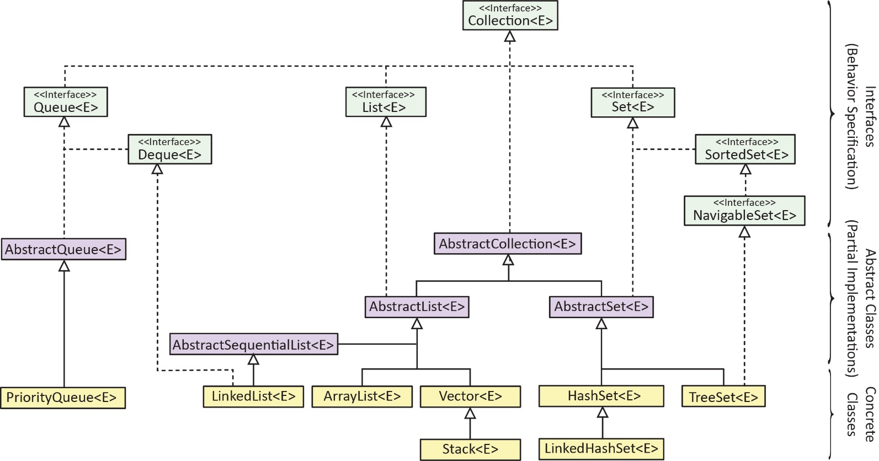
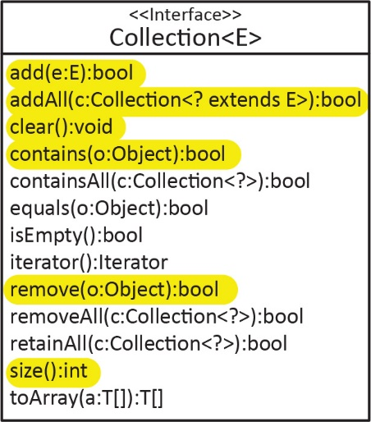
Some of the Collection interface methods are shown in the diagram on the right. The highlighted methods are ones we have considered previously in the ArrayList class. All collections have these methods. Notice that this interface does not define, a get(i:int) method. This is defined in the List sub-interface which we consider shortly.
Collections are further broken down into sub-interfaces representing Lists, Queues, and Sets.
Interface | Description
List | An ordered collection where elements can be accessed by an index
Set | A collection that does not allow duplicate elements, nor can elements be accessed by an index
Queue | A collection that is designed to hold elements that wait to be processed
In this chapter, we will consider the (a) List interface and the ArrayList and LinkedList classes, (b) Set interface and HashSet, LinkedHashSet, and TreeSet classes. The Appendices consider the: (a) the Vector and Stack classes, (b) the Queue interface and the PriorityQueue class. A detailed tutorial about the JCF is found at:
http://docs.oracle.com/javase/tutorial/collections/

The List Interface & Additional ArrayList Methods.
The code for the example in this section is in the example_collection_methods package.
The class diagram below shows that all the methods for the ArrayList class that we have studied so far (highlighted) have been defined in the Collection and List interfaces. The List interface specifies that any implementing class must be indexed. Thus, it provides methods that require an index to reference an object. For example: add(i:int), get(i:int), remove(i:int), set(i:int,val).
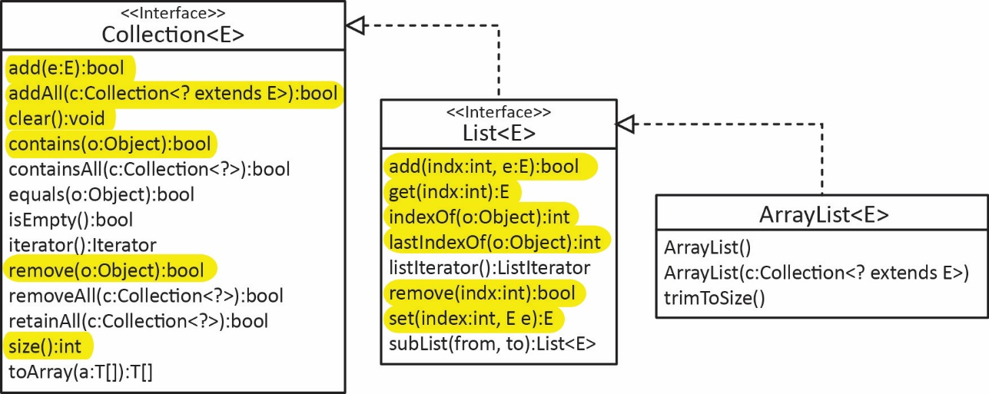
As we saw in a previous chapter, the ArrayList has an addAll method that accepts another ArrayList and adds those elements to the list. As shown above, the Collection interface specifies that any type of Collection (of the same type or subtype) can be used as an argument. As a review:
List<String> cities = new ArrayList<>(Arrays.asList("New York", "San Francisco", "Moab"));
List<String> cities2 = new ArrayList<>(Arrays.asList("Atlanta", "Memphis"));
cities.addAll(cities2); // cities2=[New York, San Francisco, Moab, Atlanta, Memphis]
Similarly, the ArrayList has a constructor that accepts any type of Collection (of the same type or subtype) and initializes the list with those elements. As a review:
List<String> cities3 = new ArrayList<>(cities2); // cities3=[Atlanta, Memphis]
In this section, we consider the retainAll, removeAll, and containsAll methods defined in the Collection interface. In the next section we consider the iterator method. The retainAll method accepts any type of Collection (of the same type or subtype) and retains in its collection those elements that are in common with elements in the argument. Thus, it does a set intersection storing the result in the list that has had the method called on it. For example:
List<String> cities = new ArrayList<>(Arrays.asList("New York", "San Francisco", "Moab"));
List<String> cities2 = new ArrayList<>(Arrays.asList("Atlanta","Moab","New York", "Memphis"));
cities.retainAll(cities2); // cities=[New York, Moab]
If you didn’t want to modify the two existing lists: cities and cities2, then you could simply make a copy of one of the lists before using retainAll. For example:
List<String> cities = ...
List<String> cities2 = ...
List<String> citiesIntersection = new ArrayList<>(cities);
citiesIntersection.retainAll(cities2);

The Collection interface defines a removeAll method that accepts any type of Collection (of the same type or subtype) and removes from its collection those elements that are also in the argument. In other words, it removes from the first list the intersection with the second list. For example:
List<String> cities = new ArrayList<String>(Arrays.asList("New York", "San Francisco", "Moab"));
List<String> cities2 =new ArrayList< >(Arrays.asList("Atlanta","Moab","New York","Memphis"));
cities.removeAll(cities2); // cities=[San Francisco]
The Collection interface defines a containsAll method that accepts any type of Collection (of the same type or subtype) and returns true if the collection contains all the elements in the argument; and false otherwise. For example:
List<String> cities1 = new ArrayList<>(Arrays.asList("New York","San Francisco", "Moab"));
List<String> cities2 = new ArrayList<>(Arrays.asList("Atlanta","Moab","New York", "Memphis"));
List<String> cities3 = new ArrayList<String>(Arrays.asList("Moab", "New York"));
boolean isC2inC1 = cities1.containsAll(cities2); // isC2inC1=false
boolean isC3inC1 = cities1.containsAll(cities3); // isC3inC1=true
For the retainAll, removeAll, and containsAll methods to work correctly with a list of custom objects, equals must be overridden in the custom class.

Exercises
For the next several problems, suppose you have two Lists of jersey numbers (int) for two different basketball teams. The solutions for all these problems are in the exercise_jerseys package.
- Write a method, commonJerseys that accepts two lists of jersey numbers and returns a new List with all the jersey numbers that are in common. Hint: use retainAll. For example: if jerseys1={2,3,4,5} and jerseys2={1,5,3}, then the result of this method is a list with: {3,5}.
- Write a method, firstButNotSecond that accepts two lists of jersey numbers and returns a new List with all the jersey numbers that are in the first list but not in the second. For example: if jerseys1={2,3,4,5} and jerseys2={1,5,3}, then the result of this method is a list with: {2,4}. (a) Solve using a loop. Hint: use contains. (b) Solve without using any loops. Hint: use removeAll.
- Write a method, mergeJerseys that accepts two Lists of jersey numbers and returns a new list that combines the two lists but with no duplicates. You can assume that each list, individually, does not contain any duplicates; however, there could be duplicates between the lists. The method should not change either of the two input lists. For example: if jerseys1={2,3,4,5} and jerseys2={1,5,3}, then the result of this method is a list with: {2,3,4,5,1}. Hint: the easiest way is to use a loop and contains.
- Write a method, notInBoth that accepts two lists of jersey numbers and returns a new List with all the jersey numbers that are in either the first list or the second list, but not both. For example: if jerseys1={2,3,4,5} and jerseys2={1,5,3}, then the result of this method is a list with: {2,4,1}. (a) Solve using two sequential (i.e. not nested) loops. Hint: use contains. (b) Solve without using any loops. Hint: use the firstButNotSecond method from a previous problem twice and then put the two lists together to return.

Iterators
The code for the examples in this section are in the example_iterator_players package.
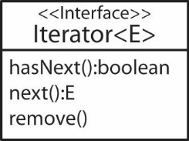
The Collection interface defines an iterator method that returns an object that implements the Iterator interface, which is shown in the class diagram on the right. An Iterator object serves two functions: (a) a way to iterate over all the objects in a collection without having to know how they are stored in the collection. (b) a way to remove items from a collection while you are iterating over it.

Iterating over a Collection with an Iterator
For the examples that follow, we will use a list of Player objects, where a Player has a name and a score.
ArrayList<Player> players = new ArrayList<>();
players.add(new Player("Pam", 24));
players.add(new Player("Len", 19));
players.add(new Player("Malia", 37));
players.add(new Player("Bob", 13));
players.add(new Player("Rea", 46));
To use an iterator to traverse this list:
Iterator<Player> iter = players.iterator();
while(iter.hasNext()) {
Player player = iter.next();
System.out.println(player);
}
Note that the Iterator interface is generic, so we must specify what type of objects we are iterating over. The result of the code above is of course, no different from either of the approaches below:
for-each Loop |  | Indexed Loop
for(Player player : players) {  System.out.println(player);  } |  | for(int i=0; i<players.size(); i++) {  System.out.println(players.get(i));  }
Most people would not use an iterator to iterator over a collection, they would use the for-each or indexed loop. A good use for an iterator is to remove certain elements as we iterate over it, which we consider in the next section. Interestingly, the for-each loop compiles down to an iterator.
he Iterator interface is an excellent example of object-oriented design, which uses information hiding. An iterator hides the actual storage mechanism of the data. Thus, the user of an iterator does not need to know how the data is stored, it just knows that it can access the next item. For example, with the indexed loop, if you are using an ArrayList, you must use the get method, with other types of collections, there may be some other method to access an item, or no method at all. With an iterator, you don’t need to know these.

Filtering a Collection with an Iterator – Removing Elements
Filtering a collection refers to the idea of finding all the elements in a collection that meet certain criteria. The way we consider it here, is we will remove all elements that meet the criteria from the collection. An Iterator is the preferred way to filter a collection by removing elements.
In the players list considered above, suppose we want to remove all players whose score is less than 20. In this case, we can use the Iterator’s remove method:
Iterator<Player> iter = players.iterator();
while(iter.hasNext() ) {
Player player = iter.next();
if(player.getScore() < 20) {
iter.remove();
}
}
A common mistake is to use a for-each loop and then using the collection’s remove method. However, such code will fail if the remove method is executed, throwing a ConcurrentModificationException. You cannot modify a collection (add to or remove from) while iterating over it with a for-each loop. An example is found in an Appendix. Another common mistake is to use an indexed loop, somewhat naively. An example is found in an Appendix. Other approaches to filtering that work are: an indexed loop with a subtle modification of the index inside the loop (bad practice), a while loop, an indexed loop traversing the list in reverse order, or using the Stream’s filter method. Examples of these are found in an Appendix.

Filtering a Collection with an Iterator – Removing & Returning Elements
Suppose you want to remove certain elements from a collection and also return the removed elements in a new collection. Considering the example from above, suppose we want to (a) remove all players whose score is less than 20 from the players list and (b) put those removed players in another list named lowScorePlayers. Note that every time the next method is called, the next element in the collection is retrieved. Thus, if you call next twice inside the loop, you will receive the next two elements, respectively. Thus, if you need the next element more than once in the loop, you must store it in a variable. The correct version is shown in the table below on the left. There, we make one call to next inside the loop, capturing the item in the player variable. Then, player is used twice. Both examples define this list to store the players that are to be stored in a separate list:
ArrayList<Player> lowScorePlayers = new ArrayList<>();
Correct | Incorrect
Iterator<Player> iter = players.iterator();  while( iter.hasNext() ) {  Player player = iter.next();  if(player.getScore() < 20) {  iter.remove();  lowScorePlayers.add(player);  }  }  // Result  players: [Pam-24, Malia-37, Rea-46]  lowScorePlayers: [Len-19, Bob-13] | Iterator<Player> iter = players.iterator();  while(iter.hasNext()) {  if(iter.next().getScore() < 20) {  iter.remove();  lowScorePlayers.add(iter.next());  }  }  // Result  players: [Pam-24, Malia-37, Rea-46]  lowScorePlayers: [Malia-37, Rea-46]
For the incorrect version, consider the original list of players:
[Pam-24, Len-19, Malia-37, Bob-13, Rea-46]
When the player, “Len-19” is found, it is removed, but then the subsequent call to iter.next() advances to the next player, “Malia-13”, which is added to lowScorePlayers. Then, the loop repeats, where the first next retrieves: “Bob-13, which is removed and the subsequent call to iter.next() adds “Rea-46” to lowScorePlayers. So, we can see that (a) we are putting the wrong players in the list, (b) some players do not have their score checked – we are affectively skipping them, (c) if there has been a player with score less than 20 in the last space, then there is the possibility that the code would throw an exception as the coded tried to add the next element to lowScorePlayers, (d) the loop, in this case only executed 3 times. This is a common mistake. Thus, if you need the current element in the loop more than once, you should store it in a variable with a single call to iter.next as shown in the correct version above.

Exercises
- (Solution in exercise_cull_dogs package) Consider the Dog class below. Write a static method, cullDogs that accepts a list of Dogs, and an integer, maxAge, and removes dogs that are older than maxAge from the input list, and returns those removed dogs in new list.
public class Dog {
private int age;
public Dog(int age) {
this.age=age;
}
public int getAge() {
return age;
}
@Override
public String toString() {
return "age=" + age;
}
}

The LinkedList Class
The LinkedList class, shown in the class diagram below is very similar to the ArrayList class in that they both implement the List and Collection interfaces. Almost anything you can do with an ArrayList, you can do with a LinkedList. Internally, they are implemented differently. This is important because LinkedList can be faster in some situations, which we will see in an example later.
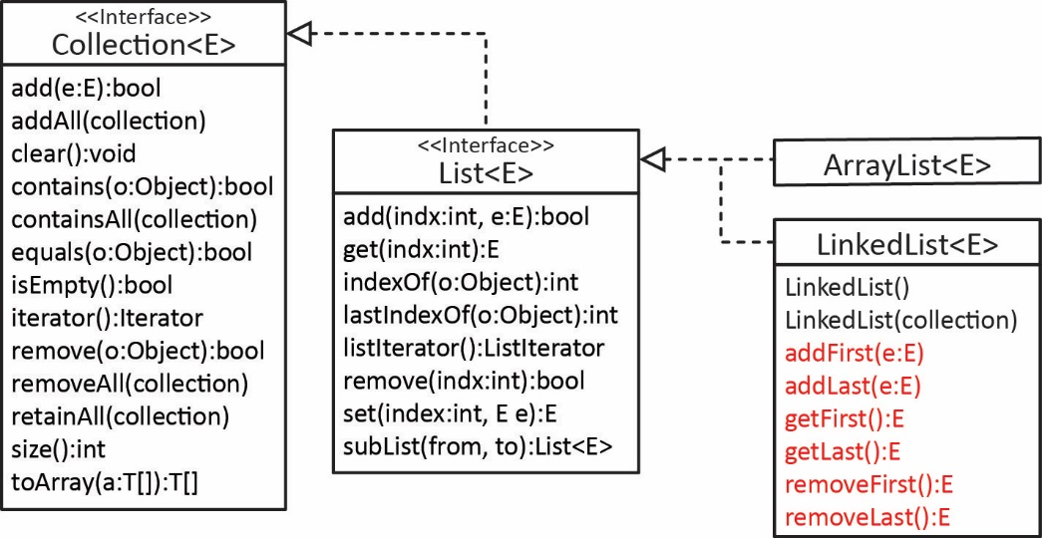
In addition, the LinkedList class introduces a few convenience methods (shown in red above) for operating on the first and last elements in the collection. They are called convenience methods because their result can be achieved by existing List interface methods, except that they are easier to use. For example:
LinkedList | List
list.addFirst(x) | list.add(0,x)
list.addLast(x) | list.add(x)
list.getFirst() | list.get(0)
list.getLast() | list.get(list.size-1)
list.removeFirst() | list.remove(0)
list.removeLast() | list.remove(list.size-1)
Consider the example from Lab 11 where did an experiment to see how long it took to add elements into the first position to an ArrayList and a LinkedList. We started with an ArrayList that initially contained 100,000 random integers. Next, we timed how long it took to insert 100,000 more random integers into the first position into this ArrayList. Then, we repeated for LinkedList. The results on my computer were:
ArrayList size: 100000, time to add 100000 vals: 3.644 sec
LinkedList size: 100000, time to add 100000 vals: 0.006 sec
Thus, in this one example, the ArrayList took more than 600 times as long as LinkedList.
In general, a linked list is a class with an association with itself (in the simplest case). For example:
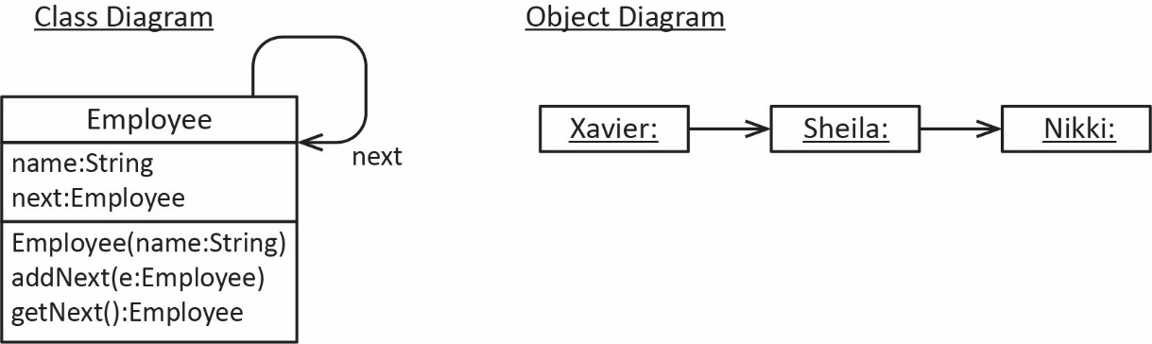
For example (code in example_custom_linkedlist package), the Employee class is shown below where we see that it has an instance variable of type Employee. In other words, an Employee has-a Employee; they form a linked list. You will learn about this in CS 3410 (Data Structures).
Class | Example
public class Employee {  private String name;  private Employee next;  public Employee(String name) {  this.name = name;  }  public void addNext(Employee e) {  this.next = e;  }  public Employee getNext() {  return next;  }  ...  } | Employee e1 = new Employee("Xavier");  Employee e2 = new Employee("Sheila");  e1.addNext(e2);  Employee e3 = new Employee("Nikki");  e2.addNext(e3);  Employee e = e1;  while(e != null) {  System.out.println(e);  e = e.getNext();  }
As we stated earlier, an ArrayList is backed by an array. A LinkedList uses an approach similar to above where space is allocated in memory (the heap) dynamically.
How to choose between ArrayList, LinkedList, and Array – performance characteristics
- Prefer ArrayList when you need positional (random) access without adding or removing from the beginning of the list. In CS 3410 you will learn that: add, remove, contains are O(n) and get is O(1).
- Prefer LinkedList when you need to add or remove from the beginning of a list. In CS 3410 you will learn that: add and remove are O(1) and contains and get are O(n).
- Prefer Array when you don’t need to add or remove elements at all. In other words, you have a fixed list.

The Comparator Interface
In another chapter, we saw how we could sort a list containing instances of a custom class by having the class implement Comparable, by providing a compareTo method. This allowed us to sort on one set of criteria. However, what if we want to sort on different criteria at different times? For example, suppose we want to sort a list of Employee objects based on name, and then later based on SSN, and then later on salary. A solution is to use the Comparator interface.
With this approach, we define a separate Comparator class for each different ordering. Then, the Collections class has an overloaded sort method that accepts a list and a comparator. For example, we can define a list of Employees:
List<Employee> employees = new ArrayList<>();
Employee e1 = new ...
...
employees.add(e1);
Then create a name comparator (considered shortly) and supply it to the sort method:
EmployeeNameComparator compName = new EmployeeNameComparator();
Collections.sort(employees, compName);
And later create an SSN comparator and supply it to the sort method:
EmployeeSSNComparator compSSN = new EmployeeSSNComparator();
Collections.sort(employees, compSSN);
And finally create a salary comparator and supply it to the sort method:
EmployeeSalaryComparator compSalary = new EmployeeSalaryComparator();
Collections.sort(employees, compSalary);
Thus, Comparator provides a more flexible way of ordering objects as multiple comparators can be defined to order objects in different ways.
Comparator is a generic interface in Java (shown below on left) that is used to compare two objects to see which one is “larger”, “smaller”, or if they are “equal”. In this sense, it is very similar to the Comparable interface. The compare method accepts two arguments of generic type T and the return is defined in the table below on the right:
Comparator Interface | Return values for compare method
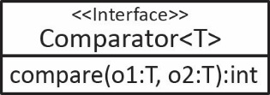 | Return Condition  Negative Integer o1<o2  0 o1=o2  Positive Integer o1>o2
Thus, we simply create a class that implements Comparator and provide a compare method that defines how to compare two objects.
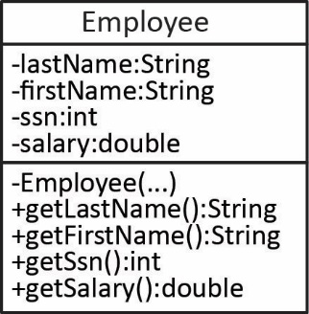
For example (code in example_comparator_employee package), consider the Employee class shown on the right. We can define a Comparator to order on SSN’s.
public class EmployeeSSNComparator implements Comparator<Employee> {
public int compare(Employee e1, Employee e2) {
return e1.getSSNum() - e2.getSSNum();
}
}

We can define another Comparator to order on names (last, then first).
public class EmployeeNameComparator implements Comparator<Employee> {
public int compare( Employee e1, Employee e2 ) {
int diff = e1.getLastName().compareTo(e2.getLastName());
if( diff != 0 ) {
return diff;
}
else {
return e1.getFirstName().compareTo(e2.getFirstName());
}
}
}
Finally, we can define a Comparator to order Employees on their salaries:
public class EmployeeSalaryComparator implements Comparator<Employee> {
public int compare( Employee e1, Employee e2 ) {
double diff = e1.getSalary() - e2.getSalary();
if(diff < 0.0) {
return -1;
}
else if(diff > 0.0) {
return 1;
}
else {
return 0;
}
}
}
Finally, we can use the comparators:
// Build a list of employees
List<Employee> employees = buildEmployeesList();

// Create a new list with original employees
List<Employee> empsName = new ArrayList<>(employees);
EmployeeNameComparator compName = new EmployeeNameComparator();
// Sort new list based on name
Collections.sort(empsName, compName);

List<Employee> empsSSN = new ArrayList<>(employees);
EmployeeSSNComparator compSSN = new EmployeeSSNComparator();
Collections.sort(empsSSN, compSSN);

List<Employee> empsSalary = new ArrayList<>(employees);
EmployeeSalaryComparator compSalary = new EmployeeSalaryComparator();
Collections.sort(empsSalary, compSalary);

The binarySearch static method of the Collections class is used to search for an item in a collection. The list must be sorted for this method to work. The general syntax is:
int pos = Collections.binarySearch(list, objectToSearchFor, comparator);
Note the following about the parameters:
Variable | Description
list | List to be searched. Must have previously been sorted using a Comparator.
objectToSearchFor | The object we are searching for. But why are we searching for an object if we already have it? The idea is that we may only know the SSN for Employee and want to find the complete Employee object with a matching SSN. To do this, we will create a dummy employee with the information we have. For example, suppose we know the SSN (243558673) of the employee we want to look for, we would create a dummy Employee like this:  Employee eKey = new Employee("don't know", 243558673, -9999.0);  Notice that we simply made up a value for the name and salary.
comparator | This specifies how we want to compare objects. For example, the binary search algorithm needs to know if we are looking for an Employee based on SSN, or name, or salary.
pos | Returns the location of the item if it is found or a negative integer if not found, which is exactly the same as the indexOf method in the ArrayList class except that with indexOf, it returns -1 if the item is not found. binarySearch returns a negative integer, which has meaning, but we won’t consider it here.
Let’s summarize how to use binary search for the situation where we are looking for an Employee object in a List with a matching SSN (code in example_comparator_employee package):
- Ask the user what the SSN is for the Employee object they want to search for. (Suppose that value is: 243558673).
- Next, we create a dummy employee using just the information we have (the SSN):
Employee eKey = new Employee("don't know", 243558673, -9999.0);
- Make sure list is sorted according to SSN:
EmployeeSSNComparator ssnComp = new EmployeeSSNComparator();
Collections.sort(employees, ssnComp);
- Do the binary search:
int pos = Collections.binarySearch(employees, eKey, ssnComp);
- Check to see if Employee was found. If so, get them employee and print.
if(pos >= 0) {
Employee e = employees.get(pos);
System.out.println( "Employee found : " + e);
}
else{
System.out.println("*** Employee Not Found ***, pos=" + pos);
}

Exercises
- (Solution in exercise_blobs package) Consider the Blob class below.
- Write a BlobAgeComparator that orders Blobs based on age, ascending. Write a test method(s) in a BlobComparatorTest class (we will use the same test class for all the methods that test comparators).
- Write a BlobVolumeComparator that orders Blobs based on volume, ascending. Write a test method(s) in a BlobComparatorTest class
- Write a BlobAgeVolumeComparator that orders Blobs based on age, ascending, then volume, ascending. Write a test method(s) in a BlobComparatorTest class
public class Blob {
private int age;
private double volume;
public Blob(int age, double volume) {
this.age = age;
this.volume = volume;
}
public int getAge() {
return age;
}
public double getVolume() {
return volume;
}
@Override
public String toString() {
return "(age=" + age + ":vol=" + volume +")";
}
}
- (Solution in exercise_blobs package) Consider the Blob class from the previous problem, and the BlobManager class below.
- Write a method, getYoungest that returns the Blob with the least age. Hint: you don’t need a loop, use a method from the Collections class. snippet of code to obtain a reference to the Blob with the least age.
- Write a method, getBlobsOnAge that returns a list of Blob object that are sorted on age. This method should not alter the original the order in the blobs instance variable.
- Write a method, getSortedBlobs that accepts a string, sortType. The valid values of sortType and the appropriate return is shown in the table below. This method should not alter the original the order in the blobs instance variable.
sortType | Description
“age” | The method returns a list of Blob object that are sorted on age
“vol” | The method returns a list of Blob object that are sorted on volume
“agevol” | The method returns a list of Blob object that are sorted on age, followed by volume
- Write a snippet of code to sort the Blobs on age ascending, followed by volume ascending
public class BlobManager {
private List<Blob> blobs = new ArrayList<>();
public BlobManager() {}

public int getNumBlobs() {
return blobs.size();
}
public void addBlob(Blob b) {
blobs.add(b);
}
public Blob getBlob(int i) {
if((i >= 0) && (i < blobs.size())) {
return blobs.get(i);
}
return null;
}
public String toString() {
String msg = "";
for(int i=0; i<getNumBlobs(); i++) {
String acnt = String.format("%d - %s\n", i+1, blobs.get(i));
msg += acnt;
}
return msg;
}
}

The Set Interface
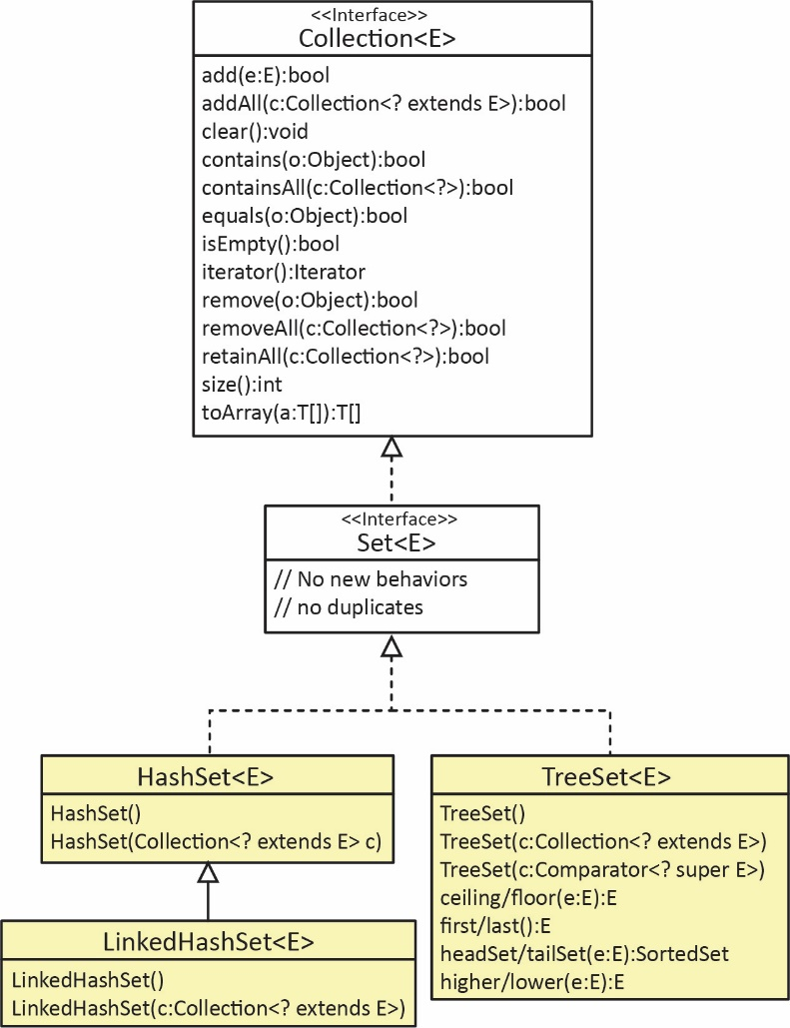
Set is a sub-interface of Collection that:
- Doesn’t allow duplicates.
- There are no two elements: e1 and e2 in the set such that e1.equals(e2).
- mySet.add(e1) simply returns false if e1 already exists.
- Does not specify any additional methods. Set is a (somewhat) marker interface.
- Doesn’t provide random (positional) access.
- The Collection interface does not specify a get(pos) method.
- The only way to access the elements is by using a for-each loop, or an iterator.
Java provides three common implementations:
- HashSet – Doesn’t guarantee any particular ordering. If you iterate over a HashSet, you will see all the elements, but they will not be (in general) in the order that you added them.
- LinkedHashSet – Elements are ordered according to the order they were added.
- TreeSet – Elements are ordered according to Comparable or Comparator.
The Set classes are extremely fast, in fact, there is nothing faster for some operations. Consider the add, remove, contains methods.
- HashSet – Very fast, O(1)*. Essentially a constant amount of time no matter how many items are in the set.
- LinkedHashSet – Very fast, O(1)*
- TreeSet – Fast, O(log n)*
* This is called Big ‘O’ notation. You will learn about this in a data structures course (CS 3410). It is a measure of how fast an algorithm is. We will briefly discuss the graph at the top of this page: http://bigocheatsheet.com/. Another reference:
http://infotechgems.blogspot.com/2011/11/java-collections-performance-time.html

The HashSet Class
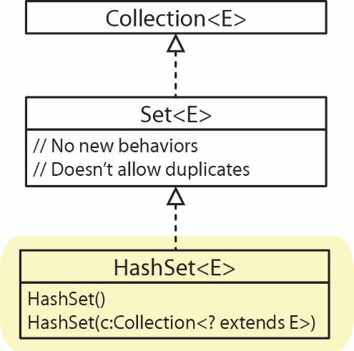
The only methods that HashSet provides are Collection methods. It has two constructors:
- A no-arg constructor, for example:
Set<String> hsCities = new HashSet<>();
- One that accepts any type of Collection (of the same type or subtype) and initializes the set with those elements. For example:
ArrayList<String> alCities = new ArrayList<>();
...
Set<String> hsCities = new HashSet<>(alCities);
We can iterate over a HashSet using a for-each loop or an iterator. As we noted earlier, there is no guarantee of order. For example (code in example_hash_set package):
Set<String> names = new HashSet<>();
names.add("cat"); names.add("dab"); names.add("fia");
names.add("fre"); names.add("gor"); names.add("pet");
For-each loop | Iterator
for(String name : names) {  System.out.print(name + " ");  }  System.out.println(); | Iterator<String> iter = names.iterator();  while(iter.hasNext()) {  System.out.print(iter.next() + " ");  }
Output: dab cat fre gor pet fia | Output: dab cat fre gor pet fia
As stated earlier, we cannot use an indexed loop, as a Set is not a List, i.e. there is no positional access with a Set.
As mentioned previously, filtering a collection refers to the process of iterating over the collection and selectively removing (collecting, etc.) certain elements and the preferred way to do that is to use an Iterator. For example, if we have a set of names, a snippet of code to remove names that contain the letter, “a”:
Set<String> names = new HashSet<>();
...
Iterator<String> iter = names.iterator();
while(iter.hasNext()) {
if(iter.next().contains("a"))
iter.remove();
}
We can store instances of a custom class in a HashSet, but you must override hashCode and equals. We will not consider this in this class; however, you will learn what a hash code is in CS 3410 .

Exercises
- (Solution in exercise_names package) Write a method, removeLongNames that accepts a set of names and an integer, len. The method should remove any names from the set with length greater than len. See Section 3.3 if needed.
- (Solution in exercise_names package) Write a method, separateLongNames that accepts a set of names and an integer, len. The method should remove any names from the set with length greater than len and return a set of the names that were removed. See Section 3.3 if needed.
- (Solution in exercise_names package) Write a method, getUniqueNames that accepts a list of names and returns a list with duplicates removed, e.g. Example: getUniqueNames(“alpha”, “beta”, “alpha”, “gamma”} -> {“alpha”, “beta”,”gamma”}. Hint: use a HashSet and before returning, convert it to a list.

The LinkedHashSet Class
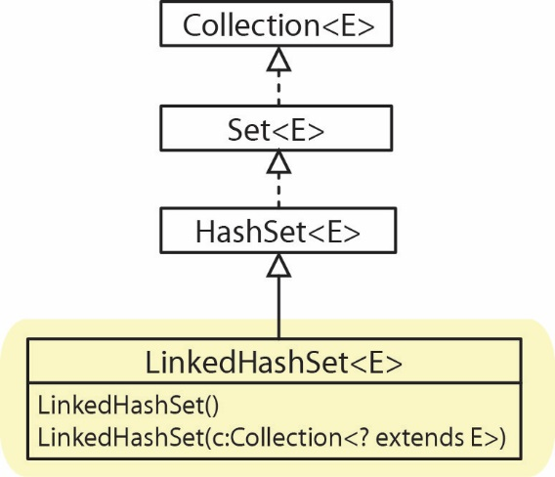
LinkedHashSet is a subclass of HashSet as shown in the class diagram on the right. LinkedHashSet is identical to HashSet except that the order of insertion is preserved. For example (code in example_linked_hash_set package):
private static void testLinkedHashSet() {
Set<String> names = new LinkedHashSet<>();
names.add("cat"); names.add("dab");
names.add("fia"); names.add("fre");
names.add("gor"); names.add("pet");

for(String name : names) {
System.out.print(name + " ");
}
}
Output: cat dab fia fre gor pet

The TreeSet Class
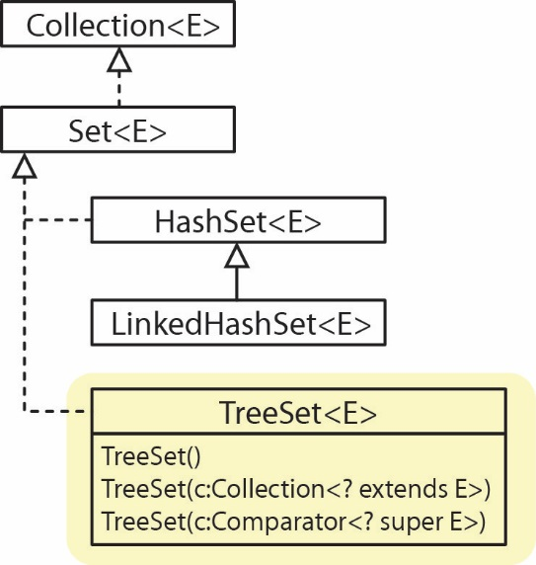
The TreeSet class is an implementation of the Set interface as shown in the class diagram on the right. A TreeSet is an ordered set where elements are ordered according to Comparable or Comparator. A TreeSet can be created with no arguments, a Collection, or a Comparator.
The TreeSet class does inherit other methods, which are considered in an appendix.
Example (code in example_tree_set package) – A TreeSet of Strings
TreeSet<String> tsCities = new TreeSet<>(
Arrays.asList("New York", "Atlanta",
"Savannah", "Tampa", "Durango"));

for(String city : tsCities) {
System.out.print(city + " ");
}

Output: Atlanta Durango New York Savannah Tampa

Exercises
- (Solution in exercise_names package) Write a method, getUniqueNames2 that accepts a list of names and returns a set with duplicates removed and ordered alphabetically, e.g. Example: getUniqueNames2(“Leno”, “Rich”, “Leno”, “Kate”} -> {“Billie”, “Kate”, ”Rich”}.
- (Solution in exercise_get_words_alphabetic package) Write a method, getWordsAlphabetic which accepts a comma-delimited string of words, words and returns a set of the words, with no duplicates, ordered alphabetically. For example:
getWordsAlphabetic("beetle,dog,beetle,ant,cat,ant")
returns the set: [ant, beetle, cat, dog].
- (Solution in exercise_get_domains_alphabetic package) Write a method, getDomainsAlphabetic which accepts a comma-delimited string of email addresses and returns a list of domains alphabetically with no duplicates. The format for an email address is: local-part@domain. For example, if the input is:
"earl@inorbit.com,bip@run.com,arf@run.edu,cam@inorbit.com,dg@gmail.com,repo@ant.edu”
then the returned list is:
[ant.edu, gmail.com, inorbit.com, run.com, run.edu]
Hint: very similar to the last problem except that you have to parse off the domain, and return a list instead of a set.
- (Solution in exercise_get_paid_list package) You will write two methods, both accept a list of names and a set of integers. The integers represent indices in the list of names of names that have paid their bill.
Method | Description
getPaidList(names, indices) | Returns a list of names that have paid their bill.
getNotPaidList(names, indices) | Returns a list of names that have not paid their bill.
You must not change the input list nor set. For example, suppose the input is: names=[t,b,d,g,m,e] and iPaid=[4,1,2]; then the getPaidList returns: [b,d,m] and getNotPaidList returns: [t,g,e].
Consider this method: getPaidList(names, indices) – Returns a list of names that have paid their bill while also removing those from the list. This is a little harder problem because when you remove from the list of name, the subsequent names in the list have their indices renumbered. No solution is provided for this method.

The TreeSet Class with Custom Objects
A TreeSet can hold instances of a custom class provided the class implements Comparable or a Comparator exists which is supplied in the constructor. For example (code in example_treeset_players package):
- TreeSet with Comparable
Class | Example
public class Player implements Comparable<Player> {  private String name;  private int score;  ...  @Override  public int compareTo(Player p) {  return this.name.compareTo(p.name);  }  } | TreeSet<Player> players = new TreeSet<>();  players.add(new Player("zeke", 300));  players.add(new Player("ben", 100));  players.add(new Player("alan", 400));  for(Player p : players)  System.out.println(p);  Output  Name=alan, Score=400  Name=ben, Score=100  Name=zeke, Score=300
- TreeSet with Comparator
Comparator (same class as above) | Example
public class PlayerScoreComparator  implements Comparator<Player> {  @Override  public int compare(Player p1, Player p2) {  return p1.getScore()-p2.getScore();  }  } | TreeSet<Player> players =  new TreeSet<>(new PlayerScoreComparator());  players.add(new Player("zeke", 300));  players.add(new Player("ben", 100));  players.add(new Player("alan", 400));  for(Player p : players)  System.out.println(p);  Output  Name=ben, Score=100  Name=zeke, Score=300  Name=alan, Score=400
Next, we consider (code in example_treeset_employees package) using the contains and remove methods both of which accept an Object as an argument:
- Suppose we have an Employee class:
public class Employee {
private String lName;
private String fName;
private int ssn;
private double salary;

public Employee(String lName, String fName, int ssNum, double salary) {
...
}
...
}
- And a comparator that orders on SSN:
public class EmployeeSSNComparator implements Comparator<Employee> {
public int compare(Employee e1, Employee e2) {
return e1.getSSNum() - e2.getSSNum();
}
}
- Then, we can create a TreeSet of Employees using the comparator:
TreeSet<Employee> emps = new TreeSet<>(new EmployeeSSNComparator());
Employee e1 = new Employee("Boggs", "Kay", 716533892, 12.57);
Employee e2 = new Employee("Lyton", "Ben", 476227851, 77.88);
Employee e3 = new Employee("Boggs", "Amy", 553572246, 22.32);
Employee e4 = new Employee("Dern", "Donald", 243558673, 23.44);

emps.add(e1); emps.add(e2); emps.add(e3); emps.add(e4);
- Write a static method, contains that accepts (a) a TreeSet of Employee objects (as described above, i.e. with a Comparator that orders on SSN) and (b) an SSN. This method returns true if there is an Employee in the set with SSN equal to the input SSN and false otherwise.
private static boolean contains(TreeSet<Employee> emps, int ssn) {
Employee key = new Employee("", "", ssn, 0);
return emps.contains(key);
}
Similarly, we could write a static method, remove that accepts (a) a TreeSet of Employee objects and (b) an SSN. This method removes the Employee in the set with SSN equal to the input SSN if it exists. If the remove is successful, it should return true, otherwise, false.
private static boolean remove(TreeSet<Employee> emps, int ssn) {
Employee key = new Employee("", "", ssn, 0);
return emps.remove(key);
}

Exercises
- (Solution in exercise_get_ids package) Consider the Student class below. Write a static method, getIds which accepts two TreeSets of Student objects and returns a list of the ids for the students that are in both sets (not a list of the students, a list of the ids).
public class Student implements Comparable<Student> {
private int id;
private double score;

Student(int id, double score) {
this.id = id;
this.score = score;
}
int getId() {
return id;
}
double getScore() {
return score;
}
public int compareTo(Student s) {
return this.getId() - s.getId();
}
public String toString() {
return "id=" + id + " score=" + score;
}
}

Performance of Sets & Lists
I wrote some code (in the example_speed_comparison package) to compare how long it took to remove integers from HashSet, LinkedHashSet, TreeSet, ArrayList, and LinkedList. First 50,000 unique integers were generated and stored in a each of the collections. These are the collections where we will be removing from. Next, 25,000 of these values were selected at random. These are the values we will be removing from each of the collections. Finally, we timed how long it took to remove the 25,000 from the 50,000 in each of the collections. This process was repeated for collections of size: 100,000; 150,000; and 200,000 (continuing to remove 25,000 from each). The results are shown in the graph below.
The graph does not show LinkedHashSet nor TreeSet because the results were almost identical to HashSet. The interesting point is that we see that with ArrayList and LinkedList, the time required increases as the collection size increases whereas the there is no difference in time for the HashSet, which is also theoretical result.
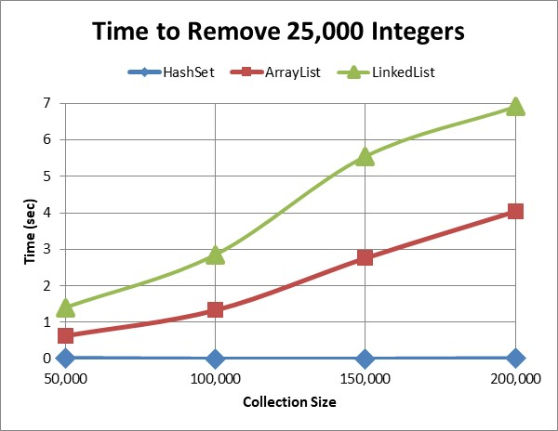
The numerical results are shown below (seconds):
Collection Size | HashSet | LinkedHashSet | TreeSet | ArrayList | LinkedList
50,000 | 0.007 | 0.010 | 0.017 | 0.629 | 1.393
100,000 | 0.003 | 0.004 | 0.012 | 1.335 | 2.844
150,000 | 0.003 | 0.003 | 0.015 | 2.765 | 5.544
200,000 | 0.006 | 0.006 | 0.018 | 4.049 | 6.907

Example: Counting Keywords
Consider a situation where you need to count and/or identify the occurrences of certain keywords in a body of text. For example, in a security scenario, suppose you want to scan a person’s Twitter feed for the occurrences of certain words that might indicate the person had a tendency towards violence.
In the example (code in example_counting_happywords_set) that follows, we write methods to read the text of the novel, The Catcher in the Rye to: (a) count the number of “happy words” that occur in the text, (b) return a set of happy words in the order they occur in the text, (c) a sorted list of happy words that occur in the text.
Consider the following set of “happy words”:
static String[] happyWordsAry = {"content", "cheerful", "cheery",
"merry", "joyful", "joy", "jovial", "jolly", "joking", "joke", "jocular", "gleeful",
"glee", "carefree", "untroubled", "delighted", "delight", "smiling", "smile",
"delighted", "delight", "elated", "elation",
"glad", "joyous", "jubilant", "lively", "pleased", "thrilled", "happy",
"upbeat", "blessed", "blest", "blissful", "chipper", "chirpy", "content",
"convivial", "gay", "gratified", "laughing", "laugh", "mirthful", "peppy",
"playful"};

static Set<String> happyWords = new HashSet<>(Arrays.asList(happyWordsAry));
- An algorithm to count the number of occurrences of happy words in the text:
Create a HashSet with all happy words
Loop over all words in file
If word is in happy words set
Increment count
Return count
Next, we write a method that accepts a File object that references a text file and a Set of happy words. This method should return this count.
public static int countKeywords(File file, Set<String> happyWords) throws Exception {
int count = 0;
Scanner input = new Scanner(file);

while (input.hasNext()) {
String word = input.next();
word = getCleanWord(word);
if (happyWords.contains(word))
count++;
}
input.close();
return count;
}

Where, getCleanWord simply removes any leading or trailing blanks spaces, converts the word to lower-case, and removes any punctuation or double quotes:

public static String getCleanWord(String word) {
String punctuation = ".,;:\"?!";
String cleanWord = word.trim();
cleanWord.toLowerCase();
if(cleanWord.length()>0) {
String lastChar = String.valueOf(cleanWord.charAt(cleanWord.length()-1));
if(punctuation.contains(lastChar)) {
cleanWord = cleanWord.substring(0,cleanWord.length()-1);
}
}
return cleanWord;
}
- Next, we write a method that accepts a File object that references a text file and a Set of happy words. This method returns a set of happy word used in the text, in the order they appear. Thus, it is similar to the previous method.
public static Set<String> getWordsUsedInOrder(File file, Set<String> happyWords) throws FileNotFoundException {
Set<String> happyWordsUsed = new LinkedHashSet<>();
Scanner input = new Scanner(file);
while (input.hasNext()) {
String word = input.next();
word = getCleanWord(word);
if (happyWords.contains(word)) {
if(!happyWordsUsed.contains(word)) {// not nec., but makes more understandable
happyWordsUsed.add(word);
}
}
}
input.close();

return happyWordsUsed;
}
- Finally, we write a method that is the same as the previous one, except that it returns a set of happy word used in the text, in alphabetical order. The solution is simple, we replace the LinkedHashSet that stores the result with a TreeSet:
Set<String> happyWordsUsed = new TreeSet<>();

Appendix
- Filtering a Collection Incorrectly
  - Filtering a Collection with a for-each Loop Incorrectly
This code below is very simple and obvious, and it will compile. However, if the remove method is executed (which it will in this example) then a ConcurrentModificationException will be thrown. We remember from a previous chapter that when using a for-each loop the corresponding collection cannot be modified (added to or removed from). Thus, this is not a viable approach for removing elements from a collection.
for(Player player : players) {
if(player.getScore() < 20) {
players.remove(player);
}
}

  - Filtering a Collection with a Forward, Indexed Loop Incorrectly
The code for the examples in this section are in the example_iterator_cities package.
Consider a list of strings and we want to remove all occurrences of “New York”:
ArrayList<String> cities = new ArrayList<>(Arrays.asList("Dallas", "New York", "New York", "San Fran", "Madison"));
Filtering a collection using an indexed loop, advancing forward through the list, will sometimes work incorrectly. For example:
for(int i=0; i<cities.size(); i++) {
if(cities.get(i).equals("New York")) {
cities.remove(i);
}
}
It will not work correctly if the list has duplicates and at least two are side-by-side. For example, consider the list of cities in the list in previous examples:
0 | 1 | 2 | 3 | 4 | …
“Dallas” | “New York” | “New York” | “San Francisco” | “Madison”
With the loop above, at the conclusion, cities will still contain the second New York. The reason is that when the first New York is removed, all the cities to the right are moved over one position to the left and re-indexed. Thus, when i=1, the first New York is removed, but then the second New York is moved over and is now at index 1. Then, the next iteration begins at i=2, thus, skipping the second New York. For example:
i=1, beginning of loop:
0 | 1 | 2 | 3 | 4 | …
“Dallas” | “New York” | “New York” | “San Francisco” | “Madison”

i=2, beginning of loop:
0 | 1 | 2 | 3 | …
“Dallas” | “New York” | “San Francisco” | “Madison”

- Other Approaches to Filtering a Collection
Consider a list of strings and we want to remove all occurrences of “New York”:
ArrayList<String> cities = new ArrayList<>(Arrays.asList("Dallas", "New York", "New York", "San Fran", "Madison"));
An approach to removing, that works is to use an indexed loop, forward over the elements, but decrement the index of the loop after any remove. This is done so that the loop doesn’t skip over an element when it removes. For example:
for(int i=0; i<cities.size(); i++) {
if(cities.get(i).equals("New York")) {
cities.remove(i--); // decrement i after removing, so doesn't skip
}
}
This is a poor approach because it is harder to understand and easier to get wrong. Best practice is to never change the index of a for loop inside the body of the loop itself. If an index needs to change in a loop, then it is preferred to use a while loop:
int i=0;
while(i < cities.size()) {
if(cities.get(i).equals("New York")) {
cities.remove(i);
}
else {
i++;
}
}
Another approach is to use an indexed loop to iterate over the elements in reverse order. For example:
for(int i=cities.size()-1; i>=0; i--) {
if(cities.get(i).equals("New York")) {
cities.remove(i);
}
}
This works because removing an element does not affect any of the elements before the element that was removed. Many people might choose this approach. I would consider this approach more subject to programmer error in the specification of the loop parameters as compared to the iterator approach.
To see that the indices before a removed element are not affected, consider this example: when i=4, and i=3, no change to the list is made. Now, see what happens when i=2:
i=2, beginning of loop (will remove “New York” at i=2):
0 | 1 | 2 | 3 | 4 | …
“Dallas” | “New York” | “New York” | “San Francisco” | “Madison”
i=1, beginning of loop (will remove “New York” at i=1):
0 | 1 | 2 | 3 | …
“Dallas” | “New York” | “San Francisco” | “Madison”
i=0, beginning of loop (no change):
0 | 1 | 2 | …
“Dallas” | “San Francisco” | “Madison”

Another approach is to use the Collection’s removeIf method:
cities.removeIf(x -> x.equals("New York"));
Another approach is to use the Stream’s filter method to collect the items that meet a set of criteria and then use removeAll:
List<String> duplicates = cities
.stream()
.filter(x -> x.equals("New York"))
.collect(Collectors.toList());

cities.removeAll(duplicates);
- Static Methods for Lists & Collections
The Collections class contains static methods for operating on Collections and Lists (and Maps). A few are listed below.
Method | Description
sort(l:List) | Sorts the list
sort(l:list, c:Compartor) | Sorts the list with the comparator
binarySearch(l:list,key:Object):int | Returns the location of key in the sorted list, negative otherwise
binarySearch(l:list,key:Object,c:Comparator):int | Returns the location of key in the sorted list using the comparator, negative otherwise
reverse(l:List) | Reverses the elements in the list
reverseOrder():Comparator | Returns a comparator with the reverse ordering
rotate(l:List,distance:int) | Rotates the elements in the list by distance
shuffle(l:List) | Shuffles the elements in the list randomly
copy(dest:List,source:List) | Copies source list into destination list
nCopies(n:int,o:Object):List | Returns a list with n copies of the object
fill(l:list,o:Object) | Fills the list with the object
max(c:Collection):Object | Returns the max object in the collection
max(c:Collection,cmp:Comparator):Object | Returns the max object in the collection using the comparator
min(c:Collection):Object | Returns the min object in the collection
min(c:Collection,cmp:Comparator):Object | Returns the min object in the collection using the comparator
disjoint(c1:Collection,c2:Collection):Boolean | Return true if c1 and c2 have no elements in common
frequency(c:Collection,o:Object):int | Returns the number of occurrences of the object in the collection.
The reverseOrder method above is also overloaded to take a Comparator. For example, we could reverse the order of the SSN comparator:
List<Employee> employees = new LinkedList<>();
...
EmployeeSSNComparator comp = new EmployeeSSNComparator();

Collections.sort(employees, Collections.reverseOrder(comp));

- Class Diagram for Collection Classes
These are the classes and methods you are responsible for on a test. I will provide a copy of this image on a test.
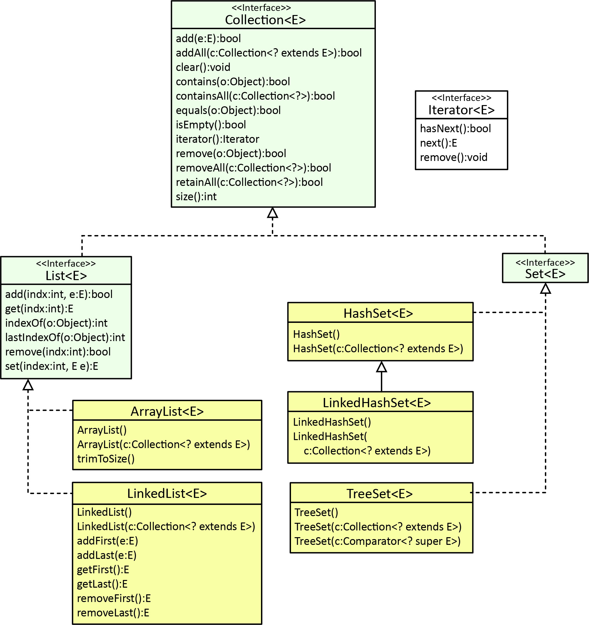

This is a fuller version of the collection classes and methods.
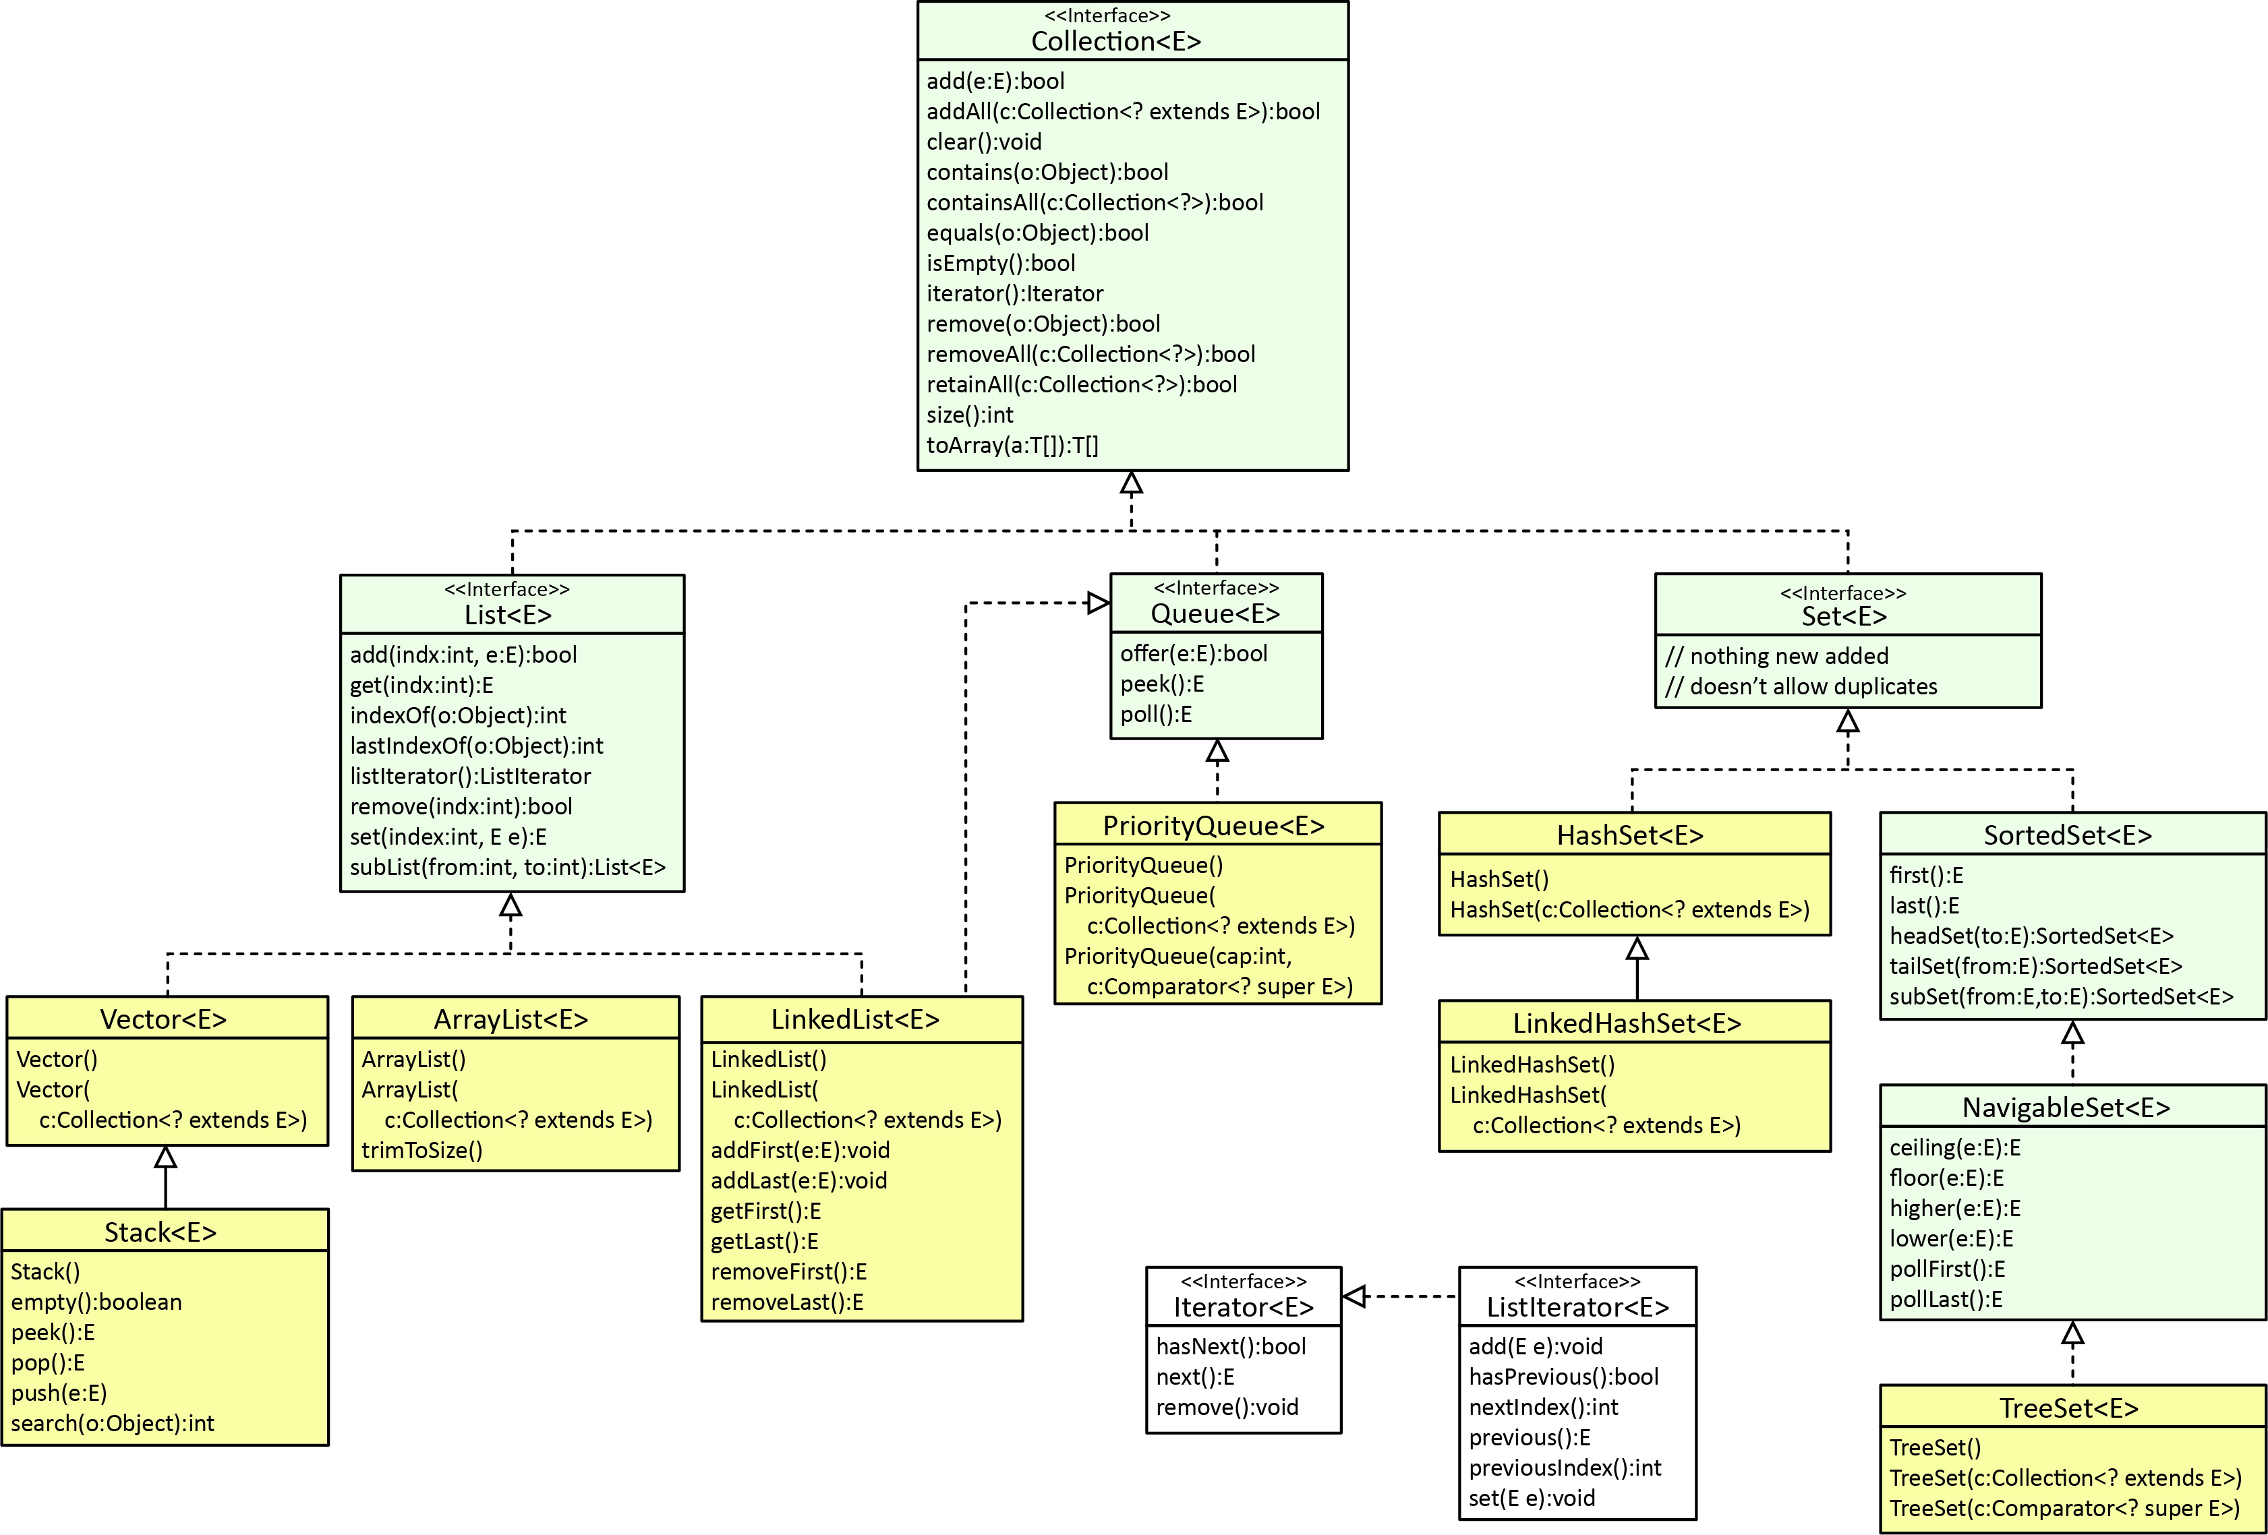

- The Vector & Stack Classes
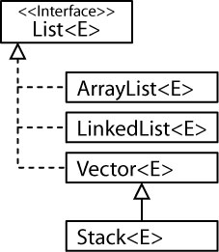
The Java Collections Framework (JCF) was introduced with Java 2 (1998). Thus, prior to that there was no ArrayList, HashSet, etc. The earliest version of Java supported two data structures: the Vector class and the Stack class. As shown in the diagram on the right, they were retrofitted to be generic and to fit in the JCF. However, the method names were preserved to support compatibility.
Vector is the same as ArrayList, except (a) that Vector contains the synchronized methods for accessing and modifying the elements. Synchronization means that the class is thread-safe, i.e. multiple threads can use the structure without stepping on each other, (b) it has legacy methods, e.g. insertElement, etc. Note that ArrayList and LinkedList are not synchronized. If synchronization is required, you can use the synchronized versions of the collection classes which can be obtained with static methods in the Collections class (e.g. synchronizedList).
The Vector and Stack classes are shown in the class diagram below.
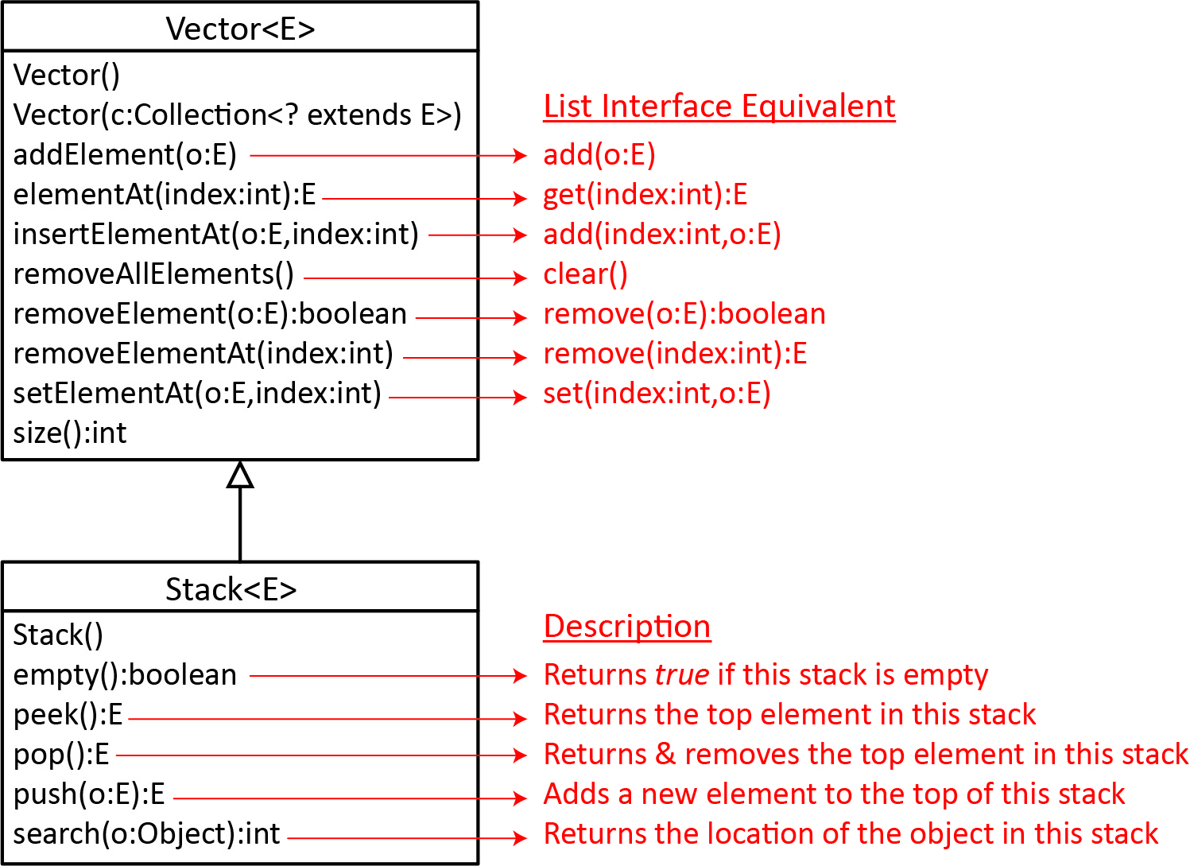

- Queues and Priority Queues
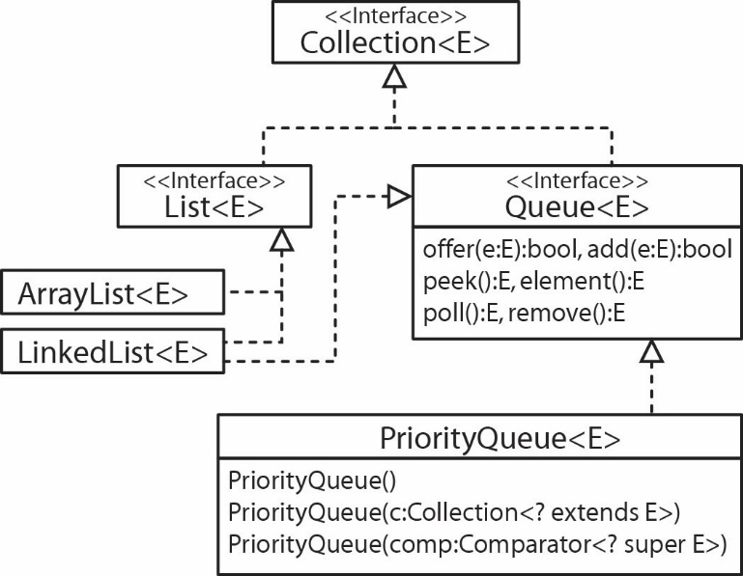
A Queue is a structure that models things that are waiting, for instance people waiting in line, or jobs waiting to be processed by a processor. When you add (offer) an element to a queue it is placed at the end (tail), when you remove (poll) an element from a queue it is removed from the front (head). A queue is usually a first-in first-out (FIFO) data structure. As shown in the class diagram on the right, the Queue interface extends the Collection interface. The three methods in Queue are:

Methods | Description
offer(e:E):bool,  add(e:E):bool | Adds e to the end (tail) of the queue. offer returns false if the element cannot be added while add throws an exception.
peek():E,  element():E | Retrieves but doesn’t remove the first element (head) of the queue. peek returns null if the queue is empty while element throws and exception.
poll():E,  remove():E | Retrieves and removes the first element (head) in the queue. poll returns null if the queue is empty while remove throws an exception.

Java does not define a concrete Queue class (Queue is an interface). However, as the class diagram on the right above shows, a LinkedList is-a Queue. For example, we could create a queue like this:
Queue<Integer> ints = new LinkedList<>();
Java defines a concrete PriorityQueue class as shown in the diagram above which implements Queue. A PriorityQueue orders its elements according to their natural ordering using Comparable or a Comparator. The element with the least value is assigned the highest priority and is the first one removed. In other words, when you offer an element to a PriorityQueue, the lower the value the closer it’s location is to the head of the queue.
For example:
Queue<Integer> ints = new PriorityQueue<>();
ints.offer(8);
ints.offer(2);
ints.offer(5);

while(ints.size()>0) {
System.out.print(ints.poll() + " ");
}

Output: 2 5 8

Example – We create a PriorityQueue of Employee objects. The constructor requires a Comparator (and also an initial capacity, we won’t discuss this, below, we just use the value 20).
Employee e1 = new Employee("Boggs", "Kay", 716533892, 12.57);
Employee e2 = new Employee("Lyton", "Ben", 476227851, 77.88);
Employee e3 = new Employee("Boggs", "Amy", 553572246, 22.32);
Employee e4 = new Employee("Dern", "Donald", 243558673, 23.44);

// Create priority queue to hold Employee objects
Queue<Employee> pqEmps = new PriorityQueue<>(20, new EmployeeSalaryComparator() );

// Add employees to p.queue
pqEmps.offer(e1);
pqEmps.offer(e2);
pqEmps.offer(e3);
pqEmps.offer(e4);

while( pqEmps.size() > 0) {
// Remove employee from head of queue and print
System.out.println( pqEmps.poll());
}
Output:
(Boggs, Kay - 716533892, 12.57)
(Boggs, Amy - 553572246, 22.32)
(Dern, Donald - 243558673, 23.44)
(Lyton, Ben - 476227851, 77.88)

- The SortedSet & NavigableSet Interfaces
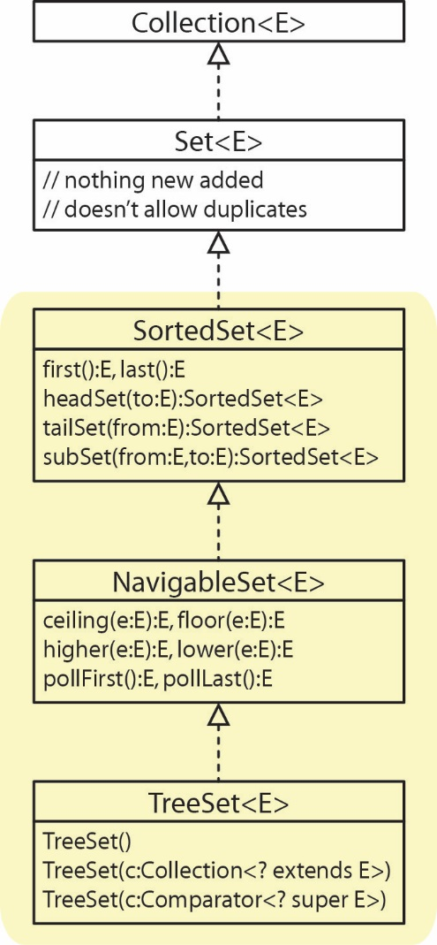
Above, we showed that TreeSet is-a Set. Actually, there are two interfaces in between (as shown in the class diagram on the right) that prescribe methods that provide access to certain elements.
Method | Description
first():E | The first (smallest) element is returned
last():E | The last (largest) element is returned
headSet(to:E)  :SortedSet<E> | Returns a SortedSet of elements that are strictly less than toElement. {x|x<toElement}
tailSet(from:E)  :SortedSet<E> | Returns a SortedSet of elements greater than or equal to fromElement. {x|x>=fromElement}
subSet(from:E,to:E)  :SortedSet<E> | Returns a SortedSet of elements between fromElement, inclusive to toElement exclusive.  {x|fromElement <= x < toElement}
See Lab 10 for examples of these methods.
Note that headSet, tailSet, subSet return a SortedSet. This is an odd structure. Consider the documentation for the headSet method:
Returns a view of the portion of this set whose elements are strictly less than toElement. The returned set is backed by this set, so changes in the returned set are reflected in this set, and vice-versa.
Thus, there may be situations where you might want to create a TreeSet from the SortedSet in order to break this bond. In other words, you want to preserve the result of headSet and then subsequently modify the TreeSet or vice-versa.
Next, we consider a few of the methods specified in the NavigableSet interface. The first four below) are similar to the methods in SortedSet except that they return a single item (or nothing).
Method | Description
floor(e:E) | The largest element <= e is returned
lower(e:E) | The largest element < e is returned
ceiling(e:E) | The smallest element >= e is returned
higher(e:E) | The smallest element > e is returned
pollFirst() | Returns the smallest element and removes it
pollLast() | Returns the largest element and removes it
*headSet(to:E,in:bool):NavigableSet<E> | Returns elements {x|x<=to} , when in=true
*tailSet(from:E,in:bool):NavigableSet<E> | Returns elements {x|x>=from} , when in=true
*subSet(to:E,in1:bool,from:E,in2:bool)  :NavigableSet<E> | Returns elements {x|from<=x<=to} , when in1=true and in2=true
*descendingIterator():Iterator<E> | Returns an iterator over the elements in this set, in descending order.
*descendingSet():NavigableSet<E> | Returns a reverse order view of the elements contained in this set.

* Not shown in class diagram above.

Similar to SortedSet above, NavigableSet is a view of the underlying set and changes to either are reflected in the other.

Actually, these methods are defined in the Deque interface.
https://javarevisited.blogspot.com/2011/10/override-hashcode-in-java-example.html
https://medium.com/codelog/overriding-hashcode-method-effective-java-notes-723c1fedf51c

