Compiling & Running from the Command Line

Contents
1 Using Eclipse to Write Java Programs to Read/Write Text Files 1
2 Change the Default Location that Eclipse uses to Look for a Text File 3
3 Example 1 – Portable Approach for Reading a Text File 4
3.1 Eclipse Development 4
3.2 Distributing the Code 4
4 Example 2 – Text File in Subfolder 5
5 Example 3 – Code in a Package 6
6 Distributing Code – JAR Files 6
Appendix 1 Error Running a Java File 8
Appendix 2 Reference Material 8

Using Eclipse to Write Java Programs to Read/Write Text Files
The purpose of this document is to illustrate how to use Eclipse (or other IDE) to develop Java programs to read/write text files and how to distribute them so that they can be run from the command line on another computer.
Consider the Eclipse Package Explorer shown below, on the left. Using Eclipse to write a Java program (ReadFile.java) to read a text file (numbers.txt), one creates a project (project) which creates a src folder. Inside src, we generally specify a package (ver1). The default location where Java looks for a text file, is the project folder.
Eclipse Package Explorer:
project
src
ver1
ReadFile.java
numbers.txt
In such a situation, we would use a File object as shown below:
File inFile = new File("numbers.txt");
It is convenient when developing and testing code to place the file that is to be read, in the folder where the code is. file to place the text file at the same location where the code is, in the package folder as shown in the table below, on the left and the File object required is shown on the right.
Eclipse Package Explorer: | File Object
project  src  ver1  ReadFile.java  numbers.txt | File inFile = new File("src\\ver1\\numbers.txt");
However, hard-coding the path to the text file as shown above is not a portable solution. Code using such a setup, can run in Eclipse, on another computer, provided the package structure is duplicated. However, running it from the command line is problematic. One problem is the hard-coded path to the file in the File statement above, the src\ver1 folder structure would have to be created. Second, the fact that the code is in a package, makes it a bit more awkward to run from the command line. Gradle and Maven are two build automation tools that can automate these tasks. However, this is not a good use for either simply because of the hard-coded path – we don’t need to specify it so rigidly.
In the next section, we illustrate how to change the default location that Eclipse uses to look for text files. This is useful so that we can develop and test the code in Eclipse without the hard-coded path. The section after that, we show a good approach to developing a simple program that is portable.

Change the Default Location that Eclipse uses to Look for a Text File
You can change the default location of where Java looks for text files by following the process below. However, this still doesn’t address the portability issue, which we consider in the next section.
- Right-click the file in the Package Explorer and choose: Run As, Run Configurations
- Choose the Arguments tab and scroll down to the Working Directory
- Choose: Other and then specify the location. For the example below, the project is: IOExamples2 and the package is ver1. Thus, the location is: ${workspace_loc:IOExamples2/src/ver1}

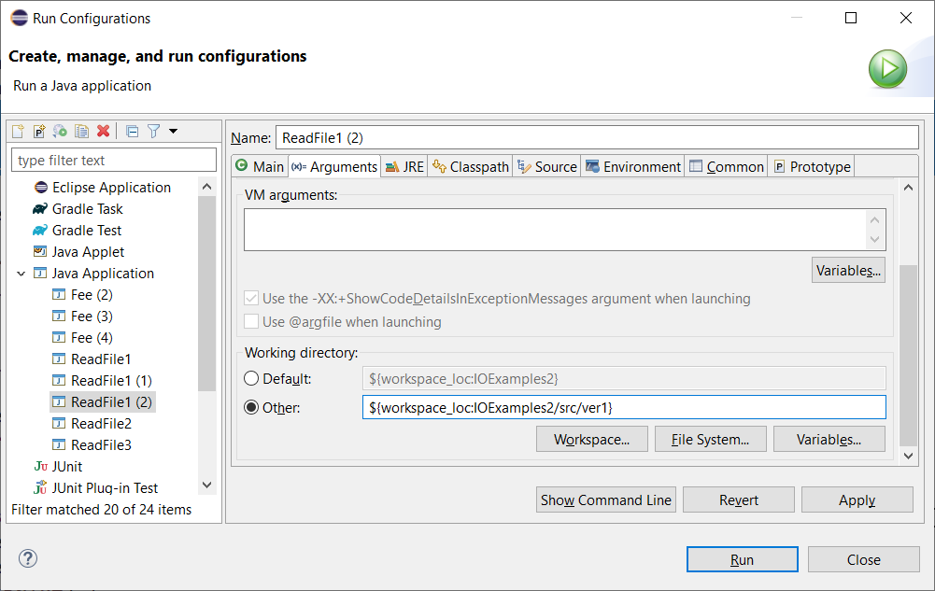
- Choose: Apply and Close (or Run). After doing this, the file can be placed in the package folder, alongside the code, and the File can be created as shown below
File inFile = new File("numbers.txt");
As we see in the next section, this solves some of the portability problem.

Example 1 – Portable Approach for Reading a Text File
If you want to use Eclipse to develop and test code to read a text file, that is also relatively portable, the simplest approach is:
- Create a class that does not specify a package (the default package, as it is called)
- Change the default location of text files in Eclipse to the src folder.
Next, we illustrate this with an example.

Eclipse Development
For this example: (a) the project is: IOExamples, (b) the code is: ReadFile1.java, (c) and the file being read is numbers.txt. (The source code for this example is in an accompanying zip file.) To start development in Eclipse:
- Create a project, IOExamples, and the copy (or write) the two files above into the src folder (no package).
- Change the default location to: ${workspace_loc:IOExamples/src}
Then, the layout in Eclipse, and the required File object are as shown below.
Eclipse Package Explorer: | File Object
IOExamples  src  ReadFile1.java  numbers.txt | File inFile = new File("numbers.txt");

Distributing the Code
Next, we’ll simulate distributing this code and running it on another machine. In theory, all we need to distribute is the class file, ReadFile1.class and the text file, numbers.txt. Do the following:
- Copy these two files (ReadFile1.class is located in: IOExamples\bin) to a folder somewhere else on your drive, in this case, I use temp.
Thus, the folder structure in this new location is shown below:
Folder Structure
temp
ReadFile1.class
numbers.txt
- Open a command prompt.
One way to open the command prompt in Windows is: (a) press Windows key + R, (b) type: “cmd”, (c) press OK).
- Navigate to the temp folder.
On a PC, you can use MS-DOS, the cd command.
- From the command prompt, issue this command (red) to run the program:
C:\...\temp>java ReadFile1
They program may not run as explained in this Appendix. If this is the case, then you need to compile the source code first, then run as above. To do this, copy ReadFile1.java (located in IOExamples\src) to the temp folder and then compile and run as shown below.

Folder Structure | Compile Program
temp  ReadFile1.java  ReadFile1.class  numbers.txt | C:\...\temp>javac ReadFile1.java
 | Run Program
 | C:\...\temp>java ReadFile1

Example 2 – Text File in Subfolder
This is similar to the last example, except the file to read is now in a subfolder, data_ex2. For this example: (a) the project is: IOExamples, (b) the code is: ReadFile2.java, (c) and the file being read is numbers.txt. (The source code for this example is in an accompanying zip file.) To start development in Eclipse:
- Create a project, IOExamples, and the copy (or write) the two files above into the src folder (no package).
- Change the default location to: ${workspace_loc:IOExamples/src}
Then, the layout in Eclipse, and the required File object are as shown below.
Eclipse Package Explorer: | File Object
IOExamples  src  ReadFile1.java  data_ex2  numbers.txt | File inFile = new File("data_ex2\\numbers.txt");
Next, we’ll simulate distributing this code and running it on another machine. Do the following:
- Copy, ReadFile1.java to a folder somewhere else on your drive, in this case, I use temp. Then create the folder data_ex2 in temp and copy numbers.txt there.
Thus, the folder structure in this new location is shown below:
Folder Structure
temp
ReadFile2.class
ReadFile2.java
data_ex2
numbers.txt
- Open a command prompt and compile and run:
C:\...\temp>javac ReadFile1.java
C:\...\temp>java ReadFile1

Example 3 – Code in a Package
For this example, the code is in package and the text file is “in” the package also.
For this example: (a) the project is: IOExamples, (b) the code is: ReadFile3.java, (c) and the file being read is numbers.txt. (The source code for this example is in an accompanying zip file.) To start development in Eclipse:
- Create a project, IOExamples, a ver1 package, and then copy (or write) the two files above into the ver1 folder.
- Change the default location to: ${workspace_loc:IOExamples/src}
Then, the layout in Eclipse, and the required File object are as shown below.
Eclipse Package Explorer: | File Object
IOExamples  src  ver1  ReadFile3.java  numbers.txt | File inFile = new File("numbers.txt");
Next, we’ll simulate distributing this code and running it on another machine. Do the following:
- Create a folder, ver1 in in folder on your drive, in this case, I use temp. Then copy ReadFile3.java and numbers.txt there. The folder structure in this new location is shown below:
Folder Structure
temp
ver1
ReadFile3.class
ReadFile3.java
numbers.txt
- Open a command prompt and compile and run:
example3>javac ver1\ReadFile3.java
example3>java ver1.ReadFile3
Also works:
- example3\ver1>javac ReadFile3.jav
Do not work:
- example3\ver1>javac ver1.ReadFile3.java (file not found)
- example3>javac ver1.ReadFile3.java (file not found)
- example3\ver1>java ver1.ReadFile3 (couldn’t find file or load main class)
- example3\ver1>java ReadFile3 (couldn’t find file or load main class)

Distributing Code – JAR Files
[Incomplete – to be continued] Another approach to distributing code is to create a JAR file. A JAR file enables you to package together all the files you need into a single archive file which can run from the command line (or be imported into other projects. You can create a JAR file in Eclipse or from the command line.
https://docs.oracle.com/javase/tutorial/deployment/jar/index.html
https://www.baeldung.com/java-create-jar
https://www.geeksforgeeks.org/jar-files-java/
https://www3.ntu.edu.sg/home/ehchua/programming/java/J9d_Jar.html

Appendix
- Error Running a Java File
If you run a class file generated by Eclipse from the command line, you may get this error:
Error: A JNI error has occurred, please check your installation and try again
Exception in thread "main" java.lang.UnsupportedClassVersionError: ReadFile1 has been compiled by a more recent version of the Java Runtime (class file version 60.0), this version of the Java Runtime only recognizes class file versions up to 52.0
This indicates the JRE Eclipse is using is more recent than the one you are trying to run it under on your (or some other) machine. This can be fixed in at least three ways: (a) Compile the source file from the command line, (b) in Eclipse, in the compiler options, set it to compile to a lower version (I think 1.8 would work), (c) change your PATH (Windows) so that the more recent JRE is referenced earlier in the statement. This question explains how to do b and c:
https://stackoverflow.com/questions/58125830/has-been-compiled-by-a-more-recent-version-of-the-java-runtime-class-file-versi
- Reference Material
This is background information that I have found useful.
- Difference Between JDK and JRE in Java – Useful, the last row summarizes the relationship.
- How to Set Java Path in Windows and Linux – Discussion of PATH environment variable and how to set it so that the operating system knows where to look for the java executables (java.exe, javac.exe, etc.). I followed the directions to just see the PATH (not change it). Mine was set to:
C:\Program Files\Eclipse Foundation\jdk-8.0.302.8-hotspot\bin
Meanwhile, I have another installation at:
C:\Program Files\Java\jdk1.8.0_231\bin
- How to run Eclipse under different version of JDK or JRE – This is the version of Java that is running Eclipse (which is written in Java). On my machine the vm is set to a location I’m not familiar with.
*** Date: Wednesday, September 28, 2022 at 9:31:10 AM Eastern Daylight Time
-vm
C:/Users/dgibson/.p2/pool/plugins/org.eclipse.justj.openjdk.hotspot.jre.full.win32.x86_64_16.0.2.v20210721-1149/jre/bin\server\jvm.dll

eclipse.vm=C:/Users/dgibson/.p2/pool/plugins/org.eclipse.justj.openjdk.hotspot.jre.full.win32.x86_64_16.0.2.v20210721-1149/jre/bin\server\jvm.dll

eclipse.vmargs=-Dosgi.requiredJavaVersion=11
java.vm.compressedOopsMode=32-bit
java.vm.info=mixed mode
java.vm.name=OpenJDK 64-Bit Server VM
java.vm.specification.name=Java Virtual Machine Specification
java.vm.specification.vendor=Oracle Corporation
java.vm.specification.version=16
java.vm.vendor=Oracle Corporation
java.vm.version=16.0.2+7-67
- JPMS-Modules – Java Platform Module System (JPMS) is a level of abstraction above packages (introduced in Java 9).
- jLink – A tool that generates a custom JRE image. Drawback is that it can’t create cross-platform executables. This may require javapackager.

