Chapter 6 – Exception Handling

Contents
1 Runtime Errors & Exceptions 2
2 The try/catch Block 4
3 The Exception Class Hierarchy 6
4 The catch Block 7
4.1 Exercises 7
5 Anticipating & Handling Errors 8
6 Throwing Exceptions 9
6.1 Exercises 10
7 The finally Clause 12
8 Exception Types 13
9 A Real Example 14
Appendix 1 Resources 15
Appendix 2 Catching Multiple Exceptions 15
Appendix 2.1 Exercises 16
Appendix 3 Rethrowing Exceptions 16
Appendix 3.1 Exercises 18
Appendix 4 Chained Exceptions 20
Appendix 4.1 Exercises 21
Appendix 5 Summary of Error Handling Approaches 21
Appendix 6 Custom Exceptions 22
Appendix 6.1 Exercises 23
Appendix 7 Checked Exceptions in the API 24

Runtime Errors & Exceptions
The code in this section is in the example_exceptions_in_api package.
A runtime error occurs when code performs an illegal operation (e.g divide by zero, access an array with an invalid index, etc.). When the JVM detects that a line of code is performing an illegal operation, it creates an Exception object and throws it. If the exception is not caught (we learn what this means shortly) the program ends.
As an example, in the code below, we see in line 6, that the inverse method is called, passing the value 0. Then, on line 10, there is an attempt to divide by zero, which causes the JVM to throw an ArithmeticException, which is not caught, and so the program ends displaying a stack trace in the console.
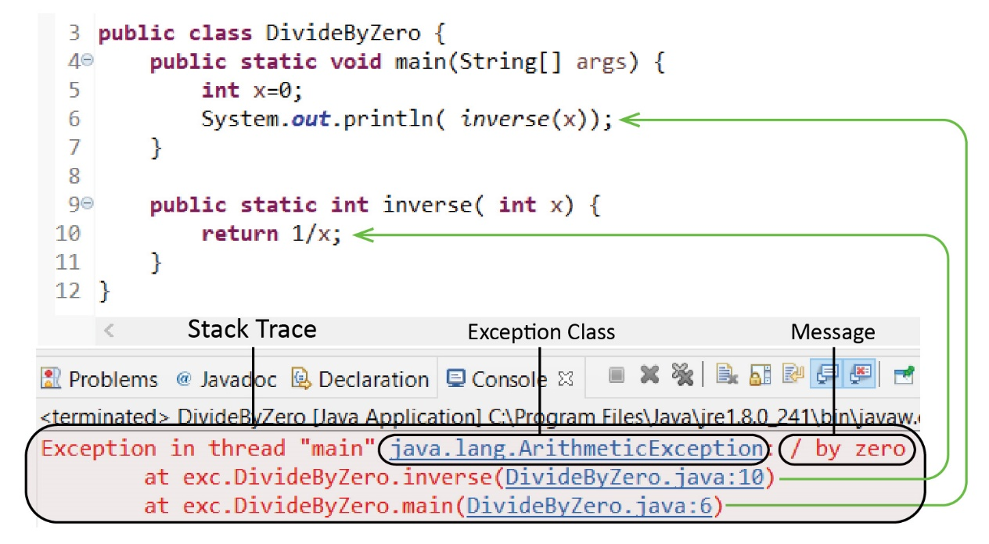
A stack trace provides useful information:
- The first entry in a stack trace shows the name of the exception class for the exception that was thrown, followed by the message, a brief (often cryptic) description
- The second entry shows the line where the run-time error occurred. In the example above, line 10.
- All subsequent entries show the exact sequence of method calls that lead to the illegal operation. In the example above, there is only one method, inverse, which is called on line 6.
As a programmer, you must learn to interpret and use a stack trace to resolve errors. Eclipse helps with this by providing links to the sequence of method calls that lead to the error. You typically work backwards. First, you inspect any code before the line of code that caused the error. Then, you move to the method that called the previous one and inspect the code before the call, etc.

In the example below, an ArrayIndexOutOfBoundsException is thrown. As you can see in the loop (line 11), the termination condition is incorrect (it should be i<x.length). The message is “3”, which means the illegal index was 3.
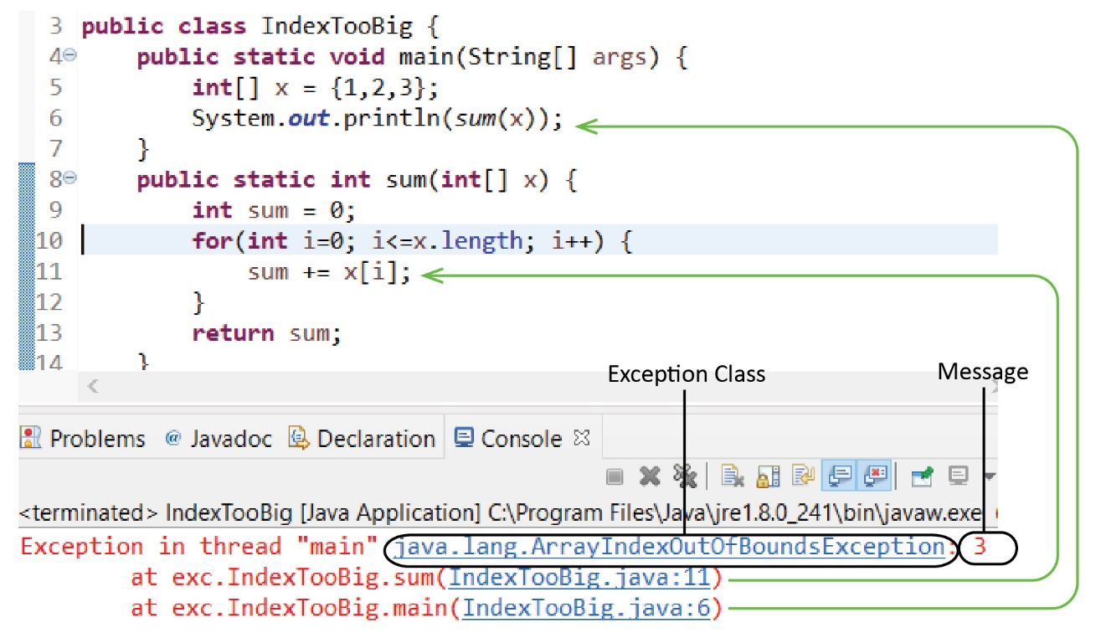
In the example below, a NullPointerException is thrown and there is no message. Of course, the problem is that on line 9, the Person object, p is null.
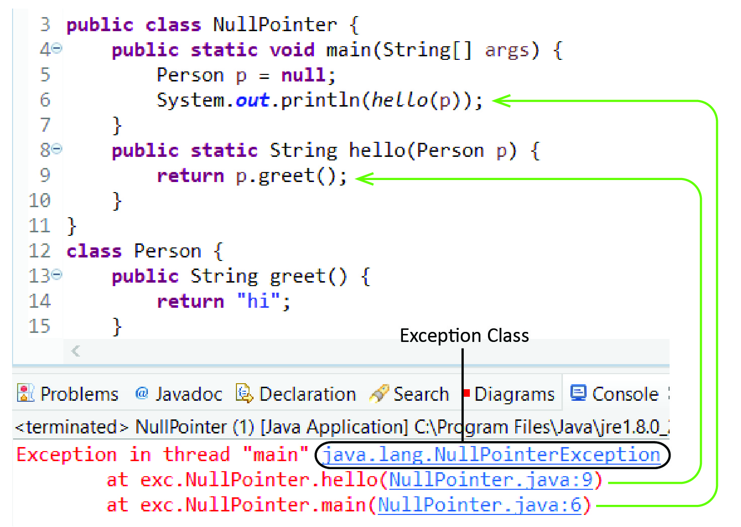
In this chapter, we discuss: how and when to catch, handle, create and throw exceptions. The appendices for this chapter consider: catching multiple exceptions, rethrowing exceptions, chaining exceptions, and creating and using custom exceptions.

The try/catch Block
The Java language provides a try/catch block to allow a program to continue running when an exception is thrown. As shown below, we use a try block to surround a block of code that could potentially cause a runtime error. Immediately following is a catch block. If a runtime error occurs in the try block, control is immediately transferred to the catch block. The purpose of the catch block is to correct or mitigate the problem (more on this later). When the catch block is complete, the code immediately after the catch block executes and the program continues with normal execution. The general syntax is:
try {
// code that may fail (cause a run-time error)
}
catch(Exception e) {
// Code to execute when an exception is thrown
Exception Thrown
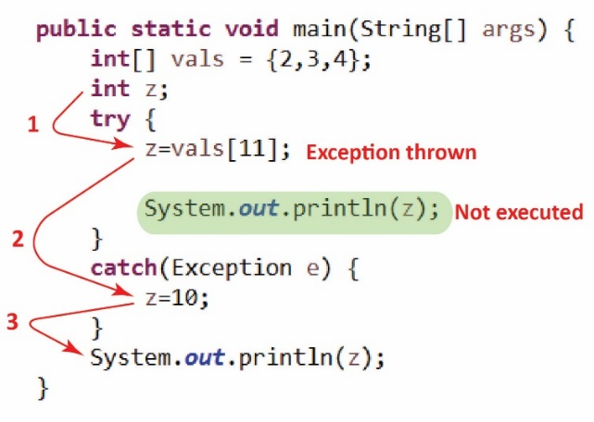
Output: 10
}
When a program has a runtime error, the JVM throws an exception object. Then, the JVM follows this general algorithm:
if exception is caught
handle exception – execute code to recover
resume normal program execution
else
program ends
When we use try/catch, the two possible paths of execution:
- Exception Thrown – see the example on the right and note the following (Code in example_first_examples, in ExceptionInMain class):
- Step 1 – An attempt is made to access the 12th element in an array that only holds 3 elements and an exception is thrown.
- Step 2 – Control is transferred to the catch block where z is assigned (arbitrarily) the value 10.
- Step 3 – The catch block ends and program execution resumes, printing z.
Additionally, note:
- The catch block looks like a method, i.e. it defines a parameter, in the example above: Exception e.
- A reference to the exception that was thrown, e is available in the catch block; however, we do not use it here. Later, we will show how we can use it.

Summary: When a run-time error occurs on a line of code in the try block, an Exception is thrown and control is immediately transferred to the catch block. The code in the catch block is executed and when complete, the code immediately after the catch block is executed (assuming no run-time error occurs in the catch block). Thus, any lines of code after the line that caused the run-time error in the try block are not executed.

No Exception Thrown
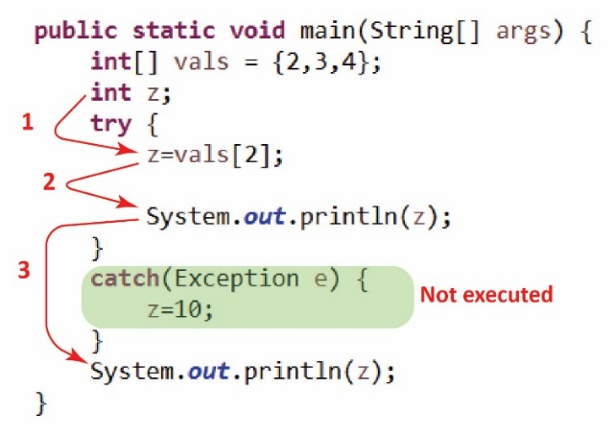
Output: 4 4
- No Exception Thrown – see the example on the right and note the following:
- Step 1 – An attempt is made to access the 3rd element in an array that holds 3 elements, which is successful.
- Step 2 – The code continues, printing z.
- Step 3 – The try block ends and program execution resumes after the catch block, printing the value of z again.

Summary: At the conclusion of the try block (i.e. no runtime error), control is transferred to the first line immediately after the catch block. Thus, the catch block is not executed

Consider the pseudo-code below and assume that statement_3 is subject to run-time failure (or calls a method that is subject to run-time failure). Which statements execute successfully when:
- Statement 3 fails?
- Statement 3 succeeds?
Code | Statements that execute successfully when:
statement_1;  try {  statement_2;  statement_3;  statement_4;  }  catch( Exception e ) {  statement_5;  }  statement_6; | - statement 3 fails: 1, 2, 5, 6  - statement 3 succeeds: 1, 2, 3, 4, 6
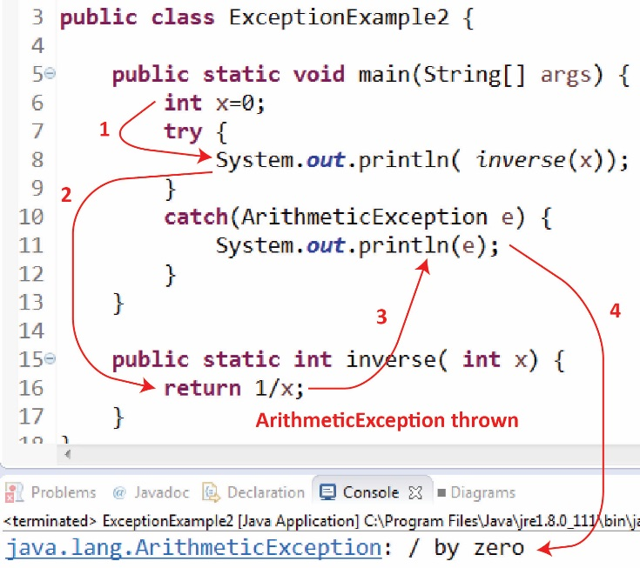
The examples we have considered so far, that use try/catch illustrated an exception being thrown and caught in the same method (main). When a runtime error occurs in a method without a try/catch block, then the exception is thrown to the calling method. If there is a try/catch block there, then the JVM attempts to catch it there. If not, it is again thrown to its calling method. In general, an exception is thrown up the call hierarchy until it is caught. If it finally gets to main and is not caught, the program terminates.
Consider the example on the right and note the following(Code in example_first_examples, in ExceptionInMethod class):
- Step 1 – inverse is called passing the value 0.
- Step 2 – An attempt to divide by zero is made, which generates an ArithmeticException.
- Step 3 – Since there is no try/catch block, the exception is thrown to the calling methed, main, where it is caught.
- Step 4 – The exception is printed.
The purpose of the catch block is to provide code to keep the code running, inform the user, send an error report, correct the error, etc. An explanation of such strategies is beyond the scope of the course. Some resources are provided at the end of this document. However, frequently, as we are learning about exception handling, we will simply print the exception in the catch block. This is illustrated in line 11 in the example above. When an exception is printed, the exception class name is displayed followed by message. In the example above:
java.lang.ArithmeticException: / by zero

The Exception Class Hierarchy
Java defines an Exception hierarchy, a part of which is shown in the class diagram below. This hierarchy includes the RuntimeException subclass, which represents failures that result from programmer error. Subclasses of RuntimeException correspond to specific types of failures that can occur in the program.
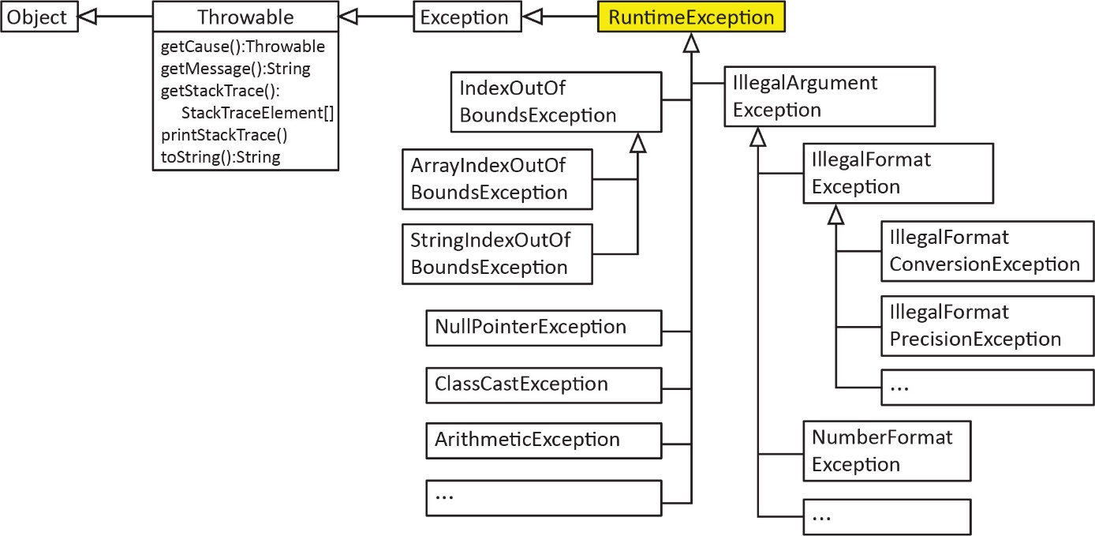
The members of the Throwable class are inherited by all RuntimeExceptions. The methods are:
Method | Description
getCause():Throwable | (Omit) Returns the cause of the exception in the situation where an exception is chained to another exception. See Appendix 7 for more information
getMessage():String | Returns the message associated with the exception, e.g. “/ zero”.
getStackTrace():StackTraceElement[] | (Omit) Contains the information in printStackTrace broken down into pieces that can be accessed by code.
printStackTrace() | Prints the stack trace to the console.
toString():String | Returns the name of the exception and the message.
For example, from the most recent example above (Code in example_first_examples, in ExceptionInMethod2 class):
e.getCause(): null
e.getMessage(): / by zero
e.toString(): java.lang.ArithmeticException: / by zero
e.getStackTrace(): first_example.ExceptionExample2.inverse(ExceptionExample2.java:30)
: first_example.ExceptionExample2.main(ExceptionExample2.java:9)
e.printStackTrace(): java.lang.ArithmeticException: / by zero
at first_example.ExceptionExample2.inverse(ExceptionExample2.java:30)
at first_example.ExceptionExample2.main(ExceptionExample2.java:9)

The catch Block
The parameter for the catch block can be Throwable or any subclass. A catch block will catch a thrown exception whose class is the same as the class of the parameter in the catch block, or any subclass.
For example, the catch block below will catch any type of Exception (for example: ArithmeticException, NullPointerException, etc.)
try {
// code that may fail
}
catch(Exception e) {
// Code to execute when an exception is thrown
}
However, the catch block below will only catch an ArithmeticException (or any subclass of ArithmeticException). If a NullPointerException is thrown, it will not be caught because a NullPointerException is not a subclass of ArithmeticException.
try {
// code that may fail
}
catch(ArithmeticException e) {
// Code to execute when an exception is thrown
}
If we know our code might exhibit a specific type of failure, then we should try to catch the corresponding exception. Often, however, we are lazy and simply catch RuntimeException, because that will catch any programming error. The appendix has a section on catching multiple exceptions.

Exercises
- Consider the try/catch block below. Name the classes of exceptions that will be caught with this block. Hint: reference the Exception hierarchy above.
try {
// code that may fail
}
catch(IndexOutOfBoundsException e) {
import java.util.Random;
public class Foo {
public Foo() {}

public int eval() {
int[] vals = {4,22,9,49,18};
Random random = new Random();
int index = random.nextInt(10);
return vals[index];
}

public static void main(String[] args) {
}
}
// Code to execute when an exception is thrown
}
- (Solution in example_foo package) Consider the class shown on the right. The eval method defines an array with 5 elements, and then generates a random integer between 0 and 9. Finally, the method attempts to return the array element at the index, which of course will fail if the index is 5 or greater.
Add code in main to create a Foo instance and call the eval method. They code should print the value returned if no exception is thrown. Otherwise, if an exception is thrown, it should be printed to the console.

Anticipating & Handling Errors
Frequently, we use the terms: error, bug, defect, failure, system crash/bomb synonymously. However, it is useful to define the terms more precisely.
- A software developer makes an error (careless error, inappropriate decision) which causes a defect in a software product.
- A defect (bug) is a flaw in any aspect of the system that contributes, or may potentially contribute to the occurrence of one or more failures.
- A failure (system crash/bomb, runtime error) is an unacceptable behaviour exhibited by a system.
All software systems have defects (bugs) and for robust software systems we must try to handle run-time errors so that the program does not stop unexpectedly. In general, there are two techniques:
- Anticipate and trap sources of error before they result in a run-time error.
- Detecting and handling run-time errors after they occur (try/catch)
If we can anticipate an error we should usually try to write code to prevent it. For example, we have seen when we have a getter for an item in an ArrayList we check to make sure the index is valid before attempting to return the object, as shown below:
public class Company {
private ArrayList<Employee> emps = new ArrayList<>();

public Employee getEmployee(int i) {
if(i<0 || i>=emps.size()) {
return null;
}
return emps.get(i);
}
...
}
It is hard to anticipate every single situation that could cause a runtime error. Hopefully it is clear, that even if we had an abundance of time, it would be nearly impossible to anticipate every possibly source of error. Thus, run-time errors are going to occur, so, we use try/catch wherever appropriate.

Throwing Exceptions
The example in this this section is in the example_circle_throws_exception package.
We sometimes find ourselves in a situation where we can anticipate and detect an error, but there is no code we can write to fix the situation. For example, suppose we have a Circle class that accepts a radius in the constructor. If the radius is required to be greater than 0, then obviously we can detect when it is not, but what should we do in that case? Arbitrarily set the radius to 1? But then how would the code that created the Circle know that this had happened?
public class Circle {
private double radius;

public Circle(double radius) {
if(radius < 0.0) {
// What should we do?
}
this.radius = radius;
}
...
}
A solution to the problem above is to have our code create an exception object and throw it. The Exception class and all its subclasses define a constructor that takes string argument, which is a description of what caused the exception (the message). Java defines the keyword throw, which allows the programmer to throw an exception. This is useful when we detect an error and we are not prepared to deal with it in that location in the code. Thus, we can create and throw Java exceptions with custom descriptions. For example:
throw new RuntimeException ("Description of error");
In the Circle example below, we throw an IllegalArgumentException, as shown below on the left, when the radius is 0 or less. On the right, in another class, we write code to create a Circle. If we do not surround that code in try/catch, then the program will terminate if the supplied radius is negative. To be safe, we surround that code with try/catch so that the program will continue running in the case of a negative radius.
Create and throw an Exception | Use Class Properly – Graceful Termination
public class Circle {  private double radius;  public Circle(double radius) {  if(radius <= 0.0) {  throw new IllegalArgumentException  ("Radius must be greater than zero.");  }  this.radius = radius;  }  ...  } | Circle c;  try{  c = new Circle(-5.5);  }  catch(IllegalArgumentException e) {  System.out.println(e);  }
 | Abnormal Termination
 | c = new Circle(-5.5);
Notes:
- IllegalArgumentException is a subclass of RuntimeException and this would be the natural, descriptive, choice of exception to throw for this example. However, we could have used RuntimeException or even Exception instead.
- In a real application, with a GUI where the user entered a radius, we would probably check to make sure it was valid before even calling the constructor, where we could inform the user and let them try again. Thus, we might not even use try/catch above. However, the throws in the constructor is there for an additional check.

Exercises
- (Solution in exercise_account package) Consider the class below. The mergeAccount method accepts another Account object and adds its balance to this balance.
public class Account {
private double balance;
private String name;

public Account(double balance, String name) {
this.balance = balance;
this.name = name;
}

public void mergeAccount(Account a) {
this.balance += a.balance;
}
}
- Modify the mergeAccount method so that it throws an IlleagalArgumentException if the account names are not the same. Otherwise, if they are the same, the method should merge the accounts as shown.
- Add a main that creates a few accounts and tries to merge them handling any exception that is thrown by printing the exception.
- (Solution in exercise_engine package, EngineTest class) Consider the class shown below.
class Engine {
public void init() {
if( Math.random() < 0.5 )
throw new RuntimeException();
else
System.out.println("init()");
}
public void run() {
System.out.println("run()");
}
public void close() {
System.out.println("close()");
}
}
Write a static method to implement an algorithm that creates an Engine, and then calls, init, run, and then close if no exception is thrown in init. Thus, if no exception is thrown, the method should display:
init()
run()
close()
However, if init does throw an exception then run should not be called, but close should be. The desired output if an exception is thrown is:
java.lang.RuntimeException
close()
- (Solution in exercise_engine package, EngineTest_MultipleChoice class) Below are five attempts at writing the static method requested in the previous problem. For each attempt answer these questions:
- Does the code compile? (Hint: only one does not)
- If the code compiles,
- What output does it produce when no exception is thrown?
- What output does it produce when an exception is thrown?
Attempt 1 | Attempt 2 | Attempt 3
Engine e = new Engine();  try {  e.init();  e.run();  }  catch( RuntimeException ex ) {  System.out.println(ex);  e.close();  }  e.close(); | Engine e = new Engine();  try {  e.init();  e.run();  e.close();  }  catch( RuntimeException ex ) {  System.out.println(ex);  } | try {  Engine e = new Engine();  e.init();  e.run();  }  catch( RuntimeException ex ) {  System.out.println(ex);  }  e.close();
Attempt 4 | Attempt 5
Engine e = new Engine();  try {  e.init();  e.run();  }  catch( RuntimeException ex ) {  System.out.println(ex);  }  e.close(); | Engine e = new Engine();  try {  e.init();  e.run();  }  catch( RuntimeException ex ) {  System.out.println(ex);  e.close();  }

The finally Clause
Java also allows us to add a finally block to a try/catch. The finally block of code is always executed no matter whether an exception was thrown or not (and even if an exception is thrown in the catch block).
try {
// Statements
}
catch( Exception e ) {
// Statements
}
finally {
// Statements
}
For example, suppose A, B, C, D, E are each a single statement of code and that A or C might throw an exception.
Code  try {  A  B  }  catch(Exception e) {  C  }  finally {  D  }  E | Scenario Statements Executed Successfully  A doesn’t throw exception A, B, D, E  A throws exception C, D, E  A & C throw exceptions D
As another example, consider the code below (Solution in example_try_catch_finally package, TryCatchFinally class). What is the output?

No Exception Thrown | Exception Thrown
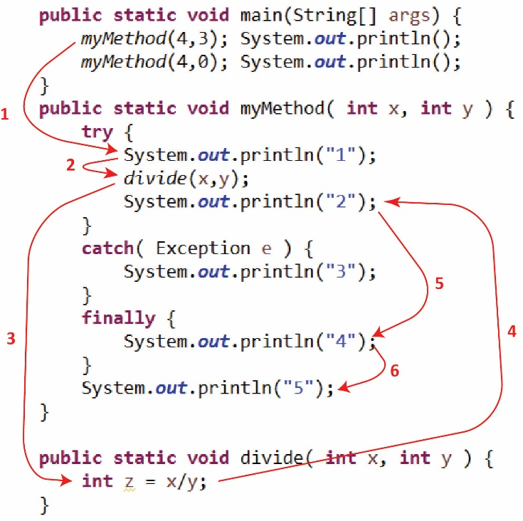 | 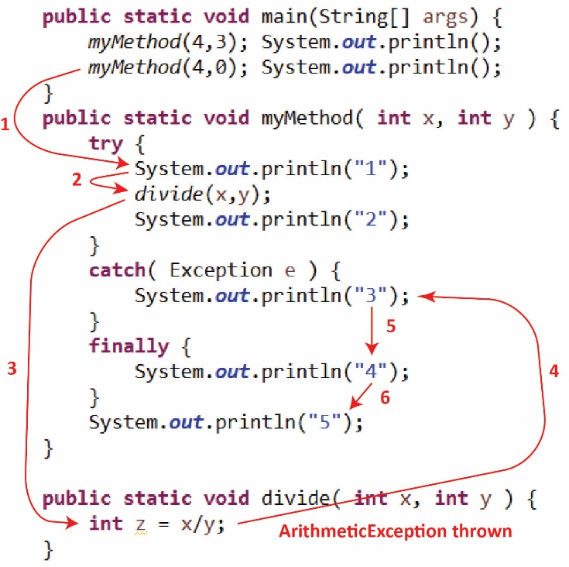
Output: 1 2 4 5 | Output: 1 3 4 5

Exception Types
The Exception hierarchy is a bit larger than shown earlier:
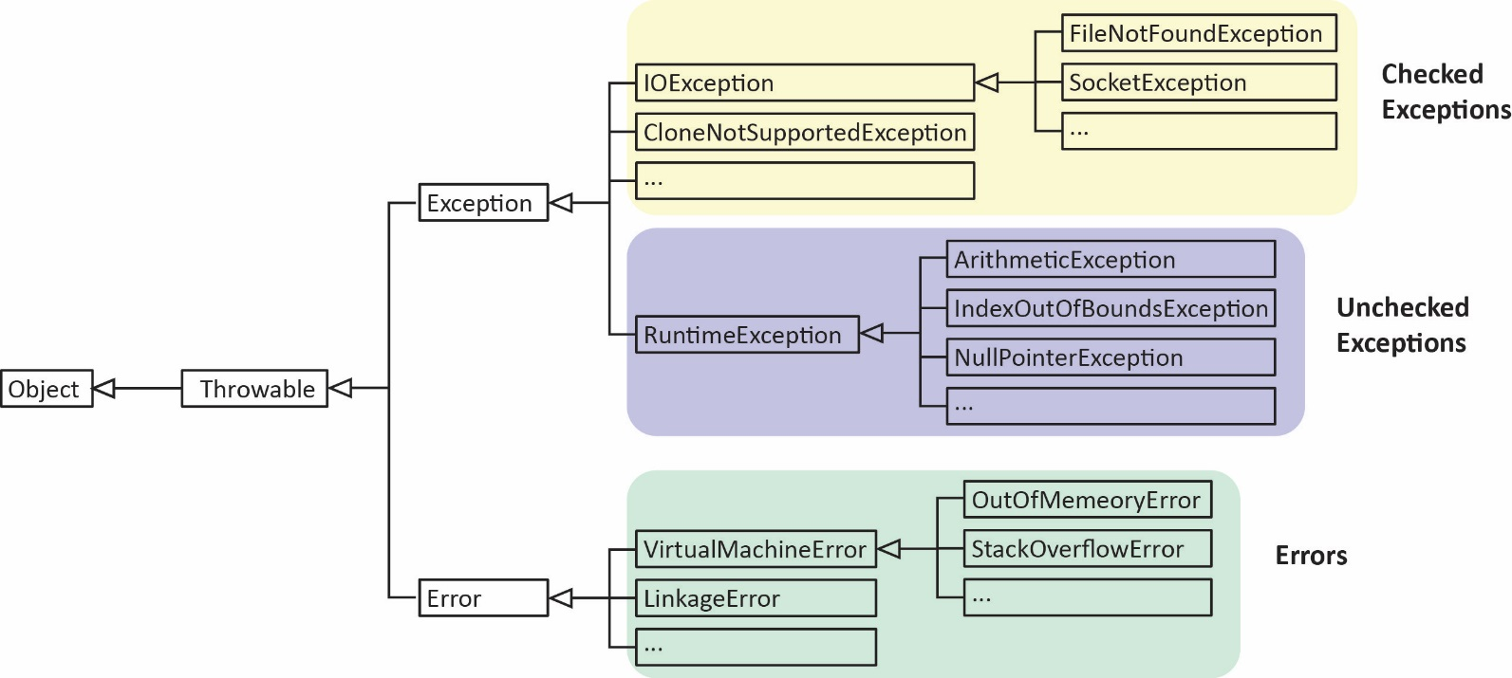
Note the following:
- The Exception class describes errors caused by your program and external circumstances. These errors can be caught and handled by your program.

- RuntimeException and its subclasses is caused by programming errors, such as bad casting, trying to access an array element that doesn’t exist, numeric errors, etc as we have discussed before. These are known as unchecked exceptions. This means that these types of errors can and will occur, but you do not have to catch them, e.g try/catch is not required.

- The Error class describes internal system errors. Such errors rarely occur. If one does, there is little you can do beyond notifying the user and trying to terminate the program gracefully.

- Checked Exceptions – Any exceptions other than RuntmeExceptions are known as checked exceptions. A checked exception that might occur in a method must be caught (with try/catch) or the method must declare the exception using the throws keyword. For example, when you attempt to read from a text file it is possible that a FileNotFoundException (subclass of IOException, a checked exception) will be thrown. Thus, one of the two approaches below must be used. We will see more of this in the next chapter.

try/catch | throws
public static void main(String[] args) {  try {  // Read file  }  catch( FileNotFoundException e ) {  System.out.println(e);  }  } | public static void main(String[] args)  throws FileNotFoundException {  // Read File  }
Good reads: Are checked exceptions good or bad? and Unchecked Exceptions — The Controversy

A Real Example
Below, are two methods from a real system. The first method, openConnection, is called to open a connection to a server and establish input and output communication (socket) channels. It utilizes try/catch and a try/catch within the catch block. It also calls a method, closeAll, which utilizes try/catch.
public final void openConnection() throws IOException {
// Do not do anything if the connection is already open
if(isConnected()) return;
//Create the sockets and the data streams
try {
clientSocket= new Socket(host, port);
output = new ObjectOutputStream(clientSocket.getOutputStream());
input = new ObjectInputStream(clientSocket.getInputStream());
}
catch (IOException ex) {
// All three of the above must be closed when there is a failure to create any of them
try {
closeAll();
}
catch (Exception exc) { }
throw ex; // Rethrow the exception.
}
clientReader = new Thread(this); //Create the data reader thread
readyToStop = false;
clientReader.start(); //Start the thread
}

private void closeAll() throws IOException {
try {
//Close the socket
if (clientSocket != null) clientSocket.close();
//Close the output stream
if (output != null) output.close();
//Close the input stream
if (input != null) input.close();
}
catch (Exception exc) {
throw exc;
}
finally {
// Set the streams and the sockets to NULL no matter what. Doing so allows,
// but does not require, any finalizers of these objects to reclaim system
// resources if and when they are garbage collected.
output = null;
input = null;
clientSocket = null;
}
}

Appendix
- Resources
Designing robust error handling for a system is beyond the scope of this course. Here, we mostly focus on the techniques themselves. Some references on designing robust error handling:
http://codebuild.blogspot.com/2012/01/15-best-practices-about-exception.html
https://stackoverflow.com/questions/4589750/exception-handling-pattern
https://stackoverflow.com/questions/425281/java-style-properly-handling-exceptions?rq=1
Some references on throwing and handling exceptions:
https://docs.oracle.com/javase/tutorial/essential/exceptions/handling.html
https://docs.oracle.com/javase/tutorial/essential/exceptions/throwing.html
http://mindprod.com/jgloss/exception.html
- Catching Multiple Exceptions
The example in this section is in the example_multiple_catch package.
Catching Multiple Exceptions – In general, you can catch multiple types of exceptions by supplying multiple catch blocks.

try {
statements; // Statements that may throw exceptions
}
catch (Exception1 e1) {
code to handle Exception1;
}
catch (Exception2 e2) {
code to handle Exception2;
}
...
catch (ExceptionN eN) {
code to handle ExceptionN;
}
Note the following:
- The compiler forces you to arrange the catch blocks from most specific to most general. In other words, subclasses must be caught before superclasses. In the example below ArithmeticException is a subclass of Exception so it must be listed as the first catch block.
Valid | Invalid (Doesn’t Compile)
try {  ...  }  catch ( ArithmeticException e ) {  ...  }  catch ( Exception e ) {  ...  } | try {  ...  }  catch ( Exception e ) {  ...  }  catch ( ArithmeticException e ) {  ...  }
- Only one catch block will activate, the first one that matches. In the example above on the left, an ArithmeticException would be caught in the first catch block even though it is also an Exception. An IndexOutOfBounds exception would be caught in the second catch block.
- If no catch block is found that matches the argument type, then the exception is passed (thrown) to the calling method and this process repeats, i.e. searches for a matching catch block. If no catch block is found through the entire chain of method calls, the program terminates and a message is printed in the console.
  - Exercises
- (Solution not available) Suppose you are trying to call a method, foo() which can throw any of these types of exceptions: IlleagalArgumentException, IllegalFormatException, IllegalFormatCoversionException. Write a snippet of code that tries to call foo and catches any of these exceptions. Hint: see Exception hierarchy presented earlier.
- Rethrowing Exceptions
We can rethrow an exception that is caught in a catch block. We do this if we want the caller to handle the situation. For example:
try {
...
}
catch(RuntimeException e) {
throw(e);
}
In the examples below, suppose A, B, C, D, E are each a single statement of code and that A might throw an exception.
Code  try{  A  B  }  catch(Exception e) {  C  throw(e) // or return  }  finally{  D  }  E | Scenario Statements Executed Successfully  A doesn’t throw exception A, B, D, E  A throws exception C, D, throw(e)

Consider the code shown (code not available) on the right below which calls a method to divide to number. The explanation of the numbered steps is shown on the left.
Step Description  1 divide is called on line 7  2 Attempt to divide by zero on line 16, throws an exception which is caught on line 19  3 Before the exception is thrown on line 20, the finally block is executed  4 Then, the catch block throws the exception which is caught by main on line 10. | 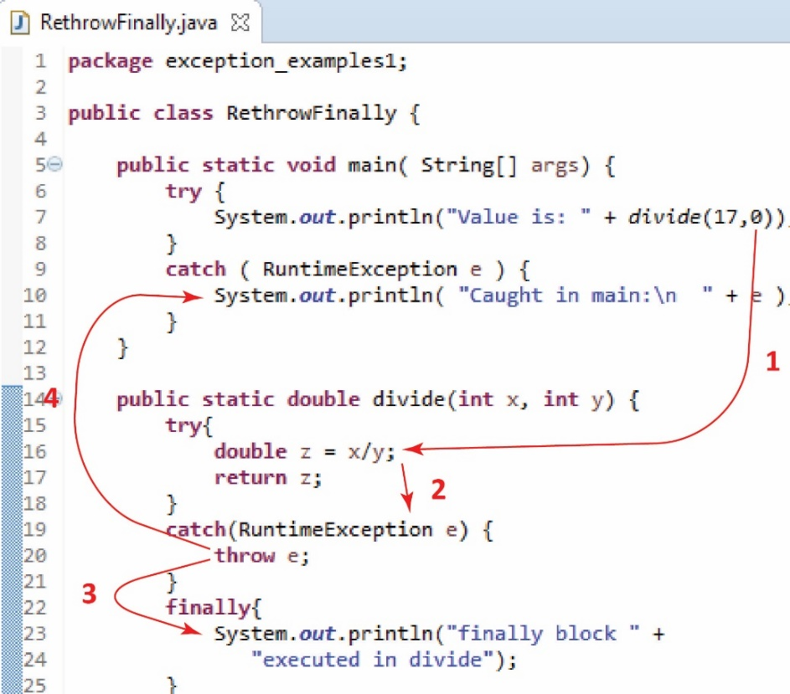

The two examples below (code in example_rethrow package) are identical except that the one on the left does not have a finally block while the one on the right does. The arrows on both examples show what is output when myMethod(4,0) is executed. What is output when myMethod(4,3) is executed for each example? Answers are in a footnote.
myMethod(4,0) 1 3 6  myMethod(4,3) ? | myMethod(4,0): 1 3 4 6  myMethod(4,3): ?
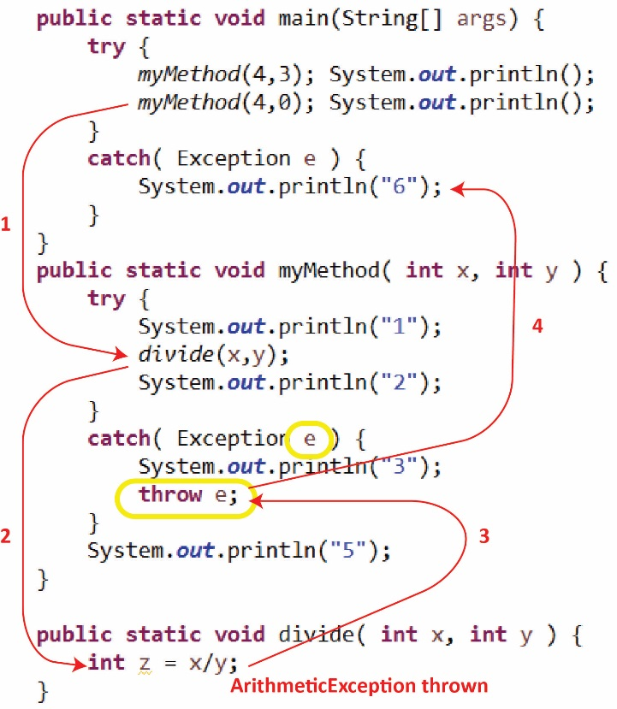 | 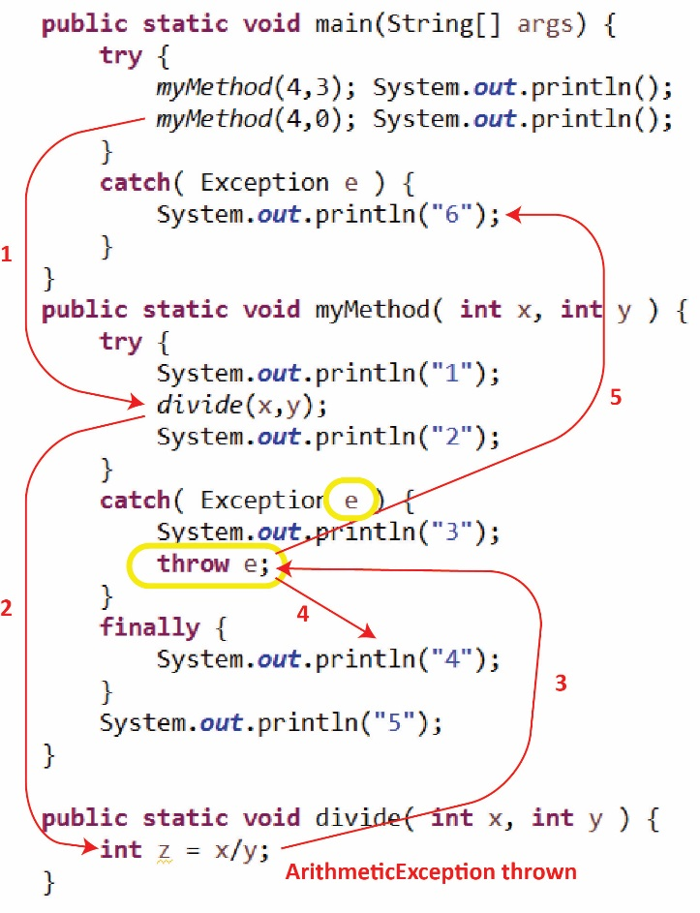
  - Exercises
- (Solution in foot note below) Consider the following:
- A and B are subclasses of RuntimeException. C is a subclass of B.
- Goo() is a method (not shown) that can throw an A, B, or C exception.
- Consider main and foo() shown below.:
public static void main(String[] args) {  try {  foo();  System.out.println("5");  }  catch(C c) {  System.out.println("6");  }  catch(RuntimeException e) {  System.out.println("7");  }  } | public static void foo() {  try {  goo();  System.out.println("1");  }  catch(C c) {  System.out.println("2");  throw(c);  }  catch(B b) {  System.out.println("3");  }  finally {  System.out.println("4");  }  }
What is the output when…
- No exception occurs?
- A B exception occurs?
- A C exception occurs?
- An A exception occurs?
- (Solution in exercise_too package) Consider the classes shown on the right. The sum method sums the values in the input array in positons 0 through numVals-1. However, the method can cause a run-time error if numVals is too big or small. You should modify this method to try the computation and if an exception is thrown, it is caught and rethrown to main. You should also modify main to catch this exception should it be thrown and print it.
public class Problem3 {
public static void main(String[] args) {
int vals[] = new int[5];
vals[0]=2; vals[1]=6; vals[2]=8;
Too too = new Too();
int sum = too.sum(vals, 7);
System.out.println(sum);
}

}

class Too {
public int sum(int[] vals, int numVals) {
int sum = 0;
for(int i=0; i<numVals; i++) {
sum += vals[i];
}
return sum;
}
}

- Chained Exceptions
Chaining Exceptions – Sometimes, we want to chain exceptions together. Here is how this works:
- Catch an exception
- Create a new exception
- Link the original (caught) exception to the new one
- Throw the new one.
We call this exception chaining. The Exception class has another constructor that takes two arguments: (1) a string description and (2) a reference to another exception. It also provides the getCause method which returns a chained exception.
Example (code in example_chained package) – Chained exceptions
public class ChainedTester1 {
public static void main(String[] args) {
try {
A a = new A();
a.m1();
}
catch( Exception e ) {
System.out.println( e + "\n" + e.getCause() + "\n" );
}
}
}

class A {
public void m1() throws Exception {
try {
B b = new B();
b.m2();
}
catch (Exception e) {
throw new Exception("A.m1() caused an exception", e);
}
}
}

class B {
public void m2() throws Exception {
throw new Exception("B.m2() caused an exception");
}
}
Output:
java.lang.Exception: A.m1() caused an exception
java.lang.Exception: B.m2() caused an exception

  - Exercises
- (Solution in exercise_roo package) Consider the classes shown on the right. The sum method sums the values in the input array in positons 0 through numVals-1. However, the method can cause a run-time error if numVals is too big or small. You should modify this method to try the computation and if an exception is thrown create a new exception (with a description) chaining the original exception to it, and rethrow it to main. You should also modify main to catch this exception should it be thrown and print it, and the chained exception.
public class Problem4 {
public static void main(String[] args) {
int vals[] = new int[5];
vals[0]=2; vals[1]=6; vals[2]=8;
Roo roo = new Roo();
int sum = roo.sum(vals, 7);
System.out.println(sum);
}
}

class Roo {
public int sum(int[] vals, int numVals) {
int sum = 0;
for(int i=0; i<numVals; i++) {
sum += vals[i];
}
return sum;
}
}
- Summary of Error Handling Approaches
There are two approaches to error handling:
- Anticipate and trap sources of error before they result in a run-time error. There are two ways to handle this:
Fix the situation | Throw a new exception
if( detect error )  fix it, etc | if( detect error )  throw new Exception(“desc”);
- Handling run-time errors after they occur. There are four ways to handle this:
Fix the situation | Throw a new exception
try {  something  }  catch(Exception e) {  fix it, etc  } | try {  something  }  catch(Exception e) {  throw new Exception(“desc”)  }
Rethrow caught exception | Throw a new exception, chaining caught exception
try {  something  }  catch(Exception e) {  throw e  } | try {  something  }  catch(Exception e) {  throw new Exception(“desc”,e)  }

- Custom Exceptions
The example in this section is in the example_custom_exception_mymathexception package.
Custom Exceptions – In some situations, it is useful to write our own customized exception classes. These are classes just like any other class except that they extend Exception or its subclasses). Thus, we can provide properties and methods that contain information about the error that might be useful to code that catches the exception.
Example – Consider a method in a class that divides two numbers which obviously can throw an exception if the value of y is 0:
class A {
public int m1( int x, int y ) {
return x/y;
}
}
We would like to detect this situation and if it occurs, throw a custom exception, MyMathException that contains a description of the error and the values of x and y.
class A {
public int m1( int x, int y ) throws MyMathException {
if( y==0 )
throw new MyMathException( "Can't divide by zero", x, y );
return x/y;
}
}
Thus, we define a MyMathException class that extends RuntimeException. The constructor accepts a description of the error and two integers. We also provide getters so the code that calls m1 above and catches an exception can obtain the values of x and y.
class MyMathException extends RuntimeException {
private int x;
private int y;
public MyMathException( String msg, int x, int y ) {
super(msg);
this.x = x;
this.y = y;
}
public int getX() { return x; }
public int getY() { return y; }
}
Finally, we can call the method and catch the exception, displaying the values of x and y.
public class ExceptionTester9 {
public static void main(String[] args) throws Exception {
A a = new A();
try {
System.out.println(a.m1(4,0));
}
catch( MyMathException me ) {
System.out.println(me);
System.out.println("x=" + me.getX() + ", y=" + me.getY() );
}
catch( Exception e ) {
System.out.println(e);
}
}
Output:
MyMathException: Can't divide by zero
x=4, y=0
  - Exercises
- (Solution in exercise_blob_custom_exception package) Consider the class shown below. We want to modify the merge method so that it only merges Blobs if their power is the same. If their power is not the same, then you should throw a custom BlobMergeException. This exception should contain a description of the error and the power value for each of the two Blobs.
- Write the BlobMergeException
- Modify the merge method to utilize the exception as described above.
- Modify main to catch any BlobMergeException that may be thrown, displaying the description and the two power values.
public class Blob {
private int power;
private int health;

public Blob(int power, int health) {
this.power = power;
this.health = health;
}

public int getPower() {
return power;
}

public int getHealth() {
return health;
}

public void merge(Blob blob) {
this.health += blob.health;
}

public String toString(){
return String.format("power=%d, health=%d", power, health);
}

public static void main(String[] args) {
Blob b1 = new Blob(5,10);
Blob b2 = new Blob(4,8);
b1.merge(b2);
System.out.println(b1);
}
}

- Checked Exceptions in the API
The Scanner constructor, Scanner(File source) can throw a checked exception as shown by the “throws” clause in the signature of method:
https://docs.oracle.com/javase/9/docs/api/java/util/Scanner.html
This means that you must either try/catch when creating a Scanner, or add throws to the method you wrote that uses Scanner.
The Scanners, nextDouble (and lots of other next methods) can throw a number of exceptions
https://docs.oracle.com/javase/9/docs/api/java/util/Scanner.html
Notice that there is NOT a throws in the signature, but below the description of method, there is a section labelled “Throws:”. These are unchecked exceptions. You can easily see this by clicking on one of the exceptions. For example, click on the second one, “NoSuchElementException”,
https://docs.oracle.com/javase/9/docs/api/java/util/NoSuchElementException.html
and you can see that it is a subclass of RuntimeException (meaning that it is unchecked)

https://docs.oracle.com/javase/8/docs/api/java/lang/Throwable.html
https://docs.oracle.com/javase/8/docs/api/java/util/Random.html
These methods are a part of the Object-Oriented Client-Server Framework (OCSF) which accompanies the text, Object-Oriented Software Engineering, by Lethbridge & Laganiere.
Left example: 1 2 5, Right example: 1 2 4 5
(a) 1 4 5 (b) 3 4 5 (c) 2 4 6 (d) 4 7

