Chapter 5 – Abstract Classes and Interfaces

Contents
1 Abstract Classes 2
2 Why use Abstract Classes & Methods? 3
3 Example 1 – Person has many Animals 4
3.1 Exercises 6
4 Interfaces 9
5 Example 2 – Person has many Animals and many Flyers 12
5.1 Exercises 15
6 Why use Interfaces? 16
7 The Comparable Interface 17
8 Example 3 – Person has many Comparable Animals 21
8.1 Exercises 22
9 Example 4 – Comparable Rectangle 24
10 Some Java API Examples 25
11 Additional Points about Abstract Classes & Interfaces 26
Appendix 1.1 The Cloneable Interface 28
Appendix 1.2 Exercises 32

Abstract Classes
In this chapter we make the superclass-subclass relationship more versitile with the introduction of abstract classes and interfaces. In Java, we can define an abstract class that contains one or more abstract methods:
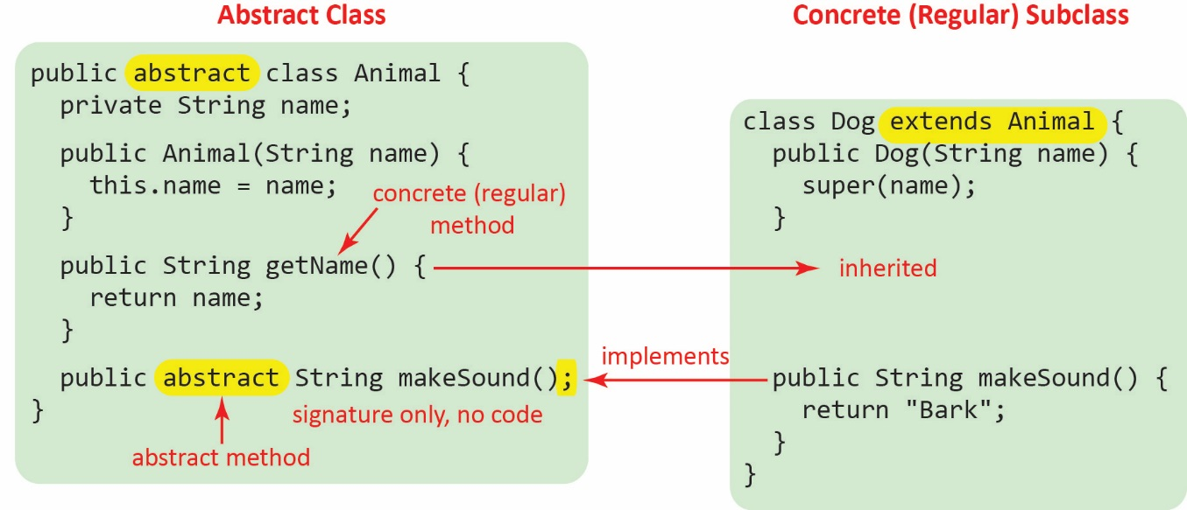
Note the following about an abstract class:
- Can have instance variables, a constructor, and (concrete) methods just like a regular class.
- Can have abstract methods, which specify the signature of a method, but no code. Thus, it is a partially implemented class.
- Can have abstract methods which specify the signature of a method, but no code.
- Cannot be instantiated (because there is no code for the abstract methods):
Animal a = new Animal("Leo"); // Doesn’t compile
- It is a superclass that can be extended by another concrete class (we use the term concrete class to emphasize that a class can be instantiated), just as we extended concrete classes in the last chapter:
class Dog extends Animal {
- Can be used as a reference type, just as we did in the last chapter
Animal a1 = new Dog("Mocho"); // Allowable
Dog d1 = new Dog("Wu");
ArrayList<Animal> animals = new ArrayList<>();
animals.add(a1);
animals.add(d1);
for(Animal a : animals) {
a.makeSound();
}
Note the following about a concrete class that extends an abstract class:
- It must implement all abstract methods in the superclass:
@Override
public String makeSound() {
return "Bark";
}

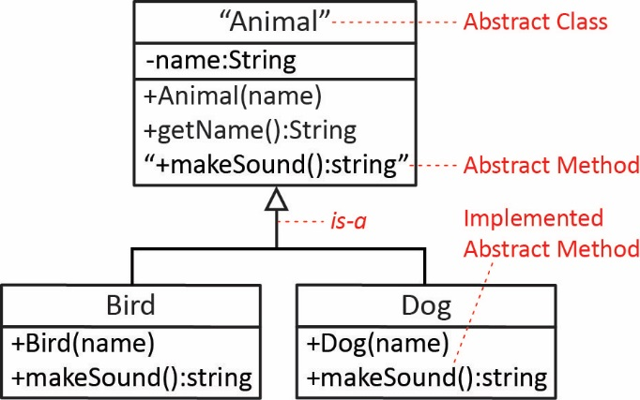
In a class diagram, we indicate abstract classes and abstract methods using italics (for hand-drawn, you should use double-quotes) as shown in the figure on the right.

Why use Abstract Classes & Methods?
The approach in the last chapter was more along the lines of we have a concrete class, say Account. Later, we need a new class, say GoldAccount that is basically the same as Account except that a few methods need to be changed, say, applyInterest, or endOfMonth. Although we do use this approach, usually, we take a different, more general approach to modelling.
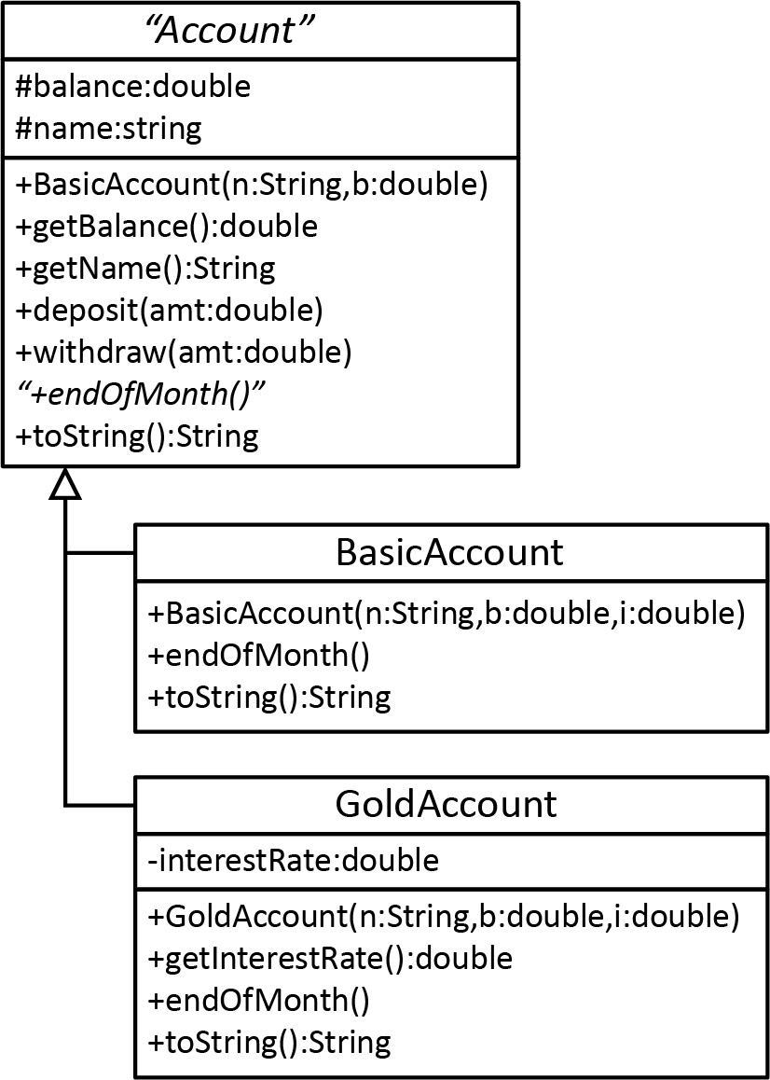
There are two scenarios. In one, we have need several different classes that are strongly related. For example, we need a BasicAccount and a GoldAccount. Next, we ask ourselves what they have in common. Then, we abstract out the commonalities into an abstract class. As part of this process, we usually recognize that:
- There is certain state that is common to all subclasses. Thus, these instance variables are defined in the abstract superclass. In the example on the right, all accounts have a name attached to it and a balance.
- Some of the behaviors can be implemented in the abstract class because the behavior will be the same for all subclasses. Thus, these concrete methods will be inherited by subclasses. In the example on the right: the getters, deposit and withdraw.
- Some of the behaviors are common among the subclasses, but cannot be implemented in the abstract class because they depend on what the concrete classes actually represent. These become abstract methods. For example, the implementation of the endOfMonth method depends on whether it is a BasicAccount or a GoldAccount. Similarly, in the example from the previous section, all animals can makeSound, but the implementation depends on the type of animal it is.
In another scenario, as we are modelling, we decide we need, at present, only one particular class. However, we anticipate that we might need similar, variations of the class at some later time. In this case, we analyze the situation just as we did above: deciding what we can abstract out to the abstract class, what can be implemented, and what needs to be abstract.

Example 1 – Person has many Animals
The code for the example in this section is in the example_person_animals_ver1 package
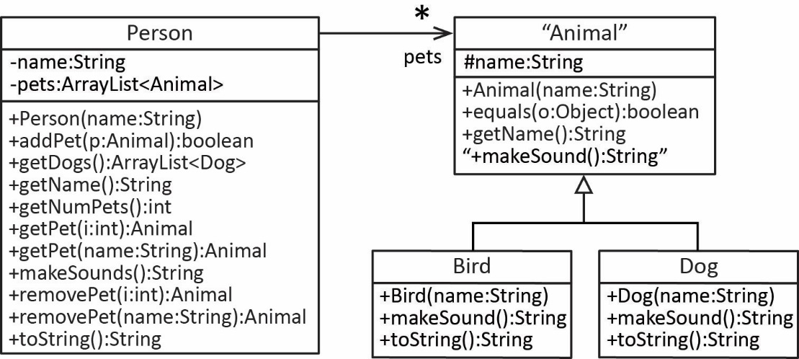
The example shown on the right is identical to the example considered in Chapter 4, Section 6 – “Example: 1-to-Many,” except that here, the top of the inheritance hierarchy is abstract (also the context is different, in Chapter 4 was: Person has many Accounts. However, the code for this example is identical to the Chapter 4 code. The code for this example is shown below.

The Animal, Dog, & Bird classes below.
Animal Abstract Class | Dog & Bird Classes
public abstract class Animal {  protected String name;  public Animal(String name) {  this.name = name;  }  public boolean equals(Object o) {  if(o instanceof Animal) {  Animal a = (Animal)o;  return this.name.equals(a.name);  }  return false;  }  public String getName() {  return name;  }  public abstract String makeSound();  } | public class Dog extends Animal {  public Dog(String name) {  super(name);  }  @Override  public String makeSound() {  return "Bark";  }  @Override  public String toString() {  return "Dog: name=" + name;  }  }  public class Bird extends Animal {  public Bird(String name) {  super(name);  }  public String makeSound() {  return "Chirp";  }  @Override  public String toString() {  return "Bird: name=" + name;  }  }

The Person class is shown below:
Person Class | Person Class (cont’d)
public class Person {  private String name;  private ArrayList<Animal> pets =  new ArrayList<>();  public Person(String name) {  this.name = name;  }  public boolean addPet(Animal a) {  if(!pets.contains(a)) {  pets.add(a);  return true;  }  return false;  }  public ArrayList<Dog> getDogs() {  ArrayList<Dog> dogs =  new ArrayList<>();  for(Animal a : pets) {  if(a instanceof Dog) {  dogs.add((Dog)a);  }  }  return dogs;  }  public String getName() {  return name;  }  public int getNumPets() {  return pets.size();  }  public Animal getPet(int i) {  if( i>=0 && i<pets.size()) {  return pets.get(i);  }  return null;  } | public Animal getPet(String name) {  Animal a = new Dog(name);  // or...  // Animal a = new Bird(name);  if(pets.contains(a)) {  int loc = pets.indexOf(a);  return pets.get(loc);  }  return null;  }  public String makeSounds() {  String msg = "";  for(Animal a : pets) {  msg += a.makeSound() + " ";  }  return msg;  }  public Animal removePet(int i) {  if( i>=0 && i<pets.size()) {  return pets.remove(i);  }  return null;  }  public Animal removePet(String name) {  Animal a = new Dog(name);  if(pets.contains(a)) {  int loc = pets.indexOf(a);  return pets.remove(loc);  }  return null;  }  @Override  public String toString() {  String msg = name + "'s pets:\n";  for(Animal a : pets) {  msg += a + "\n";  }  return msg;  }  }

Exercises
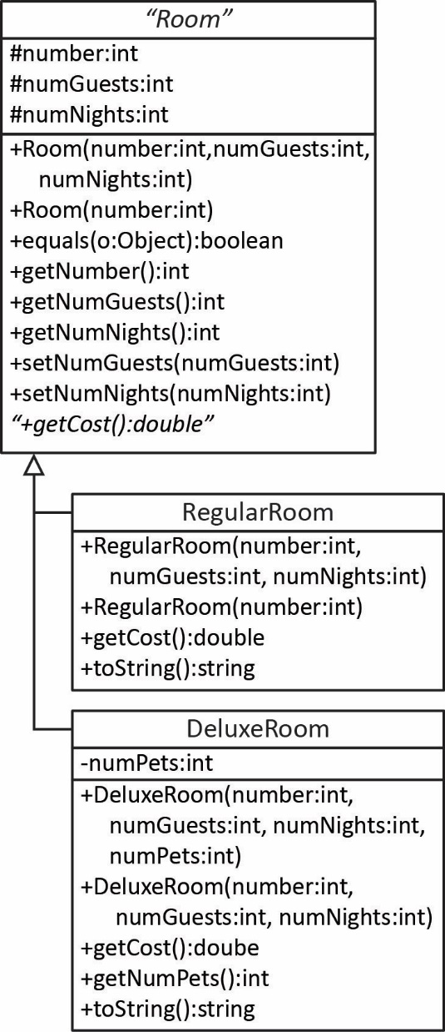
- (Solution in exercise_hotel_rooms_ver1 package) Consider the class diagram on the right. The notes only discuss some of the methods in the diagram. The ones that are not discussed should be obvious.
Notes on Room class:
- number – the room number (any integer)
- Room(number:int) – Creates a room with 1 guest for 1 night, with room number, number.
- equals – rooms are considered equal if they have the same (room) number.
Notes on RegularRoom class:
- RegularRoom(number:int) – Creates a room with 1 guest for 1 night, with room number, number.
- getCost – The cost per night for a regular room is $80.00 plus $20.00 per guest, and this value is then multiplied by the number of nights.
- toString() – returns a string like this (should be a single line):

Regular Room: room number=228, num guests=3, num nights=2, cost=$280.00
Notes on DeluxeRoom class:
- DeluxeRoom(number:int,numGuests:int,numNights:int) – Creates a room with 1 pet (originally, this was supposed to be 0 pets, but the code and test code has already been written, so leave it at 1 if you want to use the solution).
- numPets – the number of pets in the room
- If number of pets is not specified (second constructor), then the number of pets is set to 0.
- getCost – The cost of a deluxe room is $150.00 plus $10.00 per guest beyond the second plus $20.00 per pet, and this value is then multipled by the number of nights.
- toString() – returns a string like this (should be a single line):

Deluxe Room: room number=334, num guests=3, num pets=1, num nights=2, cost=$180.00
Do the following.
- Write the code for these classes
- Write a test class to test the getCost method for each class.
- (Solution in exercise_hotel_rooms_ver1 package) Consider the class diagram below to write the Hotel class (use the Room classes from above). The solution for this problem and the next one is found in the: practice_problem_hotel_ver1 package in the code download for this chapter.
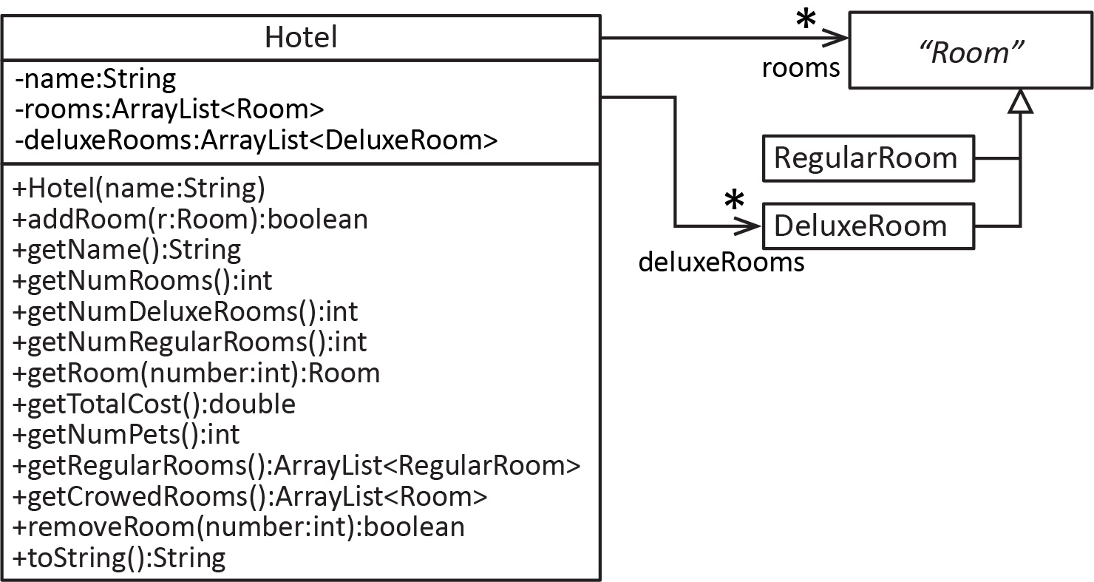
Notes about the Hotel class:
- There are two lists of rooms: rooms, which contains all the rooms that have been added (regular and deluxe or any future subclass) and deluxeRooms, which contains only the deluxe rooms (thus, there is some reduncancy).
- addRoom(r:Room) – Adds r to rooms if it doesn’t already exist (i.e. can’t add a room with a room number that already exists). If r is a deluxe room, then it is also added it to deluxeRooms. Return true if the add was successful and false otherwise. Hint: (a) you overrode equals in Room, (b) what method do you need to use from the array list class to see if the room already exists.
- getNumRooms – returns the total number of rooms
- getNumDeluxeRooms – returns the total number of deluxe rooms
- getNumRegularRooms – The inefficient way to do this is to loop over rooms and count which ones are regular. There is a much easier, one-liner, way to do this. Hint: what is the relationship between the number of rooms and deluxeRooms.
- getRoom(number:int):Room – Accepts a room number and returns the Room that it corresponds to, if it exists. Hint: Use the RegularRoom(number:int) constructor to create a “dummy” room to use for seeing if if it already exists, using the approach from addRoom.
- getTotalCost() – adds the cost of each room and returns this total
- getNumPets() – returns the total number of pets.
- getRegularRooms():ArrayList<RegularRooms> - returns a list of only the regular rooms.
- getCrowdedRooms():ArrayList<Room> - returns a list of all the rooms that have 4 or more guests.
- removeRoom(number:int):boolean – Accepts a room number and removes and returns the Room that it corresponds to, returning true, if it exists. If the room is deluxe, then it should also be removed from the deluxe rooms list. If there is no room with the room number, then the method should return false. Hint: use the approach from getRoom.
- toString – returns a string list the hotel name and all the rooms like this:
Hotel: Indigo
------------------
Num rooms: 4, num reg rooms: 2, num deluxe rooms: 2, total cost=$1170.00
------------------
1. Regular Room: room number=228, num guests=3, num nights=2, cost=$280.00
2. Deluxe Room: room number=334, num guests=3, num pets=1, num nights=2, cost=$360.00
3. Deluxe Room: room number=114, num guests=1, num pets=1, num nights=1, cost=$170.00
4. Regular Room: room number=356, num guests=2, num nights=3, cost=$360.00

- Write the code for the Hotel class.
- Write a test class that tests all the Hotel methods except: getName.
- (Solution in exercise_drawing_shapes package) Consider the following description of some classes below. The solution is found in the: practice_problem_drawing_shapes package in the code download for this chapter.
- An abstract class, Shape defines a color property (string) which is assigned in a constructor and can be retrieved. It also defines abstract methods: getArea and getPerimeter which both return doubles.
- A subclass, Circle. Hint: what state information do you need to represent in the Circle class so that you can implement the abstract methods. This information should be passed in with the constructor.
- A subclass, Rectangle. Hint: what state information do you need to represent in the Rectangle class so that you can implement the abstract methods. This information should be passed in with the constructor.
- A Drawing class that contains these members:
  - A list that can hold any number of shapes.
  - A method to add a shape (any type).
  - A method to get a shape when provide an index. The shape at that index should be returned provided the index is valid. If the index is not valid, then null should be returned.
  - A method to remove a shape when provide an index. The shape at that index should be removed and returned provided the index is valid. If the index is not valid, then null should be returned.
  - A method to return a list of all shapes with area larger than a value supplied as a argument
  - A method to return a string that contains the length and width of all the rectangles. For example, if the Drawing contains these shapes: [C(3),R(2.0,3.0),R(5.0,7.0)] the return from this method would be: “2.0 3.0 5.0 7.0”.
- Draw a class diagram.
- Write all the classes
- Write code to test.

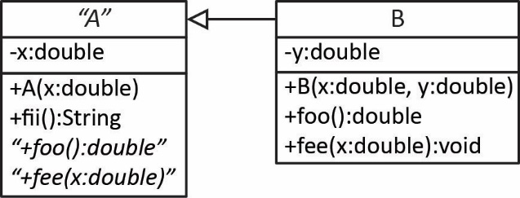
- (Solution in exercise_a_b package) Consider the class diagram on the right. Write these classes as completely as possible. Note: you do not know what the methods do, but you can write stubs. A stub is a method that simply fulfills the signature in a most basic way. For example, a stub for toString might be:
public String toString() {
return “ “;
}

- (Solution in exercise_grade_report package) Classes are needed to represent a GradeReport which holds the name of the student and a list of their scores for a class. Both properties are supplied when a GradeReport is first created. The class should also have a getter for the name. Finally, there needs to be a method to calculate the average and return it; however, the calculation can be done in various ways. In a GradeReportRegular the average is implemented by simply averaging all the scores. The GradeReportDropLowest class has a constructor that accepts the number of scores to drop and the average is calculated by averaging the scores that weren’t dropped. It should not modify the original scores list.
The solution for this problem is found in the: practice_problem_grade_report package in the code download for this chapter.
- Model this system with a class diagram.
- Write the code for all classes.
- Write code to test.

- Define an inheritance relationship that involves an abstract class for a situation that you know something about (sports, hobbies, anything). Identify the behaviors that are in common. Which can be implemented in the abstract class and which need to be abstract? Are there any behaviors that are only in a subclass? Draw a class diagram and an object diagram.

Interfaces
The code for all examples in this section are in the example_animal_interface package.
An interface in Java is similar to an abstract class except: (a) all methods are abstract and (b) it cannot define any instance variables (it can define constants). Thus, an interface is simply a specification of behavior, there is no code. A concrete class can implement an interface which means that all the methods defined in the interface must be implemented (have code).
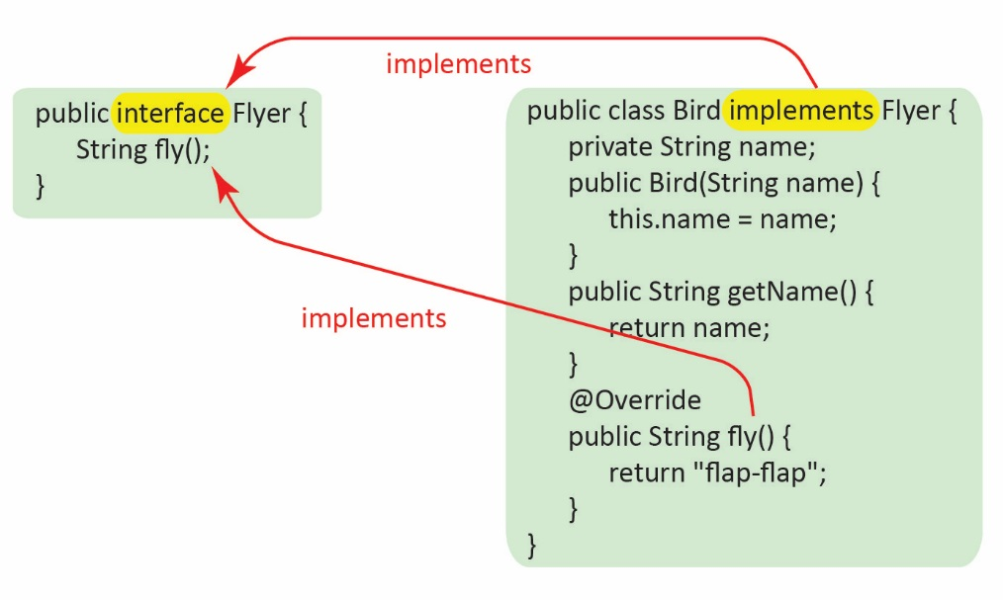
In the example on the right, we define a Flyer interface that specifies a single method, fly. Then, we define a Bird class that implements that interface by defining a fly method that has the same signature as the one in the interface. Study the figure on the right and note the following:
- We use the interface modifier to define an interface.
- Methods in an interface are by default, public and abstract, so we don’t have to add those modifiers (however, we can). Notice above in the Flyer interface, we specified the method as:
String fly();
Which is exactly the same as:
public abstract String fly();
- We use the implements keyword to denote that a class is implementing an interface.
- Since Bird is a concrete class, it must implement the (abstract) fly method.

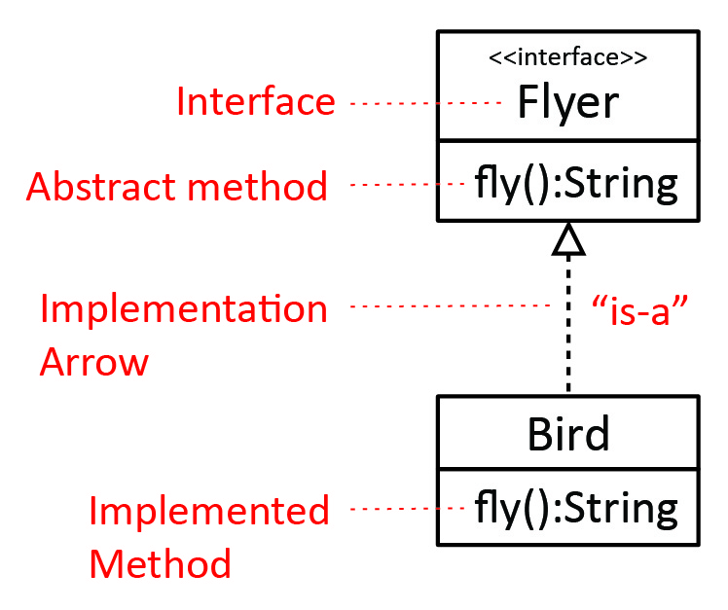
An interface generally follows the is-a rule, e.g. a Bird is-a Flyer. However, sometimes it is easier to think about it as is-able-to, or can-do, or is-kind-of.
In UML, a dashed line is drawn from the class implementing the interface, to the interface, with a hollow triangle pointing to the interface. Technically, an interface should be labeled with a stereotype, <<interface>> as shown in the figure on the right. However, for our class, it is OK to leave it off since the implementation arrow indicates that it is an interface.
Summary:
 | Can be instantiated? | Abstract Methods?
Class | Yes | None
Abstract Class | No | Some
Interface | No | All

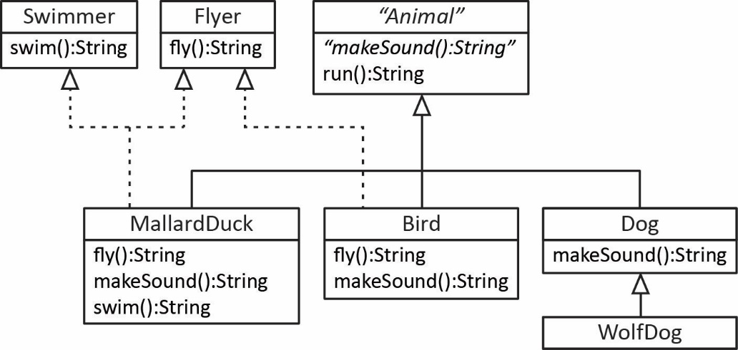
In Java, a class can extend only one other class or abstract class. However, a class can also implement as many interfaces as needed.
The example on the right shows that a:
- MallardDuck is-a Swimmer, a Flyer, and an Animal
- Bird is-a Flyer and an Animal
- Dog is-a Animal
- WolfDog is-a Dog and an Animal

The MallardDuck class is shown below to illustrate the syntax for both extending and implementing: extends comes first, followed by implements and a comma-separated list of interfaces.
public class MallardDuck extends Animal implements Flyer, Swimmer {
public MallardDuck() { super(); }

@Override
public String makeSound() {
return "honk-honk";
}

@Override
public String fly() {
return "flying...";
}

@Override
public String swim() {
return "swimming...";
}
}
An interface can be used as a reference type in exactly the same way we use an abstract class as a super-type reference. The following example, based on the class diagram immediately above, then, in essence is a review:
- If we create a MallardDuck and refer to it as a MallardDuck it can makeSound, run, fly, swim:
MallardDuck duck = new MallardDuck("Daffy");
duck.makeSound(); duck.run(); duck.fly(); duck.swim();
- We can use an interface as a reference type, but we can only access the behaviors that are specified in the reference type (interface). For example, if we create a Bird and refer to it ias a Flyer, then the only thing it can do is fly.
Flyer bird = new Bird("Tweety");
bird.fly();
//bird.makeSound(); // doesn't compile
//bird.run() // doesn't compile

- We can cast to an interface:
Animal donald = new MallardDuck("Donald");
...

if(donald instanceof Flyer) {
Flyer f = (Flyer)donald;
f.fly();
}
- Or cast from an interface reference:
Flyer daffey = new MallardDuck("Daffey");
...

if(daffey instanceof MallardDuck) {
MallardDuck s = (MallardDuck) daffey;
s.swim();
}
- We can use an interface as the generic type argument for an ArrayList:
ArrayList<Flyer> flyers = new ArrayList<>();
- And add Birds, MallardDucks, and Flyers:
Bird b = new Bird("Woodstock");
MallardDuck md = new MallardDuck("Daffey");
Flyer f = new MallardDuck("Donald");

flyers.add(b); flyers.add(md); flyers.add(f);
- An object with an Animal reference, even if the instance is a Bird, cannot be added because an Animal is not an Flyer
Animal b2 = new Bird("Tweety");

flyers.add(b2); // Compile error

- Of course, we could cast it to Flyer and then add it to flyers:
if(b2 instanceof Flyer) {
flyers.add((Flyer)b2);
}
- Loop through the flyers:
for(Flyer flyer : flyers)
flyer.fly();

Example 2 – Person has many Animals and many Flyers
(Solution in example_person_animals_ver2 package) We will modify the example considered earlier in this chapter. The affected methods are highlighted in yellow and are explained in the code that follows. This code is found in the: example_person_animals_ver2 package in the code download for this chapter.
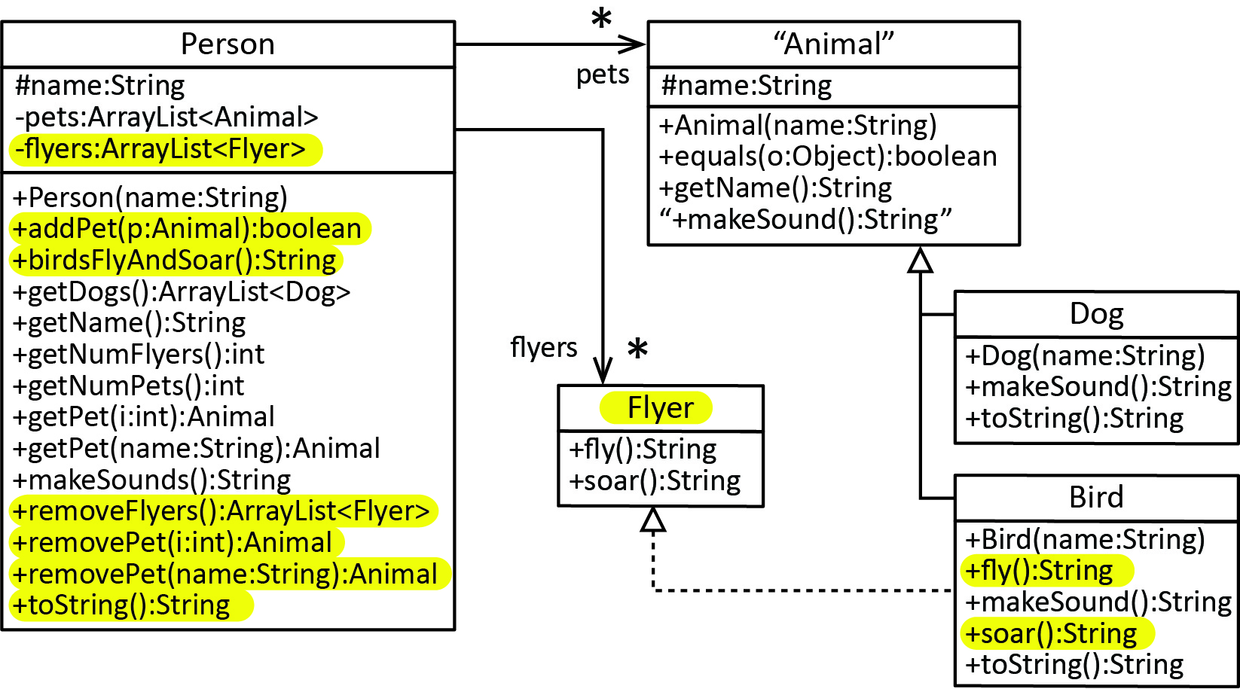
Note:
- We maintain both a list of Animals (pets) and a list of Flyers (flyers). We choose to do this as a convenience. All animals (Dogs and Birds) are stored in pets. However, we also store the Birds in the flyers list. For this particular example, the flyers list could have been birds; however, we are making the system more flexible so that in the future, if we have more animals that are flyers, we don’t have to modify any code.
- We have to modify addPet so that if the animal that is passed in is not only added to the pets list, it is also added to the flyers list, if it is a flyer. Similar for both removePet methods, we will also need to remove the animal from flyers if it is a flyer.
An object diagram is shown below:
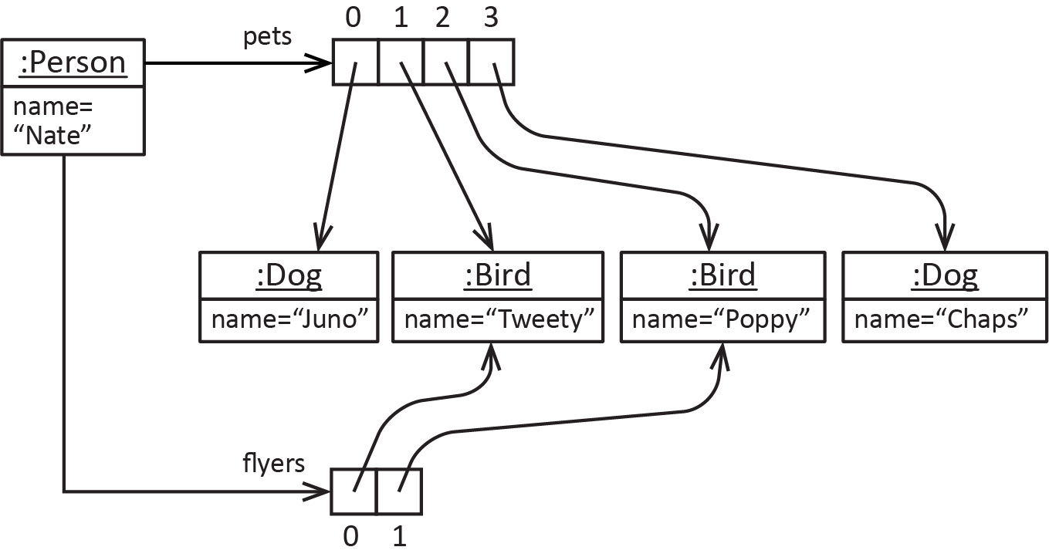

Next, we detail the changes required in the highlighted methods above:
- Define the Flyer interface:
public interface Flyer {
String fly();
String soar();
}
- Bird implements Flyer:
public class Bird extends Animal implements Flyer {
...
@Override
public String fly() {
return name + " is flying";
}

@Override
public String soar() {
return name + " is soaring";
}
...
}
- The Person class has an instance variable that is a list of Flyers:
private ArrayList<Flyer> flyers = new ArrayList<>();
- The addPet method is modified to add Flyers to flyers
public boolean addPet(Animal a) {
if(!pets.contains(a)) {
pets.add(a);
if(a instanceof Flyer) {
Flyer f = (Flyer)a;
flyers.add(f);
}
return true;
}
return false;
}
- Add the birdsFlyAndSoar method
public String birdsFlyAndSoar() {
String msg = "";
for(Flyer f : flyers) {
msg += f.fly() + ", " +
f.soar() + "\n";
}
return msg;
}

- Modify removePet(i:int) to also remove from flyers if the animals is a Flyer.
public Animal removePet(int i) {
if(i<0 || i>=pets.size()) {
return null;
}
Animal a = pets.get(i);
pets.remove(i);
if(a instanceof Flyer) {
Flyer f = (Flyer)a;
flyers.remove(f);
}
return a;
}
- Modify removePet(name:String) to also remove from flyers if the animals is a Flyer. The approach below is to create an Animal from name and then use that to find the index of where the animal is located. Then, we use that index to call removePet(i:int).
public Animal removePet(String name) {
Animal a = new Dog(name);
int loc = pets.indexOf(a);
return removePet(loc);
}
- The removeFlyers method removes all flyers and returns them in a list:
public ArrayList<Flyer> removeFlyers2() {
ArrayList<Flyer> remFlyers = new ArrayList<>();
for(Flyer f : flyers) {// Loop over flyers & remove from pets
Animal a = (Animal)f;
pets.remove(a);
remFlyers.add(f);
}
flyers.clear(); // Remove all flyers
return remFlyers;
}
In theory, another approach is to iterate over the pets, and pick out the Flyers and remove them. To implement this, though, is more complex and error prone with strategies you know now. For example, if you use an enhanced for loop (for each loop) to iterate over pets, then pets cannot be modified (added to or removed from). Or, with a indexed loop, you would need to modify the index inside the loop (bad practice), or run the loop backwards over the list, which is more error prone. There is a natural way to use this approach by using an Iterator which we study in another chapter. However, the code above would probably be preferred.
Why do we need to add Flyers to the return list, remFlyers? Why don’t we just assign flyers to remFlyers and skip the add? For example:
public ArrayList<Flyer> removeFlyers() {
ArrayList<Flyer> remFlyers = flyers;
for(Flyer f : flyers) {// Loop over flyers & remove from pets
Animal a = (Animal)f;
pets.remove(a);
}
flyers.clear(); // Remove all flyers
return remFlyers;
}
This does not work. The return is always an empty list. We see that remFlyers is another reference to the flyers list. So, when we clear towards the bottom, then flyers is an empty list, which is pointed to by remFlyers.
- Modify toString to also display the Flyers.
@Override
public String toString() {
String msg = name + "'s pets:\n";
for(Animal a : pets) {
msg += a + "\n";
}
msg += "\nFlyers\n";
for(Flyer f : flyers) {
msg += f + "\n";
}
return msg;
}

Exercises
- (Solution in exercise_hotel_rooms_ver2 package) Consider a previous version of this problem
- Add an interface named Billable which prescribes a method, getReceipt that accepts no arguments and returns a String.
- Have the Room class implement the interface by returning a nicely formatted string that contains the room number and the cost. For example: Room num=228, cost=$280.00
- Add a method to the Hotel class, getReceipts that returns a numbered list of receipts of all the rooms, and add the hotel name at the top, like this:
Hotel: Indigo
------------------
1. Room num=228, cost=$280.00
2. Room num=334, cost=$360.00
3. Room num=114, cost=$170.00
4. Room num=356, cost=$360.00
- Write code to test the method.
- (Solution in exercise_horses_cars package) Consider an interface, Drivable which specifies two methods: turn which accepts the degree to turn as a double and a string, and accelerate which takes no arguments and returns a string. The classes Horse and Car both implement this interface. Do the following:
- Draw a class diagram for these classes.
- Write the code for Drivable, Horse, Car. Hint: there is not much to write as all you have been told about the Horse and Car classes is that they implement Drivable. Thus the only methods are the methods from the interface. Simply return a string, for example for Horse for turn, something like this: “Horse is turning 90 degrees”, etc.
- Write some driver code that creates some horses and cars and puts them into an ArrayList of type Drivable. Loop through the ArrayList and call the methods.
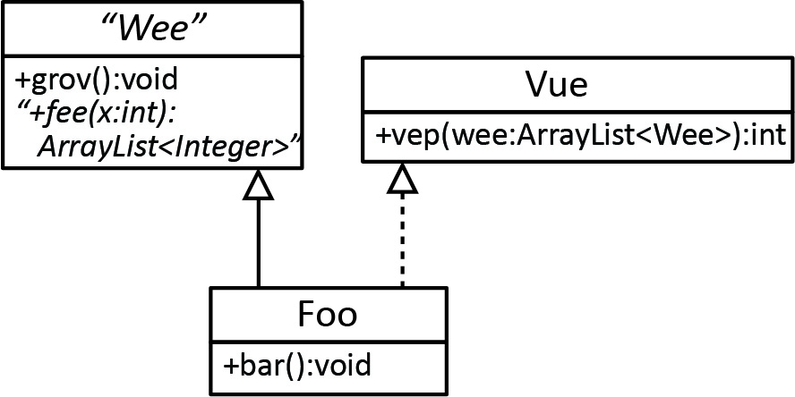
- (Solution in exercise_wee_vue_foo package) Consider the class diagram on the right.
- Write the Wee, Vue and Foo classes as completely as possible. Use stubs where necessary. A stub is a piece of code that doesn’t do anything, but it should compile and run (i.e. fulfilling the specification of the class diagram). Write some code to test.
- Write some code to test. Create a Foo object and call each of its methods. Calling vep will take a little thought.

Why use Interfaces?
This is a tougher question to answer and will probably only fully understood after you have some experience in the real world. Interfaces are used in two ways:
- A way to add “attributes” to class that don’t necessary apply to all classes in an inheritance hierarchy. Thus, in some sense they are markers, denoting that a class has additional behaviors beyond those defined in a superclass. For example: birds, some ducks, and airplanes all “fly”, but they wouldn’t all be under the same inheritance hierarchy.

- As we will see in another chapter, many times when we define an inheritance hierarchy, there are three levels of classes:

- Top Level: interfaces that define common behaviors
- Middle Level: abstract classes that implement some of the behaviors in the interface, and add new concrete or abstract methods as needed.
- Lower Level: concrete classes that implement any behaviors not implemented in the abstract class, and introduce new behaviors as needed.
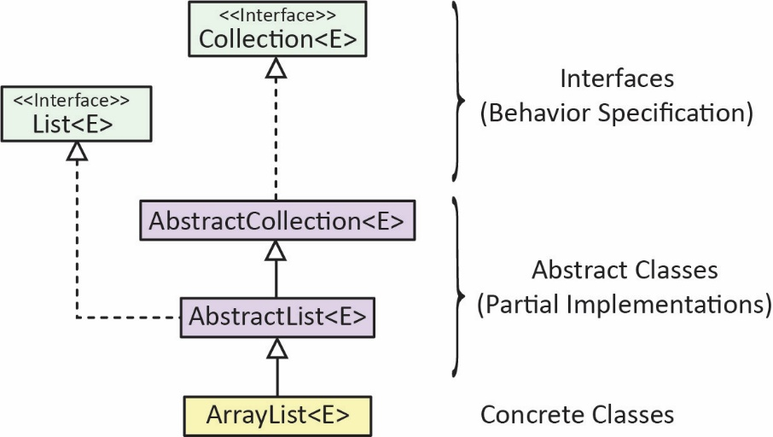
As we will see in a later chapter, an ArrayList derives from a hierarchy as shown on the right. An ArrayList gets some behaviors (almost all, I believe) from the Collection and List interfaces. Some of these behaviors are implemented in the abstract classes: AbstractCollection and AbstractList.
In this class, I would expect you to recognize when an abstract class is appropriate; however, I do not expect you to be able to determine when an interface is needed, this is something I will tell you.

The Comparable Interface
As we saw in the previous chapter, an ArrayList should be defined with a generic type argument that is a reference type. We also saw that if the type was any of the wrapper classes, or String then we could use Collections.sort to sort a list of these items. For example:
ArrayList<String> cities = new ArrayList<>(
Arrays.asList("New York City", "Boston", "Atlanta", "San Francisco"));
Collections.sort(cities);

ArrayList<Integer> vals = new ArrayList<>( Arrays.asList(55, 22, 14, 93, 8));
Collections.sort(vals);
However, we can’t sort a list of objects from a custom class, yet. For example, we can’t sort a list of animals, employees, etc. The reason is that the sort method requires that the items in the list implement the Comparable interface. For example, both the String class and Integer class implement Comparable.
public final class String extends Object
implements Serializable, Comparable<String>, CharSequence

public final class Integer extends Number implements Comparable<Integer>
Java defines the Comparable (generic) interface, which specifies a single method as shown below.
public interface Comparable<E> {
int compareTo(E o);
}
When a class implements, compareTo it should compare this object to the argument, o, returning:
Return | When
a negative integer | this < o
zero | this == o
a positive integer | this > o
Note:
- The Comparable interface is a generic interface (<E>), thus when we implement it we must specify the type of objects we are comparing.
- The compareTo method defines how two objects are compared: which is larger, smaller, or are the same. Thus, the compareTo method implemented in the String class is different from the version implemented in the Integer class.
- The Collections.sort method calls compareTo repeatedly to sort the elements in a list.
- To sort a list of custom objects (Person, House, Account, etc.) the class must implement the Comparable interface.

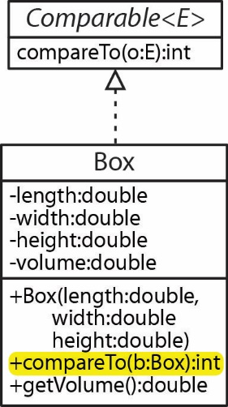
As an example (code in example_comparable_box package), consider a Box class that has a length, width, height, and volume. Suppose we want to be able to sort boxes based on their volume using Collections.sort. Then, we would need to implement Comparable as shown in the class diagram on the right and the code below.
This code (and subsequent modification) is found in the: example_compare_boxes package in the code download for this chapter.
public class Box implements Comparable<Box> {
double length, width, height, volume;

public Box( double l, double w, double h ) {
this.length=l; this.width=w; this.height=h;
this.volume = l*w*h;
}

public double getVolume() { return volume; }

public int compareTo(Box otherBox) {
double diff = this.volume - otherBox.volume;
if(diff < 0) {
return -1;
}
else if(diff > 0) {
return 1;
}
else {
return 0;
}
}
...
}
If a double field is involved, when overriding compareTo, as in this case, a slightly more involved process was used because equals returns an int. For example, the code below will not compile as a double cannot be coerced into an int:
public int compareTo(Box otherBox) {
return this.volume - otherBox.volume;
}
Now, we can sort boxes:
Code | Output
ArrayList<Box> boxes = new ArrayList<>();  boxes.add(new Box(3,5,2)); // vol=30.0  boxes.add(new Box(2,2,2)); // vol=8.0  boxes.add(new Box(2,2,4)); // vol=16.0  Collections.sort(boxes);  System.out.println("\nAfter Sort:");  for( Box b : boxes )  System.out.println( b ); | After Sort:  Box: vol=8.0  Box: vol=16.0  Box: vol=30.0

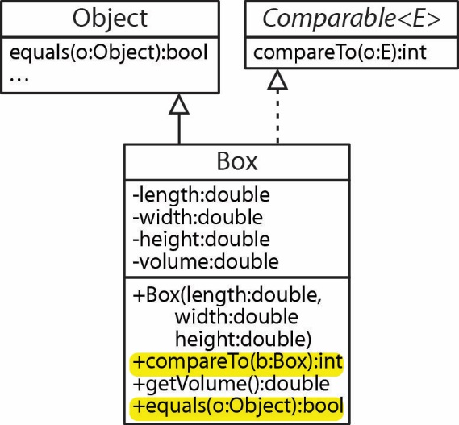
Java’s documentation strongly recommends that if you implement compareTo, then it should be consistent with equals. Thus, in the example above, we should also override the equals method so that if two boxes have the same volume, then they are considered equal:
public boolean equals(Object o) {
if(o instanceof Box) {
return this.getVolume()==((Box)o).getVolume();
}
return false;
}
Finally, note that comparing two doubles for equality can result in problems due to the representation of numbers in binary and small rounding errors that can result. For example (code in example_comparing_doubles package):
double a = 0.15 + 0.15;
double b = 0.1 + 0.2;
System.out.println(a == b); // false
System.out.println(a > b); // false
System.out.println(a < b); // true
This will only result when computation is involved, as in the example above.
As another example (code in example_comparable_person_lastname package), consider the situation where we want to be able to sort Person objects on their last name which of course is a string. As mentioned earlier, String implements Comparable. Thus, implementing Comparable in the Person class is straightforward. We simply use the String class’s compareTo method:
class Person implements Comparable<Person> {
private String lastName;
...
public int compareTo(Person other) {
return this.lastName.compareTo(other.lastName);
}

public boolean equals(Object o) {
if(o instanceof Person) {
Person other = (Person)o;
return this.lastName.equals(other.lastName);
}
return false;
}
}
Consider the problem above, suppose we want to sort on last name descending. We simply need to reverse the normal comparison by putting a negative in front of the comparison.
public int compareTo( Person2 other ) {
return -this.lastName.compareTo(other.lastName);
}

Consider the situation (code in example_comparable_person_lastname_firstname package) where we want to be able to sort Person objects on their last name and if two last names are the same, then sort on first name.
class Person implements Comparable<Person> {
private String lastName, firstName;
...
public int compareTo( Person other ) {
int diffLName = this.lastName.compareTo(other.lastName);

if(diffLName != 0)
return diffLName;
else
return this.firstName.compareTo(other.firstName);
}
public boolean equals(Object o) {
if(o instanceof Person) {
Person other = (Person)o;
return this.lastName.equals(other.lastName) &&
this.firstName.equals(other.firstName);
}
return false;
}
}
Finally, we illustrate (code in example_compare_person_lastname_firstname package, PersonTest class) Collections methods that rely on Comparable (in addition to sort). Consider this list of Person objects:
Person p1 = new Person( "Wilson", "Henry" );
Person p2 = new Person( "Purns", "Nivel" );
Person p3 = new Person( "Jones", "Sherry" );
Person p4 = new Person( "Jones", "Aron" );
Person p5 = new Person( "Purns", "Nivel" );

ArrayList<Person> persons = new ArrayList<>();
persons.add(p1); persons.add(p2); persons.add(p3); persons.add(p4); persons.add(p5);
Collections methods that rely on Comparable:
System.out.println("Collections.max(persons):" + Collections.max(persons));
System.out.println("Collections.min(persons):" + Collections.min(persons));
Illustrates ArrayList methods that rely on equals:
System.out.println("persons.contains(p3) :" + persons.contains(p3));
System.out.println("persons.indexOf(p2) :" + persons.indexOf(p2));
System.out.println("persons.lastIndexOf(p2) :" + persons.lastIndexOf(p2));
System.out.println("persons.remove(p1) :" + persons.remove(p1));
Corresponding Output:
Collections.max(persons):Wilson, Henry
Collections.min(persons):Jones, Aron
persons.contains(p3) :true
persons.indexOf(p2) :1
persons.lastIndexOf(p2) :4
persons.remove(p1) :true

Example 3 – Person has many Comparable Animals
(Solution in example_person_animals_ver3 package) We will modify the example considered earlier so that the Person class has a method, getSortedPets that returns a list of pets sorted on their name. The affected methods are highlighted in yellow and are explained in the code that follows. This code is found in the: example_person_animals_ver3 package on the Schedule.
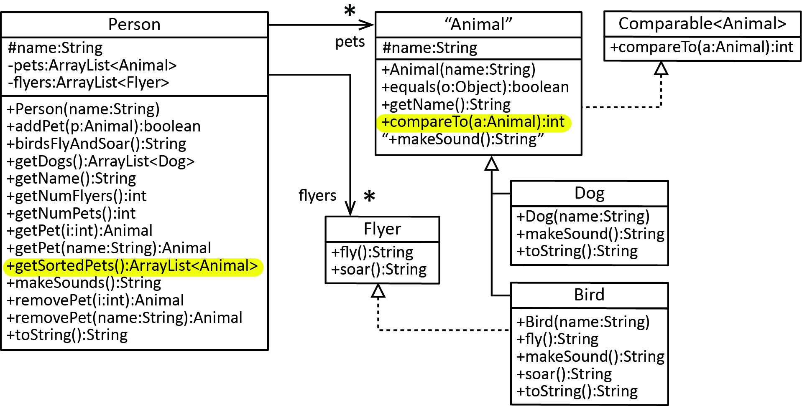
The Animal class implements Comparable to compare based on name:
public abstract class Animal implements Comparable<Animal> {
...

@Override
public int compareTo(Animal a) {
return this.name.compareTo(a.name);
}
...
}
We add a getSortedPets method to the Person class that returns a list of pets sorted on their name while not disturbing the order of the pets in the pets instance variable. To do this, we must create a new list of pets, sorted:
public ArrayList<Animal> getSortedPets() {
// Create a new list, initializing it with the pets list,
// and then sort new list. This ensures that we don't
// change the order of the pets list (as problem requested).
ArrayList<Animal> sorted = new ArrayList<>(pets);
Collections.sort(sorted);
return sorted;
}

Exercises
- (Solution in exercise_hotel_rooms_ver3 package) Consider a previous version of this problem. Make the following changes:
- We want to be able to sort rooms on the (room) number. Make a change to the Room class to facilitate this.
- Add a method to the Hotel class, getSortedRooms():ArrayList<Room> that returns a list of rooms sorted on their (room) number without changing the order of the rooms instance variable.
- Add methods to the HotelTest class to test this method.

- (Solution in exercise_blobs package) Consider the classes shown below. Suppose we want to be able to sort Blobs (either red or green) based on their ID and if the ID’s are the same, then sort based on tenacity.
- Modify the appropriate classes to achieve this.
- Write some code to test this.

Blob Class | RedBlob Class
public abstract class Blob {  protected int id;  protected double tenacity;  public Blob(int id, double tenacity) {  this.id = id;  this.tenacity = tenacity;  }  public int getId() {  return id;  }  public double getTenacity() {  return tenacity;  }  public abstract void constrict();  } | public class RedBlob extends Blob {  public RedBlob(int id, double tenacity) {  super(id,tenacity);  }  @Override  public void constrict() {  tenacity *= 0.9;  tenacity++;  }  @Override  public String toString() {  String msg = String.format("RedBlob, id=%d, tenacity=%.2f", id, tenacity);  return msg;  }  }

GreenBlob Class
public class GreenBlob extends Blob {
public GreenBlob(int id, double tenacity) {
super(id,tenacity);
}
@Override
public void constrict() {
tenacity++;
tenacity *= 0.9;
}
@Override
public String toString() {
String msg = String.format("GreenBlob, id=%d, tenacity=%.2f", id, tenacity);
return msg;
}
}

- (Solution in exercise_books package) Consider the Book class shown below. Suppose we want to sort books based on their title however, if the title begins with “The” then we want the sort to start on the words after “The.”. For example, “The Grapes of Wrath” would appear before “Moby Dick.”
- Modify the Book class to achieve this
- Write some code to test this.
public class Book {
private String title;

public Book(String title) {
this.title = title;
}
public String getTitle() {
return title;
}
@Override
public String toString() {
return title;
}
}

Example 4 – Comparable Rectangle
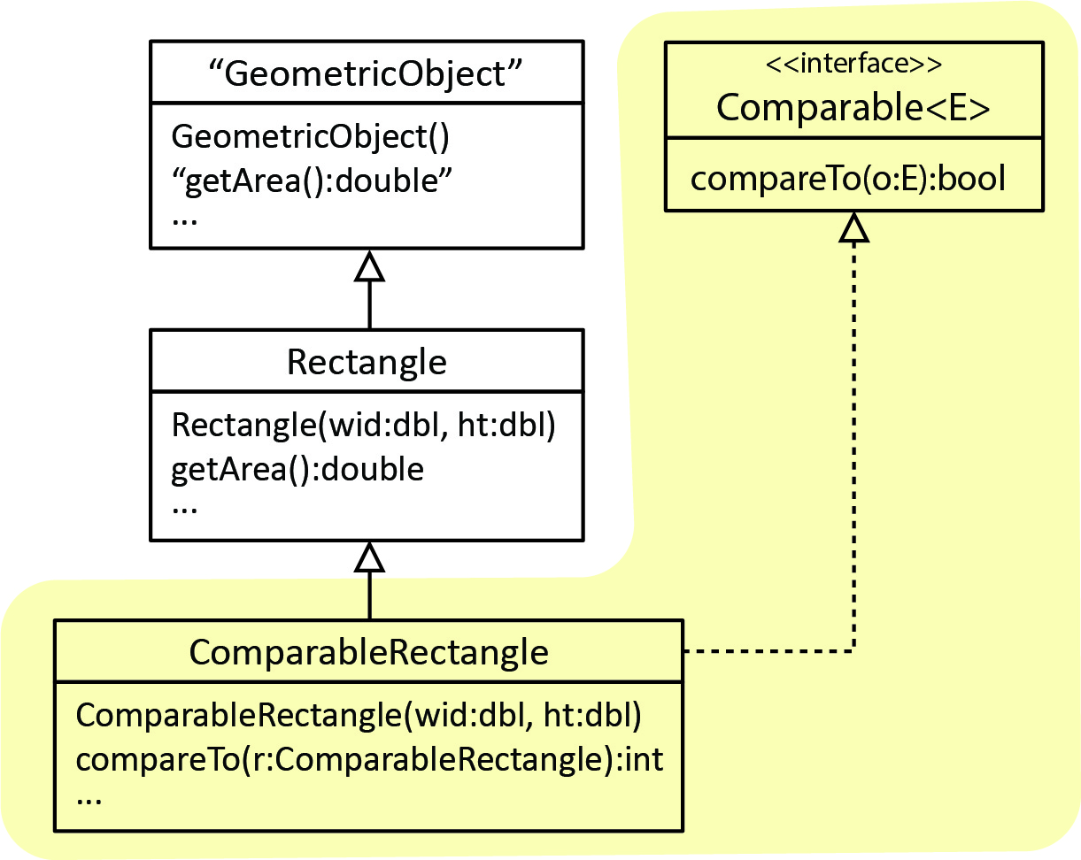
Consider this example found in Intro to Java Programming, by Daniel Liang. As shown on the right, we have a Rectangle class which is a subclass of GeometricObject. Suppose you want to sort an ArrayList of Rectangles based on their area and that you are not allowed to modify the Rectangle class. How would you do this?
The solution (example_comparable_rectangles package) would be to create a ComparableRectangle class that is a subclass of Rectangle and implements Comparable<ComparableRectangle> as shown in the shaded area of the class diagram on the right.
The code is shown below:

public class ComparableRectangle extends Rectangle implements
Comparable<ComparableRectangle> {

public ComparableRectangle(double width, double height) {
super(width, height);
}

@Override
public int compareTo(ComparableRectangle other) {
double diff = this.getArea()-other.getArea();
if(diff>0) return 1;
else if(diff<0) return -1;
else return 0;
}
@Override
public boolean equals(Object o) {
ComparableRectangle r = (ComparableRectangle)o;
return this.getArea()==r.getArea();
}
}

Some Java API Examples
Note the class hierarchy below that is defined in the Java API. Number is an abstract class which gives rise to the concrete subclasses: Double, Integer, BigInteger, etc. Here, we are just illustrating how abstract classes and interfaces are used in modeling, specifically in the design of the Java API. There are other implementations of Number not shown below. BigInteger is used for representing integers that are bigger than the long primitive type (e.g. less than $-2^{63}$ or greater than $2^{63}-1$). BigDecimal is similar.
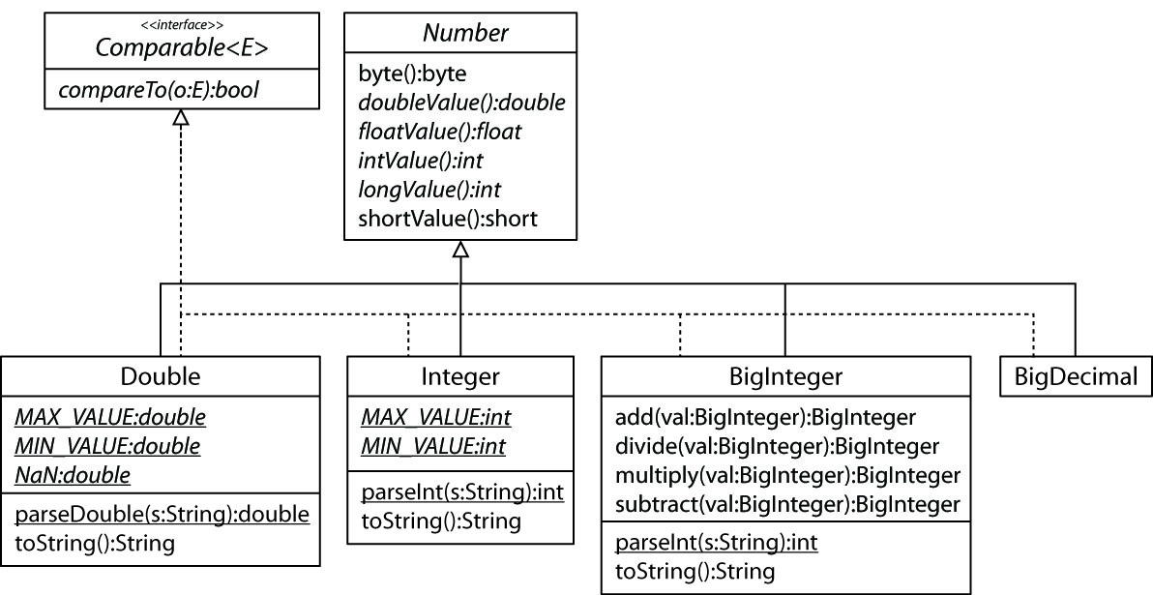

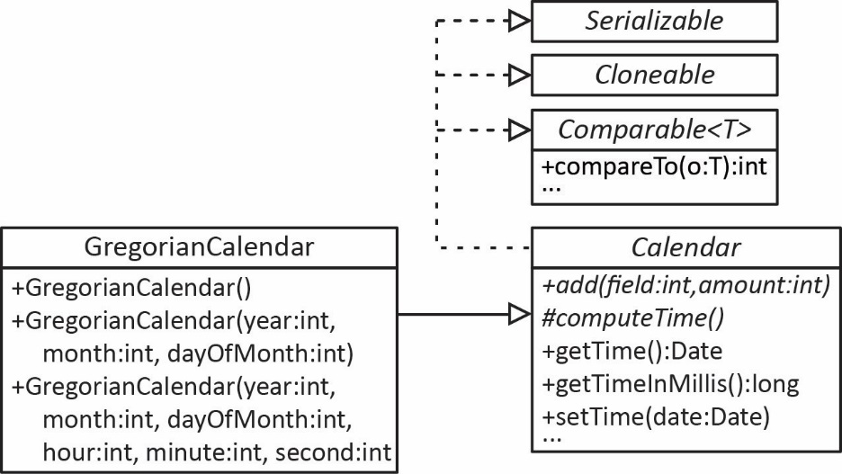
The Calendar class is an abstract class that provides methods for converting between a specific instant in time and a set of calendar fields such as YEAR, MONTH, DAY_OF_MONTH, HOUR, etc. Wikipedia lists 81 different types of calendars that are used in different places in the world. Thus, Java defines the abstract Calendar class so that other calendar systems can be created. In the United States, we use a GregorianCalendar which is a subclass of Calendar as shown below. For example: BhuddistCalendar, ChineseCalendar, CopticCalendar, HebrewCalendar, IndianCaledar, and others.

The String class is shown on the left, below and the ArrayList class is shown on the right.
String Class | ArrayList Class
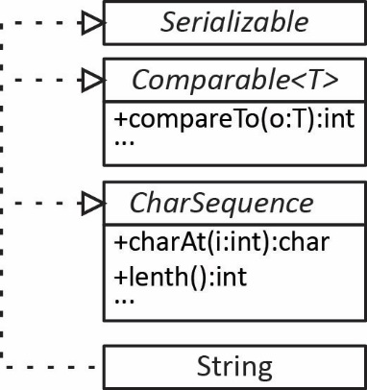 | 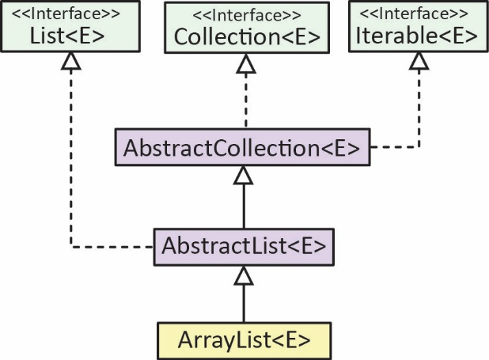
A RadioButton is a class in Java and is used when developing a graphical user interface. It has a rather deep hierarchy.

Additional Points about Abstract Classes & Interfaces
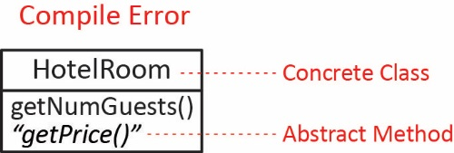
An abstract method can only be defined in an abstract class.

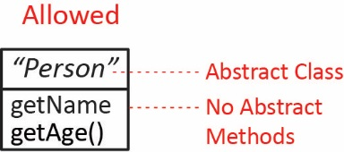
An abstract class doesn’t have to have any abstract methods (not common).

An abstract class can extend another abstract class in which case it does not have to implement abstract methods in the super (abstract) class. However, a concrete class must implement any non-implemented abstract methods defined higher in the inheritance hierarchy.
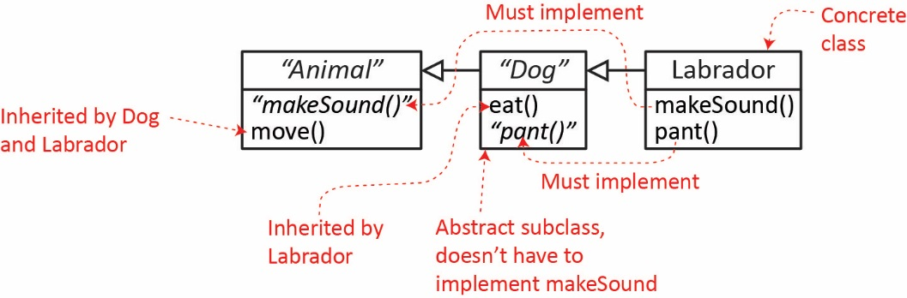

Of course, Dog can implement makeSound in which case it is inherited by Labrador (or could be overridden).
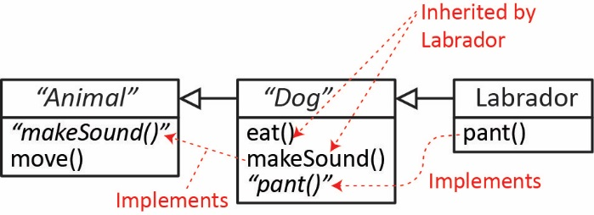
Similar to the previous point, an abstract class can implement an interface in which case it does not have to implement methods defined in the interface (though it can). However, a concrete class must implement any non-implemented abstract methods defined higher in the inheritance hierarchy.
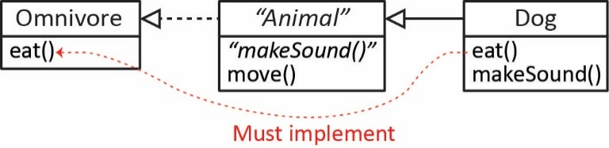
Even though an abstract class cannot be instantiated, it still can (and almost always does) have constructors which are called from the subclasses. These are important because at least one constructor in any subclass will call a superclass constructor.

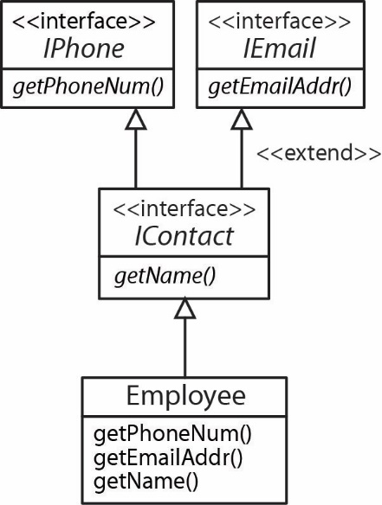
An interface (called a sub-interface) can extend another interface. Of course, it can’t implement any of its methods.
public interface IPhone {
String getPhoneNum();
}
interface IEmail {
String getEmailAddr();
}
interface IContact extends IPhone, IEmail {
String getName();
}

public class Employee implements IContact {

@Override
public String getPhoneNum() {
return null;
}

@Override
public String getEmailAddr() {
return null;
}

@Override
public String getName() {
return null;
}

}

Appendix
  - The Cloneable Interface
Sometimes a program needs a copy of an object, not a copy of the reference to the object, but a full-fledged copy of the object, a duplicate, so that there are two distinct objects with exactly the same state. We call such a copy a clone and the process of creating one is called cloning an object. Of course, we could write code in-line to do this. For example, if a Person’s state only consisted of their name and age:
Person p = new Person( “Alex”, 33 );
Then we could create a clone by creating a new Person object and copying the state from the original object.
Person p2 = new Person( p.getName(), p.getAge() )
In this case, it was pretty simple, we did it in just one line. However, it has drawbacks:
- The cloning is not encapsulated. The knowledge of how to clone an object should be encapsulated in the object itself, because who else would know better how to clone itself?
- Maintenance is harder. Suppose we do this manual cloning multiple places in our code. What if the cloning code needs to change, for example because an instance variable is added to the class? We would have to find all places where we have this manual cloning and change them all. It would be better to have the cloning code in one place.
Java provides a mechanism for cloning an object. The Object class has a protected clone method which will clone any object that implements the Cloneable interface. It works in the following way:
- The clone method creates a new object and copies all the field values from the existing object to the clone. For now, we only consider the case where fields are primitive types.
- The clone method returns an Object reference to the clone, so a client must cast it to the desired type.
Note: the Cloneable interface in Java is a marker interface which means that it specifies no methods, it just exists to tell the compiler an object might be cloned.
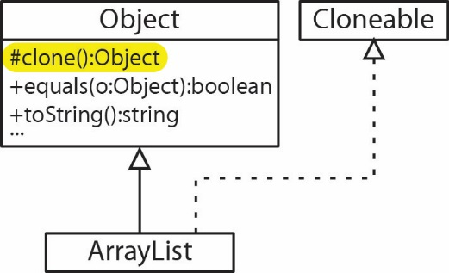
Example – As shown on the right, ArrayList inherits (actually, it overrides, which we will see shortly) the clone method from the Object class and implements the Cloneable interface. Thus, we can clone an ArrayList of ints:
ArrayList<Integer> x,y;
x = new ArrayList<>(Arrays.asList(5,2,7));
y = (ArrayList<Integer>)x.clone();
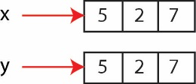
which results in two distinct copies of the object:

Notice in the class diagram above, clone is protected so it is not available outside the containing (java.lang) package or subclasses. Thus, to provide cloning in a custom class you must do two things:
- Implement Cloneable
- Override clone and increase its visibility by making it public.
Example (code in example_dog_clone package) – Consider the Dog class below. Since Dog only has one property which is a primitive data type, then the inherited clone method will clone the Dog accurately. The problem is that a user of the Dog class cannot access the clone method because it is protected. Thus, we override clone, increasing its visibility to public. The code simply calls the Object class’s clone method.
public class Dog implements Cloneable {
private int age;
public Dog(int age) {
this.age = age;
}
@Override
public Object clone() throws CloneNotSupportedException {
return super.clone();
}
}
We must add a throws declaration on the clone method above, and on the method that calls the clone method (we learn about this in a later chapter)
public static void main(String[] args) throws CloneNotSupportedException {
Dog d = new Dog(7);
Dog dClone = (Dog)d.clone();
}
Note, the method above only works properly if all the instance variables are primitive. If a field is a reference type (an object), a copy of the reference is made. Thus, the clone and the original would share this field. Each object would have a different reference, but both point to the same object (field). This is referred to as a shallow copy and is the default implementation in Java. A true copy is called a deep copy and we will consider that next. For now, let’s illustrate how a class with a reference to an object makes a shallow copy, sharing a reference to the object.
Example (code in example_person_clone_shallow package) – Consider the Person class below which has an instance variable which is an ArrayList (a reference type). And, we override the clone method to provide a default (shallow) copy:
public class Person implements Cloneable {

private String name;
private ArrayList<Integer> scores;

public Person( String name, ArrayList<Integer> scores ) {
this.name = name;
this.scores = scores;
}

public Object clone() throws CloneNotSupportedException {
return super.clone();
}
...
}

Next, consider the code on the left and the memory representation on the right:
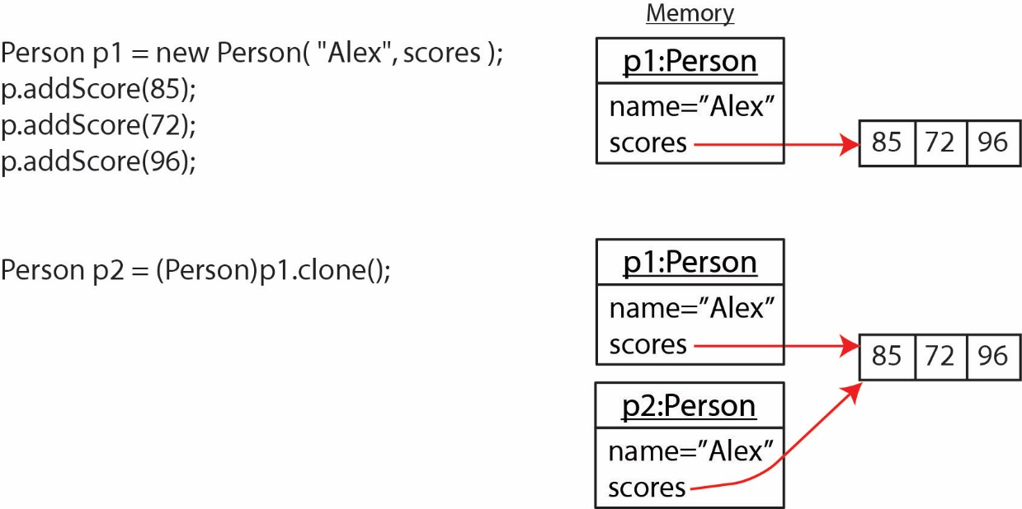
Note:
- The shallow copy clone does create another Person object and properly clones the name field.
- The instance variable scores is a shallow copy. The reference was cloned, but not the underlying ArrayList itself.
- Thus, when we use the clone to change a score, it also changes in the original (because they are the same!).
- Person has a String field, name which is a reference type. However, String is immutable so that both the original and the clone point to the same string object. However, if either changes the name, a copy will be made. Thus, we don’t have to worry about cloning a string.
A deep copy refers to a clone that makes a physical copy of the item being referred to (in the example above, making a copy of the scores ArrayList. To perform a deep copy we must write the code ourselves to do the cloning of reference objects.
Example (code in example_person_clone_deep package) – For the Person class above, it is fairly easy because the ArrayList of scores is of type Integer (which is primitive). Thus, we can rely on the ArrayList’s clone method to help us with the deep copy. Consider this revised clone method:
public Object clone() throws CloneNotSupportedException {
// Create shallow-copy clone
Person personClone = (Person)super.clone();
// Create a new list of scores by cloning the original
ArrayList<Integer> scoresClone = (ArrayList<Integer>)scores.clone();
// Then set the clone's scores list to be the cloned list
personClone.scores = scoresClone;
return personClone;
}

Next, consider the code on the left (below) and the memory representation on the right:
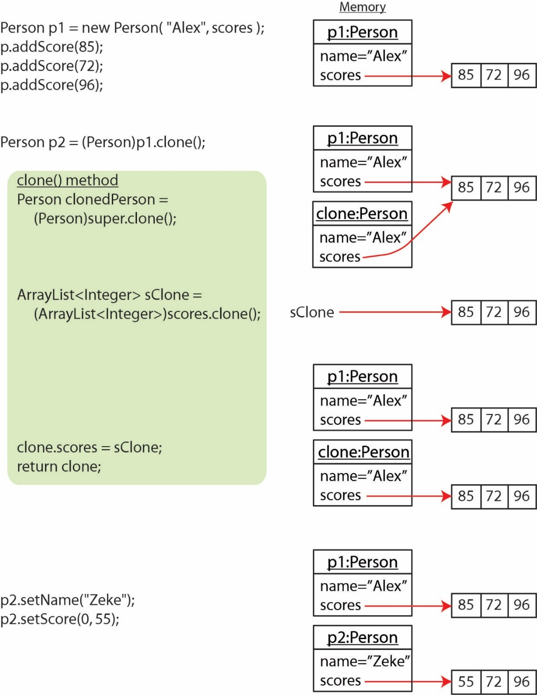
In the previous example, the ArrayList instance variable contained primitives. If the ArrayList had contained objects then the situation would have required a bit more work.
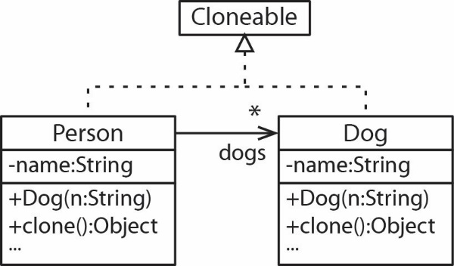
Example (code in example_person_dogs_clone_deep package)– A Person has an ArrayList of Dogs (which are Cloneable). First, the Dog class:
public class Dog implements Cloneable {

private String name;
public Dog( String name ) {
this.name = name;
}

public Object clone() throws CloneNotSupportedException {
return super.clone();
}
...
}
Next, the clone method for the Person class:
public Object clone() throws CloneNotSupportedException {
// Clone the person
Person clone = (Person)super.clone();
// Create a new list of dogs
ArrayList<Dog> cDogs = new ArrayList<>();
// Clone each dog and added to the new list
for(Dog d : dogs) {
cDogs.add((Dog)d.clone());
}
// Assign the new list of dogs to the clone list
clone.dogs = cDogs;
return clone;
}
  - Exercises
- (Solution in exercise_employee_clone package) An Employee class is needed which has a last name field and first name field and the ability to be cloned
- Write the Employee class.
- Write some code to test this.
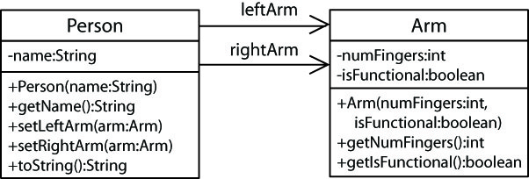
- (Solution in exercise_person_arm_clone package) Consider the class diagram on the right. Suppose we want to be able to clone a Person. Write the modifications necessary to accomplish this.

- Write the modifications you need to make to each class so that you can clone (deep) a Person. You don’t need to write the entire class.
- Write some code to test this.

Actually, from Java 8 onward, interfaces can now have default methods and static methods. https://www.geeksforgeeks.org/default-methods-java/
We learn later that an abstract class can implement an interface, but does not have to implement all the methods.
https://docs.oracle.com/javase/8/docs/api/java/lang/Comparable.html
https://docs.oracle.com/javase/8/docs/api/java/lang/String.html
https://docs.oracle.com/javase/8/docs/api/java/lang/Integer.html
https://floating-point-gui.de/errors/comparison/
https://www.pearson.com/us/higher-education/product/Liang-Intro-to-Java-Programming-Comprehensive-Version-10th-Edition/9780133761313.html
https://developer.android.com/reference/android/icu/util/BuddhistCalendar (see menu on left)
https://en.wikipedia.org/wiki/Radio_button
Coping a field that is a reference variable makes a copy of the reference. The object it points to is not copied.

