Chapter 4 – The ArrayList Class

Contents
1 Wrapper Classes 2
2 Introduction to the ArrayList Class 3
3 ArrayList Basics 4
3.1 Basic ArrayList Methods 4
3.2 Exercises 7
3.3 Creating and Populating an ArrayList 9
3.4 Sorting an ArrayList 10
4 The Object Class’s equals Method 10
4.1 Exercises 13
5 Methods that rely on equals 14
6 Example: 1-to-Many 15
6.1 Exercises 21
7 Lists of Lists 21
7.1 Exercises 22
8 Legacy ArrayList 23
9 Array vs. ArrayList 23

In this chapter we introduce the ArrayList class from the Java API. An ArrayList is similar to an array, but has many more features. It is especially useful when implementing a 1-many relationship. Before we can discuss the ArrayList class, we must first introduce wrapper classes.

Wrapper Classes
All primitive data types have a corresponding wrapper class which is simply a class that represents a primitive as an object. All the wrapper classes are shown in the table below
Primitive Type | Wrapper Class |  | Primitive Type | Wrapper Class
char | Character |  | long | Long
byte | Byte |  | float | Float
short | Short |  | double | Double
int | Integer |  | boolean | Boolean
Why do we use wrapper classes? One reason is that there are places in the Java language where a primitive type is not allowed, but the corresponding wrapper class instance is.
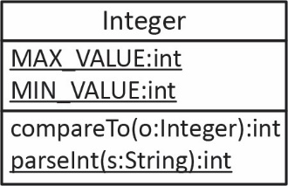
The wrapper class for int is Integer. A few of the members are shown in the class diagram on the right. There is a constructor for the class; however, it is deprecated. Instead, Java uses a technique called autoboxing. Autoboxing refers to Java’s ability to turn a primitive into an object whose class is the corresponding wrapper class. In other words, it “boxes” the primitive (wraps it up in an object). For example:
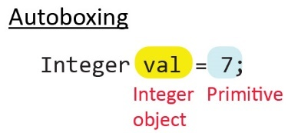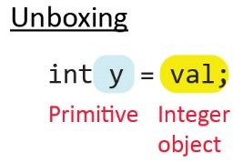
Unboxing (as shown in the figure above, on the right) refers to Java’s ability to turn a wrapper object into its corresponding primitive type. For example:
We probably will not need to explicitly box or unbox in this class; however, it is useful to know that this is what is occurring in the some of the ArrayList methods we consider in the next section. We consider the compareTo method in a later chapter. Its use with strings was considered in Chapter 1, Appendix 1 and functions similarly with the wrapper classes. In addition, the numeric-type wrapper classes can be compared with the equality and relational operators (==, <, <=, etc.). For example:
Integer x = 7;
Integer y = 4;

if(x>y) {
System.out.println("X is larger");
}

int diff = x.compareTo(y); // 1
diff = y.compareTo(x); // -1
x = y;
diff = y.compareTo(x); // 0
The static variables, MAX_VALUE and MIN_VALUE are occasionally useful and represent the largest and smallest numbers, respectively, that can be represented as an int. For example, if you were searching an int array for the smallest value, you might initialize the minimum this way:
int min = Integer.MAX_VALUE;
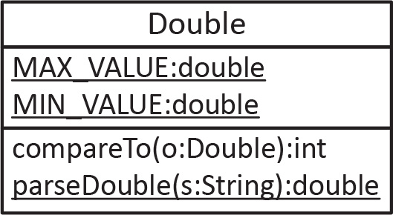
Of course, you are familiar with the static parseInt method.
The wrapper class for double is Double. A few of the members are shown in the class diagram on the right. Boxing and unboxing occur in the same way as with Integer.
Double val = 5.5; // Boxing
double y = val; // Unboxing

Introduction to the ArrayList Class
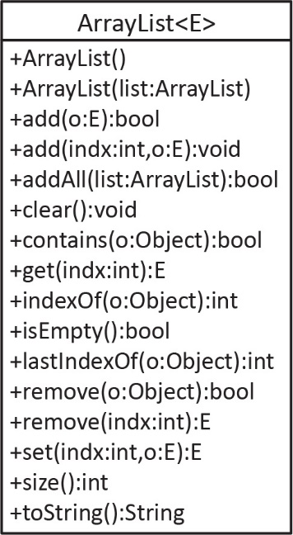
ArrayList is a class in the Java API and is similar to an array in that it is used to store objects in an indexed list, just like an array; however, it also has useful methods to manipulate the list. Some of the major methods are shown in the diagram on the right. We consider most of these methods in the material that follows. A complete reference for all the members is found in the API.
ArrayList is defined in the java.util package and so to use it, you must import it:
import java.util.ArrayList;
The ArrayList class is a generic class which is a concept in a broader topic called generics. A brief introduction to generics is considered here. The “E” in ArrayList<E> in the class diagram above, is a generic type parameter. What this means is that you must specify what type of objects the array list will hold when you create an ArrayList. For example, to create an ArrayList of integers, doubles, and Accounts, respectively:
ArrayList<Integer> ints = new ArrayList<>();
ArrayList<Double> doubs = new ArrayList<>();
ArrayList<Account> accounts = new ArrayList<>();
The generic type argument used to create an ArrayList must be a class; it cannot be a primitive. Thus, if we want to store ints then we must use ArrayList<Integer>. As we will see, the boxing and unboxing is automatic.
If you look at the source code for the ArrayList class, it will look similar to this:
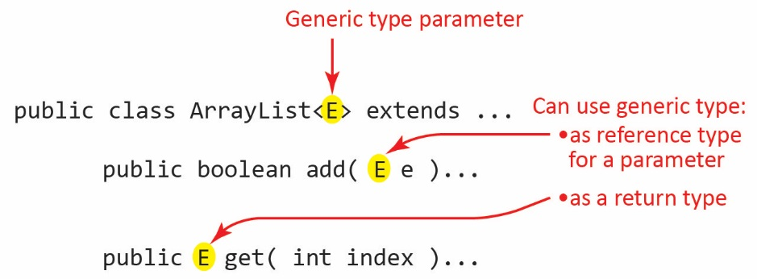
Essentially, you can think of it this way: when you declare:
ArrayList<Integer> ints = new ArrayList<>();
“Integer” is substituted everywhere there is an “E” in the class. Thus, the add method accepts an Integer which due to autoboxing can be an int. Similarly, the get method returns an Integer which due to unboxing is converted to an int.

ArrayList Basics
The code for the example in this section is in the example_arraylist_integer package.

Basic ArrayList Methods
Below we provide examples of most of the methods in the class diagram above. Here we consider an ArrayList of Iteger; however, everything would be the same with any other wrapper class, and String class. Most will be the same with an ArrayList of a custom class. We discuss this in a later section.
- We can create an ArrayList to hold integers with this statement:
ArrayList<Integer> ints = new ArrayList<>();
Note:
- We do not have to specify how many items the ArrayList can hold as we do with an array. It will hold as many items as the memory on your computer will allow.
- The ArrayList class has an add(obj) method to add objects to the end of the list (after the last one that was added, just as we did when using an array to implement 1-to-many). For example:
ints.add(47);
inserts 47 into the first position in the list:
0 | 1 | 2 | 3 | 4 | 5 | 6 | 7 | 8 | 9 | 10 | …
47
Internally, an ArrayList uses an array to hold the objects. Thus, 47 is stored at index=0. If we continue to add ints:
ints.add(91);
ints.add(16);
They will be stored as shown below:
0 | 1 | 2 | 3 | 4 | 5 | 6 | 7 | 8 | 9 | 10 | …
47 | 91 | 16
- The ArrayList class has a size method that returns the number of objects in the list. For example:
int size = ints.size();) // 3
Note:
  - size=3 in the example.
  - Just as when we consider the array to implement 1-many, there are no “holes” in an ArrayList. In other words, there are always elements in positions 0 through size()-1.
- The ArrayList class has a get(i) method to obtain a reference to the object at index, i. The index of elements is the same as an Array, it is zero-based. For example:
int x = ints.get(1);
System.out.println( x ); // 91
Note:
- If the index is less than 0, or greater than size()-1, then a runtime error will occur.

- You can iterate over an ArrayList using an enhanced for loop just as you would an Array or with an indexed loop. For example:
Enhanced for loop |  | Indexed loop
for(int i : ints) {  System.out.print(i + ", ");  } |  | for(int i=0; i<ints.size(); i++) {  System.out.print(ints.get(i) + ", ");  }
- The ArrayList class has a add(index, obj) method that adds obj at index moving the other items over one to the right (if necessary). For example, the current ArrayList has:
0 | 1 | 2 | 3 | 4 | 5 | 6 | 7 | 8 | 9 | 10 | …
47 | 91 | 16
And when we execute:
ints.add(1,33);
the result is:
0 | 1 | 2 | 3 | 4 | 5 | 6 | 7 | 8 | 9 | 10 | …
47 | 33 | 91 | 16
- The ArrayList class has a contains(obj) method that returns true if it contains obj and false otherwise. For example:
System.out.println(ints.contains(91)); // true
System.out.println(ints.contains(4)); // false
- The ArrayList class has an indexOf(obj) method that returns the index where obj is located, or -1 if not found. For example:
System.out.println(ints.indexOf(91)); // 2
System.out.println(ints.indexOf(5)); // -1
- The ArrayList class has a remove(index:int) method that removes the obj at index from the list moving items to the right over one to the left (if necessary). It also returns the removed item (but of course we don’t have to catch the return). For example, the current ArrayList has
0 | 1 | 2 | 3 | 4 | 5 | 6 | 7 | 8 | 9 | 10 | …
47 | 33 | 91 | 16
And when we execute:
int x = ints.remove(1);
System.out.print(x); // 33
the result is:
0 | 1 | 2 | 3 | 4 | 5 | 6 | 7 | 8 | 9 | 10 | …
47 | 91 | 16
The index must be between 0 and size()-1, inclusive, otherwise, a runtime error will result.
- The ArrayList class has an overloaded remove method, remove(obj) method that removes obj from the list if it is found, returning true in this case, or false otherwise. For example, the current ArrayList has:
0 | 1 | 2 | 3 | 4 | 5 | 6 | 7 | 8 | 9 | 10 | …
47 | 91 | 16
And when we execute:
boolean isRemoved = ints.remove((Integer)91);
System.out.print(isRemoved); // true
the result is:
0 | 1 | 2 | 3 | 4 | 5 | 6 | 7 | 8 | 9 | 10 | …
47 | 16
Note:
- There are two remove methods: remove(index) and remove(object). In the example above, where we use remove(object), we must represent the integer we are seeking to remove, 91 as an Integer object. If we represented it as int, e.g. remove(91), it would call the remove(index) method and try to remove from index=91 remove(index:int).
- To correctly use contains(obj), indexOf(obj), lastIndexOf(obj), or remove(obj), the generic type of the ArrayList (e.g. Integer, Double, String, etc.) must override the equals method. Most classes in the Java API do this; however, when we write custom classes to store in an ArrayList, we will need to override equals. We consider this in a later section.
- The ArrayList class allows duplicate elements. The only reason we mention this is that later in the semester, we will learn a somewhat similar class, Set, that does not allow duplicate elements. For example:
ints.add(47);
results in:
0 | 1 | 2 | 3 | 4 | 5 | 6 | 7 | 8 | 9 | 10 | …
47 | 16 | 47
- The ArrayList class has a set(index:int, obj) method that replaces the item at index with obj. It also returns the replaced value (which we do not have to catch). For example:
int z = ints.set(2,5);
System.out.println(z); // 47
results in:
0 | 1 | 2 | 3 | 4 | 5 | 6 | 7 | 8 | 9 | 10 | …
47 | 16 | 5
- The ArrayList class has an addAll(list:ArrayList) method that adds all the elements in list to this ArrayList. For example:
// Create a second arraylist and add some values
ArrayList<Integer> ints2 = new ArrayList<>();
ints2.add(51); ints2.add(9); ints2.add(7);
 | 0 | 1 | 2 | 3 | 4 | 5 | 6 | 7 | 8 | 9 | 10 | …
ints2 | 51 | 9 | 7
// Add the values in second list to first list
ints.addAll(ints2);
results in:
 | 0 | 1 | 2 | 3 | 4 | 5 | 6 | 7 | 8 | 9 | 10 | …
ints | 47 | 16 | 5 | 51 | 9 | 7

- The ArrayList class has a toString method that displays all the values. This can be useful for testing and debugging. For example:
System.out.println(ints);
Produces: [47, 16, 5, 51, 9, 7]
- The ArrayList class has a constructor that accepts another ArrayList5. For example:
ArrayList<Integer> ints3 = new ArrayList<>(ints);
Creates a new ArrayList, int3 intialized with the values in ints:

 | 0 | 1 | 2 | 3 | 4 | 5 | 6 | 7 | 8 | 9 | 10 | …
ints3 | 47 | 16 | 5 | 51 | 9 | 7

 | 0 | 1 | 2 | 3 | 4 | 5 | 6 | 7 | 8 | 9 | 10 | …
ints3 | 47 | 16 | 5 | 51 | 9 | 7
- The ArrayList class defines the isEmpty method that returns true if the list is empty (size=0) and false otherwise.
System.out.println(ints.isEmpty()); // false
System.out.println(ints.size()); // 6
- The ArrayList class defines the clear method to remove all the items from the list and sets the size to 0. For example:
ints.clear();
System.out.println(ints.isEmpty()); // true
System.out.println(ints.size()); // 0
- As stated above, some of the methods we considered so far have a return value, which can be useful in some circumstances.
Method | Return
remove(o:Object):bool | true if the remove was successful, false otherwise
remove(indx:int):E | The element that was removed
set(indx:int,o:E):E | The element that was replaced

Exercises
- (Solution in exercise_arraylist_string package) Suppose you have this code in main:
ArrayList<String> vals = new ArrayList<>();
vals.add("abc"); vals.add("def"); vals.add("ghi"); vals.add("jkl"); vals.add("mno");

String m = "zzz";
Write a single line of code to do the following. If any method returns something, you must declare a variable to catch the return.
- Get the number of items in the list
- Add m to the end of the list
- Add m to the 4th position in the list
- Get the first item in the list
- Get the 3rd item in the list
- Get the last item in the list
- Replace the value of the 3rd item in the list with m
- Remove the first item in the list
- Remove the 5th item in the list
- Remove the last item in the list
- Remove m
- See if m is in the list
- Get the index where m is located in the list
- Remove all items in the list
Write a few lines of code to do the following.
- Print all the items in the list in a single line with a “-“ in between each.
- Print every other item in the list in a single line with a “-“ in between each.
- (Solution in exercise_stringerator package) Consider the following Stringerator class which simply holds a list, words, of strings, which are passed in through the constructor.
public class Stringerator {
private ArrayList<String> words = new ArrayList<>();

public Stringerator(String[] newWords) {
for(String word : newWords) {
words.add(word);
}
}

@Override
public String toString() {
return words.toString();
}
}
Add the methods below to this class.
- countWordsThatEqual(word:String):int – accepts a word and returns how many occurrences of the word occur in words. For example:
String[] words = {"cat", "dog", "ant", "dog"};
Stringerator s = new Stringerator(words);

System.out.println(s.countWordsThatEqual("cat")); // 1
System.out.println(s.countWordsThatEqual("dog")); // 2
System.out.println(s.countWordsThatEqual("zebra")); // 0
Hint: loop through words and compare each one to word.
- moveFirstToEnd() – moves the first word to the end
Before move: [E, A, B, C, D]
After move : [A, B, C, D, E]
- swap(i:int,j:int – accepts two integers and swaps the words at those locations. If either of the two indices is invalid, it should do nothing.
Before Swap : [A, D, C, B, E]
After swap(1,3) : [A, B, C, D, E]
Suggestion: This is the perfect place for a tiny helper method to check if the indices are valid. For example:
private boolean areIndicesValid(int i, int j) {
// Return true if both i and j are valid.
}
Why is this a good place for a helper method? The variable, i, requires 2 checks to determine if it is valid, and j requires 2 also. Thus, a total of 4 checks. It is better to hide these details in their own method and by using a descriptive name for the method, out code for swap is simpler to understand:
public void swap(int i, int j) {
if(areIndicesValid(i,j)) {
// Your code goes here
}
}
- getMirrorImage():ArrayList – returns a new arraylist of words that contains the original words followed by a mirror image of the words
String[] words = {"cat", "dog", "ant"};
Stringerator s = new Stringerator(words);

System.out.println("Original words: " + s); // [cat, dog, ant]

ArrayList<String> mirror = s.getMirrorImage();

System.out.println("Mirror: " + mirror); // [cat, dog, ant, ant, dog, cat]
Hint:
- You need to create a new arraylist, mirror
- You need to put the words in words into mirror. There are 3 ways to do this
- Loop over words backwards (descending loop) and add each one to mirror
- getLocationsOf(newWords:ArrayList<String>):ArrayList<Integer> – accepts an arraylist of words and returns an arraylist of the locations of those words in words using -1 if an input word is not found
Words: [A, B, C, D, E]
Words to search for: [C, Z, E, X, A, F]
Locations: [2, -1, 4, -1, 0, -1]
Hint:
- You need to create the return arraylist.
- Loop through newWords and use indexOf on words for each new word.

Creating and Populating an ArrayList
The Arrays class has a useful static method, asList that accepts an array and returns an ArrayList. This is useful for creating and populating an ArrayList, particularly when testing. For example:
Integer[] temp = {2,5,7,3,9,6};
ArrayList<Integer> vals = new ArrayList<>(Arrays.asList(temp));
Or, with more concise notation:
ArrayList<Integer> vals2 = new ArrayList<>(Arrays.asList(2,5,7,3,9,6));

Sorting an ArrayList
We can sort an ArrayList whose generic type is a wrapper class, or String, or many other classes in the Java API using the static sort method in the Collections class. For example, if we have a list, ints with these values:
 | 0 | 1 | 2 | 3 | 4 | 5 | 6 | 7 | 8 | 9 | 10 | …
ints3 | 47 | 16 | 5 | 51 | 9 | 7
Then:
Collections.sort(ints);
Results in:
 | 0 | 1 | 2 | 3 | 4 | 5 | 6 | 7 | 8 | 9 | 10 | …
ints3 | 5 | 7 | 9 | 16 | 47 | 51
Note:
- This will only work for classes that implement the Comparable interface, which is something we study in the next chapter. The wrapper classes, and String implement Comparable so we can correctly sort any lists of these.
- If you want to sort a list, but preserve the order of the source list, then you must make a copy and sort that. For example:
// Create new list from original
ArrayList<Integer> sortedInts = new ArrayList<>(ints);
// Sort the new list
Collections.sort(sortedInts);

The Object Class’s equals Method
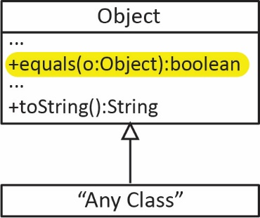
As discussed in Chapter 3, Section 5, every class inherits certain methods from the Object class. As shown in the diagram on the right, one of those methods is equals. The Object class defines an equals method as shown on the right. Thus, every class inherits the equals method. The implementation of equals in the Object class returns true if two objects occupy the same location in memory and false otherwise.
For example, consider the code below (code in example_equals_basic_account package) and the object diagram on the right. Since ba1 and ba3 point to the same object in memory, they are equal. Since, ba1 and ba2 point to the different objects in memory, so they are not equal.
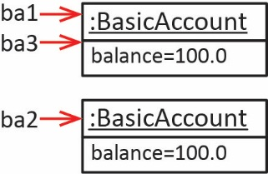
BasicAccount ba1 = new BasicAccount(100.0);
BasicAccount ba2 = new BasicAccount(100.0);
BasicAccount ba3 = ba1;

System.out.println(ba1.equals(ba3)); // true
System.out.println(ba1.equals(ba2)); // false
Thus, the implementation of equals in the Object class is exactly the same as the “==” boolean operator:
System.out.println(ba1==ba3); // true
System.out.println(ba1==ba2); // false
Many classes in the Java API override equals to define what it means for two objects to be “equal” in a particular context. For example, the String class overrides equals to return true if the contents of two strings are the same. For example:
String x = "Cat";
String y = "Hat";
String z = "Cat";

System.out.println(x.equals(y)); // false
System.out.println(x.equals(z)); // true
It is frequently useful to override the equals method to supply your own, custom definition of equals. For example, you may want to have a situation where two different Person objects are considered equal if they have the same SSN (regardless of their name, or any other details). I call this logical equality. In other words, implementing equals so that two distinct objects in memory are considered equal. Why this is useful will be illustrated in the next section. For now, the short answer is that the ArrayList class has some methods that depend on equals being overridden.
The signature of the equals method is:
public boolean equals(Object o)
Generally, we want the equals method to compare two objects of the same type. However, notice that equals accepts an Object. Thus, when we override it should cast o to the class that is overriding equals (usually).
Suppose we have a Person class as shown below and we want to we override equals to return true when two Person objects have the same ssn, regardless of their names. The code for this and subsequent variations are found in the example_equals_person package.
Class | Sample Code
public class Person {  protected int ssn;  protected String name;  public Person(String name, int ssn) {  this.ssn = ssn;  this.name = name;  }  @Override  public boolean equals(Object o) {  if(o instanceof Person) {  Person p = (Person)o;  if(this.ssn == p.ssn) {  return true;  }  else {  return false;  }  }  else {  return false;  }  }  } | Person p1 = new Person("Shay", 123);  Person p2 = new Person("Shay", 456);  Person p3 = new Person("Julie", 123);  System.out.println(p1.equals(p2)); // false  System.out.println(p1.equals(p3)); // true  Notice that p1 and p3 are different objects in memory. However, they are considered equal because they have the same SSN, regardless of the fact that they have different names.
Note that the equals method above can be written much more succinctly
public boolean equals(Object o) {
if(o instanceof Person) {
Person p = (Person)o;
return this.ssn == p.ssn;
}
return false;
}
Alternatively, if we want two Person objects to be considered equal if they have the same ssn and name, we could override equals as shown below. Notice that when we are comparing name, which is a String, that we use the String class’s equals method.
public boolean equals(Object o) {
if(o instanceof Person) {
Person p = (Person)o;
return (this.ssn == p.ssn) &&
(this.name.equals(p.name));
}
return false;
}
(The code for this variation is not in the code download) Suppose a Person class has firstName and lastName properties and that two Person objects should be considered equal if both their first and last names are the same:
public boolean equals(Object o) {
if(o instanceof Person) {
Person p = (Person)o;
return (this.lastName.equals(p.lastName)) &&
(this.firstName.equals(p.firstName));
}
return false;
}
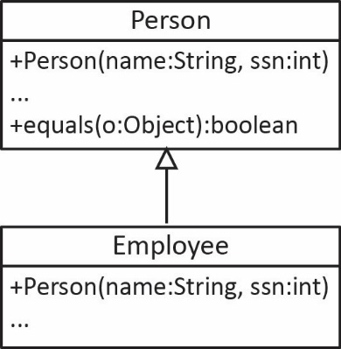
Example – Suppose we have the Person class above, which overrides equals so that two Person objects are considered equal if they have the same ssn. Suppose we also have a subclass of Person named Employee. If Employee does not override equals then it inherits the Person classes’ equals method. Thus, a Person and an Employee could be equal.
Person p1 = new Person("Shay", 123);
Employee e1 = new Employee("Jeri", 123);
Employee e2 = new Employee("Jeri", 789);
Employee e3 = new Employee("Suze", 789);

System.out.println(p1.equals(e1)); // true
System.out.println(e1.equals(e2)); // false
System.out.println(e2.equals(e3)); // true

Exercises
- (Solution in exercise_martian_equals) Suppose you have a Martian class with wavelength and elevation properties which are both int. Write an equals method for this class so that two Martian objects are considered equal if both their wavelength and elevation properties are equal.
- (Solution in exercise_department_equals) Suppose you have a Department class with code and number properties which are both String. For example, a code might be, “Engineering”, and number might be, “023”. Write an equals method for this class so that two Department objects are considered equal if both their code and number properties are equal.
- (Solution in exercise_rectangle_equals) Consider the Rectangle class below. Add an overridden equals method so that two Rectangles are considered equal if their areas are within 0.1 of each other.
public class Rectangle {
private double length;
private double width;

public Rectangle(double length, double width) {
this.length = length;
this.width = width;
}

public double area() {
return length*width;
}
@Override
public String toString() {
String msg = String.format("len=%,.2f, wid=%,.2f, area=%.2f",
length, width, area());
return msg;
}
}
For example, the following test code:
public class RectangleTest {
public static void main(String[] args) {
testEquals();
}

public static void testEquals() {
Rectangle r1 = new Rectangle(2.0,4.0);
Rectangle r2 = new Rectangle(2.0,5.0);
Rectangle r3 = new Rectangle(1.95,4.06);

String msg = String.format("r1.area()=%.2f, r2.area()=%.2f,
r3.area()=%.2f", r1.area(), r2.area(), r3.area());
System.out.println(msg);
System.out.println("r1.equals(r2)=" + r1.equals(r2));
System.out.println("r1.equals(r3)=" + r1.equals(r3));
}
}
Would produce these results:
r1.area()=8.00, r2.area()=10.00, r3.area()=7.92
r1.equals(r2)=false
r1.equals(r3)=true

Methods that rely on equals
As stated earlier, an ArrayList can hold any type of object, in particular, objects from a custom class:
ArrayList<Person> people = new ArrayList<>();
ArrayList<CheckingAccount> accounts = new ArrayList<>();
It is important to remember that an ArrayList (like an Array) stores references to objects. Thus, when you use get you are getting a reference to the object. If you then use that reference to call a method that changes the state of the object, then the ArrayList contains a reference to this changed object (of course!).
If you want to use the methods below on an ArrayList of a custom class, then the class must override equals.
public boolean contains​(Object o)
public int indexOf​(Object o)
public int lastIndexOf​(Object o)
public boolean remove​(Object o)
For example, consider Java’s implemention of indexOf below. Note that elementData is the array inside the ArrayList that holds the elements. Here, we see that the method simply loops over the elements in the array and checks to see if any one of them is equal to the argument, o. Note also that the contains method simply delegates to indexOf.
ArrayList indexOf Method | ArrayList contains Method
public int indexOf(Object o) {  ...  for (int i = 0; i < size; i++) {  if (o.equals(elementData[i]))  return i;  }  return -1;  } | public boolean contains(Object o) {  return indexOf(o) >= 0;  }
(Code is in example_equals_arraylist_dogs package) For example, suppose we have a situation where two Dog objects should be considered equal if they have the same name. As shown below on the left, we override equals. On the right, we illustrate the methods above.
Dog Class | Example
public class Dog {  private String name;  public Dog(String name) {  this.name = name;  }  public boolean equals(Object o) {  if(o instanceof Dog) {  Dog d = (Dog)o;  return name.equals(d.name);  }  return false;  }  } | ArrayList<Dog> dogs = new ArrayList<>(  Arrays.asList(  new Dog("Juno"),  new Dog("Leo"),  new Dog("Chaps"),  new Dog("Ace"),  new Dog("Chaps")  ));  System.out.println(  dogs.contains(new Dog("Ace"))); // true  System.out.println(  dogs.indexOf(new Dog("Chaps"))); // 2  System.out.println(  dogs.indexOf(new Dog("Zoro"))); // -1  System.out.println(  dogs.lastIndexOf(new Dog("Chaps"))); // 4  System.out.println(  dogs.remove(new Dog("Chaps"))); // true  System.out.println(  dogs.remove(new Dog("Zoro"))); // false

Example: 1-to-Many
The code for this example is in the example_person_accounts_arraylist package.
Consider the major example considered in Ch 3, Section 8, and continued through the end of that chapter. Here, consider that same example except that we change the array that holds the BasicAccounts to an ArrayList. We also add a few new methods (highlighted in yellow in the class diagram below). We also change the requirements of the addAccount method. See the code found on the Schedule. Below, we will consider all the methods in the Person class, and the two highlighted methods in BasicAccount.
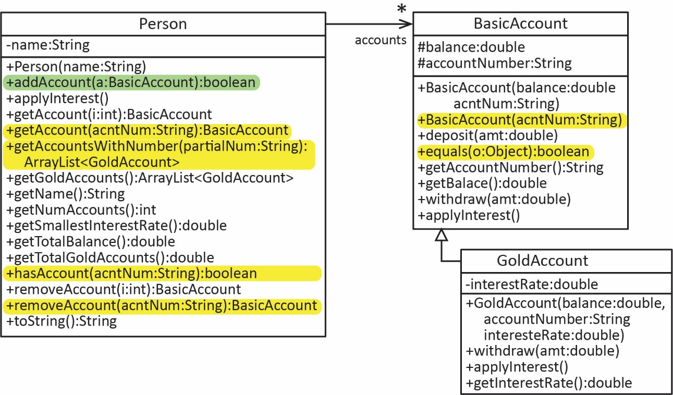
- Before we look at the modifications to the Person class, we choose to add a new requirement for accounts: two BasicAccount objects are considered the same (equal) if they have the same accountNumber. Thus, we override the equals method in BasicAccount to reflect this:
public boolean equals(Object o) {
if(!(o instanceof BasicAccount)) {
return false;
}
BasicAccount otherAccount = (BasicAccount)o;
return this.accountNumber.equals(otherAccount.accountNumber);
}
- Now, we begin to modify the Person class. First, consider the instance variables from the array implementation:
private String name;
private BasicAccount[] accounts = new BasicAccount[10];
private int numAccounts = 0;

For the ArrayList implementation, we need:
private String name;
private ArrayList<BasicAccount> accounts = new ArrayList<>();
Notice that we no longer need the numAccounts instance variable. The reason is simple: the ArrayList itself has a size method that always tells exactly how many objects it holds. Thus, getNumAccounts changes:
Array implementation | ArrayList implementation
public int getNumAccounts() {  return numAccounts;  } | public int getNumAccounts() {  return accounts.size();  }
- We add two new requirements for the addAccount method:
- An account is added only if it doesn’t already exist (i.e. there isn’t an existing account with the same accountNumber).
- Return true if the account is added successfully, and false otherwise.
Thus, we modify the addAccount to first check to see if the account we are attempting to add already exists.
public boolean addAccount(BasicAccount a) {
if(accounts.contains(a)) {
return false;
}
accounts.add(a);
return true;
}
Remember that the contains method works, here, because we have overridden equals in BasicAccount.
- Next, we consider the applyInterest method which changes only slightly:
Array implementation | ArrayList implementation
public void applyInterest() {  for(int i=0; i<numAccounts; i++)  accounts[i].applyInterest();  } | public void applyInterest() {  for(BasicAccount a : accounts) {  a.applyInterest();  }  }  // Alternate version using indexed loop  public void applyInterestAlternate() {  for(int i=0; i<accounts.size(); i++) {  accounts.get(i).applyInterest();  }  }
Notice in the first ArrayList implementation, we no longer require an indexed for loop. The for-each loop iterates over only the accounts that have been added. However, we can use an indexed for loop as shown in: applyInterestAlternate.
- Next, we consider the getAccount method which changes only slightly:
Array implementation | ArrayList implementation
public BasicAccount getAccount(int i) {  if(i>=0 && i<numAccounts) {  return accounts[i];  }  return null;  } | public BasicAccount getAccount(int i) {  if(i>=0 && i<accounts.size()) {  return accounts.get(i);  }  return null;  }
- Next, we add a new, overloaded getAccount that accepts an account number and returns the account that has an account number that matches the argument, if it exists, and null otherwise.
public BasicAccount getAccount(String accountNumber) {
- A brute-force solution is:
public BasicAccount getAccount2(String accountNumber) {
for(BasicAccount acnt : accounts) {
if(acnt.getAccountNumber().equals(accountNumber)) {
return acnt;
}
}
return null;
}
- A better approach that makes use of the BasicAccount’s equals method, indirectly through the use of indexOf is:
public BasicAccount getAccount(String accountNumber) {
BasicAccount acntKey = new BasicAccount(accountNumber, 0.0); // Create dummy account
int pos = accounts.indexOf(acntKey); // Find location of dummy account in list
if(pos>=0) { // If the location >=0, then found
return accounts.get(pos); // Return the real (matching) account
}
return null;
}
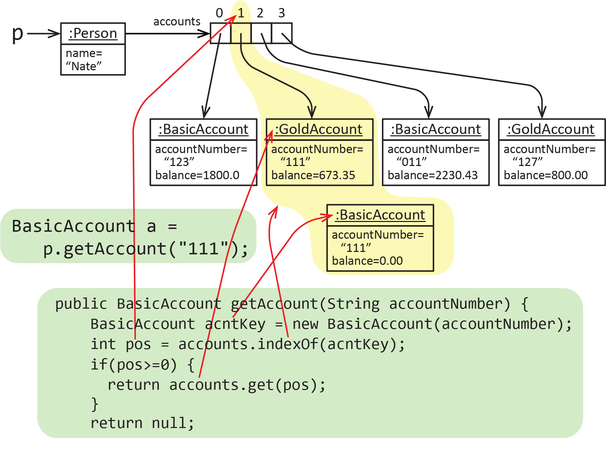
This approach creates a dummy account, acntKey using the supplied account number and an arbitrary initial balance of 0.0. Then, the dummy account is passed to indexOf to find the position of the dummy in the accounts list. Provided the return position is 0 or greater, the account at that location is returned.

Why is this approach better? If you replace a loop with a method call (indexOf), the code is simpler and less subject to error.
To make this approach slightly simpler, we introduce a new constructor in the BasicAccount class which only accepts an account number:
protected BasicAccount(String accountNumber) {
this(accountNumber, 0.0);
}
Thus, the first line of the method can be replaced with:
BasicAccount acntKey = new BasicAccount(accountNumber); // Create dummy account

- Next, we introduce a new method that accepts the beginning of an account number (a partial account number) and returns an ArrayList of all accounts that begin with that partial account number.
public ArrayList<BasicAccount> getAccountsWithNumber(String partialNum) {
In other words, the method returns accounts whose first characters exactly match partialNum. For example, suppose a Person has 4 accounts as shown below. Then, calling the method with “12” returns a list with the first and last accounts.

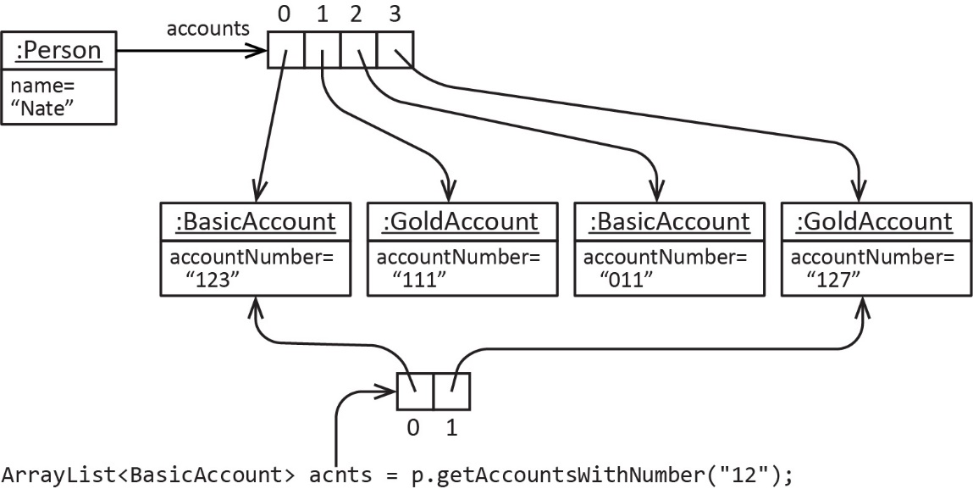
In this case, we will have to use brute force, that is, loop through all the accounts and see which one’s match.
public ArrayList<BasicAccount> getAccountsWithNumber(String partialNum) {
ArrayList<BasicAccount> acntMatches = new ArrayList<>();
int len = partialNum.length();
for(BasicAccount a : accounts) {
if(a.getAccountNumber().substring(0,len).equals(partialNum)) {
acntMatches.add(a);
}
}
return acntMatches;
}
- The getGoldAccounts method is considerably simplified with the introduction of the ArrayList.
- With the array approach, we had to use a helper method (getNumGoldAccount – not shown) to count the number of GoldAccounts so that we could set the appropriate size for the return array:
public GoldAccount[] getGoldAccounts() {
GoldAccount[] gAcnts = new GoldAccount[getNumGoldAccounts()];
int j=0;
for(int i=0; i<numAccounts; i++) {
BasicAccount a = accounts[i];
if(a instanceof GoldAccount) {
gAcnts[j++] = (GoldAccount)a;
}
}
return gAcnts;
}

- With the ArrayList approach, we don’t need to count the GoldAccounts because an ArrayList can hold any number of objects:
public ArrayList<GoldAccount> getGoldAccounts() {
ArrayList<GoldAccount> gAcnts = new ArrayList<>();
for(BasicAccount a : accounts) {
if(a instanceof GoldAccount) {
gAcnts.add((GoldAccount)a);
}
}
return gAcnts;
}
- The getTotalBalance, getSmallestInterestRate, and getTotalGoldAccounts methods require small changes:

public double getTotalBalance() {
double sum=0.0;
for(BasicAccount a : accounts) {
sum += a.getBalance();
}
return sum;
}

public double getSmallestInterestRate() {
double smallestIntRate = Double.MAX_VALUE;
for(BasicAccount a : accounts) {
if(a instanceof GoldAccount) {
GoldAccount ga = (GoldAccount)a;
if(ga.getInterestRate()<smallestIntRate) {
smallestIntRate = ga.getInterestRate();
}
}
}
return smallestIntRate;
}

public double getTotalGoldAccounts() {
double sum = 0.0;
for(BasicAccount a : accounts) {
if(a instanceof GoldAccount) {
sum += a.getBalance();
}
}
return sum;
}
- We add a new method, hasAccount to see if an account exists for a supplied account number. The approach is similar to getAccount(acntNum:String) where we used a dummy account as the search key for the contains method:
public boolean hasAccount(String accountNumber) {
BasicAccount acntKey = new BasicAccount(accountNumber);
if(accounts.contains(acntKey)) {
return true;
}
return false;
}

Alternately, we could use the indexOf method:
public boolean hasAccountAlternate(String accountNumber) {
BasicAccount acntKey = new BasicAccount(accountNumber);
int pos = accounts.indexOf(acntKey);
if(pos>=0) {
return true;
}
return false;
}
- Next, we modify the removeAccount(i:int) method to reflect that we are using an ArrayList. Notice, of course, that we no longer need to shift the accounts to the right of the one being deleted, over one position to the left, because, the ArrayList does this for us.
public BasicAccount removeAccount(int i) {
if(i>=0 && i<accounts.size()) {
BasicAccount retAccount = accounts.get(i);
accounts.remove(i);
return retAccount;
}
return null;
}
Note, that we could do this in one line of code the ArrayList’s remove(i:int) method returns the item that was removed.
public BasicAccount removeAccountAlternate(int i) {
if(i>=0 && i<accounts.size()) {
return accounts.remove(i);
}
return null;
}
- We introduce a new method, removeAccount(acntNum:String) that removes and returns an account based on an account number. Notice that we use the “dummy” account approach again as we did with the overloaded getAccount method that accepts an account number:
public BasicAccount removeAccount(String accountNumber) {
BasicAccount acntKey = new BasicAccount(accountNumber);
int pos = accounts.indexOf(acntKey);
if(pos>=0) {
return accounts.remove(pos); // uses index to remove
}
return null;
}
Note, that we could use the alternate version below which uses remove(obj:Object). However, it does not return the object that was removed (it returns true if the item was removed and false otherwise).
public BasicAccount removeAccountAlternate(String accountNumber) {
BasicAccount acntKey = new BasicAccount(accountNumber);
int pos = accounts.indexOf(acntKey);
if(pos>=0) {
BasicAccount retAccount = accounts.get(pos);
accounts.remove(acntKey); // uses Object to remove
return retAccount;
}
return null;
}

Exercises
- (Solution in practice_probem_corporation_salesreport_arraylist) Consider the CorporationReports class from a Ch. 3 Exercise. There, we saw that CorporationReports had many SalesReports (and subclass DetailedSalesReport). Do the following in the CorporationReports class:
- Change the reports instance variable from an array to an ArrayList.
- Remove the numReports instance variable.
- Change the getDetailedReports method so that it returns an ArrayList<DetailedReport> instead of an array. Modify the method appropriately so that it supports this change and adapts to the reports instance variable (ArrayList)
- Modify all methods to adapt to the reports instance variable (ArrayList). Hint: the example above is a bit more complicated because of the fact that we override equals and enforce a “no duplicates” policy. For this reports problem, we are not overriding equals, and so some of the methods are simpler than the corresponding ones above.
- Modify the test code.

Lists of Lists
The code for the example in this section is in the example_list_of_lists_of_scores package.
The generic type argument for an ArrayList can be any valid reference type. For example, suppose we have a number of lists and we would like to group them together. If the lists are all the same type, then we can create a list of lists. For example, suppose we have test scores for several sections of a class, where each section’s scores are in its own list.
ArrayList<Integer> sec1Scores = new ArrayList<>(Arrays.asList(78,89,82,94,73));
ArrayList<Integer> sec2Scores = new ArrayList<>(Arrays.asList(98,94,86,91,93,85 ));
ArrayList<Integer> sec3Scores = new ArrayList<>(Arrays.asList(63,78,74,68));
Suppose we want to create an ArrayList, sections to store these lists, then we would specify the generic type argument as ArrayList<Integer> as that is the type of each element in the list.
ArrayList<ArrayList<Integer>> sections = new ArrayList<>();
Next, we add the three sections:
sections.add(secScores1); sections.add(secScores2); sections.add(secScores3);
We can access the second list:
ArrayList<Integer> sec = sections.get(1);
We can iterate over the list of lists using an enhanced for loop:
for(ArrayList<Integer> section : sections) {
for(int score : section) {
System.out.print(score + " ");
}
System.out.print("\n");
}
Or, we can iterate over this list of lists using an indexed loop:
for(int i=0; i<sections.size(); i++) {
ArrayList<Integer> section = sections.get(i);
for(int j=0; j<section.size(); j++) {
int score = section.get(j);
System.out.print(score + " ");
}
System.out.print("\n");
}

Exercises
- (Solution in exercise_wordlists package) Consider the following class:
public class WordLists {
ArrayList<ArrayList<String>> lists = new ArrayList<>();

public WordLists() {}
}
Add the following methods to this class:

Method | Description
addList | Accepts an ArrayList of strings and adds it to lists.
getList | Accepts an integer index and if it is valid, returns the list at that index
countOccurrences | Accepts a string, word and returns the number of times word occurs in total over all the lists. No partial matches, words in the lists must exactly match word to be counted.
getAllWordsSorted | Returns an ArrayList of all the words in all the lists, sorted.
getTotalNumWords | Returns the total count of all the words in all the lists

- (Solution in exercise_list_of_lists_of_blobs package) Suppose you have a Blob class that contains an integer code which is supplied when it is created:
public class Blob {
int code;
public Blob(int code) {
this.code = code;
}
@Override
public String toString() {
return "Blob code=" + code;
}
}
Consider this snippet of code:
ArrayList<Blob> blobs1 = new ArrayList<>(Arrays.asList(
new Blob(2), new Blob(8), new Blob(6)));
ArrayList<Blob> blobs2 = new ArrayList<>(Arrays.asList(
new Blob(9), new Blob(4)));
ArrayList<Blob> blobs3 = new ArrayList<>(Arrays.asList(
new Blob(2), new Blob(8), new Blob(2), new Blob(3)));

ArrayList<ArrayList<Blob>> blobs = new ArrayList<>();
blobs.add(blobs1);
blobs.add(blobs2);
blobs.add(blobs3);
Write a static method, concatenateBlobList that accepts a list of lists of Blobs similar to the one shown above. This method should return a list of Blobs that contains all the blobs in all the lists.
- (Solution in exercise_list_of_lists_of_dogs package)Study the code below carefully. Fill in the blanks so that this code works properly.
_____________________ dogs1 = new ArrayList<>(Arrays.asList(new Dog(), new Dog()));

_____________________ dogs2 = new ArrayList<>(Arrays.asList(new Dog(), new Dog(),
new Dog()));

____________________________________ dogLists = new ArrayList<>();

dogLists.add(dogs1);
dogLists.add(dogs2);

for( _____________________ dogs : dogLists ) {

for(__________________ d : dogs)

System.out.println(d);
}

Legacy ArrayList
Generics was introduced in Java 1.5 (2004). Prior to that, the ArrayList class held Object instances. For backwards compatibility, Java allows the non-generic versions of all generic classes (and interfaces) in the API to be used (however, you will get a compile warning). For example, the ArrayList below is defined without generics.
ArrayList dogs = new ArrayList();
We can add a Dog because a Dog is an Object:
dogs.add(new Dog("Spot"));
Since the non-generic ArrayList holds Object instances, a cast is required when retrieving items (unless you want to retrieve an element as an Object):
Dog dog = (Dog)dogs.get(0);
Even though dogs is ostensibly for holding Dog objects, we can add any type of object:
dogs.add( new Computer("fast") );
So now the ArrayList holds a Dog at index 0, and a Computer at index 1. Suppose we get the Object at index 1 and (incorrectly) cast it as a Dog:
Dog d = (Dog)dogs.get(1);
The code compiles, but it will generate a runtime error when the line is executed and throws a ClassCastException. Thus, one of the benefits of generics as it provides type safety, meaning we detect errors at compile time.

Array vs. ArrayList
At this point in the course, I usually hear from a student, “why did we study arrays, when an ArrayList is simpler and more powerful?”. Some comments in response:
- An array is the basis for numerous data structures in computing, including the ArrayList itself, so it must be mastered in an introductory programming course. As an analogy, before using a nail gun, one must master the use of a hammer.
- When speed and memory are critical, then an array will provide better performance.
- If you have a fixed number of items, an array can be more efficient, and some consider it to be simpler.
- An ArrayList can’t store primitives. Thus, when primitives are added to an ArrayList they are wrapped (boxed) with the appropriate wrapper class, i.e. as an object. This increases memory. For example, an int requires 4 bytes, an Integer requires 16 bytes.
- An array can be 2-d, 3-d, or higher. These are useful for representing the visual environment of a game, an image, terrain maps, matrices, etc.
- Collections.sort converts the list to be sorted to an array before sorting.
- However, in my experience, I use an ArrayList instead of an array 95% of the time.

https://docs.oracle.com/javase/8/docs/api/java/util/ArrayList.html
Deprecated means that Oracle recommends that a class (or method, constructor, or field) not be used as it might not be supported in future releases.
https://docs.oracle.com/javase/8/docs/api/java/util/ArrayList.html
https://docs.oracle.com/javase/tutorial/java/generics/index.html
Technically, it accepts any type of Collection, a supertype of ArrayList. We consider this in a later chapter.
https://docs.oracle.com/javase/8/docs/api/java/util/Arrays.html
https://docs.oracle.com/javase/8/docs/api/java/util/Collections.html

