Chapter 3 – Inheritance

Contents
1 Introduction 2
2 The protected Visibility Modifier 4
3 The Object Class and its toString Method 5
4 Subclass Constructors and the super Keyword 6
5 Example – BasicAccount-GoldAccount 7
5.1 Exercises 8
6 Polymorphism & Dynamic Binding 9
7 Polymorphic Arrays 11
8 Example: 1-to-Many, Array Implementation 12
8.1 Account Management Methods 13
8.2 Iterative Methods 15
8.3 Exercises 16
9 Casting 17
10 Example: 1-to-Many, Array Implementation, Casting 21
10.1 Exercises 24
11 Using the super Keyword & Constructor Chaining 25
11.1 Implicit Call to super 25
11.2 Constructor Chaining 27
11.3 Exercises 29
12 Calling Overridden Superclass Methods 30
13 Preventing Extending and Overriding 32
14 OO Modelling 33
Appendix 1 The SalesReport Class 34
Appendix 2 Overriding vs. Overloading 35

Introduction
The example below is in the example_dog_wolfdog_ver1 package.
Suppose we have the Dog class shown on the left, below, and we need a new class, WolfDog as shown on the right:
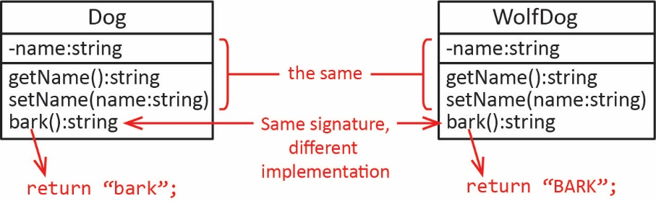
The two classes are similar; they have the same instance variable and two methods that are identical. They also both have a bark method with the same signature, but a different implementation. Java provides a mechanism (called inheritance or subclassing) that allows us to write this new class, WolfDog by extending the Dog class in a way that we don’t have to rewrite the members that are the same, they are inherited in the WolfDog class. Then, the WolfDog class can be customized as needed by adding additional members.
Using the inheritance approach, the Dog and WolfDog classes are shown below on the left and right, respectively. For now, no constructor is explicitly defined; thus, by default, each class has a no-arg constructor. We will learn about constructors shortly.
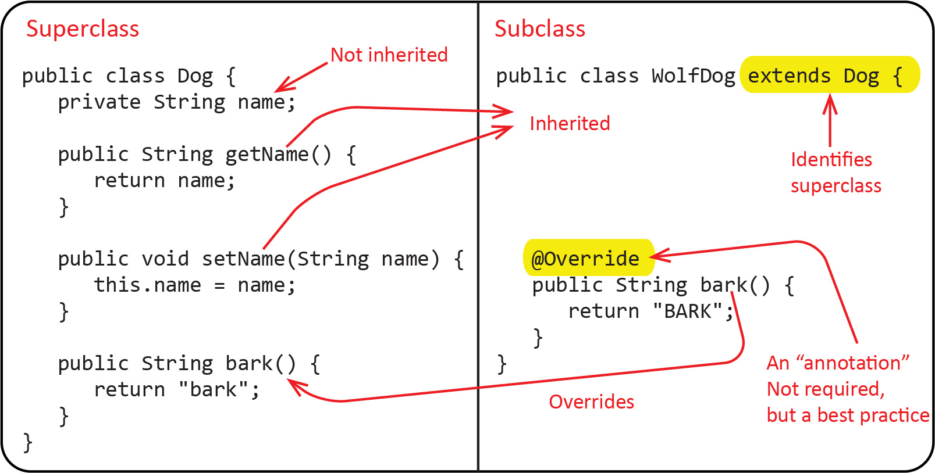
Note the following:
- There is nothing new in the Dog class. It is the same as classes we have written in the past.
- The Dog class is referred to as a superclass of the WolfDog class, while the WolfDog class is referred to as a subclass of the Dog class.
- The WolfDog class uses the extends keyword to declare its superclass.
- The Dog’s getName and setName methods are inherited by the WolfDog class. This simply means that the WolfDog class has these two methods without having to write any additional code.
- The Dog class’s name instance variable is not inherited and cannot be used in the WolfDog class. This is because it is declared private. The strange thing is that the WolfDog does have a name, but the WolfDog can only access it through getName and setName.
- The WolfDog class overrides the Dog’s bark method. This simply means that the WolfDog class redefines it instead of inheriting it.
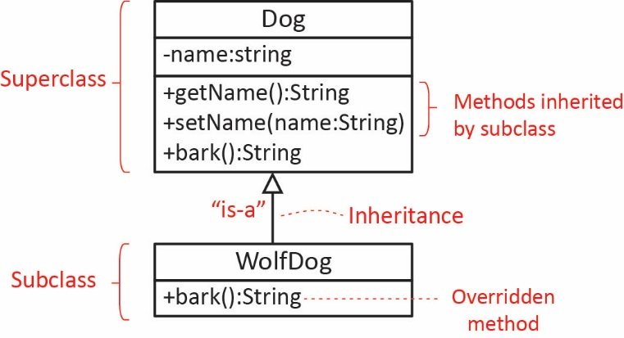
As shown in the class diagram on the right:
- We use a solid line with an open triangle pointing toward the superclass to denote a superclass-subclass relationship as shown in the diagram on the right. We also say that a WolfDog is-a Dog (but a Dog is not a WolfDog, more on this later).
- We usually do not show inherited methods in the subclass, though we can if it is helpful. However, we should show overridden methods.

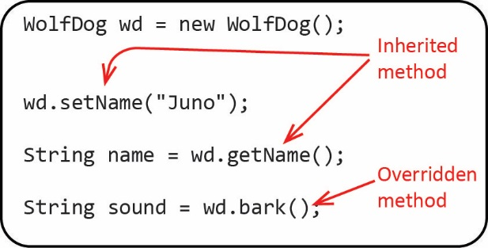
We can use the WolfDog class just as we would use any class as shown on the right. Note that the WolfDog object can call the setName and getName methods because they are inherited.

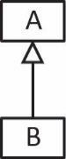
More generally, suppose we have a class, A and we need a new class, B that is similar to A. Perhaps B requires the same instance variables and/or methods as A, but just needs to change the implementation of some of A’s methods, or add some new state and/or behaviors. The technique we use allows us to define a new class, B by extending class A. In Java, we define B like this:
public class B extends A {
We call A the superclass and B a subclass. Note the following about the new class, B:
- B can be created and used just as any class can.
- B inherits all of A’s instance variables and methods (but not constructors) that are not private (i.e. public, and default visibility). This means that all non-private instance variables and methods defined in A are automatically members of B without having to rewrite them (code reuse).
- If B wants to change a (non-private) method in A then it can override the method. This is done by writing the method in B with the same signature as the method in A, but with a different implementation.
- B can add new members that are not in A (illustrated shortly).
- An instance of B can be used anywhere an instance of A is required (but not the other way around) (illustrated shortly).
We explore this useful technique throughout this chapter and the remainder of the course. In this chapter and the next we will learn all the major points about inheritance, in general, learning specifically about inheritance, polymorphism, dynamic binding, abstract classes and methods, and interfaces. In subsequent chapters, we will use classes from the Java API and as we will see, they are almost all subclasses. Thus, it is important to understand what behaviors are inherited from the superclasses. You should memorize the points above. You should reread these regularly as we go through this chapter and the next. You should add to this list as you learn more about inheritance in the chapter and the next.

The protected Visibility Modifier
The example below is in the example_dog_wolfdog_ver2 package.
The protected visibility modifier can be applied to any member (instance variable, method, constructor) of a class. For example, suppose we define a class, A, in a package named pack1. Then, any member of A that is declared with protected visibility is available:
- To any other class in the same package (pack1): B & C, below.
- To any subclass of A defined in any package: E, below.
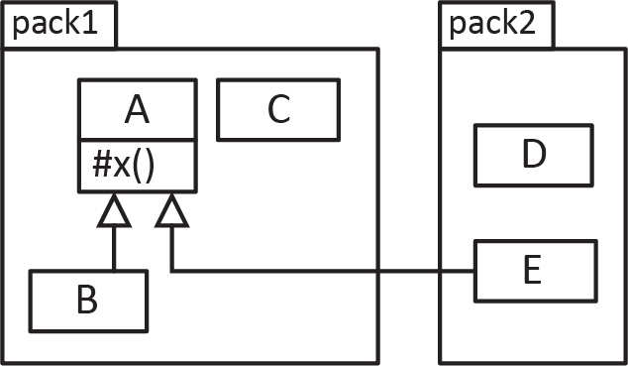
For example, note the following about the image on the right:
- A class diagram uses “#” to denote a protected member of a class.
- B inherits x because it is a subclass of A.
- E inherits x because it is a subclass of A even though it is in a different package.
- C can access (use) x because it in the same package.
- D cannot access x because it is in a different package and not a subclass of A.
Continuing the Dog-WolfDog example, if we make the name instance variable, protected, then we can use it in the WolfDog’s bark method:
Dog Class | WolfDog Class
public class Dog {  protected String name;  public String getName() {  return name;  }  public String bark() {  return "bark";  }  } | public class WolfDog extends Dog {  @Override  public String bark() {  return name + ": BARK";  }  }
In this case, it is not a big deal because we simply could have used the inherited, getName:
@Override
public String bark() {
return getName() + ":BARK";
}
However, using protected means that the subclass can define a method that changes name. This may or may not be what we want in a particular situation. For example, if you have an Employee class with a ssn (Social Security Number, a unique identifier), you would probably not want a subclass, HourlyEmployee to be able to change the ssn. Thus, you would declare ssn as private in Employee. You could make the same argument above, that name should be private; however, for the sake of the example we declare it protected.

The Object Class and its toString Method
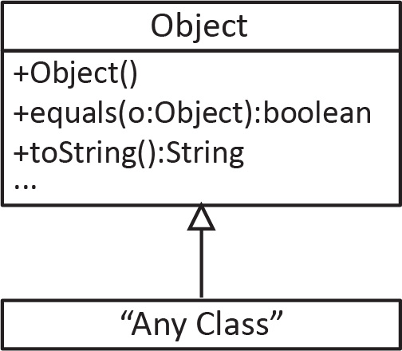
Object is a class in the Java API and it defines a number of public methods including the toString method (also the equals method which we consider in the next chapter. If a class does not extend another class, then it automatically extends Object. Thus, Object is a superclass of every class. For example:
public class Dog {}
is identical to:
public class Dog extends Object {}
Thus:
- Every class is-a Object.
- Every class inherits the toString method.
In previous chapters, we saw that it is best practice to write a toString method for every class. Now, we can see that we are overriding the Object class’s toString. What this means is that when we write a toString method in a class, as we have done before, we are really overriding the Object class’s toString method (or overriding the toString of the immediate superclass). In the example below Dog overrides Object’s toString, and WolfDog overrides Dog’s toString. If WolfDog did not override toString, then it would inherit Dog’s toString.
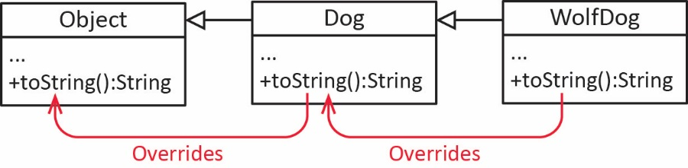
Finally, not only, “a WolfDog is-a Dog “, but also:
- A Dog is-a Object
- A WolfDog is-a Object

Subclass Constructors and the super Keyword
Constructors are not inherited; each class must have its own constructor. A subclass constructor can explicitly call an immediate superclass constructor with matching parameter list as shown below.
super( argList );
This must be the first statement in the constructor. Any other initialization would occur after the call to super.
The first line of a subclass’s constructor must either use:
- this to call another constructor in the subclass or
- super to call a constructor in the immediate superclass
For example, the Dog and WolfDog classes below each have a constructor that accepts a name. As shown, we use: super(name) in the WolfDog constructor to call the Dog constructor that accepts a string. The example below is in the example_dog_wolfdog_ver3 package.
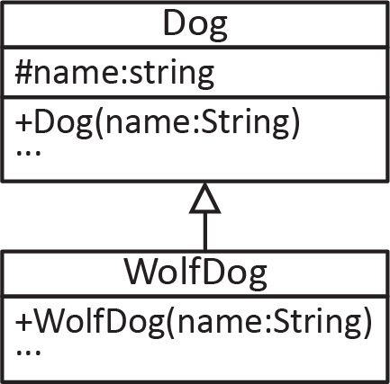
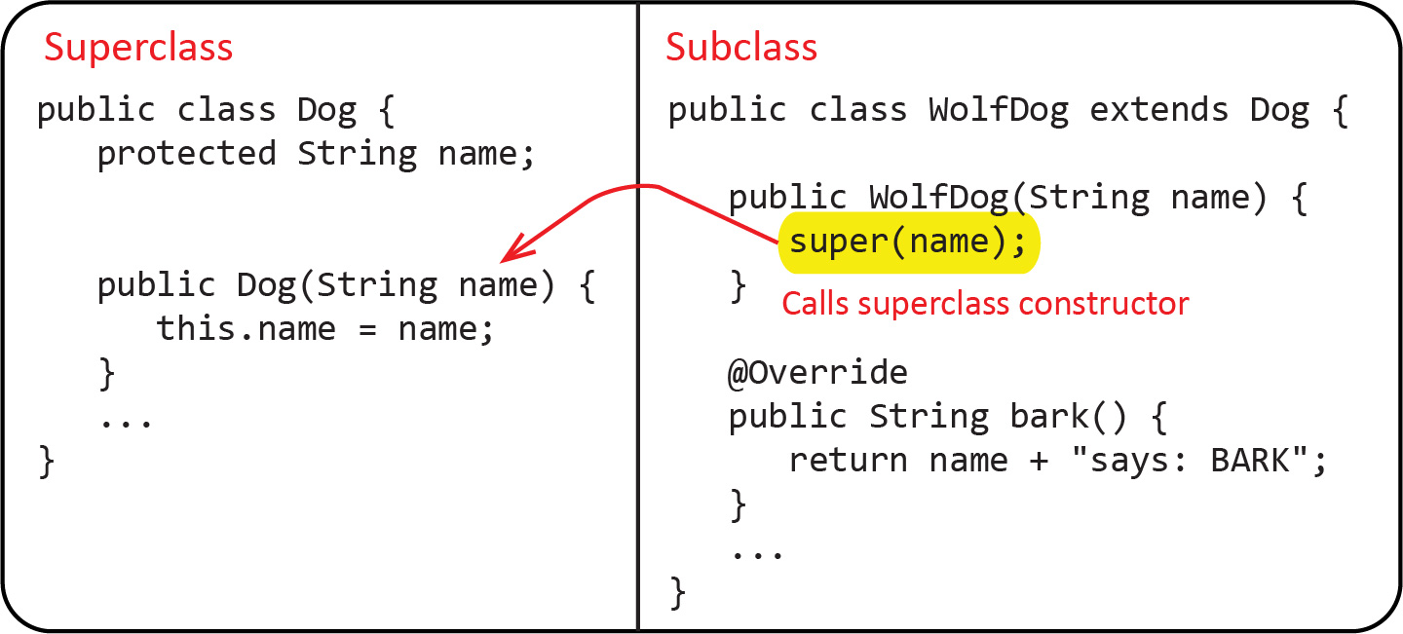
A subclass constructor should not directly access the superclass’s inherited instance variables.
Consider a modification to WolfDog so that it has a toughness property. The example below is in the example_dog_wolfdog_ver4 package.
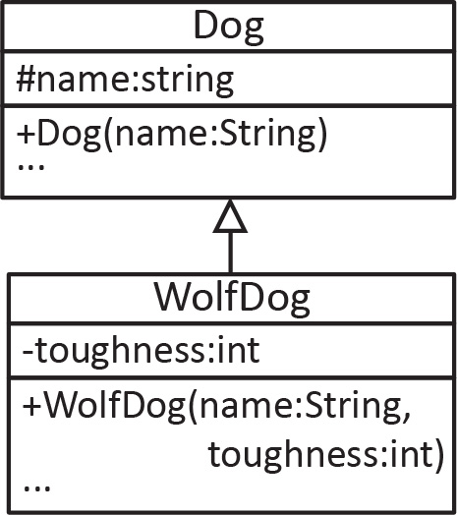
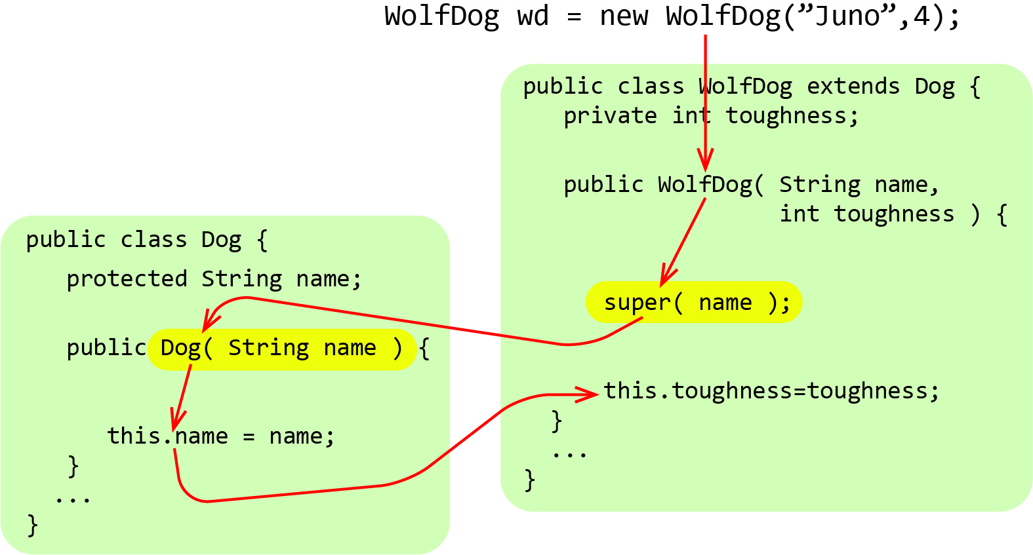

Example – BasicAccount-GoldAccount
The example below is in the example_basicaccount_goldaccount package.
Suppose we have a BasicAccount class, as shown below, that allows clients to deposit and withdraw money. In addition, there is an endOfMonth method that charges a service fee of $5, and if the balance is less than 0, then a $25 overdraft fee is also charged. Note that the balance field has protected visibility.
public class BasicAccount {
protected double balance;
private String name;

public BasicAccount(String name, double balance) {
this.name = name; this.balance = balance;
}
public double getBalance() { return balance; }
public String getName() { return name; }

public void deposit(double amount) { balance += amount; }
public void withdraw(double amount) { balance -= amount; }

public void endOfMonth() {
balance -= 5.0;
if(balance<0.0) { balance -= 25.0; }
}
...
}
Now, suppose we need a GoldAccount class that is the same as BasicAccount except for two features:
- GoldAccount needs an interest rate instance variable.
- The endOfMonth method applies the interest rate to the balance if the balance is greater than zero, otherwise it charges a $10 overdraft fee.
We can write the GoldAccount subclass as shown below:
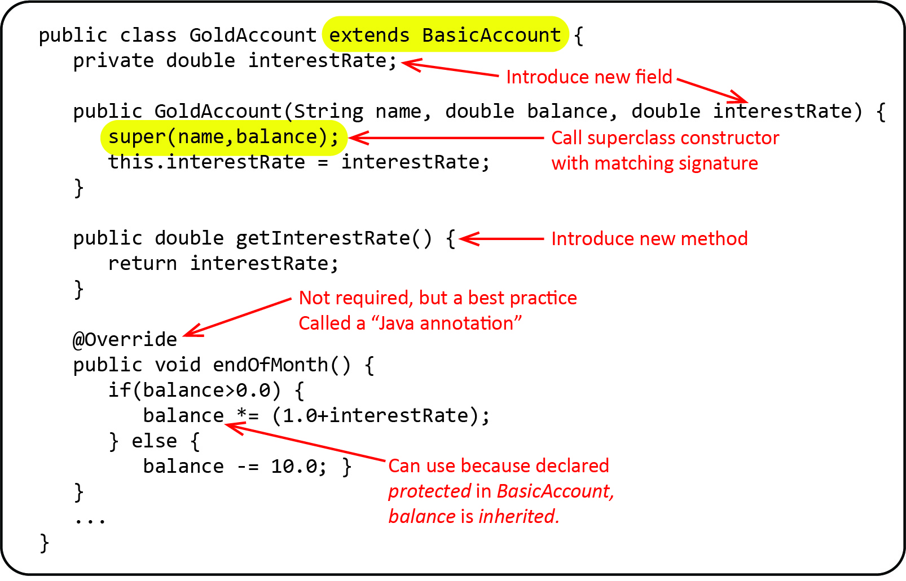
Note:
- An instance variable, interestRate is introduced in the subclass that is not in the superclass. Similarly, the getter for this variable is new in the subclass.
- The super(…) statement in the constructor calls the superclass constructor that has the same signature (String, double).
We can use the two classes as shown below:
BasicAccount | GoldAccount
BasicAccount ba = new BasicAccount("Leon",90.0);  System.out.println("Account created: " + ba);  ba.deposit(10.0);  System.out.println("$10 deposited : " + ba);  ba.endOfMonth();  System.out.println("End of month : " + ba);  Output:  Account created: Basic: bal=$90.00, name=Leon  $10 deposited : Basic: bal=$100.00, name=Leon  End of month : Basic: bal=$95.00, name=Leon | GoldAccount ga = new GoldAccount("Shay",90.0,0.1);  System.out.println("Account created: " + ga);  ga.deposit(10.0);  System.out.println("$10 deposited : " + ga);  ga.endOfMonth();  System.out.println("End of month : " + ga);  Output:  Account created: Gold: bal=$90.00, name=Shay  $10 deposited : Gold: bal=$100.00, name=Shay  End of month : Gold: bal=$110.00, name=Shay

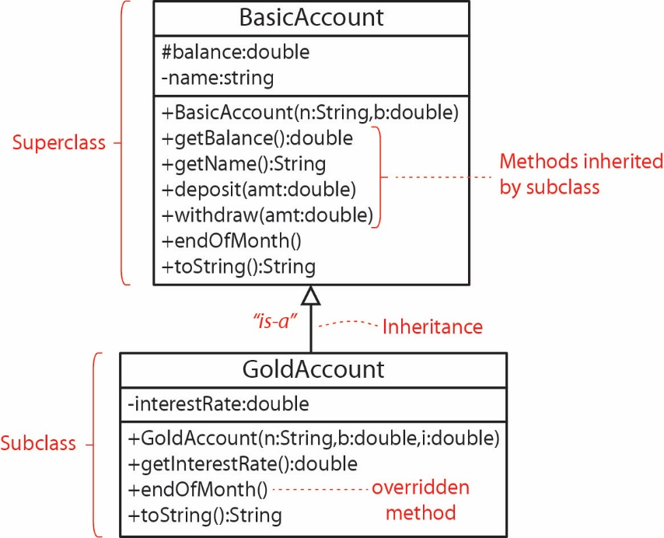
As a review, note the following:
- We represent these two classes in the class diagram shown on the right.
- We say a GoldAccount is-a BasicAccount. We can see this because a GoldAccount is, in a sense a superset of BasicAccount.
- However, a BasicAccount is-not-a GoldAccount. For example, it doesn’t have an interestRate. (This is considered in more detail in Section 9.)

Exercises
- (Solution in exercise_cellular_account package) Consider the CellularAccount class found in Exercises from Chapter 1 (code for this class can be found in the code download for Chapter 1, exercise_cellular_account package, CellularAccountVer8 class). Write a DeluxeCellularAccount class with the following characteristics:

In addition to the parameters the CellularAccount constructor takes, it also accepts a value for the freeMinutes instance variable.

The getAmountDue method changes so that the first freeMinutes are free (no cost). After that, the minutes up to minutesMax are billed at the default rate, costPerMin. Finally, minutes over minutesMax are billed at a rate 20% higher than costPerMin. For example:

Example 1: Suppose minutesUsed = 50.0, minutesMax = 500.0, costPerMin=0.05, freeMinutes=100 then:
getAmountDue() = $0.00
Example 2: Suppose minutesUsed = 200.0, minutesMax = 500.0, costPerMin=0.05, freeMinutes=100 then:
getAmountDue() = 100*0.05 = $5.00
Example 3: Suppose minutesUsed = 600.0, minutesMax = 500.0, costPerMin=0.05, freeMinutes=100 then:
getAmountDue() = 400*0.05 + 100*(1+0.2)*0.05 = $20.00 + $6.00 = $26.00
- (Solution in exercise_salesreport package) Consider the SalesReport class found in Appendix 1. Immediately after the class, there are some notes and a description of exactly what you need to do.
- Rewrite the code for the SalesReport class making the changes mentioned in Appendix 1.
- Write the code for DetailedSalesReport class (See Appendix 1 for description).
- Write a snippet of code to test the DetailedSalesReport class.
- Draw a class diagram that shows the revised SalesReport class and the DetailedSalesReport class.

Polymorphism & Dynamic Binding
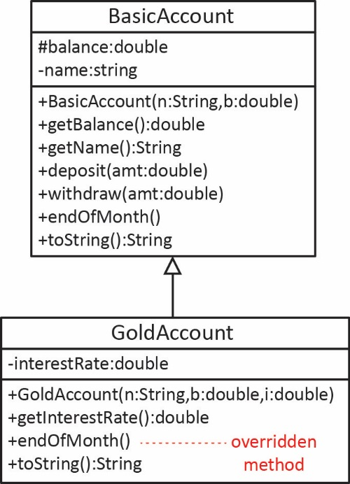
Consider the example considered earlier, shown in the class diagram on the right. As shown below, we can create a GoldAccount but refer to it as a BasicAccount.
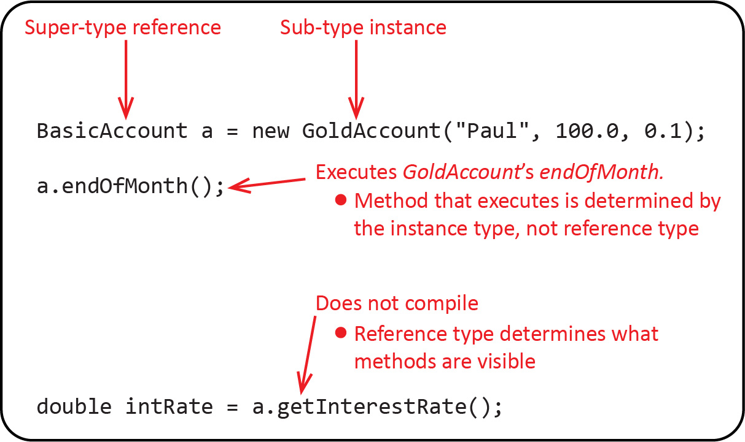
Note the following:
- We can always use a super-type reference to refer to a sub-type instance. This is referred to as polymorphism. A super-type reference is a polymorphic reference because the reference variable can hold an instance of many different classes: BasicAccount and any subclasses.
- The endOfMonth method that executes is determined by the actual instance type, not the reference type. In this case, the instance is GoldAccount. This is referred to as dynamic binding. It is called dynamic binding because at run-time, when a method is called, the JVM asks object what its actual type is, and then calls the method in that class.
- The reference type (BasicAccount) determines what methods are visible (can be called). For example, even though the variable, a, above is actually a GoldAccount object, only the methods defined in the reference type, BasicAccount can be called. Thus, we can use a to call: getBalance, getName, deposit, withdraw, endOfMonth, and toString. We cannot use a to call getInterestRate; it cannot be seen because it is not defined in BasicAccount.
- A natural question would be, why we would even want to use a super-type reference especially in light of the fact that we might not be able to access all the methods that the instance actually contains? Using a super-type reference is a best practice, when possible. It is the basis for building extensible and maintainable software systems. We will discuss this further as we go along.
The first three bullets above should be understood completely and memorized.
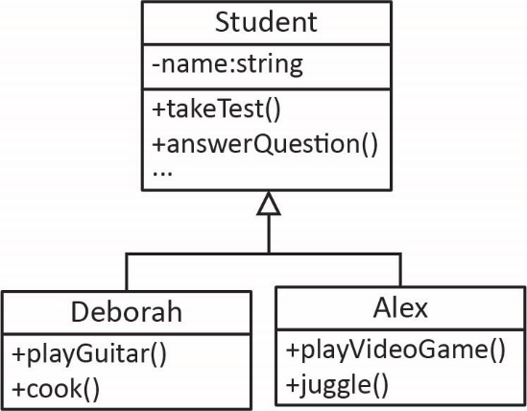
Non-software example – Consider the relationship between the reference type and the instance type discussed above. I think of it this way: the reference type is a lens through which you can see the instance and it can only reveal what is defined in the lens (reference type). For example, each of you is a person with unique capabilities (methods). However, I can only access (see) you through the lens of a Student. Thus, I can ask you to answerQuestion, takeTest, etc. However, I cannot ask you to playGuitar, cook, etc because my Student lens can’t see those behaviors.
To implement dynamic binding when a method is called, the JVM goes through a process like this:
Get the type of the instance.
If ( instance contains a definition for the behavior )
Execute behavior
Else
Find behavior in superclass & execute
Thus, the method is bound to the call at run-time (dynamically).
Consider the example below to illustrate polymorphism and dynamic binding.
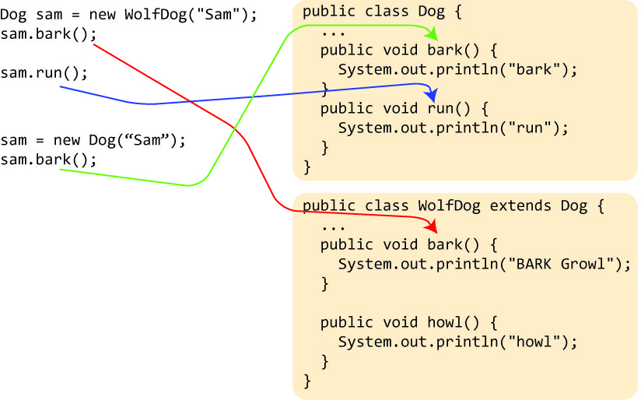
Note the following:
- First, we create a WolfDog instance, sam, but give it a (super-type) Dog reference.
- Since sam is actually a WolfDog instance, when the bark method is called, the WolfDog’s bark method is called (red arrow).
- Next, the run method is called. Since the WolfDog class does not define a run method, the JVM finds a run method in the Dog superclass (blue arrow).
- sam cannot be used to call the howl method. It would not compile because sam is a Dog reference type which doesn’t define a howl method. This point is not indicated in figure above.
- Finally, the Dog reference, sam is assigned to an instance of a Dog and then the bark method is called. Thus, the Dog class’s bark method is called (green arrow).
- Dynamic binding means that the actual method that runs is determined at run-time by the actual type of the instance, not the reference type.
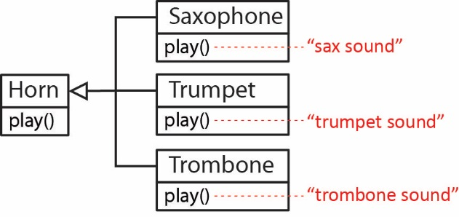
Why is polymorphism useful? Consider this non-software example – In the figure on the right, Saxophone, Trumpet, and Trombone are subclasses of Horn and each one overrides the play method in a way that is appropriate for the specific type of instrument (instance). Thus, each plays notes differently. When the conductor gestures with her baton for the horn section to play she is referring to them polymorphically, however each horn plays according to what type of horn it actually is.
The important point is, the conductor simply has to say, “Horn’s play”. She doesn’t need to know the actual sublcasses, she just has to know that they are horns and they will play appropriately. We explore this more as we go along.
Polymorphism and dynamic binding are really useful because they allow us to write code that uses supertypes that will operate on any subtypes (even ones that haven’t been written yet!). This gives programs flexibility and extensibility. It makes methods generic in a sense. We explore this extensively as we move along. It probably will take a long time before the usefulness and importance of this fully sinks in. These are one of the cornerstones of object-oriented programming.

Polymorphic Arrays
As shown below, we can create an array of BasicAccount which can hold BasicAccount objects as well as GoldAccount objects. Why? Because a GoldAccount is-a BasicAccount. Or, more formally, as we stated before, anywhere a super-type is required, a sub-type can be used.
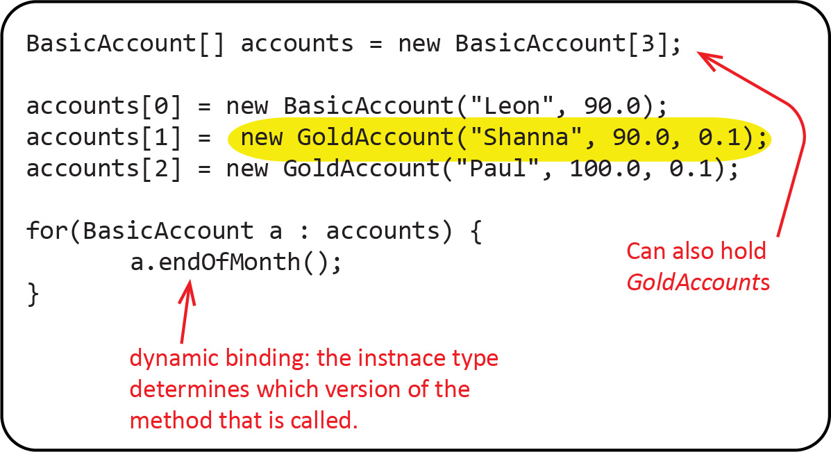
Note the following:
- We use a BasicAccount reference for the array; however, since a GoldAccount is-a BasicAccount, the array can also hold GoldAccounts (or any other subclass of BasicAccount or subclass of GoldAccount).
- As we iterate over accounts in the for loop above, each account has a BasicAccount reference type so we can only call methods defined (public and protected) in that class. Thus, we can’t call getInterestRate because it is defined in the GoldAccount class. However, through dynamic binding, the “correct” endOfMonth is called, depending on the actual instance type.
- As shown below, an array of type GoldAccount can only hold GoldAccount objects (and any subclass of GoldAccount); however, it cannot hold BasicAcocunt object because a BasicAccount is-not-a GoldAccount.

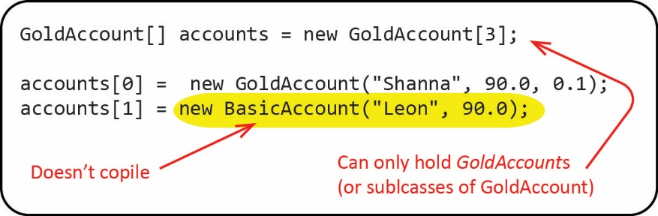

Example: 1-to-Many, Array Implementation
The code for the example in this section is found in the example_person_accounts_array package. Note that the code also contains methods added in a later section.
The fact that an array defined with a super-type reference can contain items of that class or any subclass provides for a useful implementation of the 1-to-many relationship.
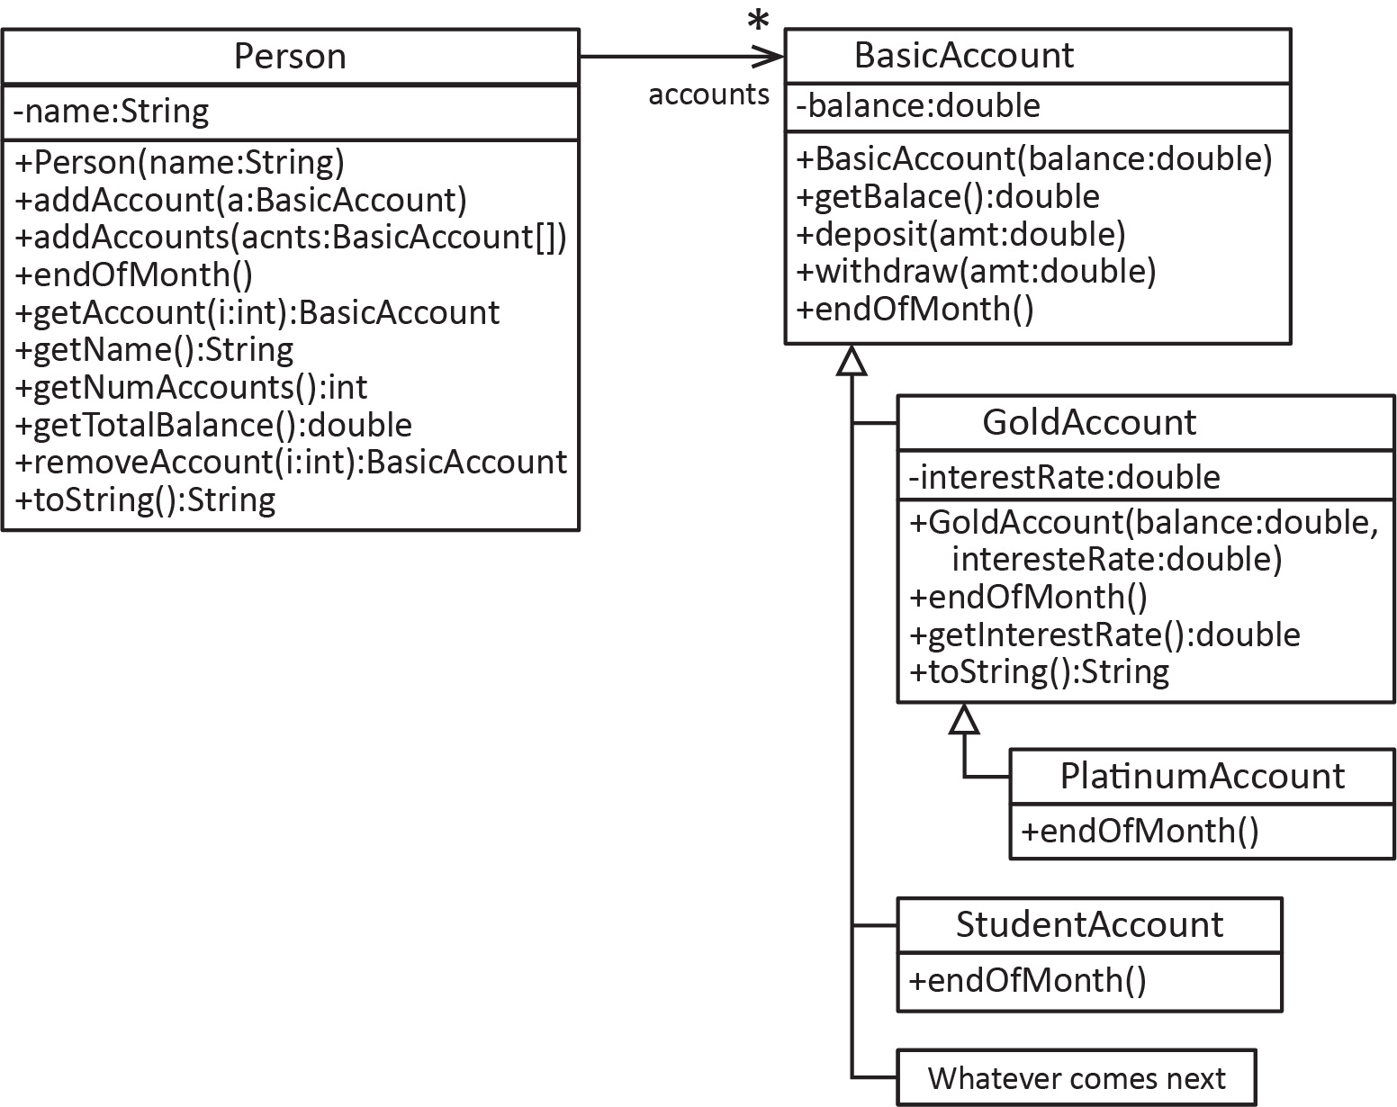
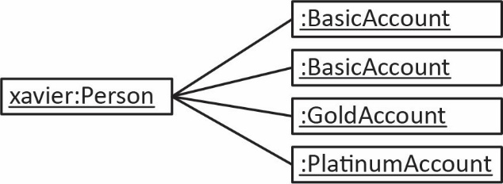
Note the following about the classes above:
- A Person can have many accounts and the accounts themselves can be of various types. For example:

- Look at the parameters and return types of the methods in the Person class. None of the methods in the Person class depend on any of the subclasses; they only depend on BasicAccount. For example, addAccount accepts anything that is-a BasicAccount. This means that we can add new subclasses and not have to modify the Person class.
- The account class hierarchy is extensible, meaning we can add new classes without breaking the Person class.
Let’s look carefully at some of the methods in the Person class above. Much of this is a review of concepts we considered in the last chapter.

Account Management Methods
Review: The first instance variable below holds the accounts. We’ve arbitrarily set a maximum of 10 accounts. The second instance variable initializes the number of accounts to zero.
private BasicAccount[] accounts = new BasicAccount[10];
private int numAccounts = 0;
Review: As we saw in the last chapter, it is typical to store the accounts sequentially in the array, accounts. For example, if the person has 3 accounts, they would be in positions 0, 1, 2, respectively; and numAccounts=3.
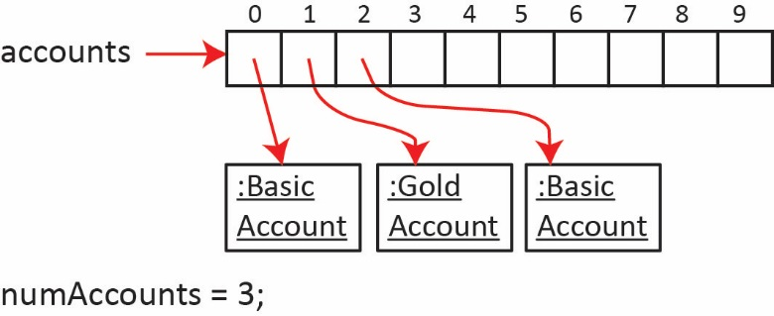
Thus, the next account that is added would go in position 3, and the number of accounts would increase to 4.
Mostly Review: The addAccount method :
public void addAccount(BasicAccount a) {
if(numAccounts<accounts.length) {
accounts[numAccounts++] = a;
}
}
Note the following:
- Review: We check to make sure there is room in the array before adding a new account:
numAccounts<accounts.length
- Review: We put the new account, a in the next available position which is found at index: numAccounts, (e.g. if there are currently 3 accounts, then then next one is added at index 3), and increment the number of accounts: numAccounts++

- New: Since the method uses a super-type reference (BasicAccount) to define its parameter, this means that the method can accept any kind of account:

Person p = new Person("Lenze");
BasicAccount ba = new BasicAccount(1900.0);
GoldAccount ga1 = new GoldAccount(500.0, 0.1);

p.addAccount(ba);
p.addAccount(ga1);

Review: The getNumAccounts method returns the number of accounts in the array.
public int getNumAccounts() {
return numAccounts;
}

Mostly Review: The getAccount method returns the account at index i, provided the index is valid:
public BasicAccount getAccount(int i) {
if(i>=0 && i<numAccounts) {
return accounts[i];
}
return null;
}
Note the following:
- Review: We check that i is valid by verifying that it is: $0≤i<numAccounts$:
if(i>=0 && i<numAccounts)
otherwise, we return null. Note that we do not check that i is less than the length of the account’s array:
if(i>=0 && i<accounts.length) {
because the array can have any number of accounts, 10 or less. The exact number is contained in the instance variable: numAccounts, so we use that for checking if an index is valid.
- New: We use a super-type reference (BasicAccount) to define its return type. Thus, we can obtain a reference to the second account with:
BasicAccount ba2 = p.getAccount(1);
Note that although the second account added above is in fact a GoldAccount, we cannot refer to it as that because the return type is BasicAccount. For example, this will not compile because the return type for the method is BasicAccount:
GoldAccount ga3 = p.getAccount(1);
Soon we will see how we can “convert” ba2 above to a GoldAccount through a process called casting, should we need to do this.

You can never use a sub-type reference to refer to something that is being referred to with a super-type reference. However, the converse is always true: you can always use a super-type reference to refer to something that is being referred to with a sub-type reference. For example, this is valid:
Object o = p.getAccount(1);
Although valid, it probably would not be particularly useful as the only method we could call on o is toString (or any other methods in the Object class, but none of the BasicAccount methods).
Review: The removeAccount method accepts an index of the account to remove, and if the index is valid: (a) it returns that account, (b) moves all accounts to the right over one position to the left, and (c) decrements the number of accounts. If the index is not valid, the method returns null.
public BasicAccount removeAccount(int i) {
if(i>=0 && i<numAccounts) {
BasicAccount renmovedAccount = accounts[i];
for(int j=i+1; j<numAccounts; j++) {
accounts[j-1] = accounts[j];
}
numAccounts--;
return renmovedAccount;
}
return null;
}

Iterative Methods
Review: The getTotalBalance method simply iterates over the accounts that exist in the array, asking each account to return its balance.
public double getTotalBalance() {
double sum=0.0;
for(int i=0; i<numAccounts; i++) {
sum += accounts[i].getBalance();
}
return sum;
}
Notice above (highlighted in yellow), that we iterate over only the accounts that exist in the array, namely, from index 0 to numAccounts-1. Either of the two approaches below, which iterate over all elements in the array would fail unless there were in fact 10 accounts in the array. Thus, clearly, these are mistakes:
getTotalBalance2 Method | getTotalBalance3 Method
public double getTotalBalance2() {  double sum=0.0;  for(int i=0; i<accounts.length; i++) {  sum += accounts[i].getBalance();  }  return sum;  } | public double getTotalBalance3() {  double sum=0.0;  for(BasicAccount a : accounts) {  sum += a.getBalance();  }  return sum;  }
Mostly Review: The endOfMonth method loops through the accounts that exist (0 through numAccounts-1) and calls endOfMonth on each one (delegation) and the actual endOfMonth method that is called depends on the actual type of the instance (dynamic binding):
public void endOfMonth() {
for(int i=0; i<numAccounts; i++)
accounts[i].endOfMonth();
}
New: The addAccounts method accepts an array of BasicAccounts, loops through them, and adds each one to the accounts array (using the addAccount method).
public void addAccounts(BasicAccount[] accounts) {
for(BasicAccount a : accounts) {
addAccount(a);
}
}
This method accepts an array of BasicAccount or an array of any subclass. For example:
An array of BasicAccount:
Person p = new Person("Nate");
BasicAccount ba = new BasicAccount(1900.0);
GoldAccount ga1 = new GoldAccount(500.0, 0.1);
GoldAccount ga2 = new GoldAccount(2300.0, 0.1);
BasicAccount[] bAcnts = {ba,ga1,ga2};
p.addAccounts(bAcnts);
An array of GoldAccount:
GoldAccount ga3 = new GoldAccount(1500.0, 0.07);
GoldAccount ga4 = new GoldAccount(2000.0, 0.09);
GoldAccount[] gAcnts = {ga3,ga4};
p.addAccounts(gAcnts);

Exercises
- (Solution in exercise_corporation_salesreports_array package) This continues from Exercise 1. Below, we define the shell of a CorporationReports class that stores up to 10 SalesReports (or DetailedSalesReport). Write the three methods that are indicated with a comment.
public class CorporationReports {
private SalesReport[] reports = new SalesReport[10];
private int numReports = 0;
public CorporationReports() {
}
public int getNumReports() {
return numReports;
}
public void addReport(SalesReport rpt) {
// Write code here
}
public SalesReport getReport(int i) {
// Write code here
}
public SalesReport removeReport(int i) {
// Write code here
}
}

- (Solution in exercise_service_provider_cellular_accounts package) Consider the ServiceProvider class below which has an array of CellularAccount objects (from a previous Exercise). Add the following methods:
- getAverageAmountDue – This method returns the average amount due for all the accounts.
- getAverageMinutesOverMax – This method returns the average number of minutes used, but only for accounts where the minutes used is above the max number of minutes for the account.
Write a ServiceProviderTest class to test these methods.
public class ServiceProvider {
private CellularAccount[] accounts = new CellularAccount[10];
private int numAccounts = 0;
public ServiceProvider() {
}
public int getNumAccounts() {
return numAccounts;
}
public void addAccount(CellularAccount a) {
if(numAccounts<accounts.length) {
accounts[numAccounts++] = a;
}
}
public CellularAccount getAcount(int i) {
if(i>=0 && i<numAccounts) {
return accounts[i];
}
return null;
}
public CellularAccount removeAccount(int i) {
if(i>=0 && i<numAccounts) {
CellularAccount removedAccount = accounts[i];
for(int j=i+1; j<numAccounts; j++) {
accounts[j-1] = accounts[j];
}
numAccounts--;
return removedAccount;
}
return null;
}
@Override
public String toString() {
StringBuilder msg = new StringBuilder();
msg.append("Account List\n");

for(int i = 0; i < numAccounts; i++) {
msg.append(String.format("%d. %s \n",
(i+1), accounts[i].toString()));
}
return msg.toString();
}
}

Casting
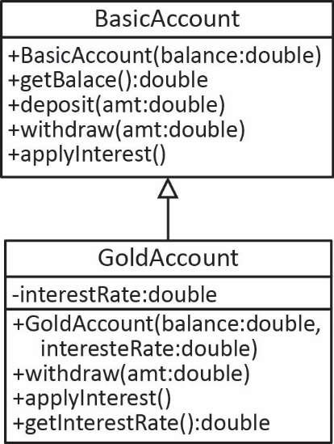
Suppose you have a super-type reference to a sub-type instance. Casting is a technique to gain access to the methods that are only defined in the sub-type. Consider the class diagram on the right and the code below.
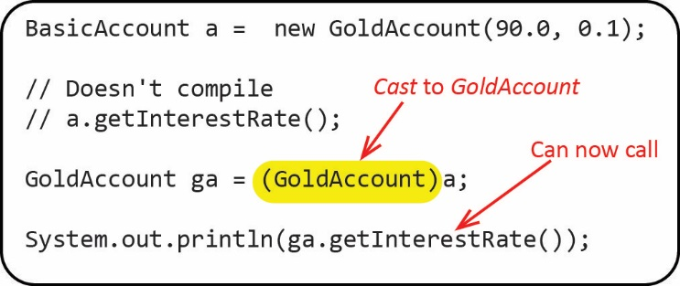
Note the following:
- Review: We create a BasicAccount reference, a, to a GoldAccount instance.
- Review: Even though the instance is a GoldAccount, we cannot call the getInterestRate method as it is not defined in BasicAccount.
- New: We can cast the instance referred to by the reference variable a, to a GoldAccount reference (because it really is one). Then, we can call the getInterestRate method.
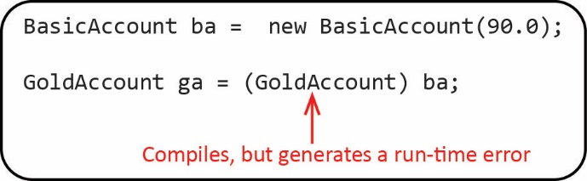
Casting can fail. The code on the right compiles, but generates a run-time error when executed: ClassCastException. The reason is simple: A GoldAccount is-a BasicAcocunt, but a BasicAccount is-not-a GoldAccount.
So why does the code compile? A BasicAccount reference, ba, can refer to a GoldAccount instance (as shown in the first example above). Thus, when you write this statement:
GoldAccount ga = (GoldAccount)ba;
the compiler doesn’t know the exact type of instance that ba refers to (it could be basic or gold); that is only known at runtime.
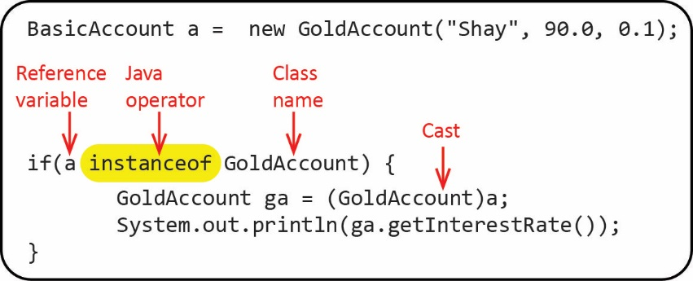
The safe way to cast is, before casting, to make sure the instance is really an instance of the class you want to cast to. As shown below, Java’s instanceof operator takes a reference variable on the left and a class name on the right, returning true if the reference variable refers to an instance that is-a instance of the class name.
In the example above, a is a GoldAccount, so instanceof returns true. The reference, a would also return true for either of these statements as well:
if(a instanceof BasicAccount) {
BasicAccount ba = (BasicAccount)a;
}
if(a instanceof Object) {
Object o = (Object)a;
}
Java 16 (March 2021) introduced a new technique for casting that accomplishes the casting automatically if instanceof returns true. For example:
if(a instanceof GoldAccount ga) {
System.out.println(ga);
}
Example
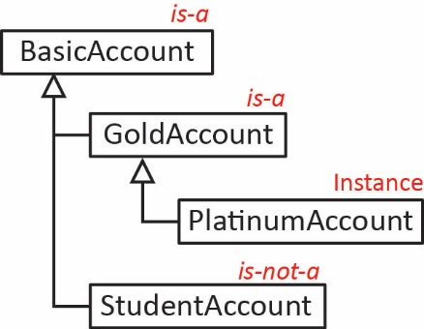
- Consider the inheritance hierarchy shown on the right. If the instance is a PlatinumAccount:
BasicAccount pa = new PlatinumAccount(600.0, 0.1);
Then, no matter what the reference type is:
System.out.println(pa instanceof GoldAccount); // true
System.out.println(pa instanceof BasicAccount); // true
System.out.println(pa instanceof StudentAccount); // false
Note the following: A PlatinumAccount
- is-a GoldAccount.
- is-a BasicAccount.
- is-not-a StudentAccount.
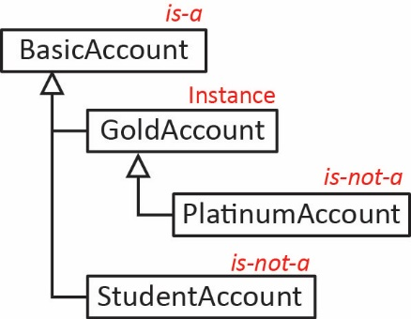
- Consider the inheritance hierarchy shown on the right. If the instance is a GoldAccount
BasicAccount ga = new GoldAccount(200.0, 0.15);
Then, no matter what the reference type is:
System.out.println(ga instanceof BasicAccount); // true
System.out.println(ga instanceof PlatinumAccount); // false
System.out.println(ga instanceof StudentAccount); // false
Note the following: A GoldAccount
- is-a BasicAccount.
- is-not-a PlatinumAccount.
- is-not-a StudentAccount.
Example – Consider the classes defined on the left and the static methods on the right.
Classes | Methods
class A {  public String toString() {  return "A";  }  }  class B extends A {  public String toString() {  return "B";  }  }  class C extends B {} | public static void m( A a ) {  System.out.println( a );  }  public static void m2( C c ) {  System.out.println( c );  }
State whether the method calls below will: (a) compile, (b) generate a run-time error, or (c) what output will it produce?: (a) m( new A() ); (b) m( new B() ); (c) m( new C() ); (d) m2( new C() ); (e) m2( new B() );
A summary of casting via an example. Consider these classes and the code below:
Explicit Casting (Downcasting)
Correct  Dog dog = new WolfDog();  WolfDog wdog = (WolfDog)dog; | Incorrect  Dog dog = new WolfDog();  WolfDog wdog = dog;  ***Compile error: incompatible types

Implicit Casting (Upcasting)
Correct:  WolfDog wdog = new WolfDog();  Dog dog = wdog;  Correct, but unnecessary:  Dog dog = (Dog)wdog; | Incorrect:  Dog dog = new Dog();  Person p = (Person)dog;  ***Compile error: inconvertible types

Example – Consider the class hierarchy shown on the left, below. Thus, if a variable has a reference type of W, we can use it to hold references to an instance of W or any of its descendants (classes that extend W), X, Y, or Z, as shown in the figure below. Consider carefully the variables defined: w, x, y, z and then the valid and invalid reassignments shown. For example, x=w is invalid because, x is of type X, which can only refer to instances of type X or Z.
Class Diagram | Relationships | References
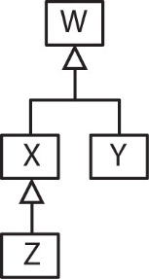 | - an X is-a W  - a Y is-a W  - a Z is-a X  - a Z is-a W.  But  - an X is not a Y  - an X is not a Z  - a Z is not a Y | W w = new W();  X x = new X();  Y y = new Y();  Z z = new Z();  Valid:  w=x; w=y; w=z;  x=z;  Invalid:  x=w;  x=y;  y=z;

Example: 1-to-Many, Array Implementation, Casting
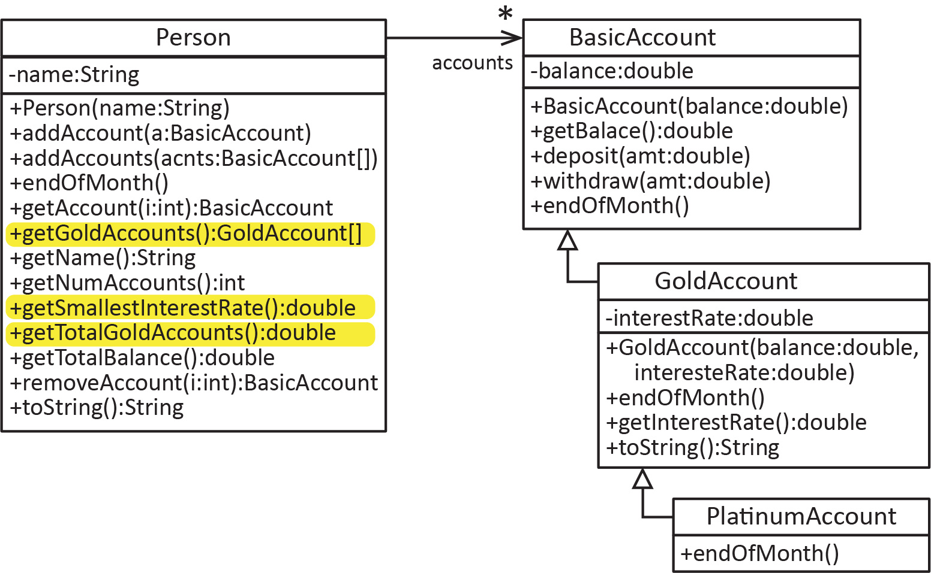
Consider the example from the Section 8. We add the methods that are highlighted yellow to the Person class. The code for the example below is in the example_person_accounts_array package.

First, we consider the getTotalGoldAccounts method which returns the total of all the balances for the GoldAccounts only
public double getTotalGoldAccounts() {
double sum = 0.0;
for(int i=0; i<numAccounts; i++) {
BasicAccount a = accounts[i];
if(a instanceof GoldAccount) {
sum += a.getBalance();
}
}
return sum;
}
Note:
- No casting was necessary since we are not calling a method that is only defined in the GoldAccount.
- This method will also include PlatinumAccounts (because a PlatinumAccount is-a GoldAccount). Thus, if we truly only wanted the sum of balances of just GoldAccounts, then we would need to exclude PlatinumAccounts:
if((a instanceof GoldAccount) && !(a instanceof PlatinumAccount)) {
sum += a.getBalance();
}

Next, we add the getSmallestInterestRate method which returns the smallest interest rate over all GoldAccounts:
public double getSmallestInterestRate() {
double smallestIntRate = Double.MAX_VALUE;
for(int i=0; i<numAccounts; i++) {
BasicAccount a = accounts[i];
if(a instanceof GoldAccount) {
GoldAccount ga = (GoldAccount)a;
if(ga.getInterestRate()<smallestIntRate) {
smallestIntRate = ga.getInterestRate();
}
}
}
return smallestIntRate;
}
Note:
- The reference variable, a is of type BasicAccount. Thus, it must be cast to GoldAccount because we are calling getInterestRate which is only defined in the GoldAccount.
- Using the newer technique for casting (Java 16 required):
if(a instanceof GoldAccount ga) {
if(ga.getInterestRate()<smallestIntRate) {
smallestIntRate = ga.getInterestRate();
}
}
- A variation of this problem is to return the GoldAccount with the smallest interest rate.
public GoldAccount getGoldAccountWithSmallestInterestRate() {
GoldAccount gaSmallest = null;
double smallestIntRate = Double.MAX_VALUE;
for(int i=0; i<numAccounts; i++) {
BasicAccount a = accounts[i];
if(a instanceof GoldAccount) {
GoldAccount ga = (GoldAccount)a;
if(ga.getInterestRate()<smallestIntRate) {
smallestIntRate = ga.getInterestRate();
gaSmallest = ga;
}
}
}
return gaSmallest;
}

Finally, we add the getGoldAccounts method to the Person class which returns a GoldAccount array of only the GoldAccounts. To do this, we are going to need to declare an array to hold the GoldAccounts that are returned:
public GoldAccount[] getGoldAccounts() {
GoldAccount[] gAcnts = new GoldAccount[“how big should it be”];
...
}
The problem is that we don’t know in advance how many GoldAccounts there are. Thus, we first write a helper method to count the number of GoldAccounts.
// Helper method to count the number of GoldAccounts.
private int getNumGoldAccounts() {
int count=0;
for(int i=0; i<numAccounts; i++) {
if(accounts[i] instanceof GoldAccount) {
count++;
}
}
return count;
}
Then, we call this method to create the array of the proper size:
public GoldAccount[] getGoldAccounts() {
GoldAccount[] gAcnts = new GoldAccount[getNumGoldAccounts()];
int j=0;
for(int i=0; i<numAccounts; i++) {
BasicAccount a = accounts[i];
if(a instanceof GoldAccount) {
gAcnts[j++] = (GoldAccount)a;
}
}
return gAcnts;
}
Note:
- We have to introduce a variable, j to keep track of the index of the current GoldAccount.
- We must cast a to be referred to as a GoldAccount in order to put it in the gAcnts array (because the array only holds GoldAccounts)
- Using the newer technique for casting (Java 16 required):
if(a instanceof GoldAccount ga) {
gAcnts[j++] = ga;
}
- We can call this method like this:
GoldAccount[] gAccounts = p.getGoldAccounts();

Exercises
- (Solution is in exercise_corporation_salesreports_array package). Continuing from the previous Exercise, add the following methods to the CorporationReports class:
public DetailedSalesReport getReportLargestAverageSalesDetailed() {
// Returns the DetailedSalesReport that has the maximum average sales value over only the
// Detailed reports. Hint: instanceof is used, and casting required. Write code here.
}

public double getLargestAverageSalesDetailed() {
// Returns the maximum average sales value over only the Detailed reports. Hint: instanceof
// is used, but not casting. Write code here.
}

public DetailedSalesReport[] getDetailedReports() {
// Returns an array of the DetailedSalesReports
// Write code here
}

// Helper method to return the number DetailedReports
private int getNumDetailedReports() {
}
Also, write a test class and test methods to test these methods.
- Define these terms in your own words:
- Reference type
- Supertype reference (or polymorphic reference)
- Polymorphism
- True or False
- You can always refer to a supertype instance with a subtype reference.
- You can always refer to a subtype instance with a supertype reference.
- You can always pass an instance of a subclass to a method with a parameter defined as a supertype.
- You can sometimes pass an instance of a superclass to a parameter defined as a subclass.
- Define dynamic binding in your own words.

- True or False
- An instance that is referenced by a supertype can call any methods on that instance as long as they are defined in the supertype.
- An instance that is referenced by a supertype can call any methods on that instance, even ones that are not defined supertype as long as they are defined in the subclass.

Using the super Keyword & Constructor Chaining

Implicit Call to super
If a constructor neither explicitly calls a superclass constructor, using super(…), nor calls a constructor in the same class, using this(…), then the compiler inserts a call to the superclass no-arg constructor, super() as the first line. For example, the two constructors below are identical:
Dog Constructor as Written | Dog Constructor after Compilation
public Dog(String name) {  this.name = name;  } | public Dog(String name) extends Object {  super();  this.name = name;  }
Since Dog does not explicitly extend another class, it automatically extends Object as we saw in Section 3. Thus, the implicit call to super() calls the Object class’s no-arg constructor, which in turn creates the object (Dog) in memory. We stated in Section 4 that a subclass constructor must always make a call to this or super as the first line. In a superclass (Dog) that is the top of the user-defined hierarchy, we may make a call to this; however, if we don’t, then we generally do not put an explicit call to super (as shown in the table above, on the left) as it is understood that it will automatically be calling the Object classes no-arg constructor to create the object in memory.
The example below illustrates a common mistake. The WolfDog constructor assigns the name parameter to the inherited name instance variable. This statement is legal, as the name instance variable in the Dog class is inherited because it has protected visibility. However, since there is no explicit call to this or super, the compiler inserts a call to super(). Since there is not a no-arg Dog constructor, WolfDog does not compile.
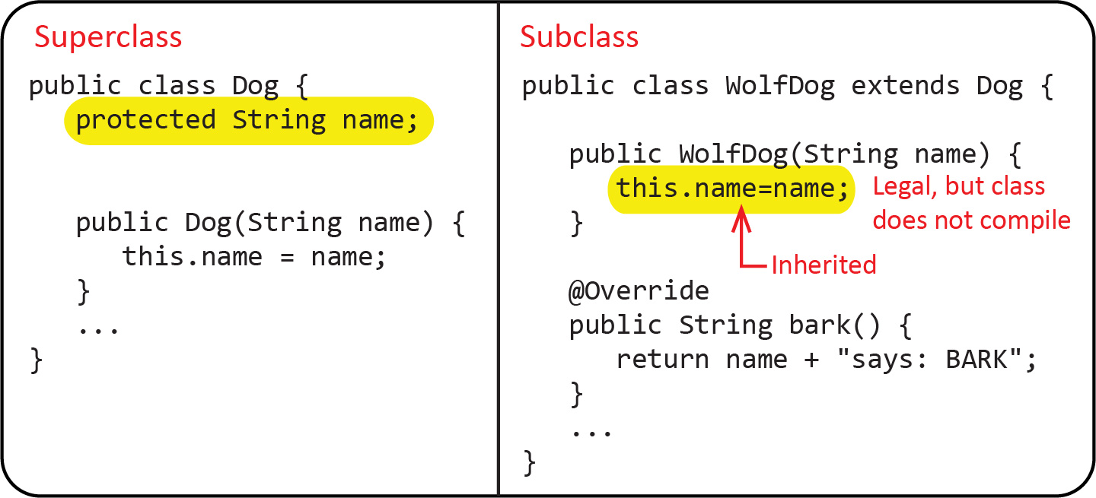 | The error message is a bit cryptic, so learn to recognize it:  error: constructor Dog in class Dog cannot be applied to given types;
As we saw in Section 4, the proper way to write the WolfDog constructor above is shown below. Also stated there, a subclass constructor should not directly access the superclass’s inherited instance variables.
public WolfDog(String name) {
super(name);
}

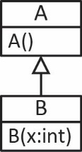
Example – As shown on the right and below, B is a sublclass of A. Note below (on left) that class B’s constructor does not explicitly call A‘s constructor; however, A’s no-arg constructor is implicitly called. This is so because, as shown, when a B object is created, it immediately (implicitly) calls the no-arg constructor in A because there is no explicit call to super or this in B’s constructor.
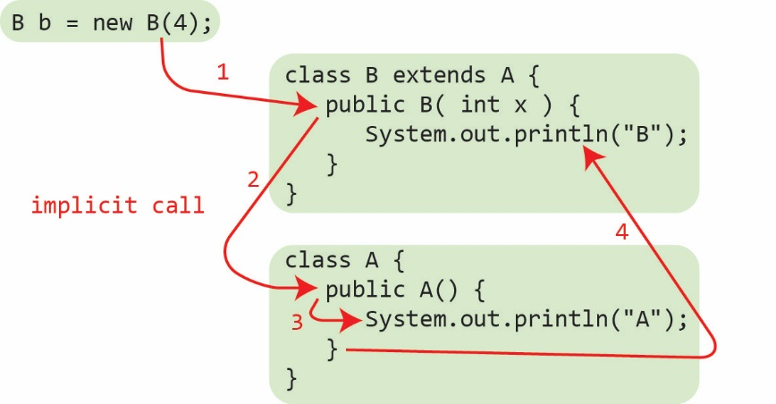 | The output is:  A  B  Thus, class B on the left is the same as below:  class B extends A {  public B( int x ) {  super();  System.out.println("B");  }  }
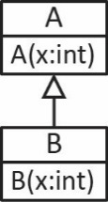
Example – The example below will not compile.
class A {  public A(int x) {  System.out.println("A");  }  } | class B extends A {  public B(int x) {  System.out.println("B");  }  }
Notice that B’s constructor does not explicitly call A’s constructor. Thus, the compiler inserts super(); however, there is no no-arg constructor in A. The compiler detects this and will not compile. The error message is a bit cryptic, so learn to recognize it:
error: constructor A in class A cannot be applied to given types;
Continuing the previous example, to “fix” the problem, both of these will compile: However, it depends on what you are trying to accomplish as to whether either of these is the right thing to do.
Approach 1 | Approach 2
class A {  public A() {}  public A(int x) {  System.out.println("A");  }  }  class B extends A {  public B(int x) {  System.out.println("B");  }  } | class A {  public A(int x) {  System.out.println("A");  }  }  class B extends A {  public B(int x) {  super(x);  System.out.println("B");  }  }

Constructor Chaining
A constructor can do one of three things:
- Call another constructor in the same class with: this( argList )
- Call a constructor in the immediate superclass with: super( argList )
- Implicitly call the no-arg constructor in the immediate superclass.
Thus, constructors can be chained together.
Rules of Constructor Chaining in Java:
- this() or super() must be the first statement in the constructor.
- We cannot use this() and super() in a same constructor, because both must be a first statement in the constructor and that is not possible.
- We cannot add this() in all the constructors of a same class, there should be at least one constructor without this() statement.
- If you do not add this() or super() in a constructor then Java compiler implicitly add a super() statement in the constructor that will call the immediate super class default (no-arg constructor).
- The execution of the constructor code (after this or super) occurs in the opposite order in which the constructors were called. For example, if we call constructors in 1, 2, 3 in that order, then the execution (after this or super) will be in the order: 3, 2, 1. We illustrate this below.
A constructor’s purpose is to define the initial state of an object (and possibly do some preliminary tasks). It does this by assigning initial values to the instance variables. Best practice is to strive to write constructors such that:
- The instance variables are only assigned a value in one constructor. The other constructors should call this constructor using this or super.
- There is only one constructor in a subclass that calls a constructor in the superclass.
Thus, in a super class, there should be one “main” constructor that does all the “work” and other constructors in that class should call it with this. The same is true for a subclass, except that the “main” constructor should also call “main” constructor in the superclass with super.
Example – (Solution in example_dog_wolfdog_constructor_chaining package) Write the Dog and WolfDog classes as described below:
Description of Dog Constructors | Description of WolfDog Constructors
A Dog can be created in two ways:  - With a name argument  - With no argument. In this case the name is set to “undefined” | A WolfDog is a subclass of Dog and also has a toughness property. A WolfDog can be created in three ways:  - With name and toughness arguments  - With a name argument in which case toughness is initialized to 1.0  - With no argument, in which case the name is set to “undefined” and toughness is initialized to 1.0

A class diagram is shown on the left, below. Study the code on the right, below carefully to see how the various constructors call one another:
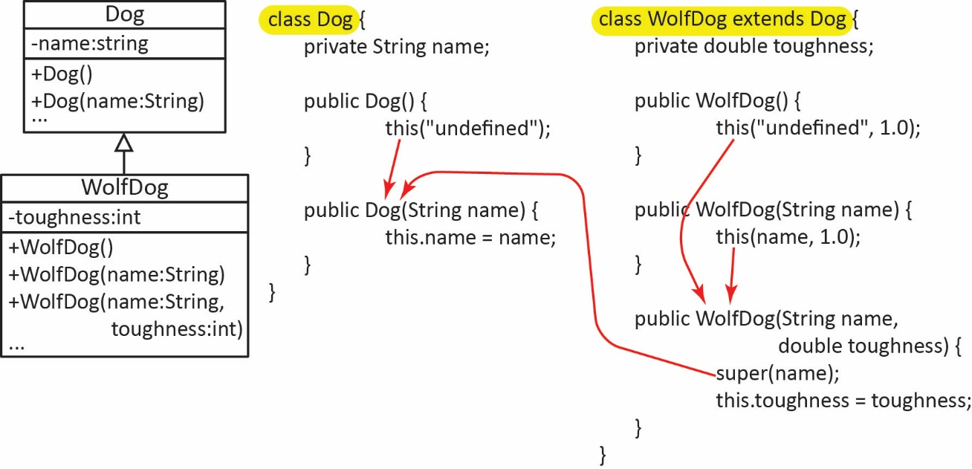
A common approach for the WolfDog constructors, which does compile and run correctly; however, is not considered best practice, is shown below:
public WolfDog() {  super("undefined");  this.toughness = 1;  } | public WolfDog(String name) {  super(name);  this.toughness = 1;  } | public WolfDog(String name,  double toughness) {  super(name);  this.toughness = toughness;  }
Example – (Solution in example_constructor_chaining_example_1 package) Consider the classes A and B shown on the right and the sample code to create a B object. What is the output? Consider the numbered steps:
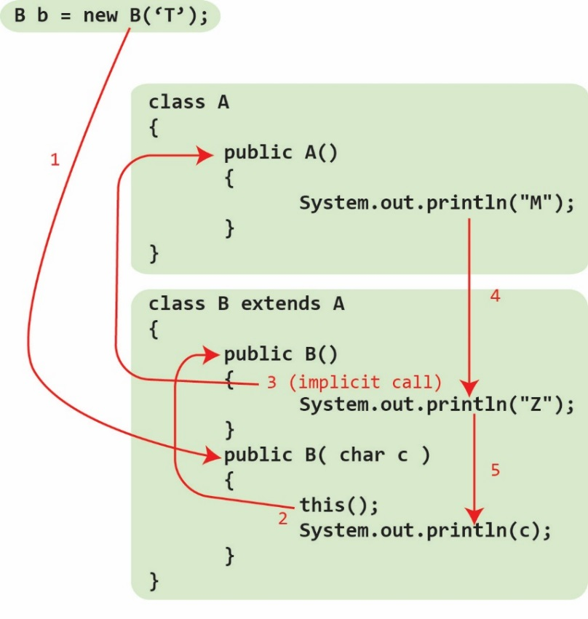
- B’s constructor that accepts a char is called
- which calls the no-arg constructor in B
- which implicitly calls A’s no-arg constructor
- which prints “M” then returns to B’s no-arg constructor and prints “Z”
- then returns to B’s constructor that accepts a char and prints “T”. When this finishes the B object has been created.
Output: M Z T
Notice that this illustrates what we said earlier about the order of execution of the constructors. The order they are called:
B(char c), B(), A()
The order they are executed:
A(), B(), B(char c)

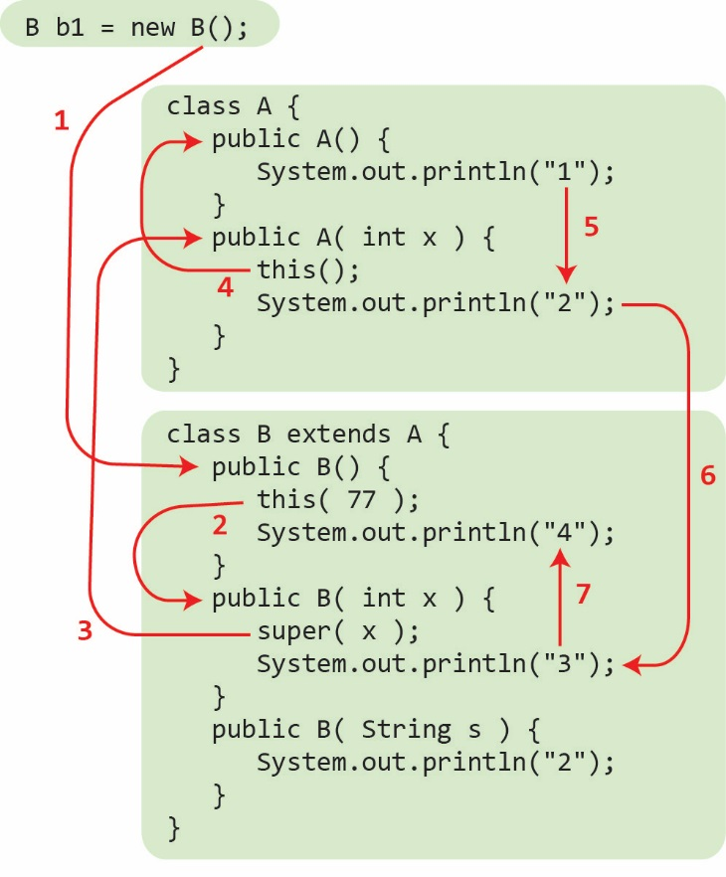
Example – (Solution in example_constructor_chaining_example_2 package) Consider the classes A and B below and the sample code to create a B object. What is the output?
What is the output from: B b2 = new B(9);
What is the output from: B b3 = new B("s");

Exercises
- (Solution in practice_problem_player_advancedPlayer package) Consider the two classes below. A Player can be created in one of two ways, by supplying: (a) a name and initial number of points (b) or, a by supplying just a name, in which case points are set to 0. An AdvancedPlayer can be created in one of three ways, by supplying: (a) a name, initial points, and initial skill level, (b) a name and initial number of points, in which case skill level is set to 1, (c) or, just a name, in which case points is set to 0, and skill level is set to 1. Write the required constructors for each class.
public class Player {
protected String name;
protected int points;
}

public class AdvancedPlayer extends Player {
protected int skillLevel;
}

Calling Overridden Superclass Methods
Sometimes you want a subclass method to call a superclass method that has been overridden in the subclass. This is accomplished with:
super.method( argList );
Occasionally I find use for this when a superclass toString method returns the state and the subclass overrides toString to provide exactly the same information as the superclass toString, but then tacks on the additional state of the subclass.
Example – (Solution in example_superclass_method_dog_wolfdog package) Consider the Dog class below. It has a name and age and a toString that returns the name and age. Consider the WolfDog class below. In addition to name and age, it also has a toughness. Suppose we want the WolfDog’s toString to return: name, age, and toughness. Then, as shown below (highlighted), we can use super.toString() to get the name and age.
Dog – Superclass | WolfDog - Subclass
public class Dog {  protected String name;  protected int age;  public Dog(String name, int age) {  this.name = name;  this.age = age;  }  ...  @Override  public String toString() {  return "name=" + name +  ", age=" + age;  }  } | public class WolfDog extends Dog {  private int toughness;  public WolfDog(String name, int age,  int toughness) {  super(name, age);  this.toughness = toughness;  }  @Override  public String toString() {  return super.toString() +  ", toughness=" + toughness;  }  }
Example – (Solution in example_superclass_method_account_studentAccount package) Consider the BasicAccount class below. The withdraw method reduces the balance by amount. Consider the StudentAccount class below which also keeps track of the number of withdrawals. Thus, the withdraw method is overridden; however, it calls back to the superclass withdraw method to reduce the balance.

BasicAccount – Superclass | StudentAccount - Subclass
class BasicAccount {  private double balance;  public BasicAccount(double balance) {  this.balance = balance;  }  ...  public void withdraw(double amount) {  balance -= amount;  }  @Override  public String toString() {  String msg = String.format(  "bal=$%,.2f", balance);  return msg;  }  } | class StudentAccount extends BasicAccount {  int numWithdrawals;  public StudentAccount(double balance) {  super(balance);  }  @Override  public void withdraw(double amount) {  super.withdraw(amount);  numWithdrawals++;  }  @Override  public String toString() {  String msg = String.format(  "%s, num withdrawals=%d",  super.toString(), numWithdrawals);  return msg;  }  }
Actually, a subclass can call any non-private superclass method with super:
super.method( argList );
However, this is redundant as any non-private methods in the superclass are inherited. Thus, if you are not calling an overridden method, then best practice is to simply call the method without super. For example:
Dog Class | WolfDog Class – Bad Practice
class Dog {  private String name;  public Dog(String name) {  this.name = name;  }  public String getName() {  return name;  }  ...  } | class WolfDog extends Dog {  private int toughness;  public WolfDog(String name, int toughness) {  super(name);  this.toughness = toughness;  }  @Override  public String toString() {  String msg = String.format(  "Name:%s, toughness:%d",  super.getName(), toughness);  return msg;  }  }
 | WolfDog Class – Best Practice
@Override
public String toString() {
String msg = String.format(
"Name:%s, toughness:%d",
getName(), toughness);
return msg;
}
}

Preventing Extending and Overriding
To prevent a class from being subclassed (extended) declare it final.
public final class Person {
...
}
To prevent a method from being overridden declare it final.
public final double getSalary() {
...
}
An instance variable (field) can be declared final. This means that once the object is created, its value cannot be change.
- Class constant – Belongs to the class and its value cannot be changed. By convention, the name of a constant is all upper-case letters with words separated by an underscore. For example:

public static final double CENTIMETERS_PER_INCH = 2.54;

- Final field (instance variable) – Belongs to the instance. Its value must be initialized in the declaration or in a constructor. Once the object is created, its value cannot not change. Syntax:
private final String name;
- Example:
public class Person {
// A class constant whose value cannot be changed.
public static final double CENTIMETERS_PER_INCH = 2.54;
// Instance variable whose value cannot be changed after the object is created.
private final String name;
private double height; // inches

public Person(String name, double height) {
this.name = name;
this.height = height;
}
...
public double getHeightMetric() {
return height*CENTIMETERS_PER_INCH;
}
...
}

OO Modelling
You should only use an inheritance relationship when “is-a” makes sense. For example, these would satisfy is-a:
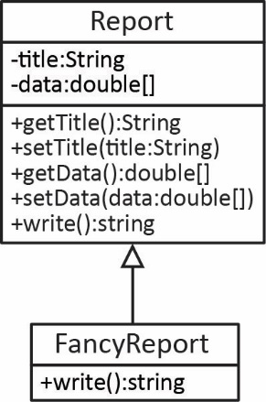 | 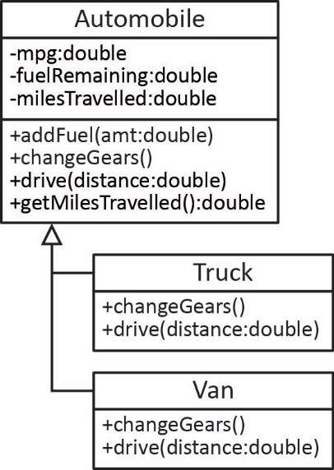 | 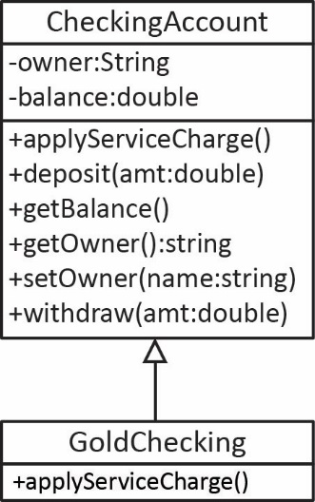

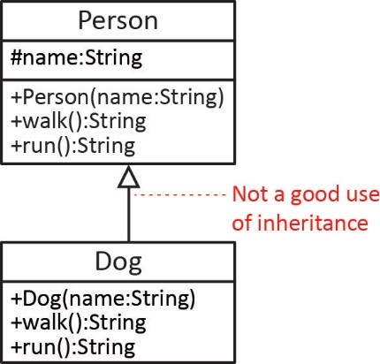
However, consider the class diagram on the right. A Person and a Dog both have a name, walk, and run, but a Dog is not a Person. Thus, we should not let a Dog class extend a Person class (or visa-versa).

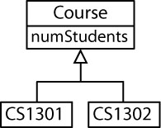
However, just satisfying the is-a relationship is not enough to use inheritance. For example, the situation on the right would not be a good use of inheritance. To use inheritance properly, there should be at least one behavior that is implemented differently. The example on the right satisfies is-a, but if there were no behavior that is different, it could be better modeled by simply adding a courseName attribute to the Course class and then you could have instances that have different values for this attribute as shown below.
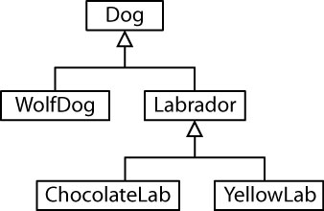
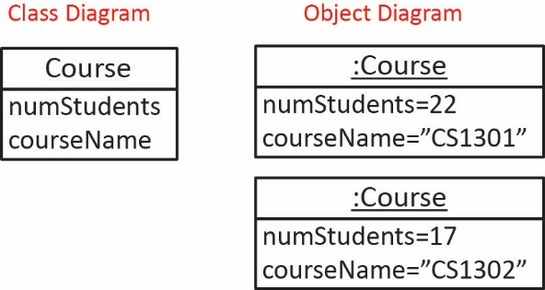
We can define a multilevel hierarchy as long as it follows the is-a rule.

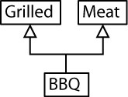
Java allows only single inheritance, that is, a class can only extend one superclass. Some languages (C++, Python) allow multiple inheritance where a class can extend several superclasses. For example, the situation on the right is not allowed in Java.

Appendix
- The SalesReport Class
This code and description accompany an Exercise from this chapter.
public class SalesReport {
private String companyName;
private double[] salesData;

public SalesReport(String companyName, double[] salesData) {
this.companyName = companyName;
this.salesData = salesData;
}

public String getCompanyName() {
return companyName;
}

public String getReport() {
String report = getHeader() + "\n" + getBody();
return report;
}

private String getHeader() {
return "Aggregate Sales Report for " + companyName;
}

private String getBody() {
String body = String.format("The average sales is $%,.2f", averageSales());
return body;
}

public double averageSales() {
double avg = 0.0;
for(double sales : salesData)
avg += sales;
avg /= salesData.length;
return avg;
}
}
Notes:
- The getReport method calls helper methods, getHeader and getBody to build the report.
- An example of using this class to generate a report:
double[] salesData = {33423.32434, 93223.92, 78293.2342, 23449.9032,
33923.92038, 49882.23432, 55239.9032, 90202.2393,
77234.9923, 63292.23423, 82332.23423, 46232.32432};

SalesReport sReport = new SalesReport("Acme Corp", salesData);
String report = sReport.getReport();
System.out.println(report);
And the output is:

Aggregate Sales Report for Acme Corp
The average sales is $60,560.87
- Consider a DetailedSalesReport class that is a subclass of SalesReport. The getHeader method should be overridden so that it returns a string like this:
Detailed Sales Report for [companyName]
The getBody method should be overridden so that it returns a string like this:
The average sales is $60,560.87
All sales figures:
$33,423.32 $93,223.92 $78,293.23 $23,449.90 $33,923.92
$49,882.23 $55,239.90 $90,202.24 $77,234.99 $63,292.23
$82,332.23 $46,232.32
Thus, as shown above, in addition to the average sales, all sales figures are shown, 5 per line.
Hints:
- The helper methods getHeader and getBody in SalesReport are private; thus, they can’t be overridden. You’ll need to change the visibility so that they can be overridden, but don’t change it to public because we do not want clients calling these methods, we only want clients to call the getReport method.
- You will need to change the visibility of the salesData instance variable in SalesReport so that it is accessible in the subclass, but not available outside the package.
- Overriding vs. Overloading
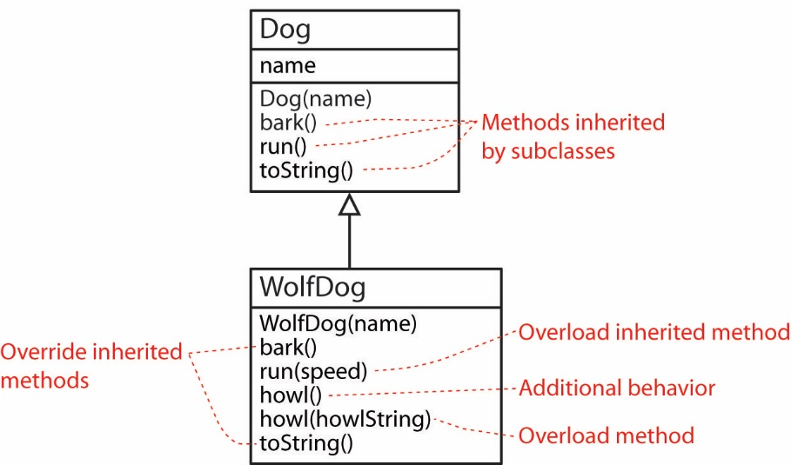
Overriding and Overloading are of course different. Overloading a method means to provide multiple methods with the same name but with different signatures. The overloaded method can be in the same class (either superclass or subclass) or, an inherited method can be overloaded in a subclass.

https://docs.oracle.com/javase/8/docs/api/java/lang/Object.html
This is actually true for any class. We consider this in more detail in Section 11.
Questions a-d all compile and run with output: “A”, “B”, “B”, “B”; respectively. Question e does not compile.
1 2 3 4
1 2 3
1 2

