Chapter 2 – Relationships between Classes

Contents
1 Introduction 2
2 One-to-One Relationships 2
2.1 One Way Navigability 2
2.2 Exercises 5
2.3 Multiple 1-1 Relationships 6
2.4 Convenience Methods & Delegation 8
2.5 Exercises 10
2.6 Two-way Navigability 11
2.7 Exercises 12
3 One-to-Many Relationships 12
3.1 UML for One-to-Many 12
3.2 Example: Implementing One-to-Many 13
3.3 Exercises 18
4 Implementing a Stack 19
4.1 Exercises 21
5 Object Oriented Programming 21

To make this document easier to read, it is recommended that you turn off spell checking and grammar checking in Word:

- Choose: File, Option, Proofing
- At the very bottom, check: “Hide spelling errors…” and “Hide grammar errors…”

Introduction
In the previous chapter, we discussed how a class can be used to model a real-world object, and how to write and test the class. In this chapter we learn how to model the relationship between two classes. Examples of three types of relationships is shown in the table below. In this chapter, we consider only one-to-one, and one-to-many.
Relationship | Example | Class Diagram
One-to-one | “A person has a dog”
One-to-many | “A bank has many customers” | 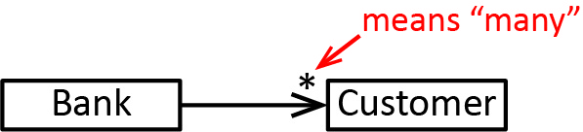
Many-to-many | “A student has many courses each course has many students”

One-to-One Relationships
To build real systems, we almost always have more than one class, and they generally have relationships between them. We begin by considering the simplest type of relationship, one-to-one.

One Way Navigability
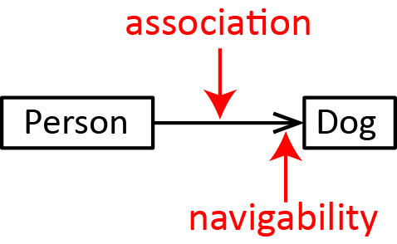
The example in this section is found in the example_person_dog_1_way_navigability package.
As shown on the right, in a class diagram, we model the one-to-one relationship between two classes with an association which is a solid line drawn between two classes. The arrow indicates navigability: “A person has-a dog.” An association is also called the has-a relationship.
When we say a “person has-a dog”, in terms of implementation, we mean that the Person class has an instance variable of type Dog. For example, in the example below, we see that this variable is named dog. This is also indicated by navigability arrow pointing from the Person to the Dog. As shown in the example below, we choose initialize the dog in the constructor, and a getter is provided.
Person Class | Dog Class
public class Person {  private String name;  private Dog dog;  public Person(String name, Dog dog) {  this.name = name;  this.dog = dog;  }  public Dog getDog() { return dog; }  public String getName() { return name; }  @Override  public String toString() {  return "name=" + name + ", dog=" + dog;  }  } | public class Dog {  private String name;  public Dog(String name) {  this.name = name;  }  public String getName() {  return name;  }  @Override  public String toString() {  return "name=" + name;  }  }

Next, let’s see how to use this class and what is occurring in memory.
Code | Memory
Dog d = new Dog("Spot"); | 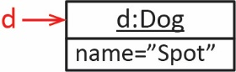
Person p = new Person("Leah", d);  System.out.println(p); // name=Leah, dog:name=Spot | 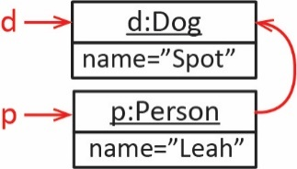
Dog d2 = p.getDog();  System.out.println(d2); // name=Spot | 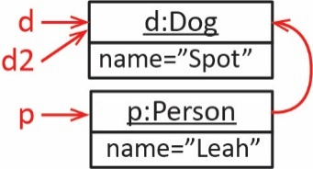
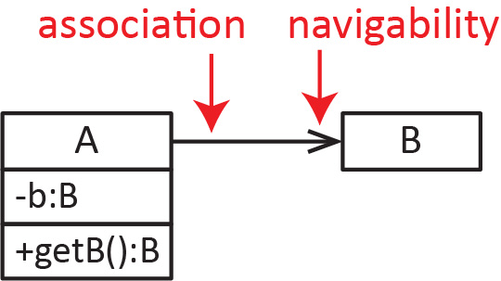
One-way navigability refers to a situation where two classes, A and B have an association and class A has a reference to class B, but B does not have a reference to A. We can indicate this in a class diagram by putting an arrow on the end of the association that points to the dependency as shown on the right. What this means is that, given an A object, you can always access the associated B object (as long as there is a getter for B). However, given a B object, you can’t access the associated A object.
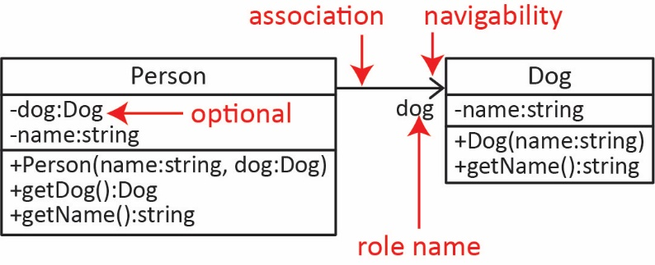
In the example above, a person knows who her dog is (because of the dog instance variable in Person), but the dog does not know who its owner is (because there is no instance variable of type Person in the Dog class). This illustrates one-way navigability. The class diagram representing these two classes is shown on the right. Note the following:
- This relationship is one-to-one. This means that each Person has exactly one Dog and each Dog can be associated with exactly one Person.
- The arrowhead drawn pointing to the Dog provides more information. It indicates that the Person class has an instance variable of type Dog. The arrowhead is referred to as navigability.
- The role name (optional) provides even more information. It indicates that the instance variable of type Dog in the Person class has the name dog. The role name should be at the end of the line where the navigability is shown (on the right in the diagram above).
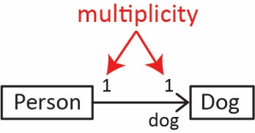
- Typically, we do not show the dog instance variable in the Person class when we show the role name, as it is redundant.
- We can explicitly specify multiplicity to show that the relationship is 1-1 as shown in the class diagram on the right. However, if the multiplicity is left off, then it is understood to be 0 or 1 (a person has one dog, or possibly none). Typically, we leave a multiplicity of 1 off of the diagram. We talk more about multiplicity in a later section.
Notice in the Person class above, we provide a getDog method, which is of course a getter for the dog instance variable.
public Dog getDog() {
return dog;
}

If we want to allow a Person to change their Dog, we could supply a setter:
public void setDog(Dog dog) {
this.dog = dog;
}
We can use this method with code like this:
Code | Memory
Dog d = new Dog("Spot");
Person p = new Person("Leah", d);
System.out.println(p); // name=Leah, dog:name=Spot
Dog d2 = new Dog("Chaps"); | 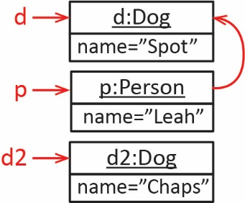
p.setDog(d2);  System.out.println(p); // name=Leah, dog:name=Chaps | 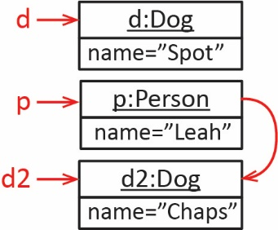
Currently, we require that a person have a dog because the only constructor requires a dog as an arguemnt.
public Person(String name, Dog dog) {
this.name = name;
this.dog = dog;
}
Suppose we do not want to require that a person have a dog. Then we can add another constructor:
public Person(String name) {
this(name,null);
}
Of course, we would need to be careful, because the getDog method could return null. For example, this code would generate a runtime error (null pointer exception):
Person p = new Person("Leah");
Dog d = p.getDog();
System.out.println(d.toString());
This is a very common type of error. Note that, after the 2nd line executes, d is null, which means d does not refer to an object in memory; there is no Dog in memory. This does not cause the error. It is the next line, where we attempt: d.toString(). It is attempting to call toString on something that is not an object. As we stated earlier, this is called a null pointer exception. When it occurs, your program stops and displays a message like this:
Exception in thread "main" java.lang.NullPointerException
at person_dog_1_way_navigability.PersonTest.testShowsAnError(PersonTest.java:42)
at person_dog_1_way_navigability.PersonTest.main(PersonTest.java:10)
So, what does a null pointer exception mean? It means you tried to call a method on an object that doesn’t exist (technically, an object that is null).
Finally, more than one Person could have the same Dog as illustrated by this sample code:
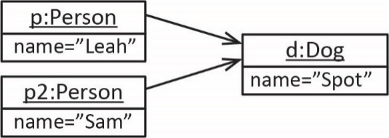
Dog d = new Dog("Spot");
Person p = new Person("Leah", d);
System.out.println(p); // name=Leah, dog:name=Spot

Person p2 = new Person("Sam", d);
System.out.println(p2); // name=Sam, dog:name=Spot
This may or may not be what we want to allow. If you had a strong reason to not allow this, then, most likely, you would need higher level classes to manage the creation of a person and dog associations. We discuss this in detail later in this chapter.

Exercises
- Consider the Car class below. Write a Person class with the characteristics shown below. Write some sample code to use this class. The solution is in the exercise_person_car1 package.
- A Person has-a Car and a name.
- A constructor that accepts the name and a car.
- A constructor that accepts just the name.
- A way to access the name (i.e. a getter).
- A way to access the car (i.e. a getter).
- A way to assign a car to the person (i.e. a setter).

public class Car {
private double totalDistance;

public Car() {
this.totalDistance = 0.0;
}

public double getTotalDistance() {
return totalDistance;
}

public void drive(double time, double rate) {
double distance = time*rate;
totalDistance += distance;
}

@Override
public String toString() {
String msg = String.format("totalDistance=%.1f" + totalDistance);
return msg;
}
}

Multiple 1-1 Relationships
The example in this section is found in the example_company_employee package.
A class can have multiple 1-1 relationships with the same class. For example, a Company has a CEO and a President. We would probably generalize CEO and President as employees (as we do here) or manager, etc. In a class diagram, we would show this is:
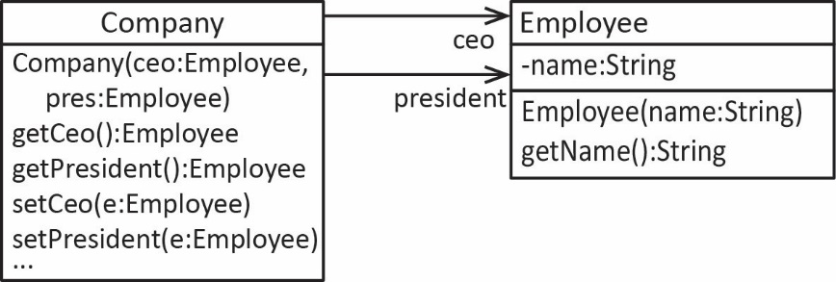
The code for Company class is shown below. Notice that we have two Employee instance variables: ceo and president
public class Company {
private Employee ceo;
private Employee president;
public Company(Employee ceo, Employee president) {
this.ceo = ceo;
this.president = president;
}
public Employee getCeo() {
return ceo;
}
public void setCeo(Employee ceo) {
this.ceo = ceo;
}
public Employee getPresident() {
return president;
}
public void setPresident(Employee president) {
this.president = president;
}
@Override
public String toString() {
return "CEO=" + ceo + ", President:" + president;
}
}

Sample code:
Code | Memory
Employee e1 = new Employee("Xavier");  Employee e2 = new Employee("Sadie"); | 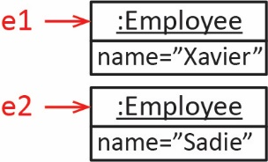
Company c = new Company(e1,e2);  System.out.println(c);  // CEO=name=Xavier, President:name=Sadie | 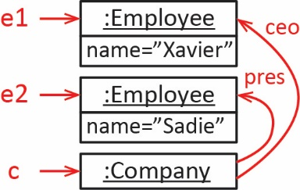
Example: Write a snippet of code to create a company and then use the Company methods to swap the CEO and president.
Code | Memory
// Create the company
Employee e1 = new Employee("Xavier");
Employee e2 = new Employee("Sadie");
Company c = new Company(e1,e2);
System.out.println(c);
// CEO=name=Xavier, President:name=Sadie
// Remember the current ceo and pres  Employee oldCeo = c.getCeo();  Employee oldPres = c.getPresident(); | 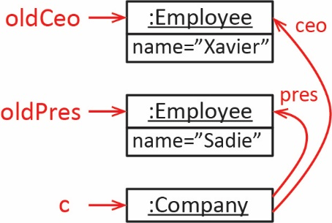
// Swap ceo and pres  c.setCeo(oldPres);  System.out.println(c);  // CEO=name=Sadie, President:name=Sadie | 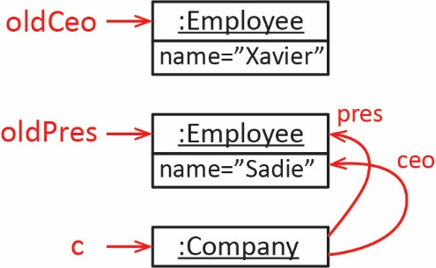
c.setPresident(oldCeo);  System.out.println(c);  // CEO=name=Sadie, President:name=Xavier | 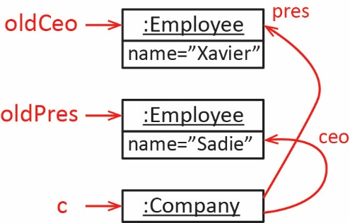
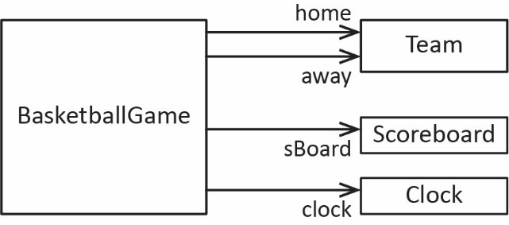
Example – As stated above, a class can also have as many associations as it needs to model a particular situation. For example, a BasketballGame might need associations with Team, Scoreboard, and Clock as shown on the right.
Finally, a class can have a reflexive association, where a class has an association with itself. In the class diagram below, a Course has another Course which is the prerequisite. In the object diagram below, the Course, cs1302 has a prerequisite that is also a Course, cs1301. A reflexive association is the basis for linked data structures (e.g. Linked List, Trees, etc.) and will be studied in another course.
Class Diagram | Object Diagram
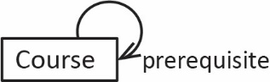 | 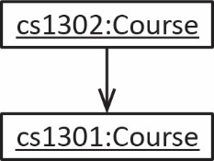

Convenience Methods & Delegation
The example below is found in the example_person_dog_1_way_navigability package.
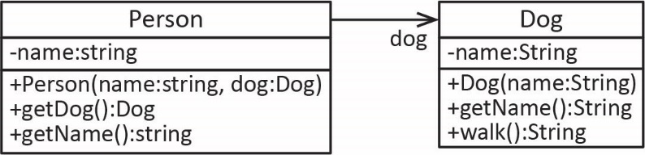
Continuing with the the Person, Dog example, suppose the Dog has a walk method:
public String walk() {
return name + " is walking";
}
If we want a person to walk their dog, we could ask the person for their dog, and then ask the dog to walk:
Person p = new Person("Sandra", new Dog("Chaps"));
Dog d = p.getDog();
String msg = d.walk();

System.out.println(msg); // Chaps is walking

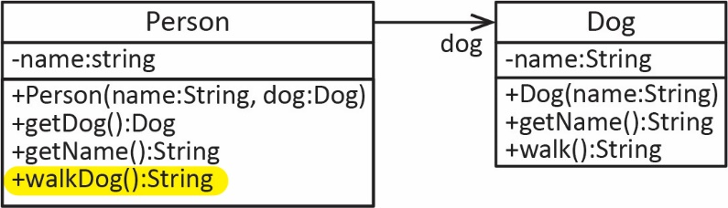
Or, we could add a convenience method to the Person class, walkDog that delegates to the Dog to accomplish the walk:
public String walkDog() {
return dog.walk();
}
Then, to walk the dog:
Person p = new Person("Sandra", new Dog("Chaps"));
String msg = p.walkDog();
System.out.println(msg); // Chaps is walking
Another convenience method we might add to the Person class:
public String getDogName( ) {
return dog.getName();
}
When designing classes, we want to make them as easy to use as possible. Frequently, that involves making a convenience method that makes accomplishing a use case simpler for a programmer building a system. In general, if class A has-a B, we should give thought to what convenience methods we should have in A that delegate to B. Clearly, we could delegate to all methods in B; however, without strong reason to, this might make A to have too many responsibilities.
For example, suppose that a Person has an Account as shown below (code is found in the example_person_account_1_way package). The Account class has deposit and withdraw methods. However, we might add For example, perhaps we have deposit and withdraw convenience methods in the Person class, but require an instance of an Account object to applyInterest:

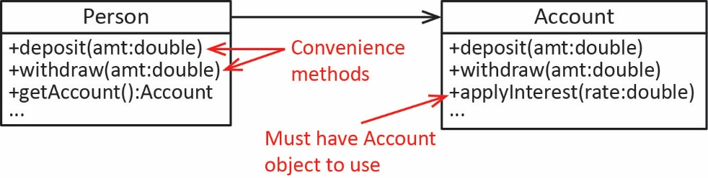
For example:
Person Class | Test Code
public class Person {  private String name;  private Account account;  public Person(String name, Account account) {  this.name = name;  this.account = account;  }  public Account getAccount() {  return account;  }  public void deposit(double amount) {  if(amount>0) {  account.deposit(amount);  }  }  public void withdraw(double amount) {  if(amount>0) {  account.withdraw(amount);  }  }  ...  } | public static void testDeposit() {  Account a = new Account(2000.00);  Person p = new Person("Vaugn", a);  p.deposit(1000.0);  System.out.println(p);  }  public static void testApplyInterest() {  Account a = new Account(2000.00);  Person p = new Person("Vaugn", a);  a = p.getAccount();  a.applyInterest(0.1);  System.out.println(p);  }
These design choices depend on a number of factors, one of which is class cohesion. Ideally, we want to class to do one thing, in which case the class would have strong cohesion. If the Person class above had many other responsibilities that relate to it being a person (get name, age, address, beneficiary, etc.) and a number of responsibilities related to managing the account, we would say that the Person class has weaker cohesion. In general, we want classes that have strong cohesion. When classes start to take on too many responsibilities, we should break them into separate classes that are associated. This is a skill that takes experience and time to develop. Mostly, in this class, I tell you what classes are needed. In subsequent classes, it will be up to you to design the classes.

Exercises
- (Solution in exercise_person_car2 package) Consider the Person class from previous Exercise. Add the following convenience methods to the Person class: (a) driveCar method that accepts a time and rate and delegates to the Car classes drive method, (b) a getDriveDistance method that returns the total distance the car has driven. Write some sample code to use this class.
- (Solution in exercise_person_account1 package) Consider the two classes, Person and Account shown below. Make the following change to the Account class and write code to test:
- Keep a running total of all deposits to the associated account (not the number of deposits, the value of all deposits). Hint: introduce a new instance variable, depositTotal and every time deposit is called, add the amount to this variable (and of course continue to update the balance). Also, write a getter for this variable, getTotalDeposits
- Modify the toString method so that it also shows the running total of deposits.
Make the following change to the Person class and write code to test:
- Provide a convenience method, getTotalDeposits, to return the total of deposits. Hint: this method simply delegates to the Account class’s getTotalDeposits method.
Account Class | Person Class
public class Account {  private double balance;  public Account() { balance = 0.0; }  public Account(double balance) {  this.balance = balance;  }  public void applyInterest(double intRate) {  balance *= (1+intRate);  // Or, balance = balance + intRate*balance;  }  public double getBalance() { return balance; }  public void deposit(double amount) {  balance += amount;  }  public void withdraw(double amount) {  balance -= amount;  }  public String toString() {  return "Account: balance=" + balance;  }  } | public class Person {  private String name;  private Account account;  public Person(String name, Account account) {  this.name = name;  this.account = account;  }  public Account getAccount() {  return account;  }  public String getName() {  return name;  }  @Override  public String toString() {  return "name=" + name + ", account: " + account;  }  }

Two-way Navigability
The code for the example below is in the example_person_dog_2_way_navigability package.
Two-way navigability refers to the situation where each end of the association knows about the other. As shown in the class diagram below, not only does the Person know who his Dog is; the Dog knows who its owner is. One way to model this is to add an owner instance variable to the Dog class and provide a getter and setter as shown below.
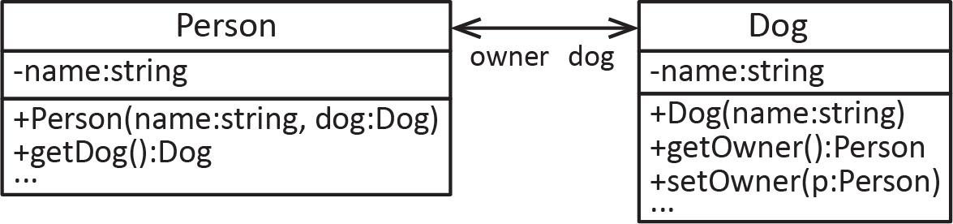
For example, the code below shows how to create the two objects and connect them, and how things are represented in memory.
Code | Memory
// Create dog  Dog d = new Dog("Mocho");  // Create person with dog  Person p = new Person("Xavier", d); | 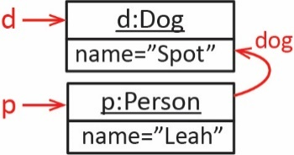
// Connect dog to its owner  d.setOwner(p); | 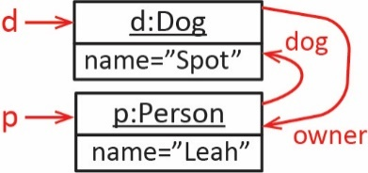
// If have a person, can always get dog
d = p.getDog();
// If have a dog, can always get person
p = d.getOwner();
The implementation is shown below.
public class Person {  private String name;  private Dog dog;  public Person(String name, Dog dog) {  this.name = name;  this.dog = dog;  }  public Dog getDog() {  return dog;  }  ...  } | public class Dog {  private String name;  private Person owner;  public Dog(String name) {  this.name = name;  }  public Person getOwner() {  return owner;  }  public void setOwner(Person owner) {  this.owner = owner;  }  ...  }

When do we implement two-way navigability? The short answer is: you will know when you need it. We consider this in a bit more detail in a later section.

Exercises
- (Solution in exercise_person_account2 package) Consider the Account class from the preceding Exercise. (a) Modify it so that it implements two-way navigability, i.e. so that an Account knows who its owner is. (b) Write code to test. (c) Draw a class diagram.

One-to-Many Relationships
Next, we consider the one-to-many relationship between classes.

UML for One-to-Many
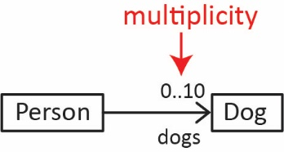
Consider the class diagram on the right which shows that a Person can have up to 10 dogs. This is an example of a 1-to-many association between two classes. Notice the role name is dogs; this is the name of the instance variable in the Person class that holds the dogs. For now, that will be an array:
private Dog[] dogs = new Dog[10];
For example, if a person has 3 (of the possible 10) dogs, we could illustrate that with an object diagram:

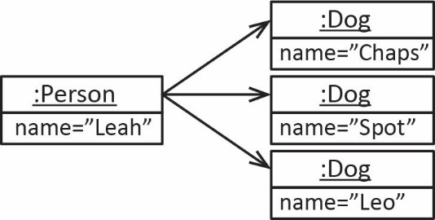

The multiplicity of an association can take on any of the values shown on the right.
Multiplicity | Meaning
n | Exacltly n instances
a..b | Any value from a to b instances
0..n | Any value from zero to n instances
* | Many (zero or more) instances
a..* | At least a instances
(blank) | Zero or one instance
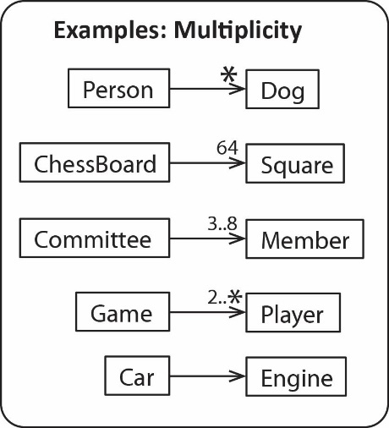
Consider the examples on the right and note the following:
- Each Person has many Dogs.
- Each ChessBoard has 64 Squares.
- Each Committee has 3-8 Members.
- Each Games has at least 2 Players.
- A Car has an Engine.

Example: Implementing One-to-Many
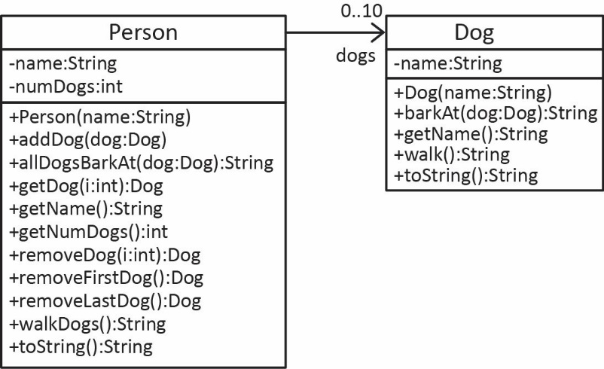
The example below is in the example_person_dogs package. In this section, we look closely at an example where a Person has many Dogs. Consider the class diagram on the right. Below, we step through the implementation of the entire Person class.
The Dog class should be straightforward. However, we show two of the methods we haven’t considered so far:
public String barkAt(Dog d) {
return name + "barks at " + d.name;
}

public String walk() {
return name + " is walking";
}
The Person class needs a way to keep track of the (up to) 10 dogs. We could have 10 instance variables:
Dog dog1; Dog dog2; ... Dog dog10;
However, this would be very unwieldly. We would need getters and setters for each one, and other issues. And, what if we wanted to change the number of dogs we allow, say, to 15. We would have to add a lot of code. A better solution (from the things we currently know) is to use an array of Dogs as the instance variable:
private Dog[] dogs = new Dog[10];
When we implement 1-many with an array, we will need an instance variable to keep track of exactly how many dogs we have, as well as a way to retrieve this value. We will also have addDog which will add a Dog to the array and increment the number of dogs.
Instance Variable | Getter | addDog
private int numDogs = 0; | public int getNumDogs() {  return numDogs;  } | public void addDog(Dog dog) {  // We’ll see this code shortly  numDogs++;  }
Note:
- The methods in the class manage numDogs, where appropriate. For example, when a Dog is added (removed) from Person, then we make sure our code increments (decrements) numDogs. Thus, we never “count” how many dogs there are in the array; numDogs will always contain the exact number of Dogs that Person has.
- Many of the methods we write below will depend on numDogs.
We begin the Person class with the code below and then we will add the other methods below.
public class Person {  private String name;  private int numDogs;  private Dog[] dogs = new Dog[10];  public Person(String name) {  this.name = name;  numDogs = 0;  } | public String getName() {  return name;  }  public int getNumDogs() {  return numDogs;  }  }

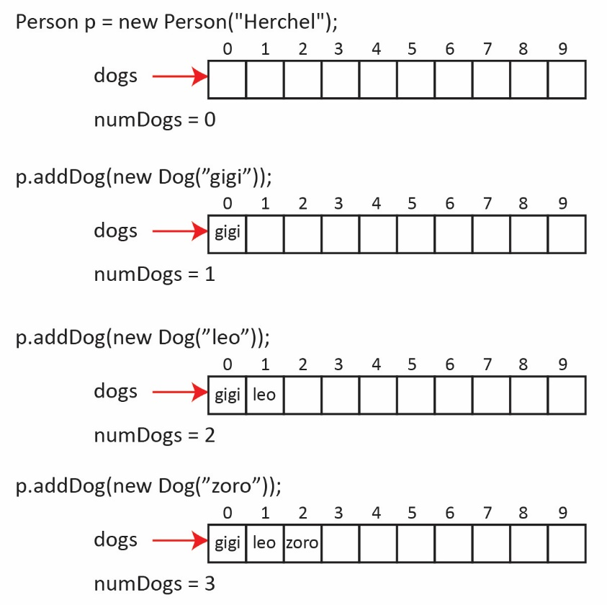
In a one-to-many relationship, I find it useful to refer to the “one” class as a manager class. In our example, the Person class is a manager class; it manages the dogs. A manager class will usually have an “add” method to add items. Thus, we provide an addDog method. The usual approach is to store the dogs sequentially in the array, starting at position 0. In the example on the right, notice that the first Dog added is added at index 0, the next at index 1, etc. And, each time we add a Dog, numDogs is incremented.
Consider the addDog method:
public void addDog(Dog dog) {
if(numDogs<dogs.length) {
dogs[numDogs] = dog;
numDogs++;
}
}
Study the addDog method carefully; afterwards, note the following:
- It first makes sure the array is not full.
- The numDogs instance variable not only stores how many dogs we currently have, it also is the position in the array where the next dog will go. Make sure you see this. Initially, there are 0 dogs. So, where does the first dog that is added go? It goes in position 0.
- Finally, we increment numDogs.

And, as stated above, the getter for numDogs simply has to return the instance variable.
public int getNumDogs() {
return numDogs;
}
I emphasize this as I have seen students many times implement the getter by writing a loop that (tries to) count all the non-null elements in the array. For example:
public int getNumDogs() {
int count = 0;
for(int i=0; i<dogs.length; i++) {
if(dogs[i]!=null) {
count++;
}
}
return count;
}
This is a very poor choice when all we have to do is increment numDogs whenever we modify the array and then the getter simply returns numDogs. Further, this method can be incorrect once we add removeDog methods (later).

We provide a getDog method that accepts an index for the Dog to return. Note that we require that the index be valid: it must be between 0 and the number of dogs that have been added.
public Dog getDog(int i) {
if(i>=0 && i<numDogs) {
return dogs[i];
}
return null;
}
A common mistake is to specify a valid index as one that is less than the length of the array. This is incorrect because the array is not necessarily full.
Correct | Incorrect
i>=0 && i<numDogs | i>=0 && i<dogs.length
We might like to be able to access dogs by their name instead of an index. This is something we consider later in the course.
We provide a way for a Person to walk all their dogs:
public String walkDogs() {
String msg = "";
for(int i=0; i<numDogs; i++) {
Dog d = dogs[i];
msg += d.walk() + "\n";
}
return msg;
}
Notice that the stopping condition for the loop above (highlighted) involves the numDogs instance variable, not the length of the array. We want to iterate over just the dogs that we have. A common mistake is to use the length of the dogs array, which is incorrect because the array is not necessarily full and a runtime error would result if it is not.
Correct | Incorrect
i<numDogs | i<dogs.length
Notice also that we cannot use a for-each loop as it will traverse the entire array:
Correct | Incorrect
for(int i=0; i<numDogs; i++) {  Dog d = dogs[i];  msg += d.walk() + "\n";  } | for(Dog d : dogs) {  msg += d.walk() + "\n";  }
We provide a way for all the dogs to bark at another dog:
public String allDogsBarkAt(Dog d) {
String msg = "";
for(int i=0; i<numDogs; i++) {
Dog dog = dogs[i];
msg += dog.barkAt(d) + "\n";
}
return msg;
}
An iterative method is one that iterates (loops) over the elements in an array (collection) and does something to or with each one. For example, the walkDogs and allDogsBarkAt methods above are both iterative methods. Creating an iterative method is a must-have skill.
Next, we consider removing a dog from a person’s array of dogs. We will do this incrementally, by first considering the easiest case, removing the last dog (removeLastDog). After this, we consider, removeFirstDog. Finally, we consider the more general, removeDog(position).
We provide a method, removeLastDog, to remove the last dog and return it (typically, remove methods not only remove the item, but also return it). Look carefully at the code below. Where is the last dog located? We know that numDogs contains the position where the next dog would be added. Thus, if we subtract 1 from numDogs, that will be the location of the last dog.
Method | Alternate Version
public Dog removeLastDog() {  if(numDogs>0) {  numDogs--;  return dogs[numDogs];  }  return null;  } | public Dog removeLastDog() {  if(numDogs>0) {  return dogs[--numDogs];  }  return null;  }

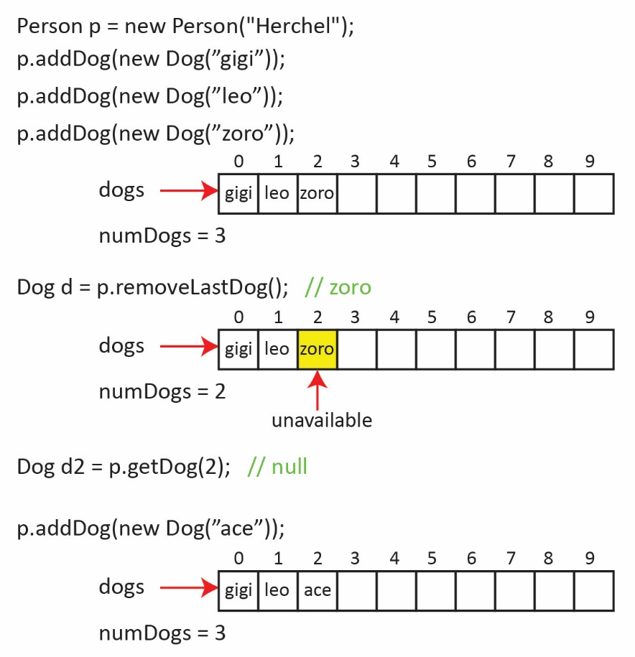
Now, follow the example on the right and correlate it with the removeLastDog method above. In the example, numDogs is 3, then we remove the last dog. However, we didn’t actually remove the last dog, we just decremented numDogs to 2. Thus, even though the dog we removed is still at index 2, it is unavailable because addDog, getDog, etc all depend on numDogs. For example, after removing the last dog, consider executing this line of code: d=p.getDog(2). Now go back and look at the getDog method and see that it will return null. Why? Because the argument, 2, is only valid:
if(i>=0 && i<numDogs)
Finally, if we add another dog, as usual, it goes in the next available spot, which overwrites (the inaccessible) zoro.
Next, we provide a method, removeFirstDog, to remove the first dog and return it. It is standard to not have an “holes” in the array. So, this means that when we remove the first dog, we need to move all the other dogs to the right, over one position to the left. The algorithm:
- Get a reference to the first dog
- Move all the other dogs over one position to the left
- Decrement the number of dogs
- Return the first dog
Study the code and example carefully, making sure you understand the loop and how it implements step 2 above. Notice that the last dog, zoro in the example below, appears twice, once in its new position (index=1), and once in its original position. However, as we noted above, it is unavailable because numDogs=2.
Method | Example
public Dog removeFirstDog() {  if(numDogs>0) {  Dog returnDog = dogs[0];  for(int i=1; i<numDogs; i++) {  dogs[i-1] = dogs[i];  }  numDogs--;  return returnDog;  }  return null;  } | 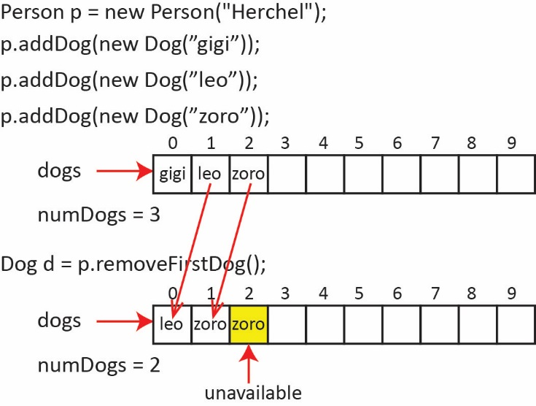
Finally, we provide a method, removeDog(index:int) to remove the dog at a particular index and return it. Similar to removeFirst, all the dogs to the right of the removed dog, must be moved over one position to the left. An algorithm:
- If the index is valid
  - Get a reference to the dog at the index
  - Loop over the dogs to the right of the one at the index
- Move current dog one position to the left.
  - Decrement the number of dogs
  - Return the dog that was at the index.
- Else, return null.
Study the code and example carefully, making sure you understand the loop and how it implements step 1b above.
Method | Example
public Dog removeDog(int i) {  if(i>=0 && i<numDogs) {  Dog returnDog = dogs[i];  for(int j=i+1; j<numDogs; j++) {  dogs[j-1] = dogs[j];  }  numDogs--;  return returnDog;  }  return null;  } | 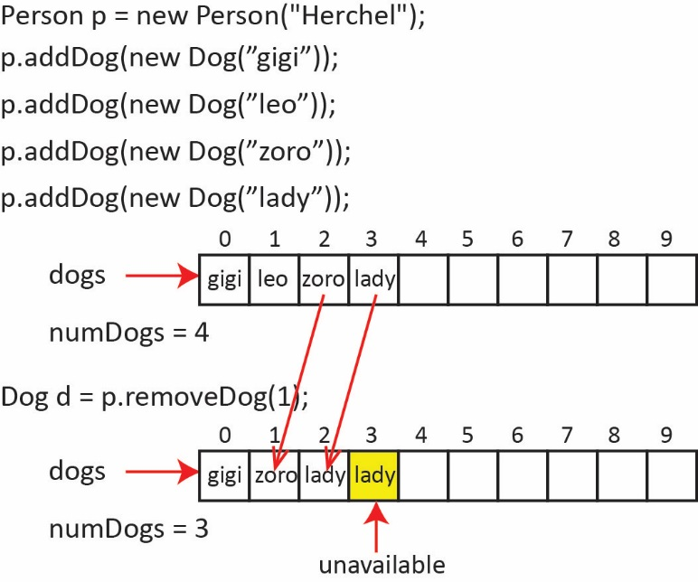

Note that removeLast and removeFirst can be made much simpler by simply calling removeDog:
public Dog removeLastDog() {  return removeDog(numDogs-1);  } | public Dog removeFirstDog() {  return removeDog(0);  }
Also, note that these two methods are convenience methods. To illustrate this: how would you use removeDog(i:int) to remove the first dog? The last dog?
Dog dFirst = p.removeDog(0);
Dog dLast = p.removeDog(p.getNumDogs()-1);
If we wanted to allow for any number of dogs, as shown in the class diagram on the right, then we could start with an array of some size, say 10 and when we try to add the 11th, we simple create a larger array. For example,
public void addDog2(Dog dog) {
// If array is full
if(numDogs>=dogs.length) {
// Create new array twice the size of current one
Dog[] temp = new Dog[dogs.length*2];
// Copy current array to new array
System.arraycopy(dogs, 0, temp, 0, dogs.length);
// Make the instance variable point to the new array
dogs=temp;
}
dogs[numDogs++] = dog;
}

Returning to the question of when do we implement two-way navigability, consider this example where a Bank has many Persons and each Person has many Accounts. Perhaps, in this situation, only one-way navigability is needed between Person and Account.
However, if the Bank also maintains a list of all Accounts, then it might be useful to be able to navigate from Account to Person.
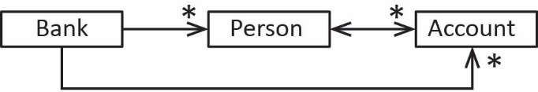

Exercises
- (Solution in exercise_person_dogs package) Consider the example for this section. Add a method to the Person class, getDogWithShortestName that returns the Dog with the shortest length name. Note: (a) this is an iterative method, (b) the code for the Person and Dog classes is in the example_person_dogs package.
- (Solution in exercise_person_accounts package) Modify the Person and Account classes from a previous Exercise (where two-way navigability was NOT used, i.e. from the classes in the exercise_person_account1 package) to fulfill these requirements:
- A Person can have up to 10 SavingsAccounts. Provide a way to get an account, add an account, remove an account, and get the number of accounts
- getTotalBalance – returns the sum of the balances of all the accounts.
- applyInterest(rate:double) – Applies the rate to all accounts.
- getSmallestAccount – Returns the account with the least balance
- removeAccount(index:int):Account – Removes and returns the account at index, provide the index is valid.
- toString – returns a nicely formatted string that contain the name of the person, and a list of all their account balances.
- Draw a UML class diagram to document your design.
- Draw an object diagram to depict the case where a person has 3 accounts.
- Write the Person class.
- Write a PersonTest class.

Implementing a Stack
The code for the example in this section is in the example_stack_of_integers package.
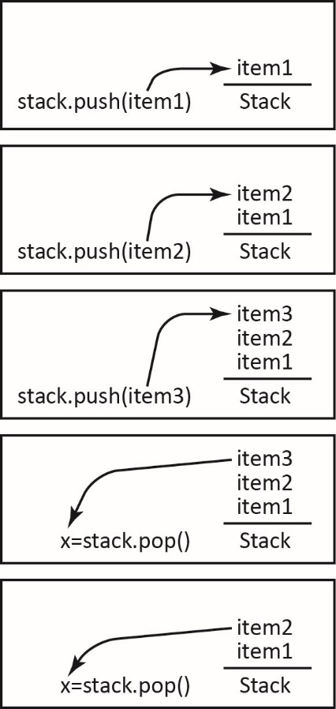
In computing, a collection (also called a container or manager) is the generic name for a class that has a 1-many relationship with another class. A collection class manages a group of items that it contains. An array is a collection in the general sense. Later in the semester we will study some other types of collections. Here, we study a stack which is a type of collection. A stack is like a stack of trays in a cafeteria, all operations occur at the top of the stack. For example:
- When you approach the stack of trays, you take a tray from the top of the stack.
- Later, an attendant places clean trays on the top of the stack.
A stack is a very useful data structure that we will consider several more times this semester, and in subsequent classes.
A collection must have a way to add and remove elements. A stack uses the terminology: push and pop to referring to adding and removing, respectively of an element. You push items onto the top of a stack and you pop the stack to remove and return the item at the top. This is illustrated in the figures on the right.
A stack is a last in – first out (LIFO) data structure: the last item pushed is the next item that is popped, i.e. the first one to come out.
The JVM utilizes a stack as it executes your program. When method A starts to execute, all its variables are pushed onto the stack. When A calls method B, all the variables in method B are pushed onto a stack. Then, when method B calls method C, method C’s variables are pushed onto the stack. When method C ends, the JVM pops the stack, removing C’s variables, leaving method B’s variables on the top of the stack, and continues running. Again, we will see this in detail in another chapter.
Standard stack operations:
Method | Description
isEmpty():boolean | Returns true if there are no items in stack, false otherwise.
peek():Item | Returns the item at the top of the stack, but does not remove it.
push(item:Item):void | Puts the item on the top of the stack.
pop():Item | Removes and returns the top item on the stack
getSize():int | Returns the number of items in the stack.
Suppose we want to design a Stack class. This is very similar to the 1-many relationship we have considered so far. The only real difference, besides the change in the names of the methods (push instead of add, and pop instead of remove), is that the remove method simply removes the last element.

Example – Write a class, StackOfIntegers to implement a stack that stores integers.
- Code
public class StackOfIntegers {
private int[] vals; // holds the integers in stack
private int size = 0;

public StackOfIntegers(int capacity) {
vals = new int[capacity];
}
public void push(int val) {
if(size<vals.length) {
vals[size++] = val;
}
}
public int pop() {
if(!isEmpty()) {
return vals[--size];
}
return Integer.MAX_VALUE;
}
public int peek() {
if(!isEmpty()) {
return vals[size-1];
}
return Integer.MAX_VALUE;
}
public boolean isEmpty() {
return size == 0;
}
public int getSize() {
return size;
}
}
- Test Code
- Create an instance of StackOfIntegers with a capacity of 10 integers.
StackOfIntegers stack = new StackOfIntegers(10);
- Add 4 integers to the stack.
stack.push(12);
stack.push(8);
stack.push(16);
stack.push(11);
- Write a statement to print whether the stack is empty and to print its size.
System.out.println("stack.isEmpty()=" + stack.isEmpty()); // false
System.out.println("stack.getSize()=" + stack.getSize()); // 4
- Write a statement to remove and return the top value on the stack.
int val = stack.pop();
System.out.println("stack.pop()=" + val); // 11
System.out.println("stack.getSize()=" + stack.getSize()); // 3

- Write a statement to obtain the top value on the stack without removing it:
val = stack.peek();
System.out.println("stack.peek()=" + val); // 16
System.out.println("stack.getSize()=" + stack.getSize()); // 3
- Write a snippet of code to completely empty the stack:
while(!stack.isEmpty() ) {
System.out.println("stack.pop()=" + stack.pop());
}
System.out.println("stack.isEmpty()=" + stack.isEmpty()); // true
System.out.println("stack.getSize()=" + stack.getSize()); // 0
- Consider the use case for 2 vi above (completely empty the stack). Add a method, clear to the StackOfIntegers class to achieve this. Hint: you do not need the loop, you can do it with a single line of code:
public void clear() {
size = 0;
}

Exercises
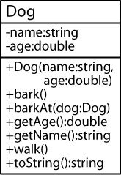
- (Solution in exercise_stack_of_dogs) Consider the Dog class shown on the right.
- Write a class, StackOfDogs to model a stack of Dog objects. Hint: look back at the StackOfIntegers class. Just a few things need to be changed to create the StackOfDogs class. For example: the vals array changes type to Dog[], the push method doesn’t accept an integer, it accepts a Dog, etc.
- Write a StackOfDogsTest class to test this class.

Object Oriented Programming
There are two aspects to OO programming: writing classes and using classes. For instance, suppose we are developing some banking software. First, we write classes like Account, Loan, Customer, etc. that model the domain of the problem. Next, we use those classes to solve the specific problem we have been given. For example, the system may need to be able to add and remove customers, accounts; display customers (or accounts) sorted on name, or account number, etc. To write such a system, we would use the classes above, and we would have to introduce a number of more classes. Mostly, for this class, you will simply write the domain classes.
A major focus in writing classes is designing classes that are easy to use and versatile. In general, these classes are not solving any specific problem; rather, they are modeling the context/domain of the problem (as discussed above). Identifying and designing these classes is a skill that takes time to develop. The more problems you solve, the better you will get at it. If you want practice at this, think about something you are interested in (a sport, music, some aspect of a job you have, anything) and try to develop a class diagram of the domain, just the classes and their associations, without the methods.
The interface (API, public interface) for a class is the set of public members (public fields and methods). In other words, the interface specifies exactly what messages can be sent (methods called) to an object from the outside. Thus, a programmer who is using a class is usually only interested in the public interface for the class because those are the only things it can use. In other words, to the person using classes, the classes themselves are black boxes. For example, for any particular method, the person doesn’t know how the code is implemented, they just care about what the class does. The term encapsulation refers to this idea of hiding the details of a class by providing an easy to use interface.

A use case is simply a statement of a single goal that an end user wants to be able to accomplish with a system. For example: - A person can walk their dog. - A person can obtain their balance from an ATM.

